An Effective, Mechanochemical One-Pot Multi Gram Scale Synthesis of N-Bridged Fused Heterocycles under Solvent-Free Conditions
Swati Chauhanª, Pratibha Verma^{b} and Vandana Srivastava^{c}*

ª Department of Applied Chemistry,
Gautam Buddha University, Greater Noida, 201312, India
Email: schauhanswati@gmail.com

^{b} Department of Chemistry
Indian Institute of Technology (BHU), Varanasi 221005, India
E-mail: pratibhav.rs.chy15@itbhu.ac.in

^{c} Department of Chemistry
Indian Institute of Technology (BHU), Varanasi 221005, India
E-mail: vsrivastava.apc@itbhu.ac.in

List of contents:
1. General Information
2. Experimental procedure for the synthesis
3. Control experiment with TEMPO
4. Analytical data of products
5. References
6. ¹H & ¹³C NMR spectra of products

- General Information
All the solvents and chemicals were purchased from commercial sources and were used without any further purification. Oxidizing agent tert-butyl hydroperoxide (70% aqueous solution) was purchased from Sigma-Aldrich. Thin layer chromatography was performed using pre-coated plates purchased from E. Merck (TLC silica gel 60 F254). TLC plates were visualized by exposure to ultraviolet light (UV) with 254 nm wavelength lamp and also analysed in iodine (I₂) chamber. The column chromatography was performed on silica gel (60-120 mesh) using a mixture of ethyl acetate and hexane as an eluent. Melting point of all the products was taken using open capillary melting point apparatus and was uncorrected. The NMR spectra were recorded on Bruker Avance 500 MHz NMR spectrometer using CDCl₃ and DMSO-d6 as a solvent. All chemical shifts were reported in ppm with reference to CDCl₃ peak (7.26 for ¹H and 77.16 for ¹³C NMR) and DMSO peak (2.50 for ¹H and 39.50 for ¹³C NMR). The ¹H NMR and ¹³C NMR of the products were compared with literature reports.

- Experimental procedures:
A mixture of aryl methyl ketone (1.0 mmol), 2-amino pyridine (1.0 mmol) and KI/TBHP (0.5/1equiv) was added in mortar and ground continuously. The mixture was ground until completion of the reaction was monitored by TLC (10 min). The syrupy formed was diluted with water and extracted with ethyl acetate. The organic layer was dried over anhydrous sodium sulphate (Na₂SO₄), concentrated and subjected for silica gel (60-120 mesh) column chromatography purification (SiO₂: ethyl acetate/hexane) to obtain the pure desired products.
3. Control experiment with TEMPO:

Aryl methyl ketone (1a) (1.0 mmol), 2-amino pyridine (1.2 mmol), KI/TBHP (.5/1equiv) and TEMPO (1.0 mmol) was added in mortar and ground continuously. The mixture was ground until completion of the reaction was monitored by TLC (10 min). The syrupy formed was diluted with water and extracted with ethyl acetate. The organic layer was dried over anhydrous sodium sulphate (Na₂SO₄), concentrated and subjected for silica gel (60-120 mesh) column chromatography purification (SiO₂: ethyl acetate/hexane) to obtain the pure desired products.

4. Analytical data of products
4.1. 2-phenylimidazo[1,2-a]pyridine (3aa) [6]: White solid; m.p. 135-136 ^{ο}C (lit. m.p. 134-136 ^{ο}C)[6]; yield 184 mg (95%); ¹H NMR (500 MHz, CDCl₃) δ 8.11 (dt, J = 6.7, 1.1 Hz, 1H), 7.99 – 7.93 (m, 2H), 7.86 (s, 1H), 7.66 – 7.60 (m, 1H), 7.47 – 7.41 (m, 2H), 7.37 – 7.30 (m, 1H), 7.19 – 7.13 (m, 1H), 6.77 (td, J = 6.8, 1.0 Hz, 1H); ¹³C NMR (126 MHz, CDCl₃)δ 145.97, 145.83, 133.90, 128.86, 128.11, 126.19, 125.71, 124.77, 117.73, 112.55, 108.24.
4.2. 2-(p-tolyl)imidazo[1,2-a]pyridine (3ba)[1]: White solid; m.p. 143-144 °C (lit. m.p. 144-146 °C)[1]; yield 193 mg (93%); ¹H NMR (500 MHz, CDCl₃) δ 8.36 (d, J = 6.1 Hz, 1H), 7.82 (d, J = 8.1 Hz, 2H), 7.76 (s, 1H), 7.42 (d, J = 9.4 Hz, 1H), 7.32 (dd, J = 9.4, 1.6 Hz, 1H), 7.25 (d, J = 7.9 Hz, 2H), 2.39 (s, 3H); ¹³C NMR (126 MHz, CDCl₃) δ 146.5, 144.2, 138.3, 132.5, 130.5, 130.4, 129.6, 126.1, 118.5, 107.5, 21.4.
4.3. 2-(4-methoxyphenyl)imidazo[1,2-a]pyridine (3ca)[5]: White solid; m.p. 138–139 °C (lit. m.p. 136–138 °C)[2]; yield 210 mg (94%); ¹H NMR (500 MHz, CDCl₃) δ 8.09 (d, J = 6.7 Hz, 1H), 7.88 (d, J = 8.4 Hz, 2H), 7.77 (s, 1H), 7.61 (d, J = 9.1 Hz, 1H), 7.14 (t, J = 7.8 Hz, 1H), 7.18 – 7.13 (m, 1H), 6.97 (d, J = 8.4 Hz, 2H), 6.75 (t, J = 6.7 Hz, 1H), 3.85 (s, 3H); ¹³C NMR (126 MHz, CDCl₃) δ 159.7, 145.8, 145.7, 127.4, 126.5, 125.5, 124.6, 117.4, 114.2, 112.4, 107.3, 55.4.

4.4. 2-(3-nitrophenyl)imidazo[1,2-a]pyridine(3da) [2]: Yellow solid, m.p. 202-203 °C (lit. m.p. 201-203 °C)[2]; yield 227 mg (95%); ¹H NMR (500 MHz, CDCl₃) δ 8.77 – 8.74 (m, 1H), 8.32 (d, J = 7.8 Hz, 1H), 8.17 (dd, J = 5.4, 4.6 Hz, 2H), 7.98 (s, 1H), 7.65 (d, J = 9.1 Hz, 1H), 7.60 (t, J = 8.0 Hz, 1H), 7.26 – 7.19 (m, 1H), 6.84 (t, J = 6.7 Hz, 1H); ¹³C NMR (126 MHz, CDCl₃) δ 148.8, 146.0, 143.5, 135.8, 131.9, 129.8, 125.9, 125.5, 122.6, 120.9, 117.9, 113.1, 109.1.
4.5. 2-(4-chlorophenyl)imidazo[1,2-a]pyridine(3ea) [3]: Yellow solid, m.p. 206-207 °C (lit. m.p. 204-206 °C)[3]; yield 211 mg (92%); ¹H NMR (500 MHz, CDCl₃)δ 8.11 (d, J = 6.8 Hz, 1H), 7.89 (d, J = 8.5 Hz, 2H), 7.84 (s, 1H), 7.62 (d, J = 9.1 Hz, 1H), 7.40 (d, J = 8.5 Hz, 2H), 7.20 – 7.16 (m, 1H), 6.79 (t, J = 6.7 Hz, 1H); ¹³C NMR (126 MHz, CDCl₃)δ 145.88, 144.85, 133.83, 132.45, 129.05, 127.41, 125.75, 125.06, 117.73, 112.76, 108.32.
4.6. 2-(4-bromophenyl)imidazo[1,2-a]pyridine(3fa)[11]: Off white solid, m.p. 200-201 °C (lit. m.p. 201-203 °C)[2]; yield 246 mg (90%); ¹H NMR (500 MHz, CDCl₃)δ 8.10 (dt, J = 6.8, 1.0 Hz, 1H), 7.85 – 7.78 (m, 3H), 7.61 (dd, J = 9.1, 0.6 Hz, 1H), 7.57 – 7.49 (m, 2H), 7.20 – 7.12 (m, 1H), 6.78 (m, 1H); ¹³C NMR (126 MHz, CDCl₃) δ 145.88, 144.85, 132.91, 131.97, 127.69, 125.75, 125.07, 122.00, 117.72, 112.76, 108.35.

4.7. 2-(4-fluorophenyl)imidazo[1,2-a]pyridine (3ga)[11]: Pale yellow solid, m.p. 164-165°C (lit. m.p. 164-166°C)[3]; yield 199 mg (94%); ¹H NMR (500 MHz, CDCl₃) δ 8.11 (d, J = 6.7 Hz, 1H), 7.95 – 7.90 (m, 2H), 7.80 (s, 1H), 7.62 (d, J = 9.1 Hz, 1H), 7.17 (t, 1H), 7.14 – 7.09 (m,2H), 6.78 (t, J = 6.7 Hz, 1H); ¹³C NMR (126 MHz, CDCl₃) δ 162.86 (d, J = 246.8 Hz), 130.12 (d, J = 3.2 Hz), 127.85 (d, J = 8.1 Hz),125.71 124.93, 117.64, 115.80 (d, J = 21.6 Hz), 112.65, 107.91.
4.8. 2-(imidazo[1,2-a]pyridin-2-yl)phenol (3ha)[2]: Colourless solid, m.p. 143-144°C (m.p. 140-141°C); yield 187 mg (89%); ¹H NMR (500 MHz, CDCl₃) δ 12.72 (s, 1H), 8.16 (d, J = 6.7 Hz, 1H), 7.87 (s, 1H), 7.64 – 7.57 (m, 2H), 7.26 – 7.21 (m, 2H), 7.04 (d, J = 7.3 Hz, 1H), 6.93 – 6.82 (m, 2H); ¹³C NMR (126 MHz, CDCl₃) δ 157.4, 145.5, 143.6, 129.8, 125.8, 125.5, 125.2, 119.1, 117.8, 116.9, 116.3, 113.2, 106.8.
4.9. 4-(imidazo[1,2-a]pyridin-2-yl)phenol (3ia)[11]: Brown solid; m.p. 230-231°C; yield 185 mg (88%); ¹H NMR (500 MHz, DMSO-d6) δ 9.62 (s, 1H), 8.47 (d, J = 6.7 Hz, 1H), 8.20 (s, 1H), 7.78 (d, J = 8.4 Hz, 2H), 7.53 (d, J = 9.1 Hz, 1H), 7.23 – 7.16 (m, 1H), 6.88 – 6.82 (m, 3H); ¹³C NMR (126 MHz, DMSO- d6) δ 157.36, 144.89, 144.69, 127.04, 126.70, 124.92, 124.61, 116.29, 115.56, 112.03, 107.55.
4.10. 2-(pyridin-2-yl)imidazo[1,2-a]pyridine (3ja)[4]: Brown solid, m.p. 240-241°C (lit. m.p. 139-140 °C)[4]; yield 166 mg (85%); ¹H NMR (500 MHz, DMSO-d6) δ 8.61 – 8.55 (m, 2H), 8.48 (s, 1H), 8.10 (d, J = 7.8 Hz, 1H), 7.88 (t, J = 6.8 Hz, 1H), 7.60 (d, J = 9.1 Hz, 1H), 7.38 – 7.23 (m, J = 15.8, 10.8, 5.9 Hz, 2H), 6.92 (t, J = 6.7 Hz, 1H); ¹³C NMR (126 MHz, DMSO-d6) δ 152.8, 149.5, 147.6, 144.9, 144.6, 137.0, 127.3, 125.4, 122.8, 119.8, 116.9, 112.6, 111.4, 108.0.
4.11. 2-(thiophen-2-yl)imidazo[1,2-a]pyridine (3ka)[2]: Yellowish white solid, m.p. 135-136 °C (lit. m.p. 136-138 °C)[2]; yield 184 mg (92%); ¹H NMR (500 MHz, CDCl₃) δ 8.07 (d, J = 6.7 Hz, 1H), 7.76 (s, 1H), 7.60 (d, J = 9.1 Hz, 1H), 7.47 (dd, J = 3.0, 0.4 Hz, 1H), 7.30 (d, J = 5.0 Hz, 1H), 7.20 – 7.12 (m, 1H), 7.10 – 7.05 (m, 1H), 6.76 (t, J = 6.7 Hz, 1H) ; ¹³C NMR (126 MHz, CDCl₃) δ 145.63, 141.06, 137.67, 127.88, 125.56, 125.20, 124.96, 123.86, 117.53, 112.71, 107.58.

4.12. 2-(naphthalen-1-yl)imidazo[1,2-a]pyridine (3la)[6]: Yellowish liquid; yield 227 mg (93%); ¹H NMR (500 MHz, CDCl₃) δ 8.61 (d, J = 9.1 Hz, 1H), 8.17 (d, J = 6.8 Hz, 1H), 7.92 – 7.87 (m, 2H), 7.83 (d, J = 8.8 Hz, 2H), 7.71 (d, J = 9.1 Hz, 1H), 7.53 (m, 3H), 7.21 (t, J = 6.5 Hz 1H), 6.82 (t, J = 6.8 Hz, 1H) ; ¹³C NMR (126 MHz, CDCl₃) δ 145.48, 145.34, 134.08, 131.87, 131.63, 128.59, 128.47, 127.83, 126.55, 126.06, 125.89, 125.66, 125.52, 124.71, 117.85, 112.55, 111.32.
4.13. 8-methyl-2-phenylimidazo[1,2-a]pyridine (3ab)[9]: Pale Yellow solid, m.p. 119-120 °C (lit. m.p. 120-121 °C)[3]; yield 189 mg (91%); ¹H NMR (500 MHz, CDCl₃) δ 8.02 – 7.96 (m, 3H), 7.83 (s, 1H), 7.48 – 7.43 (m, 2H), 7.37 – 7.31 (m, 1H), 6.96 (d, J = 6.0 Hz, 1H), 6.68 (t, J = 6.7 Hz, 1H), 2.68 (s, 3H) ; ¹³C NMR (126 MHz, CDCl₃) δ 146.3, 145.3, 134.2, 128.7, 127.8, 126.2, 123.5, 123.3, 112.4, 108.6, 17.2.
4.14. 2-(4-methoxyphenyl)-8-methylimidazo[1,2-a]pyridine(3cb)[3]: Pale Yellow solid, m.p. 132-133 °C (lit. m.p. 130-132 °C)[3]; yield 209 mg (88%); ¹H NMR (500 MHz, CDCl₃) δ 7.95 (d, J = 6.6 Hz, 1H), 7.89 (d, J = 8.7 Hz, 2H), 7.73 (s, 1H), 6.97 (d, J = 8.7 Hz, 2H), 6.92 (d, J = 6.8 Hz, 1H), 6.64 (t, J = 6.8 Hz, 1H), 3.84 (s, 3H), 2.65 (s, 3H); ¹³C NMR (126 MHz, CDCl₃) δ 159.5, 146.2, 145.2, 127.5, 127.4, 126.9, 123.4, 123.2, 114.1, 112.2, 107.8. 55.4, 17.2.
4.15. 8-methyl-2-(3-nitrophenyl)imidazo[1,2-a]pyridine(3db)[2]: Yellow solid, m.p. 168-169 °C (lit. m.p. 167-169 °C)[2]; yield 233 mg (92%); ¹H NMR (500 MHz, CDCl₃) δ 8.79 – 8.73 (m, 1H), 8.31 (dd, J = 7.7, 1.0 Hz, 1H), 8.16 – 8.11 (m, 1H), 8.00 (d, J = 6.7 Hz, 1H), 7.92 (s, 1H), 7.57 (t, J = 8.0 Hz, 1H), 6.98 (dd, J = 6.8, 1.0 Hz, 1H), 6.71 (t, J = 6.8 Hz, 1H), 2.65 (s, 3H); ¹³C NMR (126 MHz, CDCl₃) δ 148.7, 146.5, 142.8, 136.1, 132.0, 129.6, 128.0, 124.0, 123.7, 122.3, 120.9, 113.0, 109.5, 17.1.
4.16. 2-(4-chlorophenyl)-8-methylimidazo[1,2-a]pyridine(3eb)[5]: White solid, m.p. 119-120 °C (lit. mp 120-122 °C)[5]; yield 233 mg (92%); ¹H NMR (500 MHz, CDCl₃) δ 7.98 (d, J = 6.6 Hz, 1H), 7.90 (d, J = 8.4 Hz, 2H), 7.81 (s, 1H), 7.39 (d, J = 8.5 Hz, 2H), 6.96 (d, J = 6.7 Hz, 1H), 6.69 (t, J = 6.7 Hz, 1H), 2.65 (s, 3H).¹³C NMR (126 MHz, CDCl₃) δ 146.4, 144.2, 133.5, 132.8, 128.9, 127.7, 127.5, 123.6, 123.5, 112.6, 108.7, 17.2.
4.17. 2-(4-bromophenyl)-8-methylimidazo[1,2-a]pyridine(3fb)[5]: Yellow solid, m.p. 131-132 °C (lit. m.p. 128-130 °C)[3]; yield 261 mg (91%); ¹H NMR (500 MHz, CDCl₃) δ 7.97 (d, J = 5.4 Hz, 1H), 7.87 – 7.82 (m, 2H), 7.79 (s, 1H), 7.55 (d, J = 7.4 Hz, 2H), 6.96 (d, J = 6.7 Hz, 1H), 6.71 – 6.64 (m, 1H), 2.65 (s, 3H); ¹³C NMR (126 MHz, CDCl₃) δ 146.4, 144.2, 133.2, 131.8, 123.6, 123.5, 121.7, 112.6, 108.8, 17.2.
4.18. 2-(4-fluorophenyl)-8-methylimidazo[1,2-a]pyridine(3gb)[3]: White solid, m.p. 128-129 °C (lit. m.p. 129-130 °C)[3]; yield 199 mg (88%); ¹H NMR (500 MHz, CDCl₃) δ 7.96 (s, 1H), 7.93 (dd, J = 8.8, 5.4 Hz, 2H), 7.77 (s, 1H), 7.16 – 7.07 (m, 2H), 6.98 – 6.92 (m, 1H), 6.67 (t, J = 6.8 Hz, 1H), 2.65 (s, 3H); ¹³C NMR (126 MHz, CDCl₃) δ 163.7, 161.8, 146.3, 144.5, 130.5, 130.4, 127.9, 127.9, 127.7, 123.5, 115.78, 115.6, 112.5, 108.3, 77.4, 77.1, 76.9, 17.1.

4.19. 2-(8-methylimidazo[1,2-a]pyridin-2-yl)phenol (3hb)[12]: Yield 195 mg (87%); ¹H NMR (500 MHz, CDCl₃) δ 12.94 (s, 1H), 8.00 (s, 1H), 7.83 (dd, J = 5.6, 2.6 Hz, 1H), 7.58 (d, J = 7.4 Hz, 1H), 7.26 – 7.19 (m, 1H), 7.06 – 6.98 (m, 2H), 6.88 (t, J = 7.5 Hz, 1H), 6.76 (dd, J = 10.6, 4.5 Hz, 1H), 2.59 (s, 3H); ¹³C NMR (126 MHz, CDCl₃) δ 157.4, 144.7, 144.0, 129.6, 126.8, 125.7, 124.1, 123.2, 119.0, 117.7, 116.4, 113.3, 107.2, 16.9.

4.20. 4-(8-methylimidazo[1,2-a]pyridin-2-yl)phenol (3ib): Brown solid, yield 199 mg (89%); ¹H NMR (500 MHz, DMSO-d6) δ 10.50 (s, 1H), 9.56 (s, 1H), 8.32 (dd, J = 6.7, 0.7 Hz, 2H), 8.26 (s, 1H), 8.18 (s, 1H), 7.80 – 7.75 (m, 3H), 6.99 – 6.95 (m, 1H), 6.84 (d, J = 6.8 Hz, 1H), 6.77 – 6.75 (m, 1H), 2.51 (s, 3H); ¹³C NMR (126 MHz, DMSO-d6) δ 157.6, 156.7, 145.6, 145.5, 144.7, 143.0, 136.2, 127.7, 127.4, 126.2, 125.5, 124.8, 123.4, 115.9, 112.3, 109.0, 108.4, 17.1.
4.21. 6-chloro-2-phenylimidazo[1,2-a]pyridine(3ac)[11]: White solid, m.p. 207-208 °C (lit. m.p. 205-207 °C)[6]; yield 213 mg (93%); ¹H NMR (500 MHz, CDCl₃) δ 8.17 (d, J = 1.0 Hz, 1H), 7.94 (d, J = 7.4 Hz, 2H), 7.84 (s, 1H), 7.58 (d, J = 9.5 Hz, 1H), 7.44 (t, J = 7.6 Hz, 2H), 7.38 – 7.31 (m, 1H), 7.14 (dd, J = 9.5, 1.9 Hz, 1H); ¹³C NMR (126 MHz, CDCl₃) δ 147.0, 144.2, 133.4, 128.9, 128.4, 126.2, 126.1, 123.5, 120.7, 118.0, 108.6.

4.22. 6-chloro-2-(p-tolyl)imidazo[1,2-a]pyridine(3bc)[6]: Pale yellow solid, m.p. 225-226 °C (lit. m.p. 224-225 °C)[6]; yield 228 mg (94%); ¹H NMR (500 MHz, CDCl₃) δ 8.13 (d, J = 1.3 Hz, 1H), 7.81 (d, J = 8.1 Hz, 2H), 7.77 (s, 1H), 7.56 (d, J = 9.5 Hz, 1H), 7.24 (d, J = 7.9 Hz, 2H), 7.12 (d, J = 11.4 Hz, 1H), 2.39 (s, 3H); ¹³C NMR (126 MHz, CDCl₃) δ 147.0, 144.1, 138.3, 130.5, 129.6, 126.0, 126.0, 123.4, 120.5, 117.8, 108.2, 21.4.

4.23. 6-chloro-2-(4-chlorophenyl)imidazo[1,2-a]pyridine(3ec)[6]: Pale yellow solid, m.p. 206-207 °C (lit. m.p. 204-206 °C)[6]; yield 242 mg (92%); ¹H NMR (500 MHz, CDCl₃) δ 8.16 (d, J = 1.0 Hz, 1H), 7.86 (d, J = 8.5 Hz, 2H), 7.80 (s, 1H), 7.56 (d, J = 9.6 Hz, 1H), 7.40 (d, J = 8.5 Hz, 2H), 7.15 (dd, J = 9.5, 1.8 Hz, 1H); ¹³C NMR (126 MHz, CDCl₃) δ 145.9, 144.2, 134.2, 131.9, 129.1, 127.4, 126.4, 123.5, 120.9, 118.0, 108.6.

4.24. 2-(4-bromophenyl)-6-chloroimidazo[1,2-a]pyridine(3fc)[7]: Yellow solid, m.p. 199-200 °C (lit. m.p. 200-202 °C)[7]; yield 277 mg (90%); ¹H NMR (500 MHz, CDCl₃) δ 8.15 (dd, J = 1.9, 0.8 Hz, 1H), 7.81 – 7.78 (m, 3H), 7.56 (d, J = 8.6 Hz, 3H), 7.15 (dd, J = 9.6, 2.0 Hz, 1H); ¹³C NMR (126 MHz, CDCl₃) δ 145.9, 144.2, 132.4, 132.0, 127.7, 126.5, 123.5, 122.4, 120.9, 118.0, 108.6.
4.25. 2-(6-chloroimidazo[1,2-a]pyridin-2-yl)phenol (3hc)[8]: White solid, m.p. 197-199 °C (lit. m.p. 197-198 °C)[8]; yield 218 mg (89%); ¹H NMR (500 MHz, CDCl₃) δ 8.24 (d, J = 1.2 Hz, 1H), 7.87 (s, 1H), 7.61 – 7.56 (m, 2H), 7.25 (ddd, J = 11.5, 7.8, 1.9 Hz, 2H), 7.06 (d, J = 8.3 Hz, 1H), 6.92 (t, J = 7.5 Hz, 1H), 6.68 (t, J = 7.7 Hz, 1H), 1.27 (s, 1H).¹³C NMR (126 MHz, CDCl₃) δ 157.4, 146.5, 142.0, 130.1, 127.1, 126.6, 125.9, 123.3, 120.8, 119.2, 117.9, 117.2, 115.8, 107.2.
4.26. 8-(benzyloxy)-2-(4-bromophenyl)imidazo[1,2-a]pyridine (3ad)[9]: Pale yellow solid, m.p. 130-131 °C (lit. m.p. 131-133 °C)[9]; yield 337 mg (89%);¹H NMR (500 MHz, CDCl₃) δ 7.89 – 7.85 (m, 2H), 7.80 (s, 1H), 7.72 (dd, J = 6.7, 0.8 Hz, 1H), 7.55 – 7.49 (m, 4H), 7.38 (dd, J = 8.0, 6.7 Hz, 2H), 7.33 (d, J = 7.3 Hz, 1H), 6.59 (dd, J = 7.5, 6.8 Hz, 1H), 6.45 (d, J = 7.2 Hz, 1H), 5.39 (s, 2H); ¹³C NMR (126 MHz, CDCl₃) δ 148.0, 144.0, 140.5, 136.3, 132.86, 131.8, 128.7, 128.2, 127.8, 127.3, 121.8, 118.8, 112.5, 109.3, 103.4, 70.98.

4.27. 2-phenylbenzo[d]imidazo[2,1-b]thiazole(3ae)[10]: Yellow solid, m.p. 106-107 °C (lit. m.p. 106-108 °C)[10]; yield 230 mg (92%);¹H NMR (500 MHz, CDCl₃) δ 7.96 (s, 1H), 7.88 (d, J = 8.2 Hz, 2H), 7.69 (d, J = 8.5 Hz, 1H), 7.60 (d, J = 8.0 Hz, 1H), 7.46 – 7.40 (m, 3H), 7.32 (dt, J = 15.0, 7.7 Hz, 2H); ¹³C NMR (126 MHz, CDCl₃) δ 148.2, 147.8, 133.9, 132.3, 130.4, 128.8, 127.6, 126.3, 125.3, 124.9, 124.5, 112.7, 106.9.

4.28. 2-(4-bromophenyl)benzo[d]imidazo[2,1-b]thiazole(3fe)[10]: Yellow solid, m.p. 163-164 °C (lit. m.p. 164-166 °C)[10]; yield 306 mg (93%); ¹H NMR (500 MHz, CDCl₃) δ 7.97 (s, 1H), 7.75 (d, J = 7.8 Hz, 2H), 7.72 (d, J = 6.9 Hz, 1H), 7.61 (d, J = 8.6 Hz, 1H), 7.55 (d, J = 5.9 Hz, 2H), 7.47 (s, 1H), 7.36 (d, J = 5.6 Hz, 1H); ¹³C NMR (126 MHz, CDCl₃) δ 148.4, 146.7, 132.9, 132.2, 131.9, 130.4, 126.8, 126.4, 125.1, 124.6, 121.4, 112.8, 107.1.

References:
1. S. B. Bhagat and V. N. Telvekar, Tetrahedron Lett., 2017, 58, 3662. https://doi.org/10.1016/j.tetlet.2017.08.017
2. K. Pericherla, P. Kaswan, P. Khedar, B. Khungar, K. Parang and A. Kumar, RSC Adv., 2013, 3, 18923. https://doi.org/10.1039/C3RA43889A
3. S. k. Rasheed, D. N. Rao and P. Das. Asian J. Org. Chem., 2016, 5, 1213. https://doi.org/10.1002/ajoc.201600326
4. A. J. Stasyuk, M. Banasiewicz, M. K. Cyrański and D. T. Gryko, J. Org. Chem., 2012, 77, 5552. https://doi.org/10.1021/jo300643w
5. R. N. Rao, B. Maiti, R. Thakuria, and K. Chanda, ACS Comb. Sci., 2018, 20, 164. https://doi.org/10.1021/acscombsci.7b00173
6. P. Ghosh, B. Ganguly, B. Kar, S. Dwivedi and Sajal Das. Synth. Commun. 2018, 48, 1076. https://doi.org/10.1080/00397911.2018.1434893
7. S. V. Patil, N. D. Gaikwad and V. D. Bobade, Arab. J. Chem., 2016, 9, S1649. https://doi.org/10.1016/j.arabjc.2012.04.017
8. T. Mutai, H. Sawatani, T. Shida, H. Shono and K. Araki, J. Org. Chem., 2013, 78, 2482. https://doi.org/10.1021/jo302711t
9. M.‐A. Hiebel, F. Yacoub, M.-C. Scherrmann and B.‐R. Sabine, Eur. J. Org. Chem. 2014, 21, 4643. https://doi.org/10.1002/ejoc.201402079
10. S. G. Balwe and Y. T. Jeong, RSC Adv., 2016, 6, 107225. DOI https://doi.org/10.1039/C8QO00071A
11. Z. Chen, G. Cao, F. Zhang, H. Li, J. Xu, M. Miao and H. Ren, Synlett, 2017, 28, 1795. 10.1055/s-0036-1588419
12. R. Huang, S. Li, L. Fu, G. Li, Asian J. Org. Chem., 2018, 7, 1376. https://doi.org/10.1002/ajoc.201800287

6. ¹H & ¹³C NMR spectra of product

Fig. 6.1 ¹H and ¹³C NMR of product 3aa in CDCl₃
Fig. 6.2 ¹H and ¹³C NMR of product 3ba in CDCl_{3.}
Fig. 6.3 ¹H and ¹³C NMR of product 3ca in CDCl₃
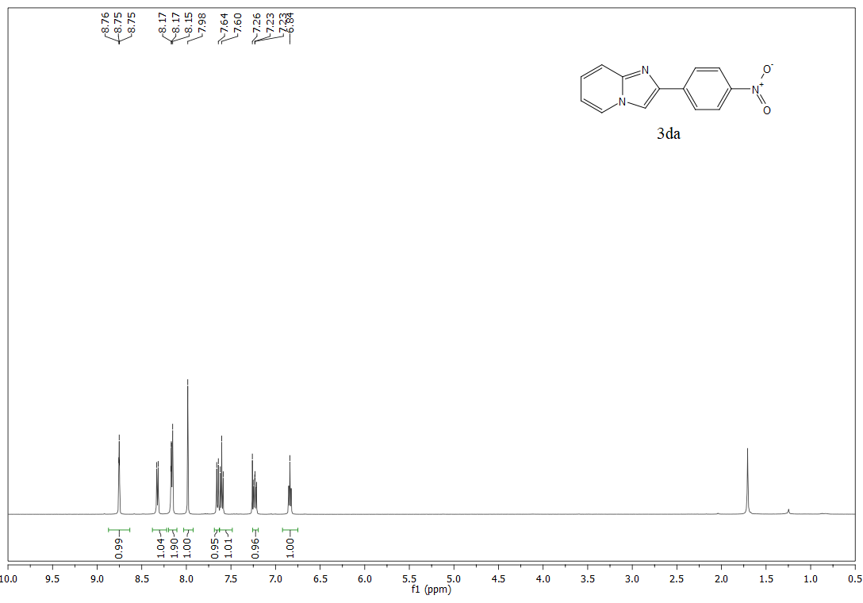
Fig. 6.4 ¹H and ¹³C NMR of product 3da in CDCl₃
Fig. 6.5 ¹H and ¹³C NMR of product 3ea in CDCl₃
Fig. 6.6 ¹H and ¹³C NMR of product 3fa in CDCl₃
Fig. 6.7 ¹H and ¹³C NMR of product 3ga in CDCl₃
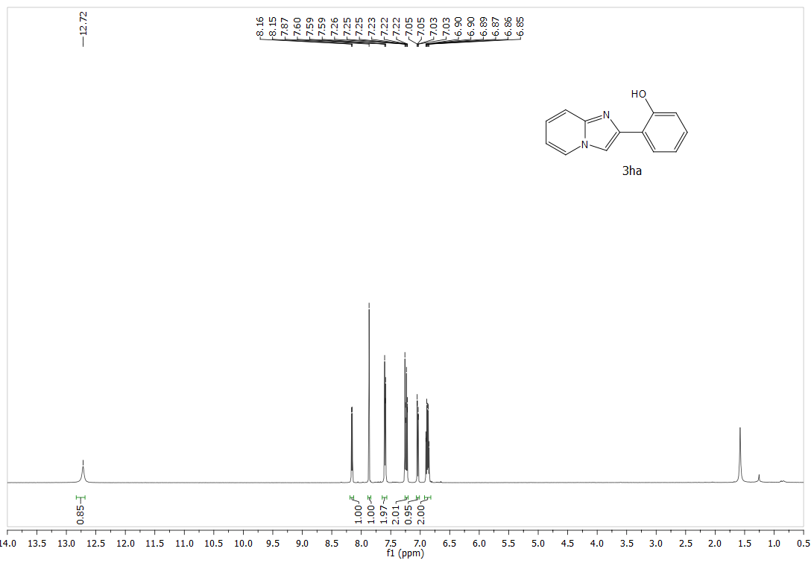
Fig. 6.8 ¹H and ¹³C NMR of product 3ha in CDCl₃
Fig. 6.9 ¹H and ¹³C NMR of product 3ia in DMSO-d6
Fig. 6.10 ¹H and ¹³C NMR of product 3ja in DMSO-d6
Fig. 6.11 ¹H and ¹³C NMR of product 3ka in CDCl₃
Fig. 6.12 ¹H and ¹³C NMR of product 3ka in CDCl₃
Fig. 6.13 ¹H and ¹³C NMR of product 3ab in CDCl₃
Fig. 6.14 ¹H and ¹³C NMR of product 3cb in CDCl₃
Fig. 6.15 ¹H and ¹³C NMR of product 3db in CDCl₃
Fig. 6.16 ¹H and ¹³C NMR of product 3eb in CDCl₃
Fig. 6.17 ¹H and ¹³C NMR of product 3fb in CDCl₃
Fig. 6.18 ¹H and ¹³C NMR of product 3gb in CDCl₃
Fig. 6.19 ¹H and ¹³C NMR of product 3hb in CDCl₃
Fig. 6.20 ¹H and ¹³C NMR of product 3ib in DMSO-d6
Fig. 6.21 ¹H and ¹³C NMR of product 3ac in CDCl₃
Fig. 6.22 ¹H and ¹³C NMR of product 3bc in CDCl₃
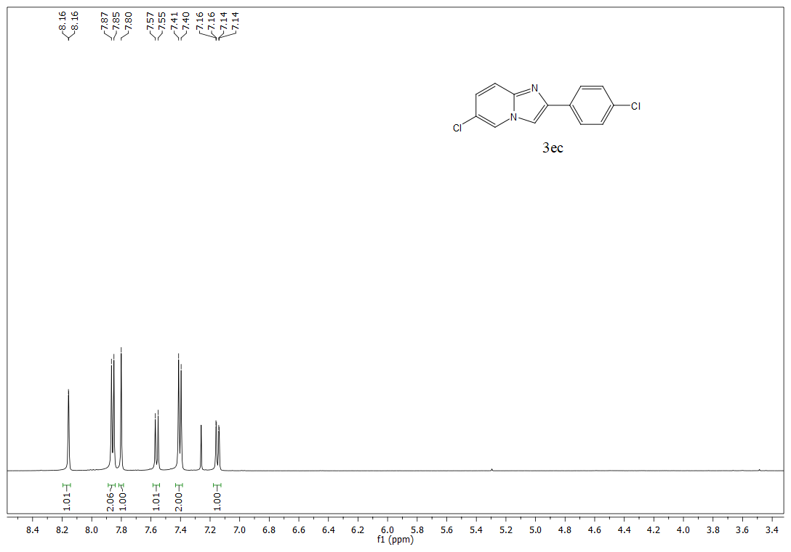
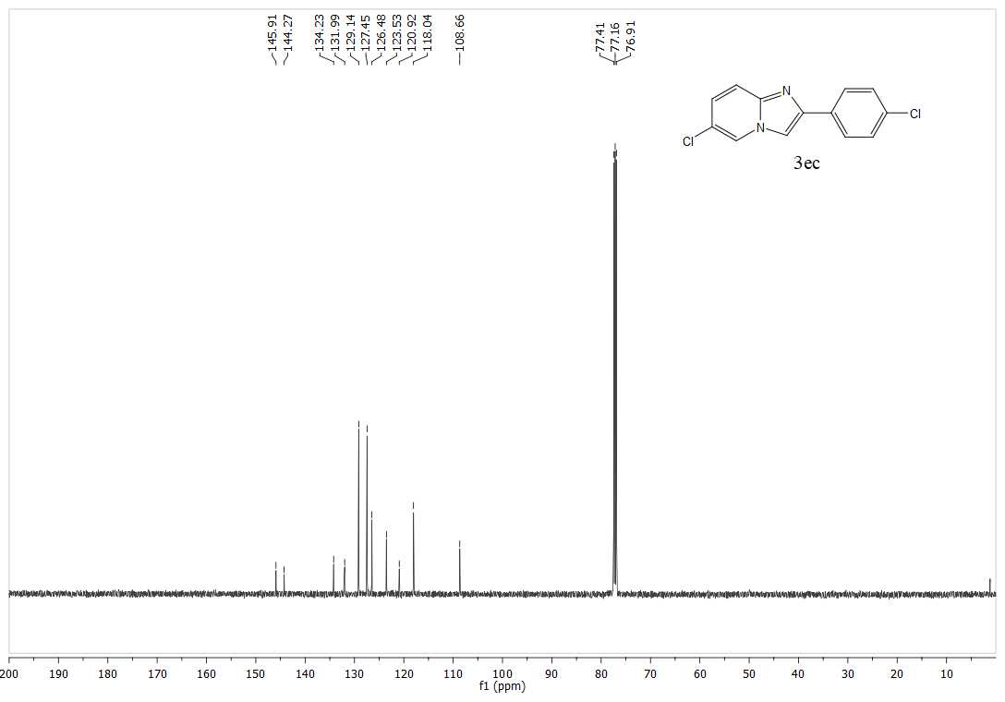
Fig. 6.23 ¹H and ¹³C NMR of product 3ec in CDCl₃
Fig. 6.24 ¹H and ¹³C NMR of product 3fc in CDCl₃
Fig. 6.25 ¹H and ¹³C NMR of product 3hc in CDCl₃
Fig. 6.26 ¹H and ¹³C NMR of product 3fd in CDCl₃
Fig. 6.27 ¹H and ¹³C NMR of product 3ae in CDCl₃
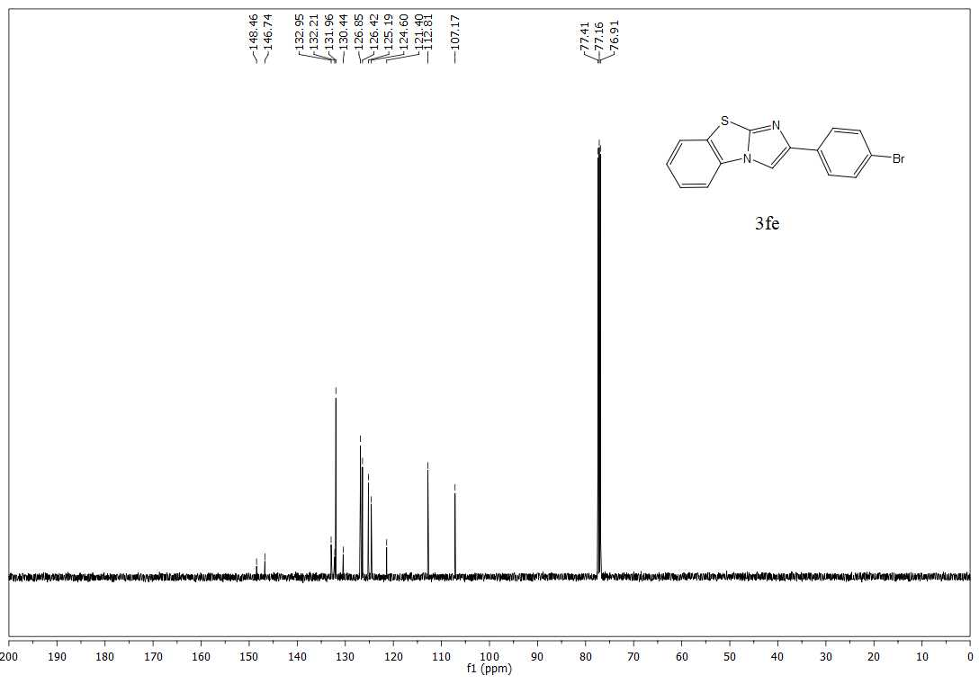
Fig. 6.28 ¹H and ¹³C NMR of product 3fe in CDCl₃

