SUPPLEMENTAL INFORMATION

Alleviation of preeclampsia-like symptoms through PlGF and eNOS regulation by hypoxia- and NF-κB-responsive miR-214-3p deletion

Supplementary Table 1. List of qRT-PCR primers
Genes | Forward primer sequence | Reverse primer sequence
hsa-pre-miR-214 | CTGGACAGAGTTGTCATGTGT | GTCATTCAGGCTGGGTTGTC
heNOS | GTGGCTGTCTGCATGGACCT | CCACGATGGTGACTTTGGCT
hPlGF | GTTCAGCCCATCCTGTGTCT | TTAGGAGCTGCATGGTGACA
hGAPDH | CCACCCATGGCCAAATTCCATGGCA | TCTAGACGGCAGGTCAGGTCCACC
mmu-pre-miR-214 | GTCTGCCTGTCTACACTTGC | CTTTCAATGGCTGGTGGTCA
meNOS | AGAGATTGGCATGAGGGACC | ATTAATTTCCACCGCTGCCT
mPlGF | TGAAGGCATGTAGAGGGGAC | CACTCTGCCTGTGTTCCAGA
sgRNA | ATAGGCCTGTACAGCAGGCACAGACG | AAAACGTCTGTGCCTGCTGTACAGGC
mGAPDH | AGCGACCCCTTCATTGAC | TCCACGACATACTCAGCAC

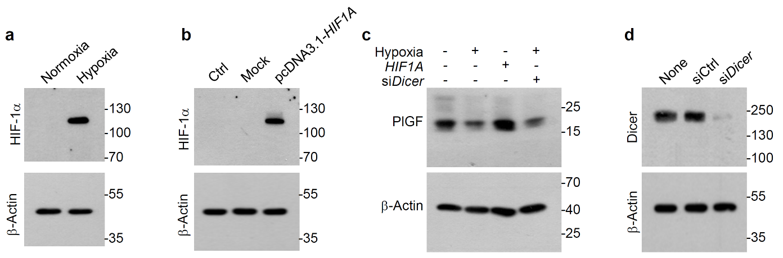
Supplementary Fig. 1. Levels of PlGF, HIF-1α, and Dicer in trophoblasts under various experimental conditions. a, b HIF-1α levels were determined in HTR-8/SVneo cells exposed to normoxia or hypoxia for 24 h or transfected with mock or pcDNA3.1-HIF1A for 24 h using western blotting. c PlGF levels were determined in HTR-8/SVneo cells exposed to normoxia or hypoxia after transfection with pcDNA3.1-HIF1A or Dicer siRNA (siDicer) using western blotting. d Dicer levels were determined in HTR-8/SVneo cells transfected with control siRNA or siDicer for 24 h using western blotting.

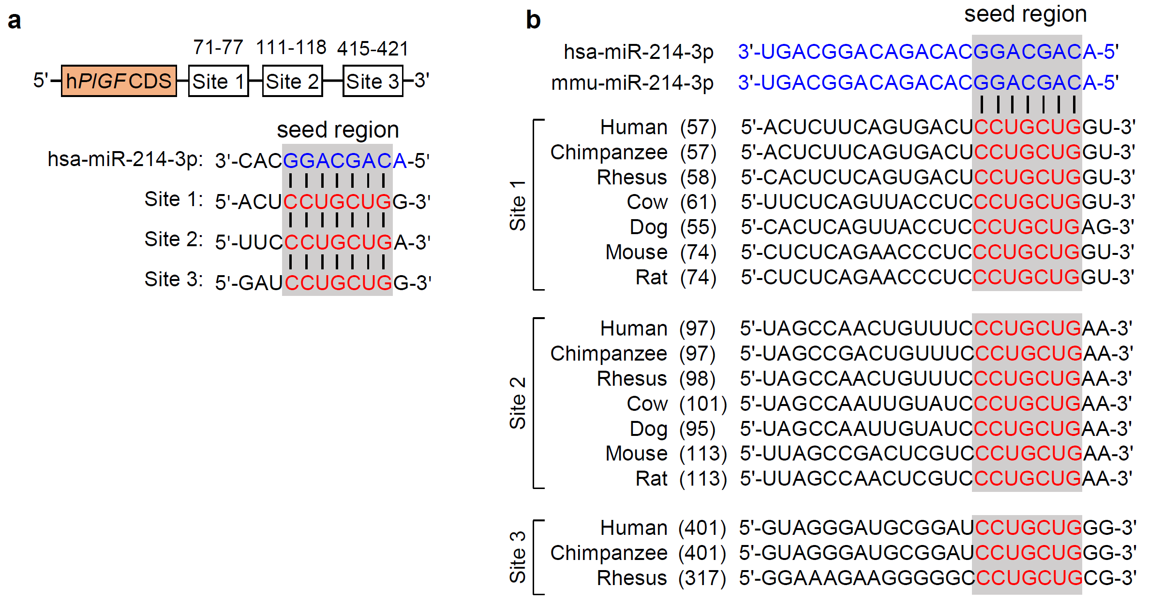
Supplementary Fig. 2. Computational prediction of miR-214-3p targets in PlGF 3′-UTRs of various species. a The computational analysis using the TargetScan algorithm shows three putative complementary binding regions (71−77, 111−118, and 415−421 nt) between human miR-214-3p and human PlGF 3′-UTR. hPlGF CDS, coding DNA sequence of human PlGF gene. b Complementary binding nucleotide sequence alignment between human or mouse miR-214-3p (hsa- and mmn-miR-214-3p) and PlGF 3′-UTRs of human, non-human primates, mouse, rat, and other species.

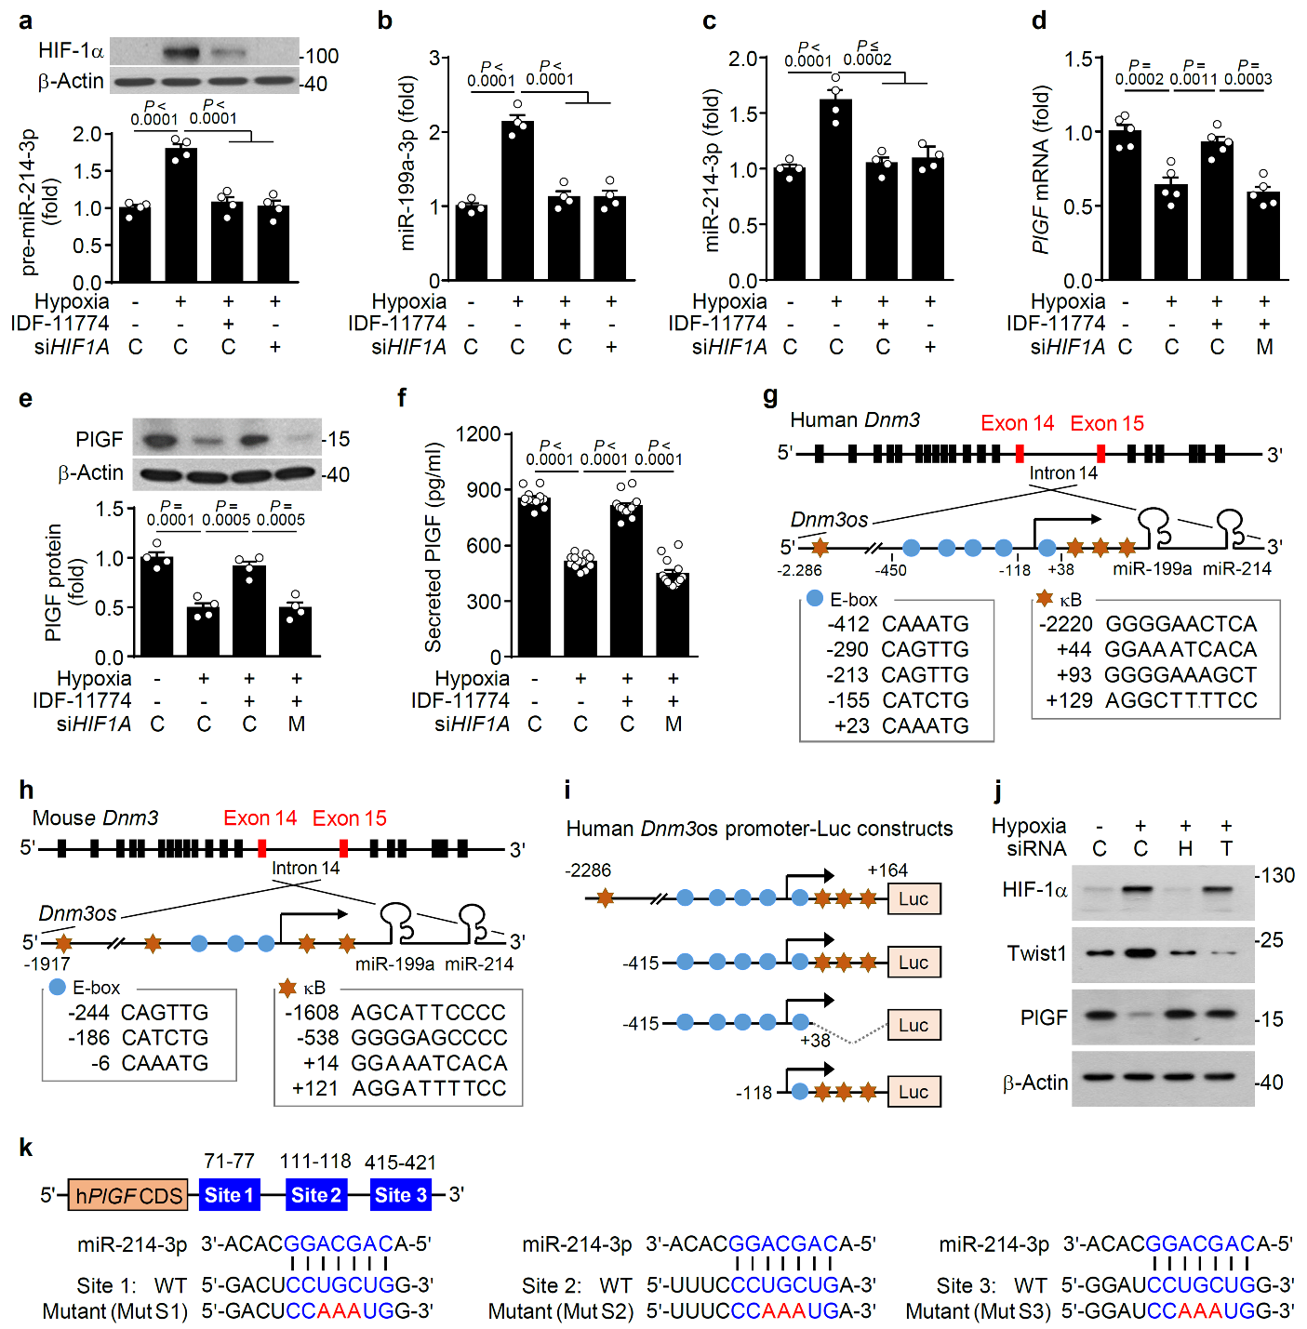
Supplementary Fig. 3. Hypoxia decreases PlGF expression through HIF-1/Twist1-dependent miR-241-3p biogenesis. a−f HTR-8/SVneo cells (a, b) or BeWo cells (c−f) were transfected with siRNA for control (C) or HIF1A (siHIF1A), control miRNA (C), or miR-214-3p mimics (M), followed by exposure to normoxia or hypoxia in the presence or absence of IDF-11774 for 24 h. a, b Levels of pre-miR-214-3p (a) and miR-199a-3p (b) were determined in HTR-8/SVneo cells using qRT-PCR (n = 4). c–f Levels of miR-214-3p (n = 4) (c), PlGF mRNA (n = 5) (d), PlGF protein (n = 4) (e), and secreted PlGF (n = 13) (f) were determined in BeWo cells using qRT-PCR, western blotting, or ELISA. g, h Computational analysis of the putative transcription factor-binding sites, E-box and κB, in the promoter regions of human (g) and mouse miR-199a/214 (Dnm3os) (h). i Schematic plasmid (pGL3) constructs containing WT, truncated, or deleted promoter of human miR-199a/214 (Dnm3os). j HTR-8/SVneo cells were transfected with siRNA for control (C), HIF1A (H), or Twist1 (T), followed by exposure to normoxia or hypoxia for 24 h. Levels of target proteins were determined using western blotting. k Schematic illustration of psiCHECK-2 luciferase constructs containing WT or mutants at site 1 (71−77 nt, Mut S1), site 2 (111−118 nt, Mut S1), and site 3 (415−421 nt, Mut S3) of human PlGF 3′-UTR (876 bp). Data are presented as the mean ± SEM. Statistical significance was determined using one-way ANOVA, followed by the Holm–Sidak’s multiple comparisons test. Source data are provided as a Source Data file.

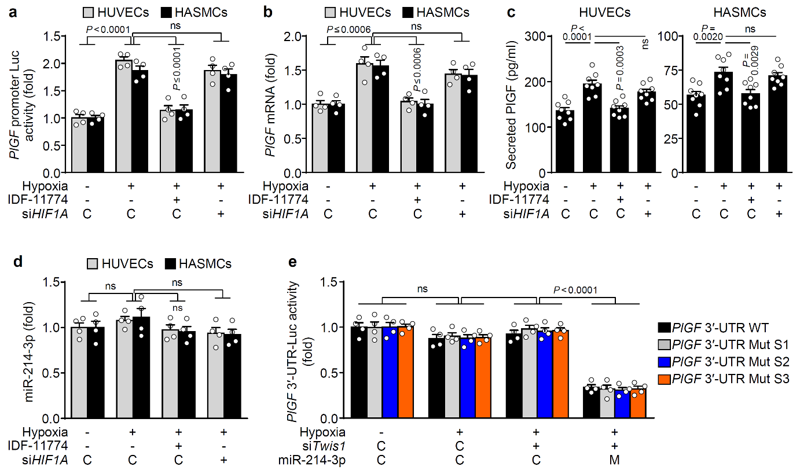
Supplementary Fig. 4. Hypoxia increases PlGF expression but does not promote miR-214-3p biogenesis in HUVECs and HASMCs. a HUVECs and HASMCs were transfected with the pGL3-PlGF promoter in combination with siRNA for control (C) or Twist1, followed by exposure to normoxia or hypoxia in the presence or absence of IDF-11774 for 24 h. Luciferase reporter activity was determined using an enzyme assay kit (n = 4). b−d Both types of vascular cells were treated as in (a) without transfection with the pGL3-PlGF promoter. Levels of PlGF mRNA (n = 4) (b), secreted PlGF (n = 8) (c), and miR-214-3p (n = 4) (d) were determined using qRT-PCR or ELISA. e HUVECs were transfected with psiCHECK-2-WT or mutant PlGF 3′-UTRs, control siRNA, Twist siRNA, control miRNA (C), or miR-214-3p mimics (M), followed by exposure to normoxia or hypoxia for 24 h. Luciferase activity was measured using an enzyme assay kit (n = 4). Data are presented as the mean ± SEM. Statistical significance was determined using one-way (a−d) or two-way (e) ANOVA, followed by the Holm–Sidak’s multiple comparisons test. ns, not significant. Source data are provided as a Source Data file.

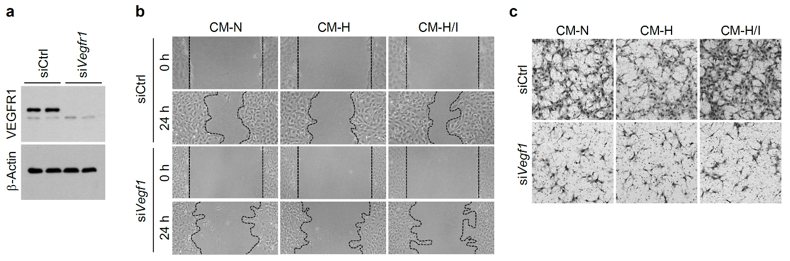
Supplementary Fig. 5. Hypoxia suppresses trophoblast function through miR-214-3p-dependent PlGF downregulation. a VEGFR1 levels were assessed in HTR-8/SVneo cells transfected with Vegfr1 siRNA using western blotting. b Representative images of the scratch-wound assay on HTR-8/SVneo cells incubated in CH-N, CH-H, or CH-H/I following of transfection with control or Vegfr1 siRNA. c Representative images of the Boyden chamber assay on HTR-8/SVneo cells incubated in CH-N, CH-H, or CH-H/I following of transfection with control or Vegfr1 siRNA. CH-N, CH-H, and CH-H/I were prepared using HTR-8/SVneo cells exposed to normoxia, hypoxia, and hypoxia with an miR-214-3p inhibitor treatment, respectively.

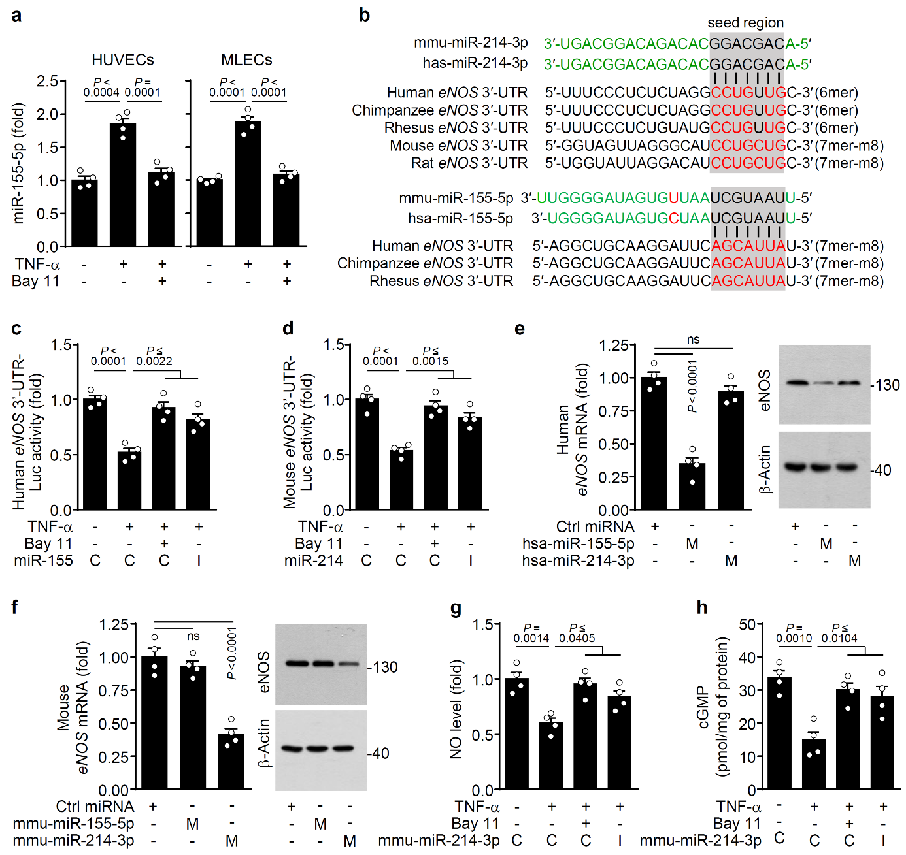
Supplementary Fig. 6. TNF-α suppresses eNOS expression in endothelial cells by elevating NF-κB-responsive miR-155-5p or miR-214-3p biogenesis in a species-specific manner. a HUVECs and MLVCs were treated with TNF-α or/and Bay 11-7082 (Bay 11), followed by measurement of miR-155-5p levels using qRT-PCR (n = 4). b Computational analysis of putative complementary binding sequences for miR-214-3p and miR-155-5p in eNOS 3′-UTRs of various species using the TargetScan algorithm. c, d HUVECs (c) and MLECs (d) were transfected with psiCHECK-2-human or mouse eNOS 3′-UTRs as well as control miRNA or an miR-214 or miR-155-5p inhibitor (I), followed by treatment with TNF-α or/and Bay 11-7082. Luciferase activity was determined using an enzyme assay kit (n = 4). e−h HUVECs (e) and MLECs (f−h) were transfected with control miRNA (C), or human or mouse synthetic miR-155-5p or miR-214 mimic (I), followed by determination of eNOS mRNA and protein levels (e, f), NO production (g), and cGMP synthesis (h) using qRT-PCR, western blotting, DAF-FM-based fluorescence microscopy, or ELISA (n = 4). Data are presented as the mean ± SEM. Statistical significance was determined using one-way ANOVA (a, b−h), followed by the Holm–Sidak’s multiple comparisons test. ns, not significant. Source data are provided as a Source Data file.

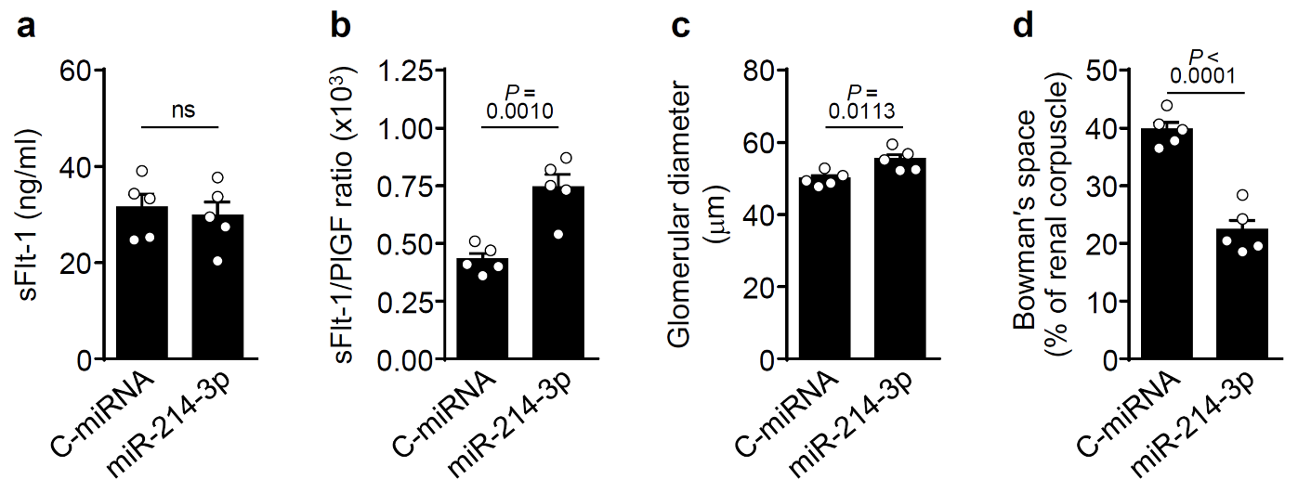Supplementary Fig. 7. Synthetic miR-214-3p administration increases the sFlt-1/PlGF ratio and induces abnormal glomerular morphology in pregnant mice. Pregnant mice were infused with control miRNA (c-miRNA) or miR-214-3p mimic (miR-214-3p) using an osmotic pump from GD 9.5 to GD 17.0. a Circulating sFlt-1 levels were determined using an ELISA kit (n = 5). b The sFlt-1/PlGF ratio was calculated from the plasma concentrations of each protein (n = 5). c Glomerular diameter was expressed as the average value of five random glomeruli in each renal tissue section (n = 5). d Bowman’s capsule space was calculated by subtracting the glomerular tuft area from the renal corpuscle area (n = 8). Data are presented as the mean ± SEM. Statistical significance was determined using the unpaired two-tailed t-test. ns, not significant. Source data are provided as a Source Data file.

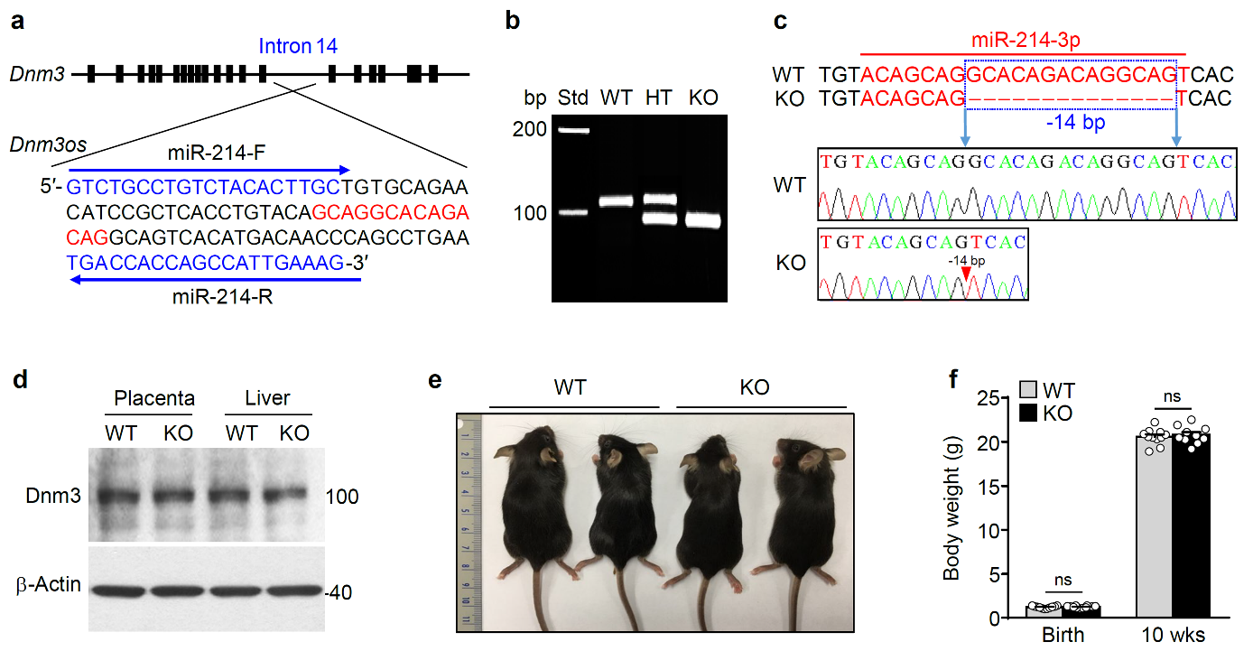
Supplementary Fig. 8. Generation of miR-214-3p KO mice. a Gene structure of mouse Dnm3 and nucleotide sequence of the PCR-amplified region encompassing the CRISPR target in mouse Dnm3os. Fourteen nucleotides marked in red were deleted using CRISPR-Cas9. MiR-214-F and miR-214-R in blue color indicate the primers used for PCR amplification. b Detection of PCR products (107 bp for WT mice and 93 bp for miR-214-3p KO mice) amplified using genomic DNA from WT and miR-214-3p KO mice. HT, heterozygous. c Sequencing chromatograms of PCR amplicons from WT and miR-214-3p KO mice. The red arrow above the chromatograms indicates the deletion of 14 nucleotides. d Dnm3 levels determined in placental and liver tissues using western blotting. e Representative photographs of WT and miR-214-3p KO mice at 8 weeks of age. f Body weight of newborn and 10-week-old mice (n = 8). Data are presented as the mean ± SEM. Statistical significance was determined using the unpaired two-tailed t-test. ns, not significant. Source data are provided as a Source Data file.

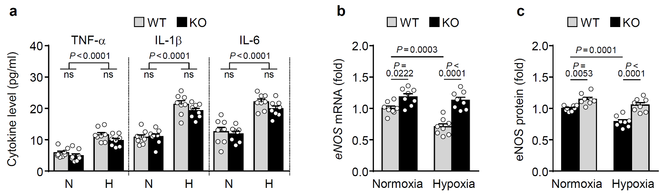
Supplementary Fig. 9. MiR-214-3p deficiency does not alter pro-inflammatory cytokine levels and rescues eNOS expression in hypoxic pregnant mice. Pregnant WT and miR-214-3p KO mice were exposed to normoxia (N) or hypoxia (H) from GD 9.5 to GD 17.5. a Serum levels of TNF-α, IL-1β, and IL-6 were determined using ELISA kits (n = 8). b, c Levels of eNOS mRNA (b) and protein (c) in aortic vessels were determined using qRT-PCR and western blotting, respectively (n = 8). Data are presented as the mean ± SEM. Statistical significance was determined using one-way ANOVA, followed by the Holm–Sidak’s multiple comparisons test. ns, not significant. Source data are provided as a Source Data file.

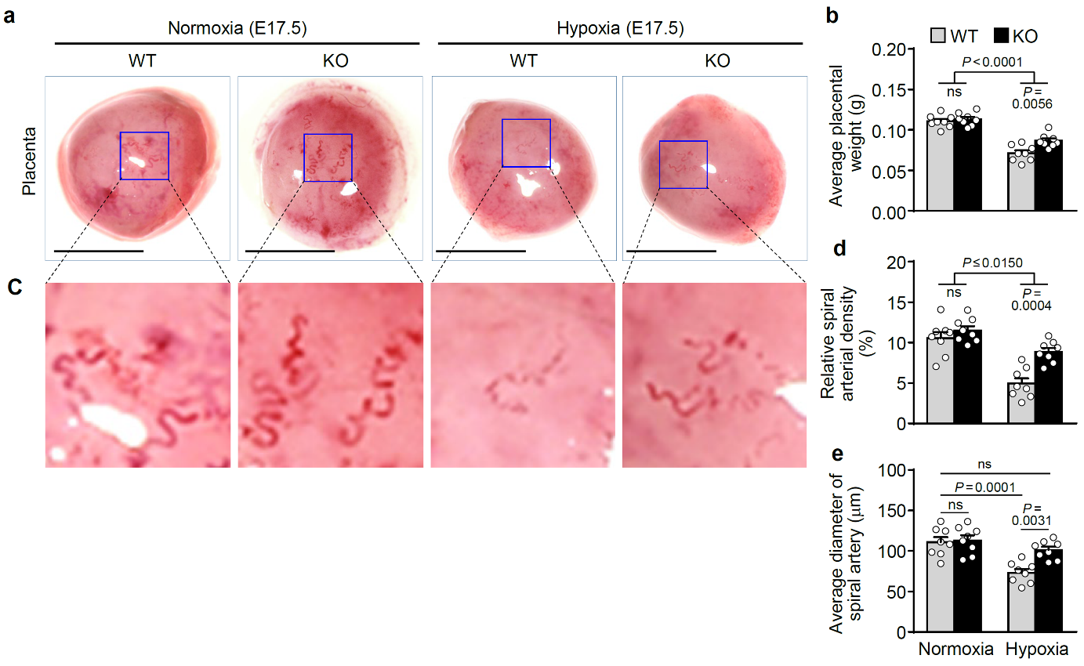
Supplementary Fig. 10. MiR-214-3p deficiency improves placental growth and arterial abnormality in hypoxic pregnant mice. a Representative images of placentas from pregnant WT and miR-214-3p KO mice exposed to normoxia or hypoxia from GD 9.5 to GD 17.5 (6–11 fetuses/litter, n = 8 litters). b Quantification of the average placental weight/litter (n = 8 litters). c Magnified images of maternal spiral arteries of the placental bed (n = 8 litters). d The relative density of the decidual spiral arteries in the placental bed was calculated using ImageJ (n = 8 litters). e The average diameter of the spiral arteries was calculated using ImageJ (n = 8 litters). Data are presented as the mean ± SEM. Statistical significance was determined using one-way ANOVA, followed by the Holm–Sidak’s multiple comparisons test. ns, not significant. Source data are provided as a Source Data file.

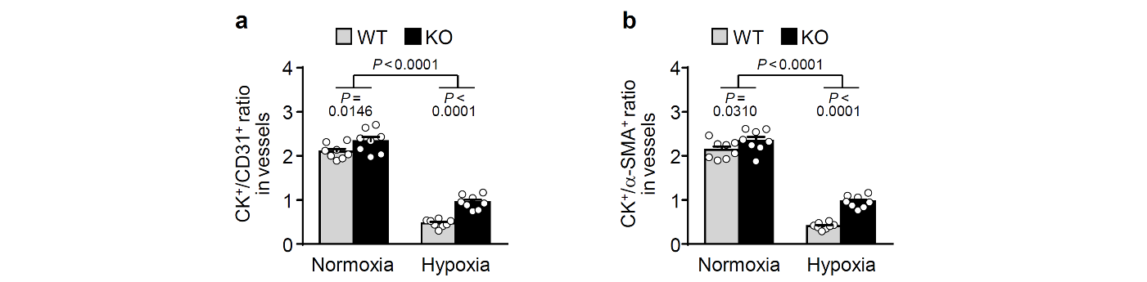
Supplementary Fig. 11. MiR-214-3p deficiency improves spiral artery remodeling by trophoblast invasion in hypoxic pregnant mice. Pregnant WT and miR-214-3p KO mice were exposed to normoxia or hypoxia from GD 9.5 to GD 17.5. a Quantification of the cytokeratin (CK)⁺ trophoblast area to the CD31⁺ endothelial cell area ratio in spiral arteries from immunohistochemical data shown in Fig. 8 (6–11 fetuses/litter, n = 8 litters). b Quantification of the CK⁺ trophoblast area to the α-SMA⁺ smooth muscle cell area ratio in spiral arteries from immunohistochemical data shown in Fig. 8 (n = 8 litters). Data are presented as the mean ± SEM. Statistical significance was determined using one-way ANOVA, followed by the Holm–Sidak’s multiple comparisons test. Source data are provided as a Source Data file.

