Annex 1
Species | Sample point data source
 | Actual sampling point data | Global Biodiversity Information Database | Historic data | Total
C. micophylla | 122 | 268 | 146 | 535
C. stenophylla | 37 | 156 | 52 | 245
C. spinifera | 19 | 23 | 21 | 63
C. korshinskii | 32 | 86 | 49 | 137
C. pygmaea | 56 | 53 | 35 | 144
 |  |  |  | 1124

Annex 2
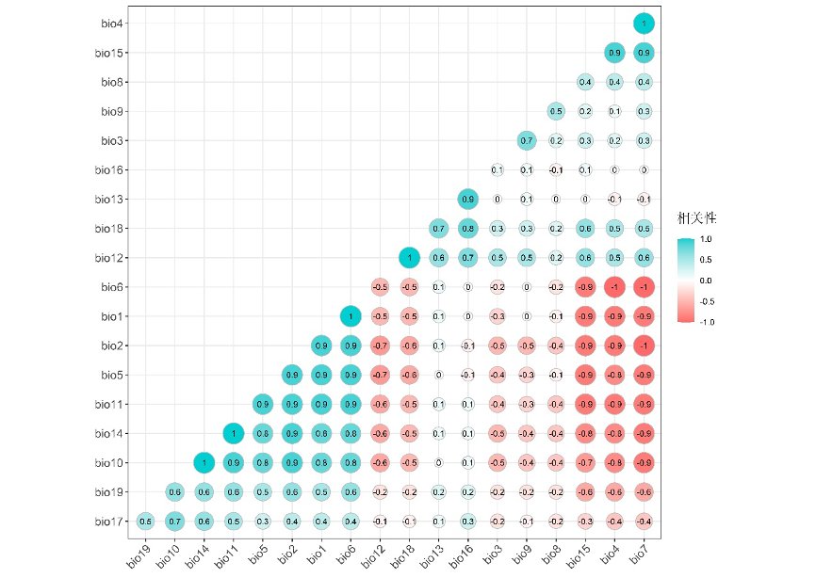
Principal Component Analysis of Phytogeographical Distribution and Bioclimatic Variables of Caragana
Annex 3
Principal component analysis of climatic factors in the distribution area of Caragana
Climate factors | Main component load
Climate factors | PC1 | PC2 | PC3
bio1 | 0.91 | 0.14 | 0.31
bio2 | 0.98 | 0.01 | -0.04
bio3 | -0.45 | 0.19 | 0.67
bio4 | -0.92 | -0.19 | -0.23
bio5 | 0.92 | -0.05 | 0.14
bio6 | 0.92 | 0.17 | 0.34
bio7 | -0.97 | -0.13 | -0.08
bio8 | -0.39 | -0.05 | 0.49
bio9 | -0.37 | 0.28 | 0.82
bio10 | 0.92 | 0.09 | -0.16
bio11 | 0.97 | 0.13 | 0.01
bio12 | -0.68 | 0.72 | 0.02
bio13 | 0.01 | 0.90 | -0.11
bio14 | 0.88 | 0.89 | -0.17
bio15 | -0.69 | 0.01 | -0.87
bio16 | -0.09 | 0.96 | -0.21
bio17 | 0.50 | 0.33 | -0.17
bio18 | -0.63 | 0.75 | -0.12
bio19 | 0.63 | 0.31 | -0.05
Eigenvalue | 10.8 | 3.3 | 1.8
Cumulative interpretation rate（%） | 56.91 | 74.09 | 83.79

