Supplementary material
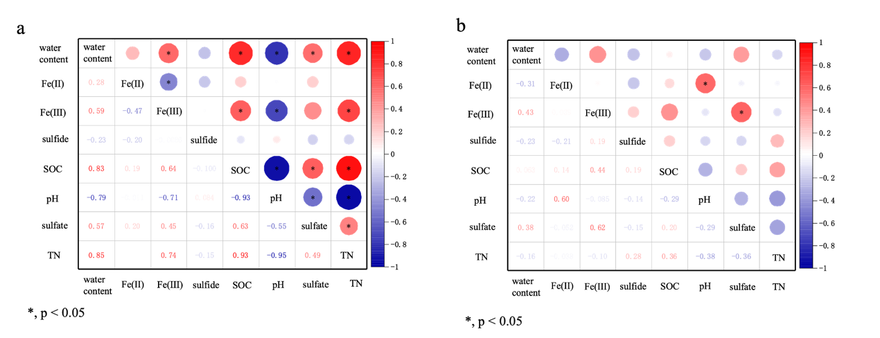
Fig. S 1. Pearson correlation analysis of soil properties of S. alterniflora (a) and S. mariqueter (b) (*, p < 0.05)
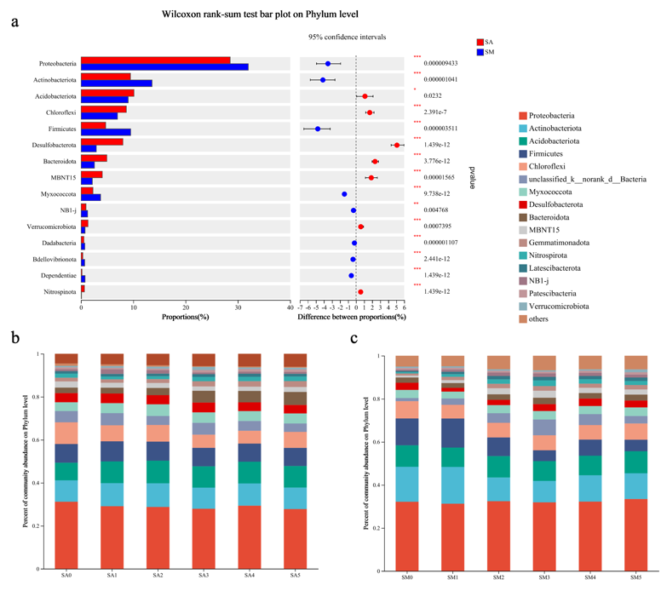
Fig. S 2. The phylum of bacteria in the soil of SA (S. alterniflora) and SM (S. mariqueter) with significant differences by Wilcoxon rank-sum test (a); Relative abundance of bacteria at the phylum level in the soil of different distance from the root zone of SA (b) and SM (c)

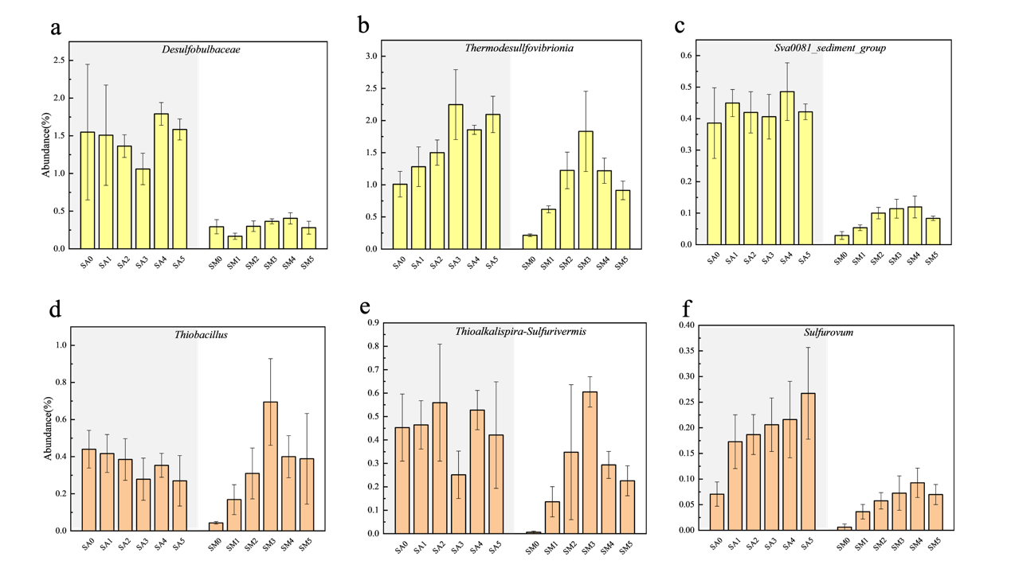
Fig. S 3. Important SRB (a~c) and SOB (d~f) in the soil of different distances from root zone predicted by FAPROTAX (SA, S. alterniflora; SM, S. mariqueter)
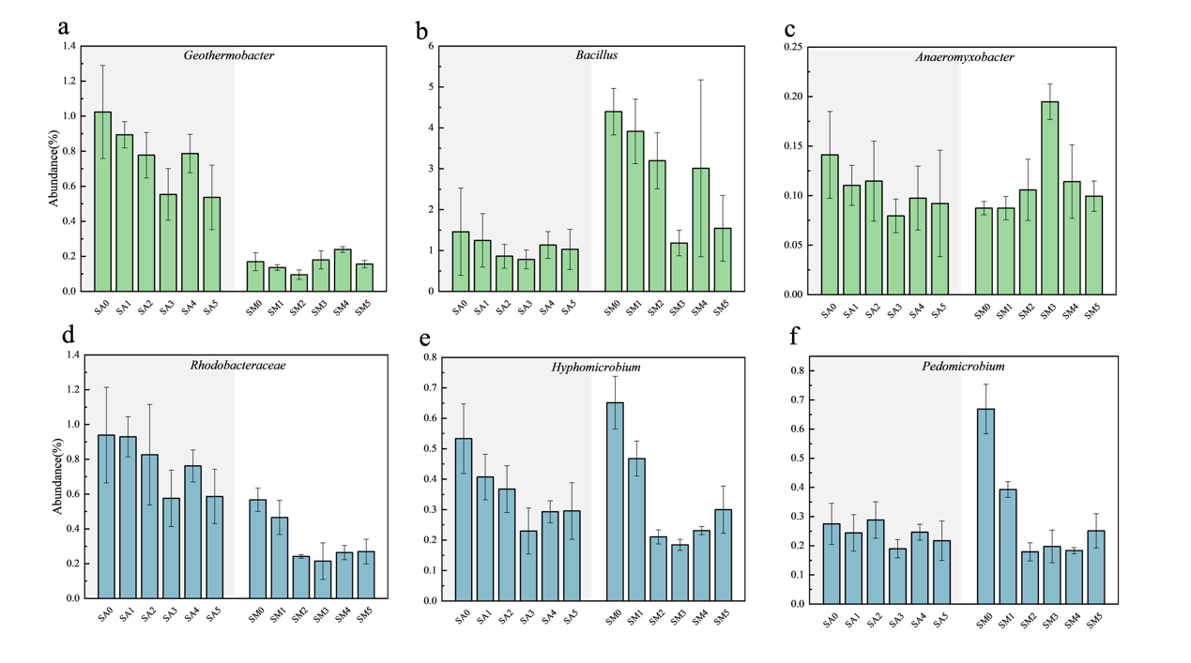
Fig. S 4. Important IRB (a~c) and IOB (d~f) in the soil of different distances from roots predicted by FAPROTAX (SA, S. alterniflora; SM, S. mariqueter)

