SUPPORTING INFORMATION
To
C-source priority and availability limits bidirectional electron transfer in freshwater mixed culture EAB biofilms

Karina Anna Michalska, Robert Keith Brown, Uwe Schröder
Institute of Biochemistry, University of Greifswald

Figure S-1: The example of resulting current densities obtained for one of the S3-BES during 4th batch of HBPR.

Figure S-2: The averaged cyclic voltammograms obtained for S1, S2 and S3-BES over the course of HBPR after each polarization stage (left – after E_{WE} = -0.5 V, right – after E_{WE} = +0.2 V). Black – cycle 1; red – cycle 2; blue – cycle 3, purple – cycle 4.

Figure S-3: Exemplary CV obtained at the OC-control WE after on half batch in batch 4 of the HBPR experimental phase.
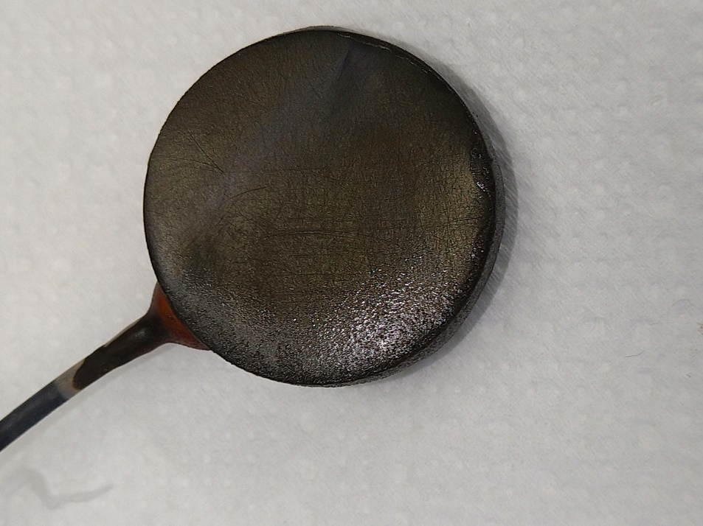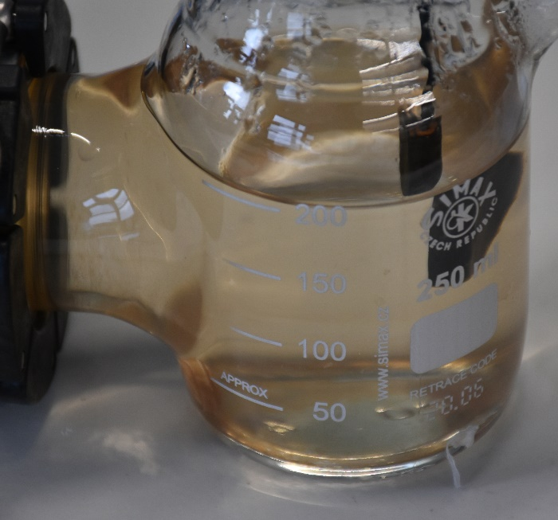
Figure S-4: Electrode without noticable biofilm taken from and a photo showing the colouration of media in one of the S1-BES.

Figure S-5: Oxidative current evolution in a S3-BES during PPR for polarization specifically at -0.5V (black line) as well as, as expected, at +0.2V (blue line).

SI - HPLC -Results
In S1-BES three substances were identified, there are three clear peaks; one at a retention time of 9.4 min, one at a retention time of 19.3 min and one at a retention time of 43 min, as shown in Figure S-6 and Figure S-7. The third and second peaks are from components of the vitamin solution and shows up in fresh media samples. The first peak was confirmed in later testing (not shown) to not be a TCA-cycle compound and was only found in S1-BES, which makes it likely that this is the EET mediator indirectly identified by CV and observation coloration changes (section 3.2 and 3.3, main manuscript).
Trace amounts of other more complex/larger compounds were also detected in various samples of all BES at the end of PPR as well as in between and at the end of HBPR batches. The exact identity was not confirmed, however based on the retention times (e.g. see Figure S-9) and being detected with DAD indicates that they are all likely C6+ compounds with at least on carboxylic group.

Table S-1: The composition of the supernatants obtained over the course of HBPR experiment after each polarization switch.
BES |  | S1 |  | S2 |  | S3
Polarization |  | -0.5 V | +0.2 V | -0.5 V | +0.2 V | -0.5 V | +0.2 V
Compo-  und | Cycle | mM | mM | mM | mM | mM | mM
Acetic acid | 1 | 0.0 | 0.0 | 6.205 ± 1.719 | 0.576 ± 0.613 | 5.668 ± 1.245 | 0.303 ± 0.332
Acetic acid | 2 | 0.0 | 0.0 | 5.792 ± 2.663 | 0.216 ± 0.253 | 6.235 ± 0.931 | 0.065 ± 0.113
Acetic acid | 4 | 0.0 | 0.0 | 5.695 ± 2.797 | 0.440 ± 0.665 | 6.863 ± 1.024 | 1.757 ± 2.537
Ethanol | 1 | 1.055 ± 0.159 | 3.333 ± 0.517 | 1.096 ± 0.548 | 0.694 ± 0.315 | 1.147 ± 0.143 | 3.856 ± 2.613
Ethanol | 2 | 0.261 ± 0.205 | 0.419 ± 0.659 | 0.343 ± 0.068 | 0.308 ± 0.123 | 1.174 ± 1.120 | 0.330 ± 0.399
Ethanol | 4 | 0.0 | 0.415 ± 0.146 | 2.661 ± 0.402 | 1.612 ± 1.280 | 0.073 ± 0.074 | 0.972 ± 0.278
Lactic  acid | 1 | 0.0 | 0.0 | 0.0 | 0.0 | 0.0 | 0.0
Lactic  acid | 2 | 0.0 | 0.0 | 0.0 | 0.002 ±0.003 | 0.0 | 0.0
Lactic  acid | 4 | 0.0 | 0.0 | 0.0 | 0.0 | 0.0 | 0.0
Propionic acid | 1 | 0.0 | 0.0 | 0.075 ± 0.067 | 0.033 ± 0.057 | 0.030 ± 0.052 | 0.030 ± 0.052
Propionic acid | 2 | 0.0 | 0.0 | 0.030 ± 0.053 | 0.0 | 0.030 ± 0.052 | 0.0
Propionic acid | 4 | 0.0 | 0.032 ± 0.056 | 0.032 ± 0.056 | 0.0 | 0.092 ± 0.004 | 0.0
Butyric acid | 1 | 0.0 | 0.0 | 0.0 | 0.002 ± 0.003 | 0.0 | 0.001 ± 0.002
Butyric acid | 2 | 0.0. | 0.0 | 0.0 | 0.002 ± 0.003 | 0.0 | 0.0
Butyric acid | 4 | 0.0 | 0.0. | 0.0 | 0.002 ± 0.003 | 0.0 | 0.0
Succinic acid | 1 | 0.0 | 0.0 | 0.008 ± 0.014 | 0.0 | 0.009 ± 0.016 | 0.008 ± 0.013
Succinic acid | 2 | 0.0 | 0.0 | 0.009 ± 0.015 | 0.016 ± 0.028 | 0.008 ± 0.014 | 0.008 ± 0.014
Succinic acid | 4 | 0.0 | 0.0 | 0.0 | 0.016 ± 0.014 | 0.008 ± 0.014 | 0.009 ± 0.016

Table S-2:The finall composition of the supernatants obtained over the course of PPR experiment S1, S2 and S3. Cycles 6 & 8 performed at lower carbon source concentration.
BES |  | S1 | S2 | S3
Compound | Cycle | mM | mM | mM
Acetic acid | 2 | 0 | 0.323 ± 0.559 | 1.511 ± 2.158
Acetic acid | 4 | 0 | 0.799 ± 0.692 | 1.497 ± 1.529
Acetic acid | 6 | 0 | 0 | 0.250 ± 0.270
Acetic acid | 8 | 0 | 0 | 0.319 ± 0.322
Ethanol | 2 | 0.455 ± 0.488 | 0.482 ± 0.489 | 0.270 ± 0.427
Ethanol | 4 | 0.378 ± 0.140 | 0.264 ± 0.414 | 0.436 ± 0.060
Ethanol | 6 | 0.333 ± 0.157 | 0.402 ± 0.141 | 0.067 ± 0.108
Ethanol | 8 | 0.202 ± 0.350 | 0 | 0.224 ± 0.233
Formic acid | 2 | 0 | 0 | 0.056 ± 0.097
Formic acid | 4 | 0 | 0 | 0
Formic acid | 6 | 0 | 0 | 0
Formic acid | 8 | 0 | 0 | 0
Propionic acid | 2 | 0 | 0 | 0
Propionic acid | 4 | 0 | 0 | 0
Propionic acid | 6 | 0.029 ± 0.050 | 0.029 ± 0.050 | 0.058 ± 0.002
Propionic acid | 8 | 0.029 ± 0.051 | 0.029 ± 0.050 | 0.089 ± 0.002
Butyric acid | 2 | 0.005 ± 0.006 | 0.006 ± 0.001 | 0.010 ± 0.002
Butyric acid | 4 | 0 | 0 | 0
Butyric acid | 6 | 0 | 0 | 0
Butyric acid | 8 | 0 | 0 | 0
Succinic acid | 2 | 0 | 0 | 0
Succinic acid | 4 | 0 | 0.008 ± 0.014 | 0
Succinic acid | 6 | 0 | 0.017 ± 0.015 | 0.008 ± 0.013
Succinic acid | 8 | 0.008 ± 0.014 | 0.016 ± 0.014 | 0.017 ± 0.015

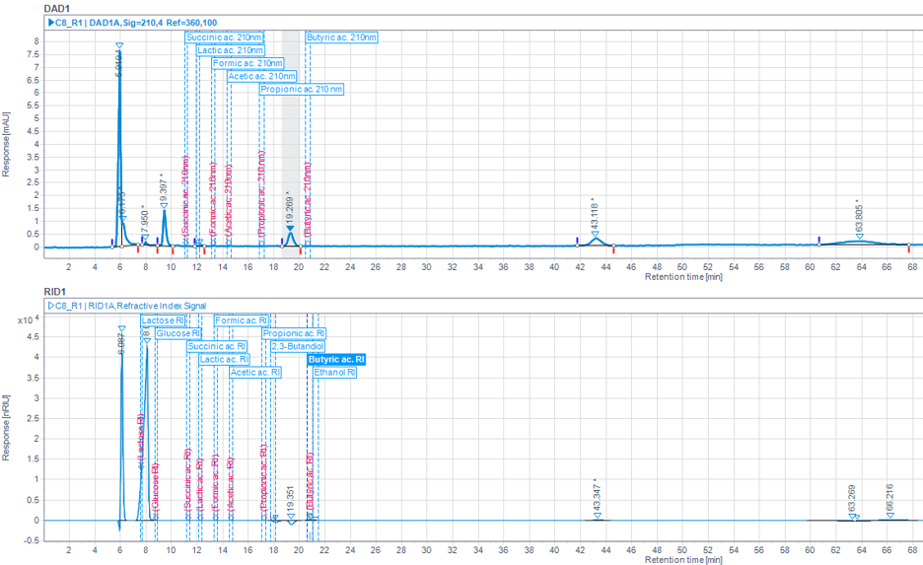
Figure S-6: The chromatograms illustrating the composition of resulting supernatants after CA at -0.5 V during 1st batch of HBPR for S1-BES.

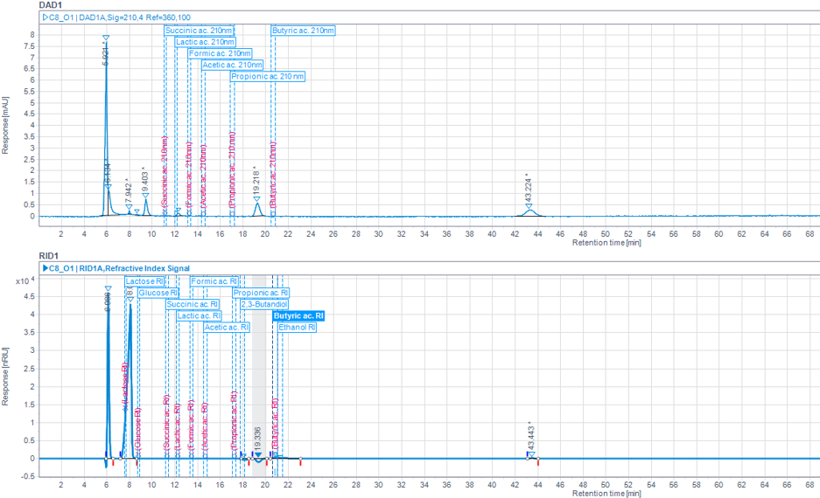
Figure S-7: The chromatograms illustrating the composition of resulting supernatants after CA at +0.2 V during 1st batch of HBPR for S1-BES.

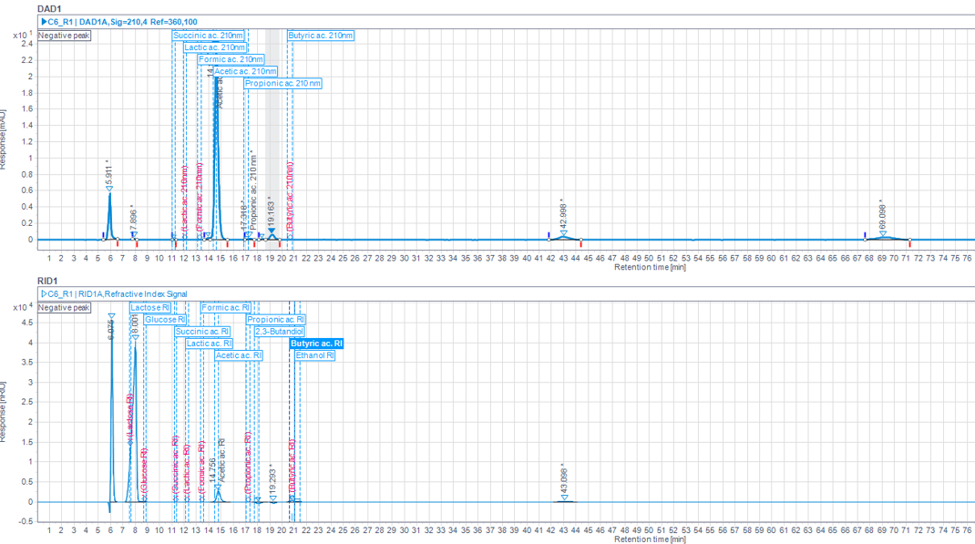
Figure S-8: The chromatograms illustrating the composition of resulting supernatants after CA at -0.5 V during 1st batch of HBPR for S2-BES.

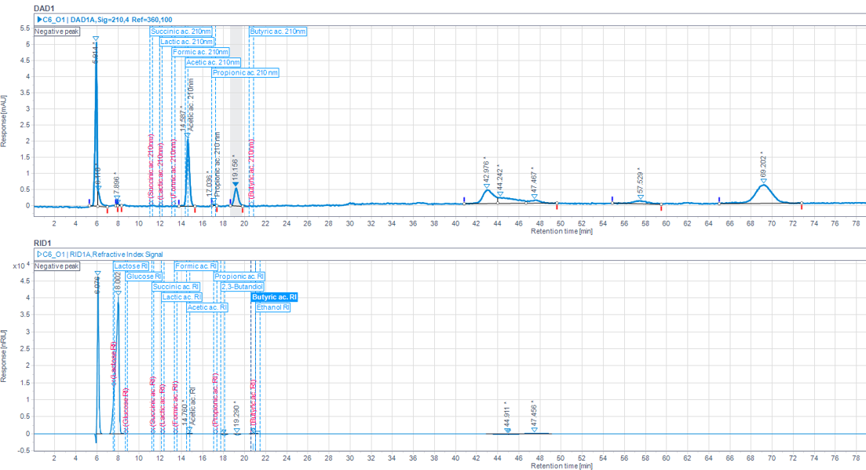
Figure S-9: The chromatograms illustrating the composition of resulting supernatants after CA at +0.2 V during 1st batch of HBPR for S2-BES.

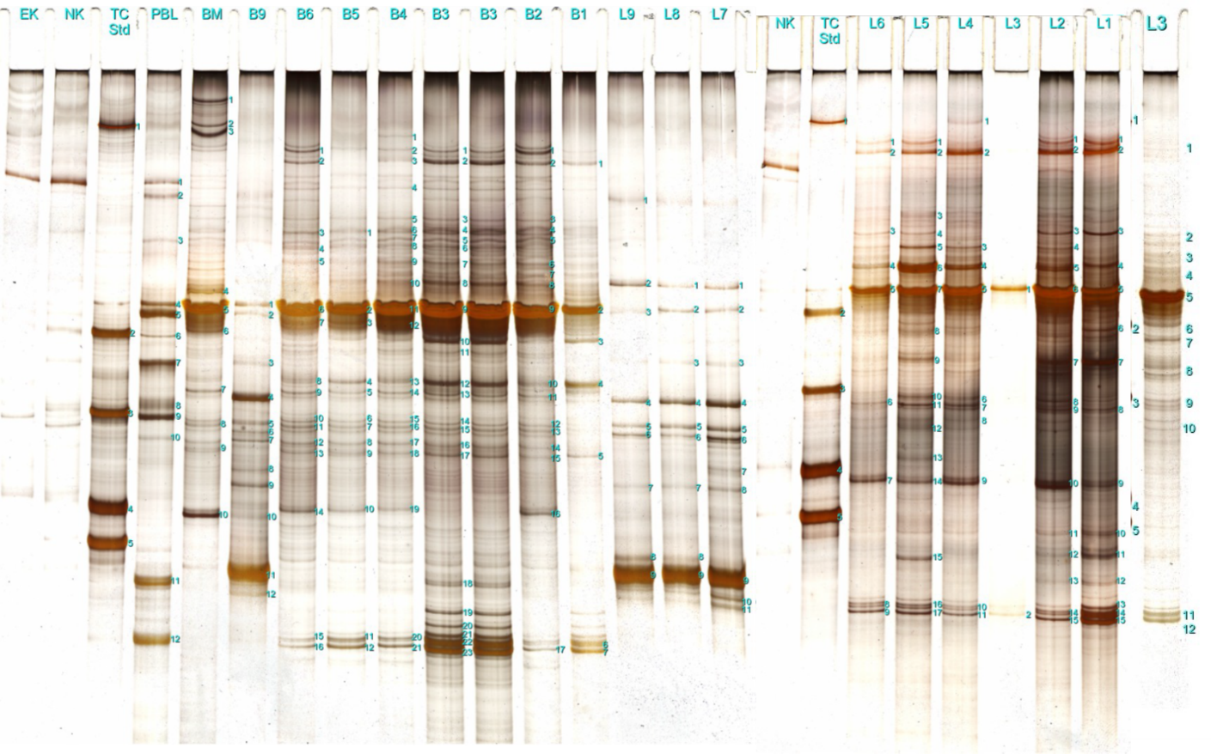
Figure S-10: Two combined electrophoresis gel images after DNA staining, related to Figure 6. The gel images are aligned on last band (top) and scaled so that the lanes have the same width. PBL is the German abbreviation for PBS. The gel images were made by and provided by the German company Amodia Bioservice GmbH, who conducted the MCA.

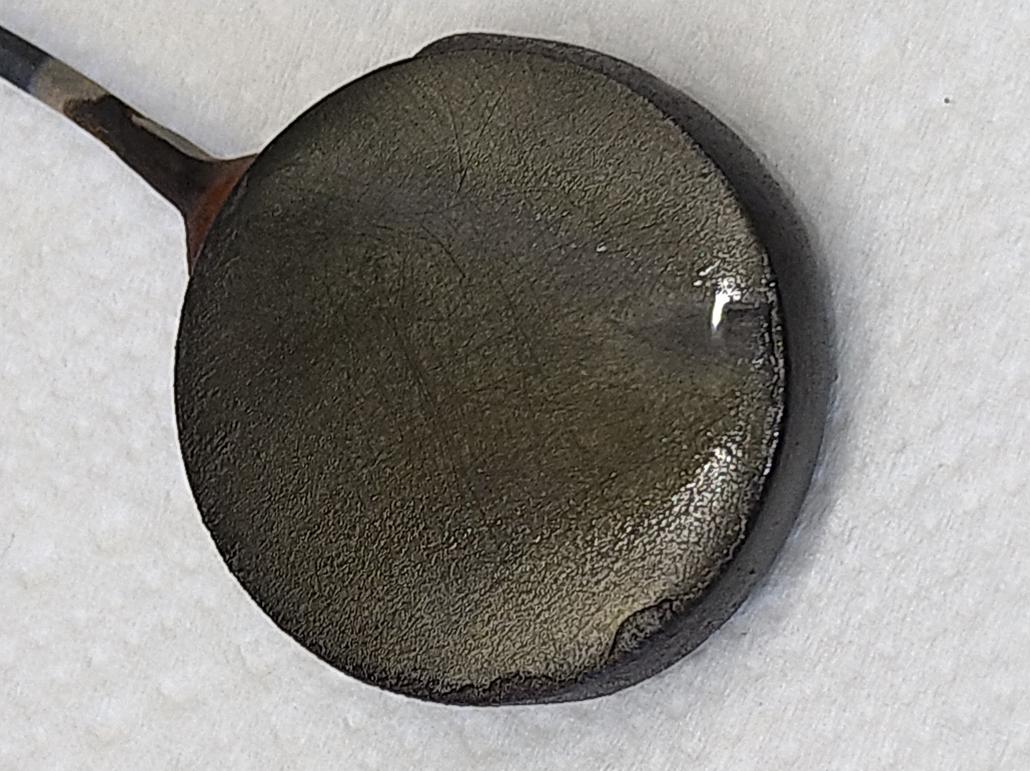
Figure S-11: Only S1-BES, i.e., R9 which had biomass on the electrode. This is the B9 sample in Figure S-10.
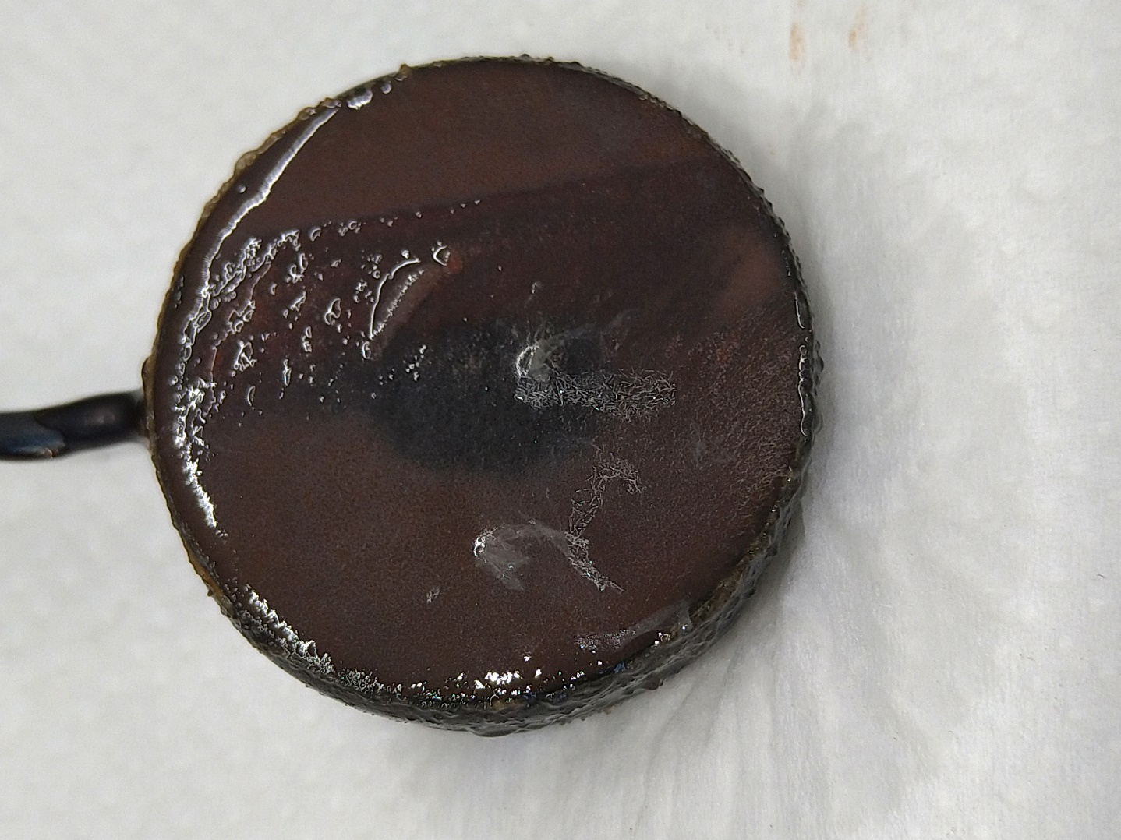
Figure S-12: Electrode biofilm established in one of the S2-BES.
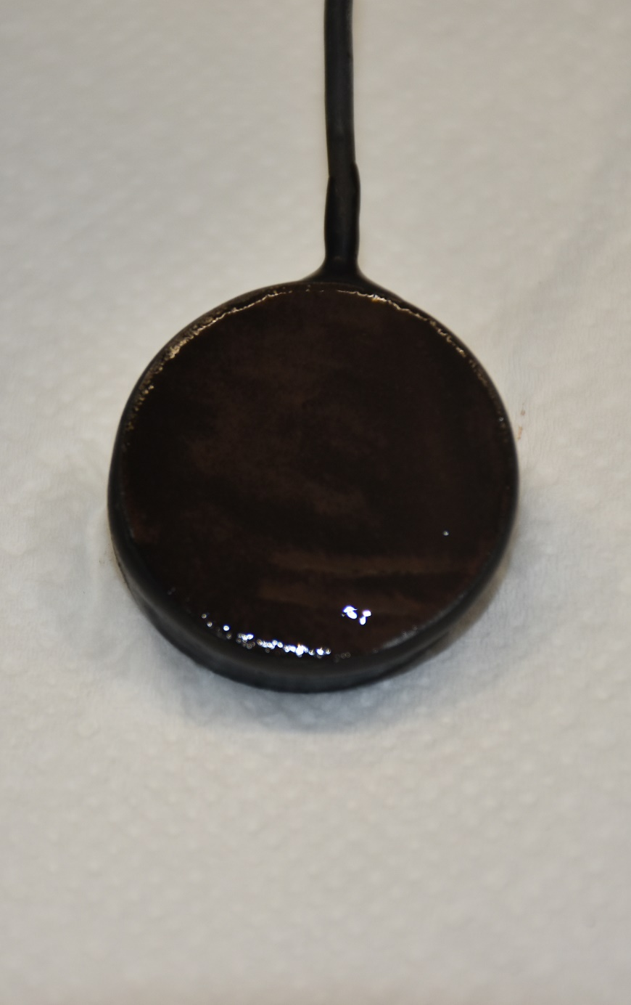
Figure S-13: Electrode biofilm established in one of the S3-BES.
Figure S-14: The relative abundance of the microbial communities in phosphate buffer solution (PBS) used for media preparation and BES-mother reactor biofilm biomass (BM) used as inoculum. n/s – no similarities.

