C-source priority and availability limits bidirectional electron transfer in freshwater mixed culture EAB biofilms
Karina Michalska, Robert Keith Brown, Uwe Schröder*

Institute of Biochemistry, University of Greifswald, Felix-Hausdorff-Str. 4, 17489 Greifswald, Germany
*Corresponding Author: Prof. Dr. Uwe Schröder, Email: uwe.schroeder@uni-greifswald.de

Graphical Abstract

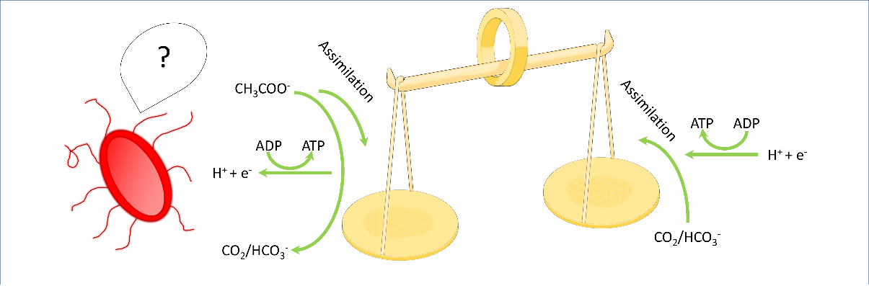

This study investigates the opportunities and limitations of adapting heterotrophically grown electroactive bacterial from oxidative to reductive or bidirectional extracellular electron transfer.

