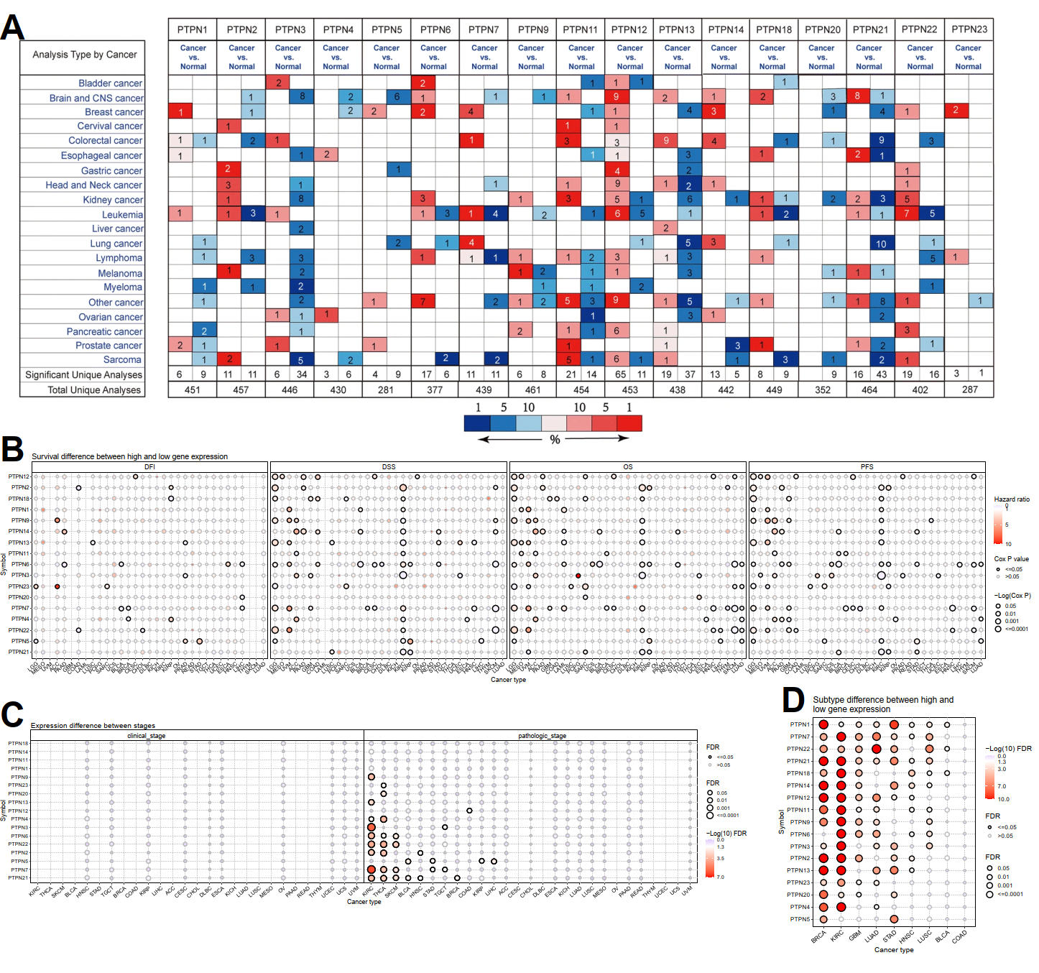
Fig. S1. (A) Differential expression of PTPNs in human Oncomine datasets. (B-D) Differential expression of PTPNs among clinical stage, pathologic stage, and subtypes.
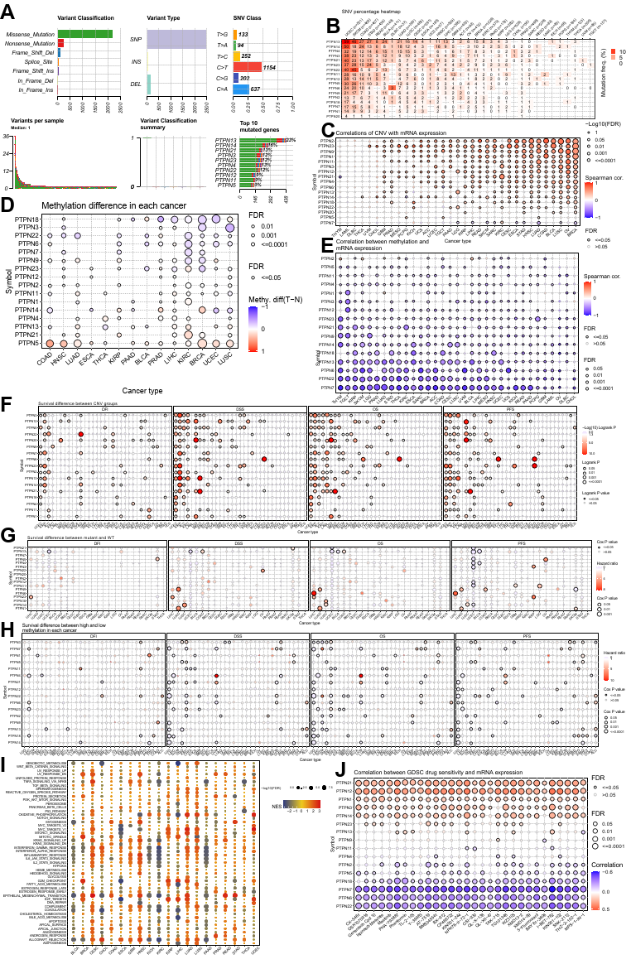
Fig. S2. (A) Summary of variants for PTPNs in pan-cancer. (B) The frequency of mutations for PTPNs in pan-cancer. (C) The correlation between PTPNs expression and CNV. (D) The difference of PTPNs methylation between tumor and normal samples in pan-cancer. (E) The correlation between PTPNs expression and methylation. (F-H) Prognostic associations of CNV, SNV, and methylation in PTPNs. (I) Enrichment analysis for metabolism pathway and cancer signaling between high and low enrichment scores of PTPNs. (J) Correlation between PTPNs expression and drug IC50.
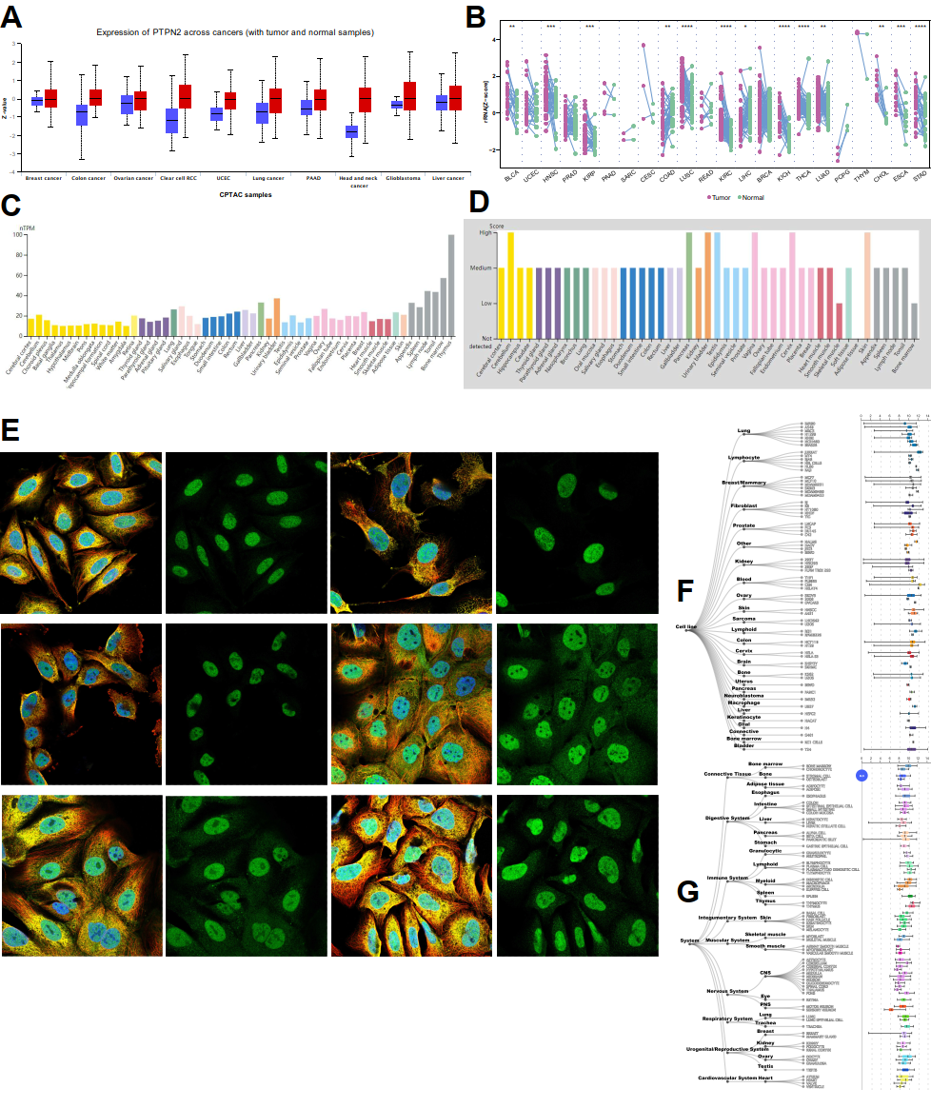
Fig. S3. (A) Expression analysis of PTPN2 protein in pan-cancer. (B) Differential gene expression analysis of PTPN2 in the paired samples. (C-D) RNA and protein expression score of PTPN2. (E) Subcellular localization of PTPN2 in different cancer cell lines. (F-G) Expression of PTPN2 in different cell lines and tissues.
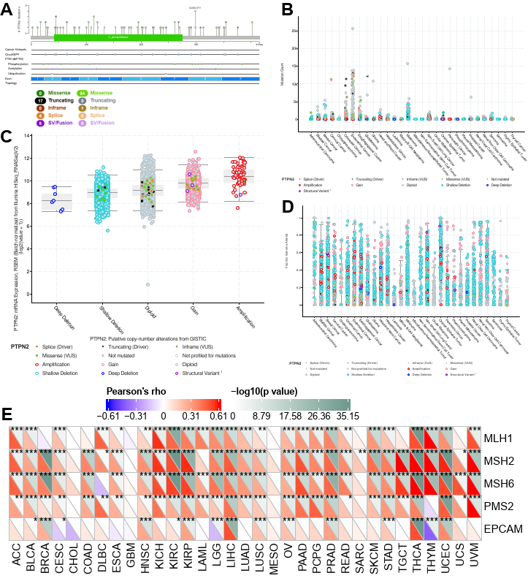
Fig. S4. (A) lollipop of PTPN2. (B) Mutation count of PTPN2. (C)PTPN2 expression in different types of CNV. (D) FGA of PTPN2. (E) Correlation between PTPN2 and MMRs related genes.
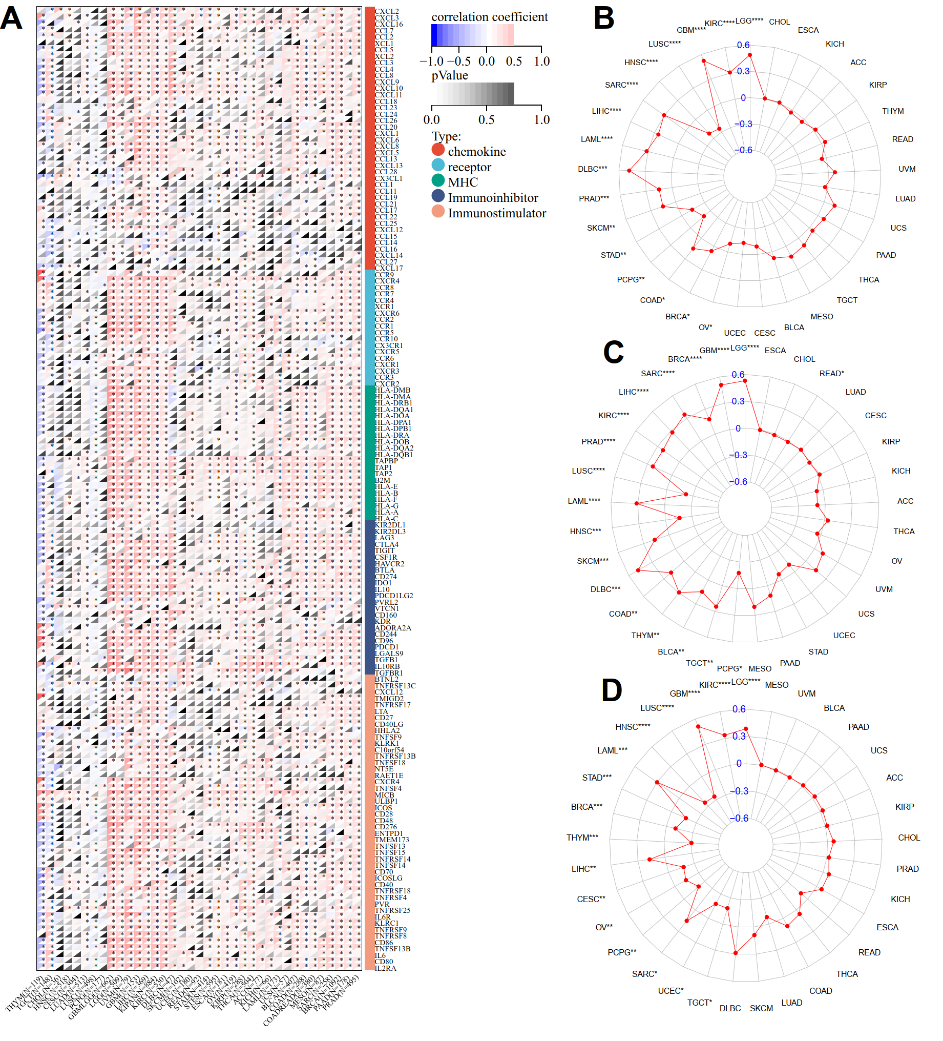
Fig. S5. (A) Correlation between PTPN2 and immunomodulatory genes. (B-D) Correlation of PTPN2 expression with ESTIMATE score, Immune score, and Stromal score.
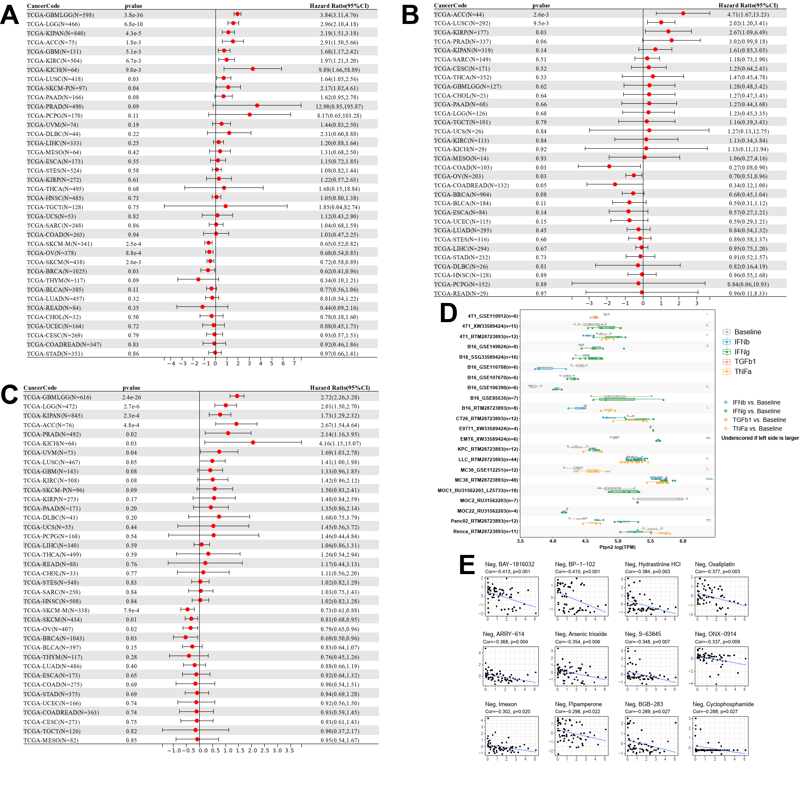
Fig. S6. (A-C) Correlation between PTPN2 expression and (A) disease-specific survival, (B) disease-free interval, and (C) progression-free interval. (D) A Comparison of PTPN2 expression before and after ICB treatments across different tumor models in vitro. (E) The top 12 drugs negatively correlated with PTPN2 expression in the CellMiner database.
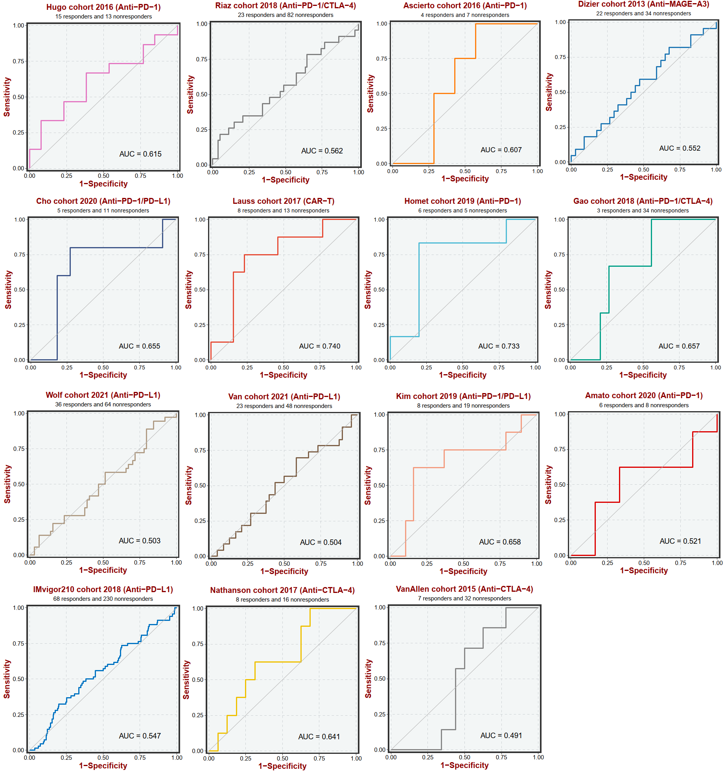
Fig. S7. The predictive value of PTPN2 to predict survival prognosis in patients in immunotherapy cohorts.
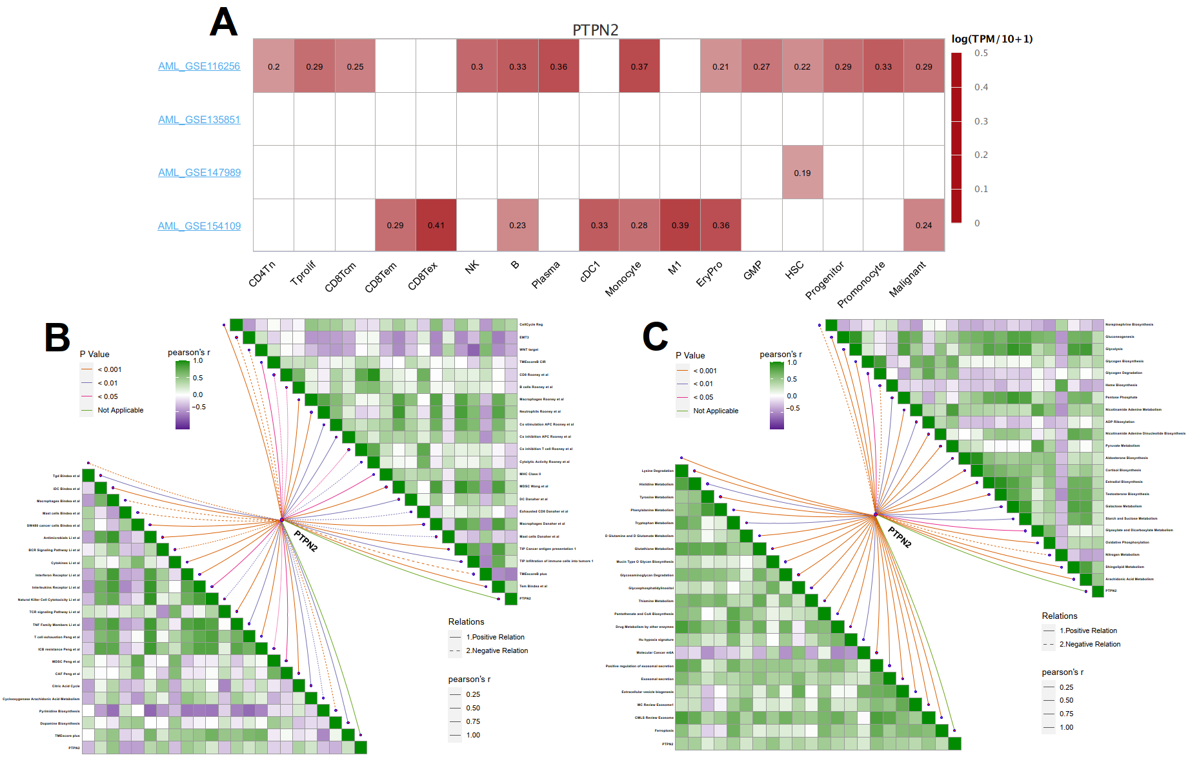
Fig. S8. (A) The expression of PTPN2 in different cell types. (B-C) Correlation between PTPN2 expression and cancer microenvironment-related signatures in TARGT-AML.
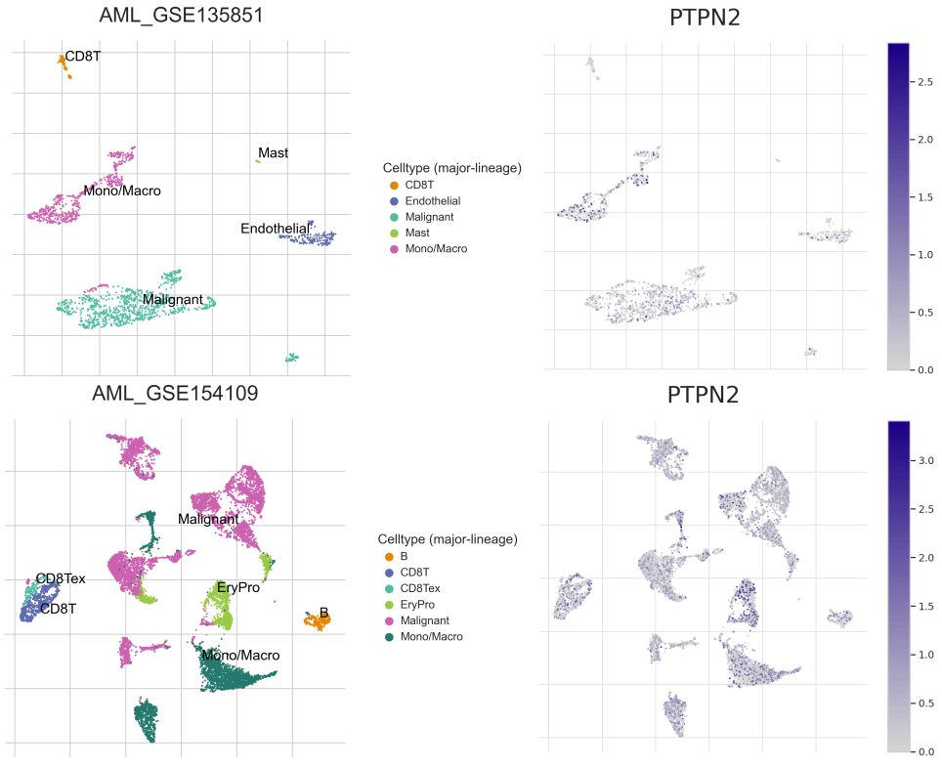
Fig. S9. The expression of PTPN2 in single-cell RNA sequencing cohort.
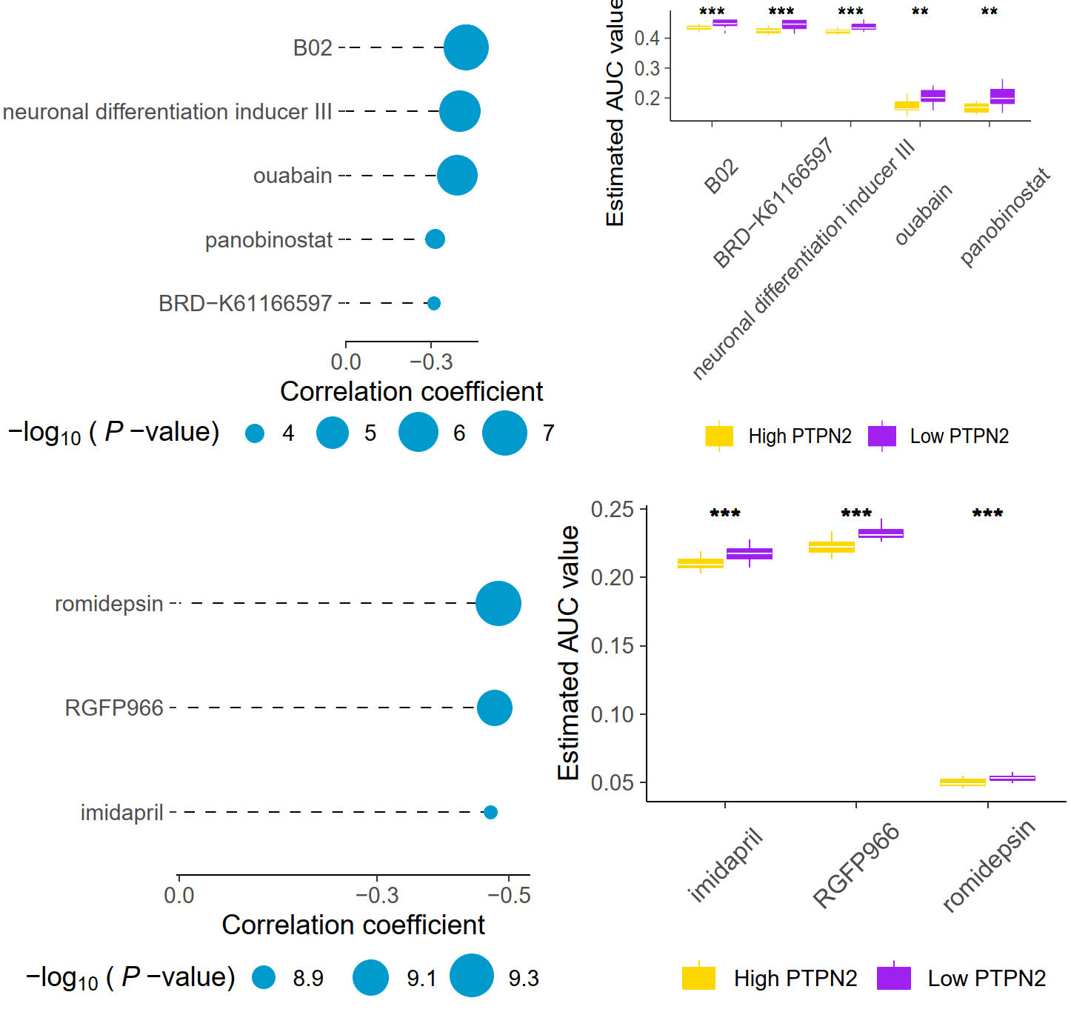
Fig. S10. Drug screening in patients with low PTPN2 expression in CTRP and PRISM.
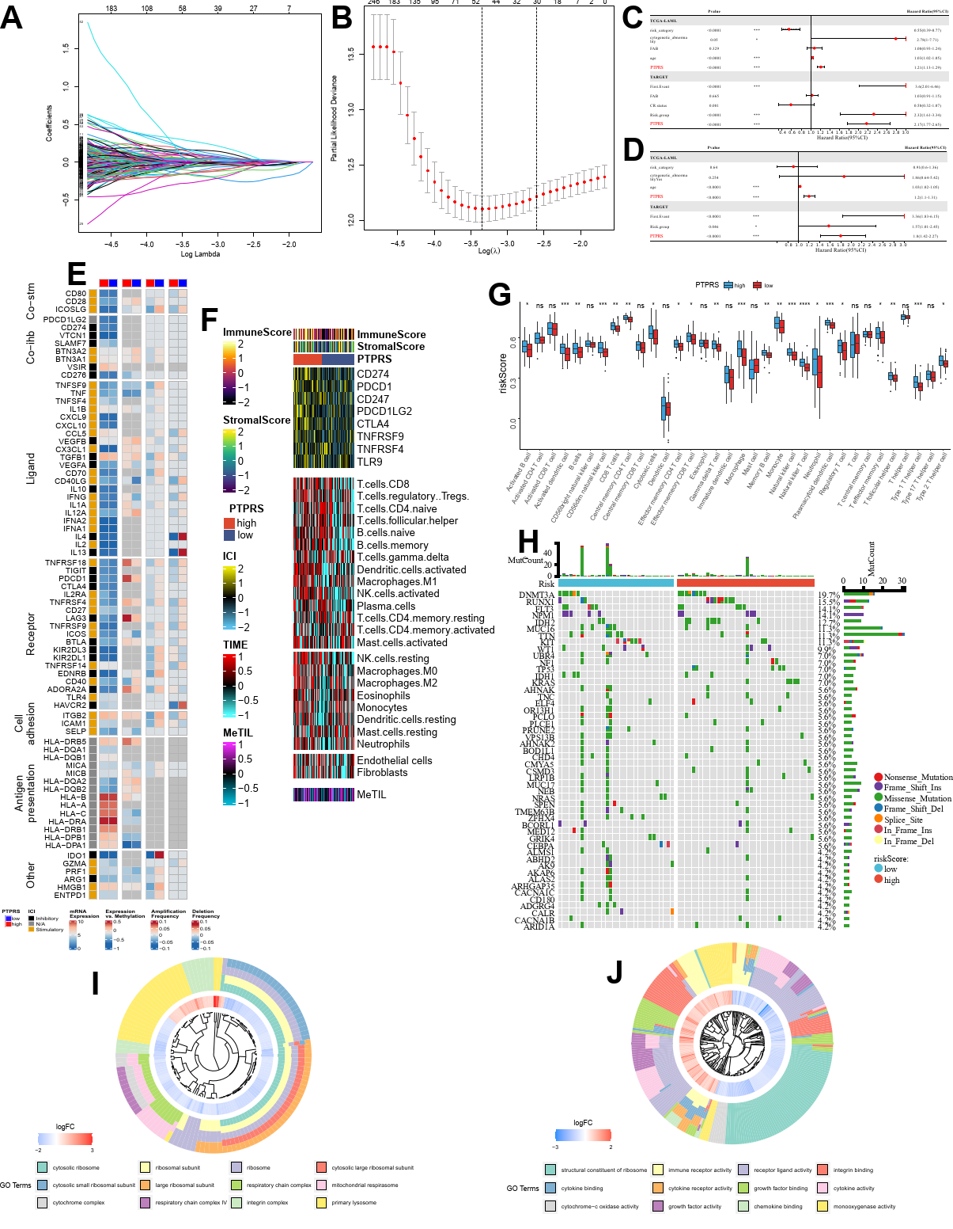
Fig. S11. (A) LASSO coefficient distribution of 826 prognostic genes in the training cohort. Coefficient profiles are drawn according to logarithmic (Lambda) sequences. (B) Cross-validation of turning parameters selected by minimum criteria in LASSO regression models. Use the minimum criterion to draw two dotted lines at the optimal value. The best genes (30 in total) with the best recognition ability were selected. (C-D) (C) Univariate and (D) multivariate Cox regression analysis in TCGA-LAML and TARGET-AML cohort. (E) From left to right: mRNA expression (median normalized expression level); Expression and methylation (correlation between gene expression and DNA methylated beta-value); Amplification frequency (the difference between the high-risk and low-risk group for which specific subtypes of immunomodulators were amplified and the amplification fraction in all samples); Deletion frequency of 75 immunomodulatory genes was analyzed by PTPRS. (F) From left to right: mRNA expression (median normalized expression level); expression and methylation (correlation between gene expression and DNA methylated beta-value); amplification frequency (the difference between the high-risk and low-risk group for which specific subtypes of immunomodulators were amplified and the amplification fraction in all samples); deletion frequency of 75 immunomodulatory genes was analyzed by PTPRS. (G) Differential expression of 27 survival related immune cell types in high-risk and low-risk group based on ssGSEA algorithm. (H) Differential expression of 27 survival related immune cell types in high-risk and low-risk group based on ssGSEA algorithm. (I-J) Functional and signaling pathway analysis of differential genes between high-risk and low-risk group in AML.
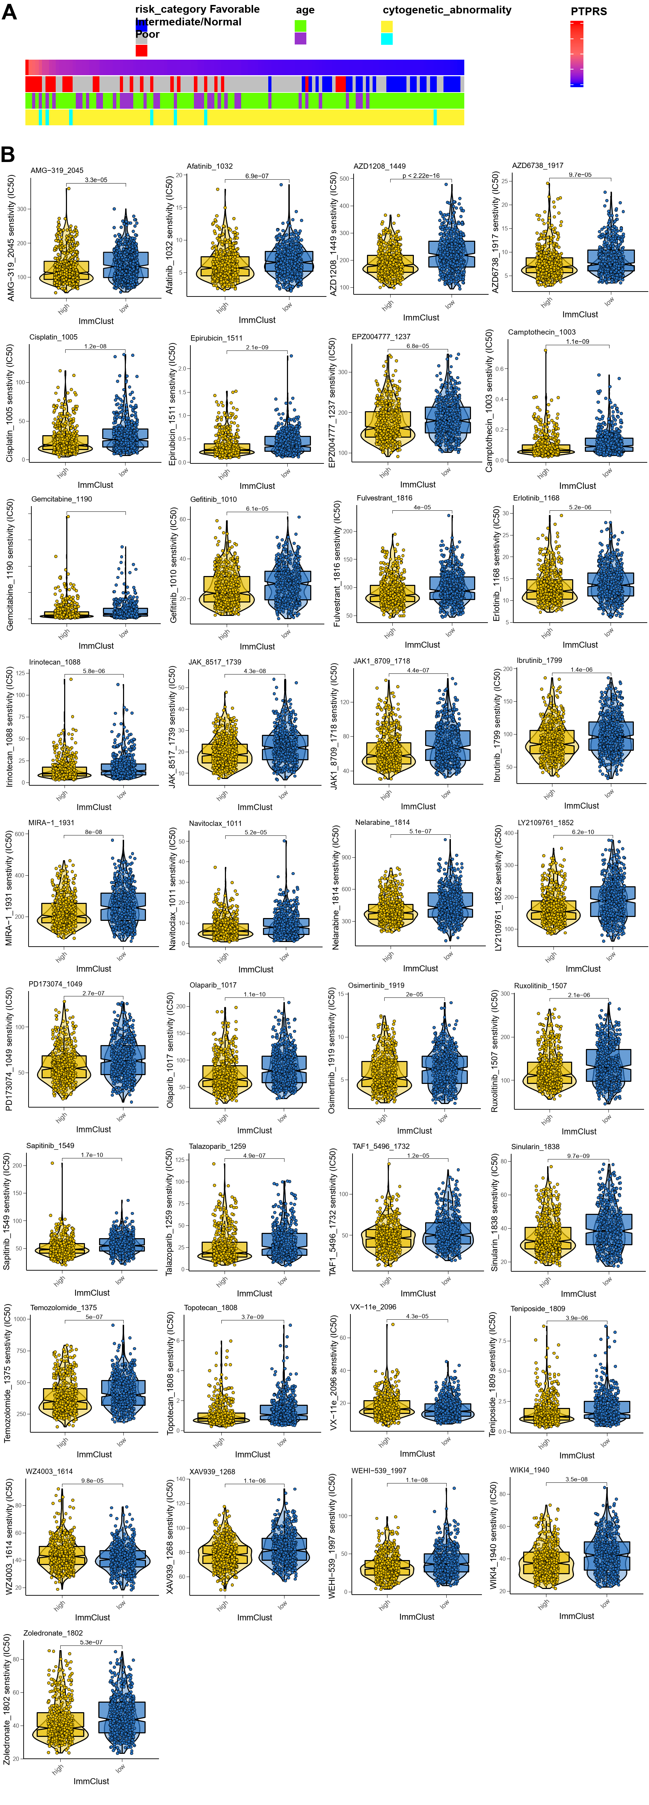
Fig. S12. (A) The heatmap for the association between clinicopathologic features and PTPRS. (B) The IC50 value of different tumor therapeutics in the high-risk and low-risk group.
Supplementary Table S1. The sequences of primers for quantitative real-time PCR assays.
Gene | Sequence
PTPN2-F | ATCGAGCGGGAGTTCGA
PTPN2-R | TCTGGAAACTTGGCCACTC
GAPDH-F | CAGCCTCAAGATCATCAGCAA
GAPDH-R | TGTGGTCATGAGTCCTTCCA

Supplementary Table S2. Gene in the prognostic classifier.
Gene | LASSO coefficient
ETS2 | 0.152206159
FGR | 0.160595683
GSTK1 | -0.323989063
NR4A2 | -0.078208265
HOXA10 | 0.082900421
MTHFR | 0.2605123
ZFR | -0.30884948
CCND3 | 0.229274358
HYAL2 | -0.128095236
LSM3 | 0.295255661
MICALL2 | -0.130326596
PACS2 | 0.445454662
MTMR9 | 0.408594217
RAB22A | -0.305984026
CYP1B1 | 0.127854503
GCH1 | 0.190644948
AOAH | -0.185088463
HCFC2 | 0.378472849
ABCA1 | -0.125409636
DNAJC15 | 0.39084415
PDE8A | -0.508755306
LY96 | -0.322871014
TBR1 | -0.253813366
GPD1 | 0.407917155

