Integrated network pharmacology and cellular assay reveal the biological mechanisms of Limonium sinense (Girard) Kuntze against breast cancer

Supplementary Materials
Table of contents

Supplementary Methods 2
1. GSEApy protocol in python 2
2. R Scripts 4
2.1. R codes for obtaining rawdata of GEO datasets 4
2.2. R codes for Figure 5C 6
2.3. R codes for Figure 8A and 8D 6
2.4. R codes for Figure 8B, 8C, 8E and 8F 7
2.5. R codes for Supplementary Figure 2A, 2B 9
Supplementary Figures 11
Supplementary Figure 1 11
Supplementary Figure 2 12
Supplementary Figure 3 13
Supplementary Tables 14
Raw data for 3D culture 15
Raw data for 2D culture 16

Supplementary Methods

1. GSEApy protocol in python
The GSEApy analysis was performed in Colab Notebooks under python environment.
Upload the gene list (Supplementary table 12) into Colab Notebooks as default path.
#Installation
%pip install gseapy

%load_ext autoreload
%autoreload 2
import pandas as pd
import gseapy as gp
import matplotlib.pyplot as plt
from gseapy import Biomart
bm = Biomart()
import numpy as np
import pandas as pd
from gseapy import barplot, dotplot
from matplotlib import figure

#Run GSEApy
gene_list=pd.read_csv("/content/ Gene_list_for_enrichment_analysis.txt",header=None,sep="\t")

#KEGG enrichment
enr_KEGG = gp.enrichr(gene_list= gene_list,
gene_sets=['KEGG_2021_Human'],
organism='human',
outdir=None,
)

enr_KEGGFrame=pd.DataFrame(data=enr_KEGG.results,columns=['Gene_set','Term','Overlap','P-value','Adjusted P-value','Odds Ratio','Combined Score','Genes'])

enr_KEGGFrame.to_csv('enr_KEGG_data',index=False)
ax_KEGG = dotplot(enr_KEGG.res2d, title='KEGG pathway', top_term=20,cmap='viridis_r',size=10, figsize=(4, 8))

#GO term enrichment
enr_GO = gp.enrichr(gene_list=gene_list,
gene_sets=['GO_Biological_Process_2021','GO_Molecular_Function_2021','GO_Cellular_Component_2021'],
organism='human',
outdir=None,
)

enr_GOFrame=pd.DataFrame(data=enr_GO.results,columns=['Gene_set','Term','Overlap','P-value','Adjusted P-value','Odds Ratio','Combined Score','Genes'])

enr_GOFrame.to_csv('enr_GO_data',index=False)

ax_GO = dotplot(enr_GO.results,
column="Adjusted P-value",
x='Gene_set',
size=6,
top_term=10,
figsize=(3,10),
title="GO Terms",
xticklabels_rot=45,
show_ring=False,
)

2. R Scripts
Raw data were imported into RStudio (version 4.2.0), Microsoft Windows (version 11) and R scripts were run.
# Set the working directory before run
# setwd("C:/Users/hz2u19/Downloads")

2.1. R codes for obtaining rawdata of GEO datasets
library(GEOquery)
library(limma)

#GSE119552
gse119552 <- getGEO("GSE119552", GSEMatrix =TRUE, AnnotGPL=FALSE)

if (length(gse119552) > 1) idx <- grep("GPL16699", attr(gse119552, "names")) else idx <- 1

gse119552 <- gse119552[[idx]]

gse119552_rawdata<- cbind(fData(gse119552), exprs(gse119552))

gse119552_rawdata <- aggregate(x=gse119552_rawdata[,2:(ncol(gse119552_rawdata))],
by=list(gse119552_rawdata $Gene_Symbol), FUN = median)

gse119552_rawdata <- na.omit(gse119552_rawdata)

rownames(gse119552_rawdata)<- gse119552_rawdata $Group.1

gse119552_rawdata <- gse119552_rawdata [,-1]

write.csv(gse119552_rawdata, "GSE119552_rawdata.csv")

#GSE120550
gse120550 <- getGEO("GSE120550", GSEMatrix =TRUE, AnnotGPL=FALSE)

if (length(gse120550) > 1) idx <- grep("GPL17692", attr(gse119552, "names")) else idx <- 1

gse120550 <- gse120550[[idx]]

gse120550_rawdata<- cbind(fData(gse120550), exprs(gse120550))

gse120550_rawdata <- aggregate(x=gse120550_rawdata[,2:(ncol(gse120550_rawdata))],
by=list(gse120550_rawdata $Gene_Symbol), FUN = median)

gse120550_rawdata <- na.omit(gse120550_rawdata)

rownames(gse120550_rawdata)<- gse120550_rawdata $Group.1

gse120550_rawdata <- gse120550_rawdata [,-1]

write.csv(gse120550_rawdata, "GSE120550_rawdata.csv")

2.2. R codes for Figure 5C
BiocManager::install("disgenet2r")
library(disgenet2r)

hub_gene_dis<- gene2disease(gene = c( "AKT1", "EGFR", "SRC", "ESR1",
"GSK3B","PTGS2"), database = "ALL")
hub_results<- extract(hub_gene_dis)
res_enrich<- disease_enrichment(entities = c("AKT1","EGFR","SRC","ESR1",
"GSK3B","PTGS2"))
table1<- res_enrich@qresult[, c("Description", "FDR","Ratio","BgRatio")]
write.csv(table1, “hub_genes_DisGeNET_data.csv”)
plot(res_enrich,class = "Enrichment", count = 3, cutoff = 0.05, nchars =50)

2.3. R codes for Figure 8A and 8D
library(ggplot2)
library(RColorBrewer)
library(gridExtra)
library(dplyr)

###gse119552_kegg_gseapy.csv was named as Supplementary Table 10

gse119552_kegg<- read.csv("gse119552_kegg_genes.csv", header = T)

ggplot(gse119552_kegg, aes(x = DEGs, y = reorder(Term, -P.value),
color = log10(1/P.value), size = Combined.Score))+
geom_point()+
scale_color_gradient(low = "deepskyblue4", high = "red3")+
theme_bw()+
labs(x="", y="", title="")+
theme(axis.text.x = element_text(angle = 270, hjust = 0.1, vjust = 0.5))+
facet_grid(cols = vars(), scales = "free_x", space = "free_x")

###gse120550_kegg_gseapy.csv was named as Supplementary Table 11

gse120550_kegg<- read.csv("gse120550_kegg_genes.csv", header = T)

ggplot(gse120550_kegg, aes(x = DEGs, y = reorder(Term, -P.value),
color = log10(1/P.value), size = Combined.Score))+
geom_point()+
scale_color_gradient(low = "deepskyblue4", high = "red3")+
theme_bw()+
labs(x="", y="", title="")+
theme(axis.text.x = element_text(angle = 270, hjust = 0.1, vjust = 0.5))+
facet_grid(cols = vars(), scales = "free_x", space = "free_x")

2.4. R codes for Figure 8B, 8C, 8E and 8F
library(pheatmap)

####gse119552_breastcancer_genes.csv was named as Raw_data_Table3

gse119552_breast_genes<- read.csv("gse119552_breastcancer_genes.csv", row.names = 1)

pheatmap(gse119552_breast_genes,
scale = 'row',
treeheight_row = 20,
treeheight_col = 20,
annotation_row = NA,
annotation_names_row = FALSE,
cluster_rows = T,
cluster_cols = T,
color = colorRampPalette(c("deepskyblue4","white", "red3"))(500),
border_color = "grey90",
angle_col = 45,
fontsize_col = 10)

#### gse119552_pathwaysincancer_genes.csv was named as Raw_data_Table4

gse119552_pic_genes<- read.csv("gse119552_pathwaysincancer_genes.csv", row.names = 1)

pheatmap(gse119552_pic_genes,
scale = 'row',
treeheight_row = 20,
treeheight_col = 20,
annotation_row = NA,
annotation_names_row = FALSE,
cluster_rows = T,
cluster_cols = T,
color = colorRampPalette(c("grey70","white", "deepskyblue4"))(500),
border_color = "grey90",
angle_col = 45,
fontsize_col = 10)

#### gse120550_cellcycle_gseapy.csv was named as Raw_data_Table5

gse120550_cellcycle_genes<- read.csv("gse120550_cellcycle_genes.csv", row.names = 1)

pheatmap(gse120550_cellcycle_genes,
scale = 'row',
treeheight_row = 20,
treeheight_col = 20,
annotation_row = NA,
annotation_names_row = FALSE,
cluster_rows = T,
cluster_cols = T,
color = colorRampPalette(c("deepskyblue4","white", "red3"))(500),
border_color = "grey90",
angle_col = 45,
fontsize_col = 10)

#### gse120550_up_pathwaysincancer_gseapy.csv was named as Raw_data_Table6

gse120550_pic_genes<- read.csv("gse120550_pathwaysincancer_genes.csv", row.names = 1)

pheatmap(gse120550_pic_genes,
scale = 'row',
treeheight_row = 20,
treeheight_col = 20,
annotation_row = NA,
annotation_names_row = FALSE,
cluster_rows = T,
cluster_cols = T,
color = colorRampPalette(c("grey70","white", "red3"))(500),
border_color = "grey90",
angle_col = 45,
fontsize_col = 10)

2.5. R codes for Supplementary Figure 2A, 2B
library(EnhancedVolcano)

#### GSE119552_DEGs_from_GEO2.csv was named as Raw_data_Table1

gse119552_vol<- read.csv("GSE119552_DEGs_from_GEO2.csv", header = T)

EnhancedVolcano(gse119552_vol, lab = NA,
selectLab = NULL,
subtitle = "DEGs of GSE119552",
subtitleLabSize = 18,
x = 'logFC', y = 'P.Value',
ylim = c(0, 12),
pCutoff = 0.05,
FCcutoff = 1,
title = "")

####gse120550_DEGs_from_GEO2.csv was named as Raw_data_Table2

gse120550_vol<- read.csv("GSE120550_DEGs_from_GEO2.csv", header = T)

EnhancedVolcano(gse120550_vol, lab = NA,
selectLab = NULL,
subtitle = "DEGs of GSE120550",
subtitleLabSize = 18,
x = 'logFC', y = 'P.Value',
ylim = c(0, 10),
xlim = c(-4, 3),
pCutoff = 0.05,
FCcutoff = 1,
title = "")

Supplementary Figures
Supplementary Figure 1. Target-Pathway (TP) network of L. sinense. Graph consists of 20 signalling pathways and 194 pathway-related targets. The red V nodes represent the top 20 enriched KEGG pathways by the potential targets of L. sinense. The blue circles represent the relevant targets. The edges represent the relationship between signalling pathways and target nodes. The node size is proportional to the node degree in the network, and the width and colour of the edges is proportional to the edge betweenness centrality. The network is generated using the Cytoscape tool.
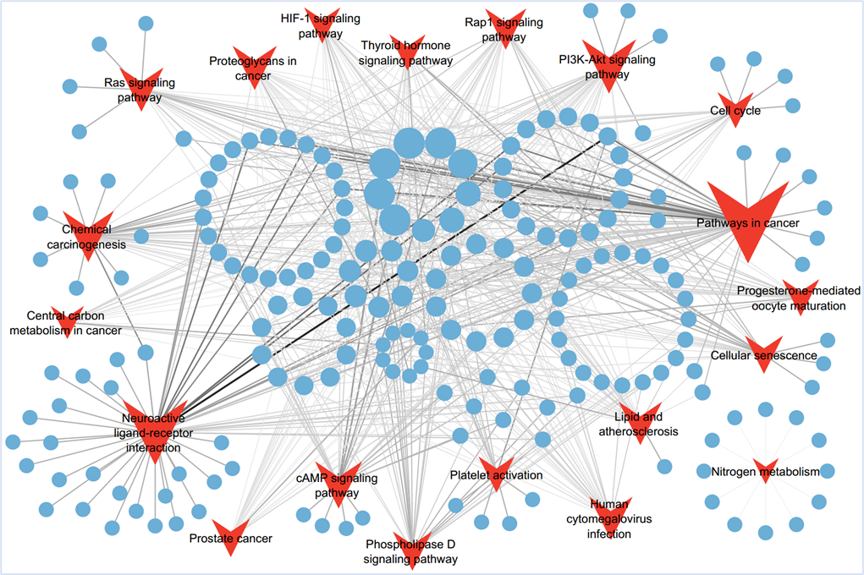

Supplementary Figure 2. Global transcriptomic changes in human breast cancer cells exposed to Apigenin. (A and B) Volcano plots showing up and down-regulated genes in Apigenin-treated human breast cancer cells within indicated GEO datasets. Log2FoldChange in x-axis and -Log10(P) in y-axis. Genes with different colors represent indicated changes in the figure legends.
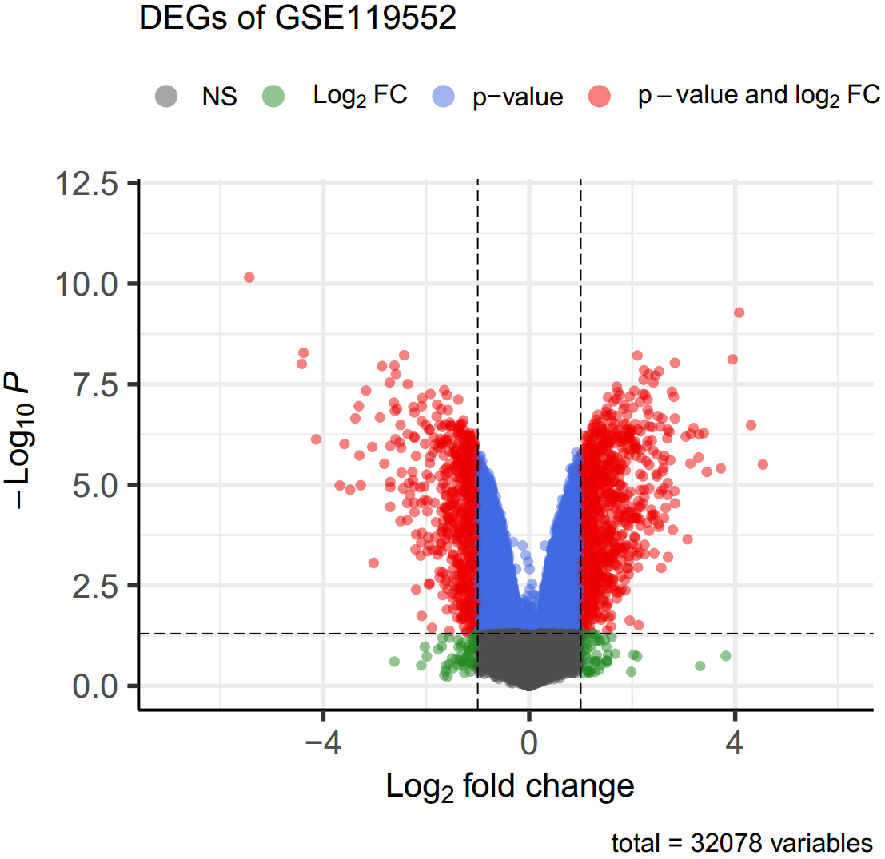
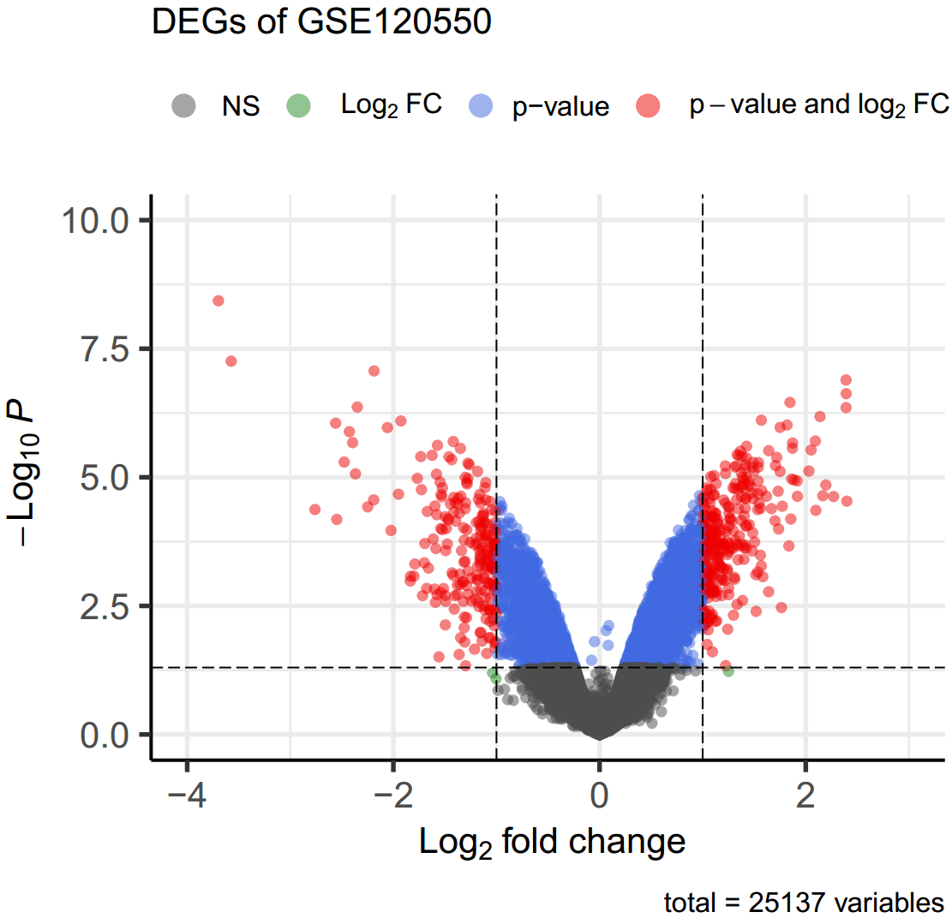
A
B

Supplementary Figure 3. Relative mRNA expression and Overall Survival of the 6 hub target genes in TCGA cancers. (A-F) Graphs showing the relative mRNA expression of each target gene obtained from the hub network in 33 TCGA cancers. ns, not significant, *P < 0.05, **P < 0.01, ***P < 0.001, ****P < 0.0001. (G) Heatmap showing the Overall Survival of each target gene obtained from the hub network in 33 TCGA cancers. Red colour represents significant correlated with overall survival, while white colour represents not significant correlated with overall survival.
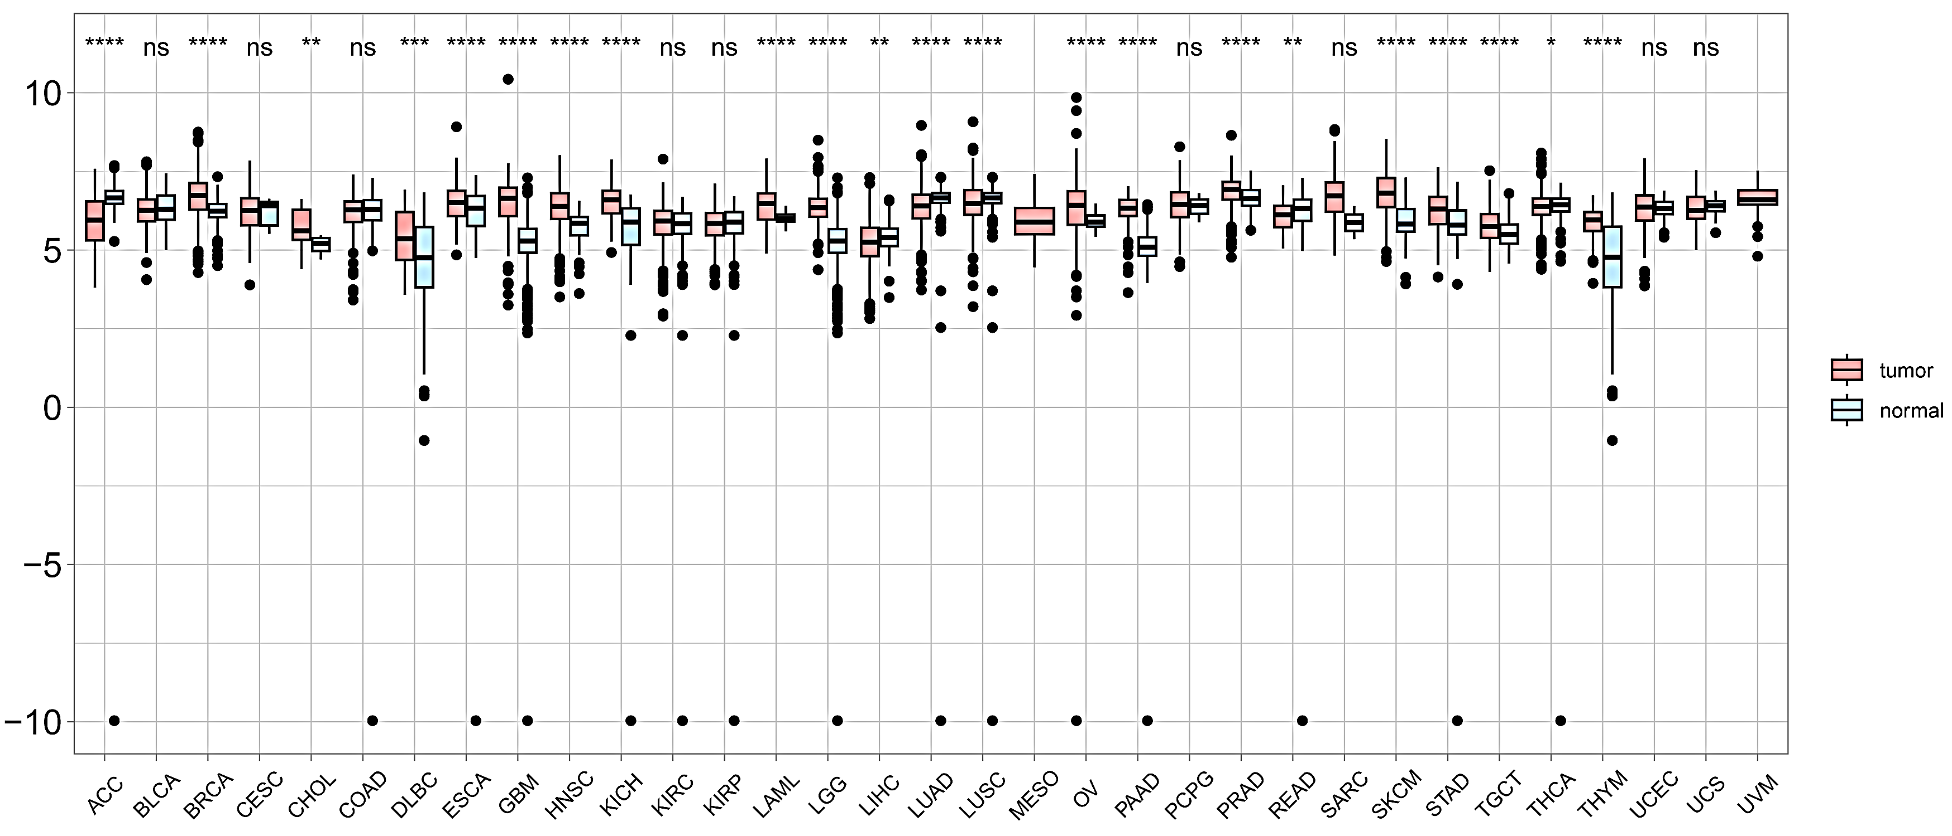
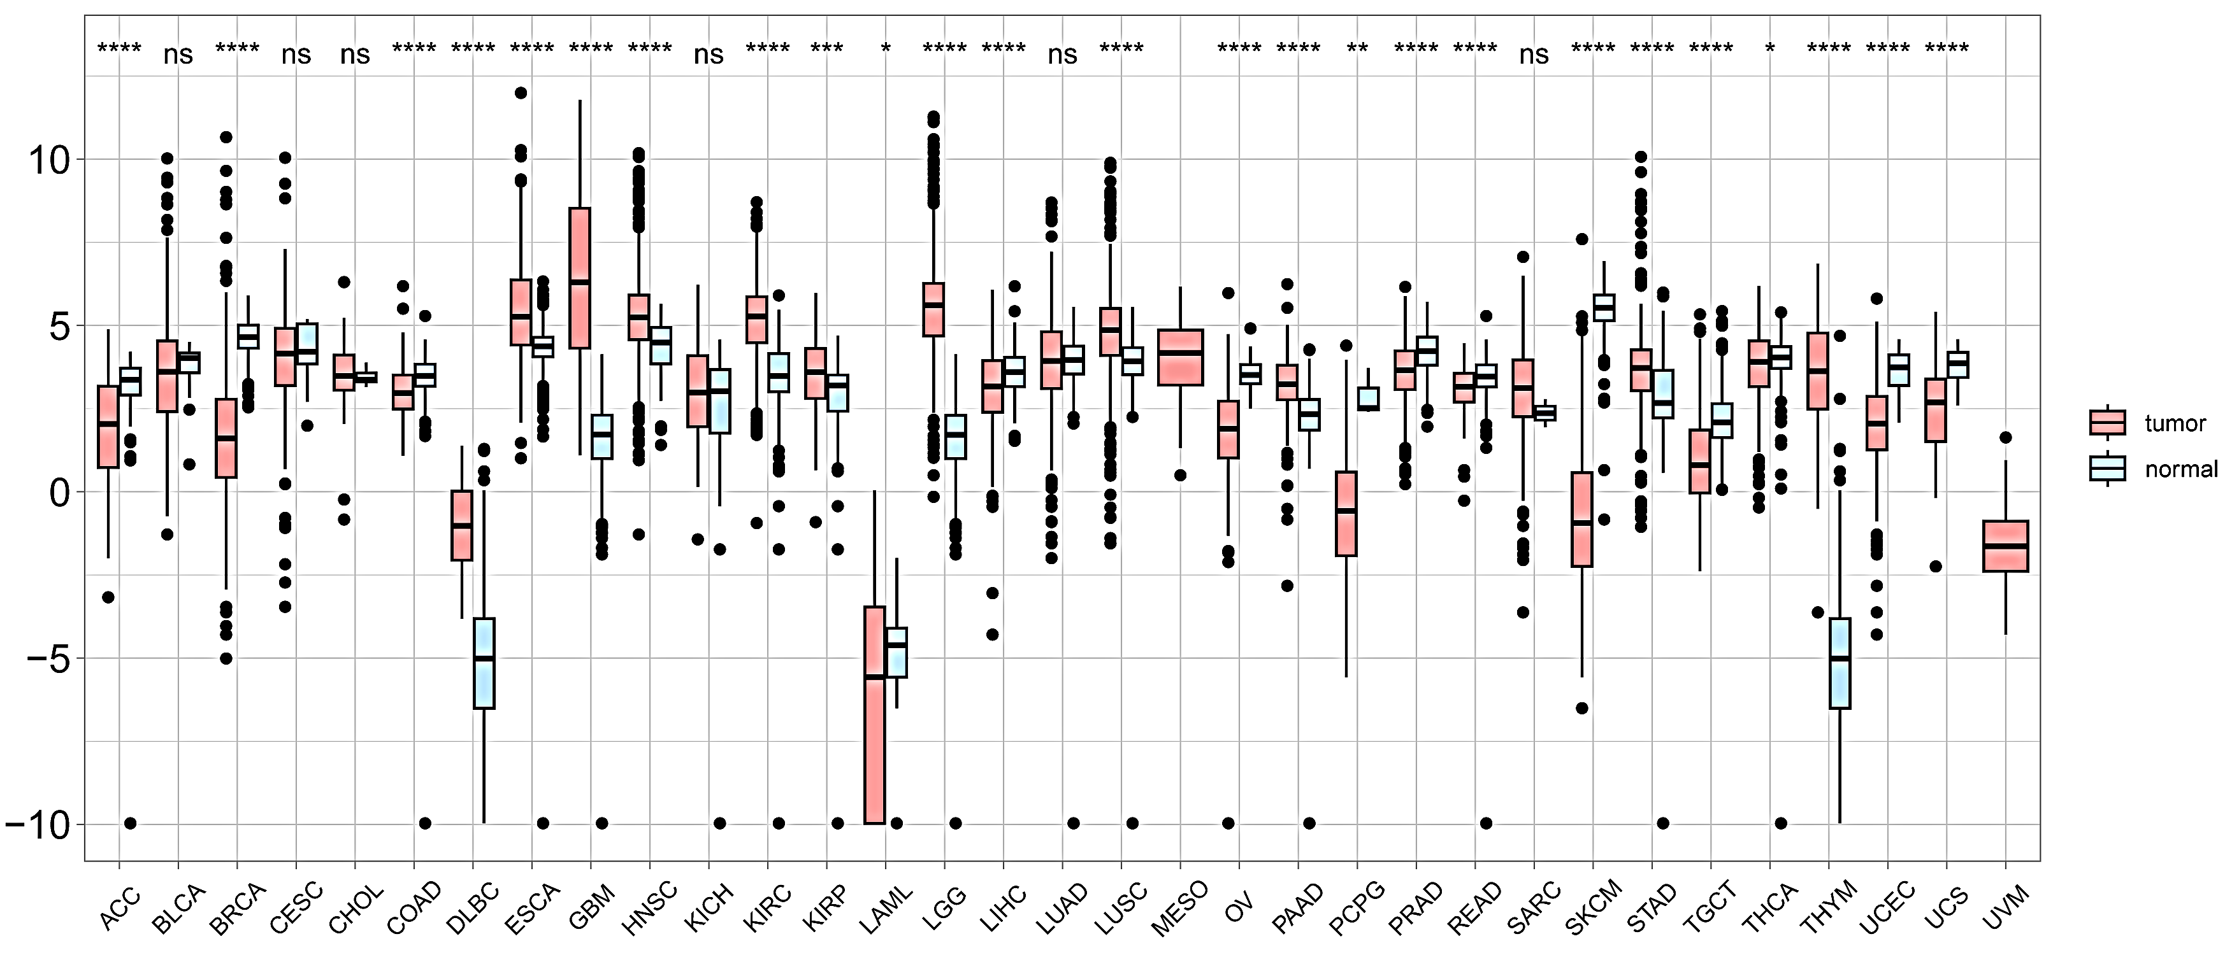
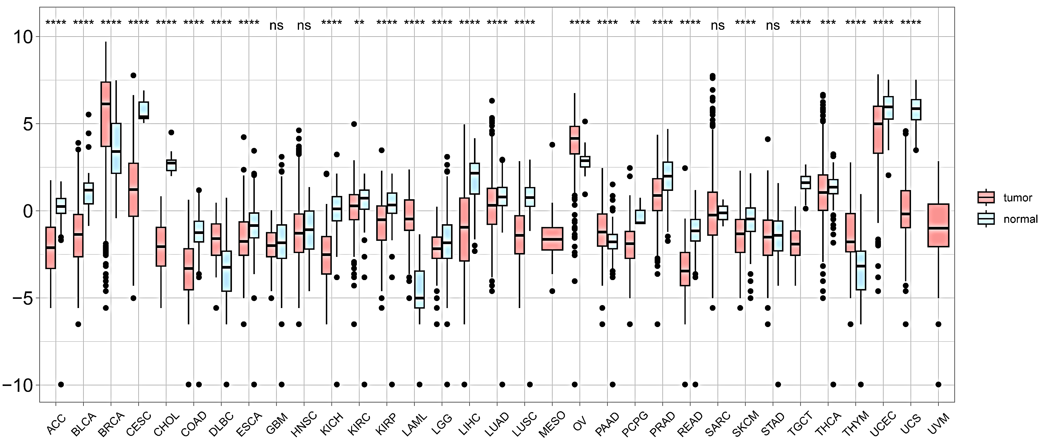
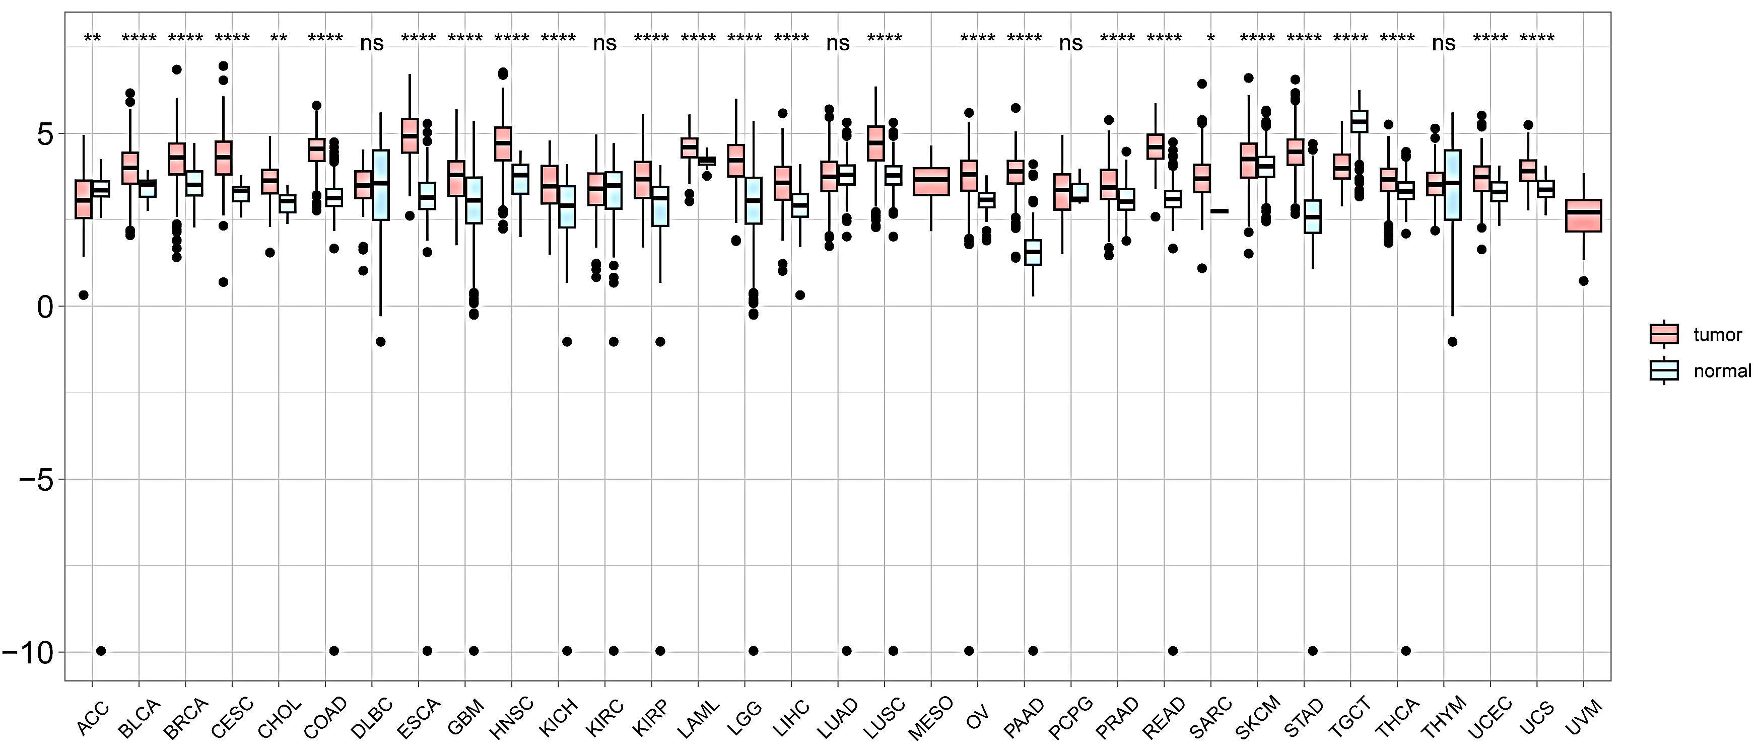
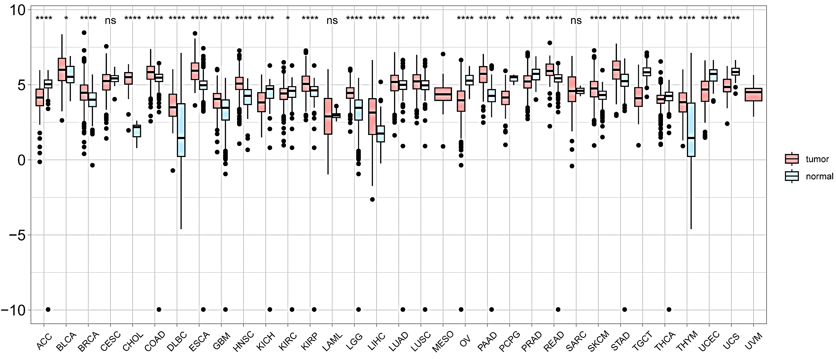
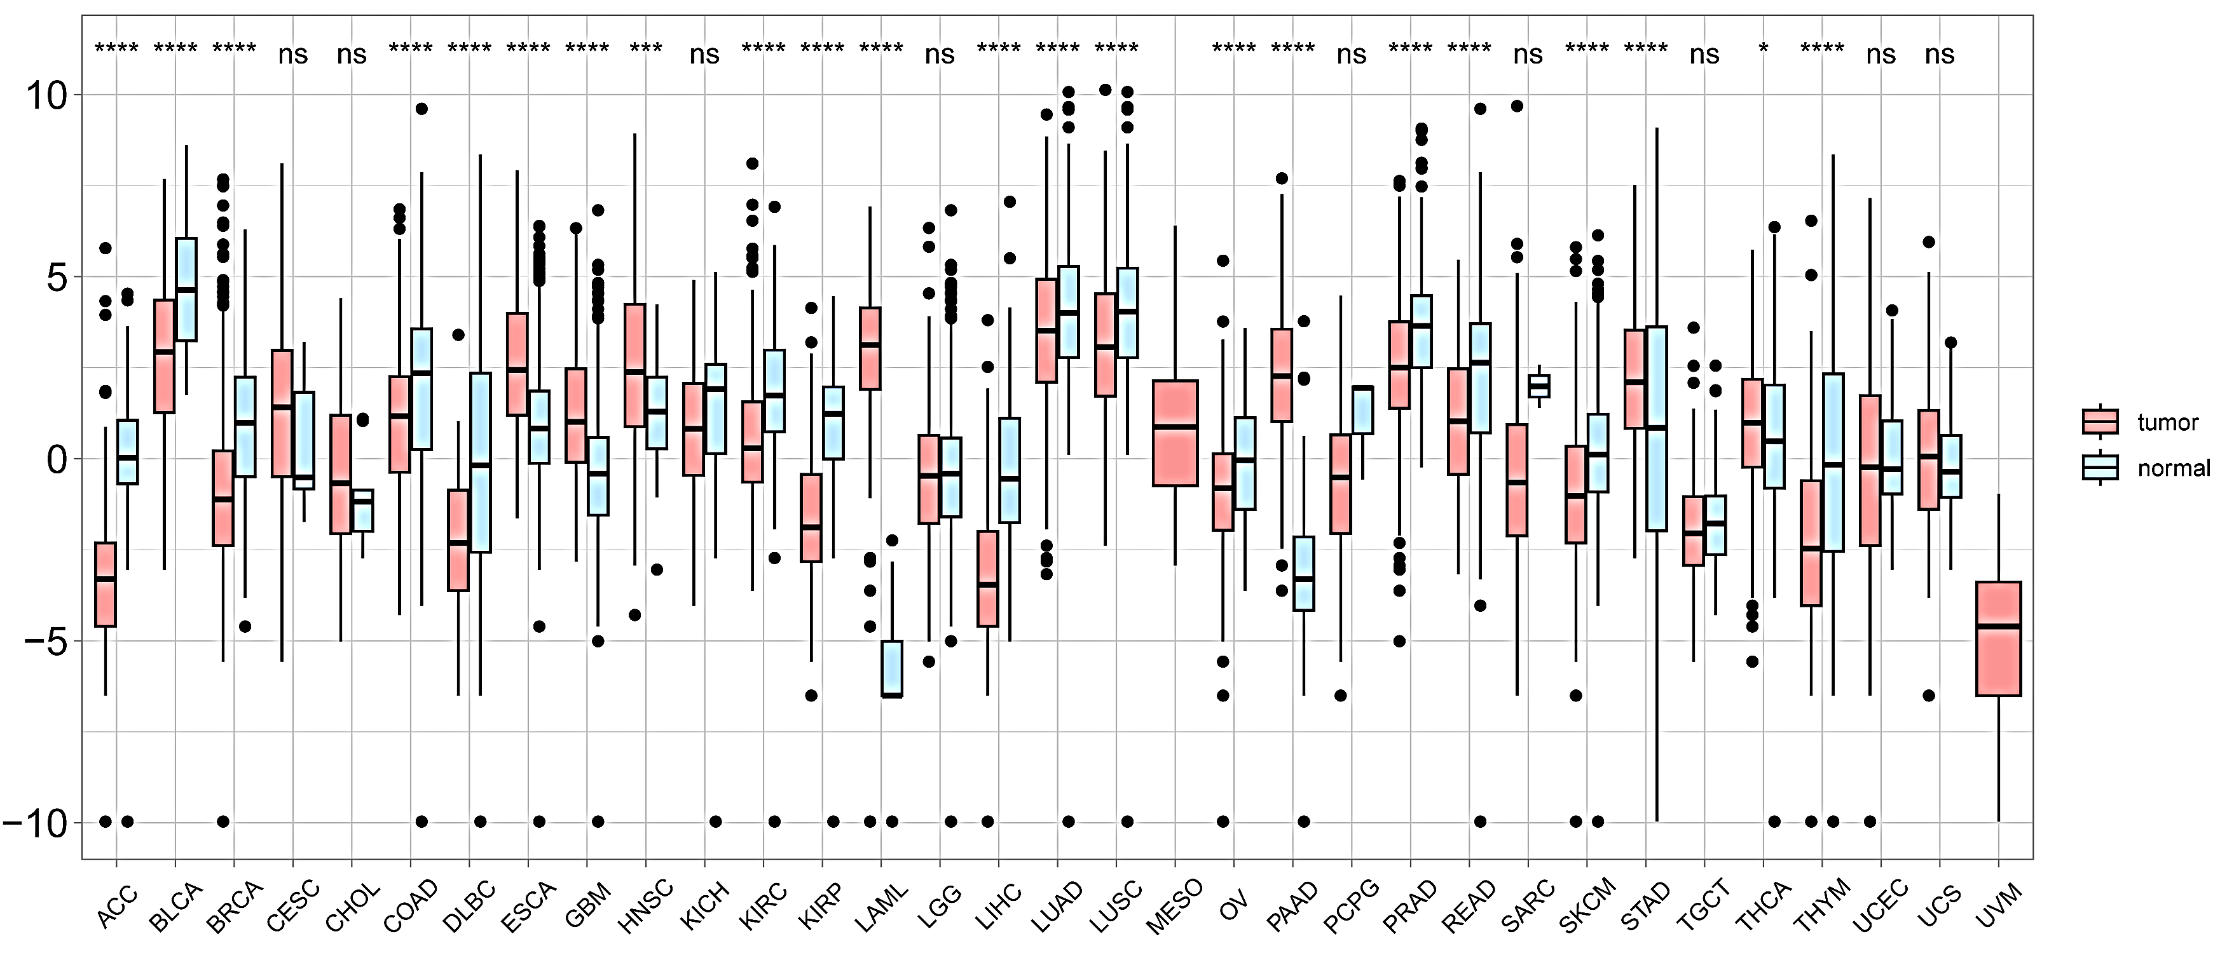
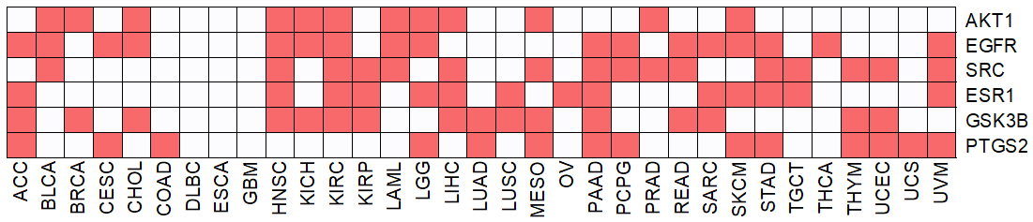
AKT1 mRNA expression
EGFR mRNA expression
ESR1 mRNA expression
GSK3B mRNA expression
SRC mRNA expression
PTGS2 mRNA expression
A
B
C
D
E
F
G

Supplementary Tables
Supplementary Table 1. Identified Compounds in Limonium Sinense
Supplementary Table 2. Compound targets of Limonium Sinense
Supplementary Table 3. Information of CT network
Supplementary Table 4. Core targets identified from PPI network
Supplementary Table 5. KEGG pathways enriched from GSEApy
Supplementary Table 6. GO terms enriched from GSEApy
Supplementary Table 7. Hub network information identified using Cytohubba
Supplementary Table 8. DisGeNET result of hub targets
Supplementary Table 9. GEO datasets information
Supplementary Table 10. KEGG enrichment pathways of GSE119552
Supplementary Table 11. KEGG enrichment pathways of GSE120550
Supplementary Table 12. Gene_list_for_enrichment_analysis

Rawdata Table 1. GSE119552_DEGs_from_GEO2
Rawdata Table 2. GSE120550_DEGs_from_GEO2
Rawdata Table 3. gse119552_breastcancer_genes
Rawdata Table 4. gse119552_pathwaysincancer_genes
Rawdata Table 5. gse120550_cellcycle_genes
Rawdata Table 6. gse120550_ pathwaysincancer_genes
Rawdata Table 7. Cell viability assay of breast cancer cell lines treatment with LSE
Rawdata Table 8. Cell viability of MDA-MB-468 cells treatment with LSE in 3D culture

Raw data for 3D culture
Control

LSE-treated

Raw data for 2D culture

Control

LSE-treated

