Supplement materials

PRISMA-NMA Checklist

Section and Topic | Item # | Checklist item | Location where item is reported
TITLE
Title | 1 | Identify the report as a systematic review.
ABSTRACT
Abstract | 2 | See the PRISMA 2020 for Abstracts checklist.
INTRODUCTION
Rationale | 3 | Describe the rationale for the review in the context of existing knowledge.
Objectives | 4 | Provide an explicit statement of the objective(s) or question(s) the review addresses.
METHODS
Eligibility criteria | 5 | Specify the inclusion and exclusion criteria for the review and how studies were grouped for the syntheses.
Information sources | 6 | Specify all databases, registers, websites, organisations, reference lists and other sources searched or consulted to identify studies. Specify the date when each source was last searched or consulted.
Search strategy | 7 | Present the full search strategies for all databases, registers and websites, including any filters and limits used.
Selection process | 8 | Specify the methods used to decide whether a study met the inclusion criteria of the review, including how many reviewers screened each record and each report retrieved, whether they worked independently, and if applicable, details of automation tools used in the process.
Data collection process | 9 | Specify the methods used to collect data from reports, including how many reviewers collected data from each report, whether they worked independently, any processes for obtaining or confirming data from study investigators, and if applicable, details of automation tools used in the process.
Data items | 10a | List and define all outcomes for which data were sought. Specify whether all results that were compatible with each outcome domain in each study were sought (e.g. for all measures, time points, analyses), and if not, the methods used to decide which results to collect.
Data items | 10b | List and define all other variables for which data were sought (e.g. participant and intervention characteristics, funding sources). Describe any assumptions made about any missing or unclear information.
Study risk of bias assessment | 11 | Specify the methods used to assess risk of bias in the included studies, including details of the tool(s) used, how many reviewers assessed each study and whether they worked independently, and if applicable, details of automation tools used in the process.
Effect measures | 12 | Specify for each outcome the effect measure(s) (e.g. risk ratio, mean difference) used in the synthesis or presentation of results.
Synthesis methods | 13a | Describe the processes used to decide which studies were eligible for each synthesis (e.g. tabulating the study intervention characteristics and comparing against the planned groups for each synthesis (item #5)).
Synthesis methods | 13b | Describe any methods required to prepare the data for presentation or synthesis, such as handling of missing summary statistics, or data conversions.
Synthesis methods | 13c | Describe any methods used to tabulate or visually display results of individual studies and syntheses.
Synthesis methods | 13d | Describe any methods used to synthesize results and provide a rationale for the choice(s). If meta-analysis was performed, describe the model(s), method(s) to identify the presence and extent of statistical heterogeneity, and software package(s) used.
Synthesis methods | 13e | Describe any methods used to explore possible causes of heterogeneity among study results (e.g. subgroup analysis, meta-regression).
Synthesis methods | 13f | Describe any sensitivity analyses conducted to assess robustness of the synthesized results.
Reporting bias assessment | 14 | Describe any methods used to assess risk of bias due to missing results in a synthesis (arising from reporting biases).
Certainty assessment | 15 | Describe any methods used to assess certainty (or confidence) in the body of evidence for an outcome.
RESULTS
Study selection | 16a | Describe the results of the search and selection process, from the number of records identified in the search to the number of studies included in the review, ideally using a flow diagram.
Study selection | 16b | Cite studies that might appear to meet the inclusion criteria, but which were excluded, and explain why they were excluded.
Study characteristics | 17 | Cite each included study and present its characteristics.
Risk of bias in studies | 18 | Present assessments of risk of bias for each included study.
Results of individual studies | 19 | For all outcomes, present, for each study: (a) summary statistics for each group (where appropriate) and (b) an effect estimate and its precision (e.g. confidence/credible interval), ideally using structured tables or plots.
Results of syntheses | 20a | For each synthesis, briefly summarise the characteristics and risk of bias among contributing studies.
Results of syntheses | 20b | Present results of all statistical syntheses conducted. If meta-analysis was done, present for each the summary estimate and its precision (e.g. confidence/credible interval) and measures of statistical heterogeneity. If comparing groups, describe the direction of the effect.
Results of syntheses | 20c | Present results of all investigations of possible causes of heterogeneity among study results.
Results of syntheses | 20d | Present results of all sensitivity analyses conducted to assess the robustness of the synthesized results.
Reporting biases | 21 | Present assessments of risk of bias due to missing results (arising from reporting biases) for each synthesis assessed.
Certainty of evidence | 22 | Present assessments of certainty (or confidence) in the body of evidence for each outcome assessed.
DISCUSSION
Discussion | 23a | Provide a general interpretation of the results in the context of other evidence.
Discussion | 23b | Discuss any limitations of the evidence included in the review.
Discussion | 23c | Discuss any limitations of the review processes used.
Discussion | 23d | Discuss implications of the results for practice, policy, and future research.
OTHER INFORMATION
Registration and protocol | 24a | Provide registration information for the review, including register name and registration number, or state that the review was not registered.
Registration and protocol | 24b | Indicate where the review protocol can be accessed, or state that a protocol was not prepared.
Registration and protocol | 24c | Describe and explain any amendments to information provided at registration or in the protocol.
Support | 25 | Describe sources of financial or non-financial support for the review, and the role of the funders or sponsors in the review.
Competing interests | 26 | Declare any competing interests of review authors.
Availability of data, code and other materials | 27 | Report which of the following are publicly available and where they can be found: template data collection forms; data extracted from included studies; data used for all analyses; analytic code; any other materials used in the review.

From: Page MJ, McKenzie JE, Bossuyt PM, Boutron I, Hoffmann TC, Mulrow CD, et al. The PRISMA 2020 statement: an updated guideline for reporting systematic reviews. BMJ 2021;372:n71. doi: 10.1136/bmj.n71
For more information, visit: http://www.prisma-statement.org/

Research strategies

Pubmed & Web of Science research strategies
Patients
- Critical illness[Mesh]; Entry terms:Critical illness; illness, critical; illnesses, critical; Critically ill
- Intensive care units[Mesh]; Entry terms:Intensive care unit; unit,intensive care; ICU intensive care units;ICU;
- Critical Care[Mesh]; Entry terms: Critical Care; care, critical; intensive care; care, intensive; surgical intensive care; care, surgical intensive; intensive care, surgical; SICU;
- Coronary care units[Mesh]; Entry terms:Care unit, coronary; Care units, coronary; Coronary care unit; Unit,coronary care; Units, coronary care; CCU;
- Respiratory care units[Mesh]; Entry terms:Care unit, respiratory; Care units, respiratory; respiratory care unit; Unit, respiratory care; Units, respiratory care; RICU;
- Entry terms: medical intensive Care Unit; MICU
- Entry terms: Emergency intensive Care Unit; EICU
- Burn units[Mesh]; Entry terms: Burn unit; Unit,burn; units,burn; burn center; center,burn; centers,burn; burn intensive care unit;
- Entry terms: Nephrotic intensive care unit; UICU;
- Entry terms: Obstetric intensive care unit; OICU;
- Entry terms: Anesthesia intensive care unit; AICU;
- Entry terms: Transplant intensive care unit; TICU;
- Entry terms: Cardiopulmonary intensive care unit; CPICU;
- Entry terms: Cardiac surgery intensive care unit; CSICU;
- Entry terms: Neurosurgical intensive care unit; NSICU;
- Entry terms: Neurological intensive care unit; NICU;
- Entry terms: stroke intensive care unit; stroke ICU;
- Entry terms: General intensive care unit; GICU;

- Weaning[Mesh];
- Ventilator Weaning[Mesh]; Entry terms:Weaning, Ventilator; Respirator Weaning; Weaning, Respirator; Mechanical Ventilator Weaning; Ventilator Weaning, Mechanical; Weaning, Mechanical Ventilator;
- Respiration, Artificial[Mesh];Entry terms:Artificial Respiration; Artificial Respirations; Respirations, Artificial; Ventilation, Mechanical; Mechanical Ventilations; Ventilations, Mechanical; Mechanical Ventilation;
- Interactive Ventilatory Support[Mesh];Entry terms:Support, Interactive Ventilatory; Ventilatory Support, Interactive; Neurally Adjusted Ventilatory Assist; Proportional Assist Ventilation; Assist Ventilation, Proportional; Ventilation, Proportional Assist;
- Respiratory Therapy[Mesh]; Entry terms:Therapy, Respiratory; Respiratory Therapies; Therapies, Respiratory; Inhalation Therapy;Therapy, Inhalation; Inhalation Therapies;Therapies, Inhalation;
- Entry terms: Supported Respiration;
- Entry terms: Supported weaning;
- Work of breathing[mesh]; Entry terms: Breathing Work; Breathing Works;

(“Critical Care”[Title/Abstract] OR “care, critical”[Title/Abstract] OR “intensive care”[Title/Abstract] OR “care, intensive”[Title/Abstract] OR “surgical intensive care”[Title/Abstract] OR “care, surgical intensive”[Title/Abstract] OR “intensive care, surgical”[Title/Abstract] OR “SICU”[Title/Abstract] OR “Coronary care units”[Mesh] OR “Care unit, coronary”[Title/Abstract] OR “Care units, coronary”[Title/Abstract] OR “Coronary care unit”[Title/Abstract] OR “Unit,coronary care”[Title/Abstract] OR “Units, coronary care”[Title/Abstract] OR “CCU”[Title/Abstract] OR “Respiratory care units”[Mesh] OR “Care unit, respiratory”[Title/Abstract] OR “Care units, respiratory”[Title/Abstract] OR “respiratory care unit”[Title/Abstract] OR “Unit, respiratory care”[Title/Abstract] OR “Units, respiratory care”[Title/Abstract] OR “RICU”[Title/Abstract] OR “medical intensive Care Unit”[Title/Abstract] OR “MICU”[Title/Abstract] OR “Emergency intensive Care Unit”[Title/Abstract] OR “EICU”[Title/Abstract] OR “Burn units”[Mesh] OR “Burn unit”[Title/Abstract] OR “Unit,burn”[Title/Abstract] OR “units,burn”[Title/Abstract] OR “burn center”[Title/Abstract] OR “center,burn”[Title/Abstract] OR “centers,burn”[Title/Abstract] OR “burn intensive care unit”[Title/Abstract] OR “Nephrotic intensive care unit”[Title/Abstract] OR “UICU”[Title/Abstract] OR “Obstetric intensive care unit”[Title/Abstract] OR “OICU”[Title/Abstract] OR “Anesthesia intensive care unit”[Title/Abstract] OR “AICU”[Title/Abstract] OR “Transplant intensive care unit”[Title/Abstract] OR “TICU”[Title/Abstract] OR “Cardiopulmonary intensive care unit”[Title/Abstract] OR “CPICU”[Title/Abstract] OR “Cardiac surgery intensive care unit”[Title/Abstract] OR “CSICU”[Title/Abstract] OR “Neurosurgical intensive care unit”[Title/Abstract] OR “NSICU”[Title/Abstract] OR “Neurological intensive care unit”[Title/Abstract] OR “NICU”[Title/Abstract] OR “stroke intensive care unit”[Title/Abstract] OR “stroke ICU”[Title/Abstract] OR “General intensive care unit”[Title/Abstract] OR “GICU”[Title/Abstract])
AND (“Weaning”[MeSH] OR “Ventilator Weaning”[MeSH]) OR “Weaning, Ventilator”[Title/Abstract] OR “Respirator Weaning”[Title/Abstract] OR “Weaning, Respirator”[Title/Abstract] OR “Mechanical Ventilator Weaning”[Title/Abstract] OR “Ventilator Weaning, Mechanical”[Title/Abstract] OR “Weaning, Mechanical Ventilator
”[Title/Abstract] OR “Mechanical Ventilation”[Title/Abstract]) OR ((“Respiration, Artificial”[MeSH]) OR “Artificial Respiration”[Title/Abstract] OR “Artificial Respirations”[Title/Abstract] OR “Respirations, Artificial”[Title/Abstract] OR “Ventilation, Mechanical”[Title/Abstract] OR “Mechanical Ventilations”[Title/Abstract] OR “Ventilations, Mechanical”[Title/Abstract] OR “Mechanical Ventilation”[Title/Abstract]) OR “Interactive Ventilatory Support”[MeSH] OR “Support, Interactive Ventilatory”[Title/Abstract] OR “Ventilatory Support, Interactive”[Title/Abstract] OR “Neurally Adjusted Ventilatory Assist”[Title/Abstract] OR “Proportional Assist Ventilation”[Title/Abstract] OR “Assist Ventilation, Proportional”[Title/Abstract] OR “Ventilation, Proportional Assist”[Title/Abstract] OR “Respiratory Therapy”[Mesh] OR “Therapy, Respiratory”[Title/Abstract] OR “Respiratory Therapies”[Title/Abstract] OR “Therapies, Respiratory”[Title/Abstract] OR “Inhalation Therapy”[Title/Abstract]OR “Therapy, Inhalation”[Title/Abstract] OR “Inhalation Therapies”[Title/Abstract]OR “Therapies, Inhalation”[Title/Abstract]) OR “Supported Respiration”[Title/Abstract] OR “Supported Weaning”[Title/Abstract]) OR “Work of breathing”[Mesh] OR “Breathing Work”[Title/Abstract] OR “Breathing Works”[Title/Abstract]

Interventions
- Entry terms:Spontaneous breathing trial; Spontaneous breathing trials;
- Entry terms:T-piece;
- Entry terms:T-tube;
- Continuous Positive Airway Pressure[Mesh]; Entry terms: CPAP Ventilation; Ventilation, CPAP; Biphasic Continuous Positive Airway Pressure; BiPAP Biphasic Positive Airway Pressure; BiPAP Bilevel Positive Airway Pressure; Biphasic Positive Airway Pressure; Bilevel Continuous Positive Airway Pressure; Bilevel Positive Airway Pressure; Nasal Continuous Positive Airway Pressure; nCPAP Ventilation; Ventilation, nCPAP; Airway Pressure Release Ventilation; APRV Ventilation Mode; APRV Ventilation Modes; Ventilation Mode, APRV; Ventilation Modes, APRV;
- Entry terms: CPAP;
- Entry terms: Pressure support ventilation;
- Entry terms: Pressure support;
- Entry terms: Breathing-controlled trials;

“Spontaneous breathing trial”[Title/Abstract] OR “Spontaneous breathing trials”[Title/Abstract] OR “T-piece”[Title/Abstract] OR “T-tube”[Title/Abstract] OR “Pressure support ventilation”[Title/Abstract] OR “pressure support”[Title/Abstract]
OR “Continuous Positive Airway Pressure”[Mesh] OR “CPAP Ventilation”[Title/Abstract] OR “Ventilation, CPAP”[Title/Abstract] OR “Biphasic Continuous Positive Airway Pressure”[Title/Abstract] OR “BiPAP Biphasic Positive Airway Pressure”[Title/Abstract] OR “BiPAP Bilevel Positive Airway Pressure”[Title/Abstract] OR “Biphasic Positive Airway Pressure”[Title/Abstract] OR “Bilevel Continuous Positive Airway Pressure”[Title/Abstract] OR “Bilevel Positive Airway Pressure”[Title/Abstract] OR “Nasal Continuous Positive Airway Pressure”[Title/Abstract] OR “nCPAP Ventilation”[Title/Abstract] OR “Ventilation, nCPAP”[Title/Abstract] OR “Airway Pressure Release Ventilation”[Title/Abstract] OR “APRV Ventilation Mode”[Title/Abstract] OR “APRV Ventilation Modes”[Title/Abstract] OR “Ventilation Mode, APRV”[Title/Abstract] OR “Ventilation Modes, APRV”[Title/Abstract] OR “Pressure support ventilation”[Title/Abstract] OR “Pressure support”[Title/Abstract] OR “Breathing-controlled trials”[Title/Abstract]

RCT
Adopted from: Biondi-Zoccai GGL, Agostino P, Abbate A, Testa L, Burzotta F. A simple hint to improve Robinson and Dickersin’s highly sensitive PubMed search strategy for controlled trials. Int J Epidemiol 2005;34:224–25.
((("randomized controlled trial"[Publication Type] OR "controlled clinical trial"[Publication Type] OR "random allocation"[Mesh] OR "double-blind method"[Mesh] OR "single-blind method"[Mesh] OR "clinical trial"[Publication Type] OR ("clinical trial"[Text Word] OR (("single"[Text Word] OR "double"[Text Word] OR "trebl"[Text Word] OR "tripl"[Text Word]) AND ("mask"[Text Word] OR "blind"[Text Word])) OR "latin square"[Text Word] OR "placebos"[Mesh] OR "placebo"[Text Word] OR "random"[Text Word] OR "research design"[Mesh:noexp] OR "follow up studies"[Mesh] OR "prospective studies"[Mesh] OR "control"[Text Word] OR "prospective"[Text Word] OR "volunteer"[Text Word])) NOT "cross-over studies"[Mesh]) NOT ("animals"[Mesh] NOT "humans"[Mesh])) NOT ("comment"[Publication Type] OR "editorial"[Publication Type] OR "meta-analysis"[Publication Type] OR "practice-guideline"[Publication Type] OR "review"[Publication Type])

Completed:
(((((((("Critical Care"[Title/Abstract] OR "care critical"[Title/Abstract] OR "intensive care"[Title/Abstract] OR "care intensive"[Title/Abstract] OR "surgical intensive care"[Title/Abstract] OR "care surgical intensive"[Title/Abstract] OR "intensive care surgical"[Title/Abstract] OR "SICU"[Title/Abstract] OR "Coronary care units"[MeSH Terms] OR "care unit coronary"[Title/Abstract] OR "care units coronary"[Title/Abstract] OR "Coronary care unit"[Title/Abstract] OR "Unit,coronary care"[Title/Abstract] OR "units coronary care"[Title/Abstract] OR "CCU"[Title/Abstract] OR "Respiratory care units"[MeSH Terms] OR "care unit respiratory"[Title/Abstract] OR "care units respiratory"[Title/Abstract] OR "respiratory care unit"[Title/Abstract] OR "unit respiratory care"[Title/Abstract] OR "RICU"[Title/Abstract] OR "medical intensive Care Unit"[Title/Abstract] OR "MICU"[Title/Abstract] OR "Emergency intensive Care Unit"[Title/Abstract] OR "EICU"[Title/Abstract] OR "Burn units"[MeSH Terms] OR "Burn unit"[Title/Abstract] OR "Unit,burn"[Title/Abstract] OR "units,burn"[Title/Abstract] OR "burn center"[Title/Abstract] OR "center,burn"[Title/Abstract] OR "centers,burn"[Title/Abstract] OR "burn intensive care unit"[Title/Abstract] OR "UICU"[Title/Abstract] OR "Obstetric intensive care unit"[Title/Abstract] OR "OICU"[Title/Abstract] OR "Anesthesia intensive care unit"[Title/Abstract] OR "AICU"[Title/Abstract] OR "Transplant intensive care unit"[Title/Abstract] OR "TICU"[Title/Abstract] OR "Cardiopulmonary intensive care unit"[Title/Abstract] OR "CPICU"[Title/Abstract] OR "Cardiac surgery intensive care unit"[Title/Abstract] OR "CSICU"[Title/Abstract] OR "Neurosurgical intensive care unit"[Title/Abstract] OR "NSICU"[Title/Abstract] OR "Neurological intensive care unit"[Title/Abstract] OR "NICU"[Title/Abstract] OR "stroke intensive care unit"[Title/Abstract] OR "stroke ICU"[Title/Abstract] OR "General intensive care unit"[Title/Abstract] OR "GICU"[Title/Abstract]) AND ("Weaning"[MeSH Terms] OR "Ventilator Weaning"[MeSH Terms])) OR "weaning ventilator"[Title/Abstract] OR "Respirator Weaning"[Title/Abstract] OR "weaning respirator"[Title/Abstract] OR "Mechanical Ventilator Weaning"[Title/Abstract]) AND "Mechanical Ventilation"[Title/Abstract]) OR ("respiration, artificial"[MeSH Terms] OR "Artificial Respiration"[Title/Abstract] OR "Artificial Respirations"[Title/Abstract] OR "respirations artificial"[Title/Abstract] OR "ventilation mechanical"[Title/Abstract] OR "Mechanical Ventilations"[Title/Abstract] OR "ventilations mechanical"[Title/Abstract] OR "Mechanical Ventilation"[Title/Abstract] OR "Interactive Ventilatory Support"[MeSH Terms] OR "Neurally Adjusted Ventilatory Assist"[Title/Abstract] OR "Proportional Assist Ventilation"[Title/Abstract] OR "ventilation proportional assist"[Title/Abstract] OR "Respiratory Therapy"[MeSH Terms] OR "therapy respiratory"[Title/Abstract] OR "Respiratory Therapies"[Title/Abstract] OR "therapies respiratory"[Title/Abstract] OR "Inhalation Therapy"[Title/Abstract] OR "therapy inhalation"[Title/Abstract] OR "Inhalation Therapies"[Title/Abstract]) OR "Supported Respiration"[Title/Abstract] OR "Work of breathing"[MeSH Terms] OR "Breathing Work"[Title/Abstract] OR "Breathing Works"[Title/Abstract]) AND "Spontaneous breathing trial"[Title/Abstract]) OR "Spontaneous breathing trials"[Title/Abstract] OR "T-piece"[Title/Abstract] OR "T-tube"[Title/Abstract] OR "Pressure support ventilation"[Title/Abstract] OR "Pressure support"[Title/Abstract] OR "Continuous Positive Airway Pressure"[MeSH Terms] OR "CPAP Ventilation"[Title/Abstract] OR "ventilation cpap"[Title/Abstract] OR "Biphasic Continuous Positive Airway Pressure"[Title/Abstract] OR "BiPAP Biphasic Positive Airway Pressure"[Title/Abstract] OR "BiPAP Bilevel Positive Airway Pressure"[Title/Abstract] OR "Biphasic Positive Airway Pressure"[Title/Abstract] OR "Bilevel Continuous Positive Airway Pressure"[Title/Abstract] OR "Bilevel Positive Airway Pressure"[Title/Abstract] OR "Nasal Continuous Positive Airway Pressure"[Title/Abstract] OR "nCPAP Ventilation"[Title/Abstract] OR "ventilation ncpap"[Title/Abstract] OR "Airway Pressure Release Ventilation"[Title/Abstract] OR "APRV Ventilation Mode"[Title/Abstract] OR "ventilation mode aprv"[Title/Abstract] OR "Pressure support ventilation"[Title/Abstract] OR "Pressure support"[Title/Abstract]) AND ((("randomized controlled trial"[Publication Type] OR "controlled clinical trial"[Publication Type] OR "random allocation"[MeSH Terms] OR "double-blind method"[MeSH Terms] OR "single-blind method"[MeSH Terms] OR "clinical trial"[Publication Type] OR ("clinical trial"[Text Word] OR (("single"[Text Word] OR "double"[Text Word] OR "trebl"[Text Word] OR "tripl"[Text Word]) AND ("mask"[Text Word] OR "blind"[Text Word])) OR "latin square"[Text Word] OR "placebos"[MeSH Terms] OR "placebo"[Text Word] OR "random"[Text Word] OR "research design"[MeSH Terms:noexp] OR "follow up studies"[MeSH Terms] OR "prospective studies"[MeSH Terms] OR "control"[Text Word] OR "prospective"[Text Word] OR "volunteer"[Text Word])) NOT "cross-over studies"[MeSH Terms]) NOT ("animals"[MeSH Terms] NOT "humans"[MeSH Terms]))) NOT ("comment"[Publication Type] OR "editorial"[Publication Type] OR "meta-analysis"[Publication Type] OR "practice-guideline"[Publication Type] OR "review"[Publication Type])

5439+1332 results

Embase research strategies
('spontaneous breathing trial'/exp OR 'spontaneous breathing trial*':ti,ab,kw OR 'artificial ventilation'/exp OR 'artificial respiration':ti,ab,kw OR 'controlled respiration':ti,ab,kw OR 'controlled ventilation':ti,ab,kw OR 'mechanical respiration':ti,ab,kw OR 'mechanical ventilation':ti,ab,kw OR 'ventilator weaning'/exp OR 'respirator weaning':ti,ab,kw OR 'weaning of ventilation':ti,ab,kw OR 'ventilation weaning':ti,ab,kw OR 'wean off mechanical respiration':ti,ab,kw OR 'wean off respiratory support':ti,ab,kw OR 'wean off vent support':ti,ab,kw OR 'weaning from artificial respiration':ti,ab,kw OR 'weaning from mechanical ventilation':ti,ab,kw OR 'weaning from respirator':ti,ab,kw OR 'weaning of artificial respiration':ti,ab,kw OR 'weaning off mechanical ventilation':ti,ab,kw OR 'weaning off the respirator':ti,ab,kw OR 'weaning off the ventilator':ti,ab,kw ) AND ('positive end expiratory pressure'/exp OR 'constant positive pressure breathing':ti,ab,kw OR 'positive-pressure respiration':ti,ab,kw OR 'continuous positive airway pressure':ti,ab,kw OR 'continuous positive pressure breathing':ti,ab,kw OR cpap:ti,ab,kw OR cppb:ti,ab,kw OR cppv:ti,ab,kw OR 'hyperbaric respiration':ti,ab,kw OR 'hyperbaric ventilation':ti,ab,kw OR 'positive pressure breathing':ti,ab,kw OR 'positive pressure ventilation':ti,ab,kw OR ' positive pressure ventilation mode':ti,ab,kw OR 'pressure respiration':ti,ab,kw OR 'pressure breathing':ti,ab,kw OR peep:ti,ab,kw OR 'positive endexpiratory pressure breathing':ti,ab,kw OR 'positive pressure ventilation':ti,ab,kw OR 'positive pressure ventilation model':ti,ab,kw OR 'pressure respiration':ti,ab,kw OR 'T-piece':ti,ab,kw OR 'T-tube':ti,ab,kw) AND 'random*':ti,ab,kw

9359 results

Cochrane research strategies
((spontaneous breathing trial*):ti,ab,kw OR (MeSH descriptor: [Respiration, Artificial] explode all trees) OR (Artificial Respiration*):ti,ab,kw OR (Mechanical Ventilation*):ti,ab,kw (Word variations have been searched) OR (MeSH descriptor: [Ventilator Weaning] explode all trees) OR (Respirator Weaning):ti,ab,kw OR (Mechanical Ventilator Weaning):ti,ab,kw) AND ((MeSH descriptor: [Positive-Pressure Respiration] explode all trees OR (Positive Pressure Respiration):ti,ab,kw OR (Positive-Pressure Respirations):ti,ab,kw OR (Positive-Pressure Ventilation*):ti,ab,kw OR (Positive Pressure Ventilation):ti,ab,kw OR (Positive End-Expiratory Pressure*):ti,ab,kw OR (Positive End Expiratory Pressure):ti,ab,kw) OR (T-piece):ti,ab,kw OR (T-tube):ti,ab,kw) OR (Continuous Positive Airway Pressure):ti,ab,kw)) AND (random):ti,ab,kw

384 results

Risk of bias summary of included studies
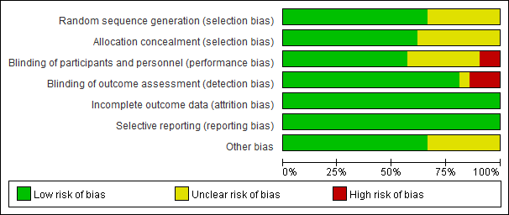
Fig S1. Risk of bias graph: review authors' judgments about each risk of bias item presented as percentages across all included studies.
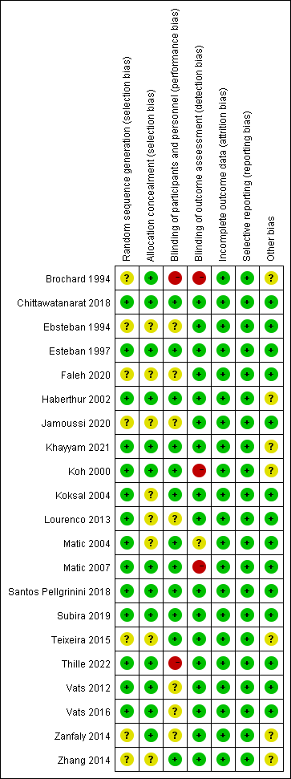
Fig S2. Risk of bias summary: review authors' judgments about each risk of bias item for each included study.

Funnel plot for successful extubation rate

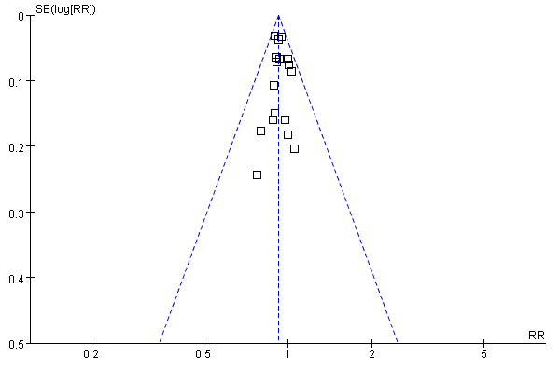
Fig.S3 Funnel plot for successful extubation rate

Forest plot for mechanical ventilation duration, ICU length of stay, hospital length of stay
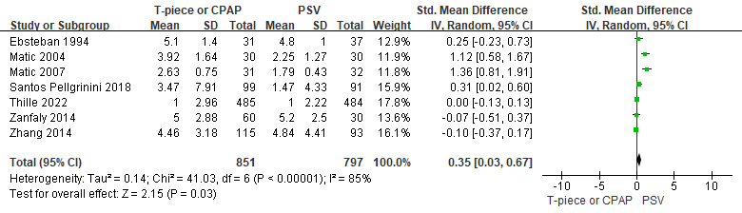
Fig. S4 Forest plot for mechanical ventilation duration

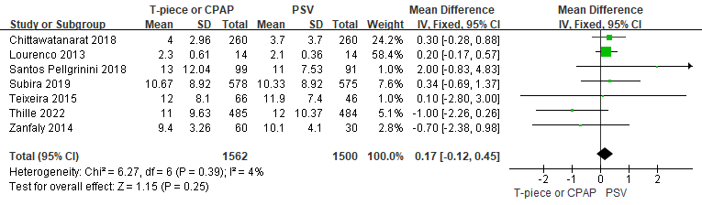
Fig. S5 Forest plot for ICU length of stay

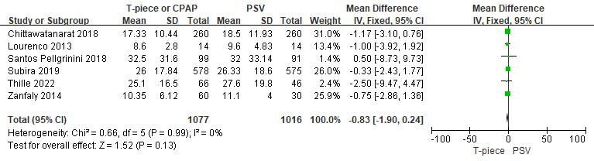
Fig. S6 Forest plot for hospital length of stay

Forest plot for subgroup of mechanical ventilation

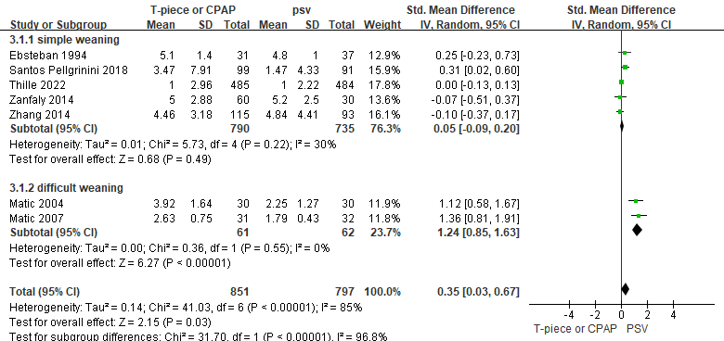
Fig. S7 Forest plot for subgroup of mechanical ventilation

Trial sequential analysis for successful rate of extubation
Trials
Name : (1997)Esteban
Effect measure : 0.9037534686724114
Standard Error : 0.06427720466601519
Weight : 84.8801652892562
Variance : 0.011781315417944598
Weight percentage : 9.61% (0.09608506232957482)
Name : (2000)Koh
Effect measure : 0.7792207792207793
Standard Error : 0.2435310232955122
Weight : 7.333333333333333
Variance : 0.13636363636363638
Weight percentage : 0.83% (0.008301395125888976)
Name : (2002)Haberthur
Effect measure : 1.0555555555555556
Standard Error : 0.20376571801031035
Weight : 9.0
Variance : 0.1111111111111111
Weight percentage : 1.02% (0.010188075836318288)
Name : (2004)Koksal
Effect measure : 0.9119571683521713
Standard Error : 0.06456358538188543
Weight : 13.556451612903226
Variance : 0.07376561570493753
Weight percentage : 1.53% (0.015346017455959716)
Name : (2004)Matic
Effect measure : 0.9090909090909091
Standard Error : 0.07124435118490152
Weight : 50.76923076923077
Variance : 0.0196969696969697
Weight percentage : 5.75% (0.057471197025385216)
Name : (2007)Matic
Effect measure : 0.9768740031897927
Standard Error : 0.1595305256303111
Weight : 18.441176470588236
Variance : 0.05422647527910686
Weight percentage : 2.09% (0.020875567154809045)
Name : (2012)Vats
Effect measure : 0.8823529411764706
Standard Error : 0.15965649400644924
Weight : 8.5
Variance : 0.11764705882352941
Weight percentage : 0.96% (0.009622071623189496)
Name : (2013)Lourenco
Effect measure : 1.0
Standard Error : 0.06780635036208103
Weight : 7.25
Variance : 0.13793103448275862
Weight percentage : 0.82% (0.00820706109036751)
Name : (2014)Zanfaly
Effect measure : 0.8
Standard Error : 0.1767766952966369
Weight : 13.333333333333334
Variance : 0.075
Weight percentage : 1.51% (0.015093445683434502)
Name : (2014)Zhang
Effect measure : 0.9331103678929766
Standard Error : 0.06695732660185795
Weight : 43.125
Variance : 0.02318840579710145
Weight percentage : 4.88% (0.04881786338235847)
Name : (2015)Teixeira
Effect measure : 1.0271132376395535
Standard Error : 0.0853363155082835
Weight : 22.392857142857142
Variance : 0.044657097288676235
Weight percentage : 2.53% (0.025348902973696696)
Name : (2016)Vats
Effect measure : 0.8947368421052632
Standard Error : 0.10702853992806366
Weight : 9.5
Variance : 0.10526315789473684
Weight percentage : 1.08% (0.010754080049447083)
Name : (2018)chittawatanarat
Effect measure : 0.9487179487179487
Standard Error : 0.03294997853870449
Weight : 117.0
Variance : 0.008547008547008548
Weight percentage : 13.24% (0.13244498587213777)
Name : (2018)Santos Pellgrinini
Effect measure : 1.009816474605207
Standard Error : 0.07625613924626165
Weight : 36.99473684210526
Variance : 0.027030872101294637
Weight percentage : 4.19% (0.041878353832445175)
Name : (2019)Subira
Effect measure : 0.9001660607036001
Standard Error : 0.03132697339326667
Weight : 237.1153512575889
Variance : 0.004217356635478467
Weight percentage : 26.84% (0.2684165756186183)
Name : (2020)Faleh
Effect measure : 1.0
Standard Error : 0.18257418583505536
Weight : 6.0
Variance : 0.16666666666666666
Weight percentage : 0.68% (0.006792050557545526)
Name : (2021)Khayyam
Effect measure : 0.8999999999999999
Standard Error : 0.14907119849998596
Weight : 10.0
Variance : 0.1
Weight percentage : 1.13% (0.011320084262575877)
Name : (2022)Thille
Effect measure : 0.9289317832858083
Standard Error : 0.03726588188471503
Weight : 188.19401444788443
Variance : 0.00531366527747313
Weight percentage : 21.3% (0.21303721012624738)
Boundaries
Name: conventional (Conventional)
Type: One-sided Lower
Type 1 Error: 0.5
Name: TSA (Alpha-spending)
Type: Two-sided
Type 1 Error: 0.5%
Alpha Spending: O'Brien-Fleming
Information Axis: Sample Size
IS Type: Estimate
Power: 80.0%
Effect Type Intervention: RRR User Defined (73.14%)
Heterogeneity Correction: Variance Based
Meta-analysis
Identifier : extubation
Group 1 Label : T-piece or CPAP
Group 2 Label : PSV
Outcome Type : Negative
Comment :
Effect Measure : Relative Risk
Effect Model : Fixed Effect Model
Zero Event handling : Constant (shared value: 1.0)
Zero-event Trials are included
Pooled Effect : 0.93 (C.I: 0.88 to 0.97)
based on conventional 99.5%
P-value : < 0.0001
Heterogeneity (Q) : 7.86
Heterogeneity (Q) P-value : 0.9694
Inconsistency (I?) : 0.0
Diversity (D?) : 0.0

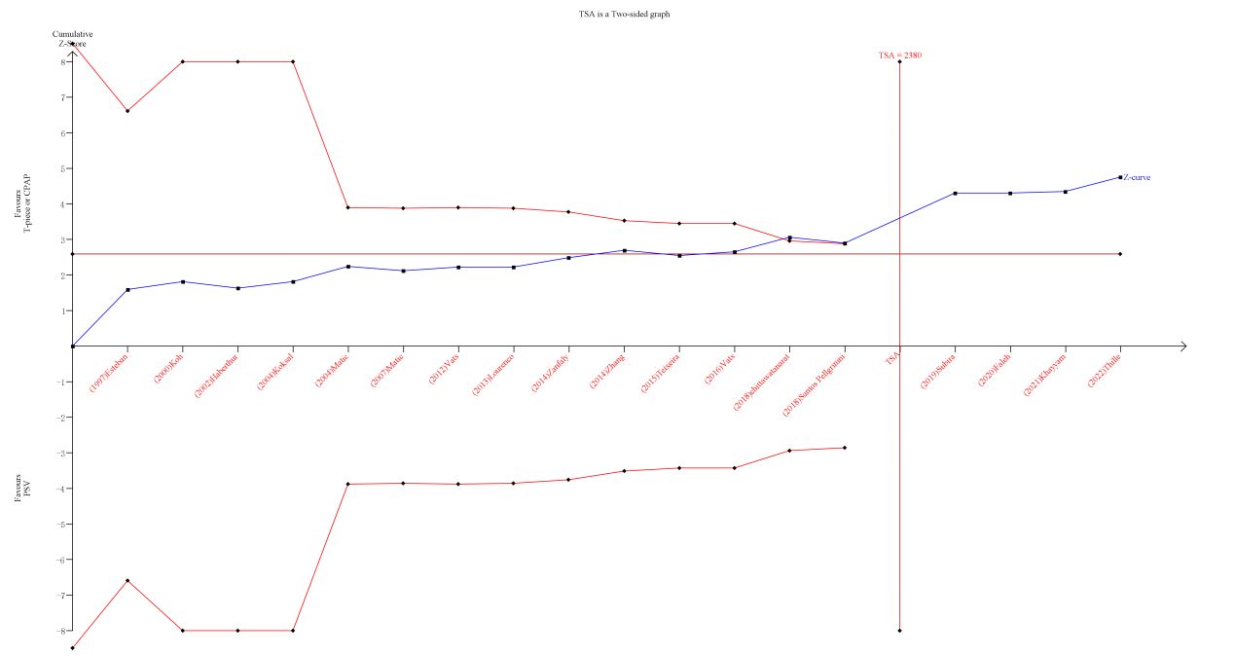
Fig. S8 TSA for successful rate of extubation

