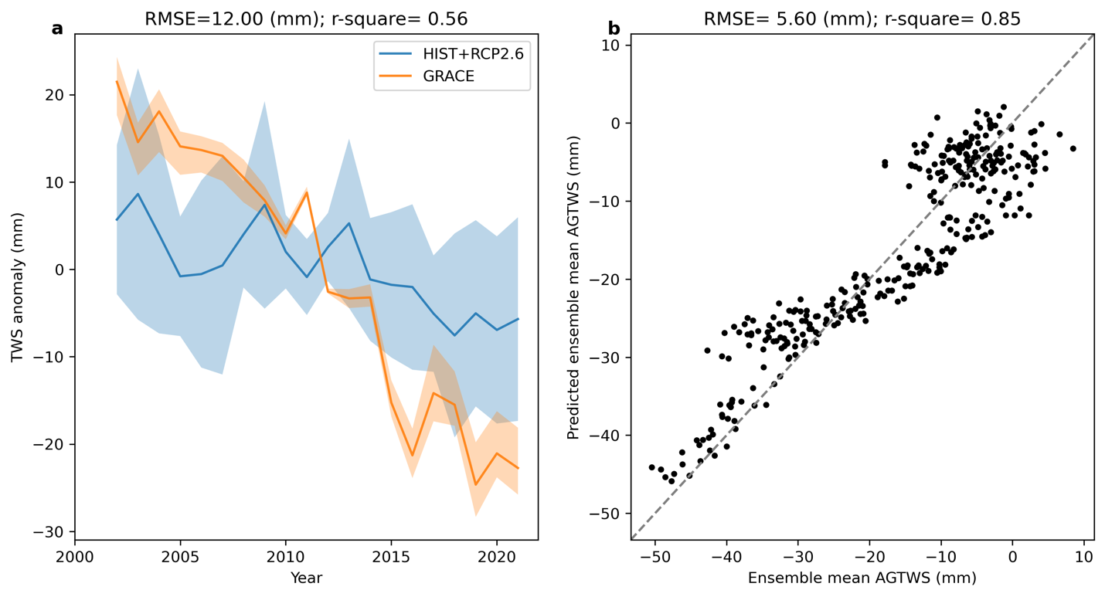
Extended Data Fig. 1 | Evaluation of performance of multi-model hydrological simulations and ridge regression models. (a), AGTWS anomalies (excluding Greenland and Antarctica) for the multi-model mean and GRACE observations. Blue shading indicates the spread among 27 ensemble members. Orange shading indicates the range among three GRACE mascon solutions. The simulations from HIST (2002–2005) were combined with the simulations from RCP2.6 (2006–2021) to cover the entire evaluation period. AGTWS anomalies are area-weighted based on monthly TWS anomalies from global grids relative to their respective 2002–2021 mean seasonal cycle. (b), evaluation of performance for AGTWS predicted from the daily pattern of surface air temperature and specific humidity. The predicted ensemble mean AGTWS anomalies were obtained by averaging seven sets of the predicted AGTWS anomalies. The comparison between multi-model means and GRACE AGTWS observations from 2002–2021 demonstrates that the multi-model means can reproduce the declining global trend in GRACE observations, but with a more gradual slope as also shown in previous studies (Scanlon et al., 2018). The performance metrics of the regularized linear regression models for each GHM/LSM’s output (corresponding to each fingerprint extracted) show that RMSEs vary conspicuously among models, ranging from 21.2 to 85.8 kg m−2 due to the relatively large discrepancy among GHMs/LSMs. The prediction error in the regression models is much lower than the prediction error measured separately for each model, with an RMSE of 5.60 kg m−2 (r2 = 0.85).

Extended Data Fig. 2 | Evaluation of performance for regional TWS predicted from the daily pattern of surface air temperature and specific humidity in Africa, Asia, Australia, Europe, North America, and South America. The predicted ensemble mean of regional TWS was obtained by averaging seven sets of the predicted anomalies of regional TWS.

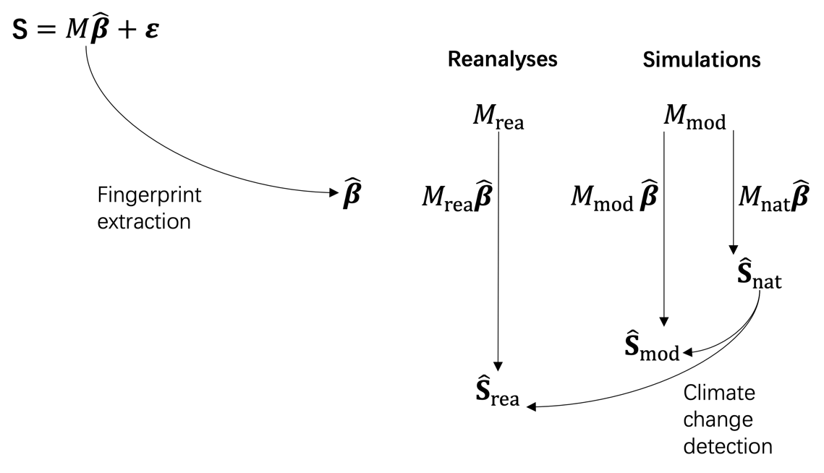
Extended Data Fig. 3 | Illustration of the detection of climate change signals in global terrestrial water storage at daily timescales

Extended Data Table 1 | Characteristics of the selected models | References | ⁸⁷ | ⁸⁸ |  | ⁸⁹ | ^{90,91} | ^{92,93} | ⁹⁴ | ^{95,96}
 | Snow scheme | Snow model | Energy balance |  | Degree day | Energy balance | Degree day | Degree day | Degree day
 | Vegetation dynamics | Yes | No |  | Yes | No | No | No | No
 | Reservoir operation | No | Yes |  | Yes | Yes | No | Yes | Yes
 | ET scheme | Monin-Obukhov  similarity theory | Bulk formulation |  | Priestley–Taylor | Bulk formulation | Penman-Monteith | Hamon formulation | Priestley–Taylor
 | Groundwater scheme | Explicit (single reservoir) | Explicit (renewable and non-renewable reservoirs) |  | Groundwater recharge and runoff calculated from seepage in soil | Explicit (single reservoir) | Implicit | Explicit (single reservoir) | Explicit (single reservoir)
 | Runoff scheme | Saturation excess, infiltration excess, groundwater discharge | Saturation excess, beta function, subsurface flow |  | Saturation excess | Saturation excess, infiltration excess | Improved Arno | Saturation excess, infiltration excess | Saturation excess, beta function
 | Model type | LSM | GHM |  | DGVM | LSM | GHM | GHM | GHM
 | Model | CLM4.5 | H08 |  | LPJML | MATSIRO | MPI-HM | PCR-GLOBWB | WATERGAP2
 | Model | CLM4.5 |  | H08 | LPJML | MATSIRO | MPI-HM | PCR-GLOBWB | WATERGAP2

Extended Data Table 2 | Description of simulation settings
Model | Meteorological forcing | Radiative forcing scenario | Socioeconomic scenario
CLM4.5 | GFDL-ESM2M, HadGEM2-ES, IPSL-CM5A-LR, MIROC5 | HIST, RCP2.6, RCP6.0 | 2005soc (HIST, RCP2.6, RCP6.0)
H08 | GFDL-ESM2M, HadGEM2-ES, IPSL-CM5A-LR, MIROC5 | HIST, RCP2.6, RCP6.0 | histsoc (HIST), 2005soc (RCP2.6, RCP6.0)
LPJML | GFDL-ESM2M, HadGEM2-ES, IPSL-CM5A-LR, MIROC5 | HIST, RCP2.6, RCP6.0 | histsoc (HIST), 2005soc (RCP2.6, RCP6.0)
MATSIRO | GFDL-ESM2M, HadGEM2-ES, IPSL-CM5A-LR, MIROC5 | HIST, RCP2.6, RCP6.0 | histsoc (HIST), 2005soc (RCP2.6, RCP6.0)
MPI-HM | GFDL-ESM2M, IPSL-CM5A-LR, MIROC5 | HIST, RCP2.6, RCP6.0 | histsoc (HIST), 2005soc (RCP2.6, RCP6.0)
PCR-GLOBWB | GFDL-ESM2M, HadGEM2-ES, IPSL-CM5A-LR, MIROC5 | HIST, RCP2.6, RCP6.0 | histsoc (HIST), 2005soc (RCP2.6, RCP6.0)
WATERGAP2 | GFDL-ESM2M, HadGEM2-ES, IPSL-CM5A-LR, MIROC5 | HIST, RCP2.6, RCP6.0 | histsoc (HIST), 2005soc (RCP2.6, RCP6.0)

Extended Data Figure 4 | The annual average temperature fingerprint trained for each model separately. The color map is reversed to match a general decreasing trend in AGMTWS corresponding to an increase in surface air temperature and a reduction in specific humidity (both are shown as red shadings). The values over the ocean are masked to focus on the AGMTWS responses over land to the external forcing.
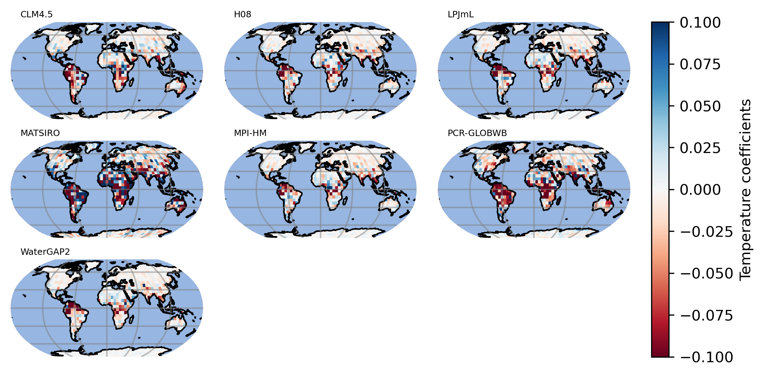

Extended Data Figure 4 | The annual average humidity fingerprint trained for each model separately. The color map is reversed to match a general decreasing trend in AGMTWS corresponding to an increase in surface air temperature and a reduction in specific humidity (both are shown as red shadings). The values over the ocean are masked to focus on the AGMTWS responses over land to the external forcing.
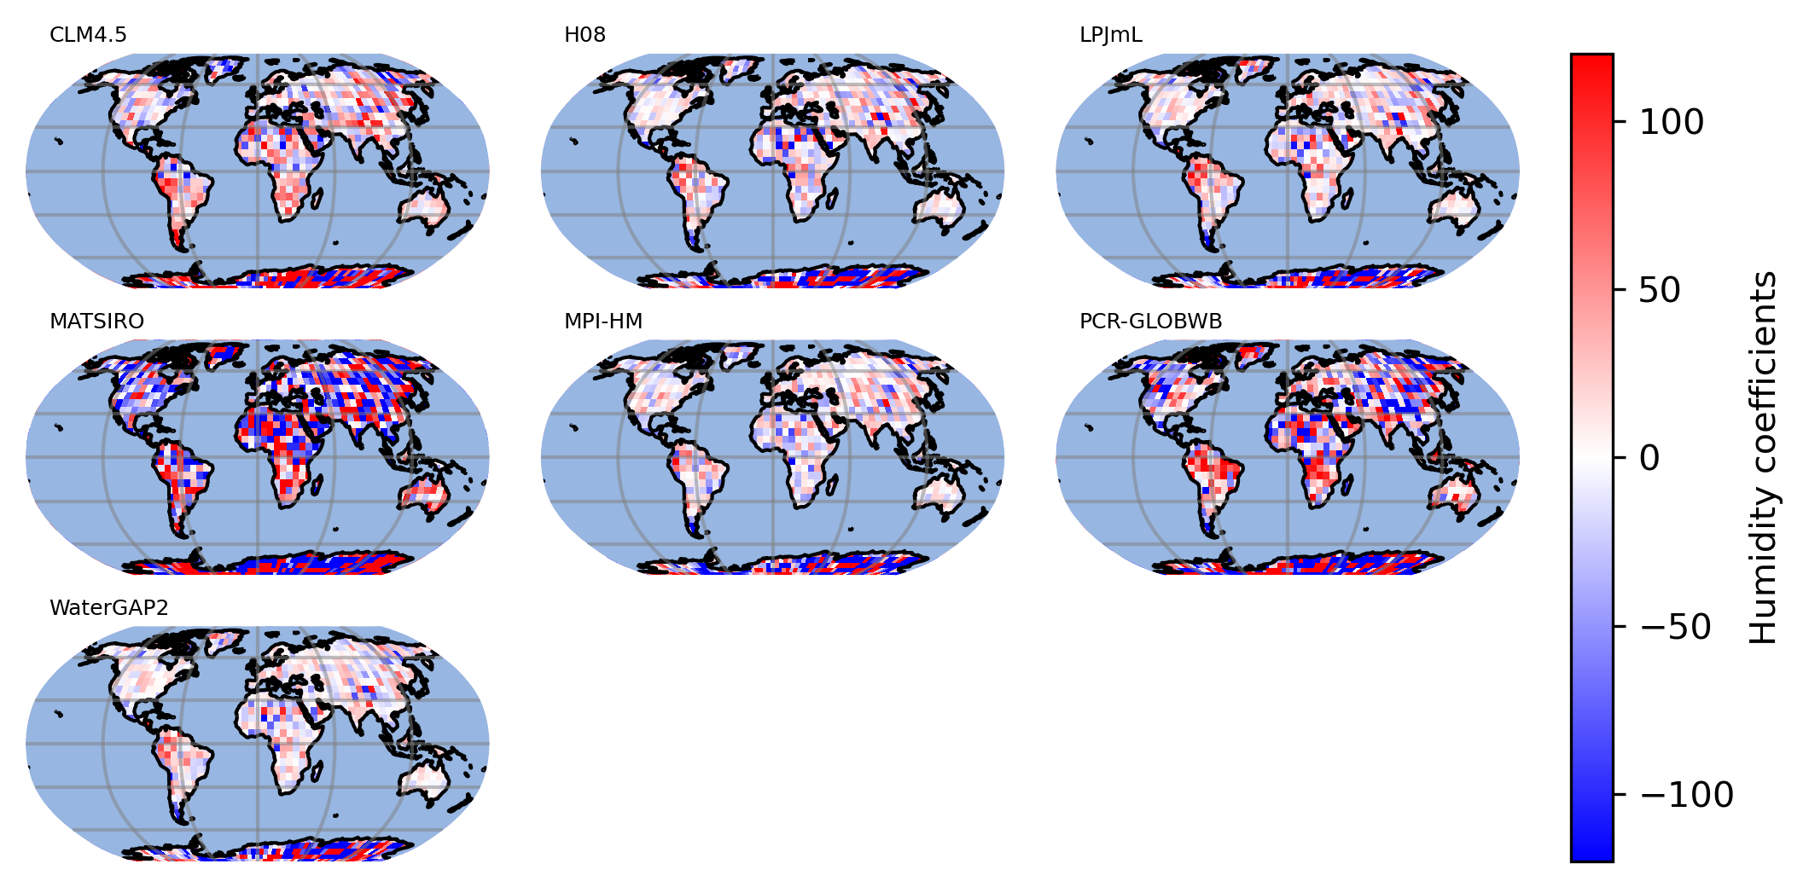

Extended Data Figure 5 | The multi-model mean temperature fingerprint at each month. Each model is trained separately.
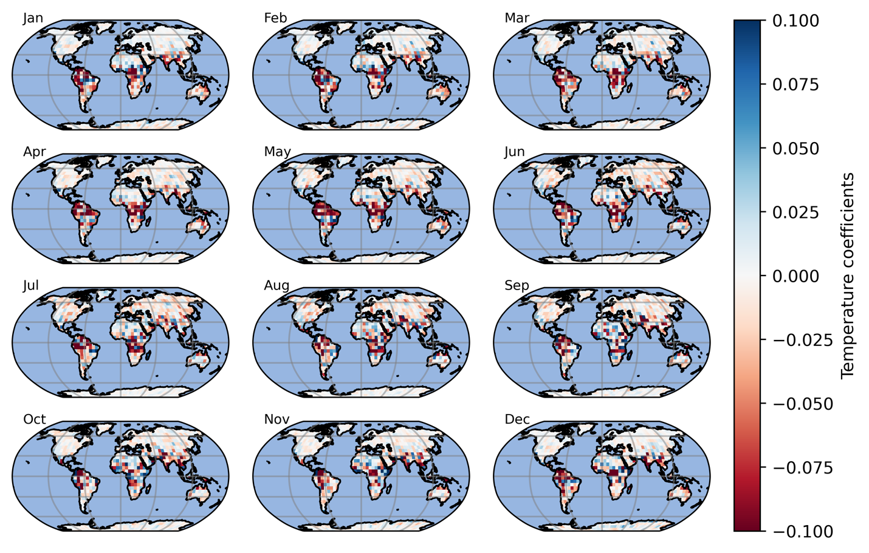

Extended Data Figure 6 | The multi-model mean humidity fingerprint at each month. Each model is trained separately.
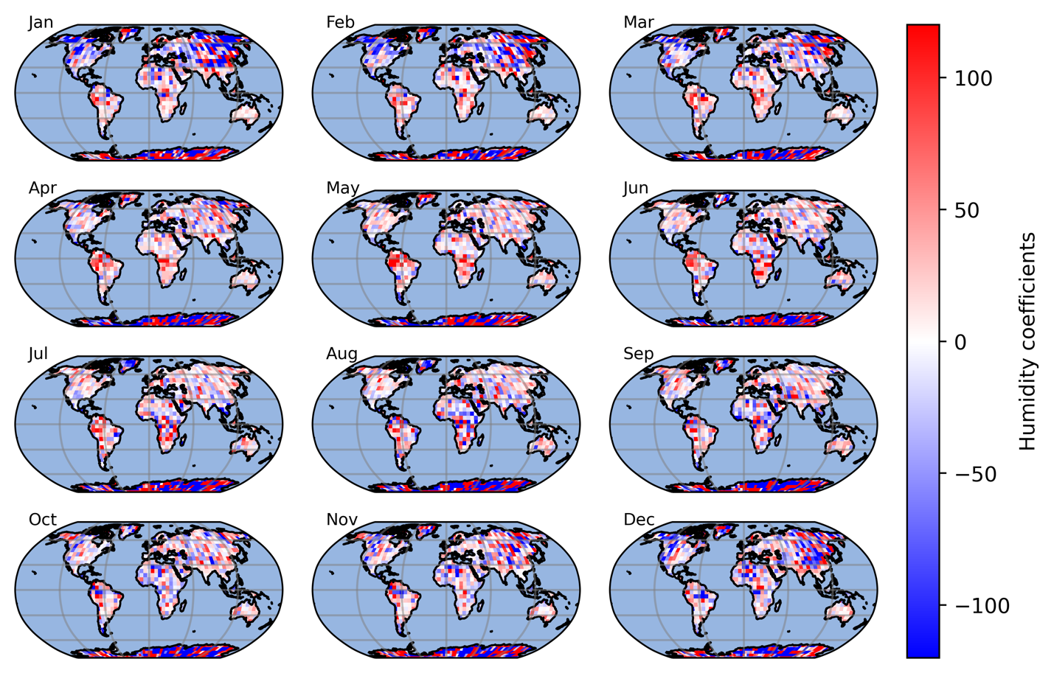

﻿
Extended Data Figure 7 | Seasonal variations of the temperature fingerprint for each model along latitudinal bands over land.
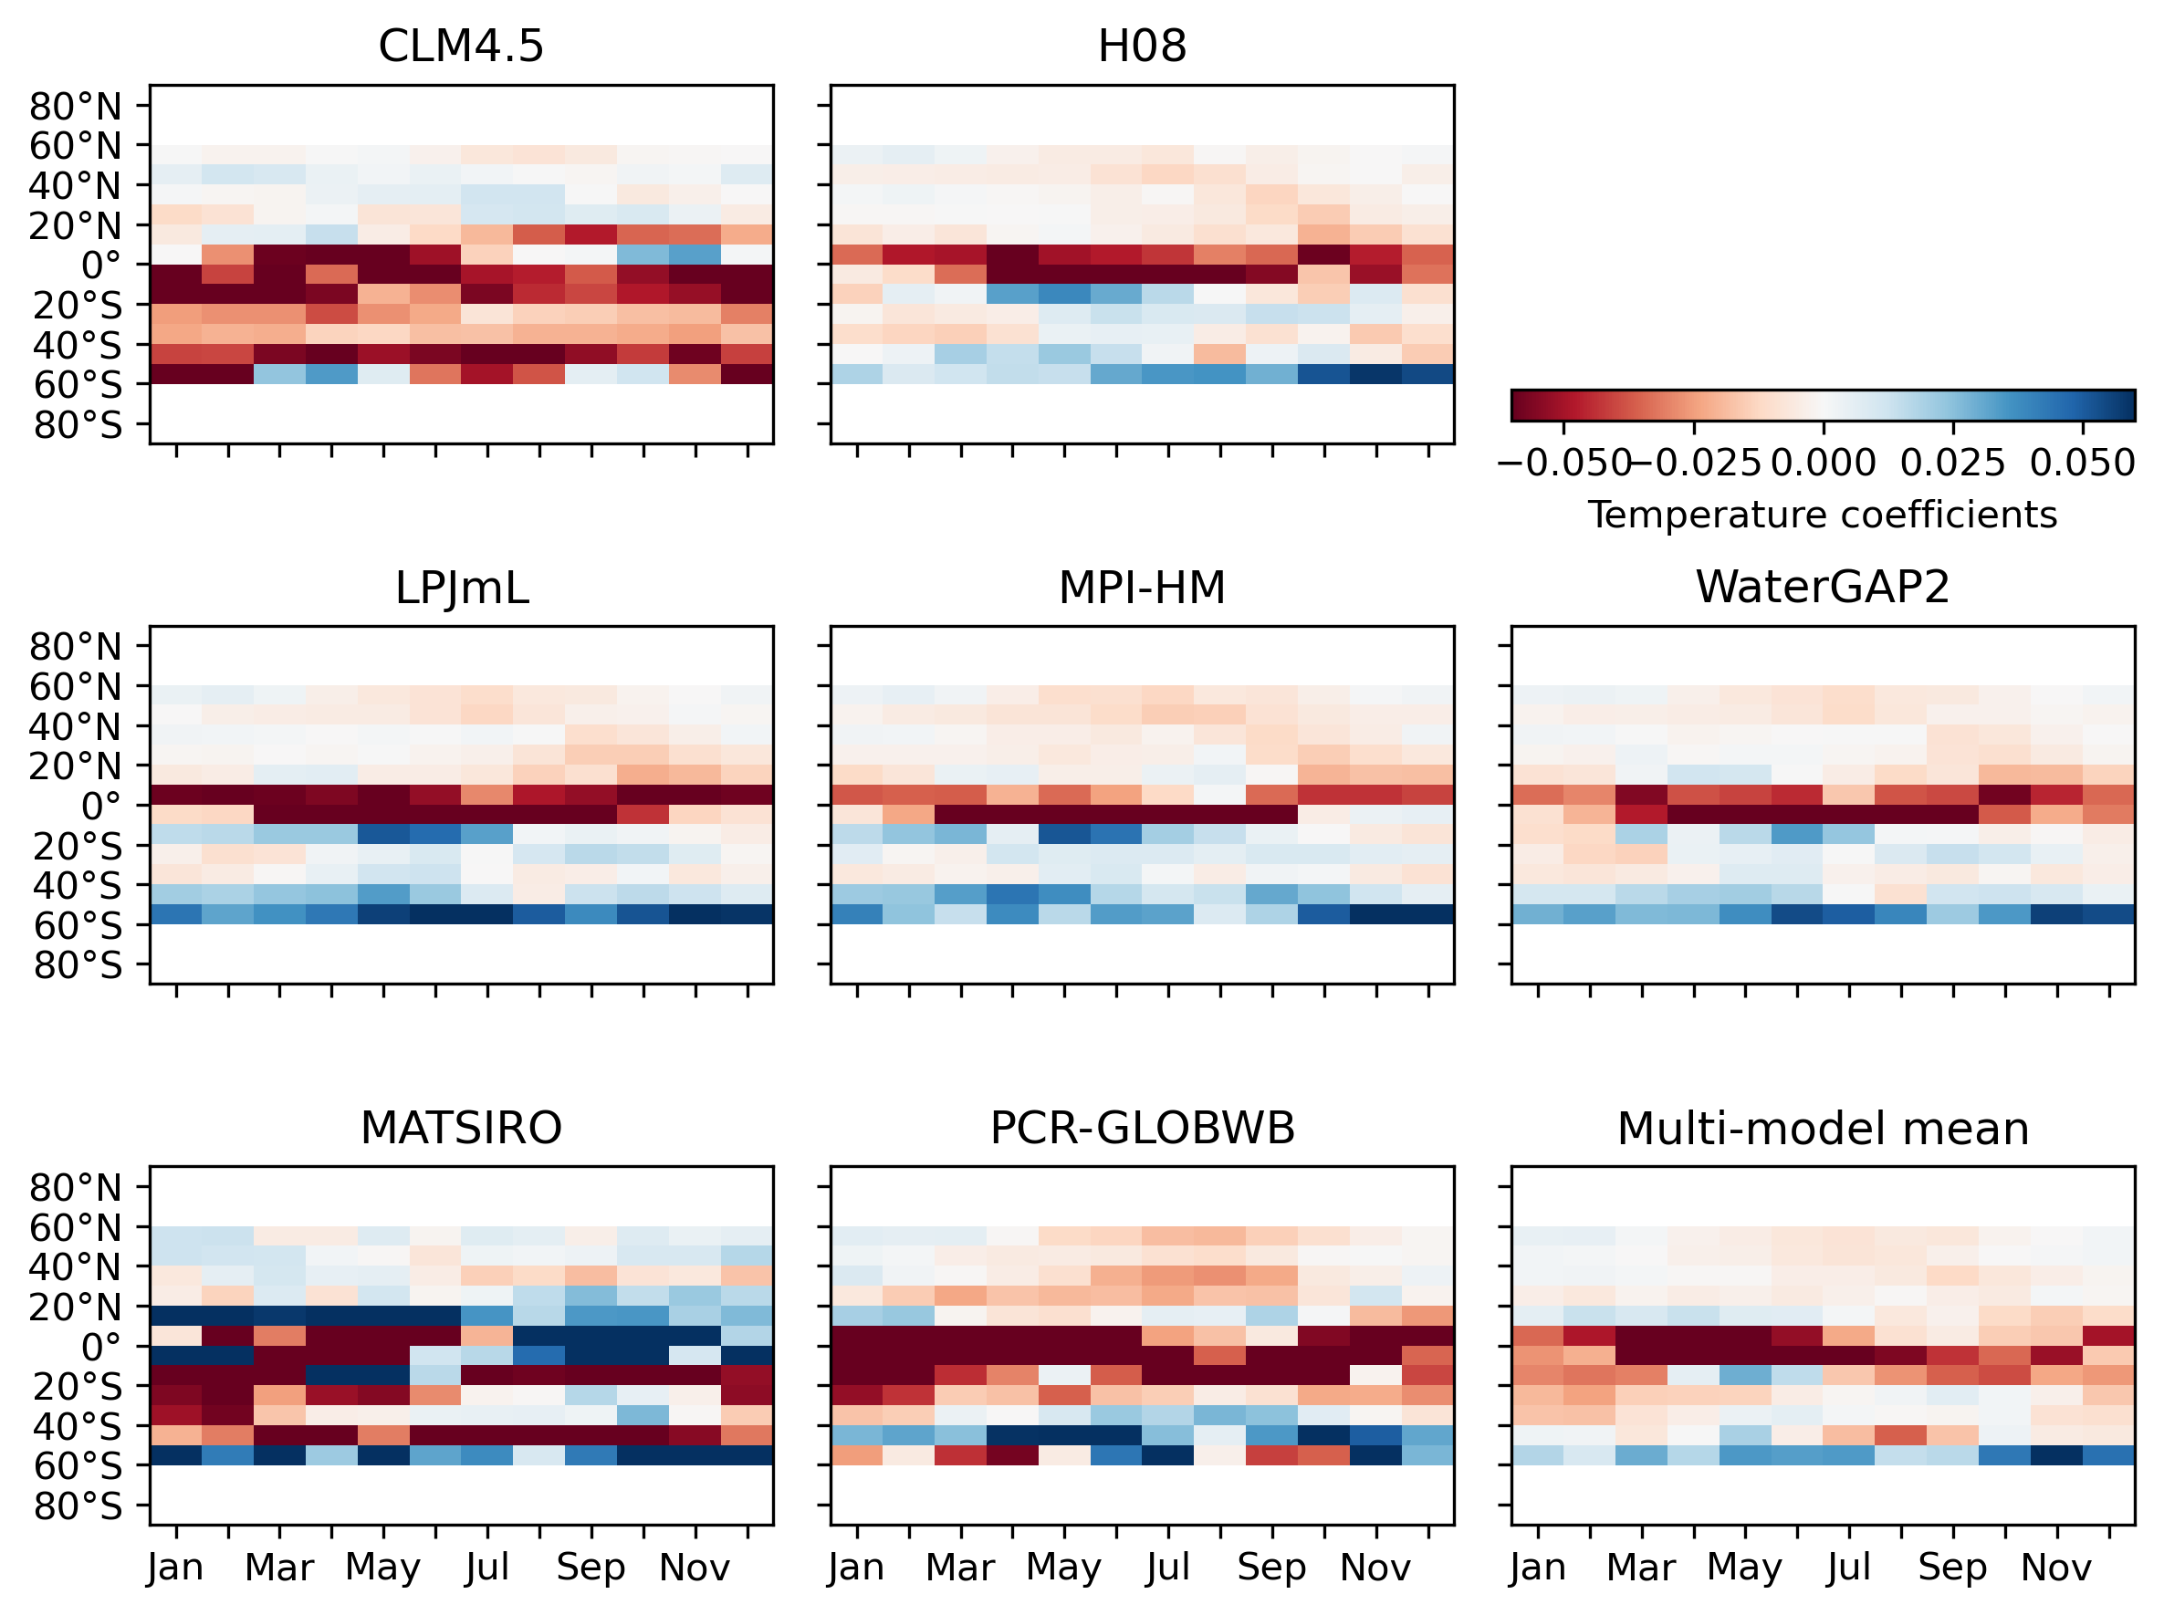

Extended Data Figure 8 | Seasonal variations of the humidity fingerprint for each model along latitudinal bands over land.
