Appendix I. Summary statistics for size (total length in cm) of silver carp and golden shiners that received an acute exposure to water from the Chicago Area Waterway (CAWS) relative to individuals that were exposed to laboratory (control) water. Standard deviation of the mean is shown by SD. Descriptions of the avoidance assay, activity assay and metabolic rate assay are provided in the main text.
Assay | Treatment | Sample Size | Mean | SD | Median | Minimum | Maximum
Silver Carp
Avoidance assay | CAWS | 8 | 12.0 | 1.3 | 11.4 | 10.6 | 14.0
Avoidance assay | Control | 8 | 12.6 | 0.6 | 12.7 | 11.9 | 13.5
Activity assay | CAWS | 9 | 11.8 | 0.7 | 12.0 | 10.5 | 12.5
Activity assay | Control | 9 | 12.3 | 1.0 | 12.5 | 11.0 | 14.0
Metabolic rate | CAWS | 12 | 12.3 | 1.0 | 12.5 | 10.5 | 14.0
 | Control | 12 | 12.2 | 0.8 | 12.0 | 11.0 | 13.5
Golden Shiner
Avoidance assay | CAWS | 8 | 9.7 | 0.4 | 9.8 | 9.2 | 10.5
Avoidance assay | Control | 8 | 9.5 | 0.4 | 9.5 | 8.9 | 10.0
Activity assay | CAWS | 9 | 9.7 | 0.7 | 9.5 | 8.5 | 10.5
Activity assay | Control | 9 | 9.3 | 0.4 | 9.5 | 8.5 | 10.0
Metabolic rate | CAWS | 12 | 9.2 | 0.5 | 9.1 | 8.5 | 10.4
 | Control | 11 | 9.0 | 0.3 | 9.0 | 8.5 | 9.5

Appendix II. Principal component (PC) analysis, factor loadings, and variance for correlated behaviors generated from the activity assay with silver carp and golden shiners.

 | Silver Carp | Golden Shiner
Metric | PC1 Loadings | PC1 Loadings
Total distance traveled (cm) | 0.995 | 0.993
Swimming velocity (cm/s) | 0.995 | 0.993
Total number of rotations | 0.981 | 0.969
Eigenvalue | 2.944 | 2.911
% Variance Explained | 98.1 | 97

Appendix III. Summary statistics for all behaviors, as well as metabolic rates, for silver carp acutely exposed to either water from the Chicago Area Waterway (CAWS) or laboratory water (control). Descriptions for each assay are given in the methods. Some fish did not shuttle in the avoidance assay section, and therefore received a value equal to the total duration of the trial (600 seconds).
Assay | Metric | Treatment | Sample Size | Mean | SD | Median | Minimum | Maximum
Avoidance assay | Did fish shuttle? (yes/no) | CAWS | 8 | - | - | - | - | -
Avoidance assay | Did fish shuttle? (yes/no) | Control | 8 | - | - | - | - | -
Avoidance assay | Count of number of shuttles | CAWS | 8 | 3.1 | 5.5 | 0.5 | 0 | 16.0
Avoidance assay | Count of number of shuttles | Control | 8 | 4.5 | 7.0 | 2.5 | 0 | 21.0
Avoidance assay | Latency to first shuttle (s) | CAWS | 8 | 443.6 | 243.3 | 594.0 | 23.0 | 600.0
Avoidance assay | Latency to first shuttle (s) | Control | 8 | 324.4 | 233.6 | 212.0 | 65.0 | 600.0
Avoidance assay | Time spent on receiving side (s) | CAWS | 8 | 498.4 | 155.1 | 594.0 | 184.0 | 600.0
Avoidance assay | Time spent on receiving side (s) | Control | 8 | 469.8 | 182.1 | 556.5 | 90.0 | 600.0
Activity assay | Total distance swam (cm) | CAWS | 9 | 2221.5 | 1003.5 | 2342.4 | 835.2 | 3715.3
Activity assay | Total distance swam (cm) | Control | 9 | 3140.1 | 2130.6 | 2192.0 | 492.9 | 5843.2
Activity assay | Swimming velocity (cm/s) | CAWS | 9 | 3.7 | 1.7 | 3.9 | 1.4 | 6.2
Activity assay | Swimming velocity (cm/s) | Control | 9 | 5.2 | 3.6 | 3.7 | 0.8 | 9.8
Activity assay | Time spent wall-hugging (s) | CAWS | 9 | 452.6 | 126.3 | 458.8 | 170.6 | 584.0
Activity assay | Time spent wall-hugging (s) | Control | 9 | 484 | 97.8 | 512.2 | 318.1 | 600.0
Activity assay | Number of rotations | CAWS | 9 | 29.1 | 13.2 | 31.0 | 9.0 | 50.0
Activity assay | Number of rotations | Control | 9 | 41.0 | 28.8 | 31.0 | 0 | 77.0
 | Turn angle (deg) | CAWS | 9 | 27.0 | 13.7 | 26.5 | 11.7 | 46.8
 | Turn angle (deg) | Control | 9 | 28.3 | 27.9 | 20.0 | 11.8 | 100.9
Metabolic rate | Standard metabolic rate (mgO₂/hr) | CAWS | 12 | 0.8 | 0.2 | 0.8 | 0.5 | 1.3
Metabolic rate | Standard metabolic rate (mgO₂/hr) | Control | 12 | 0.6 | 0.2 | 0.6 | 0.4 | 1.2

Appendix IV. Summary statistics for all behaviors, as well as metabolic rates, for golden shiners acutely exposed to either water from the Chicago Area Waterway (CAWS) or laboratory water (control). Descriptions for each assay are given in the methods. Some fish did not shuttle in the avoidance assay section, and therefore received a value equal to the total duration of the trial (600 seconds).
Assay | Metric | Treatment | Sample Size | Mean | SD | Median | Minimum | Maximum
Avoidance assay | Did fish shuttle? (yes/no) | CAWS | 8 | - | - | - | - | -
Avoidance assay | Did fish shuttle? (yes/no) | Control | 8 | - | - | - | - | -
Avoidance assay | Count of number of shuttles | CAWS | 8 | 7.8 | 16.1 | 1.5 | 0 | 47.0
Avoidance assay | Count of number of shuttles | Control | 8 | 1.9 | 4.2 | 0 | 0 | 12.0
Avoidance assay | Latency to first shuttle (s) | CAWS | 8 | 245.1 | 294.8 | 64.5 | 0.9 | 600.0
Avoidance assay | Latency to first shuttle (s) | Control | 8 | 436.9 | 244.5 | 600.0 | 56.0 | 600.0
Avoidance assay | Time spent on receiving side (s) | CAWS | 8 | 466.6 | 220.7 | 570.0 | 14.0 | 600.0
Avoidance assay | Time spent on receiving side (s) | Control | 8 | 505.6 | 171.6 | 600.0 | 129.0 | 600.0
Activity assay | Total distance swam (cm) | CAWS | 9 | 1400.8 | 921.4 | 1273.6 | 300.0 | 2898.4
Activity assay | Total distance swam (cm) | Control | 9 | 1452.8 | 835.6 | 1669.8 | 128.1 | 2281.5
Activity assay | Swimming velocity (cm/s) | CAWS | 9 | 2.3 | 1.5 | 2.1 | 0.50 | 4.8
Activity assay | Swimming velocity (cm/s) | Control | 9 | 2.4 | 1.4 | 2.8 | 0.2 | 3.8
Activity assay | Time spent wall-hugging (s) | CAWS | 9 | 442.2 | 131.7 | 483.7 | 158.0 | 594.3
Activity assay | Time spent wall-hugging (s) | Control | 9 | 368.9 | 204.7 | 412.2 | 8.9 | 589.1
Activity assay | Number of rotations | CAWS | 9 | 20.4 | 13.8 | 19.0 | 3.0 | 41.0
Activity assay | Number of rotations | Control | 9 | 19.3 | 11.9 | 26.0 | 0 | 30.0
 | Turn angle (deg) | CAWS | 9 | 9.7 | 9.8 | 4.7 | 2.2 | 30.0
 | Turn angle (deg) | Control | 9 | 32.6 | 23.1 | 32.1 | 3.8 | 63.3
Metabolic rate | Standard metabolic rate (mgO₂/hr) | CAWS | 12 | 0.4 | 0.1 | 0.4 | 0.3 | 0.5
Metabolic rate | Standard metabolic rate (mgO₂/hr) | Control | 11 | 0.3 | 0.1 | 0.3 | 0.1 | 0.5

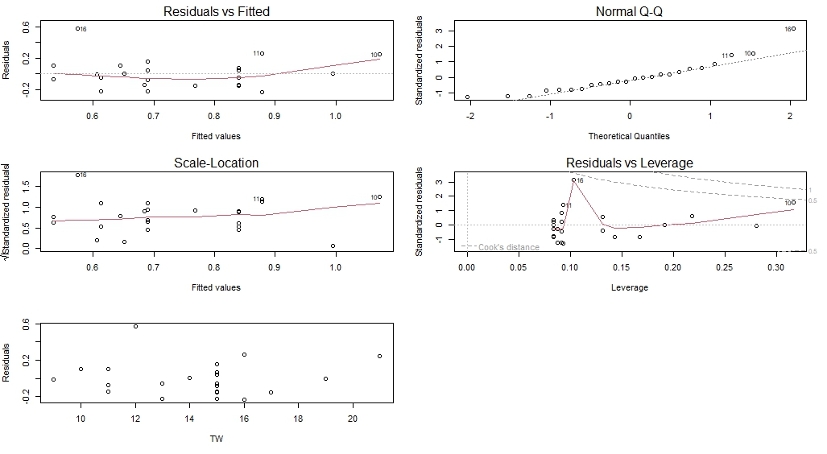
Appendix V. Residual plots for models relating standard metabolic rate (SMR) of silver carp held overnight in either in control (laboratory) water or in water collected from the Chicago Area Waterway. Plots a, b, c, and d are residual plots from the untransformed metabolic rate data, using the model SMR ~ treatment + mass, while Plot e shows the residuals from a model of metabolic rate vs. fish mass (non-transformed). Plots f, g, h, and i are residual plots from the log-log transformed metabolic rate data, using the model log(SMR) ~ treatment + log(mass) while Plot j shows the residuals from a model of log metabolic rate vs. log fish mass. Plots a-d and f-i were created using the ‘car’ package in R.
f.
g.
h.
i.
j.
a.
b.
c.
d.
e.
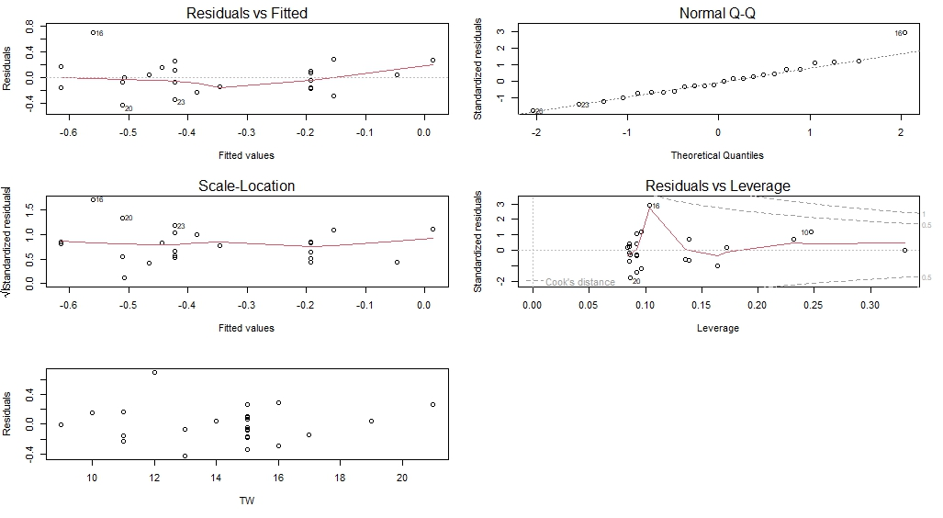
Appendix VI. Residual plots for models relating standard metabolic rate (SMR) of golden shiners held overnight in either in control (laboratory) water or in water collected from the Chicago Area Waterway. Plots a, b, c, and d are residual plots from the untransformed metabolic rate data, using the model SMR ~ treatment + mass, while Plot e shows the residuals from a model of metabolic rate vs. fish mass (non-transformed). Plots f, g, h, and i are residual plots from the log-log transformed metabolic rate data, using the model log(SMR) ~ treatment + log(mass) while Plot j shows the residuals from a model of log metabolic rate vs. log fish mass. Plots a-d and f-i were created using the ‘car’ package in R.
a.
b.
c.
d.
e.
g.
f.
h.
i.
j.
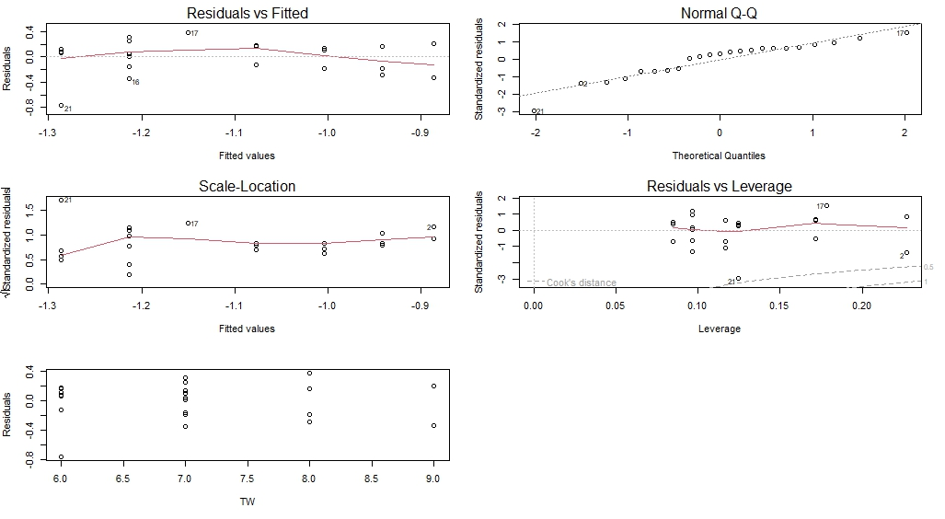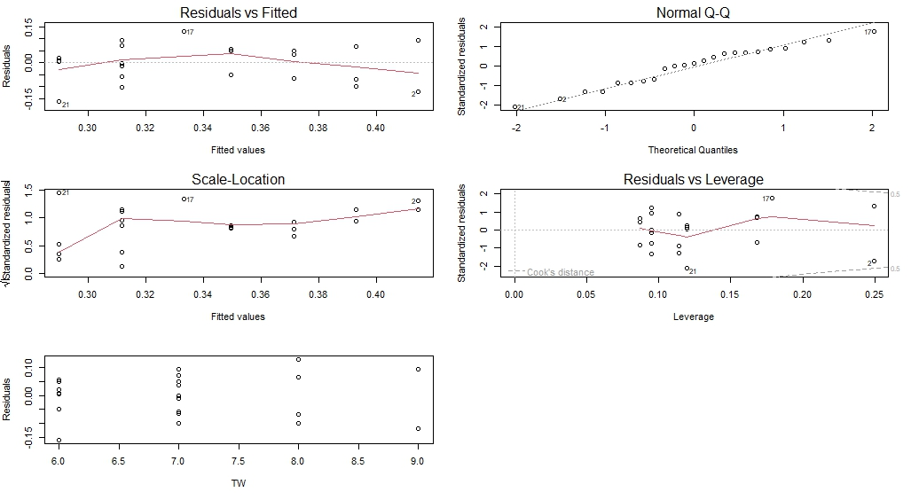
Appendix VII. Summary statistics for water quality metrics of silver carp that received an acute exposure to water from the Chicago Area Waterway (CAWS) relative to individuals that were exposed to laboratory (control) water for all experiments in this study. Standard deviation of the mean is shown by SD.
Assay | Metric | Treatment | Sample Size | Mean | SD | Median | Minimum | Maximum
Avoidance assay | Temperature (°C) | CAWS | 8 | 11.1 | 0.8 | 11.1 | 10.3 | 12.6
Avoidance assay | Temperature (°C) | Control | 8 | 11.0 | 0.5 | 11.0 | 10.3 | 12.0
Avoidance assay | pH | CAWS | 8 | 8.0 | 0.2 | 8.0 | 7.5 | 8.3
Avoidance assay | pH | Control | 8 | 8.1 | 0.1 | 8.0 | 8.0 | 8.3
Avoidance assay | Dissolved O₂ | CAWS | 8 | 10.0 | 0.4 | 9.9 | 7.5 | 10.7
Avoidance assay | Dissolved O₂ | Control | 8 | 10.1 | 0.4 | 10.0 | 8.0 | 10.8
Activity assay | Temperature (°C) | CAWS | 9 | 10.5 | 0.1 | 10.5 | 10.3 | 10.7
Activity assay | Temperature (°C) | Control | 9 | 10.2 | 0.9 | 9.9 | 9.8 | 12.6
Activity assay | pH | CAWS | 9 | 8.0 | 0.1 | 8.0 | 7.8 | 8.2
Activity assay | pH | Control | 9 | 7.9 | 0.1 | 7.9 | 7.7 | 8.1
Activity assay | Dissolved O₂ | CAWS | 9 | 10.1 | 0.3 | 10.2 | 9.6 | 10.4
Activity assay | Dissolved O₂ | Control | 9 | 8.7 | 1.2 | 9.1 | 5.8 | 9.7
Metabolic rate | Temperature (°C) | CAWS | 12 | 10.7 | 0.4 | 10.8 | 9.8 | 11.4
Metabolic rate | Temperature (°C) | Control | 12 | 10.9 | 0.2 | 10.9 | 10.4 | 11.2
Appendix VIII. Summary statistics for water quality metrics of golden shiners that received an acute exposure to water from the Chicago Area Waterway (CAWS) relative to individuals that were exposed to laboratory (control) water for all experiments in this study. Standard deviation of the mean is shown by SD.
Assay | Metric | Treatment | Sample Size | Mean | SD | Median | Minimum | Maximum
Avoidance assay | Temperature (°C) | CAWS | 8 | 11.3 | 0.6 | 11.2 | 10.7 | 12.6
Avoidance assay | Temperature (°C) | Control | 8 | 11.0 | 0.5 | 11.1 | 10.0 | 11.5
Avoidance assay | pH | CAWS | 8 | 8.0 | 0.3 | 8.0 | 7.4 | 8.3
Avoidance assay | pH | Control | 8 | 8.1 | 0.3 | 8.0 | 7.7 | 8.6
Avoidance assay | Latency to first shuttle (s) | CAWS | 8 | 10.1 | 0.4 | 10.2 | 9.5 | 10.7
Avoidance assay | Latency to first shuttle (s) | Control | 8 | 10.2 | 0.7 | 10.1 | 9.2 | 11.0
Activity assay | Temperature (°C) | CAWS | 9 | 10.6 | 0.1 | 10.5 | 10.4 | 10.9
Activity assay | Temperature (°C) | Control | 9 | 10.2 | 0.5 | 10 | 9.8 | 11.4
Activity assay | pH | CAWS | 9 | 8.0 | 0.1 | 8.0 | 7.9 | 8.1
Activity assay | pH | Control | 9 | 8.0 | 0.3 | 7.8 | 7.1 | 7.9
Activity assay | Dissolved O₂ | CAWS | 9 | 9.8 | 0.3 | 9.8 | 9.1 | 10.2
Activity assay | Dissolved O₂ | Control | 9 | 8.5 | 1.3 | 8.7 | 5.4 | 9.6
Metabolic rate | Temperature (°C) | CAWS | 12 | 10.5 | 0.4 | 10.5 | 9.5 | 11.0
Metabolic rate | Temperature (°C) | Control | 11 | 11.3 | 0.4 | 11.4 | 10.2 | 12.1

