Table 7 Molecular docking simulation results.
Gene  Symbol | Receptor  (PDB ID) | Co-Crystallized  Compound Name | Co-Crystallized  Compound Structure | Co-Crystallized  docking energy  (kcal/mol) | API docking energy  (kcal/mol)
TNF | 2az5 | 6,7-DIMETHYL-3-[(METHYL{2-[METHYL({1-[3-(TRIFLUOROMETHYL)PHENYL]-1H-INDOL-3-YL}METHYL)AMINO]ETHYL}AMINO)METHYL]-4H-CHROMEN-4-ONE | 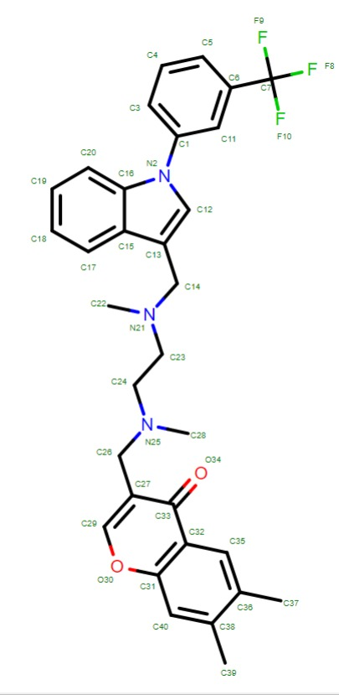 | -8.7 | -6.09
MMP9 | 5chu | (4S)-3-{[4-(4-cyano-2-methylphenyl)piperazin-1-yl]sulfonyl}-N-hydroxy-1,3-thiazolidine-4-carboxamide | 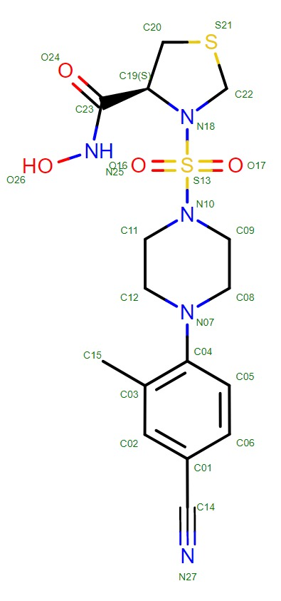 | -11.52 | -9.24
INS | 1uz9 | M-CRESOL | 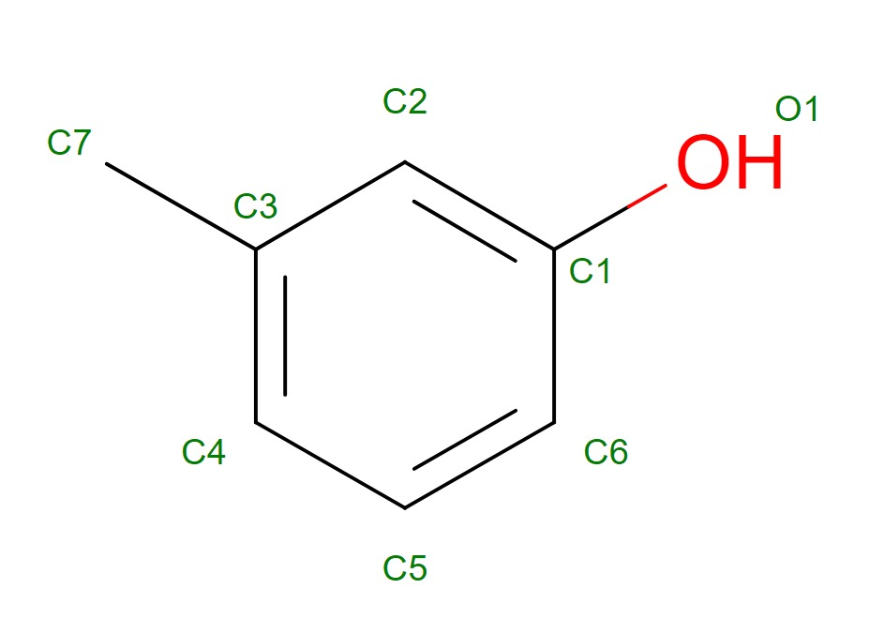 | -4.35 | -6.2
JUN | 5t01 | - | - | - | -4.88
ACTB | 6ict | S-ADENOSYL-L-HOMOCYSTEINE | 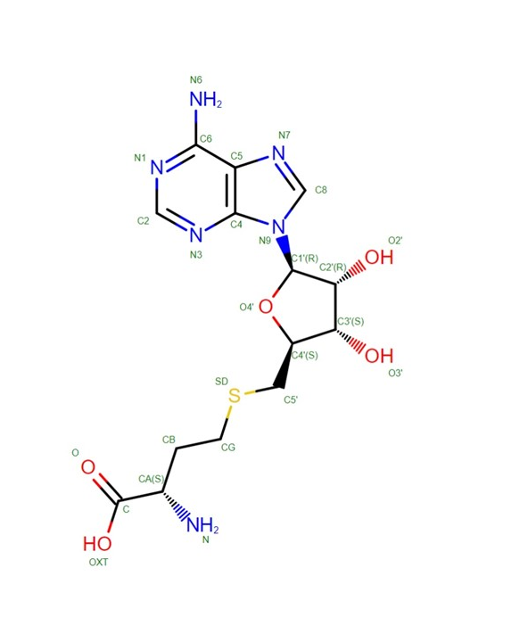 | -3.62 | -6.46

