Biogeography of high-latitude macroalgal flora: Greenland macroalgal diversity in a North Atlantic and macroecological perspective

Susse Wegeberg

supplementary material

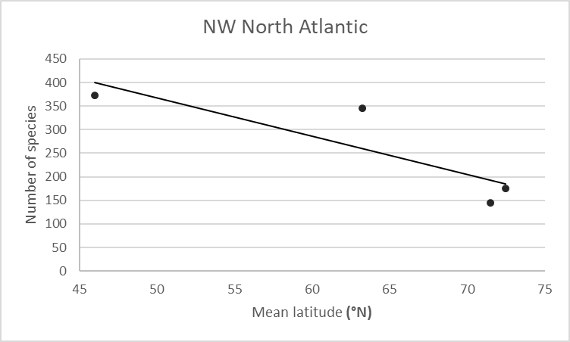 | 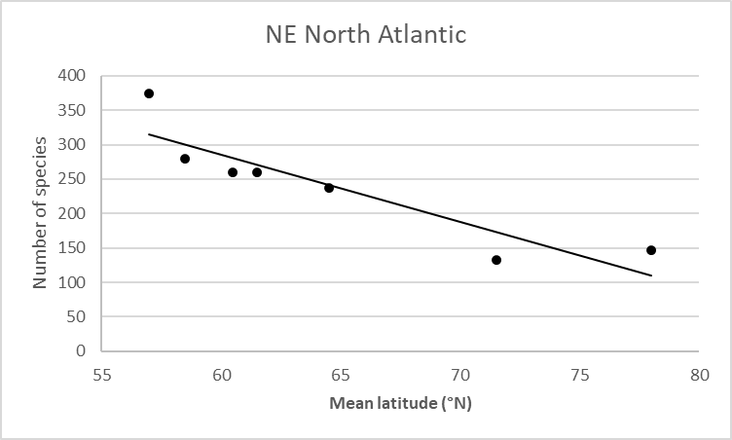
Figure S1. Linear regression for the macroalgal species number correlated to latitude in the north-western North Atlantic. R² =0.737, α=-8.1456, n=4. | Figure S2. Linear regression for the macroalgal species number correlated to latitude in the north-eastern North Atlantic. R² =0.8146, α=-9.7690, n=7.

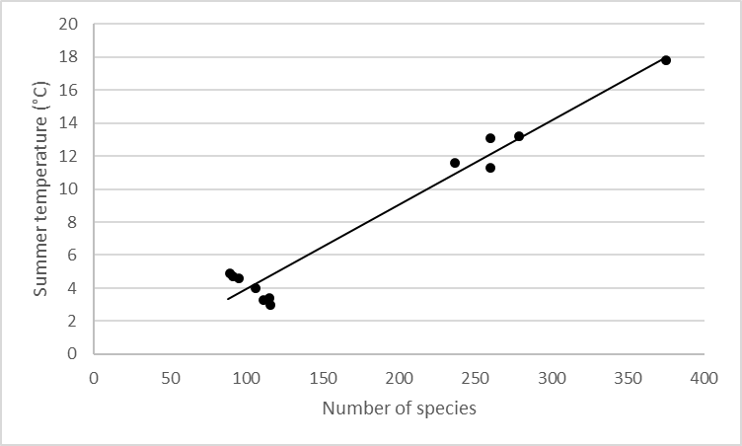
Figure S3. Number of macroalgal species correlated to highest sea surface summer temperatures along the north-eastern NA latitudinal gradient (57-72°N). R² = 0.9548, n = 18.

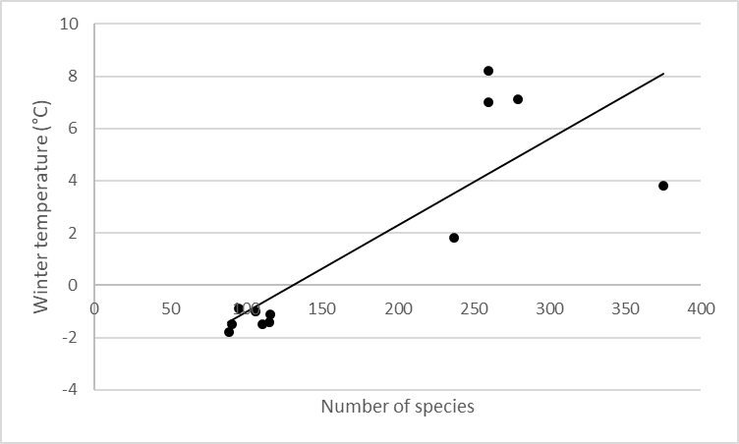
Figure S4. Number of macroalgal species correlated to lowest sea surface winter temperatures along the north-eastern NA latitudinal gradient (57-72°N). R² = 0.6957, n = 12.

Table S1. List of publications / data on the distribution of macroalgal species on the east and west coast of Greenland on which the distribution tables are based. For a more exhaustive list of publications containing macroalgal floristic data, see Krause-Jensen et al. 2020, supplementary information, Table S1. *Compilation of data from Rosenvinge (1893, 1898, 1910), Lund (1951, 1959), and Wilce 1964, as well as his own data from the Cape Farewell area.
 | Location | Coordinates (°N)
East Greenland
Pedersen 1976* | East coast
Rosenvinge 1933 | Kangerlussuak | 68
Andersen et al. 2006 | Mestersvig | 72
Borum et al. 2002 | Young Sound | 74
West Greenland
Pedersen 1976* | West coast
Lund 1938 | Nuuk | 64
Hansen & Schlütter 1992 | Disko, SW | 69
Andersen et al. 2005 | North Star Bay | 76
Registrations by taxonomic experts
Dr Poul Møller Pedersen, Copenhagen University, Denmark | Qaqqortoq area (2006) (Nordic Seaweed Project) | 60
Dr Aase Kristiansen, Copenhagen University, Denmark | Ikka Fjord (1995) | 61
Dr Poul Møller Pedersen, Copenhagen University, Denmark | Disko Bay area (2009) (Hjort et al. 2013) | 68-70

Table S2. Distribution of macroalgal species along a latitudinal gradient of the Greenland west coast. The species distributions are based on Pedersen latitudinal intervals given by Pedersen (1976). Smaller and/or isolatede registrations are supplementary data from other studies (Table S1).
Latitude (°N) WEST | 60 | 61 | 62 | 63 | 64 | 65 | 66 | 67 | 68 | 69 | 70 | 71 | 72 | 73 | 74 | 75 | 76 | 77 | 78 | 79 | 80 | 81 | 82 | 83
Rhodophyta
Grania efflorescens
Scagelothamnion pusillum
Bangia fuscopurpurea
Ptilota serrata
Neodilsea integra
Clathromorphum compactum
Coccotylus truncatus
Devaleraea ramentacea
Fimbrifolium dichotomum
Hildenbrandia rubra
Meiodiscus spetbergense
Palmaria palmata
Pantoneura fabriciana
Phycodrys rubens
Savoiea arctica
Rhodochorton purpureum
Rhodomela lycopodioides
Turnerella pennyi
Wildemania miniata
Acrochaetium secundatum
Phymatolithon foecundum
Acrochaetium microscopicum
Phymatolithon tenue
Peyssonellia rosenvingii
Lithothamnion tophiforme |  |  |  |  |  |  |  |  |  |  |  |  |  | ×
Polysiphonia stricta |  |  |  |  |  |  |  |  |  |  |  |  |  | ×
Rhodophysema lundii |  |  |  |  |  |  |  |  |  |  |  |  |  | ×
Euthora cristata |  |  |  |  |  |  |  |  |  |  |  |  |  | ×
Lithothamnion glaciale |  |  |  |  |  |  |  |  |  |  |  |  |  | ×
Vertebrata fucoides
Rubrointrusa membranacea
Heterodoxia denticulata
Ceramium virgatum
Carradoriella elongata
Porphyra umbilicalis
Pyropia thulaea
Porphyra njordii
Rhodophysema elegans
Boreophyllum birdiae
Corallina officinalis
Coccotylus hartzii
Callocolax neglectus
Halosacciocolax kjellmanii
Leptosiphonia fibrillosa
Porphyra purpurea

Phaeophyceae
Saccharina longicruris
Desmarestia aculeata
Laminaria solidungula
Platysiphon verticillatus
Agarum clathratum
Chaetopteris plumosa
Desmarestia viridis
Dictyosiphon foeniculaceus
Fucus distichus
Hedophyllum nigripes
Pylaiella littoralis
Stictyosiphon tortilis
Symphyocarpus strangulans
Pylaiella varia
Hincksia ovata
Alaria esculenta
Battersia arctica
Chordaria flagelliformis
Delamarea attenuata
Elachista fucicola
Petroderma maculiforme
Punctaria sp.
Chordaria chordaeformis
Ectocarpus fasciculatus
Dictyosiphon chordaria
Halosiphon tomentosus
Chorda filum
Ectocarpus siliculosus
Fucus vesiculosus
Leptonematella fasciculata
Eudesme virescens
Scytosiphon lomentaria
Punctaria plantaginea
Ascophyllum nodosum
Sorapion kjellmanii
Planosiphon zosterifolius
Saundersella simplex
Planosiphon complanatus
Coelocladia arctica
Phaeostroma pustulosum
Papenfussiella callitricha
Coilodesme bulligera
Laminariocolax tomentosoides
Petalonia fascia
Pogotrichum filiforme
Saccharina latissima
Saccorhiza dermatodea
Microspongium alariae
Phaeostroma longisetum
Climacosorus mediterraneus
Microspongium globosum
Protohalopteris radicans
Haplospora globosa
Porterinema fluviatile
Laminariocolax aecidioides
Stragularia clavata
Isthmoplea sphaerophora
Ralfsia fungiformis
Sphacelorbus nanus
Ralfsia ovata
Omphallophyllum ulvaceum
Pseudoralfsia verrucosa
Myriactula clandestina
Chlorophyta
Ulvaria splendens
Acrosiphonia arcta
Acrosiphonia sonderi
Ulva prolifera
Urospora penicilliformis
Blidingia minima
Chaetomorpha melagonium
Ulothrix flacca
Ulothrix subflaccida
Gomontia polyrhiza
Ostreobium queqetti
Rhizoclonium riparium
Chaetomorpha tortuosa
Oclochaete hystrix
Chlorochytrium dermatocolax
Cladophora rupestris
Monostroma grevillei
Ulva fenestrata
Ulva intestinalis
Spongomorpha aeruginosa
Bolbocoleon piliferum
Chlorochytrium cohnii
Kornmannia leptoderma
Pseudothrix groenlandica
Percursaria percursa
Ulothrix speciosa
Prasiola stipitata
Protomonostroma undulatum
Syncoryne reinkei
Urospora wormskioldii
Derbesia marina
Rosenvingiella polyrhiza
Capsosiphon fulvescens
Eugomontia sacculata
Prasiola meridionalis
Pseudendoclonium submarinum

Table S3. Distribution of macroalgal species along a latitudinal gradient of the Greenland east coast. The species distributions are based on latitudinal intervals given by Pedersen (1976). Smaller and/or isolatede registrations are supplementary data from other studies (Table S1).
Latitude (°N) EAST | 60 | 61 | 62 | 63 | 64 | 65 | 66 | 67 | 68 | 69 | 70 | 71 | 72 | 73 | 74 | 75 | 76 | 77 | 78 | 79 | 80 | 81 | 82
Rhodophyta
Grania efflorescens
Ceratocolax hartzii
Coccotylus truncatus
Savoiea arctica
Rhodomela lycopodioides
Callocolax neglectus
Rhodophycemopsis hyperborea
Lithothmanion glaciale
Lithothamnion tophiforme
Rhodophysema elegans
Phymatolithoh foecundum
Phymatolithoh tenue
Haemescharia polygyna
Clathromorphum compactum
Rhodocorton purpureum
Meiodiscus spetbergense
Turnerella pennyi
Scagelothamnion pusilla
Phycodrys rubens
Devalerea ramentacea
Ptilota serrata
Pantoneura fabriciana
Neodilsea integra
Harveyella mirabilis
Peyssonellia rosenvingii
Rubrointrusa membranacea
Colaconema hallandicum
Acrochaetium microscopicum
Hildenbrandia rubra
Ahnfeltia plicata
Euthora cristata
Halosacciocolax kjellmanii
Polysiphonia stricta
Fimbrifolium dichotomum
Palmaria palmata
Wildemania miniata
Phaeophyceae
Trachynema groenlandicum
Arcticophycus glacialis
Desmarestia viridis
Halosiphon tomentosus
Desmarestia aculeata
Elachista fusicola
Hincksia ovata
Leptonematella fasciculata
Battersia arctica
Chaetopteris plumosa
Stictyosiphon tortilis
Saccharina latissima
Pylaiella littoralis
Pleurocladia lacustris
Myrionema foecundum
Pseudolithoderma extensum
Symphyocarpus strangulans
Omphallophyllum ulvaceum
Sorapion kjellmanii
Laminaria solidungula
Fucus distichus
Alaria pylaii
Laminaria digitata
Pseudolithoderma rosenvingii
Dictyosiphon foeniculaceus
Herponema desmarestiae
Dermatocelis laminariae
Botrytella micromora
Trachynema mortensenii
Phaeostroma longisetum
Hecatonema terminale
Laminariocolax tomentosoides
Pogotrichum filiforme
Microspongium globosum
Coelocladia arctica
Haplospora globosa
Lamariocolax aecidioides
Punctaria plantaginea
Streblonema helephorum
Chorda filum
Ectocarpus siliculosus
Chordaria flagelliformis
Sytosiphon lomentaria
Ectocarpus fasciculatus
Platysiphon verticillatus
Pylaiella varia
Eudesme virescens
Jonssonia pulvinata
Isthmoplea sphaerophora
Saccorhiza dermatodea
Delamarea attenuata
Sphacelorbus nanus
Fucus vesiculosus
Acrocytis groenlandica
Protohalopteris radicans
Agarum clathratum
Laminaria nigripes
Alaria esculenta
Saccharina longicruris
Petalonia fascia
Stragularia clavata
Ascophyllum nodosum
Ralfsia fungiformis
Coilodesme bulligera
Chlorophyta
Chaetomorpha melagonium
Chlorochytrium inclusum (Spongomorpha aeruginosa)
Pseudendoclonium submarinum
Epicladia flustrae
Gomontia polyrhiza
Ostreobium queqetti
Ulothrix flacca
Arthrochaete penetrans
Chlorochytrium schmitzii
Ulothrix speciosa
Ulva prolifera
Bolbocoleon piliferum
Ulvella scutata
Rhizoclonium riparium
Acrosiphonia arcta
Chaetomorpha tortuosa
Chlorochytrium dermatocolax
Spongomorpha vernalis
Ulva clathrata
Pseudopringsheimia confluens
Urospora penicilliformis
Oclochaete hystrix
Pseudendoclonium fucicola
Ulvaria splendens
Percusaria percursa
Acrosiphonia sonderi
Pseudothrix groenlandicum
Monostroma grevillei
Ulvella parasitica
Chlorochytrium cohnii
Cladophora flexuosa?
Kornmannia leptoderma
Ulva intestinalis
Ulva compressa

Table S4. Macroalgal species list for Greenland, including Rhodophyta, Phaeophyceae and Chlorophyta. Names are of an entities that are currently accepted taxonomically according to Algaebase (https://www.algaebase.org), entry of May 23, 2022.
Rhodophyta
Acrochaetium microscopicum (Nägeli ex Kützing) Nägeli
Acrochaetium secundatum (Lyngbye) Nägeli
Ahnfeltia plicata (Hudson) E.M.Fries
Bangia fuscopurpurea (Dillwyn) Lyngbye
Boreophyllum birdiae (Neefus & A.C.Mathieson) Neefus
Callocolax neglectus F.Schmitz ex Batters
Carradoriella elongata (Hudson) Savoie & G.W.Saunders
Ceramium virgatum Hooker f. & Harvey, nom. illeg.
Clathromorphum compactum (Kjellman) Foslie
Coccotylus hartzii (Rosenvinge) Le Gall & G.W.Saunders
Coccotylus truncatus (Pallas) M.J.Wynne & J.N.Heine
Colaconema hallandicum (Kylin) Afonso-Carrillo, Sanson, Sangil & Diaz-Villa
Corallina officinalis Linnaeus
Devaleraea ramentacea (Linnaeus) Guiry
Euthora cristata (C.Agardh) J.Agardh
Fimbrifolium dichotomum (Lepechin) G.I.Hansen
Grania efflorescens (J.Agardh) Kylin
Haemescharia polygyna Kjellman
Harveyella mirabilis (Reinsch) F.Schmitz & Reinke
Heterodoxia denticulata (Kuntze) J.Agardh
Hildenbrandia rubra (Sommerfelt) Meneghini
Leptosiphonia fibrillosa (Agardh) Savoie & G.W.Saunders
Lithothamnion glaciale Kjellman
Lithothamnion tophiforme (Esper) Unger
Meiodiscus spetsbergensis (Kjellman) G.W.Saunders & McLachlan
Neodilsea integra (Kjellman) A.D.Zinova
Palmaria palmata (Linnaeus) F.Weber & D.Mohr
Pantoneura fabriciana (Lyngbye) M.J.Wynne
Peyssonnelia rosenvingei F.Schmitz
Phycodrys rubens (Linnaeus) Batters
Phymatolithon foecundum (Kjellman) Düwel & Wegeberg
Phymatolithon tenue (Rosenvinge) Düwel & Wegeberg
Polysiphonia stricta (Mertens ex Dillwyn) Greville
Porphyra njordii Mols-Mortensen, J.Brodie & Neefus
Porphyra purpurea (Roth) C.Agardh
Porphyra umbilicalis Kützing
Ptilota serrata Kützing
Pyropia thulaea (Munda & P.M.Pedersen) Neefus
Rhodochorton purpureum (Lightfoot) Rosenvinge
Rhodomela lycopodioides (Linnaeus) C.Agardh
Rhodophysema elegans (P.Crouan & H.Crouan ex J.Agardh) P.S.Dixon
Rhodophysema lundii (Edelstein) C.W.Schneider & M.J.Wynne
Rhodophysemopsis hyperborea (Rosenvinge) Masuda
Rubrointrusa membranacea (Magnus) S.L.Clayden & G.W.Saunders
Savoiea arctica (J.Agardh) M.J.Wynne
Scagelothamnion pusillum (Ruprecht) Athanasiadis
Turnerella pennyi (Harvey) F.Schmitz
Vertebrata fucoides (Hudson) Kuntze
Wildemania miniata (C.Agardh) Foslie
Phaeophyceae
Acrocytis groenlandicus Rosenvinge
Agarum clathratum subsp. yakishiriense Yamada ex G.H.Boo & P.C.Silva
Alaria esculenta (Linnaeus) Greville
Alaria pylaiei (Bory) Greville
Arcticophycus glacialis (Rosenvinge) R.T.Wilce & P.M.Bradley
Ascophyllum nodosum (Linnaeus) Le Jolis
Battersia arctica (Harvey) Draisma, Prud'homme & H.Kawai
Botrytella micromora Bory
Chaetopteris plumosa (Lyngbye) Kützing
Chorda filum (Linnaeus) Stackhouse
Chordaria chordaeformis (Kjellman) H.Kawai & S.-H.Kim
Chordaria flagelliformis (O.F.Müller) C.Agardh
Climacosorus mediterraneus Sauvageau
Coelocladia arctica Rosenvinge
Coilodesme bulligera Strömfelt
Delamarea attenuata (Kjellman) Rosenvinge
Dermatocelis laminariae Rosenvinge
Desmarestia aculeata (Linnaeus) J.V.Lamouroux
Desmarestia viridis (O.F.Müller) J.V.Lamouroux
Dictyosiphon chordaria Areschoug
Dictyosiphon foeniculaceus (Hudson) Greville
Ectocarpus fasciculatus Harvey
Ectocarpus siliculosus (Dillwyn) Lyngbye
Elachista fucicola (Velley) Areschoug
Eudesme virescens (Carmichael ex Berkeley) J.Agardh
Fucus distichus Linnaeus
Fucus vesiculosus Linnaeus
Halosiphon tomentosus (Lyngbye) Jaasund
Haplospora globosa Kjellman
Hecatonema terminale (Kützing) Kylin
Hedophyllum nigripes (J.Agardh) Starko, S.C.Lindstrom & Martone
Herponema desmarestiae (H.Gran) Cardinal
Hincksia ovata (Kjellman) P.C.Silva
Isthmoplea sphaerophora (Carmichael) Kjellman ex Gobi
Jonssonia pulvinata S.Lund
Laminaria solidungula J.Agardh
Laminariocolax aecidioides (Rosenvinge) A.F.Peters
Laminariocolax tomentosoides (Farlow) Kylin
Leptonematella fasciculata (Reinke) P.C.Silva
Microspongium alariae (P.M.Pedersen) A.F.Peters
Microspongium globosum Reinke
Myriactula clandestina (P.Crouan & H.Crouan) Feldmann
Myrionema foecundum (Strömfelt) Sauvageau
Omphalophyllum ulvaceum Rosenvinge
Papenfussiella callitricha (Rosenvinge) Kylin
Petalonia fascia (O.F.Müller) Kuntze
Petroderma maculiforme (Wollny) Kuckuck
Phaeostroma longisetum (S.Lund) P.M.Pedersen
Phaeostroma pustulosum Kuckuck
Planosiphon complanatus (Rosenvinge) McDevit & G.W.Saunders
Planosiphon zosterifolius (Reinke) McDevit & G.W.Saunders
Platysiphon verticillatus R.T.Wilce
Pleurocladia lacustris A.Braun
Pogotrichum filiforme Reinke
Porterinema fluviatile (H.C.Porter) Waern
Protohalopteris radicans (Dillwyn) Draisma, Prud'homme & H.Kawai
Pseudolithoderma extensum (P.Crouan & H.Crouan) S.Lund
Pseudolithoderma rosenvingei (Waern) S.Lund
Pseudoralfsia verrucosa (Areschoug) Parente, Fletcher & G.W.Saunders
Punctaria plantaginea (Roth) Greville
Pylaiella littoralis (Linnaeus) Kjellman, nom. cons.
Pylaiella varia Kjellman
Ralfsia fungiformis (Gunnerus) Setchell & N.L.Gardner
Ralfsia ovata Rosenvinge
Saccharina latissima (Linnaeus) C.E.Lane, C.Mayes, Druehl & G.W.Saunders
Saccharina longicruris (Bachelot Pylaie) Kuntze
Saccorhiza dermatodea (Bachelot Pylaie) J.Agardh
Saundersella simplex (De A.Saunders) Kylin
Scytosiphon lomentaria (Lyngbye) Link, nom. cons.
Sorapion kjellmanii (Wille) Rosenvinge
Sphacelorbus nanus (Nageli ex Kützing) Draisma, Prud'homme & H.Kawai
Stictyosiphon tortilis (Gobi) Areschoug ex Reinke
Stragularia clavata (Harvey) Hamel
Streblonema helophorum (Rosenvinge) Batters
Symphyocarpus strangulans Rosenvinge
Trachynema groenlandicum (S.Lund) P.M.Pedersen
Trachynema mortensenii (S.Lund) P.M.Pedersen
Chlorophyta
Acrosiphonia arcta (Dillwyn) Gain
Acrosiphonia sonderi (Kützing) Kornmann
Arthrochaete penetrans Rosenvinge
Blidingia minima (Nägeli ex Kützing) Kylin
Bolbocoleon piliferum Pringsheim
Capsosiphon fulvescens (C.Agardh) Setchell & N.L.Gardner
Chaetomorpha melagonium (F.Weber & D.Mohr) Kützing
Chaetomorpha tortuosa (Dillwyn) Kleen
Chlorochytrium cohnii E.P.Wright
Chlorochytrium dermatocolax Reinke
Chlorochytrium schmitzii Rosenvinge
Cladophora flexuosa (O.F.Müller) Kützing
Cladophora rupestris (Linnaeus) Kützing
Derbesia marina (Lyngbye) Solier
Epicladia flustrae Reinke
Eugomontia sacculata Kornmann
Gomontia polyrhiza (Lagerheim) Bornet & Flahault
Kornmannia leptoderma (Kjellman) Bliding
Monostroma grevillei (Thuret) Wittrock
Ochlochaete hystrix Thwaites
Ostreobium quekettii Bornet & Flahault
Percursaria percursa (C.Agardh) Rosenvinge
Prasiola meridionalis Setchell & N.L.Gardner
Prasiola stipitata Suhr ex Jessen
Protomonostroma undulatum (Wittrock) K.L.Vinogradova
Pseudendoclonium fucicola (Rosenvinge) R.Nielsen
Pseudendoclonium submarinum Wille
Pseudopringsheimia confluens (Rosenvinge) Wille
Pseudothrix groenlandica (J.Agardh) Hanic & S.C.Lindstrom
Rhizoclonium riparium (Roth) Harvey
Rosenvingiella polyrhiza (Rosenvinge) P.C.Silva
Spongomorpha aeruginosa (Linnaeus) Hoek
Spongomorpha vernalis (Kjellman) Jónsson
Syncoryne reinkei R.Nielsen & P.M.Pedersen
Ulothrix flacca (Dillwyn) Thuret
Ulothrix speciosa (Carmichael) Kützing
Ulothrix subflaccida Wille
Ulva clathrata (Roth) C.Agardh
Ulva compressa Linnaeus
Ulva fenestrata Postels & Ruprecht
Ulva intestinalis Linnaeus
Ulva prolifera O.F.Müller
Ulvaria splendens (Ruprecht) K.L.Vinogradova
Ulvella parasitica (Oltmanns) R.Nielsen, C.J.O'Kelly & B.Wysor
Ulvella scutata (Reinke) R.Nielsen, C.J.O'Kelly & B.Wysor
Urospora penicilliformis (Roth) Areschoug
Urospora wormskioldii (Mertens) Rosenvinge

Table S5. R² values from linear regressions for both summer and winter temperature (°C) with the latitudes from 57 to 73°N. The correlations are tested separately for temperatures from the west and east coast of Greenland at 65°N, respectively. Summer and winter are represented by highest and lowest monthly average temperature, respectively.
 | Summer | N | Winter | n
West | 0,5087 | 12 | 0,5031 | 12
East | 0,4958 | 7 | 0,4944 | 7

Table S6. R² values for linear regression when plotting species numbers within each main macroalgal group against latitude in the northern North Atlantic area.
 | R² | α | n
Rhodophyta | 0.4847 | -3,8401 | 28
Phaeophyceae | 0.6378 | -2,8718 | 28
Chlorophyta | 0.6468 | -2,3572 | 28

Table S7. Number of macroalgal species registered within countries or regions. Centroid latitudes are given for the coastal sequences with reference. Ordered according to increase in centroid latitude.
 | Mean Lat. | Total | Reference
North USA, E coast (41-51°N) | 46 | 374 | Sears 2002
Denmark | 57 | 375 | Nielsen et al. 1996
Shetland | 58.5 | 279 | Tittley and Farnham 2001
Orkney | 60.5 | 260 | Wells and Wilkinson 2003
Faroe Islands | 61.5 | 260 | Tittley et al. 2005
Canada, east coast (43.5-83°N) | 63 | 346 | Lüning 1990
Iceland | 64.5 | 237 | Gunnarsson and Jónsson 2002
Greenland | 71.5 | 185 | Herein
Canada, Arctic archipelago | 72.5 | 175 | Lûning 1990, reference herein
Svalbard | 78 | 146 | Fredriksen & Kile 2012, reference herein

Table S8. Linear regression values for correlation analyses between macroalgal species numbers and the regions of the northern North Atlantic, the north-eastern and north-western North Atlantic.
 | α | R² | n
Northern North Atlantic | -7.9898 | 0.7737 | 10
NE North Atlantic | -9.7690 | 0.8146 | 7
NW North Atlantic | -8.1456 | 0.7370 | 4

Table S9. R:P and (R+C):P indices based on macroalgal species number data obtained from literature covering the North Atlantic.
 | References | R:P | (R+C):P
Jørgen Brønlund Fjord (82° N) | Lund (1951) (calculated from species no.) | 0.4 | 0.6
Greenland | Herein | 0.6 | 1.2
Arctic Canada | Lüning (1990, table 4.1) | 0.9
Cold temperate regions | Lüning (1990, table 4.1) | 1.1
Iceland | Titley et al. (2005, calculated from table 3) | 1.2 | 2.2
Faroe Ilands | Titley et al. (2005, calculated from table 3) | 1.3 | 2.0
Shetland | Titley et al. (2005, calculated from table 3) | 1.3 | 1.8
Baltic Sea area | Nielsen et al. (1985) | 1.3 | 2.0
Tropical regions | Lüning (1990, table 4.1) | 4.3

