Supplementary file
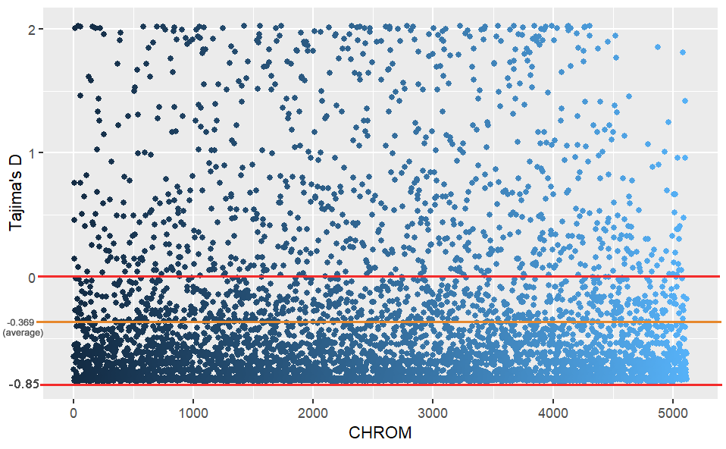
Fig. S1
The distribution of the Tajima’s D values. The maximum was 2.026, the minimum was 0.847, and the average value was 0.369. The values of 4222 among 5116 SNPs were significantly negative.

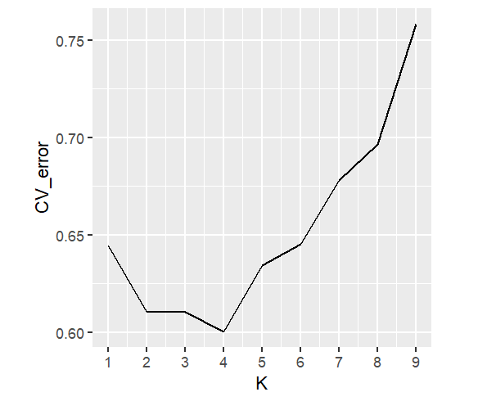
Fig. S2
The optimal K values identified using minimum CV error.

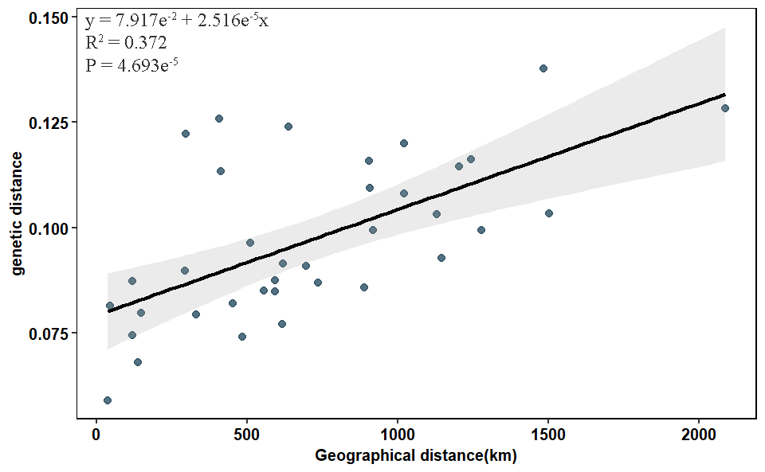
Fig. S3
Correlations between geographic distance and genetic distance, calculated by F_{ST}/(1-F_{ST}).

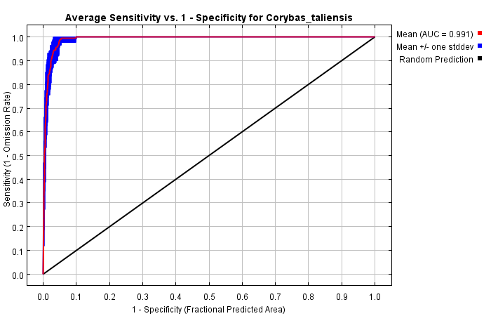
Fig. S4
The receiver operating characteristic (ROC) curve for the same data in MaxEnt, again averaged over the replicate runs. The average training area under the curve (AUC) for the replicate runs is 0.991, and the standard deviation is 0.003.

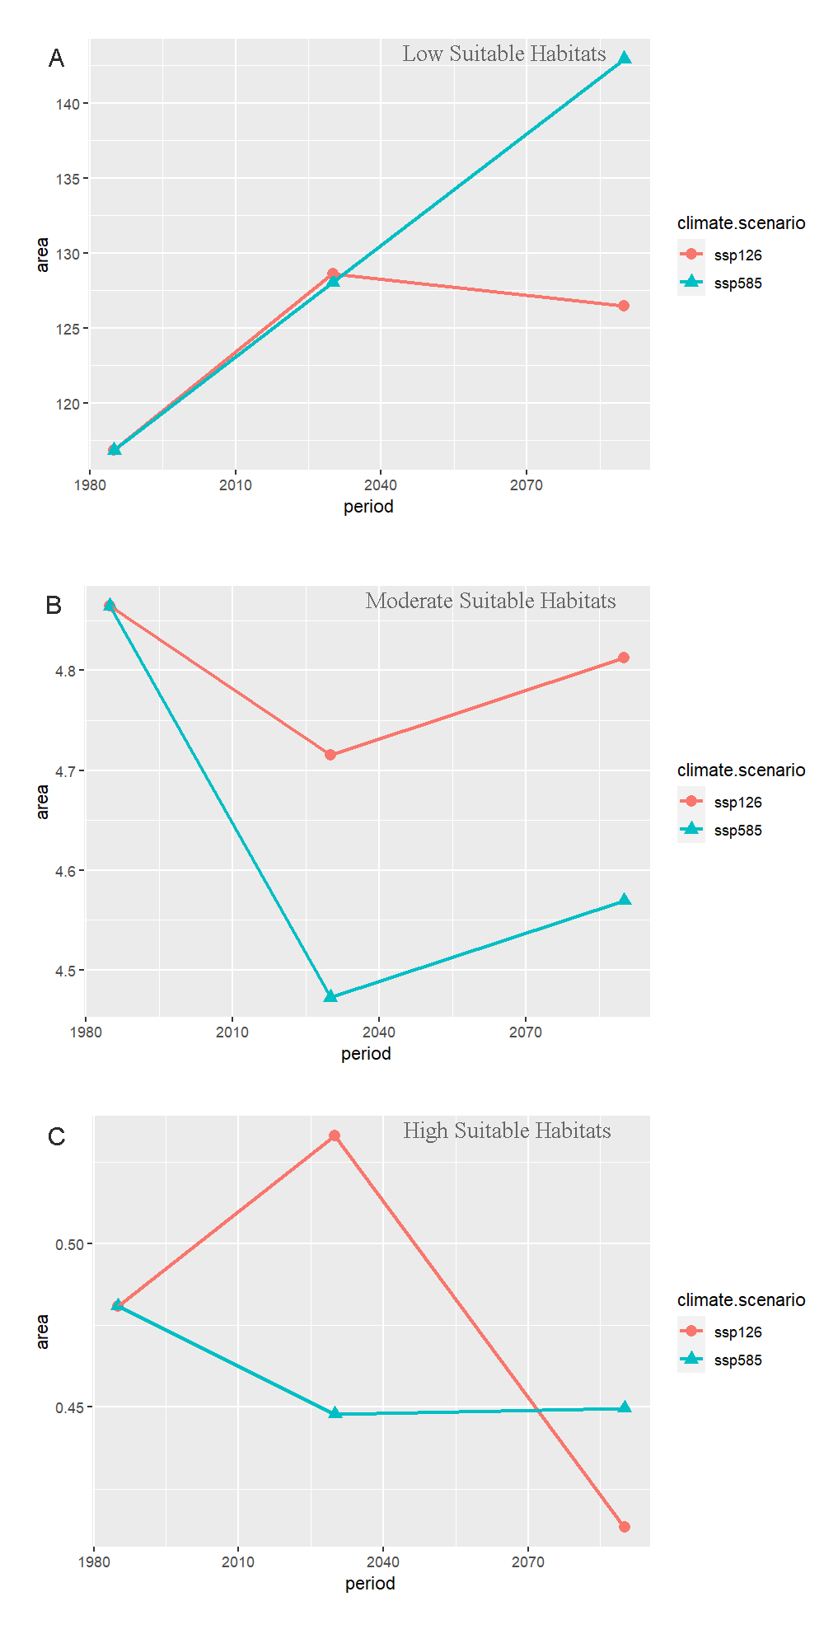
Fig. S5
The change of suitable habitat area. Including low suitable habitats (A), moderate suitable habitats (B) and high suitable habitats (C) area changes in different periods under the ssp126 and ssp585 climate scenario.

Table S1 Summary of filtered and demultiplexed data.
Table S2 The analysis of molecular variance (AMOVA) among genetic groups from PCA analysis (HM, HD and SG) and Bayesian cluster analysis (HM, MT, YN and SG).
Table S3 The change of suitable habitat area.

