Supporting material for
Identification of protein-degraders in an anaerobic digester by protein stable isotope probing combined with metagenomics

Author List
*Zhe Dengª
Jan Struckmann Poulsen^{b}
Jeppe Lund Nielsen^{b}
David G. Weissbrodt^{c,d}
Henri Spanjersª
Jules B. van Lierª

*Corresponding author: z.deng-2@tudelft.nl

ªDelft University of Technology, Faculty of Civil Engineering and Geosciences, Stevinweg 1, 2628 CN Delft, the Netherlands
^{b}Aalborg University, Section for Biotechnology, Department of Chemistry and Bioscience, Fredrik Bajers Vej 7H, DK-9220 Aalborg, Denmark
^{c}Delft University of Technology, Department of Biotechnology, van der Maasweg 9, 2629 HZ Delft, the Netherlands.
^{d}Norwegian University of Science and Technology, Department of Biotechnology and Food Science, Sem Sælands vei 8, 7034 Trondheim, Norway

Table S1 Composition of Silantes OD2 growth media.
Component | Composition (g/g DCW)
protein | 0.68
Phospholipid | 0.05
Cofactors and vitamins | 0.03
Cell wall | 0.15
Peptidoglycan | 0.09
Ash | 0.00
Table S2 Substrate utilization properties of the identified protein-degraders in the LP incubation batch. Annotation of the labelled proteins at genus level, number of hits, and metabolic information retrieved from literature are listed.
Genus | Hit counts | Ability to degrade
Genus | Hit counts | Protein or amino acids | Sugars | Reference
Acinetobacter | 87 | YES | YES | [1]
Klebsiella | 5 | n.a | YES | [2]
Escherichia | 4 | YES | YES | [3]
Enterobacter | 1 | YES | YES | [4]
Syntrophus | 1 | NO | NO | [1]
Salmonella | 1 | YES | YES | [5]
Pulveribacter | 1 | YES | YES | [6]
Shigella | 1 | NO | NO | [3]
Staphylococcus | 1 | YES | YES | [7]
Mangrovibacter | 1 | YES | YES | [8]
Pluralibacter | 1 | YES | NO | [9]
Polaromonas | 1 | YES | YES | [1]
Total of assigned proteins | 105
n.a. not available

Table S3 Substrate utilization properties of the identified protein-degraders in the LPG incubation batch. Annotation of the labelled proteins at genus level, number of hits, and metabolic information retrieved from literature are listed.
Genus | Hit counts | Ability to degrade
Genus | Hit counts | Proteins or  amino acids | Sugars | Reference
Acinetobacter | 35 | YES | YES | [1]
Christensenella | 1 | n.a. | YES | [10]
Citrobacter | 1 | YES | YES | [11]
Clostridium | 1 | YES | YES | [1]
Enterobacter | 1 | YES | YES | [4]
Escherichia | 28 | YES | YES | [3]
Klebsiella | 1 | n.a. | YES | [2]
Lysobacter | 3 | YES | YES | [1]
Pluralibacter | 2 | YES | YES | [6]
Salmonella | 1 | YES | YES | [5]
Serratia | 2 | YES | YES | [1]
Shigella | 1 | NO | NO | [3]
Shimwellia | 1 | n.a. | n.a.
Xanthomonas | 1 | n.a. | n.a.
Total of assigned proteins | 79
n.a. not available

Table S4 List of known protein degraders that holding protease according to literature and UnitPro database.
Kingdom | Phylum | Genus | Reference
Bacteria | Acidobacteria | Candidatus Koribacter | UniProt
Bacteria | Acidobacteria | Candidatus Solibacter | UniProt
Bacteria | Actinobacteria | Acidimicrobium | UniProt
Bacteria | Actinobacteria | Acidothermus | UniProt
Bacteria | Actinobacteria | Actinosynnema | UniProt
Bacteria | Actinobacteria | Arthrobacter | UniProt
Bacteria | Actinobacteria | Beutenbergia | UniProt
Bacteria | Actinobacteria | Catenulispora | UniProt
Bacteria | Actinobacteria | Frankia | UniProt
Bacteria | Actinobacteria | Geodermatophilus | UniProt
Bacteria | Actinobacteria | Gordonia | UniProt
Bacteria | Actinobacteria | Jonesia | UniProt
Bacteria | Actinobacteria | Kineococcus | UniProt
Bacteria | Actinobacteria | Kribbella | UniProt
Bacteria | Actinobacteria | Mycobacterium | UniProt
Bacteria | Actinobacteria | Mycobacteroides | UniProt
Bacteria | Actinobacteria | Mycolicibacterium | UniProt
Bacteria | Actinobacteria | Nakamurella | UniProt
Bacteria | Actinobacteria | Nocardia | UniProt
Bacteria | Actinobacteria | Nocardioides | UniProt
Bacteria | Actinobacteria | Paenarthrobacter | UniProt
Bacteria | Actinobacteria | Pseudarthrobacter | UniProt
Bacteria | Actinobacteria | Renibacterium | UniProt
Bacteria | Actinobacteria | Rhodococcus | UniProt
Bacteria | Actinobacteria | Saccharomonospora | UniProt
Bacteria | Actinobacteria | Saccharopolyspora | UniProt
Bacteria | Actinobacteria | Salinispora | UniProt
Bacteria | Actinobacteria | Sanguibacter | UniProt
Bacteria | Actinobacteria | Stackebrandtia | UniProt
Bacteria | Actinobacteria | Streptomyces | UniProt
Bacteria | Actinobacteria | Streptosporangium | UniProt
Bacteria | Actinobacteria | Thermobifida | UniProt
Bacteria | Actinobacteria | Thermomonospora | UniProt
Bacteria | Actinobacteria | Xylanimonas | UniProt
Bacteria | Aquificae | Aquifex | UniProt
Bacteria | Aquificae | Sulfurihydrogenibium | UniProt
Bacteria | Bacteroidetes | Candidatus Amoebophilus | UniProt
Bacteria | Bacteroidetes | Candidatus Sulcia | UniProt
Bacteria | Bacteroidetes | Chloroherpeton | UniProt
Bacteria | Bacteroidetes | Cytophaga | UniProt
Bacteria | Bacteroidetes | Flavobacterium | UniProt
Bacteria | Bacteroidetes | Parabacteroides | UniProt
Bacteria | Bacteroidetes | Porphyromonas | UniProt
Bacteria | Bacteroidota | Acetobacteroides | [1]
Bacteria | Bacteroidota | Bacteroides (or Prevotella) | [12]
Bacteria | Chlamydiae | Candidatus Protochlamydia | UniProt
Bacteria | Chlamydiae | Chlamydia | UniProt
Bacteria | Chloroflexi | Chloroflexus | UniProt
Bacteria | Chloroflexi | Herpetosiphon | UniProt
Bacteria | Chloroflexi | Roseiflexus | UniProt
Bacteria | Coprothermobacterota | Coprothermobacter | UniProt
Bacteria | Deinococcus-Thermus | Deinococcus | UniProt
Bacteria | Deinococcus-Thermus | Thermus | UniProt
Bacteria | Dictyoglomi | Dictyoglomus | UniProt
Bacteria | Elusimicrobia | Endomicrobium | UniProt
Bacteria | Firmicutes | Acidaminobacter | [13]
Bacteria | Firmicutes | Alicyclobacillus | UniProt
Bacteria | Firmicutes | Alkalihalobacillus | UniProt
Bacteria | Firmicutes | Bacillus | UniProt
Bacteria | Firmicutes | Brevibacillus | UniProt
Bacteria | Firmicutes | Caldanaerobacter | UniProt
Bacteria | Firmicutes | Caldicellulosiruptor | UniProt
Bacteria | Firmicutes | Clostridioides | UniProt
Bacteria | Firmicutes | Clostridium | UniProt
Bacteria | Firmicutes | Desulforamulus | UniProt
Bacteria | Firmicutes | Enterococcus | UniProt
Bacteria | Firmicutes | Finegoldia | UniProt
Bacteria | Firmicutes | Geobacillus | UniProt
Bacteria | Firmicutes | Halothermothrix | UniProt
Bacteria | Firmicutes | Heliomicrobium | UniProt
Bacteria | Firmicutes | Lachnoclostridium | UniProt
Bacteria | Firmicutes | Lacticaseibacillus | UniProt
Bacteria | Firmicutes | Lactobacillus | [1]
Bacteria | Firmicutes | Lactococcus | UniProt
Bacteria | Firmicutes | Oceanobacillus | UniProt
Bacteria | Firmicutes | Paenibacillus | UniProt
Bacteria | Firmicutes | Paraclostridium | [1]
Bacteria | Firmicutes | Priestia | UniProt
Bacteria | Firmicutes | Proteiniclasticum | [14]
Bacteria | Firmicutes | Sedimentibacter | [15]
Bacteria | Firmicutes | Sporanaerobacter | [16]
Bacteria | Firmicutes | Staphylococcus | UniProt
Bacteria | Firmicutes | Streptococcus (Lactococcus) | [12]
Bacteria | Firmicutes | Syntrophomonas | UniProt
Bacteria | Firmicutes | Tissierella | [17]
Bacteria | Fusobacteria | Fusobacterium | UniProt
Bacteria | Proteobacteria | Achromobacter | UniProt
Bacteria | Proteobacteria | Acinetobacter | UniProt
Bacteria | Proteobacteria | Anaeromyxobacter | UniProt
Bacteria | Proteobacteria | Azorhizobium | UniProt
Bacteria | Proteobacteria | Azospirillum | UniProt
Bacteria | Proteobacteria | Bdellovibrio | UniProt
Bacteria | Proteobacteria | Brucella | UniProt
Bacteria | Proteobacteria | Buchnera | UniProt
Bacteria | Proteobacteria | Campylobacter | UniProt
Bacteria | Proteobacteria | Campylobacter | UniProt
Bacteria | Proteobacteria | Caulobacter | UniProt
Bacteria | Proteobacteria | Citrifermentans | UniProt
Bacteria | Proteobacteria | Desulfatibacillum | UniProt
Bacteria | Proteobacteria | Desulfosudis | UniProt
Bacteria | Proteobacteria | Desulfotalea | UniProt
Bacteria | Proteobacteria | Desulfovibrio | UniProt
Bacteria | Proteobacteria | Dichelobacter | UniProt
Bacteria | Proteobacteria | Dickeya | UniProt
Bacteria | Proteobacteria | Erwinia | UniProt
Bacteria | Proteobacteria | Escherichia | UniProt
Bacteria | Proteobacteria | Francisella | UniProt
Bacteria | Proteobacteria | Geobacter | UniProt
Bacteria | Proteobacteria | Haemophilus | UniProt
Bacteria | Proteobacteria | Helicobacter | UniProt
Bacteria | Proteobacteria | Hydrogenovibrio | UniProt
Bacteria | Proteobacteria | Lawsonia | UniProt
Bacteria | Proteobacteria | Lysobacter | UniProt
Bacteria | Proteobacteria | Magnetococcus | UniProt
Bacteria | Proteobacteria | Methylocella | UniProt
Bacteria | Proteobacteria | Myxococcus | UniProt
Bacteria | Proteobacteria | Neorickettsia | UniProt
Bacteria | Proteobacteria | Nitrosococcus | UniProt
Bacteria | Proteobacteria | Orientia | UniProt
Bacteria | Proteobacteria | Paraburkholderia | UniProt
Bacteria | Proteobacteria | Phenylobacterium | UniProt
Bacteria | Proteobacteria | Photorhabdus | UniProt
Bacteria | Proteobacteria | Proteus | UniProt
Bacteria | Proteobacteria | Pseudomonas | UniProt
Bacteria | Proteobacteria | Rickettsia | UniProt
Bacteria | Proteobacteria | Serratia | UniProt
Bacteria | Proteobacteria | Shigella | UniProt
Bacteria | Proteobacteria | Sinorhizobium | UniProt
Bacteria | Proteobacteria | Sorangium | UniProt
Bacteria | Proteobacteria | Stenotrophomonas | UniProt
Bacteria | Proteobacteria | Syntrophobacter | UniProt
Bacteria | Proteobacteria | Syntrophotalea | UniProt
Bacteria | Proteobacteria | Syntrophus | UniProt
Bacteria | Proteobacteria | Trichlorobacter | UniProt
Bacteria | Proteobacteria | Vibrio | UniProt
Bacteria | Proteobacteria | Wolbachia | UniProt
Bacteria | Proteobacteria | Xanthomonas | UniProt
Bacteria | Spirochaetes | Borrelia | UniProt
Bacteria | Spirochaetes | Borreliella | UniProt
Bacteria | Spirochaetes | Leptospira | UniProt
Bacteria | Spirochaetes | Treponema | UniProt
Bacteria | Synergistota | Aminobacterium | [18]
Bacteria | Synergistota | Thermanaerovibrio | [19]
Bacteria | Tenericutes | Candidatus Phytoplasma | UniProt
Bacteria | Tenericutes | Malacoplasma | UniProt
Bacteria | Tenericutes | Metamycoplasma | UniProt
Bacteria | Tenericutes | Ureaplasma | UniProt
Bacteria | Tenericutes | Mesomycoplasma | UniProt
Bacteria | Tenericutes | Mycoplasma | UniProt
Bacteria | Tenericutes | Mycoplasmopsis | UniProt
Bacteria | Thermotogae | Fervidobacterium | UniProt
Bacteria | Thermotogae | Pseudothermotoga | UniProt
Bacteria | / | Aminomonas | [20]
Bacteria | / | Lutispora | [17]
Bacteria | / | Peptostrptococcus | [21]
Archaea | Candidatus Thermoplasmatota | Aciduliprofundum | UniProt
Archaea | Candidatus Thermoplasmatota | Picrophilus | UniProt
Archaea | Candidatus Thermoplasmatota | Thermoplasma | UniProt
Archaea | Crenarchaeota | Aeropyrum | UniProt
Archaea | Crenarchaeota | Caldivirga | UniProt
Archaea | Crenarchaeota | Desulfurococcus | UniProt
Archaea | Crenarchaeota | Hyperthermus | UniProt
Archaea | Crenarchaeota | Ignicoccus | UniProt
Archaea | Crenarchaeota | Metallosphaera | UniProt
Archaea | Crenarchaeota | Pyrobaculum | UniProt
Archaea | Crenarchaeota | Saccharolobus | UniProt
Archaea | Crenarchaeota | Staphylothermus | UniProt
Archaea | Crenarchaeota | Sulfolobus | UniProt
Archaea | Crenarchaeota | Sulfurisphaera | UniProt
Archaea | Crenarchaeota | Thermofilum | UniProt
Archaea | Euryarchaeota | Archaeoglobus | UniProt
Archaea | Euryarchaeota | Archaeoglobus | UniProt
Archaea | Euryarchaeota | Ferroglobus | UniProt
Archaea | Euryarchaeota | Haloarcula | UniProt
Archaea | Euryarchaeota | Halobacterium | UniProt
Archaea | Euryarchaeota | Haloferax | UniProt
Archaea | Euryarchaeota | Halomicrobium | UniProt
Archaea | Euryarchaeota | Haloquadratum | UniProt
Archaea | Euryarchaeota | Halorhabdus | UniProt
Archaea | Euryarchaeota | Halorubrum | UniProt
Archaea | Euryarchaeota | Haloterrigena | UniProt
Archaea | Euryarchaeota | Methanobrevibacter | UniProt
Archaea | Euryarchaeota | Methanocaldococcus | UniProt
Archaea | Euryarchaeota | Methanocella | UniProt
Archaea | Euryarchaeota | Methanococcoides | UniProt
Archaea | Euryarchaeota | Methanococcus | UniProt
Archaea | Euryarchaeota | Methanocorpusculum | UniProt
Archaea | Euryarchaeota | Methanoculleus | UniProt
Archaea | Euryarchaeota | Methanohalophilus | UniProt
Archaea | Euryarchaeota | Methanopyrus | UniProt
Archaea | Euryarchaeota | Methanoregula | UniProt
Archaea | Euryarchaeota | Methanosarcina | UniProt
Archaea | Euryarchaeota | Methanosphaera | UniProt
Archaea | Euryarchaeota | Methanosphaerula | UniProt
Archaea | Euryarchaeota | Methanospirillum | UniProt
Archaea | Euryarchaeota | Methanothermobacter | UniProt
Archaea | Euryarchaeota | Methanothrix | UniProt
Archaea | Euryarchaeota | Natrialba | UniProt
Archaea | Euryarchaeota | Natronomonas | UniProt
Archaea | Euryarchaeota | Pyrococcus | UniProt
Archaea | Euryarchaeota | Thermococcus | UniProt
Archaea | Nanoarchaeota | Nanoarchaeum | UniProt
Archaea | TACK group | Candidatus Korarchaeum | UniProt
Archaea | TACK group | Cenarchaeum | UniProt
Archaea | TACK group | Nitrosopumilus | UniProt

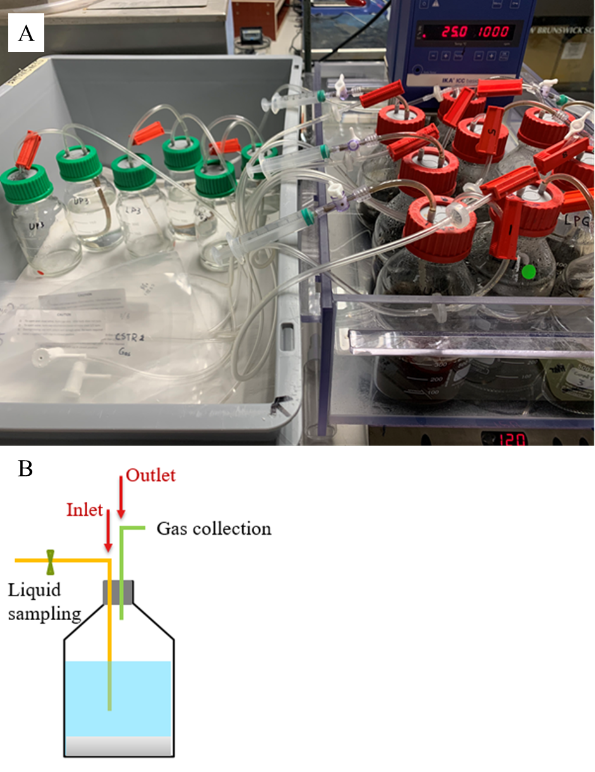
Figure S1 A) Photo of batch incubation setup and B) schematic diagram of each incubation bottle.
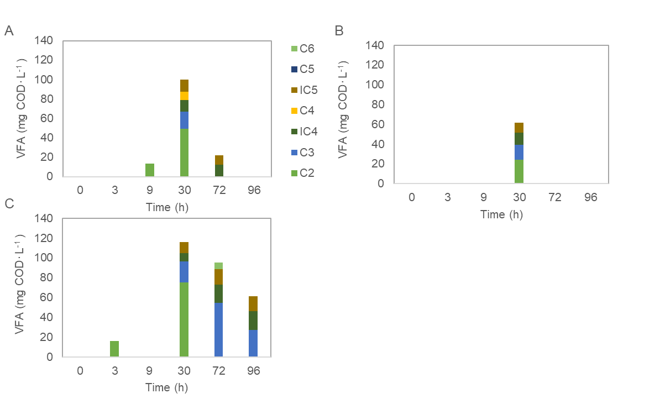
Figure S2 Concentration and composition of VFAs in the A) UP, B) LP and C) LPG incubation batches. VFAs concentrations of C2-C6 were measured and averaged results were plot in bar chart against sampling time.

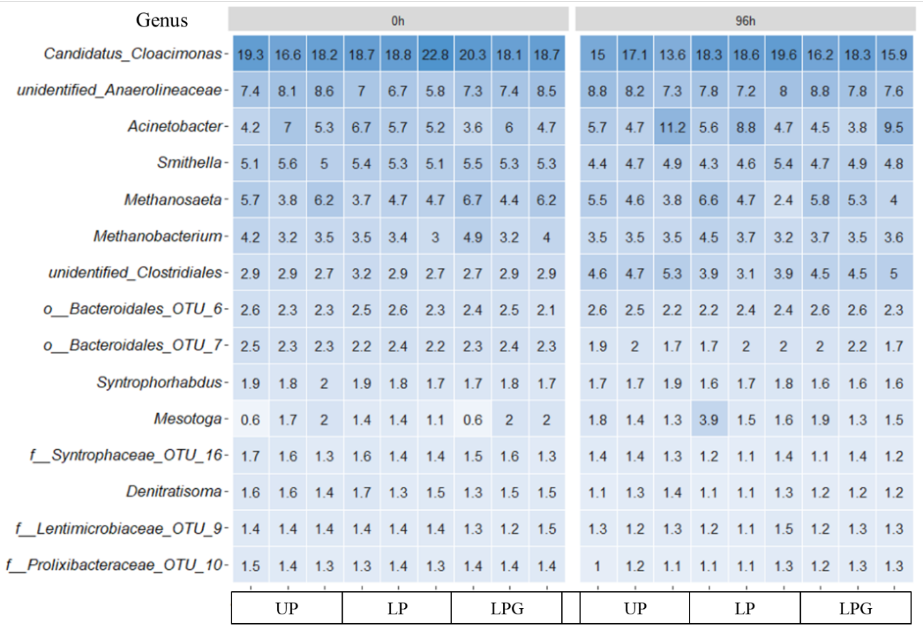
Figure S3 Evolutions of top 15 genera in UP, LP, and LPG incubation bottles over the 96 h of incubation period. V3-V4 amplicon sequencing profiles were analysed.

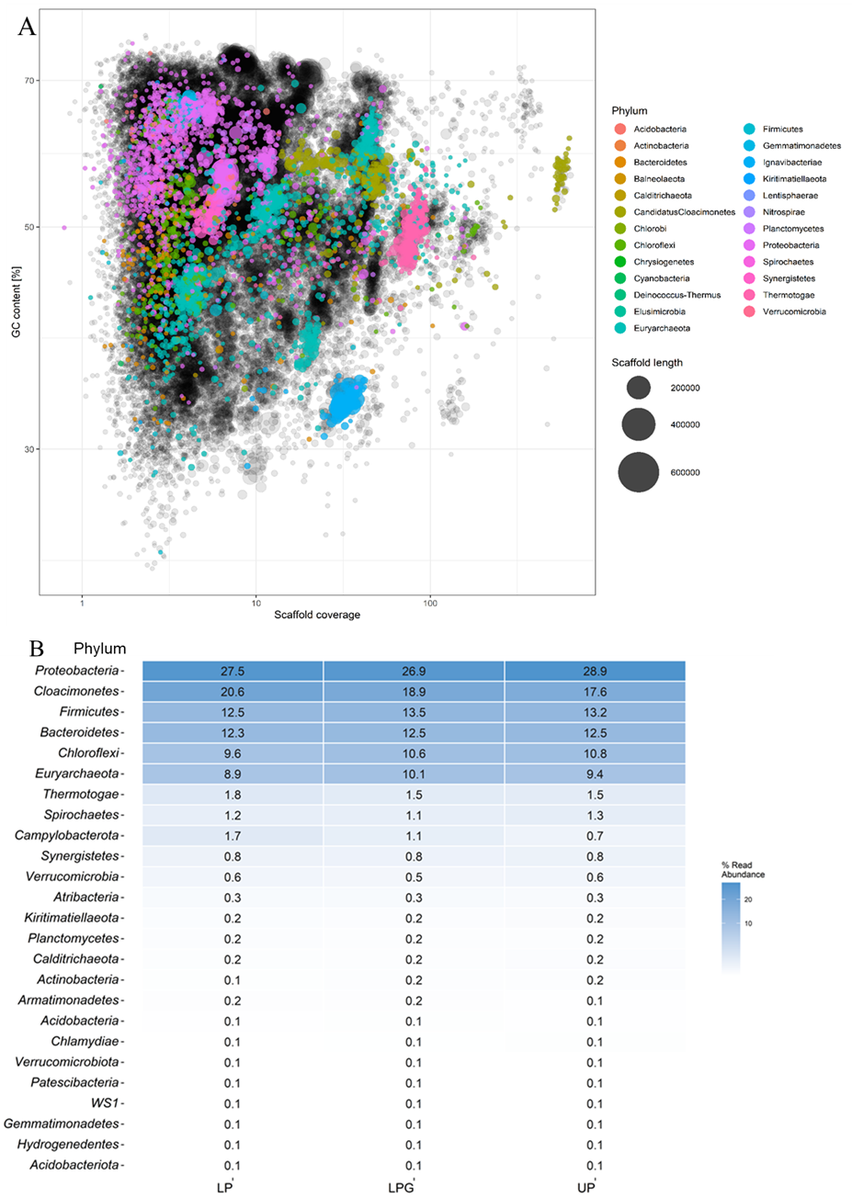
Figure S4 Comparison of phyla relative abundance in MAG and amplicon sequencing results. A) The scaffold coverage of the metagenome is plotted against the GC-content, and the scaffolds are coloured by phylum and have a minimum length of 5000 bp, the length of the scaffolds are indicated by the sizes of the dot. B) The averaged relative abundance of the top 25 phyla in the UP, LP, and LPG incubation batches.
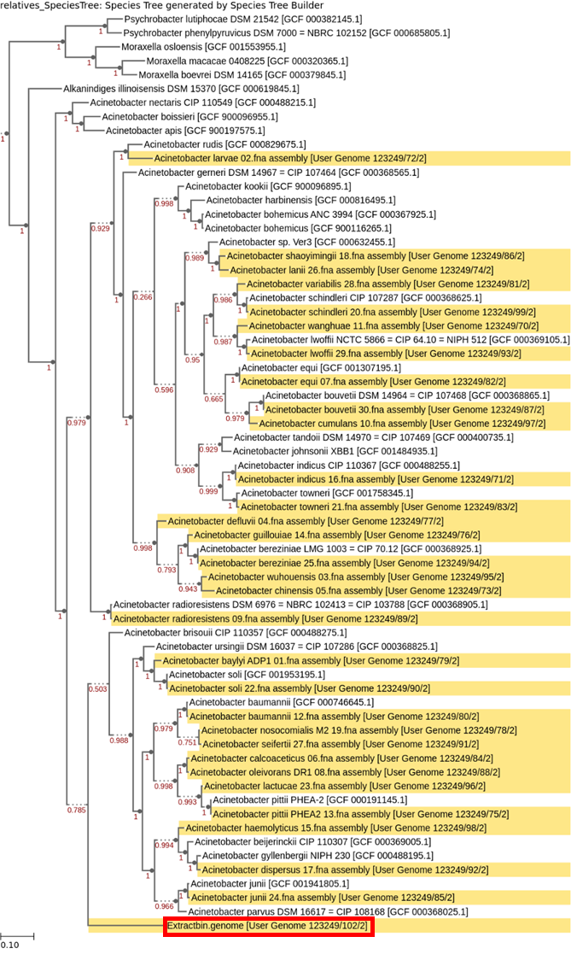
Figure S5 Phylogenetic analysis of the Acinetobacter genome bin extracted from the generated metagenome. Thirty complete Acinetobacter reference genomes were downloaded from the NCBI database and highlighted in yellow, and the extracted Acinetobacter genome was highlighted in red rectangle.

Reference
1. Dueholm, M.S., et al., MiDAS 4: A global catalogue of full-length 16S rRNA gene sequences and taxonomy for studies of bacterial communities in wastewater treatment plants. (2021).
2. Pishchik, V.N., et al., Metabolic features of bacteria of the genus Klebsiella. Microbialogy-New York. 66(1): p. 43-47 (1997).
3. Ud-Din, A. and S. Wahid, Relationship among Shigella spp. and enteroinvasive Escherichia coli (EIEC) and their differentiation. Braz. J. Microbiol. 45(4): p. 1131-1138 (2015).
4. Grimont, F. and P.A.D. Grimont, The Genus Enterobacter, in The Prokaryotes. p. 197-214 (2006).
5. Grimont, P.A., et al., Taxonomy of the genus Salmonella, in Salmonella in domestic animals. p. 1-17 (2000).
6. Heo, J., et al., Pulveribacter suum gen. nov., sp. nov., isolated from a pig farm dust collector. Int. J. Syst. Evol. Microbiol. 69(7): p. 1864-1869 (2019).
7. Sivakanesan, R. and E.A. Dawes, Anaerobic glucose and serine metabolism in Staphylococcus epidermidis. Microbiology. 118(1): p. 143-157 (1980).
8. Zhang, H., et al., Mangrovibacter yixingensis sp. nov., isolated from farmland soil. Int. J. Syst. Evol. Microbiol. 65(8): p. 2447-2452 (2015).
9. Brady, C., et al., Taxonomic evaluation of the genus Enterobacter based on multilocus sequence analysis (MLSA): proposal to reclassify E. nimipressuralis and E. amnigenus into Lelliottia gen. nov. as Lelliottia nimipressuralis comb. nov. and Lelliottia amnigena comb. nov., respectively, E. gergoviae and E. pyrinus into Pluralibacter gen. nov. as Pluralibacter gergoviae comb. nov. and Pluralibacter pyrinus comb. nov., respectively, E. cowanii, E. radicincitans, E. oryzae and E. arachidis into Kosakonia gen. nov. as Kosakonia cowanii comb. nov., Kosakonia radicincitans comb. nov., Kosakonia oryzae comb. nov. and Kosakonia arachidis comb. nov., respectively, and E. turicensis, E. helveticus and E. pulveris into Cronobacter as Cronobacter zurichensis nom. nov., Cronobacter helveticus comb. nov. and Cronobacter pulveris comb. nov., respectively, and emended description of the genera Enterobacter and Cronobacter. Syst. Appl. Microbiol. 36(5): p. 309-19 (2013).
10. Morotomi, M., et al., Description of Christensenella minuta gen. nov., sp. nov., isolated from human faeces, which forms a distinct branch in the order Clostridiales, and proposal of Christensenellaceae fam. nov. Int. J. Syst. Evol. Microbiol. 62(1): p. 144-149 (2012).
11. Brenner, D.J., et al., Biochemical identification of Citrobacter species defined by DNA hybridization and description of Citrobacter gillenii sp. nov.(formerly Citrobacter genomospecies 10) and Citrobacter murliniae sp. nov.(formerly Citrobacter genomospecies 11). J. Clin. Microbiol. 37(8): p. 2619-2624 (1999).
12. Macfarlane, G., et al., Protein degradation by human intestinal bacteria. Microbiology. 132(6): p. 1647-1656 (1986).
13. Stams, A. and T. Hansen, Fermentation of glutamate and other compounds by Acidaminobacter hydrogenoformans gen. nov. sp. nov., an obligate anaerobe isolated from black mud. Studies with pure cultures and mixed cultures with sulfate-reducing and methanogenic bacteria. Arch. Microbiol. 137(4): p. 329-337 (1984).
14. Li, D., et al., Effects of feedstock ratio and organic loading rate on the anaerobic mesophilic co-digestion of rice straw and cow manure. Bioresour. Technol. 189: p. 319-326 (2015).
15. Breitenstein, A., et al., Reclassification of Clostridium hydroxybenzoicum as Sedimentibacter hydroxybenzoicus gen. nov., comb. nov., and description of Sedimentibacter saalensis sp. nov. Int. J. Syst. Evol. Microbiol. 52(3): p. 801-807 (2002).
16. Hernandez-Eugenio, G., et al., Sporanaerobacter acetigenes gen. nov., sp. nov., a novel acetogenic, facultatively sulfur-reducing bacterium. Int. J. Syst. Evol. Microbiol. 52(4): p. 1217-1223 (2002).
17. Chen, S., et al., Microbial responses and metabolic pathways reveal the recovery mechanism of an anaerobic digestion system subjected to progressive inhibition by ammonia. Chem. Eng. J. 350(April): p. 312-323 (2018).
18. Baena, S., et al., Aminobacterium mobile sp. nov., a new anaerobic amino-acid-degrading bacterium. Int. J. Syst. Evol. Microbiol. 50(1): p. 259-264 (2000).
19. Nanninga, H., et al., Fermentation of glutamate by Selenomonas acidaminophila sp. nov. Arch. Microbiol. 147(2): p. 152-157 (1987).
20. Baena, S., et al., Aminomonas paucivorans gen. nov., sp. nov., a mesophilic, anaerobic, amino-acid-utilizing bacterium. Int. J. Syst. Evol. Microbiol. 49(3): p. 975-982 (1999).
21. Dürre, P., et al., Glycine fermentation via a glycine reductase in Peptococcus glycinophilus and Peptococcus magnus. Arch. Microbiol. 134(2): p. 127-135 (1983).

