Supplementary Materials for
Magneto-engineering towards high thermoelectric performance in topological insulator Bi₈₈Sb₁₂
Yu Pan^{1, †, *}, Bin He^{1, †}, Fan Li^{2, †}, Dong Chen¹, Ulrich Burkhardt¹, Claudia Felser^{1,*}
¹Max Planck Institute for Chemical Physics of Solids, Nöthnitzer Str. 40, Dresden 01187, Germany.
²NISE Department, Max Planck Institute of Microstructure Physics, Halle, Germany.
†These authors contributed equally to this work.
*E-mail address: yu.pan@cpfs.mpg.de; claudia.felser@cpfs.mpg.de

Magneto-engineering enhances zT
The magnetic field affects the transport of charge carriers, particularly fast charge carriers that have strong magneto-responses, thus modulating the thermoelectric properties. Herein, we propose magneto-engineering as an effective strategy to tune three of the thermoelectric parameters for topological materials (Fig. S1(a)).
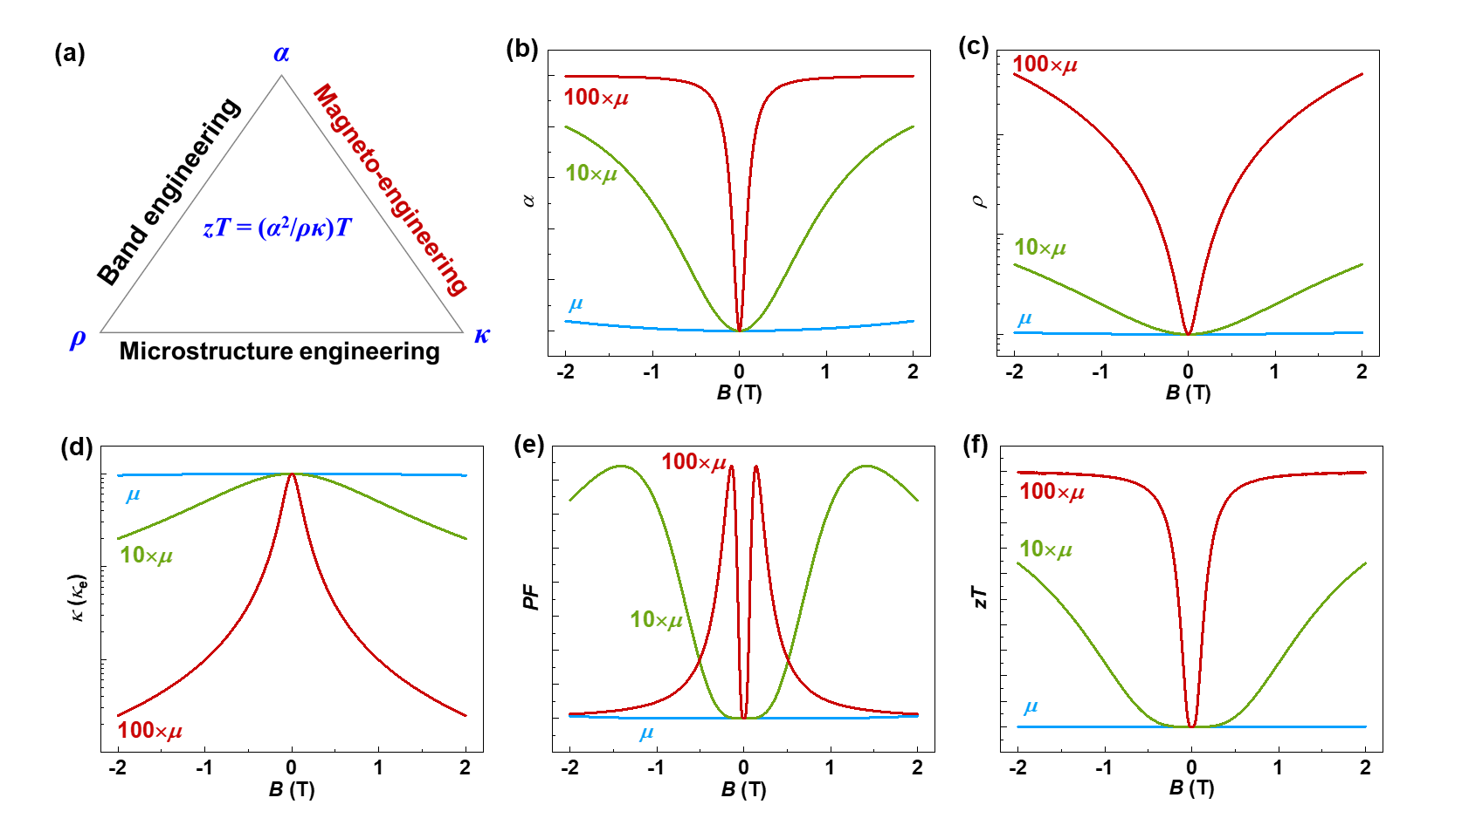
Fig. S1 Magneto-engineering enhances magneto-zT. (a) Schematic of magneto-engineering to simultaneously modulate the thermoelectric parameters including Seebeck coefficient α and thermal conductivity κ. Classic modelling of magnetic field dependence of (b) Seebeck coefficient, (c) resistivity, (d) thermal conductivity, (e) power factor, and (f) zT. Three different mobilities increasing from μ to 10 μ to 100 μ (μ = 0.1 m²/Vs) are illustrated. The higher the mobility, the smaller the magnetic field required for a large zT.

The general trends of magnetic-field dependence of the Seebeck coefficient, resistivity, thermal conductivity, power factor and zT for different mobilities are shown in Fig. S1(b)–(f), respectively. As indicated by the blue lines, thermoelectric parameters barely changed under a magnetic field with low mobility. For intermediate-high mobility, the Seebeck coefficient and resistivity were enhanced along with a decrease in thermal conductivity, as indicated by the green lines. For ultrahigh mobility (100 times higher), the requirement of an external magnetic field to obtain a high Seebeck coefficient can be reduced to a much lower value, as illustrated by the red line in Fig. S1(b). Therefore, high mobility causes a rapid increase in the power factor and zT value under a low magnetic field, as shown in Fig. S1(e) and (f), respectively.

Single crystal quality
The crystals of this work are of high quality. As shown in Fig. S2, the crystal is millimeters large with a shining cleavage plane. The cleavage plane is (111) plane. IPF Z (inverse pole Figure Z) images further demonstrates the high quality of the single crystallinity, as shown in Fig. S2. Here the [001] direction in EBSD is the c-axis of Bi₈₈Sb₁₂ in hexagonal structure, which is identical to the [111] direction in rhombohedral structure. The single crystal quality becomes better in the middle part (left part in Fig. S2) than the beginning part (right part in Fig. S2) along the as-grown crystal.
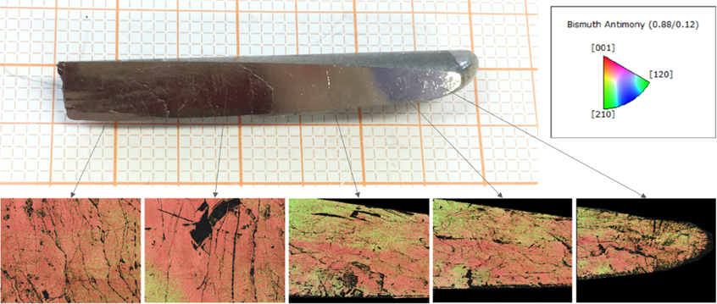
Fig. S2 Single crystallinity. Optical image (top left), and color coded orientation of the unit cell of the Bi_{1-x}Sb_{x} phase perpendicular to the cleaving plane at different areas along the as-grown crystal (inverse pole figure Z, IPF Z) (bottom images, with color code in the hexagonal setting shown on top right). The crystal was millimeters in size with a shining cleavage plane of high single crystal quality.

Composition homogeneity
The composition and homogeneity of the crystal were examined by energy-dispersive X-ray spectroscopy (EDX) and EBSD. Fig. S3 show the backscattered electrons (BSE) images and EDX results, which confirm the uniform distribution of the elements and indicate the homogeneous elemental composition ratio of Bi:Sb close to 88:12, or 89:11, which agrees well with the stoichiometric ratio.
The elemental mapping along with elemental ratio analysis of the single crystals, and the electron images recorded with the forescattered electron detector of the EBSD system are shown in Fig. S4. The results demonstrate the Bi and Sb elements are almost homogenous distributed in the single crystal, with a ratio close to the stochiometric ratio. Slight differences are observed because Bi and Sb form solid solution with a large segregation coefficient.

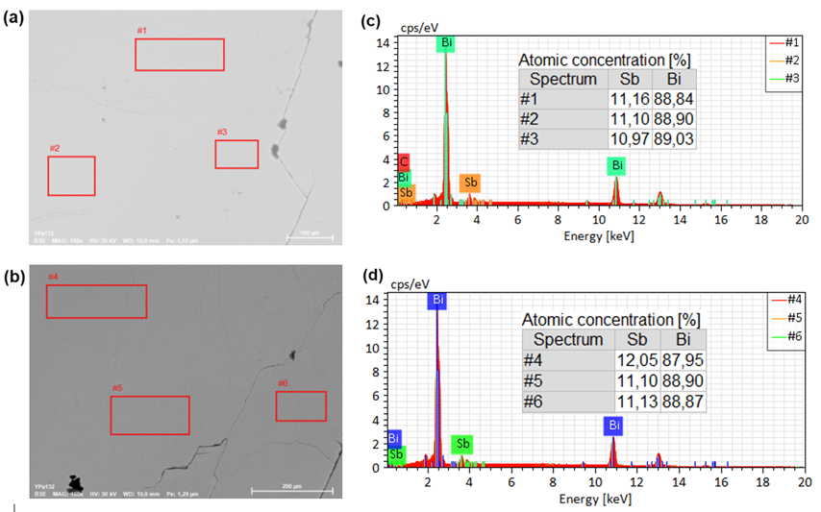
Fig. S3 Microstructure image and composition homogeneity. (a), (b) Backscattered electron (BSE) image and (c), (d) energy-dispersive X-ray spectroscopy (EDX) analysis (acc. voltage 30 kV) at various areas on the Bi₈₈Sb₁₂ single crystal.

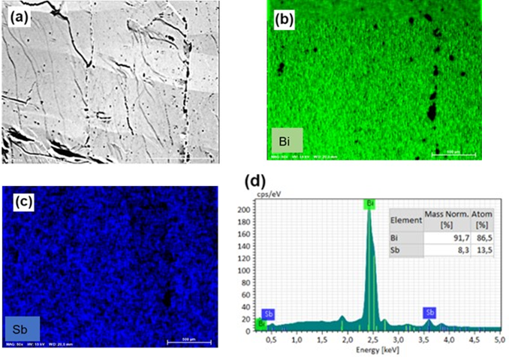
Fig. S4 Elemental mapping of the as-grown crystal. (a) Fore-scattered electron image (70° tilt corrected) on the cleaved surface with (111) orientation of the crystal. Material contrast and element mapping images show the homogeneity of the single crystalline sample. Black lines and particles originate from terraces steps and cleaving residues, respectively. X-ray intensity distributions of (b) Bi Mα (2.4 keV) and (c) Sb Lα (3.6 keV). (d) Element concentration calculated from X-ray intensities (15 kV, ZAF matrix correction model) of the energy dispersive spectra.

Thermoelectric properties of various samples
In order to explore the origin of the high thermoelectric performance, as well as to demonstrate the role of weak antilocalization for high thermoelectric performance of the Bi₈₈Sb₁₂ single crystals, four samples were measured. The thermoelectric transport properties of sample #1 are shown in the main text, and the thermoelectric transport properties of samples #2 - #4 are shown in Fig. S5-S7, respectively. Comparing the thermoelectric properties of all the samples, it is found that the magneto-Seebeck coefficient values are almost identical, while the magneto-resistivity can have a large difference, which therefore leads to a large difference in magneto-zT. We attribute the different magneto-resistivity to the sensitive perturbation of the charge carriers transport by the quantum weak antilocalization effect. As such, we expect even better thermoelectric performance by further well controlling the single crystal quality.

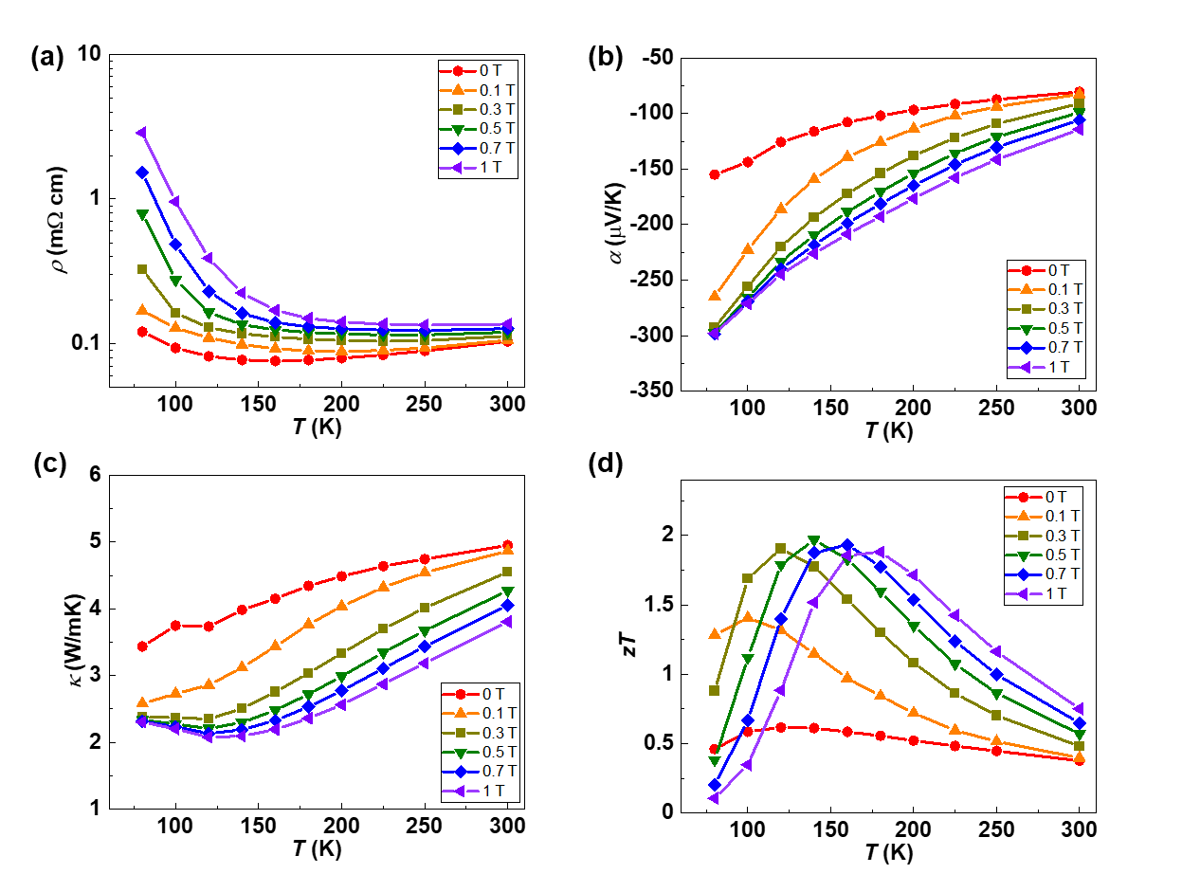
Fig. S5 Thermoelectric properties of sample #2. Temperature dependence of the thermoelectric transport properties. (a) resistivity, (b) Seebeck coefficient, (c) total thermal conductivity, and (d) zT values of sample #2 of the Bi₈₈Sb₁₂ single crystal under 0-1 T.

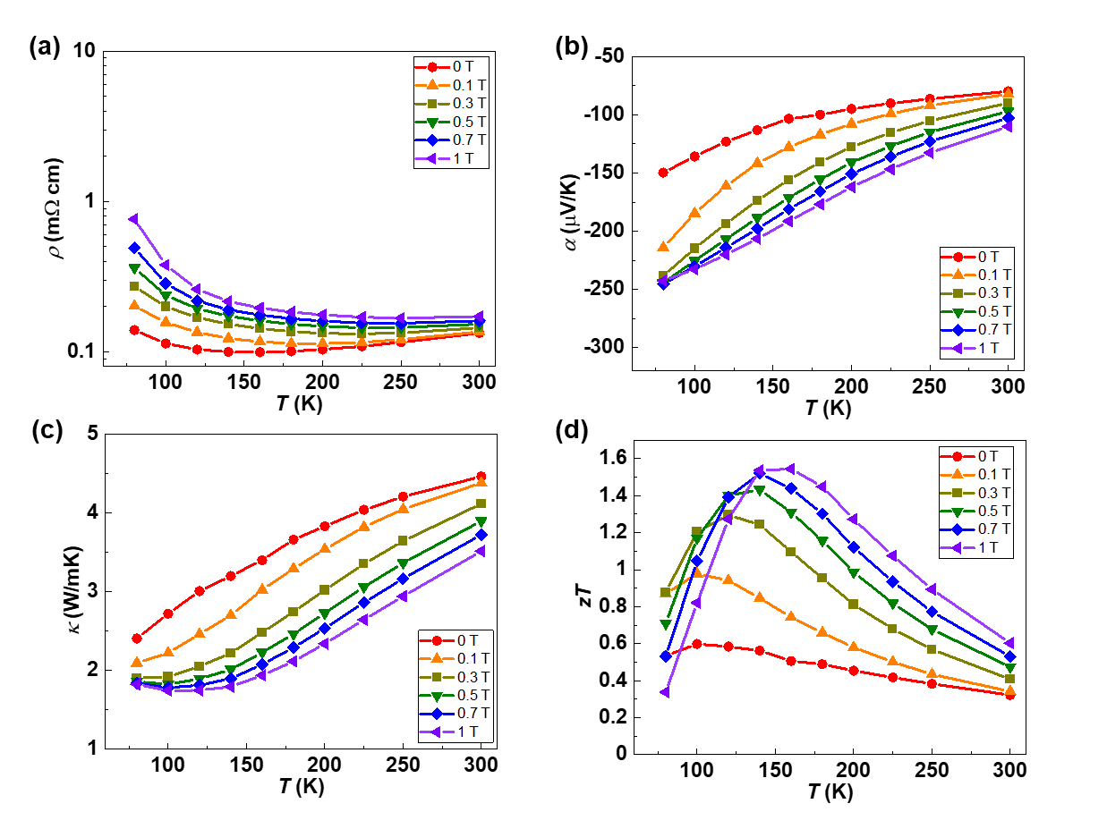
Fig. S6 Thermoelectric properties of sample #3. Temperature dependence of the thermoelectric transport properties. (a) resistivity, (b) Seebeck coefficient, (c) total thermal conductivity, and (d) zT values of sample #3 of the Bi₈₈Sb₁₂ single crystal under 0-1 T.

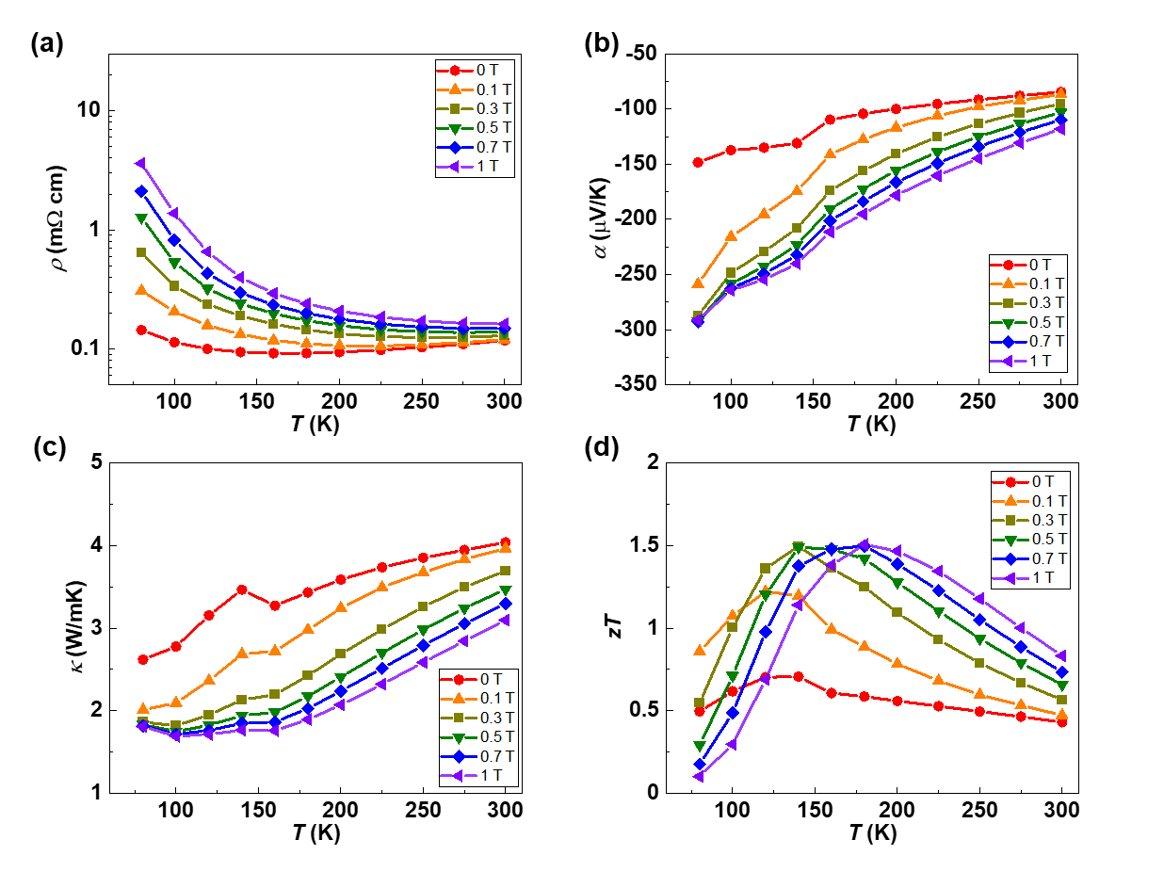
Fig. S7 Thermoelectric properties of sample #4. Temperature dependence of the thermoelectric transport properties. (a) resistivity, (b) Seebeck coefficient, (c) total thermal conductivity, and (d) zT values of sample #4 of the Bi₈₈Sb₁₂ single crystal under 0-1 T.

Magneto-resistivity analysis
Different samples present a different magneto resistivity behavior, and the dip at low magnetic field indicates the existence of two types of charge carriers with different mobilities, or weak antilocalization effect. Two samples with a maximum magneto-zT value of ~1.9 (sample #1), ~1.5 (sample #3), respectively, are chosen as representatives to illustrate if the weak antilocalization effect on the thermoelectric performance. As shown in Fig. S8(a), S#1 shows a nearly quadratic increase resistivity with magnetic field, but with a tiny dip at very low magnetic field. While S#3 present a mustache-shaped magnetoresistance with a more obvious dip at the low magnetic field. The dip of the magnetoresistance at the low magnetic field is usually recognized as a signature of the antilocalization effect. The different behaviors of the “dip” magnetoresistance indicate the varied quantum interference effects in different samples.
By applying the Hikami-Larkin-Nagaoka (HLN) model, it is possible to analysis the weak antilocalization effect by fitting the change of the conductivity σ. According to the HLN model^{[1,2]}:
$$∆σ/σ\left(0\right)=\frac{σ\left(B\right)-σ\left(0\right)}{σ\left(0\right)}=C\left(\ln{\frac{B_{ϕ}}{B}}-ψ(\frac{1}{2}+\frac{B_{ϕ}}{B})\right)$$

In which C is a constant, $ψ$ is the digamma function, and B_{ϕ} is the phase coherence characteristic field. Then it is possible to evaluable the phase coherence length L_{ϕ} by:
$$B_{ϕ}=\frac{ℏ}{4eL_{ϕ}^{2}}$$
As shown in Fig. S8(b), the experimental mustache-shaped part of the change of conductivity can be well fitted by the HLN model. It is found that the coherence length L_{ϕ} of both samples is almost identical, showing a value about 100 nm. Moreover, we compared the L_{ϕ} to the mean free path of the electrons L_{e}, since the quantum interference is only effective when the L_{ϕ} < L_{e}. The obtained L_{e} is much larger than the L_{ϕ}, demonstrating the effectiveness of the weak antilocalization effect in all the samples. Quantitively, the correction to the magneto-resistivity due to weak-antilocalization is proportional to (-1/L_{e} + 1/L_{ϕ}), where L_{ϕ} and L_{e} are the quantum coherence length and mean free path of the electrons, respectively. Evidently, a larger L_{e} (or higher mobility) produces a larger enhancement in magneto-zT. To understand how much gain can be achieved for magneto-zT enhancement from the weak antilocalization effect, we go through the basic integral equation below^{[3]},
$$\frac{∆σ}{σ}=-\frac{λ^{2}v}{D^{3/2}t^{3/2}}\int_{τ}^{τ_{φ}}{(\frac{3}{2}e^{-\frac{t}{τ_{so}}}-\frac{1}{2})dt}$$

$=\frac{λ^{2}v}{D^{\frac{3}{2}}}[\left(\frac{1}{\sqrt{τ}}-\frac{1}{\sqrt{τ_{φ}}}\right)+3(\frac{1}{\sqrt{τ_{φ}}}e^{-\frac{τ_{φ}}{τ_{so}}}-\frac{1}{\sqrt{τ}}e^{-\frac{τ}{τ_{so}}})]$
in which $λ=\frac{a}{π}, v=\frac{πℏ}{am^{*}}$, $D=lv=v^{2}τ$, a is the lattice parameter, m* is the effective mass, respectively. By plugging the numbers $τ$ = 10⁻¹² s, $τ_{SO}$ = 10⁻¹³ s, and $τ_{φ}$ = 10⁻¹¹ s, we found the change in $\frac{∆σ}{σ}$ is very small (in the order of 10⁻¹²). In this case, we clarify that quantitively weak antilocalization has a small contribution to the conductivity change, so as the zT change.

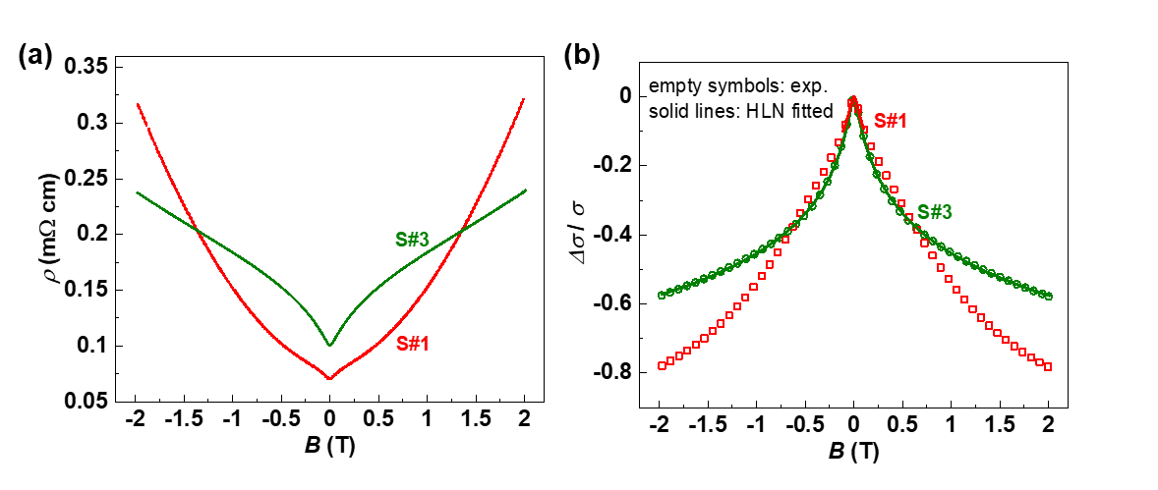
Fig. S8 Magneto-resistivity analysis. (a) Magneto resistivity and (b) fitting of the change of conductivity as a function of magnetic field by the Hikami-Larkin-Nagaoka (HLN) model for sample #1 and #3.

References

- H. Hayasaka, Weak antilocalization in spin-orbit coupled lattice systems: Effect of nonadiabatic transitions and estimation of spin relaxation length. Phys. Rev. B 104, 205404 (2021).
- D. M. Vu, W. Shon, J.-S. Rhyee, M. Sasaki, A. Ohnishi, K.-S. Kim, H.-J. Kim, Weak antilocalization and two-carrier electrical transport in Bi_{1− x}Sb_{x} single crystals (0%≤ x≤ 17.0%). Phys. Rev. B 100, 125162 (2019).
- A. A. Abrikosov, Fundamentals of the theory of metals. Dover edition, Garden City, New York (2017).

