Table s1 Sheep weight and production records.
Sheep | Weight（Kg） | Litter size | Birth date | Birth weight of lamb（Kg）
HLS-1 | 37.87 | 3 | 2020.4.5 | 2.6/2.8/2.6
HLS-1 | 37.87 | 3 | 2020.11.27 | 2.9/2.8/2.8
HLS-1 | 37.87 | 3 | 2021.8.31 | 2.4/2.8/2.7
HLS-2 | 40.74 | 3 | 2020.4.11 | 2.3/2.7/2.36
HLS-2 | 40.74 | 3 | 2020.12.8 | 2.7/2.9/3.0
HLS-2 | 40.74 | 3 | 2021.9.8 | 3.0/2.9/2.7
HLS-3 | 41.88 | 3 | 2020.3.30 | 3.0/2.8/2.9
HLS-3 | 41.88 | 3 | 2020.11.25 | 3.1/2.6/2.8
HLS-3 | 41.88 | 3 | 2021.8.28 | 2.8/3.0/2.8
LLS-1 | 41.39 | 1 | 2020.4.15 | 4.3
LLS-1 | 41.39 | 1 | 2020.11.30 | 5
LLS-1 | 41.39 | 1 | 2021.8.28 | 5.2
LLS-2 | 42.41 | 1 | 2020.4.7 | 3.9
LLS-2 | 42.41 | 1 | 2020.12.1 | 4.1
LLS-2 | 42.41 | 1 | 2021.9.5 | 3.8
LLS-3 | 42.23 | 1 | 2020.4.15 | 4.6
LLS-3 | 42.23 | 1 | 2020.12.10 | 4.4
LLS-3 | 42.23 | 1 | 2021.9.01 | 4.3

Table s2. Blood biochemical ELISA kit information
Item | Name of kit | Item number | Manufacturer | Origin
E₂ | Ovine estradiol, E2 ELISA kit | F3906-B | Kexing Trading Co. LTD | Shanghai,  China
LH | Ovine luteinizing hormone, LH ELISA kit | F72141-B | Kexing Trading Co. LTD | Shanghai,  China
FSH | Ovine follicle-stimulating hormone, FSH ELISA kit | F7100011-B | Kexing Trading Co. LTD | Shanghai,  China
T | Ovine testosterone, T ELISA kit | F3907-B | Kexing Trading Co. LTD | Shanghai,  China
Prog | Ovine progesterone, PROG ELISA kit | F3911-B | Kexing Trading Co. LTD | Shanghai,  China

Figure S1. Function enrichment of granule cell sub-cluster marker genes.
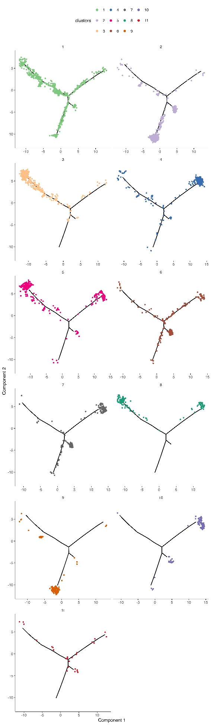
Figure S2. Cell trajectory by clusters.
Figure S3. The relative expression of key genes in the pathways in granulosa cell subtypes.

