Appendix

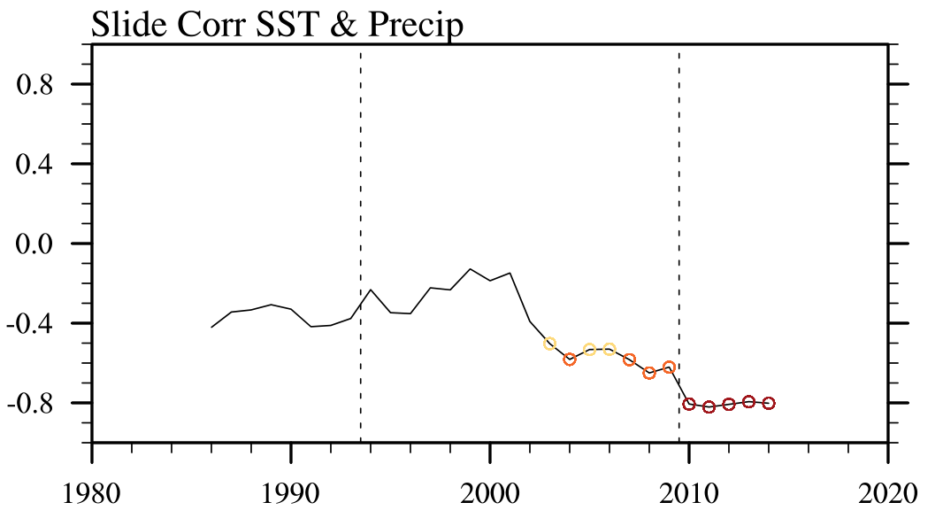
Fig. S1. The 11-year sliding correlation coefficients of local precipitation and SST over the SCS. The yellow, orange and red circles indicate the correlation exceeding the 90%, 95%, and 99% confidence level, respectively.

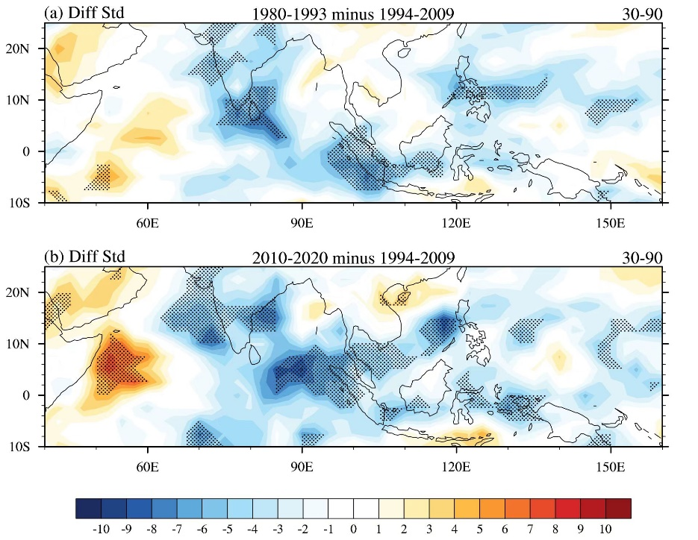
Fig. S2. Composite different squared deviation (W/m²) of 30-90-day OLR in May. (a) 1980-1993 minus 1994-2009, (b) 2010-2020 minus 1994-2009. Dots indicate the difference passed the 90% confidence level (Monte Carlo test).

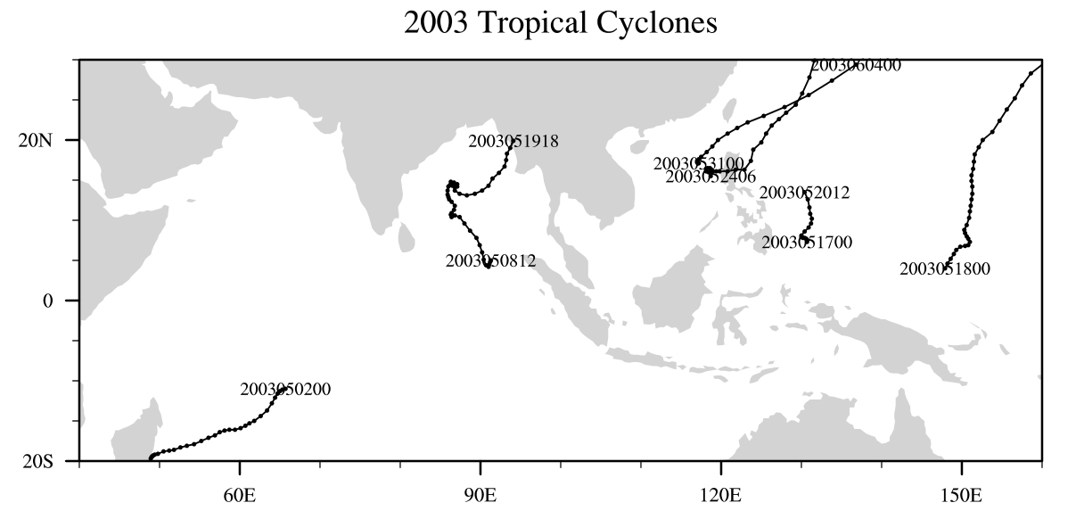
Fig. S3. The tropical cyclone tracks in the Indo-Northwest Pacific Region in May 2003. Data comes from Joint Typhoon Warning Center (JTWC) (navy.mil).

