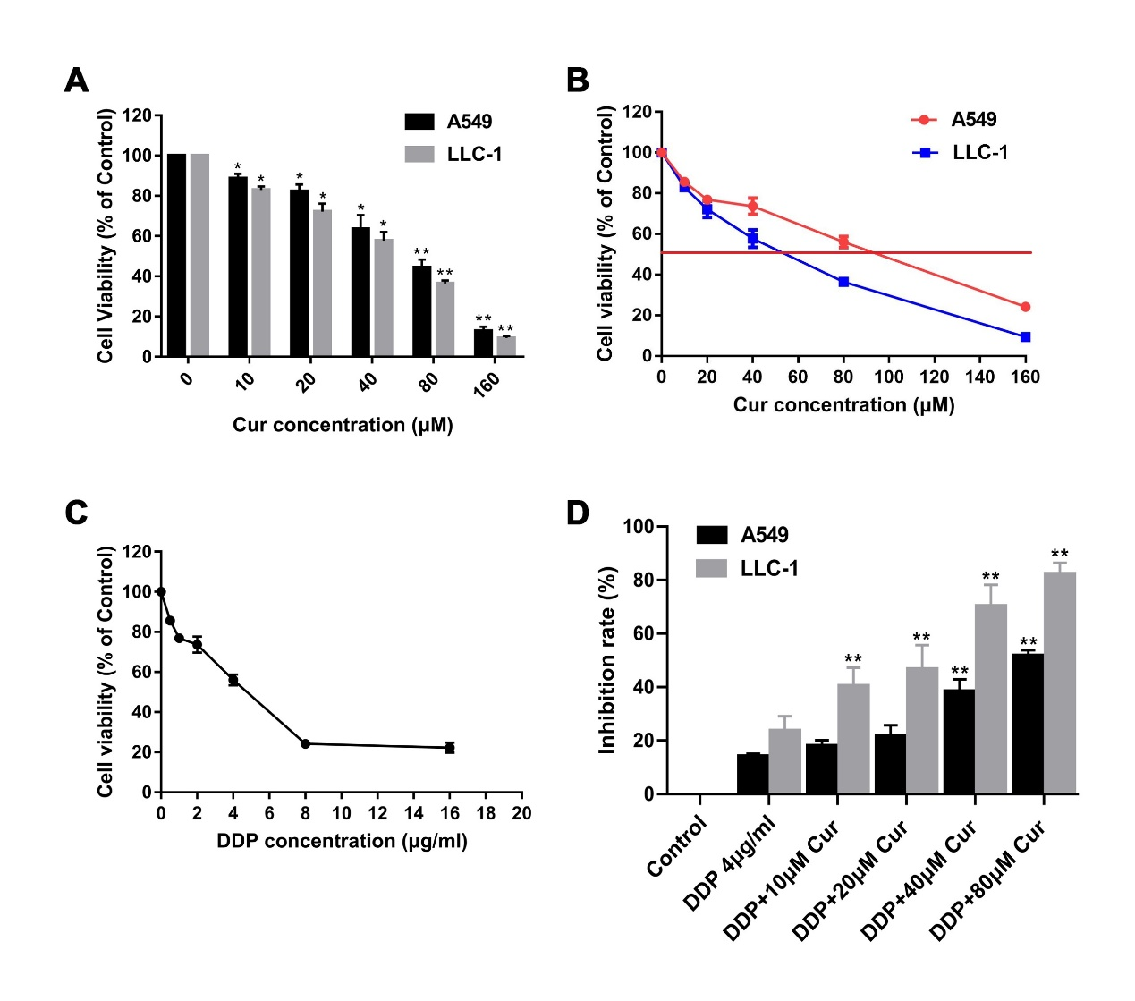
Fig. S1. Cur combined with DDP inhibits the proliferation activity of A549 and LLC-1 cell lines. (A) MTT assay was used to determine the inhibitory effect of different concentrations of Cur on the growth of lung cancer cell lines. (B) Half maximal inhibitory concentration (IC50) of Cur treatment for A549 and LLC-1. (C) MTT assay was utilized to determine the inhibitory effect of different concentrations of DDP on the growth of lung cancer cell lines. (D) MTT assay was performed to determine the inhibitory effect of different concentrations of Cur combined with DDP on the growth of lung cancer cell lines. *P < 0.05, **P < 0.01, compared to control group.

