Supplementary Materials for

Modular compliant cube with anisotropic nonlinear responsiveness

Hongyi Yao, Xiaoyu Zhao, and Shengli Mi
Corresponding author: mi.shengli@sz.tsinghua.edu.cn

The PDF file includes:

Materials and Methods
Supplementary Text
FigureS1 Geometric definition of ASCBp.
FigureS2 Schematic diagram of the transformation process of ribbon and frame.
FigureS3 Detail diagram of the geometric features used for connection on the ribbon and frame.
FigureS4 Diagram of the assembly process of MCC.
FigureS5 Detail schematic of the load frame connected to the tilt angle Ω.
FigureS6 Numerical simulation results of the ribbon.
FigureS7 Design diagram of the generic interface.
FigureS8 Deformation performance of the MCC for different A under the condition of fixed a.
FigureS9 Procedure diagram of assembling AHMM.
FigureS10 Procedure diagram for assembling AHMM-DN.
FigureS11 Physical diagram of AHMM-DN sample with size 3×3×3.
FigureS12 Procedure diagram for assembling CRU.
FigureS13 Physical diagram of the two eCRUPs.
FigureS14 Physical diagram of the modular compliant octahedron.
Tables S1 The connection table of MCC
Other Supplementary Materials for this manuscript include the following:

MovieS1 Demonstration of compression of a single MCC.
MovieS2 Compression demonstration of AHMM.
MovieS3 Demonstration of anisotropic shear stiffness of AHMM and bouncing after free fall.
MovieS4 Demonstration of CRU deformation.
MovieS5 Linear and turing motion of a CRUP.
MovieS6 Straight-line racing of two eCRUPs.
MovieS7 Demonstration of an eight-legged flexible robot traversing a complex scene.

Supplementary Text
1. Overview of procedural modelling of the MCC
Procedural modelling is an automated modelling method. Based on this, one can build complex 3D geometric models by cascading basic geometric elements, such as points, lines and surfaces; this cascading gives these geometric models programmability, that is, a number of interface parameters can be changed to drive continuous changes in the model geometry.
The cascade architecture of the MCC is divided into three layers; the first is the basic layer, whose constituent elements are the arc-serpentine curved beam pairs (ASCBp); the second is the derivative layer, whose constituent elements are the ribbon and frame structures derived from the ASCBp; and the third is the model layer, whose constituent elements are the MCC. The third layer is the model layer, which is composed of the MCC, a unit consisting of a given number of ribbon and frame interconnected to form a positive polyhedral structure. Without loss of generality, the orthopolyhedron used in this paper is the orthohexahedron (cube).
The MCC modelling is a top-down and then bottom-up process as follows:
(1)Decompose a cubic template of dimension A (mm) into six movable face elements and reduce them to a in equal proportions while maintaining their position and orientation.
(2)Replace the moved surface element with a frame.
(3)Use of ribbons to connect frames to form modular resilience.

In the above steps, step one implements the top-down decomposition of the square template, and steps two and three implement the programmatic modelling and assembly of the modular unit from the decomposed face element in a bottom-up direction; clearly, the nature of the entire MCC is determined only by the size of the and.
The design of the ASCBp as a basic layer element is described in detail in subsection 2; based on this, the ribbon generation algorithms for the frames in step 2 and step 3 are briefly described in subsections 3 and 4 respectively; the core, coupling algorithm for determining the number and distribution of ribbons (i.e. which two frames are connected by a ribbon) is described in subsection 5; finally, the mechanical assembly details for achieving fixed constraints between ribbons and frames are briefly exemplified in subsection 6.

2.Arc-serpentine curved beam pairs (ASCBp)
The ASCB is a composite curve consisting of a circular arc of equal curvature combined with a serpentine, the neutral axis of the ASCB being the serpentine curve with a rectangular cross section, the ratio of width to thickness being $β$. The curve is centered on the serpentine and has an arc of equal curvature but opposite direction at the beginning and end of the curve. Compared to the traditional serpentine, the serpentine curve retains its central symmetry (i.e., handedness), but discards the straight section in the central region and replaces it with a circular arc.
Since a single arc serpentine curve can be subdivided into four circular arc segments of equal curvature, the mathematical model of the curve is chosen to be built in the complex domain. Firstly, the four arc segments $A_{j}^{0}(j=1,2,…4)$ with the center of the circle at the origin can be expressed as:
$$\begin{aligned}A_{j}^{0}=ρ_{j}e^{i\left(φ_{j}+sign\left(2.5−j\right)t_{j}\right)I_{h}}\#\left(1\right)\end{aligned}$$
where $ρ_{j}$, $φ_{j}$and $t_{j}$ are the radius of curvature, phase angle and position parameters corresponding to the jth arc segment, respectively. And, $φ_{j}$satisfies the iterative relation:
$$\begin{aligned}φ_{j+1}=φ_{j}+γ_{j}θ_{j}−0.5π (1−γ_{j}γ_{j+1})\#\left(2\right)\end{aligned}$$
In particular, define $φ_{1}=−π/2。γ=[1,1,−1,−1]$ as a vector consisting of the signs of the curvature of each arc segment. $θ_{j}$ is the angle of the corresponding circle centre of the arc segment, so that ${t_{j}∈[0,θ}_{j}]$. $I_{h}$ is the chiral indicative value and the arc serpentine curve for $I_{h}=1$is defined as a left-handed curve. Conversely, the arc serpentine curve of $I_{h}=−1$ is defined as a right-handed curve.
Secondly, the four arc segments are docked in a translational manner with their heads and tails connected, and the circular arc segment after the translation is $A_{j}\left(t_{j}\right)$:
$$\begin{aligned}A_{j+1}\left(t_{j+1}\right)=A_{j+1}^{0}\left(t_{j}\right)− A_{j+1}^{0}\left(0\right)+A_{j}^{0}\left(θ_{j}\right)\#\left(3\right)\end{aligned}$$
Finally, the expressions for the segments after the translation are summed:
$$\begin{aligned}G\left(t\right)= \sum_{j=1}^{4}{δ_{jl}A_{j}(t−\sum_{k=1}^{l}{θ_{k}})}\#\left(4\right)\end{aligned}$$
where $t∈\left[0,\sum_{j=1}^{4}{θ_{j}}\right],l=5−\sum_{j=1}^{4}{\left\lfloor \min\left\{\sum_{k=1}^{j}{θ_{k}},k\right\}/t\right\rfloor }$. For an arc serpentine curve to be internally tangent to a square, the radius $ρ_{j}$ of each circular segment and the angle $θ_{j}$ of the center of the circle need to satisfy the following relationship:
$$\begin{aligned}\begin{matrix}θ_{1}=θ_{4} \\ θ_{2}=θ_{3} \\ ρ_{1}=ρ_{4}\end{matrix} \\ ρ_{2}=ρ_{3}=0.25ρ_{1}(2−secθ_{1})\end{aligned}\left(5\right)$$
At this point, the mathematical model of a standard arc serpentine curve, consisting of a serpentine with two arc segments, is established. Next, the extended arc serpentine curve will be described. The extended arc serpentine curve adds a circular arc segment to the standard arc serpentine curve at its beginning/end. This segment can be coplanar or anisotropic with the complex plane, forming a coplanar expanded arc serpentine curve (used in the frame scenario) and a non-coplanar expanded arc curve (used in the ribbon scenario), respectively, with the standard arc curve. Therefore, the mathematical description of the expanded arc serpentine curve is the basis for subsequent work. The specific process is as follows:
1) Extend the description of the standard arc serpentine curve in the complex domain to three-dimensional space. Establish a three-dimensional orthogonal coordinate system $C^{3}$.
$$C^{3}=\left\{\left(x_{1},ix_{2},x_{3}\right):x_{j}∈R for j=1,2,3\right\}$$
and take $\left(e_{1},e_{2},e_{3}\right)$ as a set of bases for $C^{3}$, i.e. $C^{3}=span\left(e_{1},e_{2},e_{3}\right)$,where $e_{1}=\left(1,0,0\right),e_{2}=\left(0,i,0\right),e_{3}=\left(0,0,1\right)$.
2) The standard arc serpentine curve is constructed in the plane of the $e_{1}ande_{2}$ expansions according to the above process, i.e:
$$\begin{aligned}G\left(t\right)∈span\left(e_{1},e_{2}\right)\#\left(6\right)\end{aligned}$$
3) For a coplanar expanding arc serpentine curve, a segment of coplanar arc of equal curvature extends smoothly from the end/head of the standard left/right-handed circular arc curve. Denote this type of circular arc segment as coplanar arc segment $A_{c}$. The corresponding circular centre angles and radii of curvature are $ρ_{c}and θ_{c}$ respectively, i.e:
$$\begin{aligned}A_{c}\left(t_{c}\right)=ρ_{c}e^{i\left(φ_{c}−t_{c}\right)I_{h}}+\frac{\left(I_{h}+1\right)}{2} G\left(\sum_{j=1}^{4}{θ_{j}}\right)\#\left(7\right)\end{aligned}$$
where ${t_{c}∈[0,θ}_{c}]$, and:
$$\begin{aligned}φ_{c}=\left\{\begin{aligned}φ_{4}+θ_{4}, for I_{h}=1 \\ 0, for I_{h}=−1\end{aligned}\right. \#\left(8\right)\end{aligned}$$
Thus, in $C^{3}$, the parametric mathematical model for the coplanar expanding arc serpentine curve is：
$$\begin{aligned}G_{c}\left(t\right)=\left(Re\left(G_{c}\left(t\right)\right),iIm\left(G_{c}\left(t\right)\right),0\right)\#\left(9\right)\end{aligned}$$
where:
$$\begin{aligned}G_{c}\left(t\right)= \left\{\begin{aligned}G\left(t\right), for t∈\left[0,\sum_{j=1}^{4}{θ_{j}}\right] \\ A_{c}\left(t−\sum_{j=1}^{4}{θ_{j}}\right), for t∈\left(\sum_{j=1}^{4}{θ_{j}}\right.,\left.\sum_{j=1}^{4}{θ_{j}}+θ_{c}\right]\end{aligned}\right.\#\left(10\right)\end{aligned}$$
(4) For a non-coplanar extended circular curve, an isocurvature non-coplanar arc $A_{b}$ extends smoothly from the end/head of the standard left/right handed circular curve. The angle between the plane in which $A_{b}$ lies and the plane in which $A_{c}$ lies is $θ_{r}$. The corresponding angle of centre and radius of curvature of this arc are $ρ_{b }and θ_{b}$ respectively.
To facilitate the description, the plane in which the non-coplanar circular arc segment is located is first coincident with the plane in which the circular curve is located, at which point the mathematical description of the non-coplanar circular arc segment $A_{b}$ is the same as that of the coplanar arc segment $A_{c}$, i.e:
$$\begin{aligned}A_{b}\left(t_{b}\right)=ρ_{b}e^{i\left(φ_{b}−t_{b}\right)I_{h}}+\frac{\left(I_{h}+1\right)}{2} G\left(\sum_{j=1}^{4}{θ_{j}}\right)\#\left(11\right)\end{aligned}$$
where ${t_{c}∈[0,θ}_{c}]$, and:
$$\begin{aligned}φ_{b}=\left\{\begin{aligned}φ_{4}+θ_{4}, for I_{h}=1 \\ 0, for I_{h}=−1\end{aligned}\right. \#\left(12\right)\end{aligned}$$
The rotation operation is performed next. Let the unit velocity vector at the end/head endpoint of the left/right standard arc serpentine curve be $e_{v}$ and the unit quaternion $q=\left(\cos\left(θ_{r}/2\right),sin⁡(θ_{r}/2)e_{v}\right)$. The rotated non-coplanar arc segment $A_{b}^{r}\left(t\right)$ can then be expressed as:
$$\begin{aligned}A_{b}^{r}\left(t\right)=R[q\left(1,Re\left(A_{b}\left(t\right)\right),Im\left(A_{b}\left(t_{b}\right)\right),0\right)q^{∗}]\#\left(13\right)\end{aligned}$$
where $R[∙]$ is the part of the vector that takes the corresponding quaternion.
Thus, in $C^{3}$, the parametric mathematical model for the non-coplanar expanded arc serpentine curve is:
$$\begin{aligned}G_{b}\left(t\right)=\left\{\begin{aligned}\left(Re\left(G\left(t\right)\right),iIm\left(G\left(t\right)\right),0\right), for t∈\left[0,\sum_{j=1}^{4}{θ_{j}}\right] \\ A_{b}^{r}, for t∈\left(\sum_{j=1}^{4}{θ_{j}}\right.,\left.\sum_{j=1}^{4}{θ_{j}}+θ_{c}\right]\end{aligned}\right.\#\left(14\right)\end{aligned}$$
At this point, the mathematical models for both forms of the expanded arc serpentine curve have been built.
Further, we will construct pairs of ASCB from pairs of arc serpentine curves. The first endpoint of any right-handed arc serpentine curve is translated to coincide with the endpoint of a left-handed arc serpentine curve with the same parameters (radius of curvature and centre angle), and the connection is kept smooth (i.e. the velocity vectors of the two arc serpentine curves at the point of contact are kept the same by pre-rotation before translation). The composite curve formed by this rotation-translation operation is defined as the arc serpentine curve pair. With this as the neutral axis and the rectangle as the cross-section, the arc serpentine curve pair is swept into shape. In addition, to prevent off-surface instability of the arc serpentine curves, the ratio of the width $W$ to the thickness $T$ is taken to be $β=4$ and the thickness $T=\sqrt{2}mm$. These three pairs form the base layer of the MCC cascade architecture. On their basis, we construct the derived layer, as described in subsections 3 and 4;

3. Frame structure generation process
The frame structure is a square structure composed of ACSBp. Obviously, the conversion of a square made of straight lines into a frame made of ACSBp is the core of the entire structure generation process. To refine this, it is necessary to determine the type, size, number and position of the corresponding ACSBp according to the length of the sides of the square. There are two types of ACSBp used in this part of the method, the standard pair and the coplanar expansion pair.
For the sake of brevity, the relevant parameters are defined here. The minimum ASCB size allowed by the actual process is $ρ_{min}$; the number of ASCBp's contained in a quarter of the frame is $n_{0.25}$; as the standard arc serpentine curve has a square cut into it, the side length $ρ$ of the square is the corresponding ASCBp size; the half length of the square template is $L=a/2$.
The specific generation process is as follows:
(1) Decompose the four sides of the square template into four identical fold segments by taking the midpoints of the four sides of the square and carrying out the following steps using the first quadrant fold segment as an example.
2) The number of ASCBp required for a rough calculation of the folded segment ${\overline{n}}_{0.25}$:
$$\begin{aligned}{\overline{n}}_{0.25}=2\left\lceil \frac{β_{f}−1}{2}\right\rceil −1\#\left(15\right)\end{aligned}$$
where $β_{f}$ is the length scaling factor:
$$\begin{aligned}β_{f}=\frac{L}{ρ_{min}}−0.5\#\left(16\right)\end{aligned}$$
3) Rough calculation of ASCBp size $\overline{ρ}$:
$$\begin{aligned}\overline{ρ}=\frac{L}{{\overline{n}}_{0.25}+0.5}\#\left(17\right)\end{aligned}$$
4) Verify the validity of $\hat{ρ}$ and determine the final number of ASCBp's $n_{0.25}$:
$$\begin{aligned}n_{0.25}=\left\{\begin{aligned}{\overline{n}}_{0.25}, for \hat{ρ}≥ρ_{min} \\ {\overline{n}}_{0.25}−2, for \hat{ρ}<ρ_{min} \end{aligned}\right.\#\left(18\right)\end{aligned}$$
5) Calculate the ASCBp final size $ρ_{f}$:
$$\begin{aligned}ρ_{f}=\frac{L}{n_{0.25}+0.5}\#\left(19\right)\end{aligned}$$
In the framework structure, we set $ρ_{1}=ρ_{c}=ρ_{f}$ and $θ_{1}=θ_{c}=π/4$.
(6) If $n_{0.25}=1$, then only one coplanar expansion pair needs to be generated; if $n_{0.25}>1$, then only one coplanar expansion pair needs to be generated at the same time, along with $n_{0.25}−1$ standard pairs. In this case, the standard pairs are connected uniformly symmetrically and smoothly to the first and last endpoints of the coplanar expansion pair.
7) Repeat steps 2-6 for the remaining quadrant of the folded segments. When complete join the four sets of arc-snake curve pairs in sequence to form a smooth closed curve and use this as the neutral axis to form the body of the frame structure by sweeping as described in subsection 2.
8) Add an octagonal connector with an internal diameter of 2.2mm to the center of each serpentine beam. Further details can be found in subsection 6.
With the above algorithm, we can convert any square template into a frame and ensure that the sides of the square pass through the geometric centers of all the curves of the frame. The converted body of the frame remains square, and the side length becomes $a+ρ$ and the thickness $βT$.

4. Ribbon structure generation process
A ribbon structure is a spatial vertical structure consisting of pairs of curved serpentine beams, similar to a corner piece. Similarly, to the frame structure, the conversion of vertical folded segments made up of straight lines into ribbon structures made up of ASCBp is the core of the generation process. Specifically, it is necessary to determine the type, size, number and position of the corresponding ASCBp based on the side lengths of the vertical folds. There are two types of ASCBp used in this part of the method, the standard pair and the non-coplanar expanded pair. Unlike frame structures, which are converted at square corners using co-planar expansion pairs, ribbon structures are converted at vertical bends using non-coplanars expanded pairs. This treatment ensures the alignment of the normal vectors between the ribbon and the frame at the joint interface.
Again, the relevant parameters are defined first. Denote the minimum ASCB size allowed by the actual process as $ρ_{min}$; the number of ASCBp contained in a ribbon as $n_{1}$; the size of the resulting ASCBp as $ρ$; and the radius of the non-coplanar arc $ρ_{b}$:
$$\begin{aligned}ρ_{b}={ω_{c}ρ}_{f}\#\left(20\right)\end{aligned}$$
where $ω_{c}$ is the radius scale factor. This is an adjustment parameter with a default value of 1.2. The coordinates of the start, end and intersection points of the vertical dash are noted as $P_{a}{，P}_{b} and P_{c}$ and the velocity vectors at the start and end points are $V_{a} and{ V}_{b}$ respectively.
The specific process is as follows:
(1) Calculate $P_{c}=F\left(P_{a}{,P}_{b},V_{a},V_{b} \right)$ according to the classical intersection finding algorithm.
(2) In general, unlike frames, in ribbons $ρ_{b}≠ρ_{1}$. Therefore, the area of radius $ρ_{b}$ around the intersection point (fold corner) needs to be set aside separately for the generation of heterogeneous expanding circular beams in the rough calculation of the number of ASCBp required. With this, the number of ASCBp required for the rough calculation of the folding segments, ${\overline{n}}_{1}$, is
$$\begin{aligned}{\overline{n}}_{1}=2\left\lceil \frac{β_{r}}{2.5}\right\rceil −1\#\left(21\right)\end{aligned}$$
where $β_{r}$is:
$$\begin{aligned}β_{r}=\frac{\left\|P_{c}−P_{a}\right\|−ρ_{b}}{ρ_{min}}\#\left(22\right)\end{aligned}$$
Note that the two sides of the vertical fold segment to be converted in the scenario in this paper are of equal length, thus $\left\|P_{c}−P_{a}\right\|=\left\|P_{c}−P_{b}\right\|$. Therefore, for more generalised conditions, the two side lengths need to be calculated separately for each ${\overline{n}}_{1}$.
(3) Rough calculation of ASCBp size $\overline{ρ}$:
$$\begin{aligned}\overline{ρ}=\frac{\left\|P_{c}−P_{a}\right\|}{{\overline{n}}_{1}−0.5}\#\left(17\right)\end{aligned}$$
(4) Verify the validity of $\hat{ρ}$ and determine the final number of ASCBp$,n_{1}$:
$$\begin{aligned}n_{1}=\left\{\begin{aligned}{\overline{n}}_{1}, for \hat{ρ}≥ρ_{min} \\ {\overline{n}}_{1}−2, for \hat{ρ}<ρ_{min} \end{aligned}\right.\#\left(18\right)\end{aligned}$$
(5) Calculate the final size of the ASCBp $ρ_{r}$:
$$\begin{aligned}ρ_{r}=\frac{\left\|P_{c}−P_{a}\right\|}{n_{1}−0.5}\#\left(19\right)\end{aligned}$$
In the ribbon, we set $ρ_{1}=ρ_{r}$ and $θ_{1}=θ_{b}=π/4$.
(6) If $n_{1}=1$, only one non-coplanar expanded pair is generated; if $n_{1}>1$, one non-coplanar expanded pair and $n_{1}−1$ standard pairs are generated. In this case, the standard pairs are connected uniformly symmetrically and smoothly to the first and last endpoints of the non-coplanar expanded pair. This is then used as the neutral axis to form the body of the ribbon by sweeping as described in subsection 2.
(7) Unlike the frame, an octagonal connector with an internal diameter of 2.2mm is added at the centre of the first and last ASCBs. Further details can be found in subsection 6.
With the above algorithm, we can convert a given vertical fold segment into a ribbon, and ensure that the vertical fold passes through the geometric center of the ribbon's first and last arc snake curves. The converted ribbon body is "L" shaped and has an overall length of $2\left\|P_{c}−P_{a}\right\|+ρ+{ρ_{b}π}/4$ and a thickness of $βT$.
At this point, we have described the rules for the generation of the basic elements (frames and ribbons) of the second derivative layer of the cascade architecture. In the third model layer, the two elements are stacked and assembled in a given number and distribution to form the final MCC, obviously with the number and position of the frames corresponding to the six square templates. And the way in which these six frames are connected to each other by ribbons determines the number, position and attitude of the ribbons in a single MCC. In this document, this information is given in the connection table. The contents of the connection table and the algorithm used to generate it therefore directly determine the topology and corresponding mechanical properties of the entire MCC.

5. Algorithm for generating connection tables
For documentation and description purposes, it is necessary to define the face number $I_{f}$ for all frames in a single MCC, followed by the point number $I_{p}$ for the interfaces in a single frame, each of which is an integer and must be unique. The face number can take the value range $I_{f}∈\left[0,5\right]$, which is not specific and can be generated randomly. The point number range $I_{p}∈\left[0,8n_{0.25}−1\right]$ is defined in the order in which the arc-snake pairs are generated in the individual frames described in subsection 3, i.e. starting with the arc serpentine curve closest to the Y-axis in the first quadrant and proceeding clockwise from 0. The interface reference syntax is defined as interface $I_{f}−I_{p}$. For example, interface 2-0 indicates an interface with point number 0 in a frame with face number 2. It should be noted that only the interfaces of the co-planar expanded pairs in this chapter are used for assembly with ribbons in the frame, and all interfaces in subsequent content refer to such interfaces.
Before generating the connection table, it is necessary to calculate the tangent connection matrix $T$ First, the nearest neighbour interfaces for each interface are calculated and form a $6×8n_{0.25}×2$ three-dimensional matrix $H$. $H_{ij1}$denotes the point number of the nearest neighbour interface for the $i−j$ interface (the interface with point number j in the frame with face number i); similarly, $H_{ij2}$ denotes the point number of the nearest neighbour interface for the i-j interface (the interface with point number j in the frame with face number i) of the nearest neighbouring interface. Next, the three-dimensional matrix $T$ is calculated by deriving from $H$.
$$\begin{aligned}\left\{\begin{aligned}T_{ij1}=H_{ij1}+{(−1)}^{\left\lceil 0.5H_{ij1}\right\rceil −1} \\ T_{ij2}=H_{ik2}\end{aligned}\right.\#\left(20\right)\end{aligned}$$
where $k=j+{(−1)}^{\left\lceil 0.5H_{ij1}\right\rceil −1}$. On the basis of $T$, the connection table is generated. In the initial state, all interfaces are available and the corresponding state indicator $I_{j}=0$ When any interface is recorded in the connection table, its$I_{j}=1$, indicating that the interface is used. At the same time, the state indicator of the interface's neighbouring interfaces in the same co-planar expanded pair, and the corresponding interface in H, becomes $I_{j}=−1$, indicating that the interface is disabled and does not enter the connection table (i.e. two pairs are disabled while one pair is credited). The specific algorithm is as follows.
1) Starting from the frame with face number 0, the interfaces with an even number of point numbers are connected to their corresponding interfaces by $T$ and recorded in the connection table. Each correspondence occupies one row of the connection table, and the elements of each row are the starting interface and the target interface, in that order;
2) For frames with a non-zero face number, a judgement needs to be made based on the number of used holes. If the number of used interfaces is 1 and the corresponding centrosymmetric interface $I_{j}=0$ located on that frame, the centrosymmetric interface and its corresponding interface in T will be recorded in the connection table; if the number of used interfaces is greater than 1, the interfaces with the smallest point number among all available interfaces will be recorded in the connection table in turn. It is important to note that each time a connection is entered into the connection table, the smallest point numbered interface is re-evaluated. When the number of available interfaces in the frame is zero, jump to the next frame and repeat step 2;
3) When all frames have completed their pairing work, the algorithm ends and the join table is generated.
For the cube MCC, the corresponding $H$, $T$ are:
$$\begin{aligned}H_{∙∙1}=\left[\begin{matrix}\begin{matrix}3 & 6 & 5 \\ 3 & 0 & 7 \\ 3 & 2 & 1\end{matrix} & \begin{matrix}0 & 7 & 2 \\ 0 & 7 & 0 \\ 0 & 7 & 6\end{matrix} & \begin{matrix}1 & 4 \\ 7 & 4 \\ 5 & 4\end{matrix} \\ \begin{matrix}3 & 4 & 3 \\ 5 & 6 & 5 \\ 1 & 2 & 7\end{matrix} & \begin{matrix}0 & 7 & 4 \\ 6 & 5 & 6 \\ 2 & 1 & 2\end{matrix} & \begin{matrix}3 & 4 \\ 5 & 6 \\ 1 & 2\end{matrix}\end{matrix}\right]\#\left(21\right)\end{aligned}$$
$$\begin{aligned}H_{∙∙2}=\left[\begin{matrix}\begin{matrix}1 & 5 & 5 \\ 2 & 5 & 5 \\ 3 & 5 & 5\end{matrix} & \begin{matrix}3 & 3 & 4 \\ 0 & 0 & 4 \\ 1 & 1 & 4\end{matrix} & \begin{matrix}4 & 1 \\ 4 & 2 \\ 4 & 3\end{matrix} \\ \begin{matrix}0 & 5 & 5 \\ 1 & 0 & 0 \\ 1 & 2 & 2\end{matrix} & \begin{matrix}2 & 2 & 4 \\ 3 & 3 & 2 \\ 3 & 3 & 0\end{matrix} & \begin{matrix}4 & 0 \\ 2 & 1 \\ 0 & 1\end{matrix}\end{matrix}\right]\#\left(22\right)\end{aligned}$$
$$\begin{aligned}T_{∙∙1}=\left[\begin{matrix}\begin{matrix}7 & 2 & 1 \\ 1 & 2 & 1 \\ 3 & 2 & 1\end{matrix} & \begin{matrix}4 & 3 & 6 \\ 6 & 1 & 6 \\ 0 & 7 & 6\end{matrix} & \begin{matrix}5 & 0 \\ 5 & 6 \\ 5 & 4\end{matrix} \\ \begin{matrix}5 & 2 & 1 \\ 7 & 4 & 7 \\ 3 & 0 & 3\end{matrix} & \begin{matrix}2 & 5 & 6 \\ 4 & 7 & 4 \\ 0 & 3 & 0\end{matrix} & \begin{matrix}5 & 2 \\ 7 & 4 \\ 3 & 0\end{matrix}\end{matrix}\right]\#\left(23\right)\end{aligned}$$
$$\begin{aligned}T_{∙∙2}=\left[\begin{matrix}\begin{matrix}5 & 1 & 3 \\ 5 & 2 & 0 \\ 5 & 3 & 1\end{matrix} & \begin{matrix}5 & 4 & 3 \\ 5 & 4 & 0 \\ 5 & 4 & 1\end{matrix} & \begin{matrix}1 & 4 \\ 2 & 4 \\ 3 & 4\end{matrix} \\ \begin{matrix}5 & 0 & 2 \\ 0 & 1 & 3 \\ 2 & 1 & 3\end{matrix} & \begin{matrix}5 & 4 & 2 \\ 0 & 2 & 3 \\ 2 & 0 & 3\end{matrix} & \begin{matrix}0 & 4 \\ 1 & 2 \\ 1 & 0\end{matrix}\end{matrix}\right]\#\left(24\right)\end{aligned}$$
The corresponding ribbons are generated in sequence according to the generation table shown in Table S1 and are assembled with the frames in a stacked fashion through the interfaces of the corresponding serial numbers.

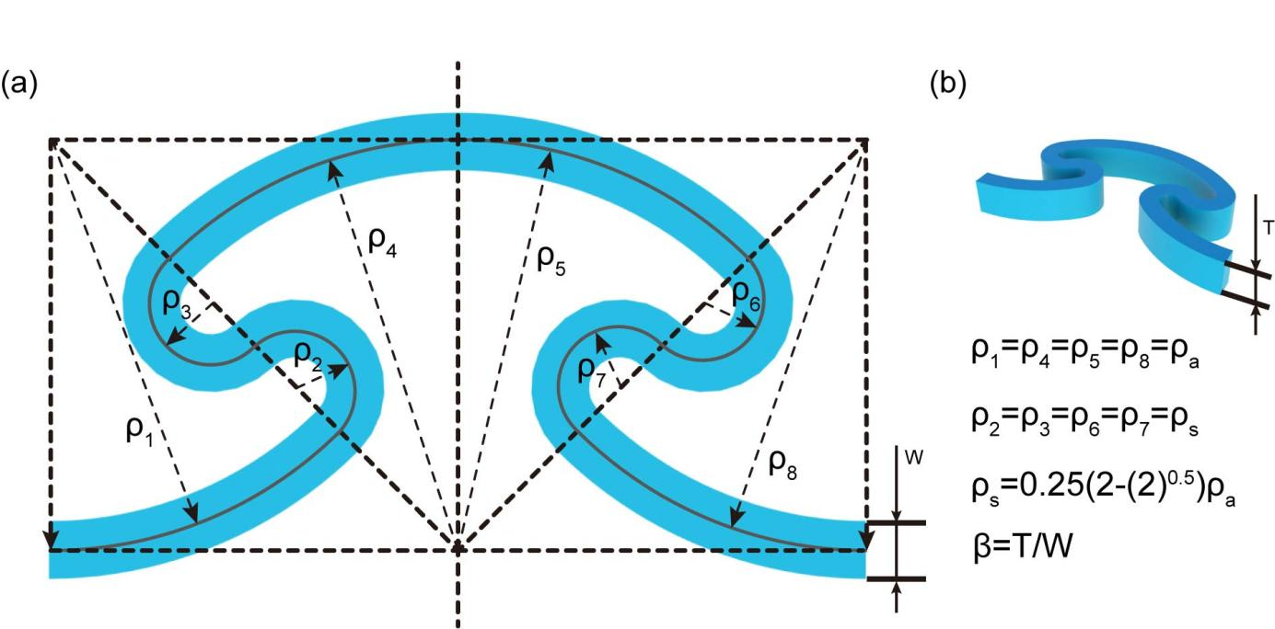

Fig. S1. Geometric definition of ASCBp. (a) Definition of the key geometric parameters. (b) The definition of ASCBp thickness and the constraint relationship between geometric parameters.

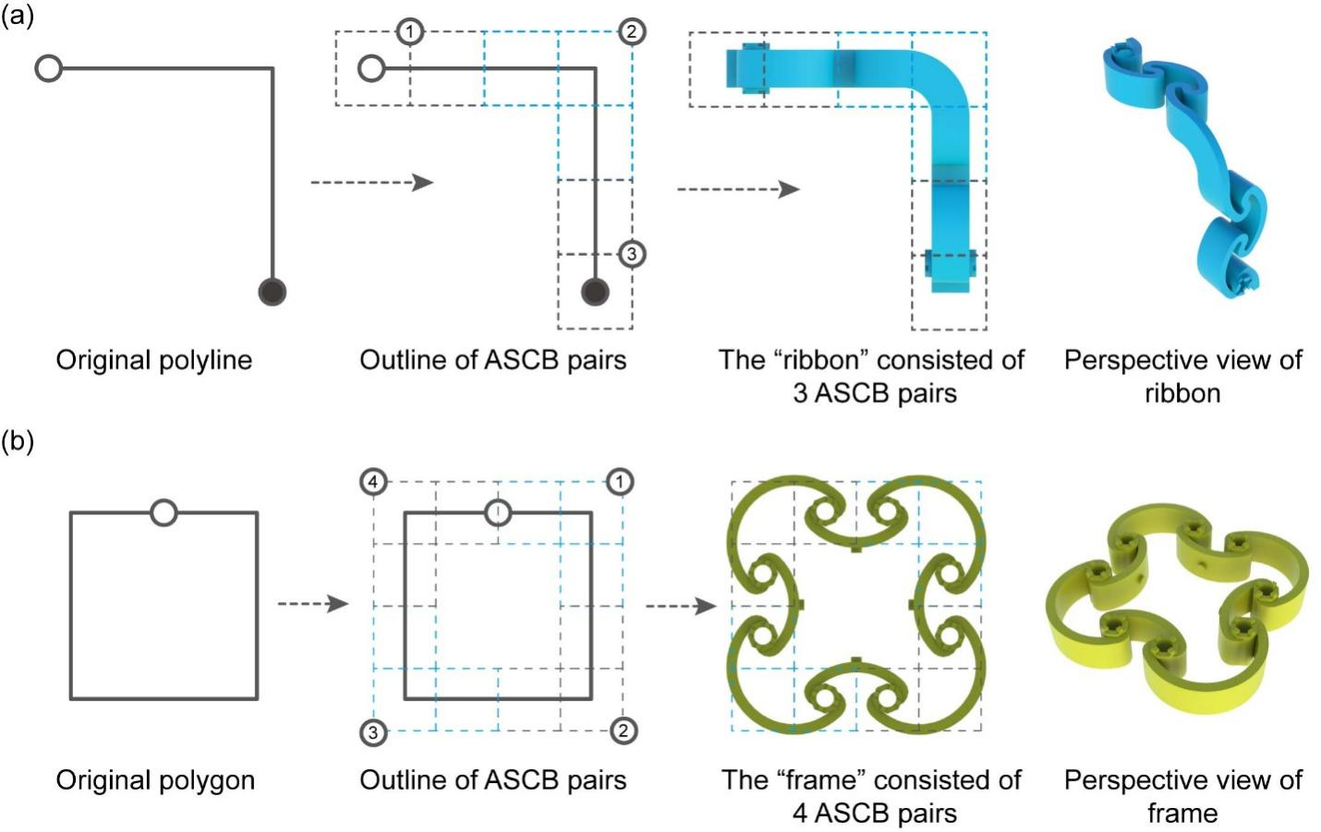

Fig. S2. Schematic diagram of the transformation process of ribbon and frame. (a) Schematic diagram of the transformation process from polyline to ribbon. (b) Schematic diagram of the transformation process from square to frame.

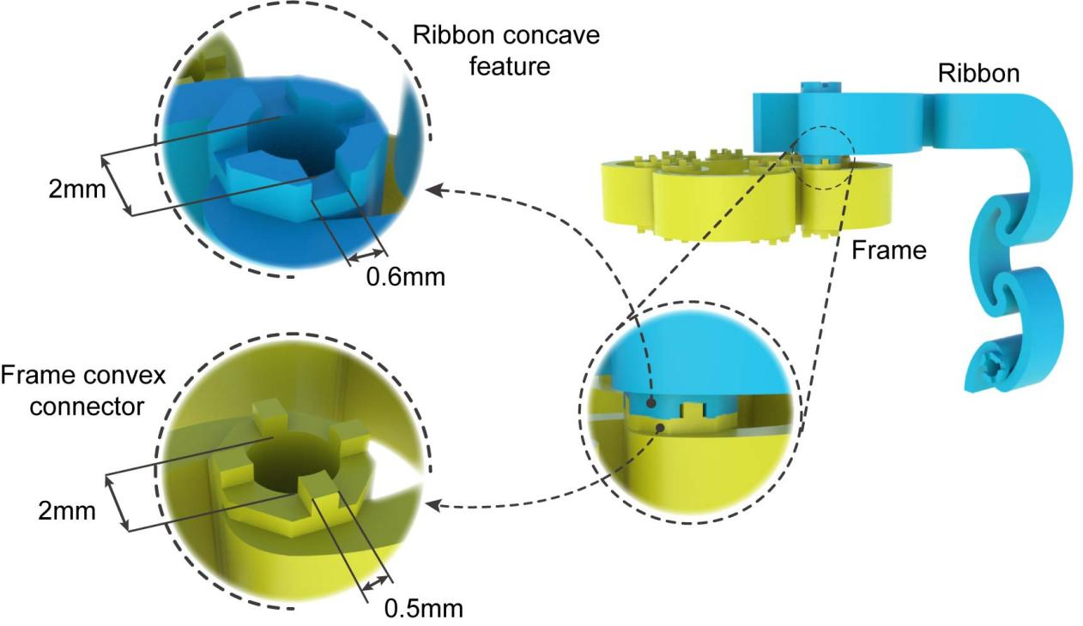

Fig. S3. Detail diagram of the geometric features used for connection on the ribbon and frame.

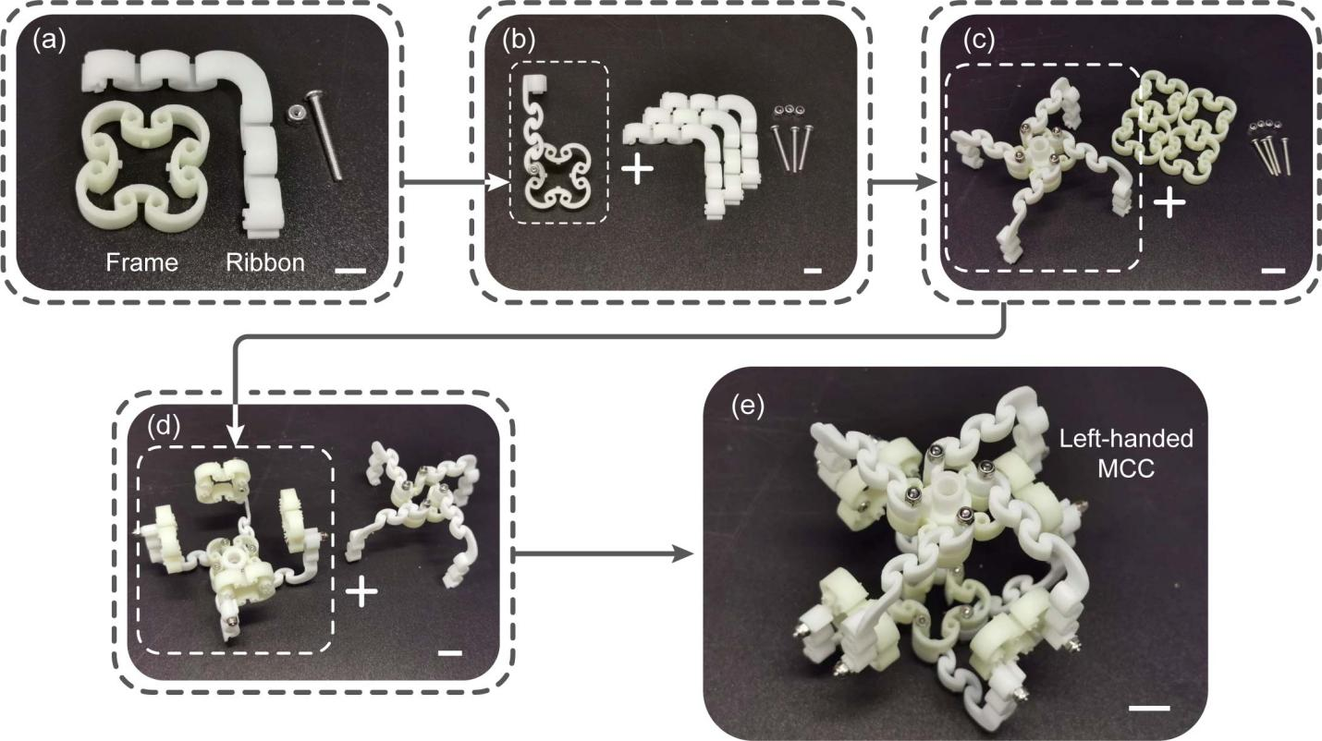

Fig. S4. Diagram of the assembly process of MCC. (a) Details of the frame and ribbon, and the bolts and locknuts required to connect the two. (b) The parts assembled in the above step with the three ribbons and the related standard parts. (c) The quadruple connected frame from the above step with the four frames and the associated standard parts. (d) The parts from the above step with another four-link frame. (e) The final assembly of the left-handed MCC with a scale bar length of 12 mm.

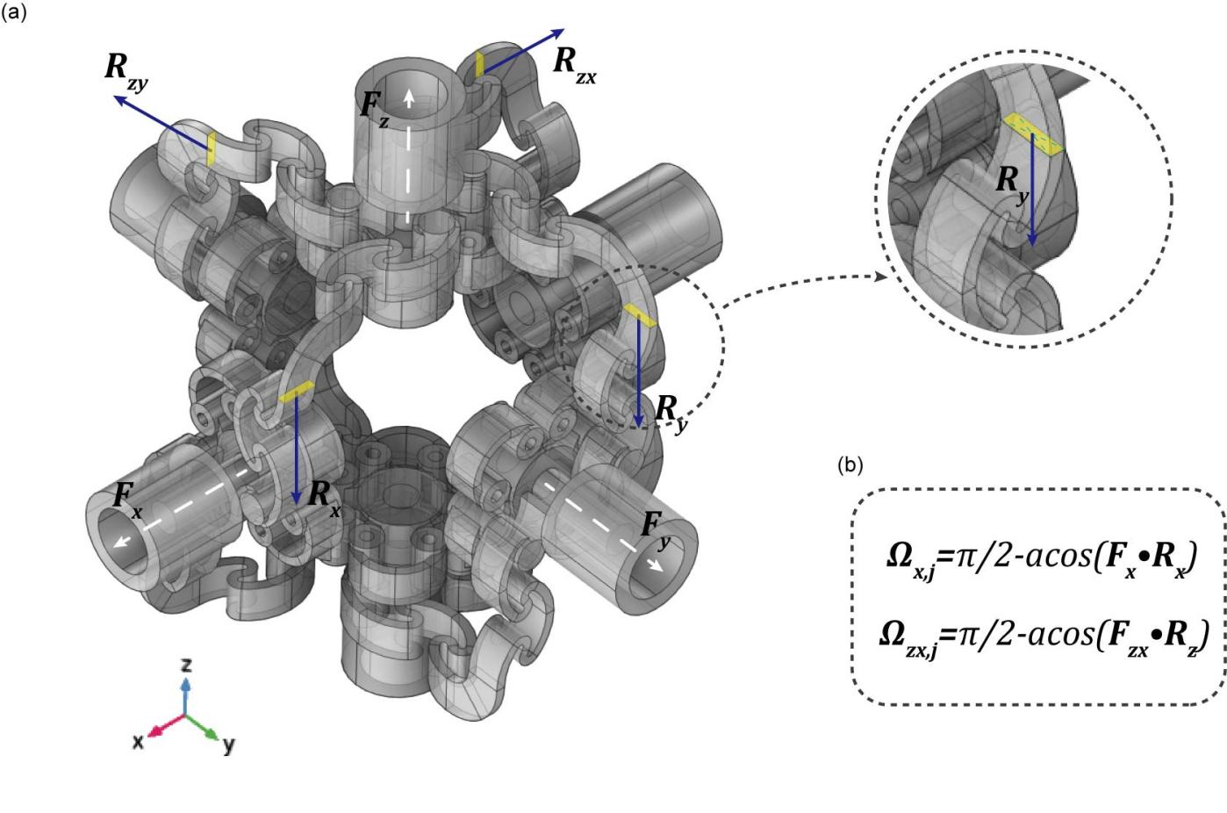

Fig. S5. Detail schematic of the load frame connected to the tilt angle Ω. (a) Definition of the ribbon direction vector R and the load frame normal vector F. (b) Calculated relationship between Ω and R and F.

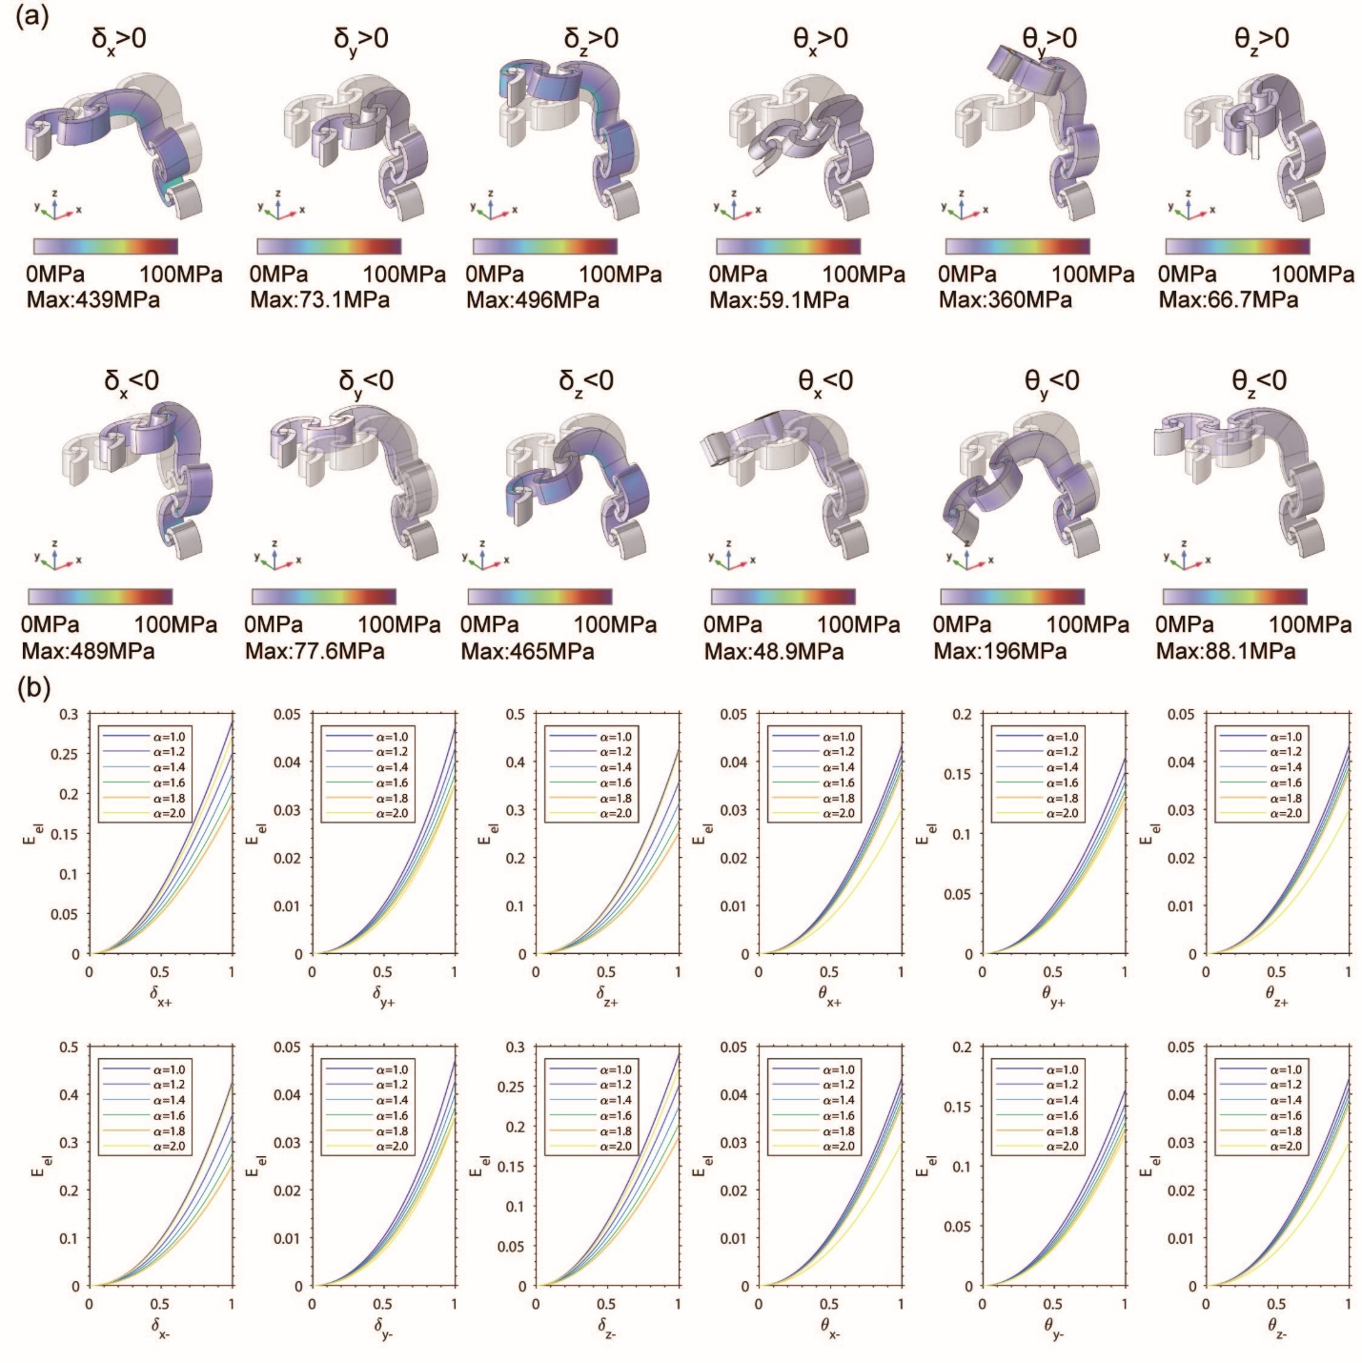

Fig. S6. Numerical simulation results of the ribbon. (a) Deformation diagram and von Mises stress distribution under different boundary displacement conditions. (b) The trend of the elastic energy of the ribbon structure under different values of α corresponding to the above deformation cases.

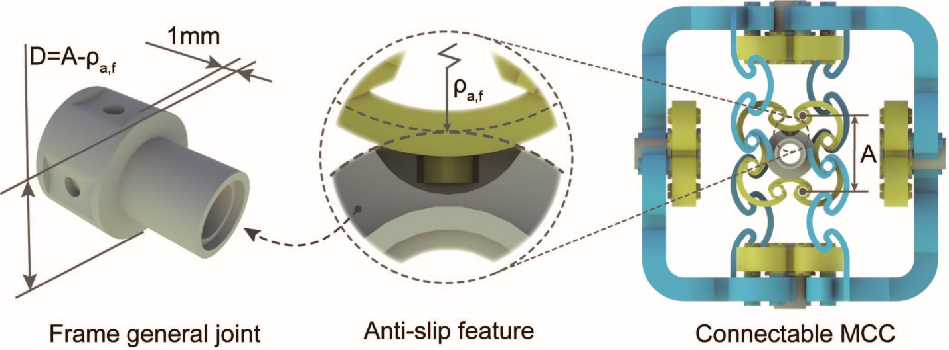

Fig. S7. Design diagram of the generic interface.

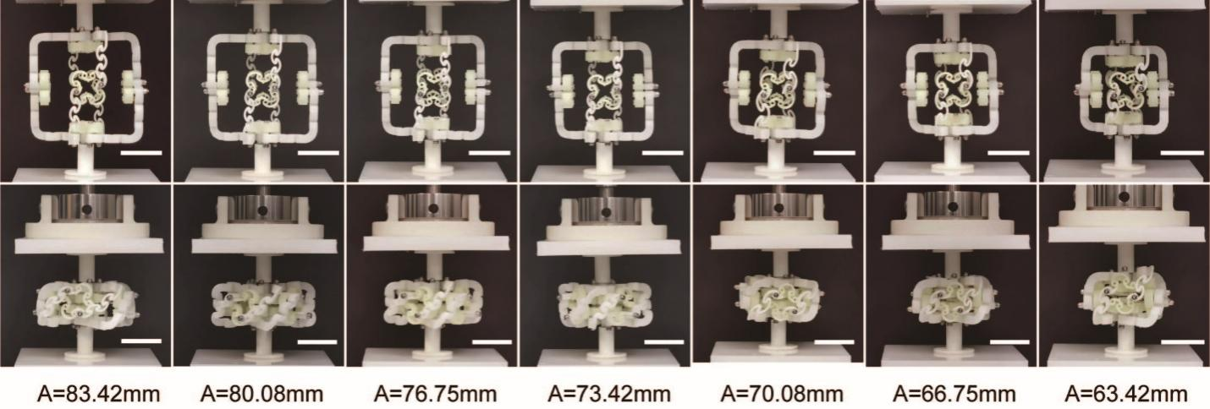

Fig. S8. Deformation performance of the MCC for different A under the condition of fixed a. The length of scale bar in the figure is 40mm.

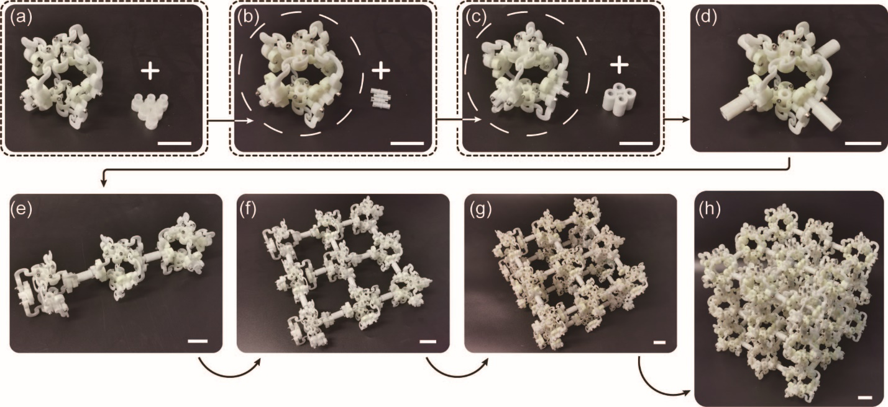

Fig. S9. Procedure diagram of assembling AHMM. The first step (a-b): Six universal interfaces are assembled into one MCC at the center of each frame. The second part (b-c): insert six LEGO parts (1x2 smooth pin 3673) into the six general joints. Step three (c-d): Install the connecting tubes into the above parts. Step 4 (d-e): Assemble the three MCCs into a one-dimensional bar along the X-axis through the 2 connecting tubes. Step 5 (e-f): Similarly, 9 MCCs are connected into a 3×3 two-dimensional sheet by 12 connecting tubes. The sixth step (f-g) repeats the above steps and stacks two 3 × 3 two-dimensional sheets along the Z-axis. The final step (g-h) is assembled on the above basis to form a 3×3×3 3D block AHMM. the length of the scale bar in the figure is 20 mm.

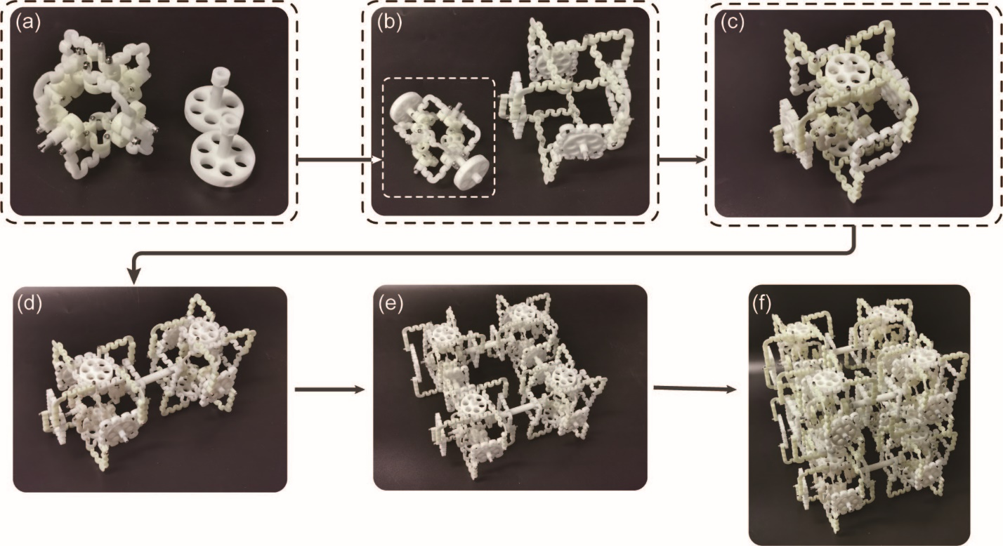

Fig. S10. Procedure diagram for assembling AHMM-DN. The first step (a-b): the double-layer general joints are loaded into the core MCC. The second step (b-c): load the core MCC into the shell MCC to form a bilayer MCC. the third step (c-d):form the two-bilayer MCC into a one-dimensional bar by core-core connection. The fourth step (d-e): the two one-dimensional rods are formed into two-dimensional sheets by means of shell-shell connection. Finally (e-f): two 2D plates are formed into 2×2×2 blocks of AHMM-DN by shell-core connection. the length of scale bar in the figure is 20mm.

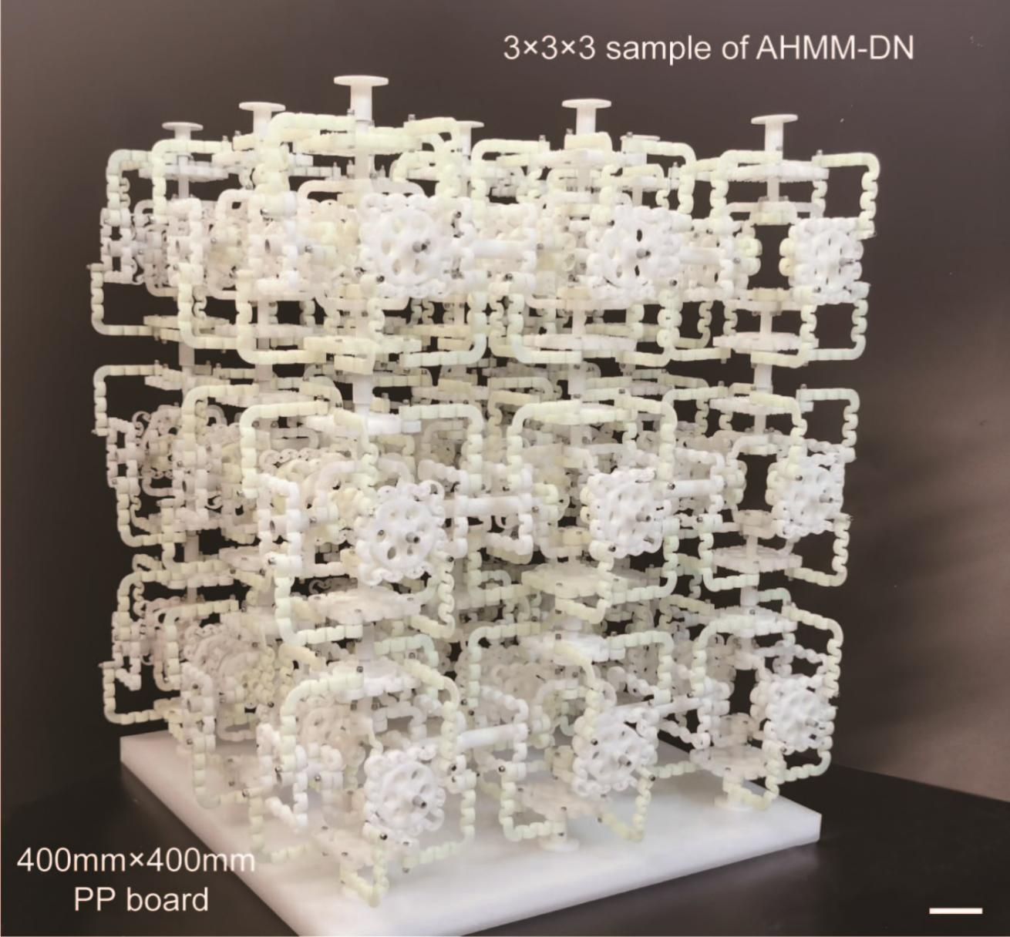

Fig. S11. Physical diagram of AHMM-DN sample with size 3×3×3.

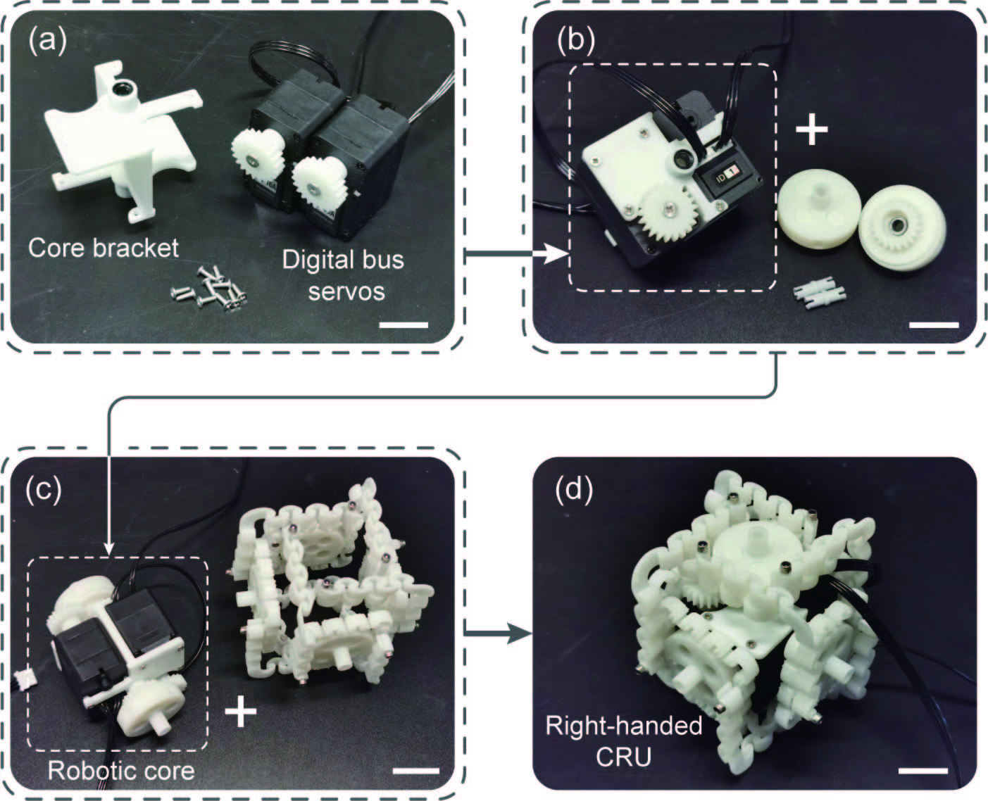

Fig. S12. Procedure diagram for assembling CRU. Step 1 (a-b): Two digital bus servos are connected to the core bracket through standard parts to become the core power component body. The second step (b-c): install the non-standard gear set to the corresponding position of the servos and brackets. The third part (c-d): install the core power component into the shell MCC to form the CRU. the length of scale bar in the figure is 20mm.

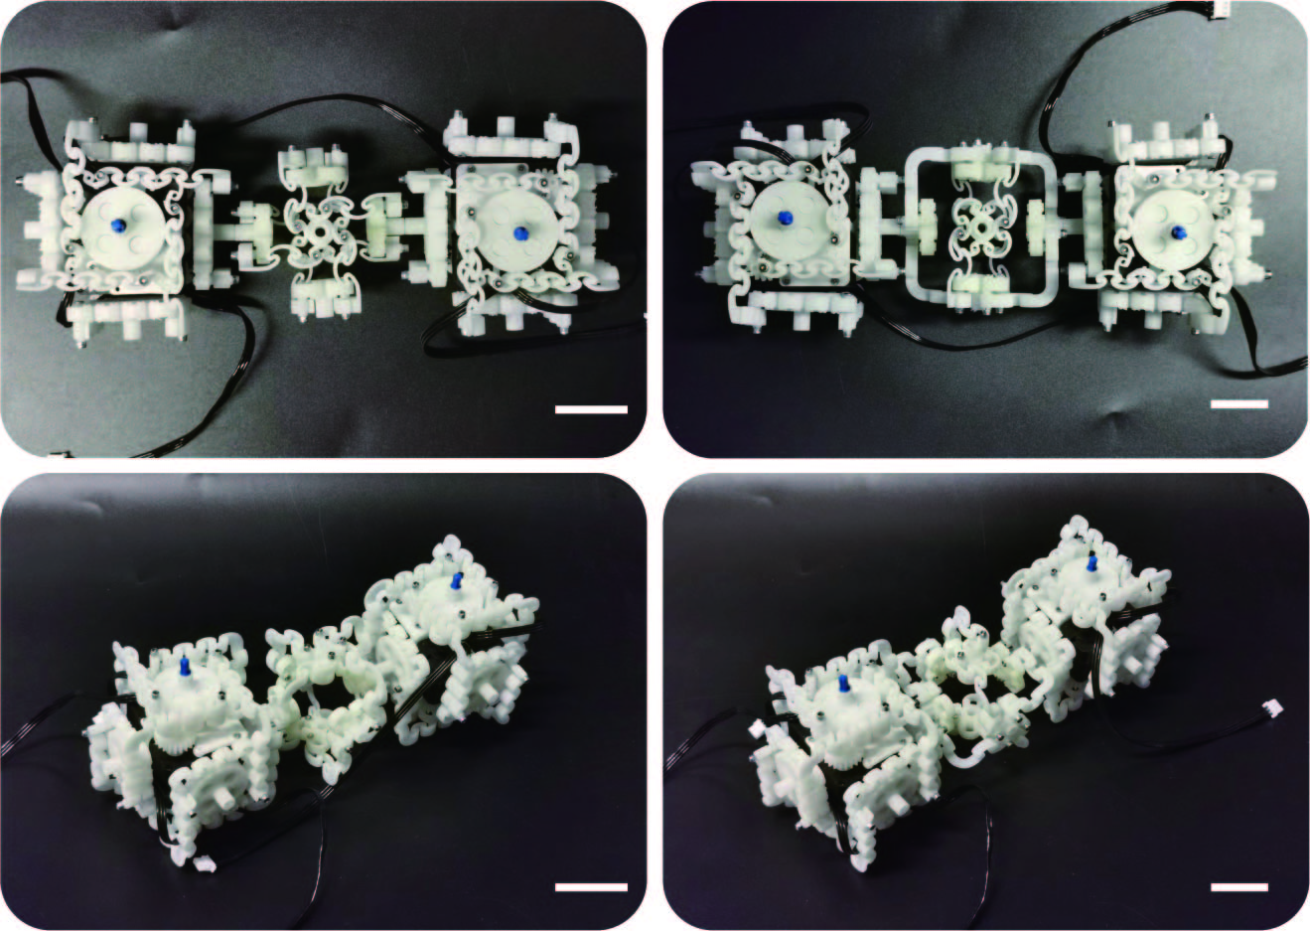

Fig. S13. Physical diagram of the two eCRUPs. The eCRUP-I is shown in the second column on the left and the eCRUP-II in the second column on the right. the length of the scale bar in the figure is 35 mm.

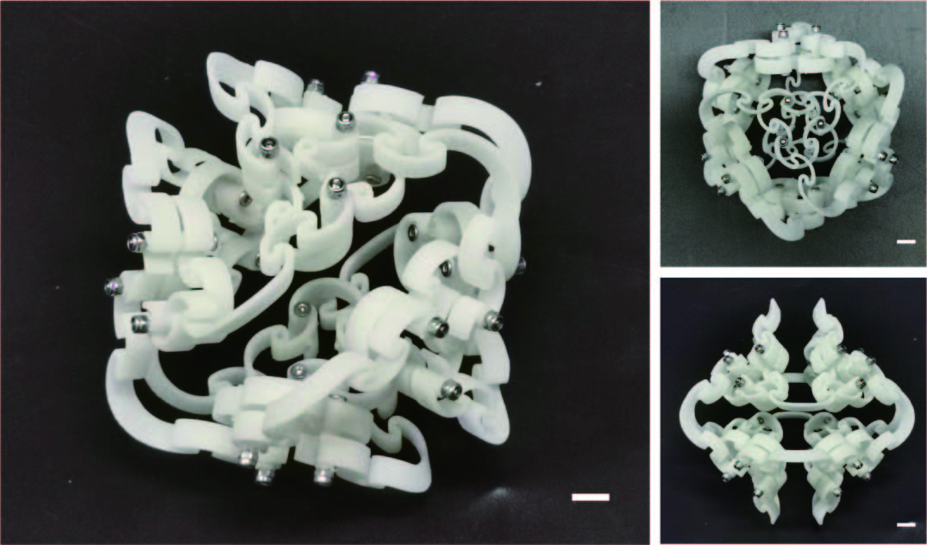

Fig. S14. Physical diagram of the modular compliant octahedron. The length of scale bar is 6 mm.

Starting interface | Target interface
0-0 | 5-7
0-2 | 3-1
0-4 | 4-3
0-6 | 1-5
1-1 | 2-2
2-6 | 3-5
2-0 | 5-3
4-7 | 2-4

Table S1. The connection table of MCC

Movie S1.
Demonstration of compression of a single MCC.

Movie S2.
Compression demonstration of AHMM.

Movie S3.
Demonstration of anisotropic shear stiffness of AHMM and bouncing after free fall.

Movie S4.
Demonstration of CRU deformation.

Movie S5.
Linear and turing motion of a CRUP.

Movie S6.
Straight-line racing of two eCRUPs.

Movie S7.
Demonstration of an eight-legged flexible robot traversing a complex scene.

