Structure of full-length cobalamin-dependent methionine synthase and cofactor loading captured in crystallo

Johnny Mendoza^{1‡}, Meredith Purchal^{2,3‡}, Kazuhiro Yamada^{1,4*}, Markos Koutmos^{1,2,5*}

¹ Department of Chemistry, University of Michigan, Ann Arbor, MI, 48109
² Program in Chemical Biology, University of Michigan, Ann Arbor, MI, 48109
³ New England Biolabs, Inc., Ipswich, MA, 01938
⁴ Department of Biological Chemistry, University of Michigan, Ann Arbor, MI, 48109
⁵ Program in Biophysics, University of Michigan, Ann Arbor, MI, 48109
‡ Johnny Mendoza and Meredith Purchal contributed equally to this work
*To whom correspondence should be addressed: yamadak@umich.edu (co-corresponding), mkoutmos@umich.edu (corresponding)

Supplementary Figures

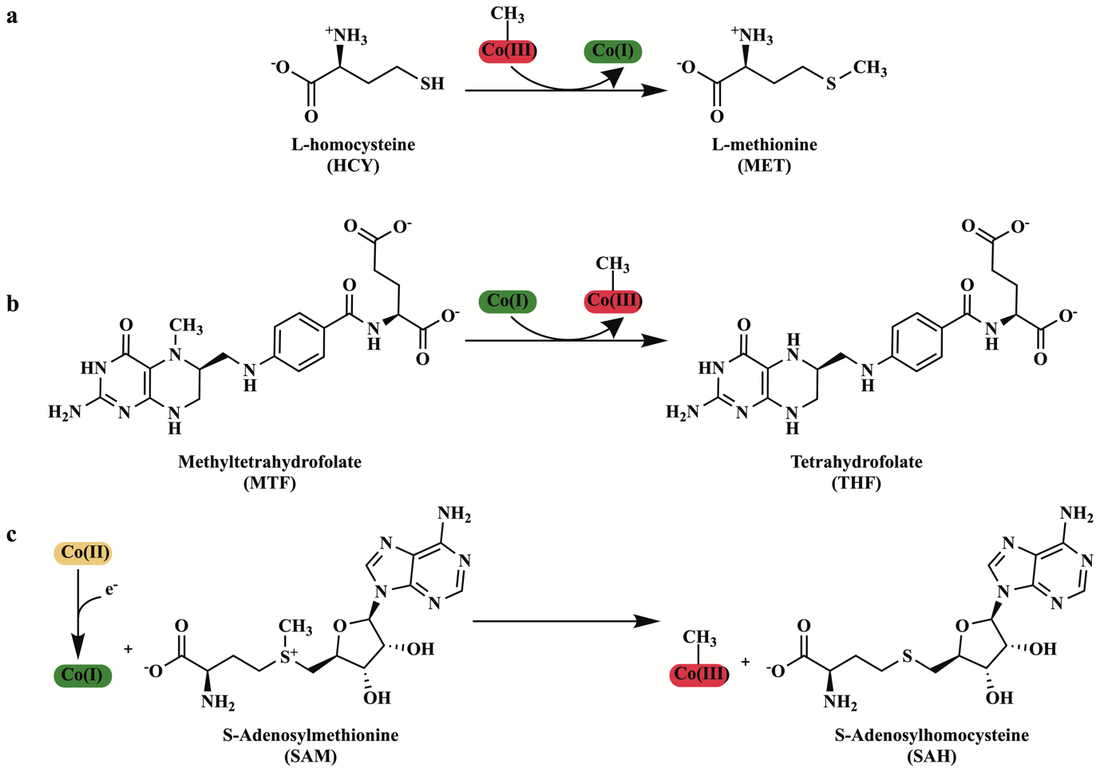
Supplementary Figure 1. The three methylations catalyzed by methionine synthase. a The methylation of homocysteine by MS using CH₃-Co(III) (MeCbl) to form methionine. b The demethylation of methyltetrahydrofolate by MS using Co(I) to yield CH₃-Co(III) (MeCbl). c The reactivation reaction catalyzed by MS, a reductive methylation and reactivation of Co(II) to yield CH₃-Co(III) (MeCbl).

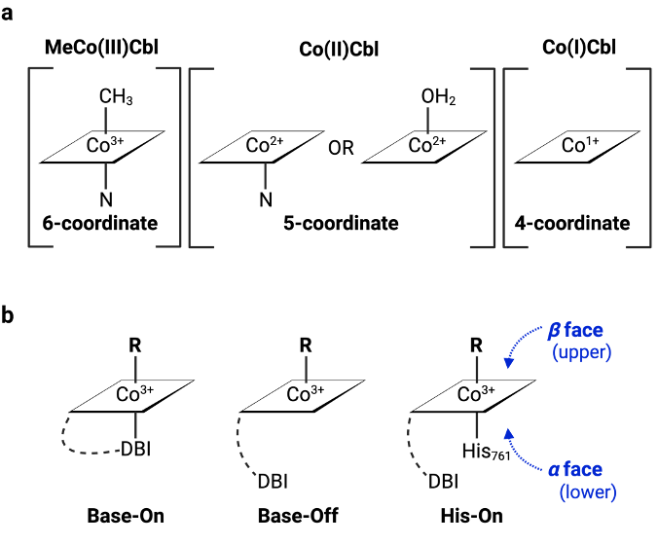
Supplementary Figure 2. Cobalamin coordination environment. a Coordination environment of cobalamin in different cobalt oxidation states. b Base-on/Base-off. In solution, the DBI tail is coordinated in the lower axial position. Upon binding, the DBI tail is replaced with His to achieve the His-on state.

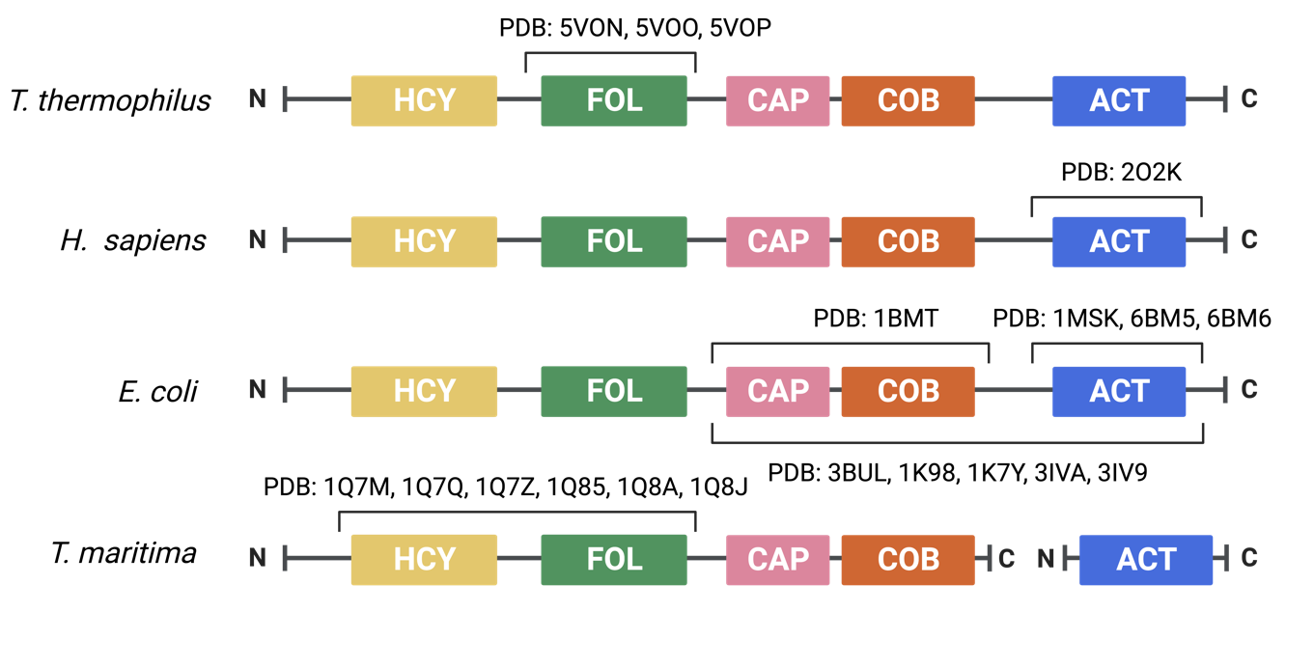
Supplementary Figure 3. MS domain organization and PDB structures.

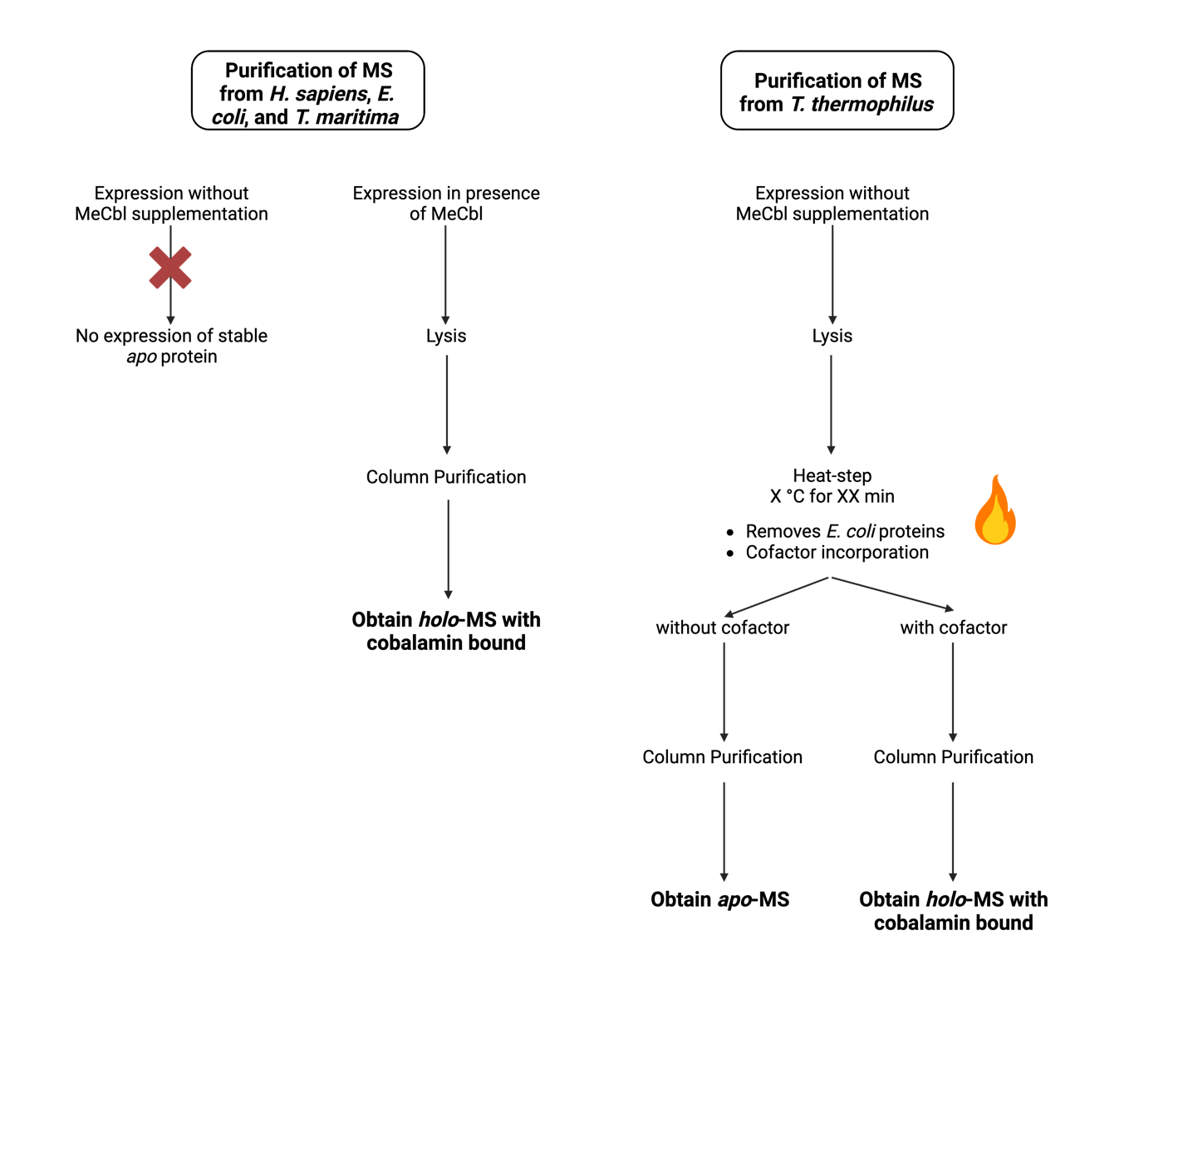
Supplementary Figure 4. MS versus tMS purification workflow.

Supplementary Figure 5. Tetrahydrofolate acid-catalyzed conversion to methenyltetrahydrofolate. The resulting product has a characteristic absorbance at 350 nm and is used to track tMS activity in a coupled-assay described in Methods.

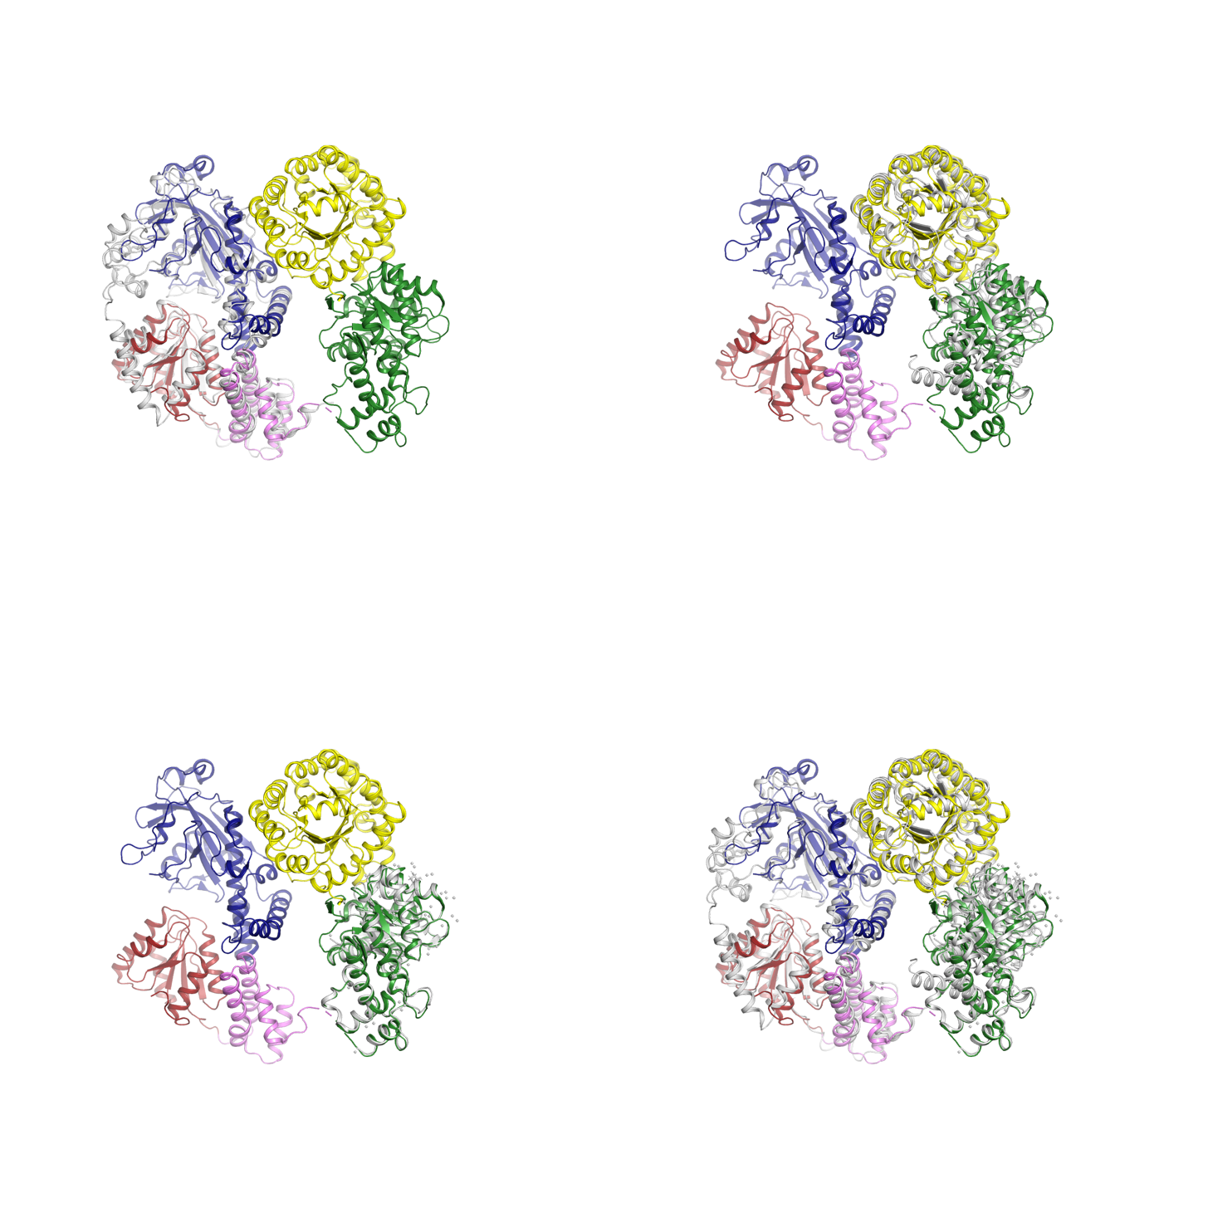
a
b
c
d
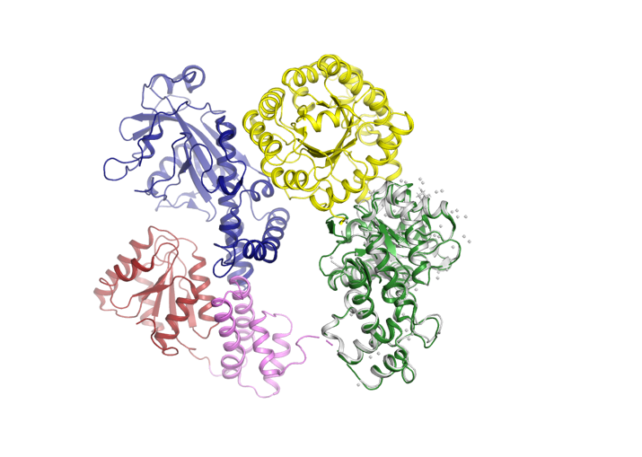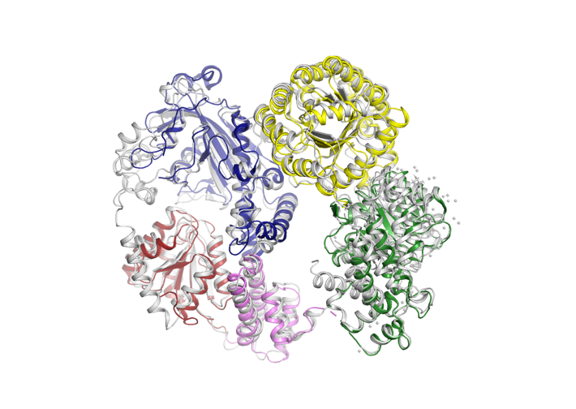
Supplementary Figure 6. Alignment excised MS domains with full-length tMS. a Alignment of Cap:Cob:Act domains from 1K7Y (gray) with Cap (pink), Cob (red), and Act (blue) in full-length tMS – RMSD=2.16 Å. b Alignment of Fol and Hcy domains from 3BOL (gray) with the Fol (green) and Hcy (yellow) domains in full-length tMS – RMSD=2.64 Å. c Alignment of Fol 5VON (gray) domain with Fol domain (green) in full-length tMS – RMSD=0.46 Å. d Alignment of the excised domains (gray) from 1K7Y, 3BOL, and 5VON with full-length tMS.
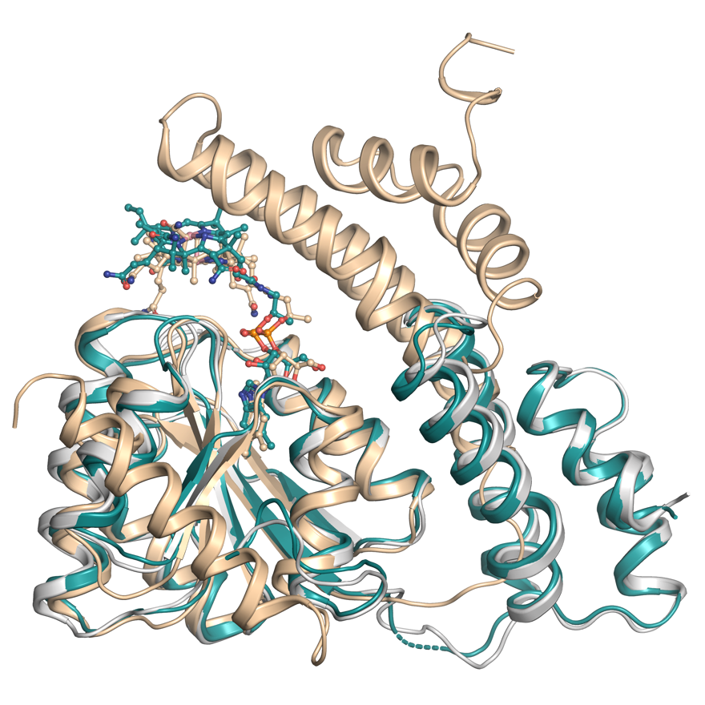
Supplementary Figure 7. Displacement of Cap-domain in full length MS. Alignment of Cap:Cob domains from the full length structure (gray, reactivation) with the Cob domain from holo-Cap:Cob:Act (teal, reactivation, His-off) – RMSD=0.72 Å and the Cap:Cob domains from 1BMT (wheat, reactivation, His-on) – RMSD=0.85 Å.

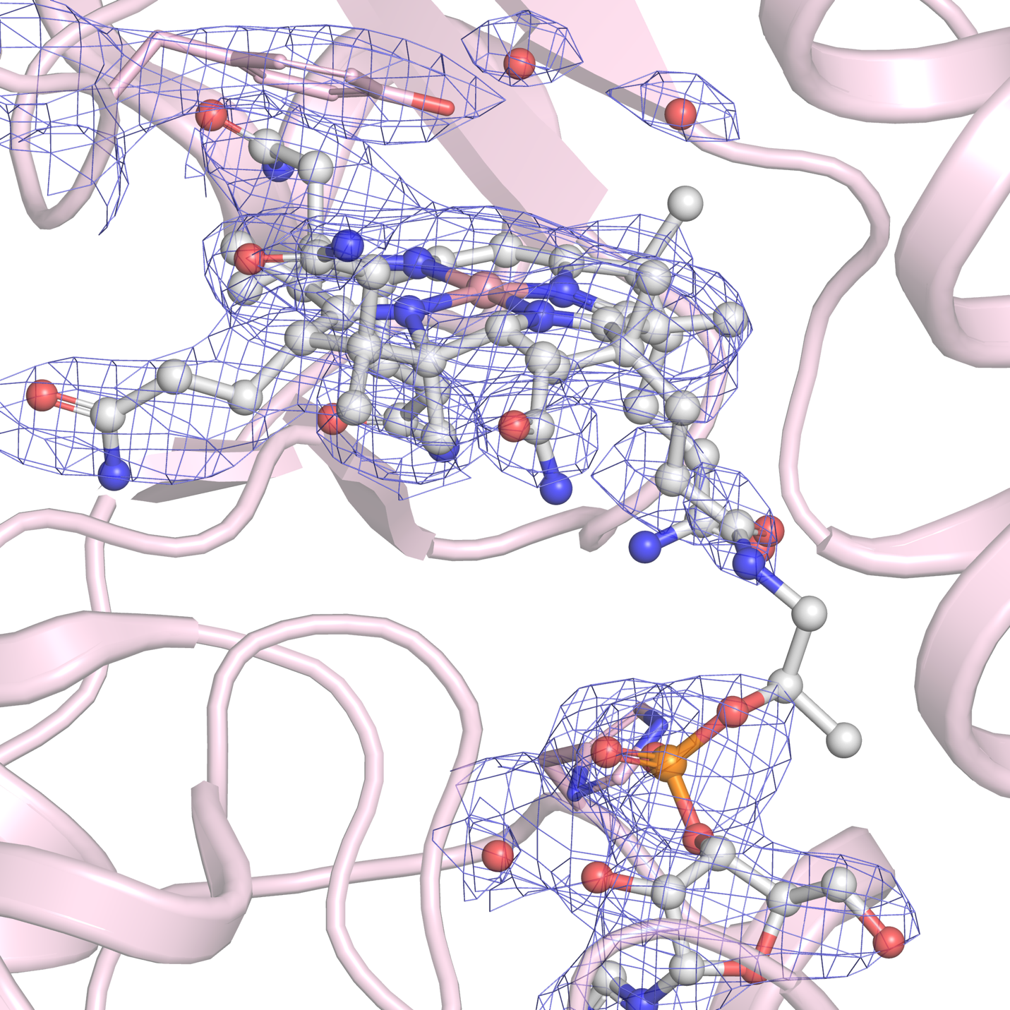
Supplementary Figure 8. tMS electron density around the cobalamin cofactor. Holo-Cap:Cob:Act (light pink) and its cobalamin cofactor (gray), along with Tyr1132 and His761 in the axial cofactor positions. Their corresponding electron density (2F_{o}-F_{c}) contoured at 1.5 σ are shown in blue.

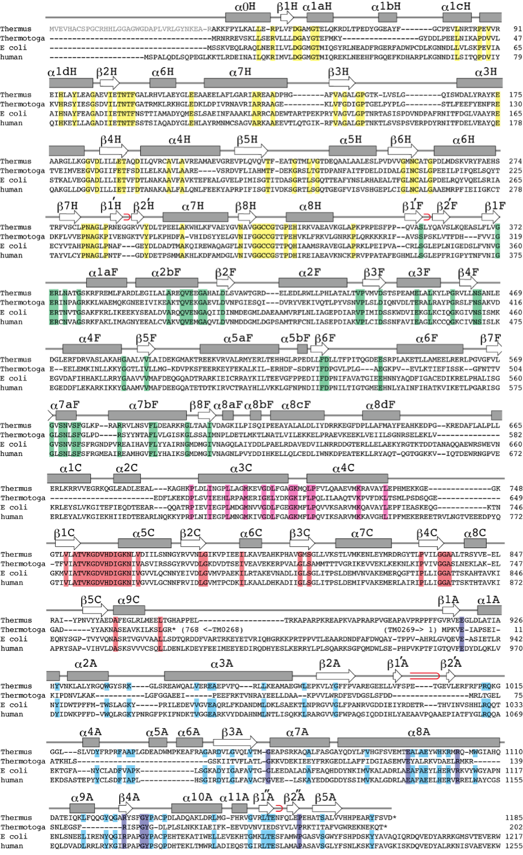
Supplementary Figure 9. Methionine synthase (MS) sequence alignment. Schematic illustration of the secondary structure of tMS and alignments with the amino acid sequence of MS from Thermus thermophilus [Genbank accession number NC_00646], Thermotoga maritima [NC_000853], Escherichia coli [J04975], and human [U73338]. α-helices and β-sheets are shown in boxes and arrows, respectively. Red loops indicate β-hairpins. The N-terminal residues absent in tMS^{ΔN35} are shown in gray. Conserved amino acid residues are highlighted by yellow, green, pink, red, and blue for the homocysteine, folate, Cap, cobalamin, and S-adenosylmethionine domains, respectively. In the activation (Act) domain, cyan is used to highlight conserved amino acid residues in T. thermophilus, E. coli, and human MS.

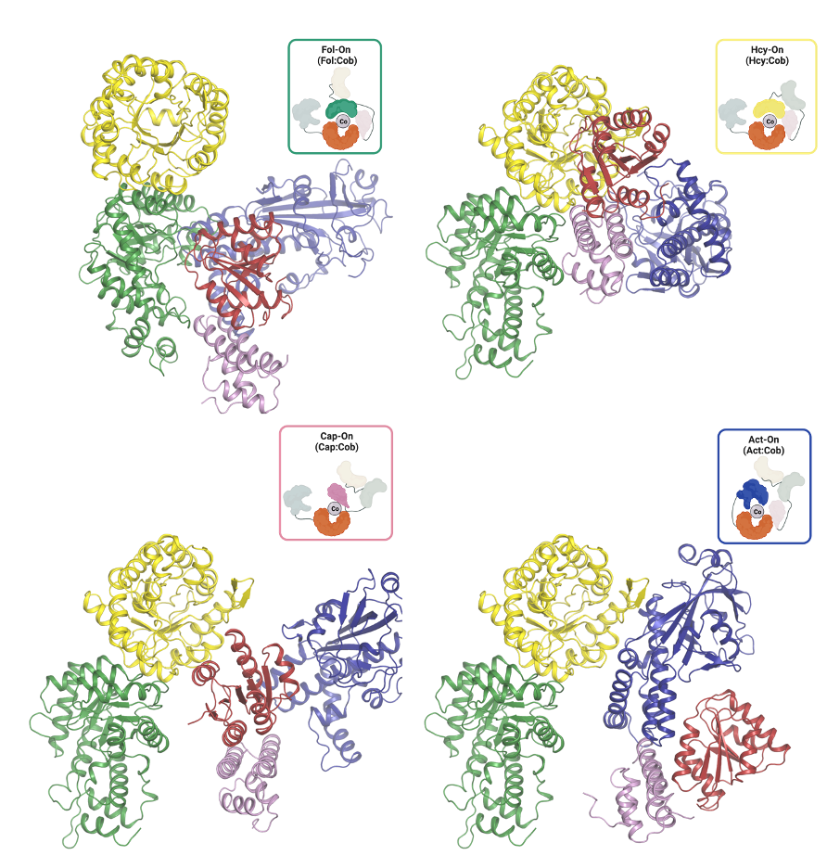 Supplementary Figure 10. Conformational dynamics of MS. The proposed conformations adopted by MS throughout the catalytic and reactivation cycles with different substrate binding domains positioned above the cofactor; Fol-on (top-left), Hcy-on (top-right), Cap-on (bottom-left), and Act-on (bottom-right).

Supplementary Tables

Supplementary Table 1. Kinetic parameters of Methionine Synthase
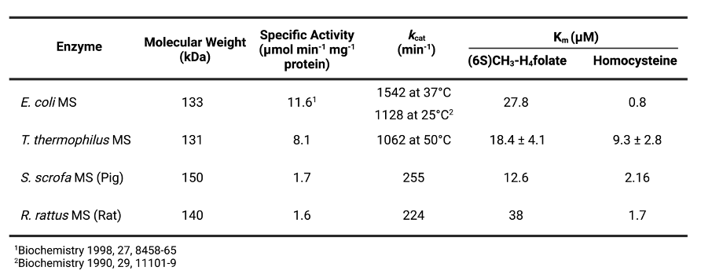

Supplementary Table 2. X-Ray Data Collection and Refinement Statistics for tMS^{ΔN35}, Apo-tMS^{Cap:Cob:Act}, and Holo-tMS^{Cap:Cob:Act}
 | tMS^{ΔN35} | Apo-tMS^{Cap:Cob:Act} | Holo-tMS^{Cap:Cob:Act}
Data collection
Beamline | APS, GMCA 23-IDB | APS, GMCA 23-IDB | APS, GMCA 23-IDB
Wavelength (Å) | 1.033 | 1.033 | 1.033
Temperature (K) | 100 | 100 | 100
Resolution (Å) | 106.64-2.75 (2.85-2.75) | 40.55-2.40 (2.50-2.40) | 49.30-3.15 (3.15-3.23)
Space group | P4₁2₁2 | P3₁21 | C121
Cell dimensions (Å) | a = b = 134.84,  c = 174.74 | a = b = 96.18,  c = 356.04 | a = 166.135, b = 95.844,  c = 238.745
Cell dimensions (°) | α = β = γ = 90 | α = γ = 90, β = 120 | α = γ = 90, β = 91.96
Observed reflections | 669,916 (51,333) | 711,608 (42,258) | 222,439 (11,567)
Unique reflections | 42,467 (4,373) | 76,051 (4,396) | 64,264 (3,294)
R_{meas} (%) | 19.7 (167.3) | 18.7 (95.4) | 22.0 (116.7)
R_{merge} (%) | 19.1 (160.0) | 17.7 (90.3) | 18.5 (98.6)
<I/σ> | 12.3 (1.8) | 8.1 (2.5) | 5.1 (1.3)
CC(1/2) | 0.993 (0.672) | 0.99 (0.667) | 0.99 (0.581)
Multiplicity | 15.8 (11.7) | 9.4 (9.6) | 3.5 (3.5)
Completeness (%) | 100.00 (100.00) | 100.00 (100.00) | 98.50 (99.22)
Overall B (Å²) (Wilson plot) | 56.2 | 47.00 | 60.70
Refinement
Resolution range | 106.96 - 2.75 | 39.85 - 2.95 | 49.30 - 3.15
Number of reflections  (work/test set) | 40,263/2,154 | 75,954/3,830 | 64,264/3,294
R_{work}/R_{free} (%) | 22.6/25.3 | 26.5/29.9 | 24.6/30.1
No. of non-H atoms
Protein | 8751 | 12,223 | 24,885
Water | 131 | 493 | 299
Ligand | 11 | 0 | 546
B-factors (Å²)
Protein | 81.63 | 40.63 | 84.67
Water | 58.80 | 44.00 | 44.50
Ligand | 133.13 | 0.00 | 70.93
Rmsd deviations
Bond lengths (Å) | 0.008 | 0.0075 | 0.012
Bond angles (°) | 1.36 | 1.70 | 1.99
Favored/allowed/outliers | 96.9/3.0/0.1 | 97.5/2.5/0.0 | 97.9/2.1/0.0
MolProbity Score | 1.03 (100th percentile) | 0.60 (100th percentile) | 0.99 (100th percentile)
PDB | 8SSC | 8SSD | 8SSE

Supplementary Table 3. Purification Yield and Activity
