Supporting Information for

New perspectives on Australian hydroclimate and population dynamics during Last Glacial Maximum and terminal Pleistocene

Haidee Cadd^{1,2,3}*, Alan N. Williams^{4,5}, Wanchese M. Saktura^{1,3}, Tim J. Cohen^{1,3}, Scott D. Mooney⁶, Chengfei He⁷, Bette Otto‐Bliesner⁸, Chris S.M. Turney^{2,9}

Email: haidee@uow.edu.au

Supporting Information Text

Methods

iTRACE
Climate models provide an alternate method for understanding regional and continental climate changes through time (1). Climate models can be particularly informative in regions with limited proxy records of climate like Australia. The iTRACE model utilizes the Community Earth System Model (CESM) version 1.3. and the iTRACE-21 model used here incorporates fully coupled water isotopes (δ¹⁸O and δD) modules (iCESM) in the atmosphere, ocean, land, sea ice and river run-off components. This allows model-data comparisons with isotope proxy palaeoclimate archives (2). This isotope-enabled Transient Climate Experiment simulates global, long-term millennial scale climate evolution across the terminal Last Glacial Maximum (LGM) and post glacial period.
The iTRACE simulations are designed with a factorized forcing scheme that enables individual forcing effects to be isolated and sequentially added to generate sensitive experiments. The baseline simulation incorporates changing ice sheets and ocean bathymetry (ICE), orbital (ORB) and greenhouse gas (GHG) forcings (ICE + ORB and ICE + ORB + GHG) and then incorporates meltwater forcing (MWF) (ICE + ORB + GHG + MWF). Full forcing (ICE + ORB + GHG+MWF) iTRACE model simulations are presented in this study.
We examined the iTRACE model variables for precipitation and temperature using the transient simulations from 21 – 11 kiloanni (ka). Precipitation (m/s) combines the large-scale (stable) precipitation rate (including both liquid and ice; m/s) and convective precipitation rate (including both liquid and ice; m/s). The temperature output represents the radiative surface temperature (TS; degree Kelvin; K). Simulations are presented from time slices at 20, 18, 16, 14, 13.5, 12.5 and 11 ka. The 20 ka simulation represents the initial 1000 year simulation from 20 – 19 ka. The 18, 16, 14, 13.5 and 12.5 ka simulations each represent a 200 year average, ± 100 years from each age, while the 11 ka simulation represents a 300 year period from 11.3 – 11 ka. Precipitation and temperature outputs are presented both annually (ANN) and as seasonal means (Austral Summer, DJF; Autumn, MAM; Winter, JJA; Spring, SON).
Decadal averages of precipitation (precp; m/s) and radiative surface temperature (TS; Kelvin; K) were extracted from the fully coupled, non-accelerated iTRACE paleoclimate simulation. The simulated precipitation and temperature estimates range from 20,000 to 11,000 years BP at a resolution of 1.9° in latitude and 2.5° in longitude and were converted to precipitation (mm/day) and temperature (degrees Celsius; ºC) before comparison. Decadal averages of modelled precipitation and temperature were extracted and averaged across grid cells that encompassed the entire Australian continental land mass (Figure S15, n=168), the Murray-Darling Basin (Figure S2, n=26), the Lake Eyre Basin (Figure S2, n=32) and the region covered by continuous proxy records used in the change point analysis (Figure S5, n=36). The modelled temperature and precipitation are based on grid cells that cover the designated regions, but some of these encompass relatively small areas outside these regions.
Modern precipitation (mm/day; 1900-2020) and temperature (ºC; 1961-1990) were extracted from the gridded climate data available from the Australian Bureau of Meteorology (BOM). Modern precipitation (mm/day) from the MBD and LEB were extracted from the average annual precipitation gridded data, averaged across the basins and decadal averages calculated from 1900 onwards. Modern temperature (ºC) from the MDB and LEB were extracted from the 1961-1990 gridded data average for each basin. Climatological data for each drainage basin were extracted using digital elevation derived drainage basin shape files.

Continuous proxy records
Speleothem records from continental Australia that covered any time period between 25 – 8 ka were sourced from the Speleothem Isotope Synthesis and Analyses (SISAL) V2 database (3). Bayesian age models were developed for each speleothem record in the SISAL V2 database and these updated chronologies were used here. Precipitation (mm/day) outputs from the iTRACE model were extracted for the grid cell containing each speleothem record (Figure S2).
Continuous lacustrine proxy records from late in the last glacial cycle in Australia are classically low-resolution, and include poorly constrained records of vegetation change (4). Proxy records of vegetation change are sensitive to changes in moisture balance, temperature, disturbance (e.g., fire) and atmospheric CO₂ levels (5–8). Consequently, changes in vegetation proxy records are rarely attributable to a single driver. We used the recent compilation of continuous proxy records that covered the late last glacial cycle from Australia from Cadd et al. (2021) to examine palaeoenvironmental changes. Proxy records (Figure S5; n=35) were analyzed for the period 22-8ka using the same methodology as Cadd et al. (4). Individual change point probability density functions (PDF) from each record were summed. Summed PDF were determined for all change points identified as representing a change to decreasing or increasing climate indicators (including temperature, precipitation and CO₂). Cadd et al. (4) provides further details on the methods used.

Discontinuous proxy records
Discontinuous proxy records provide a snapshot of the palaeoenvironmental, or climate conditions, experienced by a system at an individual point in time. In Australia, geomorphological indicators of water flow or volume, such as fluvial systems and lake shoreline reconstructions, are typically discontinuous indicating the minimum or maximum volume of water at a particular time. The length of time, or return interval, of these conditions experienced by the system may be variable and are complex to characterize. Fluvial discharge and higher bank full discharge may reflect increased moisture balance, either via increased precipitation or increased run-off. Reduced temperature reduces evaporation, while decreases in vegetation cover and arboreal vegetation reduces evapotranspiration, both resulting in increased run-off. Discontinuous changes identified in fluvial systems may therefore be interpreted to also reflect changes in climate or the presence of a more variable climate regime, characterized by extremes.
Discontinuous records from fluvial and lacustrine settings were accessed from the OCTOPUS database v.2 (https://octopusdata.org/) (9). Optically Stimulated Luminescence (OSL) and Thermo Luminescence (TL) ages from lacustrine beach and shoreline deposits (lake level indicators) and fluvial (both overbank and channel) deposits were compiled and summarized across Australia’s two major river systems, the Lake Eyre Basin (LEB) and the Murray-Darling Basin (MDB) (Figure S1, S19, S20). A kernel density estimate (KDE) of compiled ages from each facies or geotype was determined for all ages between 30 – 5 ka from both basins. Precipitation and temperature outputs from the iTRACE model were extracted from the grid cells covering the drainage basins for these major drainage systems (Figure S1).

Archaeological data (SahulArch)
Archaeological geochronology data was obtained from SahulArch database (Saktura et al. 2023), including radiocarbon (10), OSL, and TL collections (11) which are accessible through the OCTOPUS v.2 (https://octopusdata.org/; 9). Data used in this study were screened for region of relevance (Australia only), age range of interest (¹⁴C = 8 – 22 ka, OSL and TL = 8 – 22 ka), appropriate associations with archaeological deposit (CONTEXT ≠ ‘Sterile’, OCCUPATION = ‘No’ + CONTEXT ≠ ‘Occupation’), replicate and superseded analyses, indications of possible contamination and general author commentary where issues with reliability of an age was raised by author (Figure S21). Radiocarbon ages were then calibrated using the Southern Hemisphere calibration curve, SHCal20 (12), for terrestrial material and the marine calibration curve, Marine20 (13) for material from marine sources. Calibrated probability densities were extracted for each ¹⁴C age and included in Gaussian KDE analysis. The archaeological data that satisfied the above criteria included 1,254 observations (¹⁴C = 1045 (inc. 72 marine ages), OSL = 175, TL = 34). Probability of age occurrence from ¹⁴C calibrated distribution or OSL and TL age ± error normal distribution was determined every 20 years from 8.68 to 26.34 ka. Age estimates that had a probability > 0.01 of occurrence at the time of the iTRACE output times (11 ka, 12.5 ka, 13.5 ka, 14 ka, 16 ka, 18 ka and 20 ka, ± 200 years) are shown on output maps (Figure S8 – S14).
A Gaussian KDE calculation with a Monte Carlo method was applied to calibrated ¹⁴C, OSL and TL ages. The KDE bandwidth was set to 30 with 1000 random iterations. Densities were calculated at 1024 points in time. KDEs, summed probabilities and spatial mapping were conducted using modified code from McLaughlin (14) in R (15).

Results

Comparison of the iTRACE and palaeoclimatic proxies
The location of all proxy records, continuous lacustrine palaeoenvironmental records, OSL, TL and ¹⁴C ages from fluvial archives and speleothem records are shown in Figure S1. The Lake Eyre and Murray-Darling drainage basins are also shown in Figure S1.
Four speleothem records from mainland Australia were identified from the SISAL V2 database (3), KNI151, Ball Gown Cave, Cave C126 and Mairs Cave. The δ¹⁸O of calcite from each of these speleothems was compared to decadal averaged modelled precipitation outputs from the grid cell encompassing each speleothem record (Figure S2). δ¹⁸O of calcite in each of these records has been interpreted to represent precipitation amount (16–19). Isotopic response to site specific effects, moisture source and evaporation are expected, however broad scale trends between modelled precipitation and δ¹⁸O of calcite is evident for all records, with very good agreement in two of the four stalagmite records (Cave C126 and Mairs Cave; Figure S3). Coherence between rainfall derived changes in δ¹⁸O of calcite in Australian speleothem records and modelled precipitation suggests the iTRACE modelled precipitation output can accurately reconstruct past precipitation patterns, even if exact amounts are less certain (Figure S3). Recent studies from the Sunda shelf and monsoon regions have similarly shown the ability of the iTRACE models to predict local scale rainfall patterns (2, 20, 21). Modelled precipitation from 20, 16 and 11 ka show similar spatial patterns when compared to present day precipitation (Figures S7, S10 – S14).
Summed probability distribution function of change points from continuous proxy records show few change points identified as a change to decreasing conditions in either temperature, precipitation, or CO₂ as defined by Cadd et al. (4) (Figure S6). Changepoints identified as a change to increasing conditions in either temperature, precipitation, and CO₂ as defined by Cadd et al. (4) occur consistently throughout the period 8 – 22 ka, recording a broad peak from 17.5 – 12 ka and a secondary peak at 10 – 11 ka (Figure S6). The broad peak suggests the time period of changes towards increasing conditions in the majority of records coincides with substantial increases in temperature, precipitation and CO₂ concentrations (Figure S6). CO₂ concentrations were low during the LGM, fluctuating between ~180 – 195 ppm until a sustained increase throughout the terminal Pleistocene. Beginning at 17.3 ka, CO₂ values had reached 220 ppm by 16 ka, 230 ppm by 14.5 and were >260 ppm by 11.5 ka. A sustained >3 ºC increase in temperature and >100 mm increase in precipitation occurs across the locations of pollen proxy records from 18 ka. The sustained increase in temperature, precipitation and CO₂ after 18 ka coincides with the increase in changepoints recording changes to arboreal vegetation, suggesting the changes documented in many of these records are likely influenced by a combination of temperature, precipitation and changing CO₂ concentrations. It is notable that changepoints towards increasing conditions decline following the Antarctic Cold Reversal (ACR, from 14.7 – 13 ka).
Modelled temperature from both the Murray-Darling and Lake Eyre basins shows similar trends across the 11 – 20 ka period (Figure S4). Lower temperatures are modelled from 20 to 18 ka, after which an increase of 3 – 6°C occurs between 18 – 12 ka. Modern (1961 – 1990) mean temperature is slightly lower than modelled temperatures at the beginning of the Holocene in both basins. Modelled precipitation also displays similar trends across both basins, suggesting higher precipitation from 17.5 – 14.7 ka before a decline at 14.7ka. Average modern decadal precipitation within the MDB is higher than the majority of modelled decadal values from 20 – 11ka, however the lowest standard deviation values fall within the range of variability of decades with the highest precipitation. Average modern precipitation in the LEB is lower than the variability at any point from 20 – 11 ka, however modern upper standard deviations are within the range of variability modelled during the ACR at 14.2 – 14 ka (Figure S4). An increase in change-points to decreased arboreal vegetation is not recorded during the ACR, suggesting that vegetation remained stable during this period.
Kernel density estimates (KDEs) of fluvial overbank and channel facies display similar patterns within the LEB, with both recording their highest number of ages between 19 – 17 ka (Figure S4). Beach and shoreline ages are low throughout the entire 20 – 11 ka period within the LEB. In the MDB beach and shoreline ages are highest (in density) from 20 – 18 ka before steadily dropping to a minimum at 11 ka (Figure S4). Fluvial channel ages record an increase from 20 – 17 ka before a decline and rise in ages again from 14 – 12 ka. Overbank records within the MDB show a similar but lower and more muted trend to the channel facies ages. The highest values in the MDB are seen when temperatures are lowest, between 20 – 17.5 ka. Higher lake levels and fluvial discharge in the MDB has previously been interpreted to reflect greater seasonal run-off. Cooler temperatures, particularly in the headwaters of the Murray-Darling catchment, could result in greater snowfall and therefore greater discharge volumes through these river systems during periods of spring or summer melt. Modelled seasonal temperature suggest the largest change in temperature occurred during Austral Autumn (MAM), potentially increasing the length of annual snowfall and subsequent volumes of snow melt (Figure S8 – S14). Alternatively higher precipitation in some regions of the basin or reduced evaporation would result in greater volumes of water entering the connected lacustrine systems of the MDB would lead to increased lake and river levels.

Modern temperature and precipitation
Modern average annual precipitation (mm/yr; 1980-2010) and average annual temperature (°C; 1961-1990) from Australia is shown in Figure 1 and Figure S7. Modern average annual precipitation across much of the continent is generally <500 mm. Rainfall >2500 mm per year is restricted to the northern monsoonal region, small portions of the east coast and western Tasmania. Average annual temperature north of 26°S is >20°C while coastal regions south of 26°S, including Tasmania, have average annual temperatures <20°C (Table 1).
Present-day Australian climate in the southern regions is broadly characterised by dry and warm to hot summers (DJF) and wet and cold to cool winters (JJA). Northern Australia is dominated by wet and warm to hot summers (DJF) and dry and mild to warm winters (JJA). Boundary seasons, Autumn (MAM) and Spring (SON), are characterised by transitional climates. Modern and iTRACE derived average daily temperature (ºC) and precipitation (mm/season) for each season; summer (DJF), autumn (MAM), winter (JJA) and spring (SON) are shown in Figures S7 – S14.

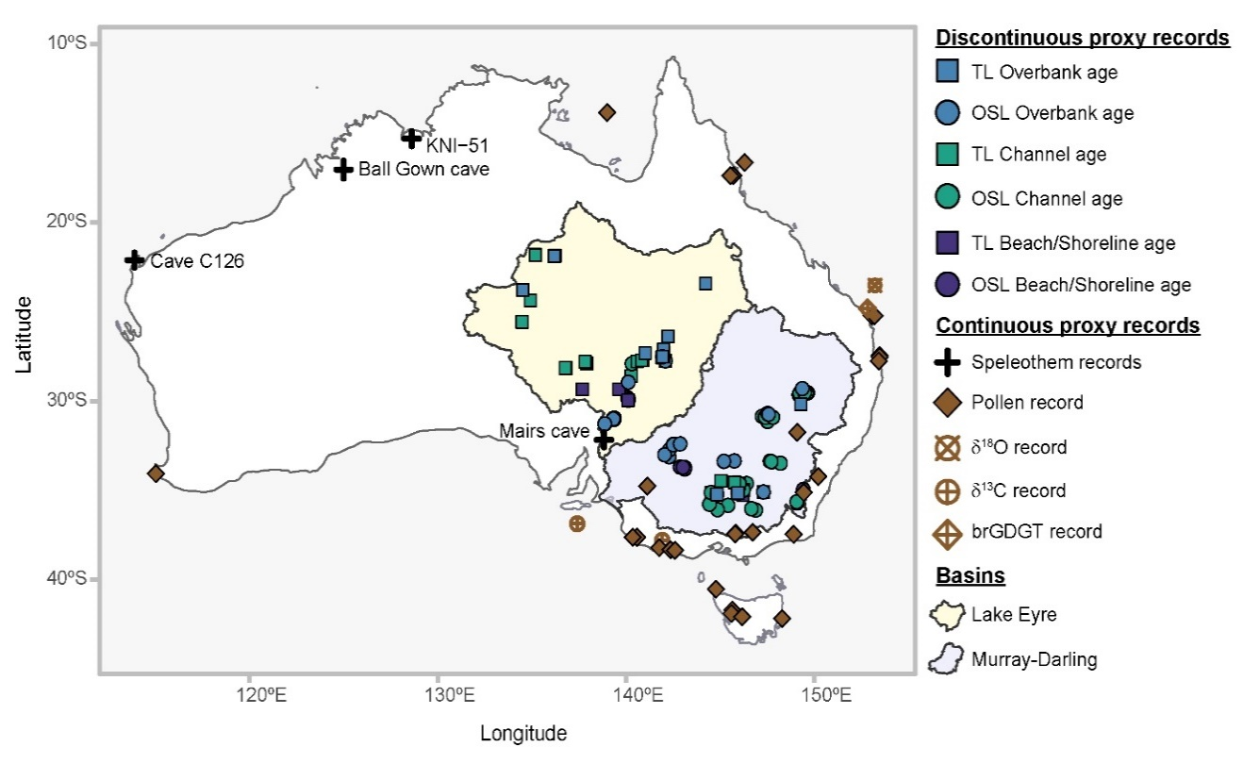

Fig. S1. Map of Australia showing site locations of proxy records used in analysis and major drainage basins discussed in manuscript.

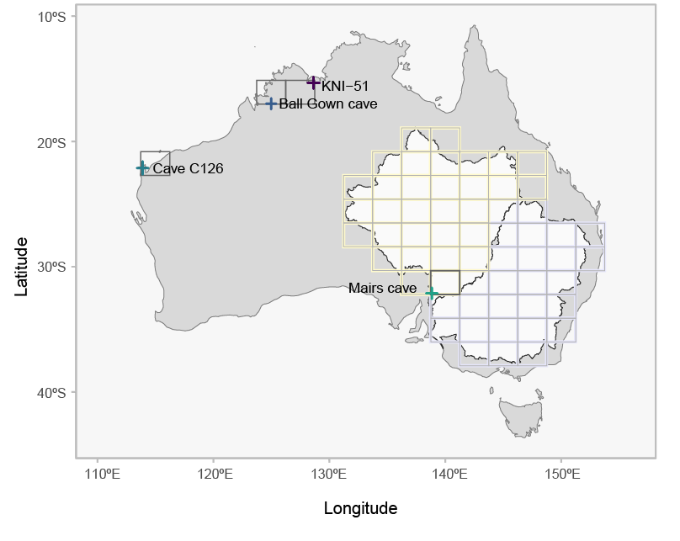
Fig S2. Grid cells of iTRACE temperature and precipitation outputs for the Murray-Darling Basin (MDB) shown in purple squares and the Lake Eyre Basin (LEB) shown in yellow squares used in Figure S3. The outline of the MBD and LEB are shown in black. Grid cells used to compare with speleothem data are shown in dark grey with the 4 speleothem records used for comparison shown as + symbols.

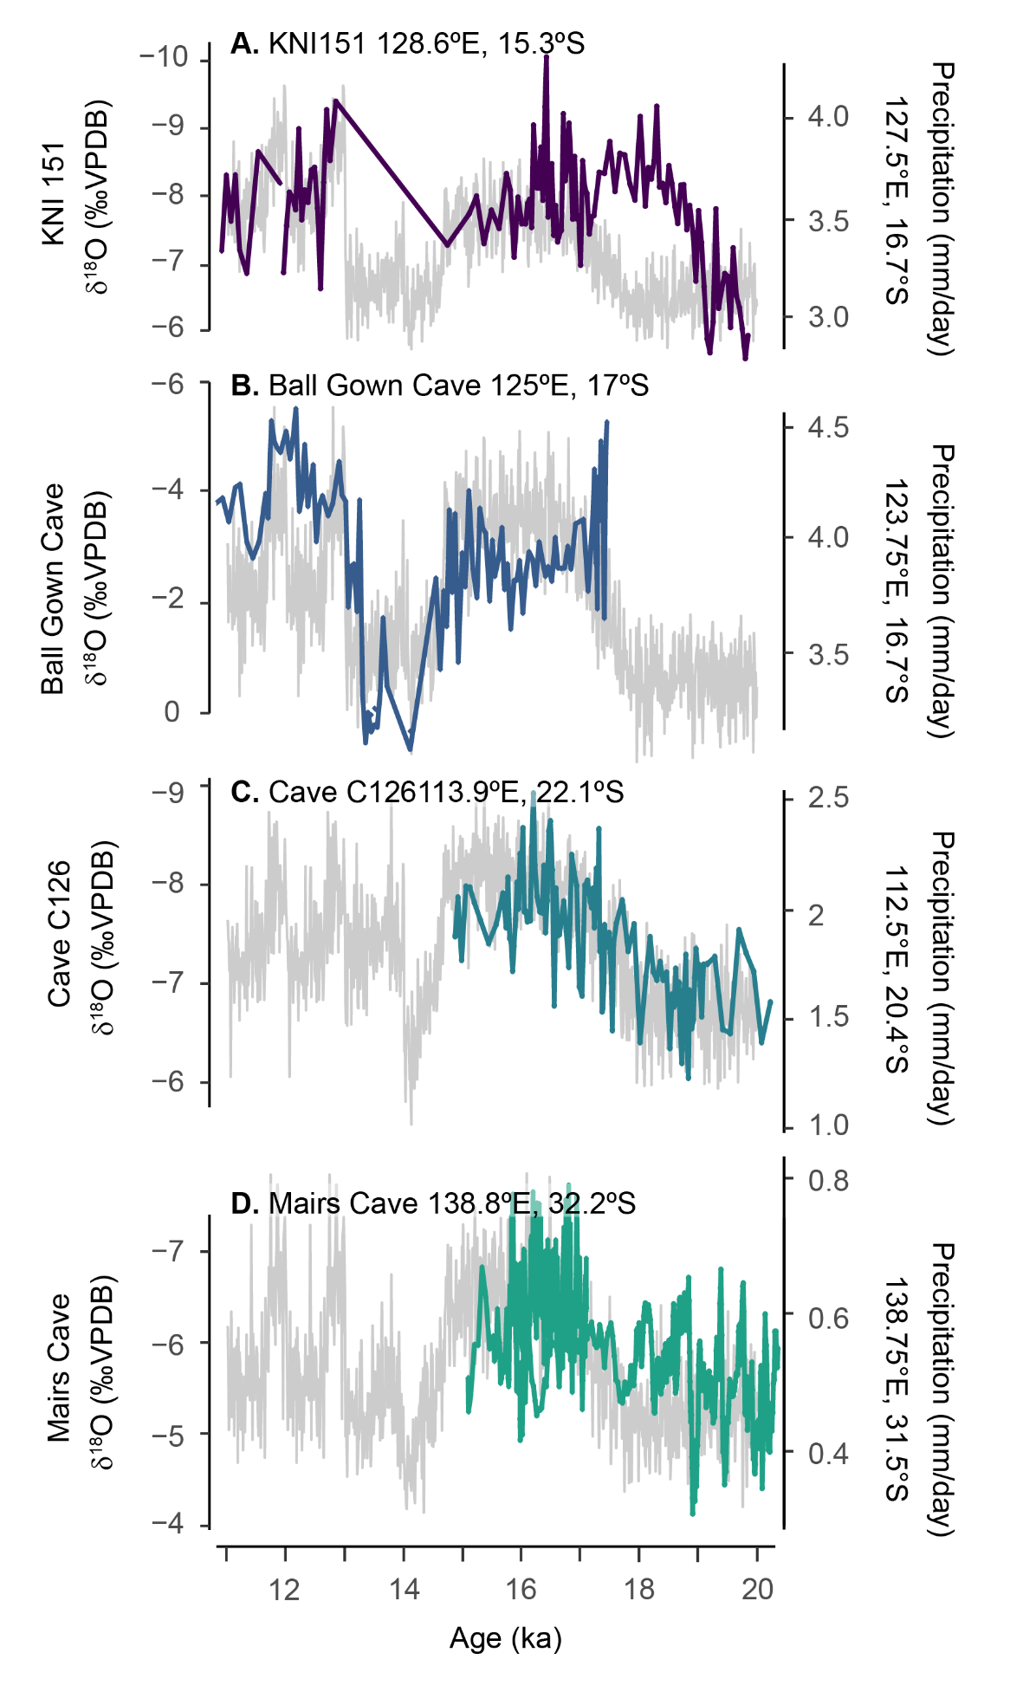
Fig S3. iTrace precipitation outputs (grey lines) for grid cell locations of Australian speleothem records (coloured lines) between 11 – 20 ka. Site locations and grid cell locations used in the analysis are shown in Figure S2.
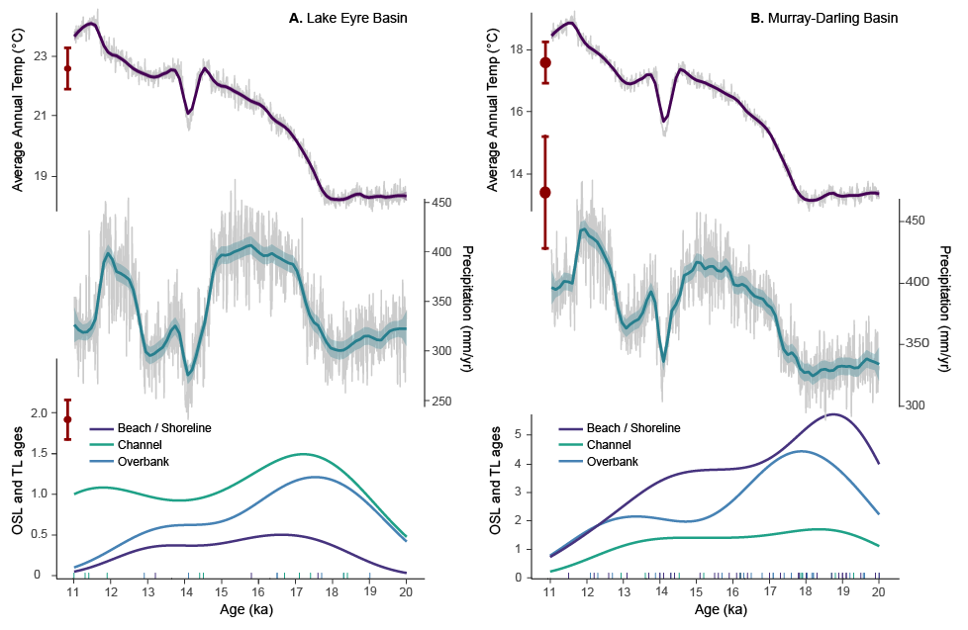

Fig S4. iTrace temperature (top panel) and precipitation (middle panel) outputs from grid cells corresponding to the two largest river basins in Australia (Figure S2), A. Lake Eyre Basin (LEB) and B. Murray Darling Basin (MDB). Modern (1900-2021) decadal average annual temperature and rainfall within each basin are shown in red (with error bars representing standard deviation). The bottom panel shows kernel density estimates KDE) of optically stimulated luminescence (OSL) and thermoluminescence (TL) ages from all beach/shoreline, channel and overbank geomorphological features dated within the LEB and MDB.
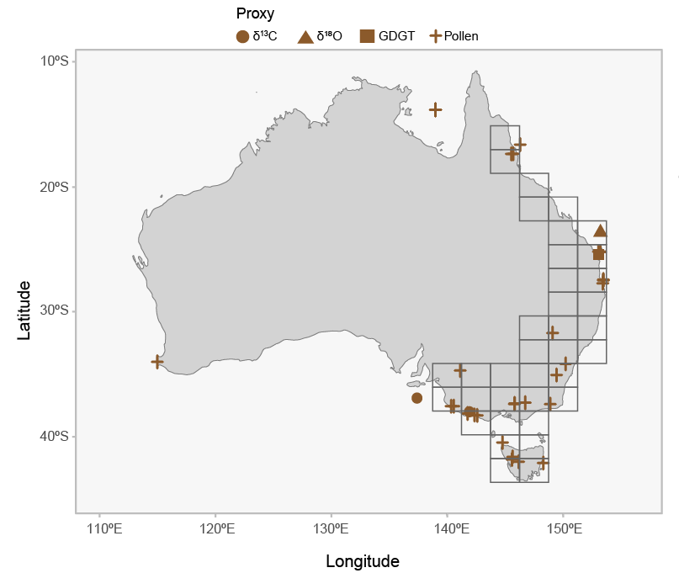
Fig S5. Location of proxy records of vegetation, δ¹³C, δ¹⁸O and GDGT’s utilised for changepoint analysis. Grid cells show the iTRACE temperature and precipitation outputs covering the continuous proxy records used to determine changepoints in Fig S6.
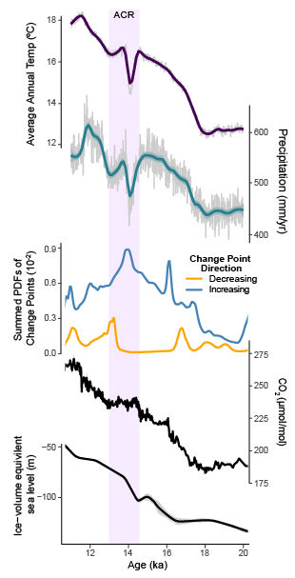
Fig S6. iTrace Temperature (top panel) and precipitation (middle panel) outputs from grid cells covering the majority of environmental proxy records analysed in Cadd et al. (2021) (Figure S5). Summed probability density function of all change points identified in vegetation, δ¹³C, δ¹⁸O and GDGT records as representing a change to decreasing (orange line) and increasing (blue line) climate indicators (including temperature, precipitation, and CO₂) from22 - 8 ka. Sites used in analysis are shown in Figure S1. (B) Compilation of ice core atmospheric CO₂ measurements (ppm) for the period 35–15 ka (Köhler et al., 2017). (C) Ice volume equivalent sea level (m) (black line) and 95% probability limiting values (grey shading) (Lambeck et al., 2014).

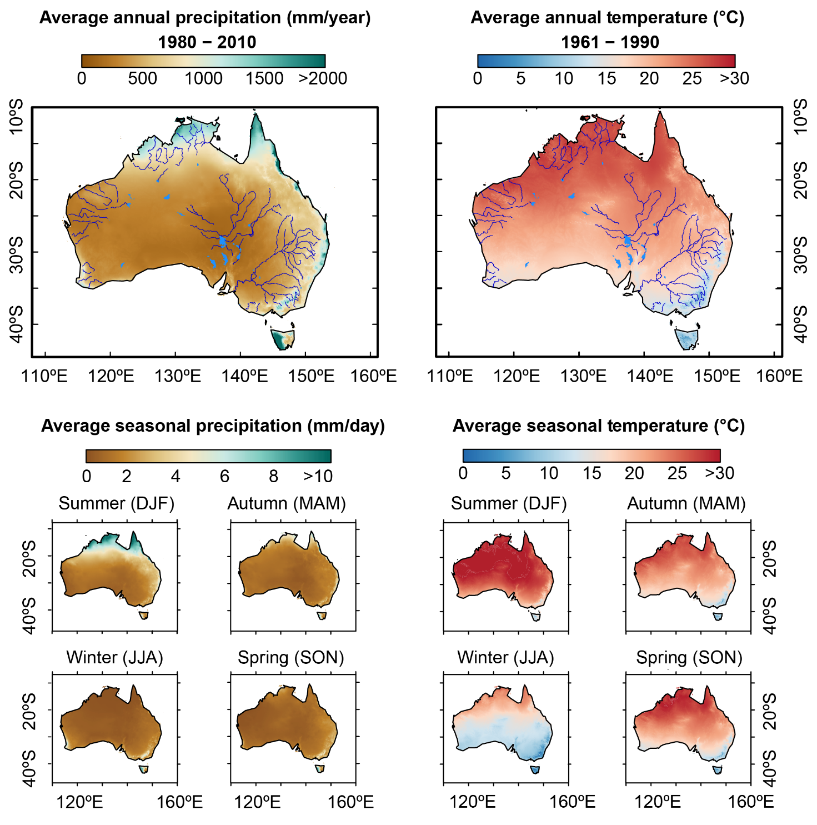
Fig S7. Top panels: Modern average annual precipitation (left; 1980 – 2010) and temperature (right; 1961 – 1990). Major river systems and lakes are shown in blue. Bottom panels: Modern average seasonal precipitation (1980 – 2010) and temperature (1961 – 1990) for Summer (December, January, February; DJF), Autumn (March, April, May; MAM), Winter (June, July, August; JJA) and Spring (September, October, November; SON).

For Fig S8 – S14; Top panels: iTRACE modelled average annual precipitation (left) and temperature (right). The location of archaeological dates (¹⁴C, OSL & TL) that had a probability >0.01 of occurring ± 200 years of time slice are plotted as grey circles (with the size of the circles proportional to the probability of occurrence). The middle panel shows a Gaussian Kernel Density Estimate (bandwidth=30) of archaeological dates (¹⁴C, OSL & TL) through time. Major river systems and lakes are shown in blue. Bottom panels: modelled average seasonal precipitation and temperature for Summer (December, January, February; DJF), Autumn (March, April, May; MAM), Winter (June, July, August; JJA) and Spring (September, October, November; SON).

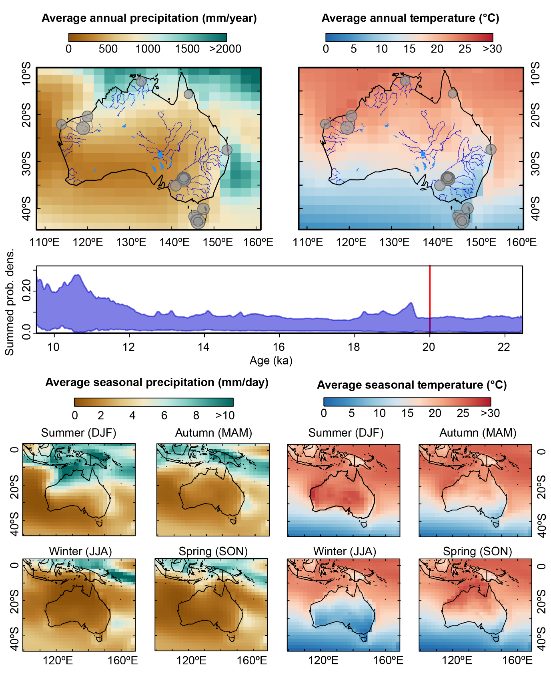
Fig S8. iTRACE modelled average annual precipitation (left) and temperature (right) and archaeological ages at 20 ka

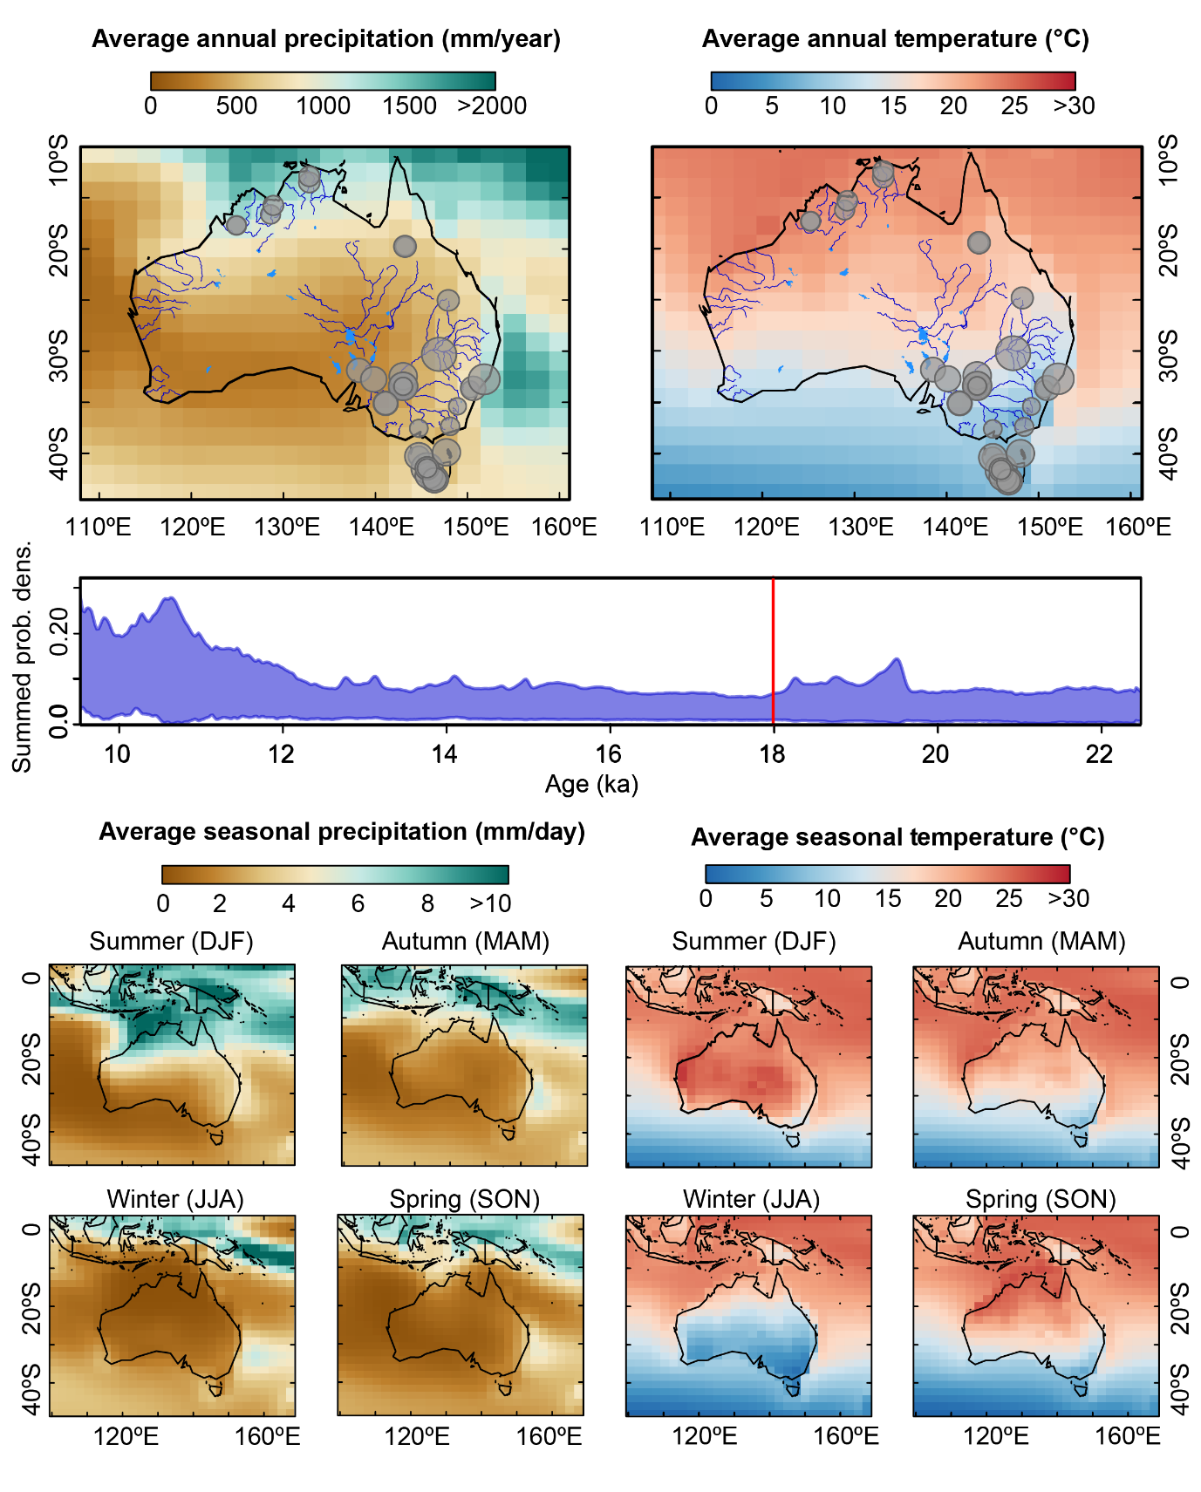
Fig S9. iTRACE modelled average annual precipitation (left) and temperature (right) and archaeological ages at 18 ka.

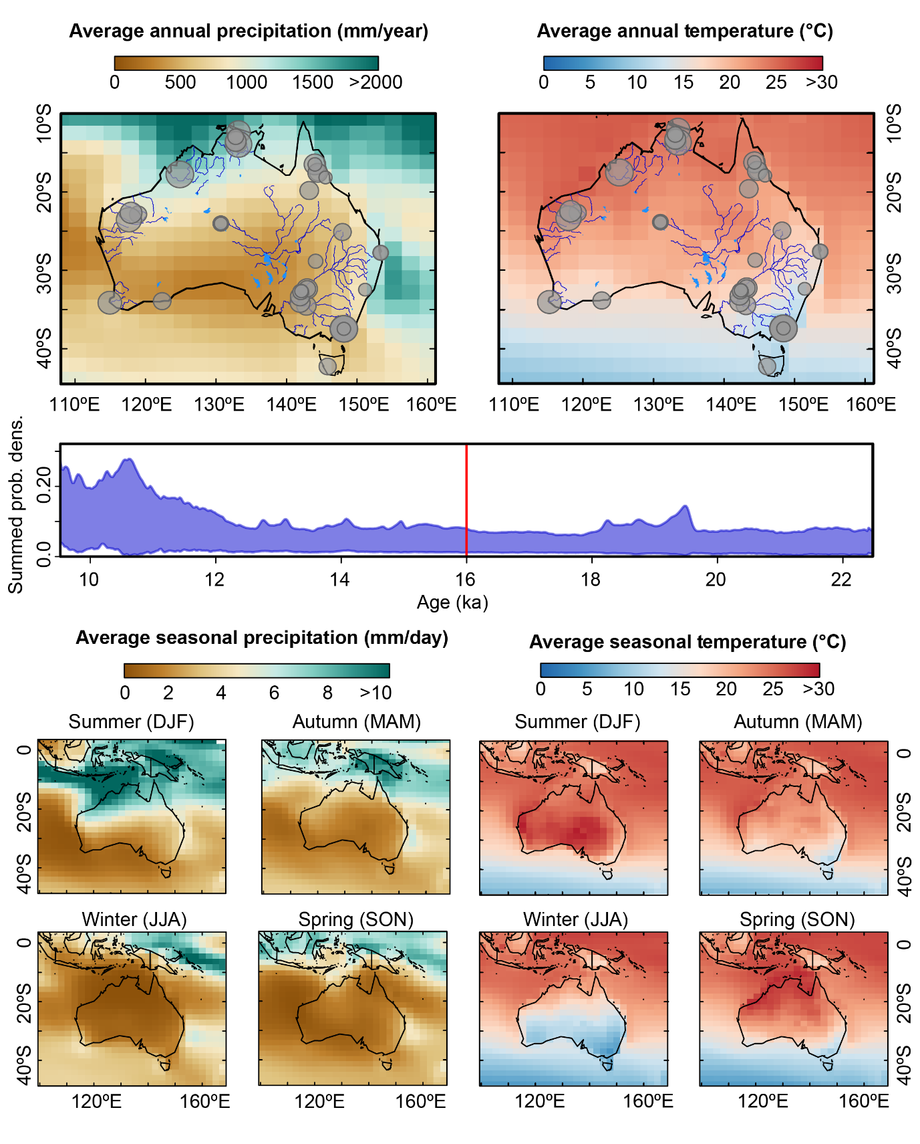
Fig S10. iTRACE modelled average annual precipitation (left) and temperature (right) and archaeological ages at 16 ka.

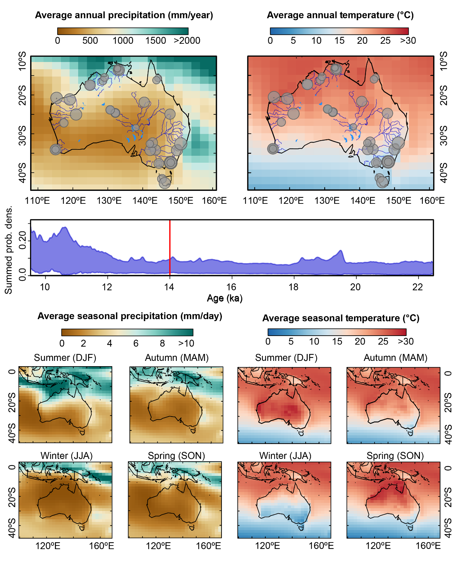
Fig S11. iTRACE modelled average annual precipitation (left) and temperature (right) and archaeological ages at 14 ka.

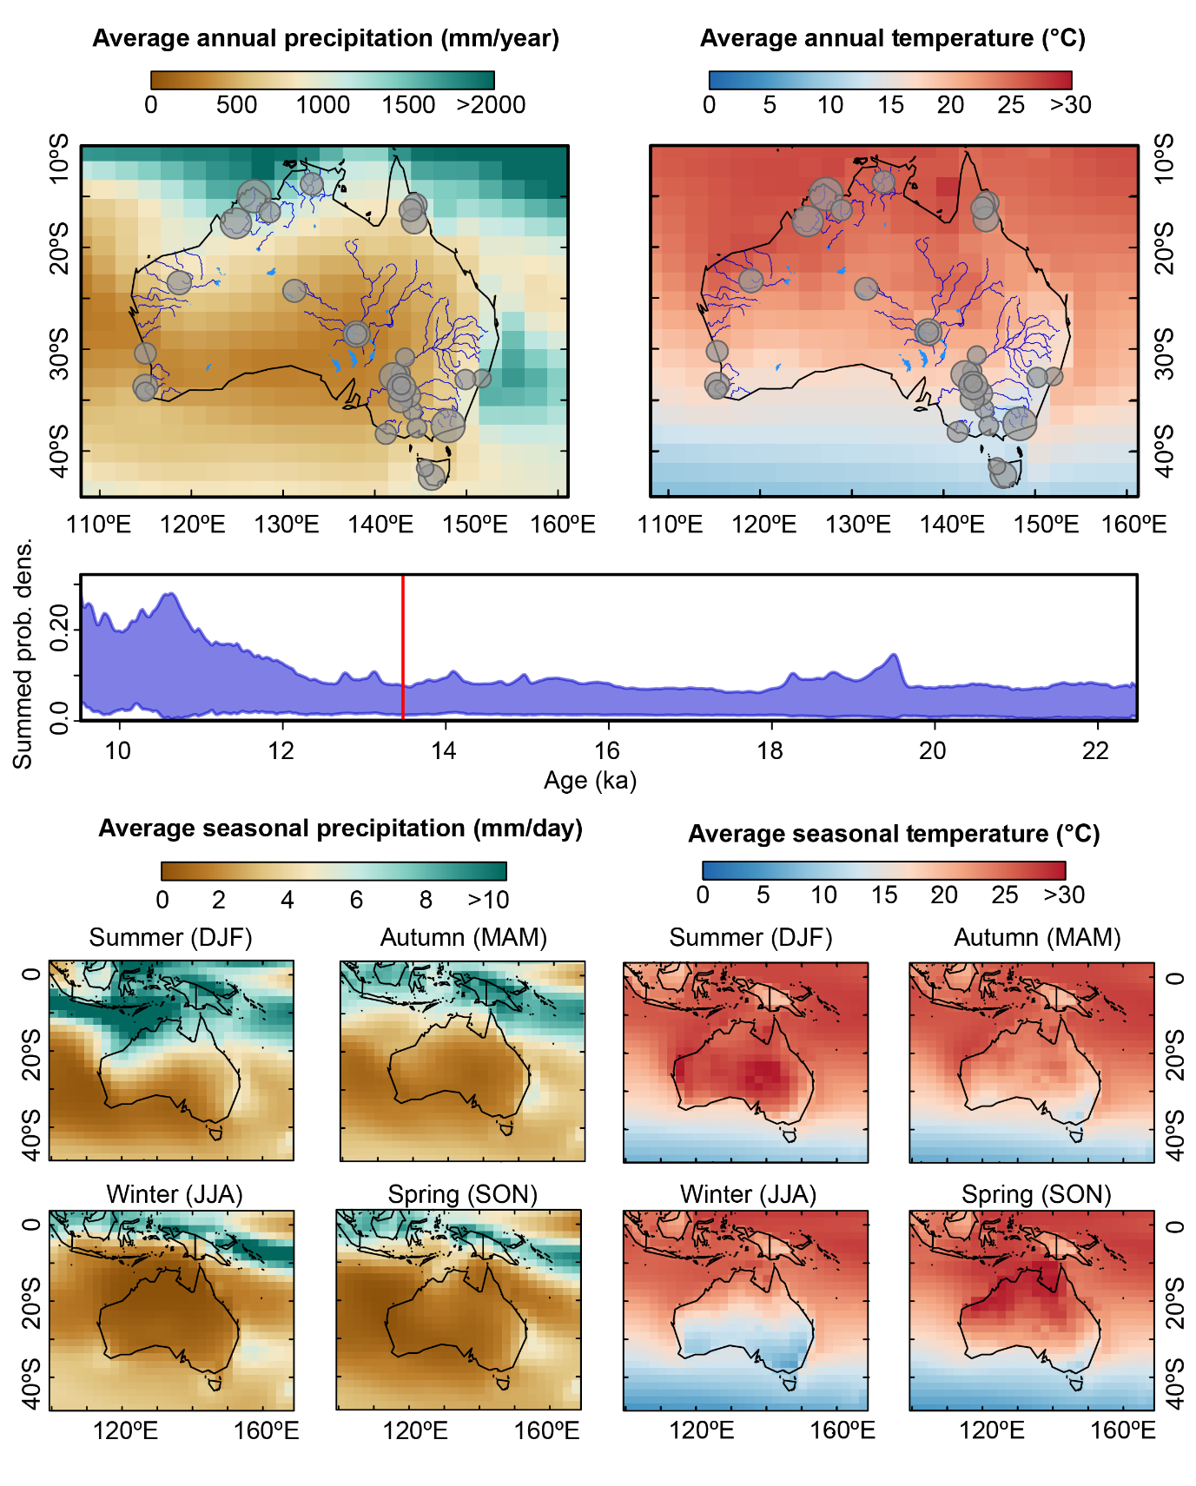
Fig S12. iTRACE modelled average annual precipitation (left) and temperature (right) and archaeological ages at 13.5 ka.

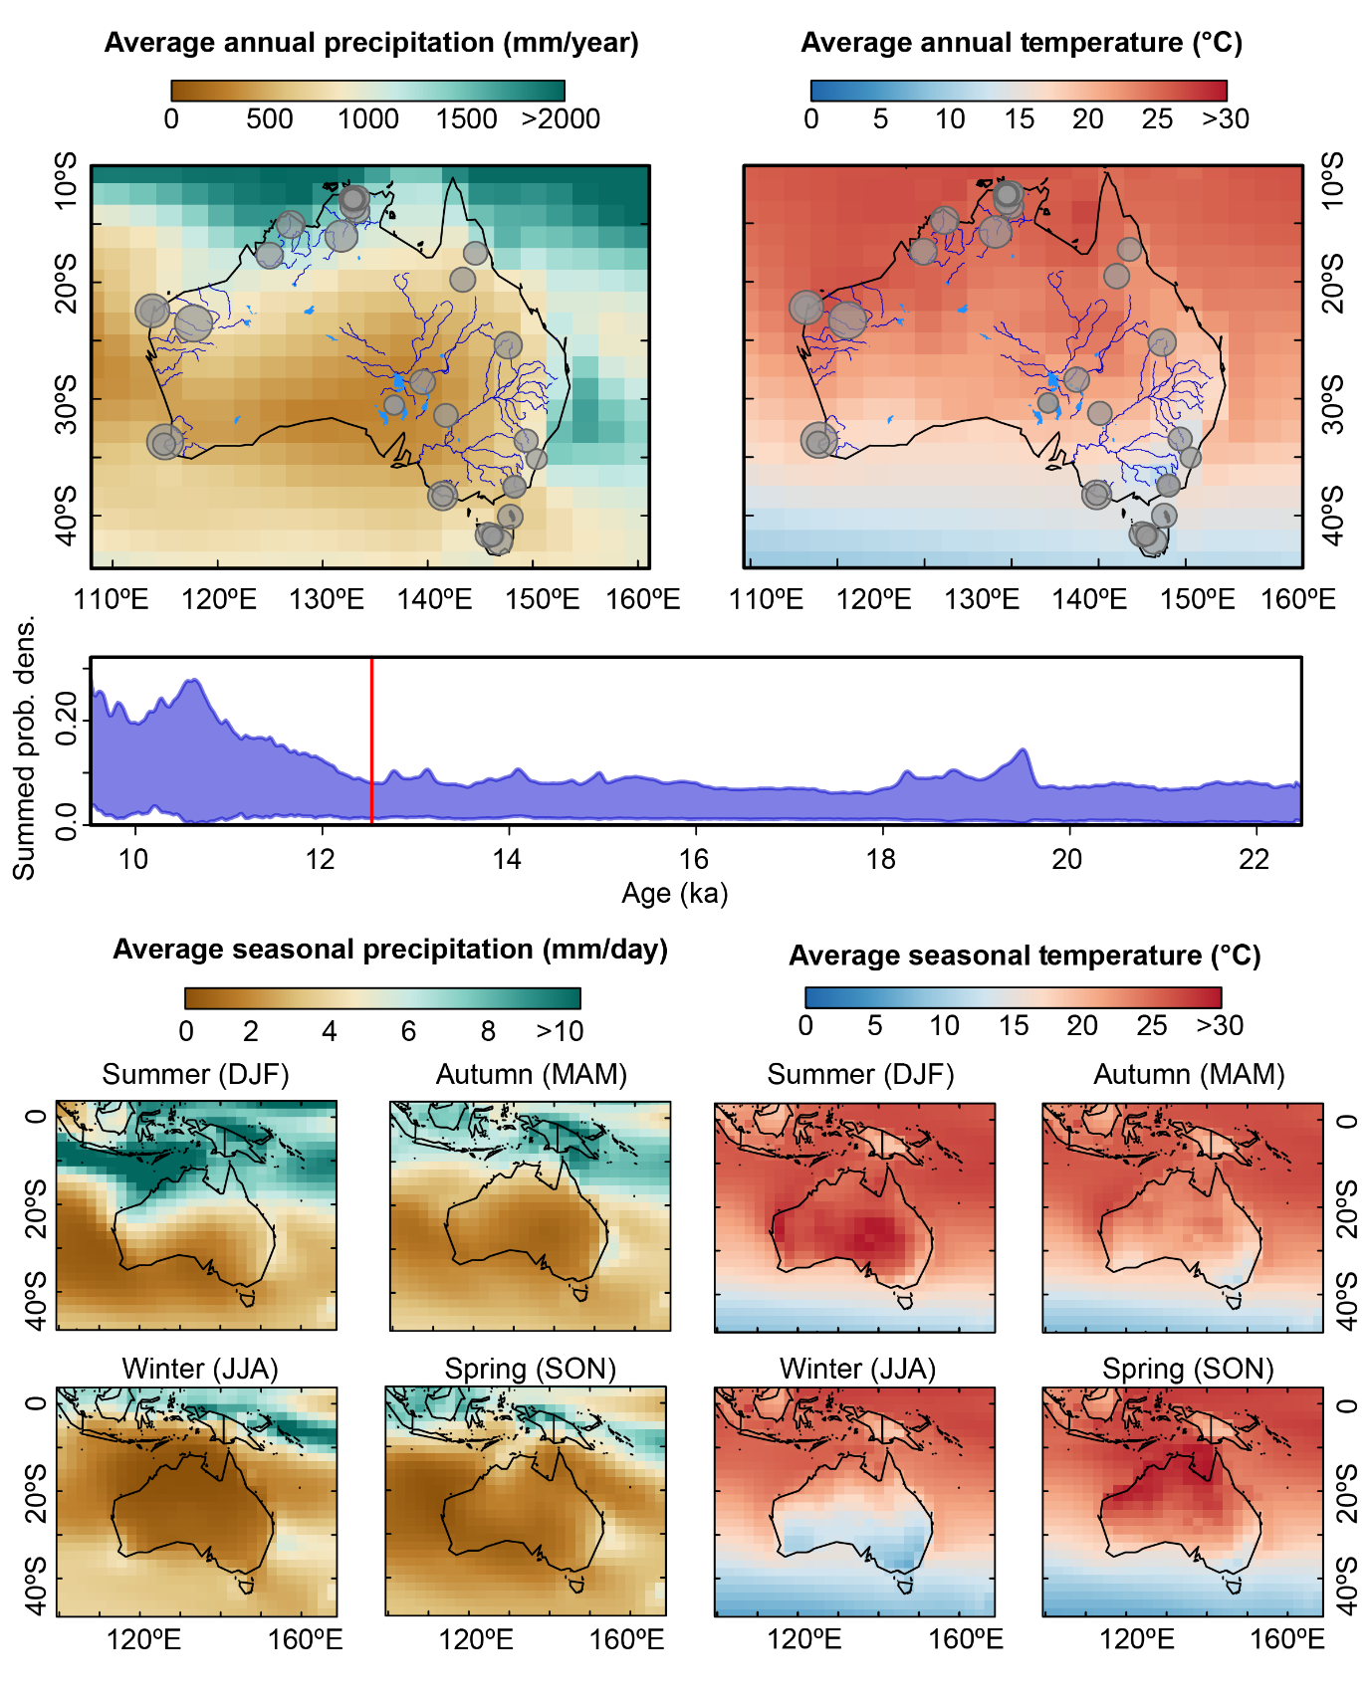
Fig S13. iTRACE modelled average annual precipitation (left) and temperature (right) and archaeological ages at 12.5 ka.

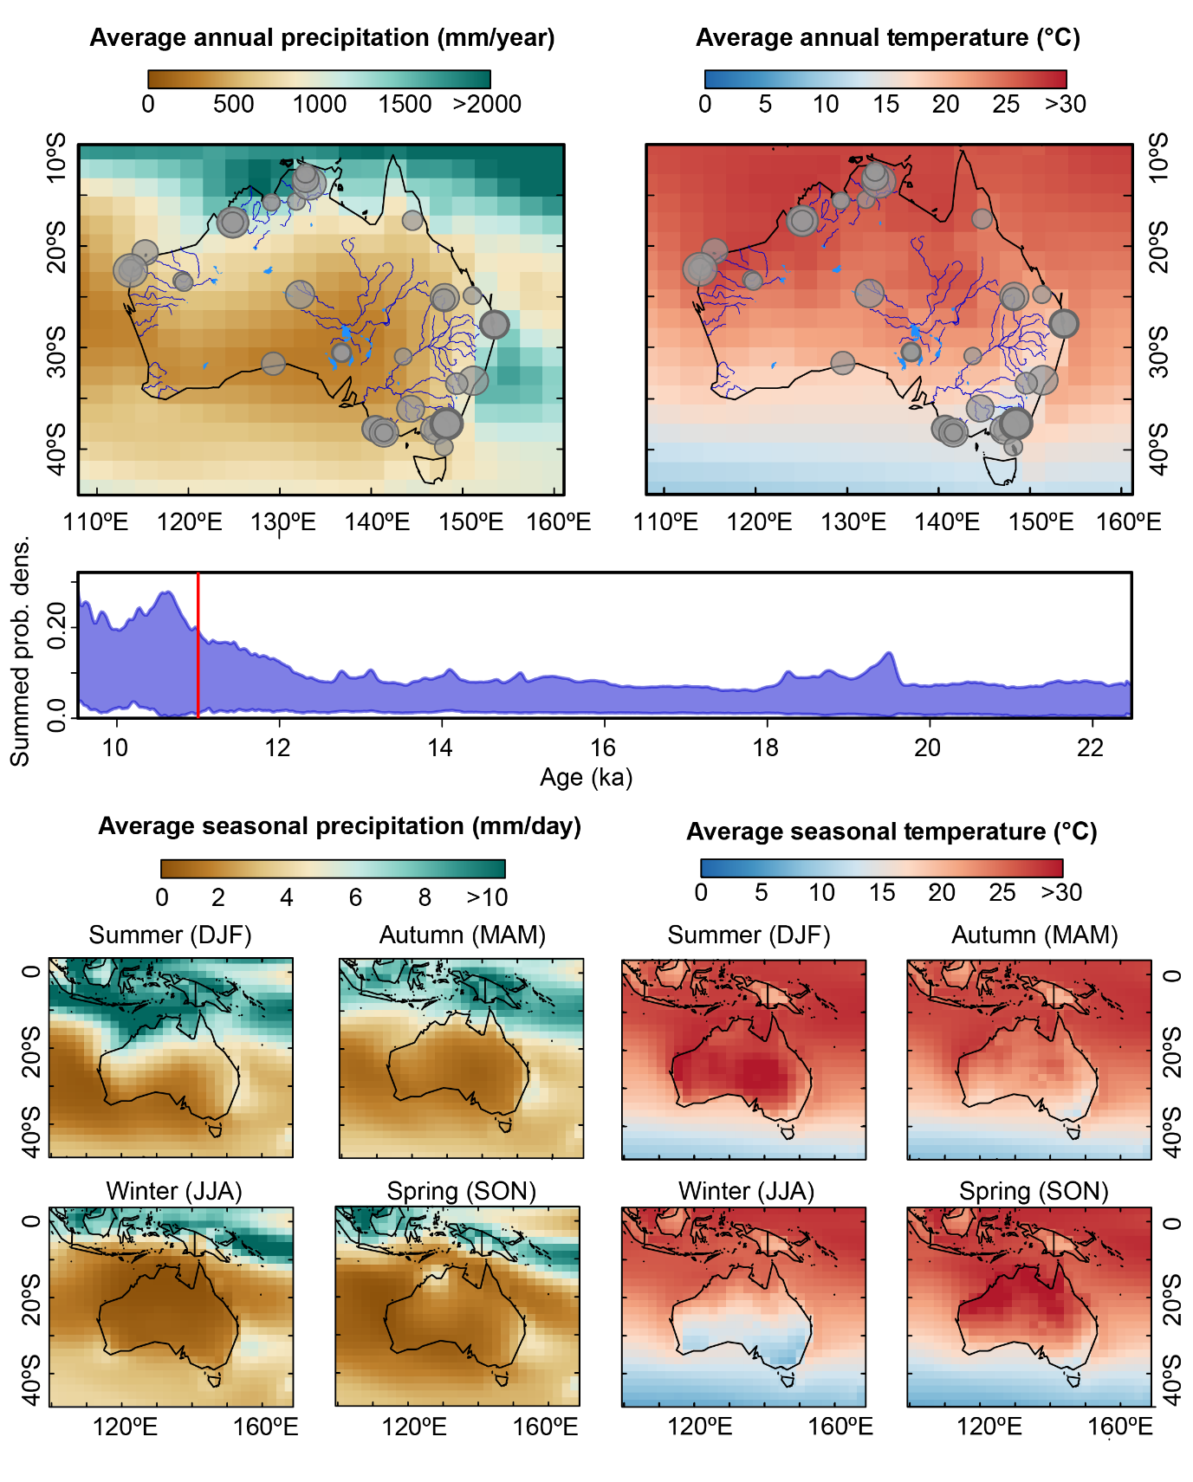
Fig S14. iTRACE modelled average annual precipitation (left) and temperature (right) and archaeological ages at 11 ka.

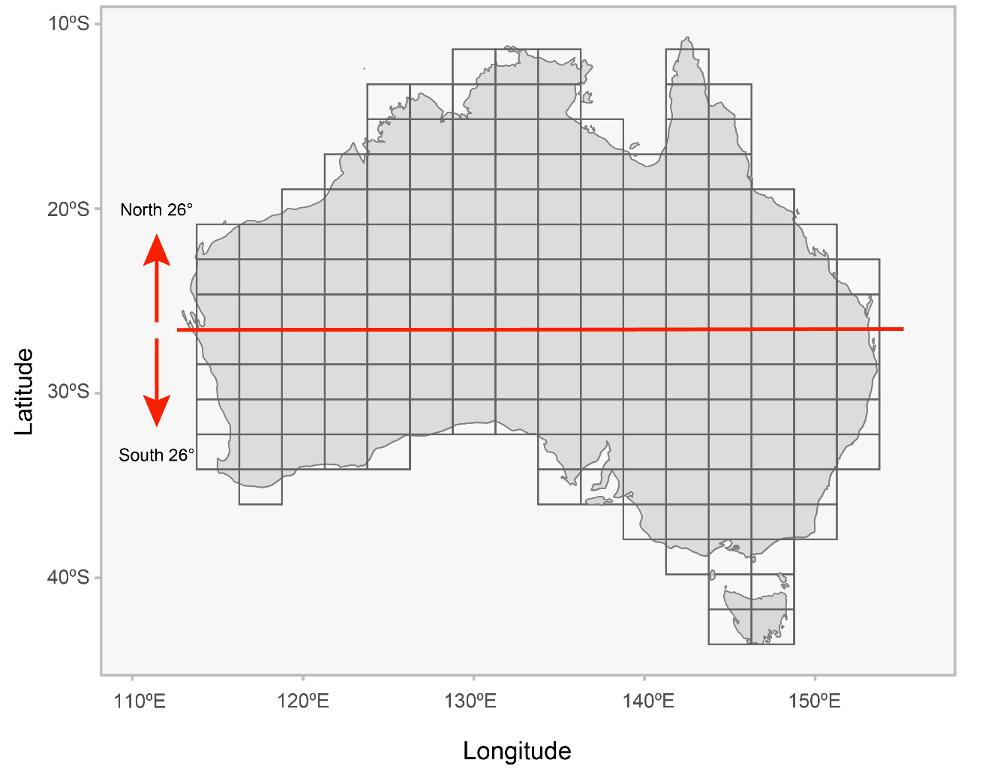
Fig S15. Grid cells of iTRACE temperature and precipitation outputs for the entire continent and grid cells north of 26°S and south of 26°S on the Australian continent.

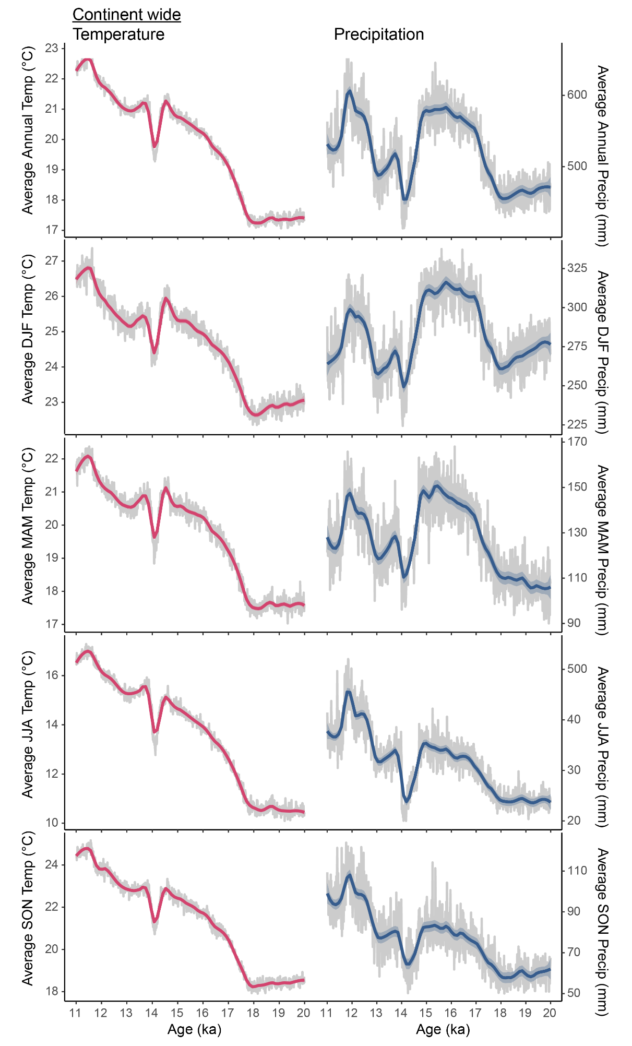
Fig S16. Decadal averaged iTRACE modelled temperature (left) and precipitation (right) averaged across all continental grid cells for Australia for A. Annual, B. Summer (December, January, February; DJF), C. Autumn (March, April, May; MAM), D. Winter (June, July, August; JJA) and F. Spring (September, October, November; SON).
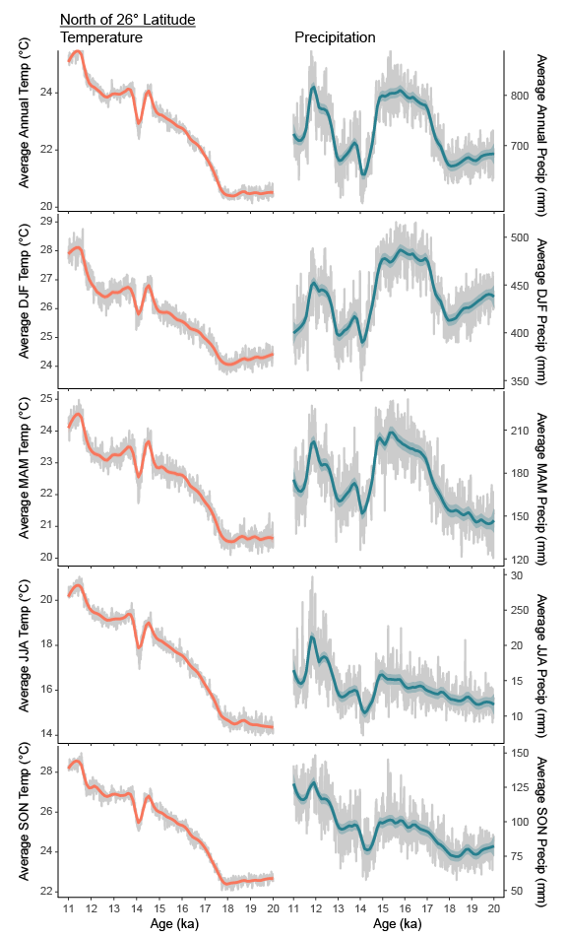
Fig S17. Decadal averaged iTRACE modelled temperature (left) and precipitation (right) averaged across all grid cells North of 26°S latitude for Australia for A. Annual, B. Summer (December, January, February; DJF), C. Autumn (March, April, May; MAM), D. Winter (June, July, August; JJA) and F. Spring (September, October, November; SON).
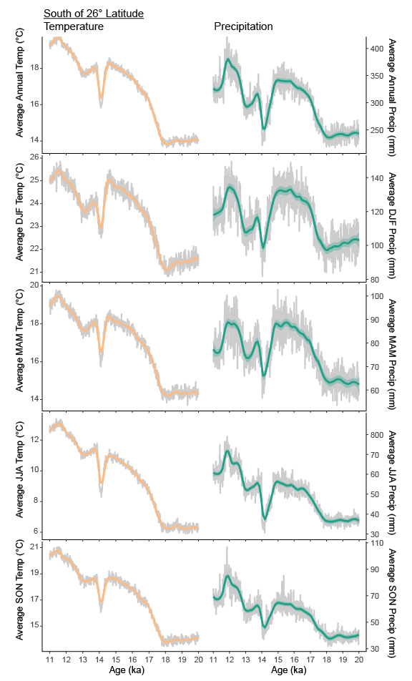
Fig S18. Decadal averaged iTRACE modelled temperature (left) and precipitation (right) averaged across all grid cells South of 26°S latitude for Australia for A. Annual, B. Summer (December, January, February; DJF), C. Autumn (March, April, May; MAM), D. Winter (June, July, August; JJA) and F. Spring (September, October, November; SON).
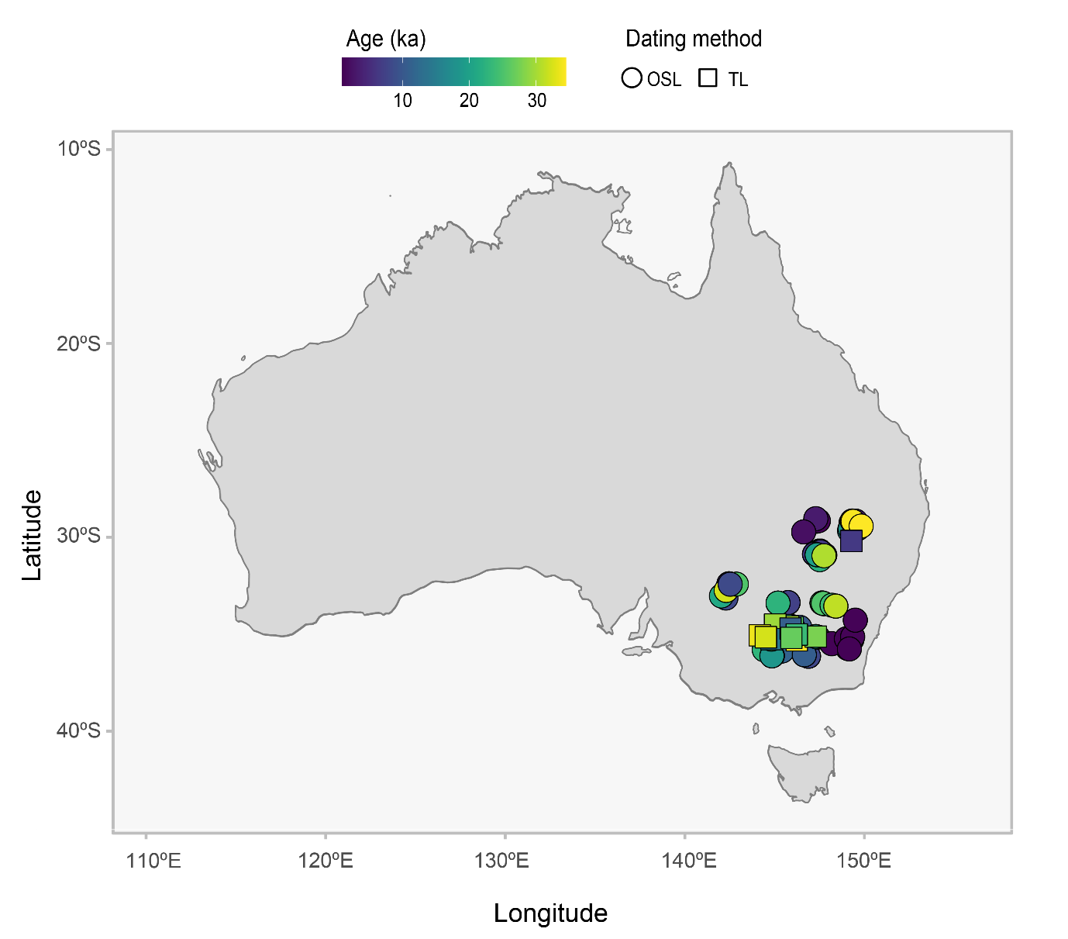
Fig S19. Location and mean age of optically stimulated luminescence (OSL) and thermoluminescence (TL) ages from all beach/shoreline, channel and overbank geomorphological features dated within the Lake Eyre Basin and used in Kernel Density Estimates in Fig 4 and Fig S3.

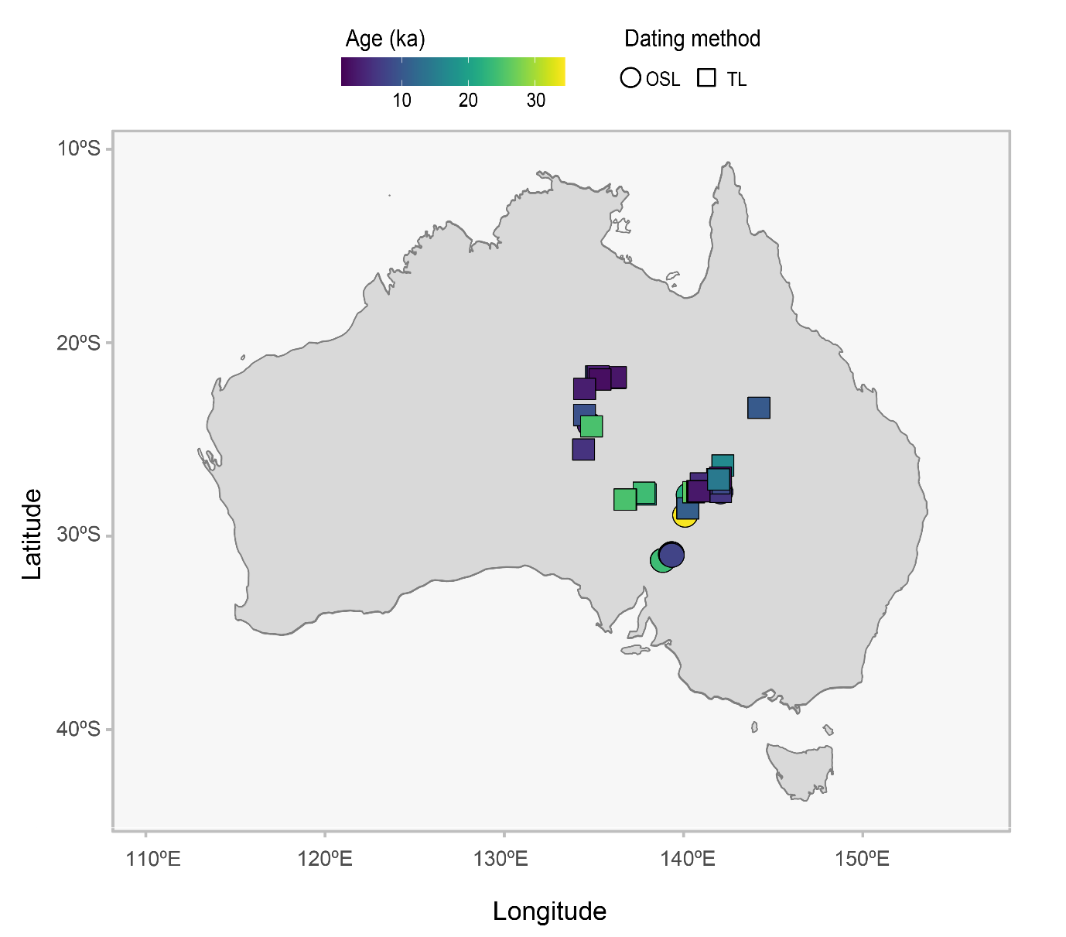
Fig S20. Location and mean age of optically stimulated luminescence (OSL) and thermoluminescence (TL) ages from all beach/shoreline, channel and overbank geomorphological features dated within the Murray-Darling Basin and used in Kernel Density Estimates in Fig 4 and Fig S3.

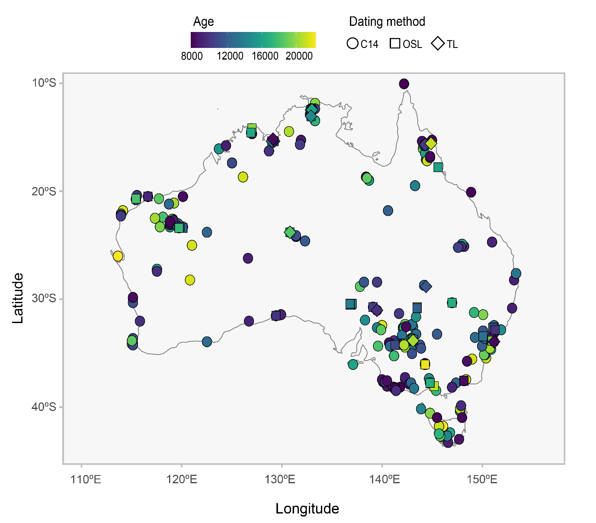
Fig S21. Location and mean age of optically stimulated luminescence, thermoluminescence and uncalibrated radiocarbon ages from the SahulArch database used in analysis.

SI References

1. J. E. Tierney, C. J. Poulsen, I. P. Montañez, T. Bhattacharya, R. Feng, H. L. Ford, B. Hönisch, G. N. Inglis, S. V. Petersen, N. Sagoo, et al., Past climates inform our future. Science (80-. ). 370 (2020).
2. C. He, Z. Liu, B. L. Otto-Bliesner, E. C. Brady, C. Zhu, R. Tomas, S. Gu, J. Han, Y. Jin, Deglacial variability of South China hydroclimate heavily contributed by autumn rainfall. Nat. Commun. 12, 5875 (2021).
3. L. Comas-Bru, K. Rehfeld, C. Roesch, S. Amirnezhad-Mozhdehi, S. P. Harrison, K. Atsawawaranunt, S. M. Ahmad, Y. A. Brahim, A. Baker, M. Bosomworth, et al., SISALv2: A comprehensive speleothem isotope database with multiple age-depth models. Earth Syst. Sci. Data 12, 2579–2606 (2020).
4. H. Cadd, L. Petherick, J. Tyler, A. Herbert, T. J. Cohen, K. Sniderman, T. T. Barrows, R. H. Fulop, J. Knight, A. P. Kershaw, et al., A continental perspective on the timing of environmental change during the last glacial stage in Australia. Quat. Res. 102, 5–23 (2021).
5. W. J. Bond, F. I. Woodward, G. F. Midgley, The global distribution of ecosystems in a world without fire. New Phytol. 165, 525–538 (2005).
6. W. J. Bond, G. F. Midgley, F. I. Woodward, The importance of low atmospheric CO2 and fire in promoting the spread of grasslands and savannas. Glob. Chang. Biol. 9, 973–982 (2003).
7. S. A. Cowling, M. T. Sykes, Physiological Significance of Low Atmospheric CO 2 for Plant–Climate Interactions. Quat. Res. 52, 237–242 (1999).
8. I. C. Prentice, S. F. Cleator, Y. H. Huang, S. P. Harrison, I. Roulstone, Reconstructing ice-age palaeoclimates: Quantifying low-CO2effects on plants. Glob. Planet. Change 149, 166–176 (2017).
9. A. T. Codilean, H. Munack, W. M. Saktura, T. J. Cohen, Z. Jacobs, S. Ulm, P. P. Hesse, J. Heyman, K. J. Peters, A. N. Williams, et al., OCTOPUS database (v.2). Earth Syst. Sci. Data 14, 3695–3713 (2022).
10. W. M. Saktura, H. Munack, A. T. Codilean, R. Wood, F. Petchey, Z. Jacobs, A. Williams, S. Ulm, OCTOPUS Database v.2: The SahulArch Radiocarbon collection. Sahul-wide database of published archaeological records with radiometric ages (2021) https:/doi.org/10.25900/2mb4-rr36.
11. W. M. Saktura, E. Rehn, L. Linnenlucke, H. Munack, R. Wood, F. Petchey, A. T. Codilean, Z. Jacobs, T. J. Cohen, A. N. Williams, et al., SahulArch: A geochronological database for the archaeology of Sahul. Aust. Archaeol., 1–13 (2023).
12. A. G. Hogg, T. J. Heaton, Q. Hua, J. G. Palmer, C. S. Turney, J. Southon, A. Bayliss, P. G. Blackwell, G. Boswijk, C. Bronk Ramsey, et al., SHCal20 Southern Hemisphere Calibration, 0–55,000 Years cal BP. Radiocarbon 62, 759–778 (2020).
13. T. J. Heaton, P. Köhler, M. Butzin, E. Bard, R. W. Reimer, W. E. N. Austin, C. Bronk Ramsey, P. M. Grootes, K. A. Hughen, B. Kromer, et al., Marine20—The Marine Radiocarbon Age Calibration Curve (0–55,000 cal BP). Radiocarbon 62, 779–820 (2020).
14. T. R. McLaughlin, On Applications of Space–Time Modelling with Open-Source 14 C Age Calibration. J. Archaeol. Method Theory 26, 479–501 (2019).
15. R Core Team, R: A Language and Environment for Statistical Computing. R Found. Stat. Comput. Vienna, Austria 0, {ISBN} 3-900051-07-0 (2017).
16. R. F. Denniston, K. H. Wyrwoll, Y. Asmerom, V. J. Polyak, W. F. Humphreys, J. Cugley, D. Woods, Z. LaPointe, J. Peota, E. Greaves, North Atlantic forcing of millennial-scale Indo-Australian monsoon dynamics during the Last Glacial period. Quat. Sci. Rev. 72, 159–168 (2013).
17. R. F. Denniston, Y. Asmerom, M. Lachniet, V. J. Polyak, P. Hope, N. An, K. Rodzinyak, W. F. Humphreys, A Last Glacial Maximum through middle Holocene stalagmite record of coastal Western Australia climate. Quat. Sci. Rev. 77, 101–112 (2013).
18. R. F. Denniston, Y. Asmerom, V. J. Polyak, A. D. Wanamaker, C. C. Ummenhofer, W. F. Humphreys, J. Cugley, D. Woods, S. Lucker, Decoupling of monsoon activity across the northern and southern Indo-Pacific during the Late Glacial. Quat. Sci. Rev. 176, 101–105 (2017).
19. P. C. Treble, A. Baker, L. K. Ayliffe, T. J. Cohen, J. C. Hellstrom, M. K. Gagan, S. Frisia, R. N. Drysdale, A. D. Griffiths, A. Borsato, Hydroclimate of the Last Glacial Maximum and deglaciation in southern Australia’s arid margin interpreted from speleothem records (23-15 ka). Clim. Past 13, 667–687 (2017).
20. X. Du, J. M. Russell, Z. Liu, B. L. Otto-Bliesner, Y. Gao, C. Zhu, D. W. Oppo, M. Mohtadi, Y. Yan, V. V. Galy, et al., Deglacial trends in Indo-Pacific warm pool hydroclimate in an isotope-enabled Earth system model and implications for isotope-based paleoclimate reconstructions. Quat. Sci. Rev. 270, 107188 (2021).
21. F. L. Buckingham, S. A. Carolin, J. W. Partin, J. F. Adkins, K. M. Cobb, C. C. Day, Q. Ding, C. He, Z. Liu, B. Otto-Bliesner, et al., Termination 1 Millennial-Scale Rainfall Events Over the Sunda Shelf. Geophys. Res. Lett. 49, 1–10 (2022).

