Supplementary Information for Light-field-driven non-Ohmic current and Keldysh crossover in a Weyl semimetal

Author: R. Ikeda¹, H. Watanabe^{2,1}, J. H. Moon³, M. H. Jung^{3,1}, K. Takasan⁴, S. Kimura^{2,1,5}

¹Department of Physics, Graduate School of Science, Osaka University, Toyonaka, Japan
²Graduate School of Frontier Biosciences, Osaka University, Suita, Japan
³Department of Physics, Sogang University, Seoul, Republic of Korea
⁴Department of Physics, The University of Tokyo, Tokyo, Japan
⁵Institute for Molecular Science, Okazaki, Aichi, Japan

S1. The intense THz pump/reflective THz-TDS optical system
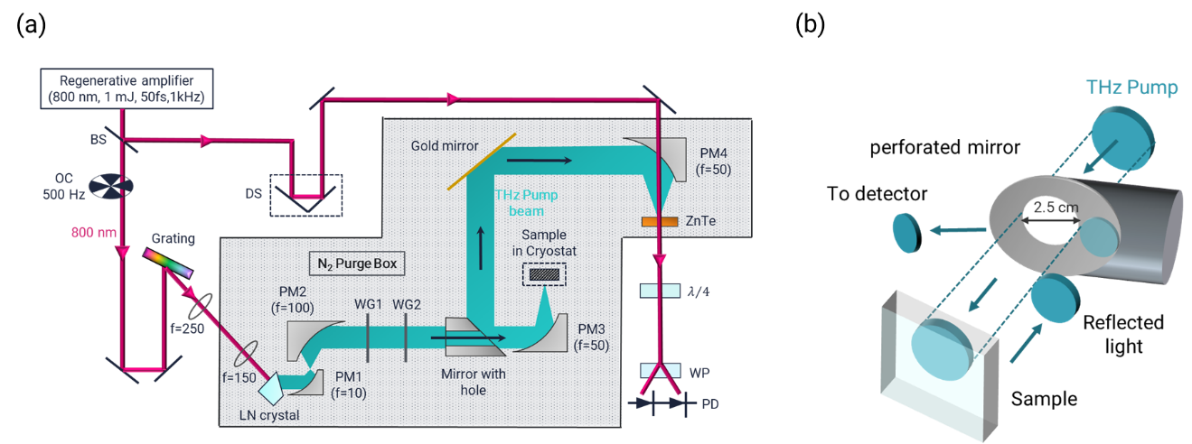
Fig.S1 The constructed intense THz pump/reflective THz-TDS optical system. (a) THz waves generated from the LN crystal are focused onto the sample, and the reflected light is reflected using a perforated mirror and focused onto the ZnTe crystal. (b) Details of a performed mirror.

A schematic of the constructed intense THz pump/reflective THz-TDS optical system is shown in Fig. S1. The THz pulse was generated using the Cherenkov optical rectification technique using a LiNbO₃ nonlinear optical crystal, pumped by a Ti:sapphire regenerative amplifier (1 mJ, 1.55 eV, repetition rate of 1 kHz , pulse width of 50 fs). The generated THz beam was expanded by a factor of 10 using parabolic mirrors with focal lengths of 10 and 100 mm and then focused onto the sample using a parabolic mirror with a focal length of 50 mm. The spot size of the THz wave on the sample was approximately 500 µm. The THz waves reflected from the sample surface were reflected using a perforated mirror and guided to the detection system. The details are shown in Fig. S1(b). A hole with a 25 mm was drilled into the perforated mirror, and the pump THz beam was focused onto the sample after passing through this hole. By slightly tilting the sample, the path of the reflected light was shifted such that the THz beam was reflected at the mirror plane near the hole as shown in Fig. S1(b). A part of the Ti:sapphire regenerative amplifier (<1 μJ) was used for generating the sampling pulse for EO detection, and ZnTe crystals were used as the EO crystals. This experimental setup facilitates the observation of the ultrafast time evolution of the reflection spectrum instead of the transmission. Therefore, the ultrafast THz electric field response can be measured in bulk single crystals but not in thin-film samples.

