Supplementary information

Inhibition of defect-induced α-to-δ phase transition for efficient and stable formamidinium perovskite solar cells
Tian Chen^{1,2}, Jiangsheng Xie^{1,2}*, Bin Wen^{1,2}, Qixin Yin^{1,2}, Ruohao Lin^{1,2}, Shengcai Zhu¹*, Pingqi Gao^{1,2}*
¹School of Materials, Shenzhen Campus of Sun Yat-sen University, No. 66, Gongchang Road, Shenzhen, Guangdong 518107, P.R. China
²Institute for Solar Energy Systems, State Key Laboratory of Optoelectronic Materials and Technologies, Sun Yat-sen University, Guangzhou, 510275, P.R. China
*Corresponding author. xiejsh8@mail.sysu.edu.cn (J. X.); zhushc@mail.sysu.edu.cn (S. Z.); gaopq3@mail.sysu.edu.cn (P. G.).

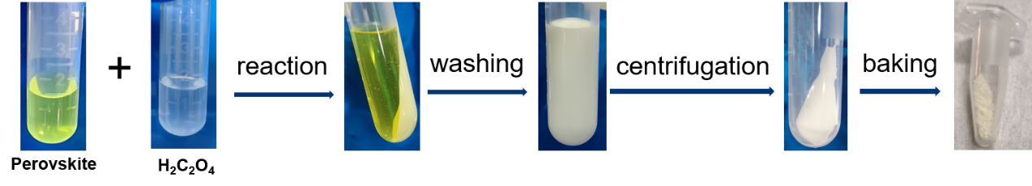
Supplementary Figure 1. Synthetic process of PbC₂O₄ powder by perovskite precursor solution and H₂C₂O₄.

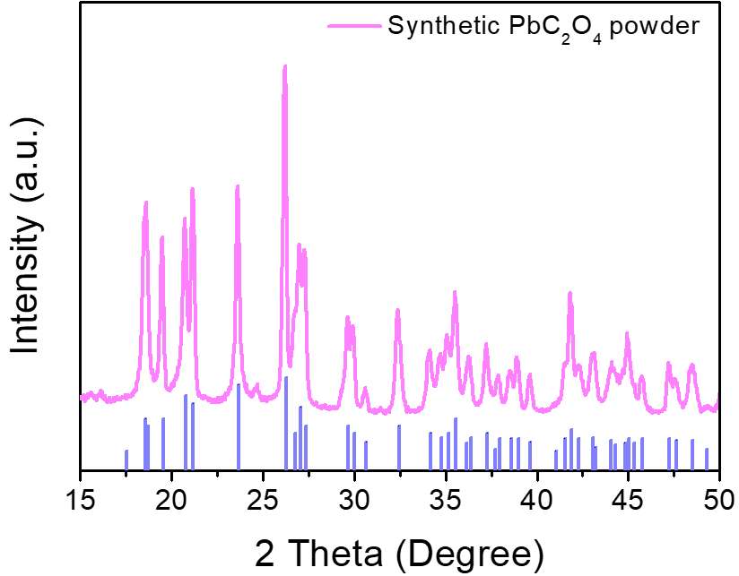
Supplementary Figure 2. XRD spectra of prepared PbC₂O₄ (JCPDS: 14-0803).

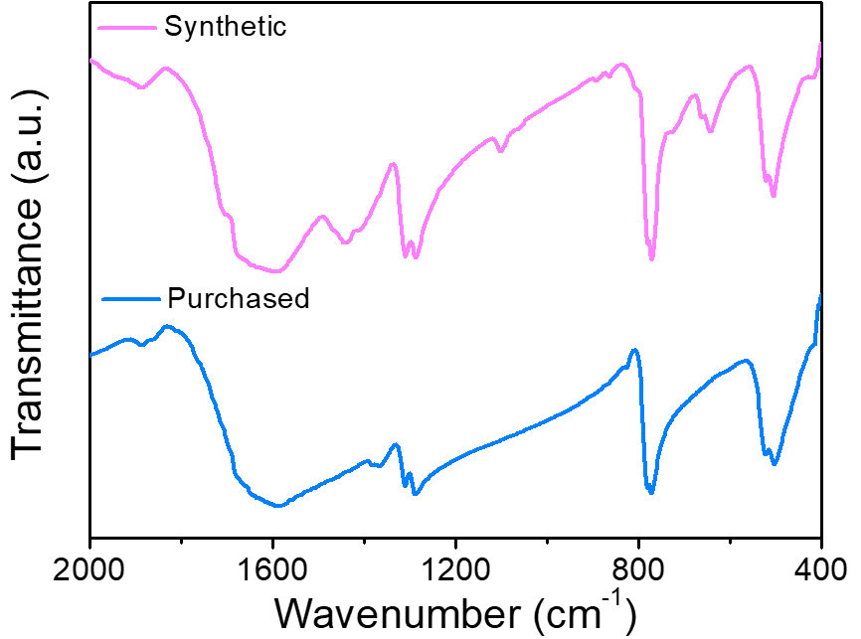
Supplementary Figure 3. FTIR spectra of the purchased PbC₂O₄ powder (Purchased) and the prepared PbC₂O₄ powder (Synthetic).

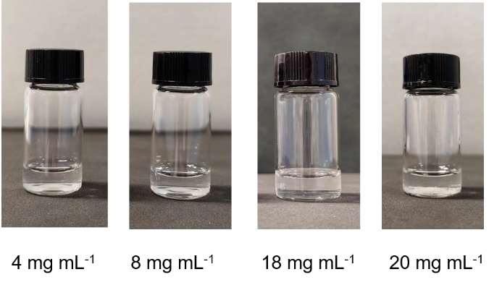
Supplementary Figure 4. The dissolving capacity of H₂C₂O₄ in isopropanol. It dissolves well until 18 mg mL⁻¹ and some undissolved powder appears at 20 mg mL⁻¹.

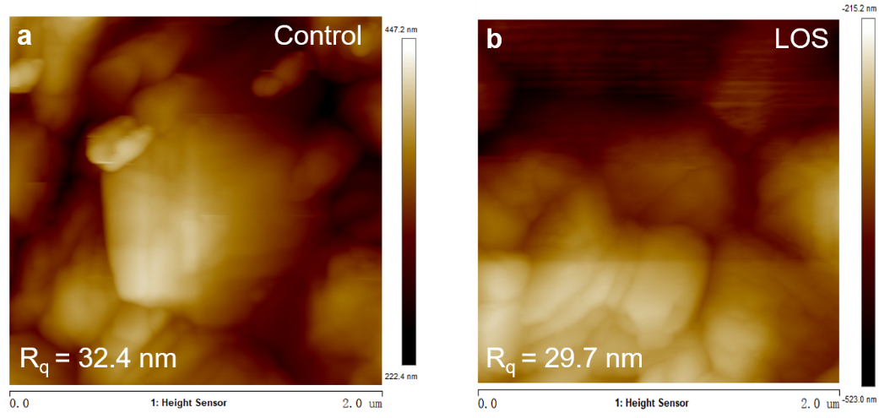
Supplementary Figure 5. AFM images of the (a) control and (b) LOS perovskite films. R_{q} is root mean square roughness.

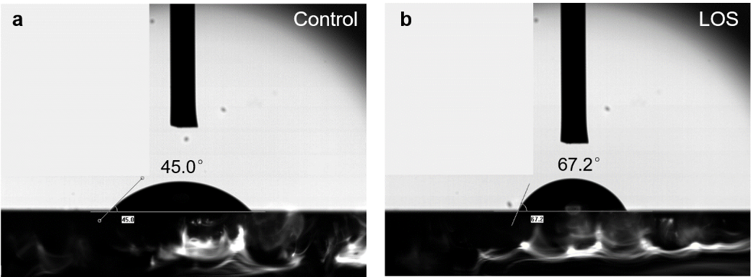
Supplementary Figure 6. Characterization of water contact angles of the (a) control and (b) LOS perovskite films.

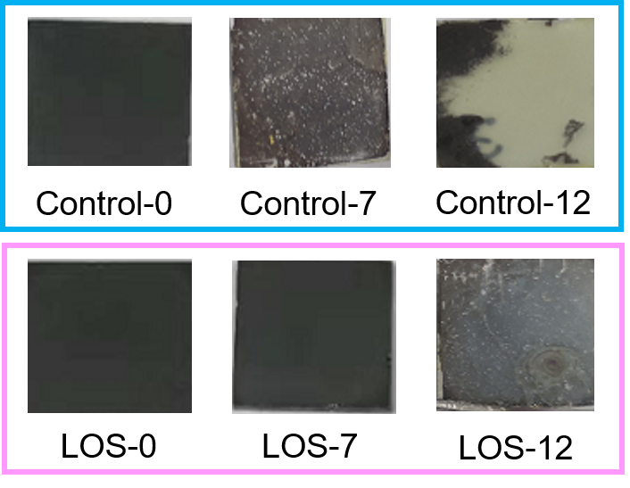
Supplementary Figure 7. The photographs of control and LOS perovskite films stored in 30%-60% relatively humidity after 0, 7 and 12 days.

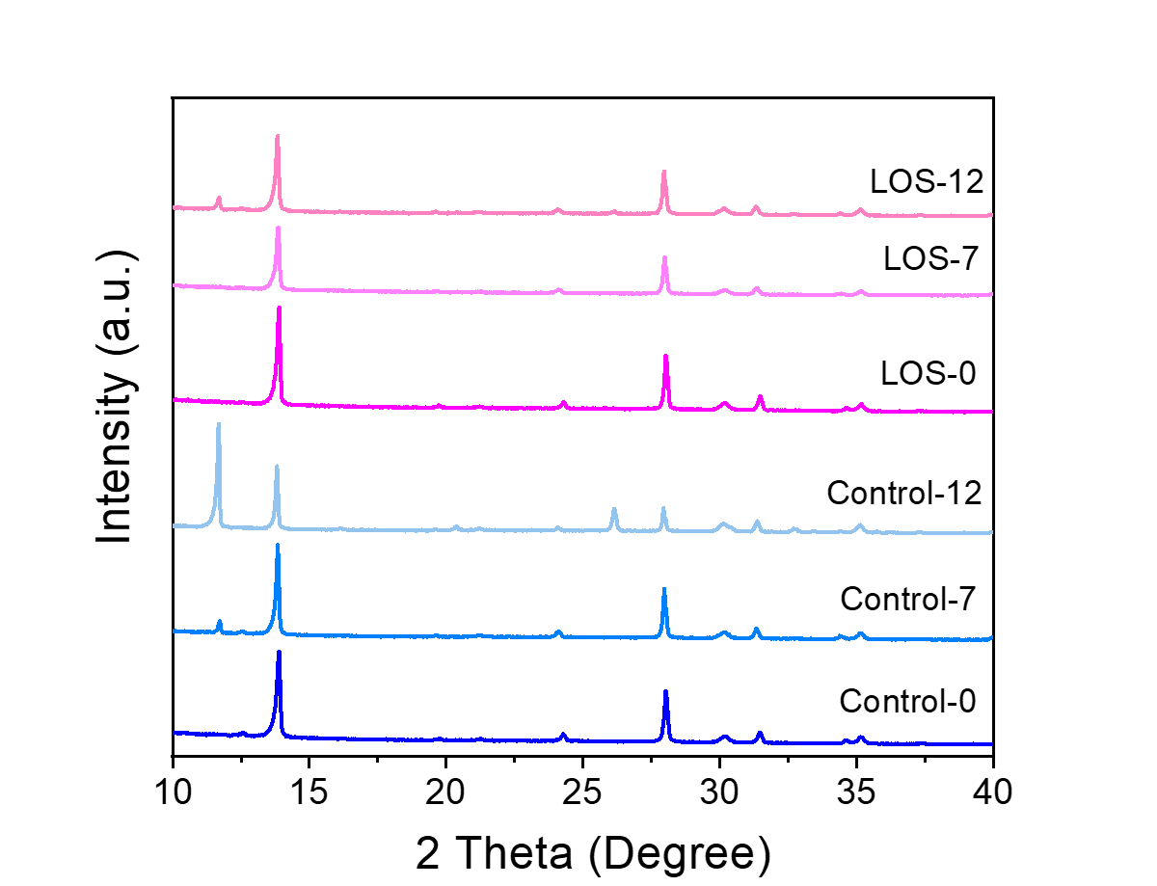

Supplementary Figure 8. XRD patterns of control and LOS perovskite films stored in 30%-60% relatively humidity after 0, 7 and 12 days.

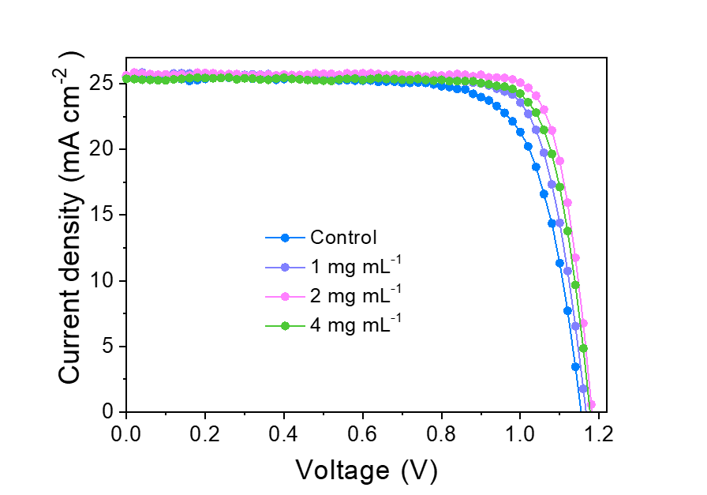
Supplementary Figure 9. The J-V curves of control and LOS PSCs (1, 2, and 4 mg mL⁻¹ H₂C₂O₄), respectively.

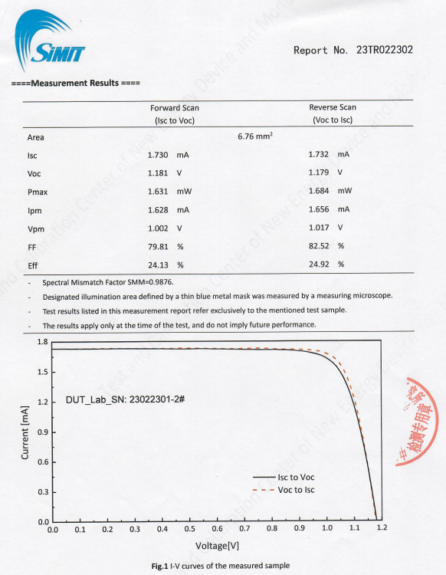
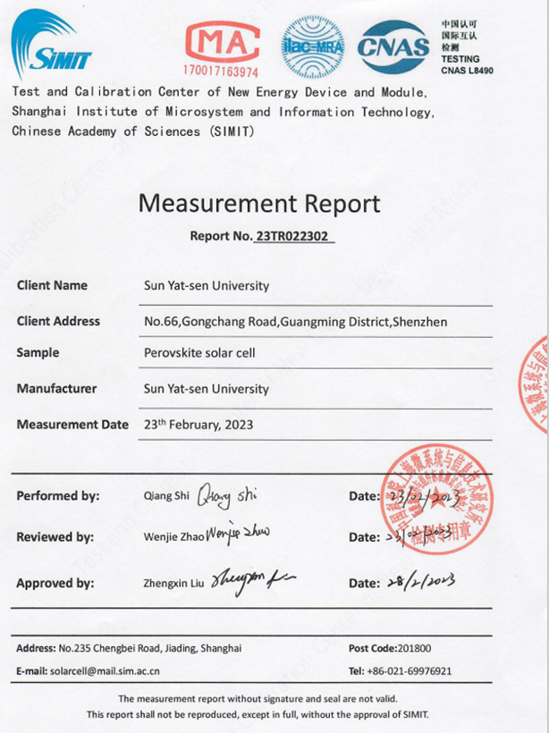
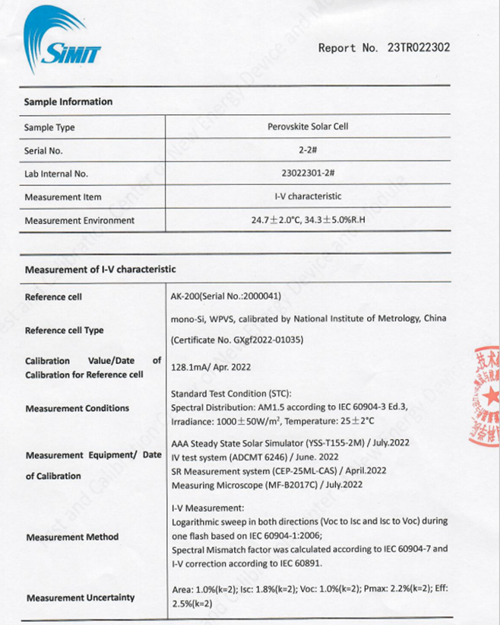
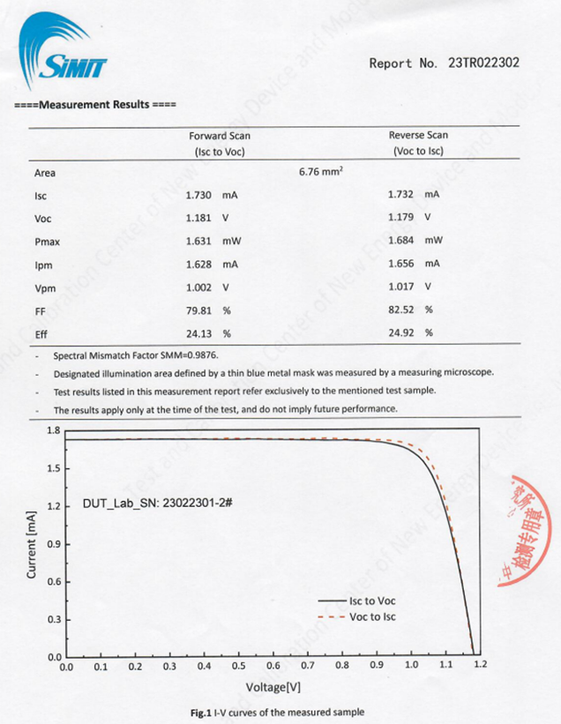

Supplementary Figure 10. Independent certification by Shanghai Institute of Microsystem and Information Technology (SIMIT) of the LOS device.
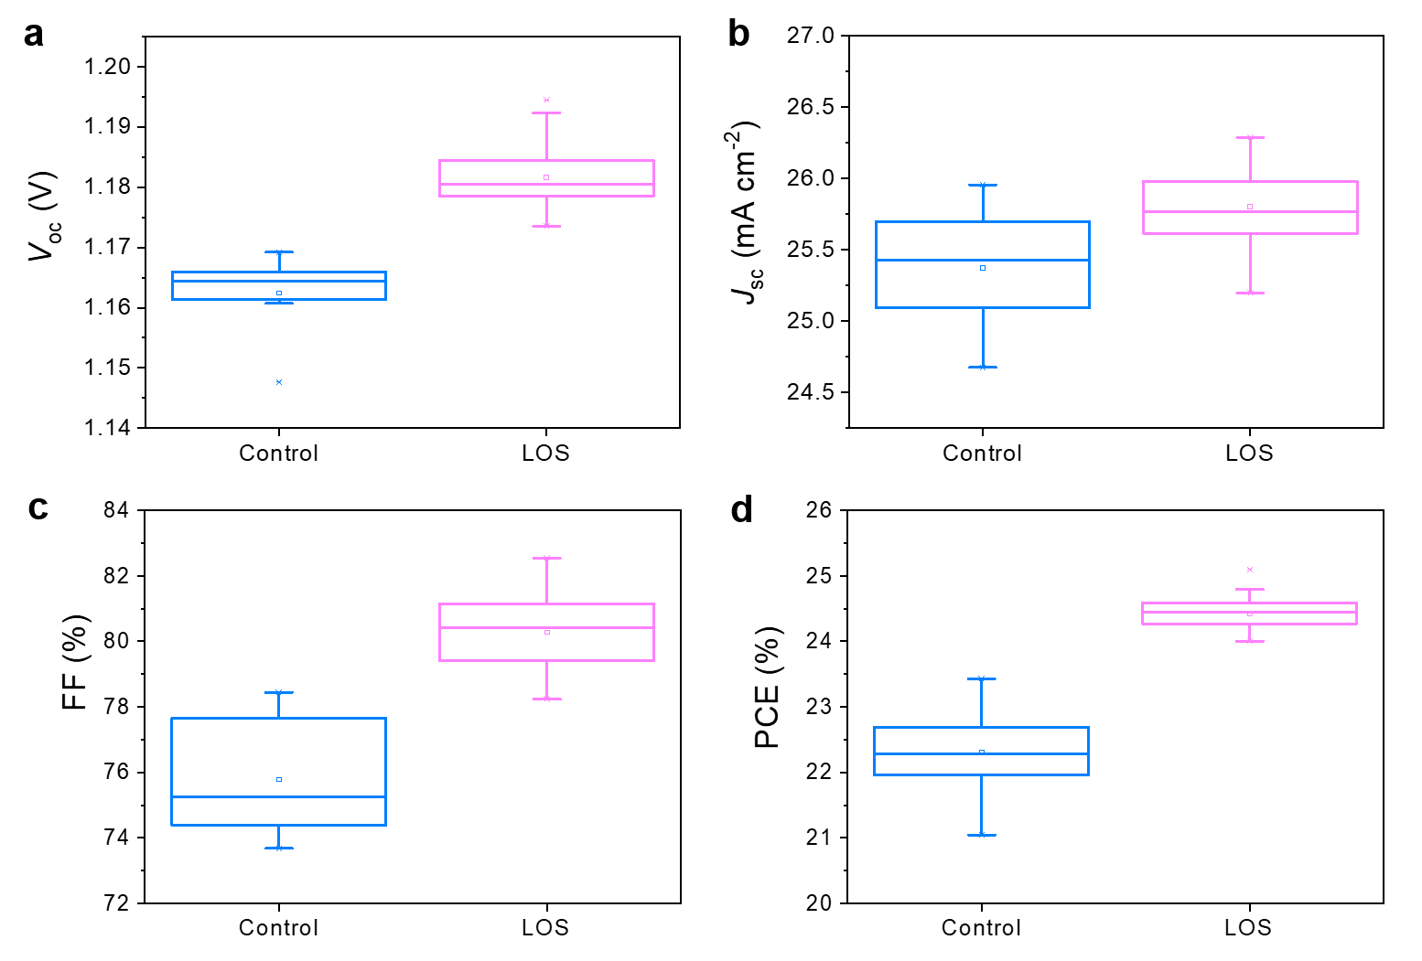
Supplementary Figure 11. The statistical distribution of (a) V_{oc}, (b) J_{sc}, (c) FF, and (d) PCE for control and LOS perovskite devices (H₂C₂O₄, 2 mg mL⁻¹). 20 devices were collected from the different batches.

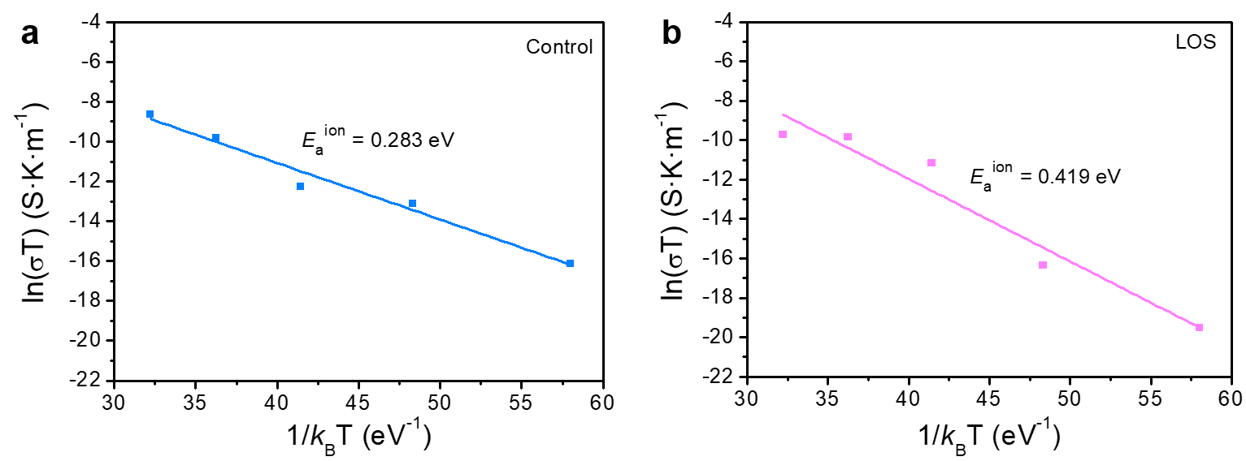
Supplementary Figure 12. The lateral conductivity (σ) changes of FAPbI₃ films at different temperatures (T) in darkness. E_{a}^{ion} is activation energy of the ion migration.

Supplementary Table 1. The best photovoltaic parameters of PSCs for the control and LOS devices measured in forward (F) and reverse (R) scan directions under standard AM 1.5 illumination (100 mW cm⁻²).

Cell | J_{sc} [mA cm⁻²] | V_{oc} [V] | FF [%] | PCE [%]
Control-F | 25.74 | 1.16 | 76.69 | 22.94
Control-R | 25.75 | 1.16 | 78.40 | 23.43
LOS-F | 25.77 | 1.18 | 81.42 | 24.76
LOS-R | 25.77 | 1.18 | 83.50 | 25.39

