Supporting Information for

Anisotropic surface quenching of upconversion nanoparticles

This file includes:
Methods
Supplementary Figures S1 to S10
Supplementary Table S1 and S2

Methods
Materials. YCl₃·6H₂O (99.99%), ErCl₃·6H₂O (99.99%), YbCl₃·6H₂O (99.99%), oleic acid (OA, 90%), and 1-octadecene (ODE, 90%) were purchased from Sigma-Aldrich. Ammonium fluoride (NH₄F) were purchased from Sigma-Aldrich. Sodium hydroxide (NaOH), ethanol, and methanol were purchased from Shanghai Ling Feng Chemical Reagent Co., Ltd. Cyclohexane were purchased from Aladdin. Quartz petri dish containing alphanumerically labeled grids were purchased from IBIDI (Germany). Unless otherwise noted, all the chemicals were used as starting materials without further purification.
Synthesis of core nanoparticles. The NaYF₄ core nanoparticles were synthesized using co-precipitation method. In a typical procedure, 1 mmol LnCl₃·6H₂O (Ln=Y, Yb, Er) with a molar ratio of 56:40:4 was added to a 50 ml three-neck round-bottom flask containing 6 ml OA and 15 ml ODE. The mixture was heated to 170℃ under argon atmosphere for 40 min to obtain clear solution and then cooled to RT. Then 10.5 ml methanol solution of NaOH (2.5 mmol) and NH₄F (4 mmol) were added into the solution and stirred for 30 min at RT. The temperature was then slowly heated to 80℃ and maintained for 30 min to evaporate excessive methanol. Next, the mixture was heated to 150℃ and maintained for 40 min to remove residual methanol and water. The solution was further heated to 300℃ for 90 min before cooling to RT. The resulting core nanoparticles were collected and re-dispersed in 5 ml cyclohexane after washing with cyclohexane/ethanol/methanol for several times.
Synthesis of core@shell plate nanoparticles. To realize longitudinal growth of nanorod at single dimension, the surfactant should be utilized. The major surfactants from reaction solvent are oleic acid molecules (OAH) and oleic acid anions (OA⁻). Specifically, their binding preferences towards particle facets are different with OA⁻ on side (100)/(010) facets and OAH on top (001) facets¹. On (001) facet, the bind energy of OAH (-9.40 meV/Å²) is weaker compared with OA⁻ (-21.80 meV/Å²), which implies that OAH molecules on (001) facets tend to detach under unstable environment such as high temperature or high pH. To this end, H⁺-rich or low temperature environment can be employed, so that the OAH can be bound strongly with lanthanides onto the (001) facet during transversal shell coating without detaching. To realize H⁺-rich environment, two approaches can be used including higher OA and lower NaOH ratio. Another significant factor is the control of activation energy during hot-injection process according to the equation².
$${∆G}^{*} = {∆G}_{0}^{*}{\left.\left(1- \frac{ε}{E_{1}}\right.\right)}^{2}{\left.\left(1- \frac{2ε}{∆μ}\right.\right)}^{-2}$$
Here, ∆G₀ is the activation energy of unstrained nucleation, ε is strain energy per bond, E₁ is bonding energy, and ∆μ is driving force of crystallization (such as the chemical potential difference during reaction). Since growth rate on a facet is negatively dependent to the activation energy³, variation of chemical potential difference ∆μ may cause competition between growth in different crystallographic directions, thereby leading to shell coating on bath facets. To avoid such competition shell growth, the major approach is to reduce the chemical potential difference ∆μ by reducing the growth rate of shell. During hot-injection process, ∆μ is mainly determined by the change of supersaturation, hence a smaller amount of shell precursor per injection circle can diminish the change of ∆μ. In brief, the transversal growth of nanoplate can be realized by slightly reducing the reaction temperature and pH to create comparatively stable environment, while decreasing the injection rate to stabilize chemical potential.
The NaYF₄ nanoplates were synthesized through transversal growth of shell precursor onto core nanoparticles using hot-injection method. Firstly, shell precursor was prepared. 1.5 mmol LnCl₃·6H₂O (Ln=Y, Yb, Er) with a molar ratio of 56Y:40Yb:4Er (active shell) or 100Y (inert shell) was added to a 50 ml three-neck round-bottom flask containing 6 ml OA and 15 ml ODE. The mixture was heated to 170 °C under argon for 40 min to obtain a clear solution and then cooled down to RT, followed by the addition of 13.5 mL methanol solution of NaOH (1.5 mmol) and NH₄F (6 mmol). After stirring for 30 min, the solution was heated to 80 °C under argon for 30 min to remove methanol, and then the solution was further heated to 150 °C for another 10 min. Finally, the reaction solution was cooled down to RT and labeled as plate shell precursors.
For the transversal growth, 0.2 mmol core nanoparticles were added to 50 mL flask containing 6.5 mL OA, 6.5 mL ODE, and an additional amount of 0.2 mmol NaOH was also added to increase the Na source since the Na in the precursor is comparatively low. The mixture was heated to 170 °C under argon for 30 min, and then the solution was further heated to 295 °C. After that, 0.05 mL of plate shell precursors were injected into the reaction mixture and ripened at 295 °C for 1 min followed by the same injection and ripening cycles for different times to obtain nanoplates with different diameter. Finally, the reaction solution was cooled down to RT. The resultant nanoplate samples were washed several times and dispersed in cyclohexane.
Synthesis of core@shell rod nanoparticles. As mentioned above, on (001) facet, the bind energy of OAH (-9.40 meV/Å²) is weaker compared with OA⁻ (-21.80 meV/Å²), which implies that OAH on (001) facets tend to detach under unstable environment such as high temperature or high pH^{4, 5}. On the contrary, OA⁻ are strongly bound to the lanthanides on (100)/(010) facets (-35.40 meV/Å²), such that they will not be detached even under comparatively unstable environment, preventing the shell growth on side facets. Moreover, a smaller amount of shell precursor per injection circle is equally important in rod preparation to reduce crystallization rate. In brief, the 1D epitaxial growth of nanorod can be realized by slightly increasing the reaction temperature and pH to create comparatively unstable environment, while decreasing the injection rate to stabilize chemical potential.
The NaYF₄ nanorods were synthesized through longitudinal growth of shell precursor onto core nanoparticles using hot-injection method. Firstly, shell precursor was prepared. The amount of solvent, Ln resources and procedures were the same as that used for the preparation of plate shell precursor, and the only difference were the amount of NaOH and NH₄F. Herein, their amounts were NaOH (3.75 mmol) and NH₄F (6 mmol), and KOH (3 mmol) was added as well.
For the longitudinal growth, 0.2 mmol core nanoparticles were added to 50 mL flask containing 3.6 mL OA, 9.2 mL ODE, and 1 mmol NaOH was added to balance the high amount of OH⁻ in shell precursor, so that the chemical potential is maintained. The mixture was heated to 170 °C under argon for 30 min, and then the solution was further heated to 310 °C. After that, 0.04 mL of plate shell precursors were injected into the reaction mixture and ripened at 310 °C for 1 min followed by the same injection and ripening cycles for different times to obtain nanorods with different length. Finally, the reaction solution was cooled down to RT. The resultant nanorod samples were washed several times and dispersed in cyclohexane.
DFT simulation details. We optimized the geometric structures of OA-NaYF₄ systems and calculated the corresponding dipole moments using density functional theory (DFT) implemented in the Vienna ab initio simulation package with the projector augmented wave method^{6, 7}. The Perdew–Burke–Ernzerh generalized gradient approximation (GGA-PBE) was employed to approximate the exchange-correlation interactions between electrons⁸. We chose the low-index (001) facet terminated with Y and F atoms as a model surface for its low surface energy and high stability⁹. Throughout the DFT calculations, the bottom five layers of the slab were fixed to mimic the bulk counterpart and a 15-Å vacuum layer was constructed to eliminate the spurious interaction caused by periodic boundary conditions. The energy cut-off of the plane wave, the energy convergence criterion, and the maximum residual force on each atom were set to 520 eV, 110⁻⁵ eV, and 0.02 eV/Å, respectively.
Our computational method utilizes periodic boundary conditions, allowing the configuration of the ligand to extend infinitely on the plane (UCNP surface) in both directions. It is not just a single ligand adsorbed on the surface, but rather the calculation accounts for the comprehensive effect on this plane, representing the overall result rather than an average effect.
The connection mode between lanthanide ions and surface ligand molecules is generated automatically based on software simulation, and similar methods are also applicable to other molecules⁹.
General Materials characterization. The morphology of the as-synthesized nanoparticles was characterized via transmission electron microscopy (TEM) imaging (Hitachi HT7700) with an operating voltage of 100 kV. The samples were prepared by dropping a dilute suspension of nanocrystals onto copper grids. The surface morphology characterization of nanoparticles and the light-electron microscopic correlation experiment were performed by using scanning electron microscope (SEM, Hitachi Regulus 8100) with an operating voltage of 15 KV. Fourier transform infrared (FTIR) spectroscopy spectra were obtained on Nicolet IS 50/6700 (Thermofisher).
Preparation of sample slides for confocal measurement. Glass coverslip and slide were first washed by ethanol and air-dried on draught cupboard. The nanoparticles were diluted by cyclohexane to the concentration level of 0.5×10⁻⁵ mmol/ml. Then, 10 μL of diluted sample were dropped onto the surface of a coverslip. After the volatilization of cyclohexane by air, the coverslip was upside down onto the glass slide and sealed before measurement.
Confocal imaging and lifetime measurement. The inverted confocal optical systemwas built for intensity and lifetime measurements. A single mode fiber-coupled polarized 980 nm diode laser was used as the excitation source and was focused onto the sample through an oil-immersion objective lens (UPlanAPO, Olympus; ×100, NA = 1.4). The sample emission was collected by the same objective lens then refocused into an optical fiber that has a core size matching with system Airy plate. A single photon counting avalanche diode (SPAD) detector was connected to the collection optical fiber to detect the emission intensity (counts). The luminescence spectra were measured with a fiber-coupled spectrometer (Andor) with a grating of 1200 grooves/mm (gain: 100; exposure time: 0.5 s; accumulation time: 5). And the polarization of nanoparticles was obtained by rotating a Zero-Order Half-Wave Plate (WPH10M-633, Thorlabs) integrated with a polarizer (620-1000 nm). For lifetime measurement, the laser diode was modulated to produce 2000 μs excitation pulse. The power density of 980 nm laser is 4.5×10⁶ W/cm². The pulsed excitation, time-gated data collection, and confocal scanning were controlled and synchronized using a multifunction data acquisition device (USB-6343, National Instruments) and a purpose-built LabVIEW program.

Supplementary Figures. S1-S10
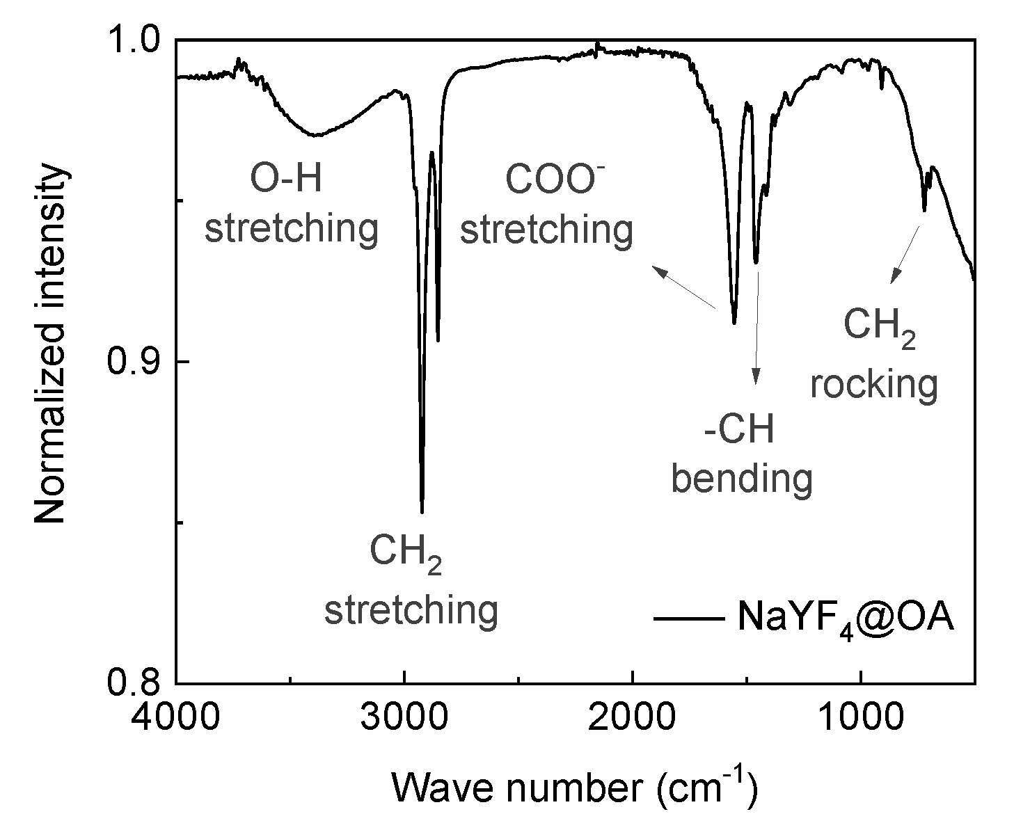
Figure S1. FTIR spectrum of plate sample. The vibration modes of surface molecules are labeled.

Table S1. Calculated dipole moments of systems under study.
 | ¹Ionic dipole moment |  |  | ²Electronic dipole moment²
 | x | y | z | x | y | z
³Bare Y³⁺ | 110.08009 | -63.17490 | -2944.79499 | -12.72571 | 6.95188 | 17.16805
⁴Y³⁺-OA⁻ (⁵short) | -59.50623 | 9.44077 | -2773.92328 | 4.16042 | -59.50623 | 9.44077
Y³⁺-OA⁻ (medium) | -89.92555 | -1.05824 | -5777.41882 | 7.66292 | -7.69042 | 4.79826
Y³⁺-OA⁻ (long) | -29.01565 | -89.04786 | -8318.56480 | 1.81692 | 6.83122 | 9.42070
Bare Yb³⁺ | 52.61656 | -54.47986 | -2803.39663 | -0.82080 | 0.00563 | 21.11983
Yb³⁺-OA⁻ (short) | -135.83947 | 46.37130 | -2621.24181 | -1.57835 | 5.33337 | -4.10203
Yb³⁺-OA⁻ (medium) | -158.75868 | 32.89536 | -5603.47248 | -8.61534 | 7.68172 | 14.61316
Yb³⁺-OA⁻ (long) | -122.35465 | -25.15880 | -8612.47485 | -8.31950 | 2.71606 | 1.52795
Bare Er³⁺ | 43.45285 | -24.46536 | -2829.61436 | -0.88591 | -0.13210 | 6.62249
⁶Er³⁺-OA⁻ (short) | -162.40088 | 98.03661 | -2635.30005 | -4.97931 | 5.62885 | -15.0569
¹Ionic dipole is the contribution of interaction between positively and negatively charged ions. The dipole vector is resolved into three components that are parallel to the x, y, and z directions.
²Electronic dipole is the contribution of electrons that are unevenly distributed.
³Bare Ln³⁺ represents the dipole moment of a NaYF₄ supercell containing one surface lanthanide dopant.
⁴Ln³⁺-OA⁻ represents the dipole moment of a NaYF₄ supercell containing one surface lanthanide dopant and one absorbed ligand.
⁵Short, medium, and long indicate the length of the carbon chain used for the calculation of dipole moment, in which short represents the chain with 2 carbon atoms, medium for 3 and long for 4.
⁶The dipole moments of Er³⁺-OA⁻ systems with medium- and long-chain ligands are unavailable because the corresponding DFT calculations do not converge after the incorporation of 4f electrons.
The simulation results are shown in Table S1 including the three resolved dipole configurations (x, y, and z) of evenly and unevenly distributed electronic interaction.
We calculated the ligand-induced dipole changes using the dipole moment configurations (xyz) of the lanthanide-doped surface model with (Ln³⁺-OA⁻) and without (bare Ln³⁺) OA⁻ adsorbates. Let’s take Y³⁺-doped NaYF₄ containing a short OA⁻ for instance. The ionic dipole component x of OA⁻ was calculated by subtracting line 3 (110.08009) from line 4 (-59.50623) shown in table S1, which applies to the components y and z accordingly. Similarly, we used the same method to calculate the vector components of the electronic dipole moment. By adding the x component of ionic and electronic dipole moments, the x component of the total dipole moment can be obtained, as well as y and z. After the 3-step calculation, the vector configuration (xyz) of the total dipole moment of short OA is obtained (Figure S2a). The angles of Y³⁺-OA⁻, Yb³⁺-OA⁻, and Er³⁺-OA⁻ with short OA (2 C atoms) over (001) facet are calculated to be 48.18°, 36.39°, and 35.62°, respectively; the angles of Y³⁺-OA⁻ and Yb³⁺-OA⁻with medium OA (3 C atoms) over (001) facet are calculated to be 86.26° and 85.13°, respectively; and the angles of Y³⁺-OA⁻ and Yb³⁺-OA⁻with long OA (4 C atoms) over (001) facet are calculated to be 88.64° and 88.18°, respectively.
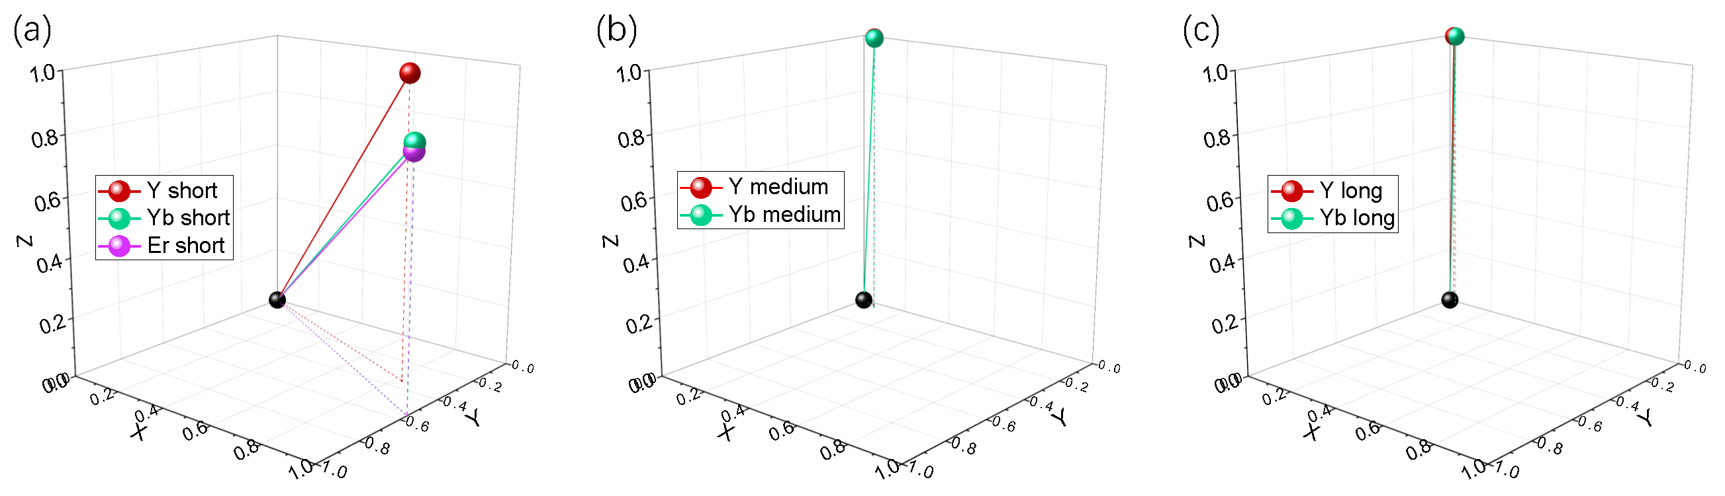
Figure S2 Ligand orientation over (001) facet with respect to the chain length based on the simulation results. (a-c) OA⁻ molecule chain with different C atoms. Short, medium, and long refer to 2, 3, and 4 C atoms, respectively.

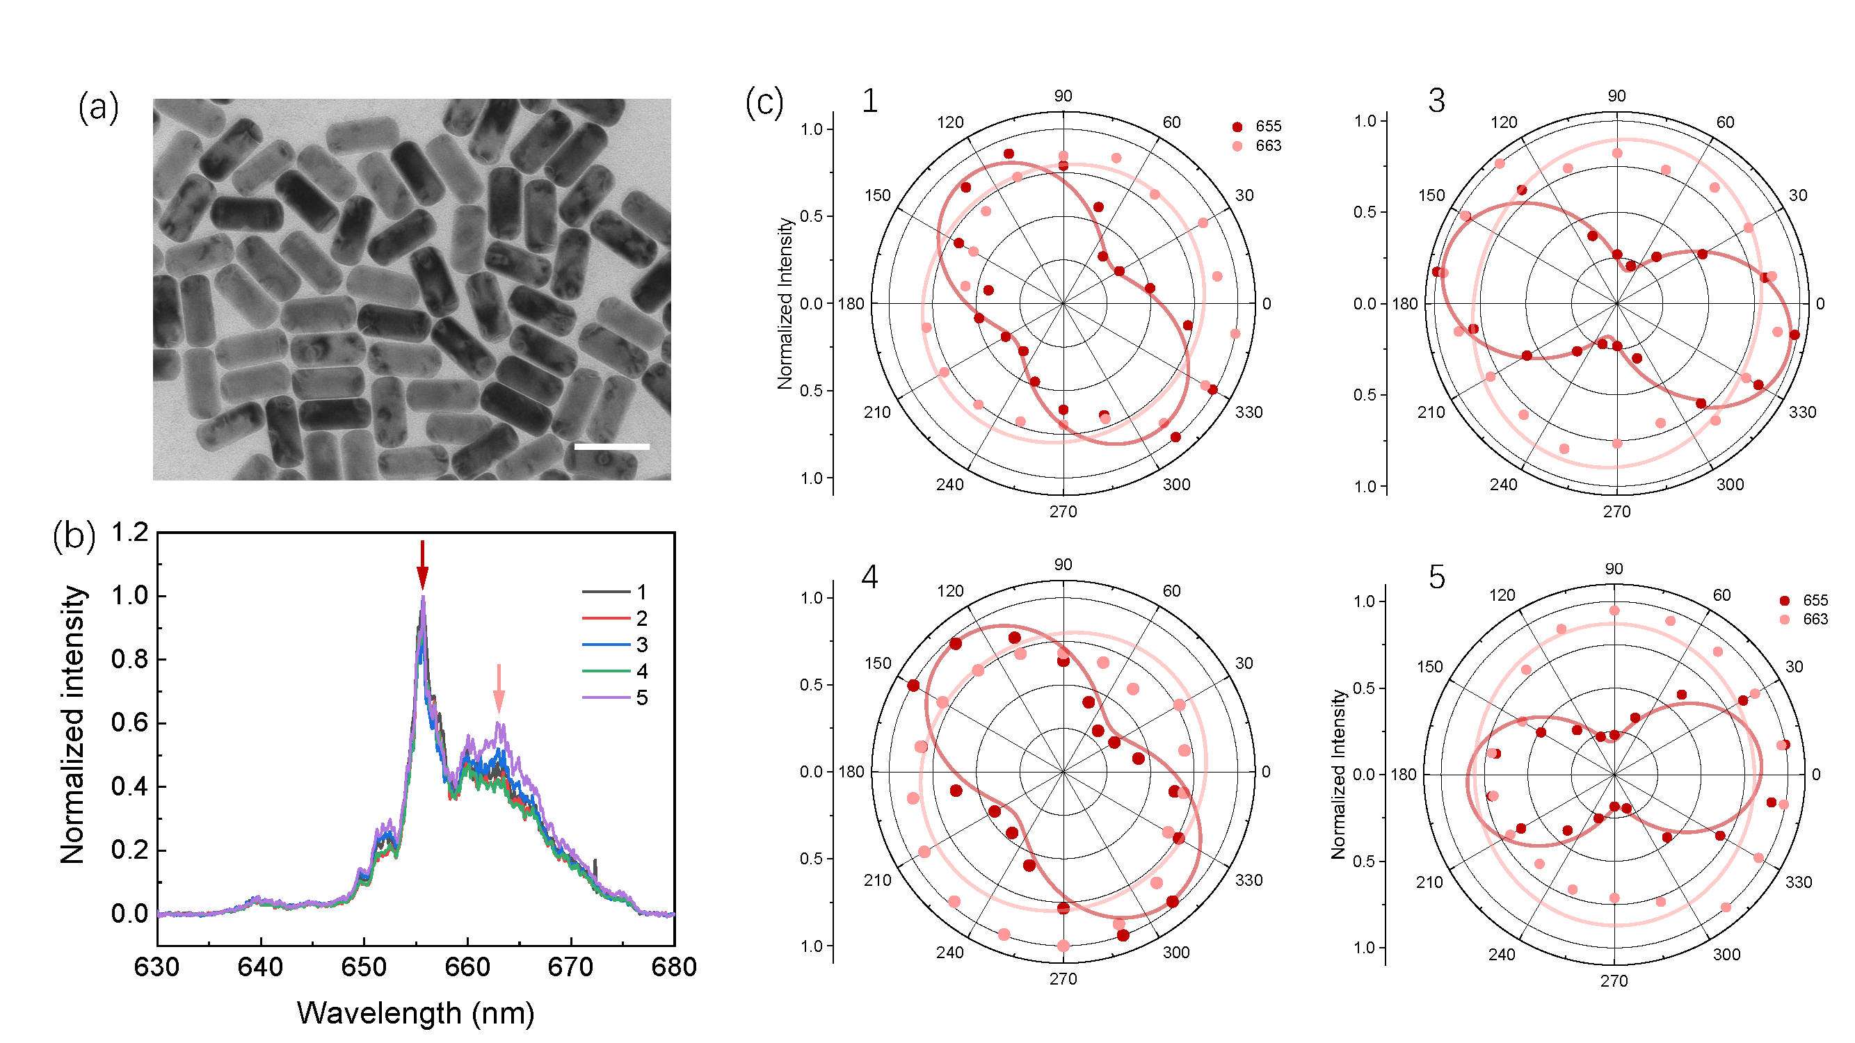
Figure S3. Linear polarization feature of nanorod under side up orientation. (a) TEM image of rod sample proving their side-up facet distribution. Scalebar: 100nm, particle size: 45 nm*101 nm. (b) PL spectra of Particle 1, 2, 3, 4, 5 as labeled in Figure 2b showing the intensity difference of two splitting peaks. (c) I–θ polar diagrams of Particle 1, 3, 4, 5 as labeled in Figure 2b verifying the linear polarization patterns of splitting transitions under side-up orientation. The PL and polar data of Particle 2 are displayed in the main article, Figure 2c.
The calculation of polarization degree is based on the following equation¹⁰:
$$ρ=\frac{I_{max}-I_{min}}{I_{max}+I_{min}}$$
Where I_{max} and I_{min} present the maximum and minimum emission intensities, respectively. And the polar angle (α) between the electric dipole and the c-axis can be calculated based on the following equation¹⁰:
$$\frac{I_{max}}{I_{min}}=\frac{2}{\tan^{2}α}$$
Table S2. The maximum and minimum emission intensities of each particle.
655 nm band |  |  |  |  | 663 nm band
 | I_{max} | I_{min} | ρ | α (°) |  | I_{max} | I_{min} | ρ | α (°)
1 | 0.909 | 0.348 | 0.446 | 41.19 | 1 | 0.830 | 0.771 | 0.037 | 53.73
2 | 0.912 | 0.422 | 0.367 | 43.89 | 2 | 0.926 | 0.821 | 0.06 | 53.09
3 | 0.975 | 0.186 | 0.680 | 31.70 | 3 | 0.883 | 0.822 | 0.036 | 53.76
4 | 0.967 | 0.370 | 0.447 | 41.18 | 4 | 0.841 | 0.772 | 0.043 | 53.57
5 | 0.850 | 0.191 | 0.633 | 33.84 | 5 | 0.872 | 0.806 | 0.039 | 53.67
Ave. | 0.923 | 0.303 | 0.515 | 39.02 | Ave. | 0.870 | 0.798 | 0.043 | 53.56
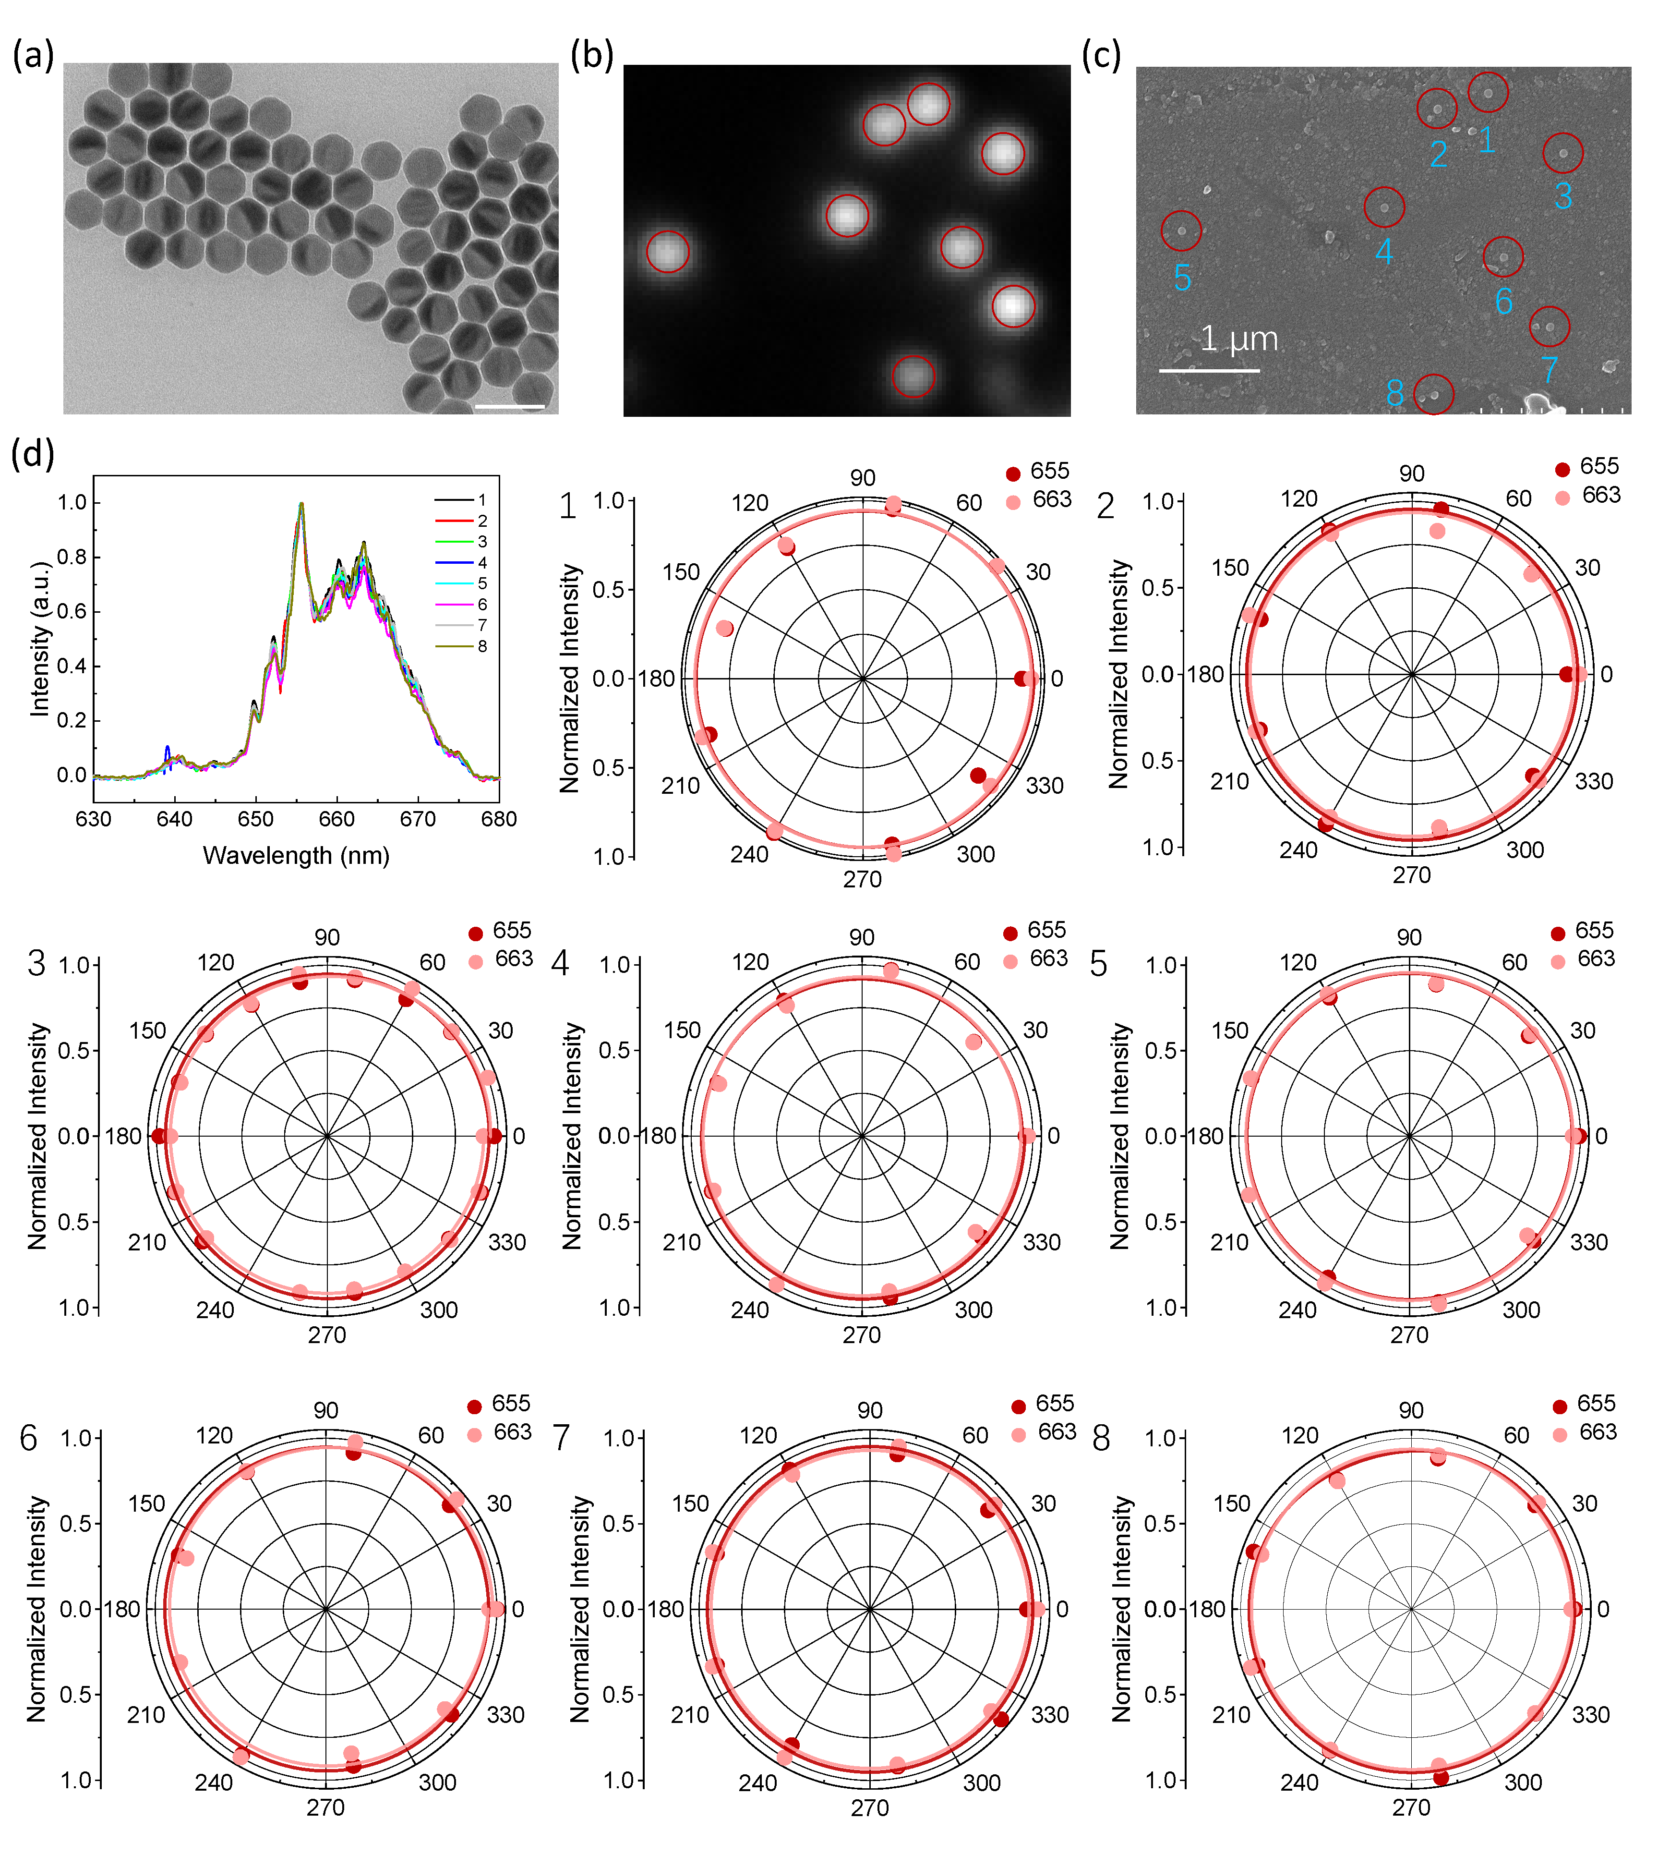
Figure S4. Non-Linear polarization feature of nanoplate under top-up orientation. (a) TEM image of nanoplate sample proving their top-up facet distribution. Scalebar: 100nm, particle size: 59 nm*36 nm. (b, c) Correlated confocal optical and SEM images of nanoplates. (d) PL spectra and I–θ polar diagrams of nanoplates as labeled in b, c verifying the non-linear polarization patterns of splitting transitions under top-up orientation.

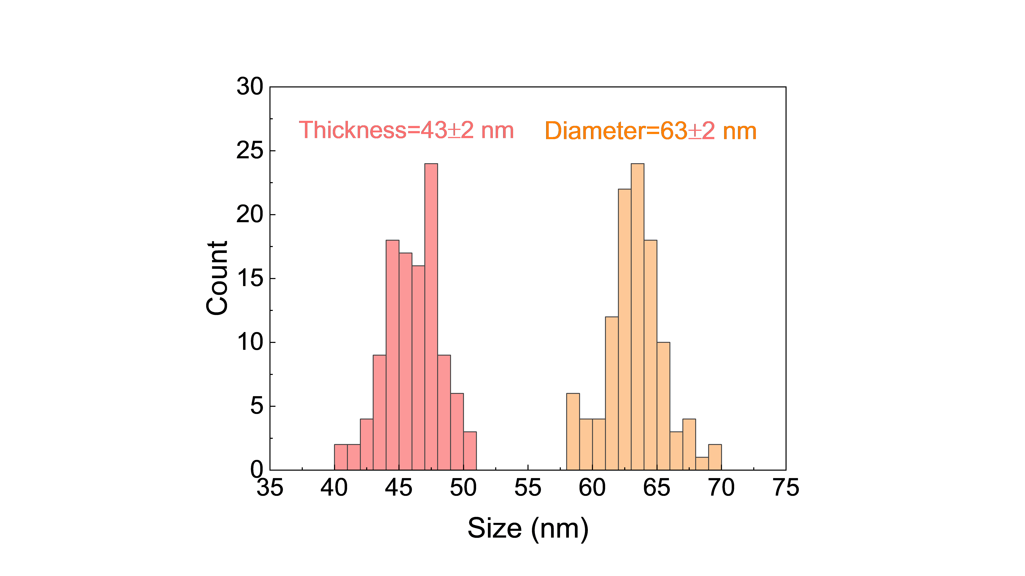
Figure S5. Thickness and Diameter histogram of the nanoparticles shown in Figure 2d.
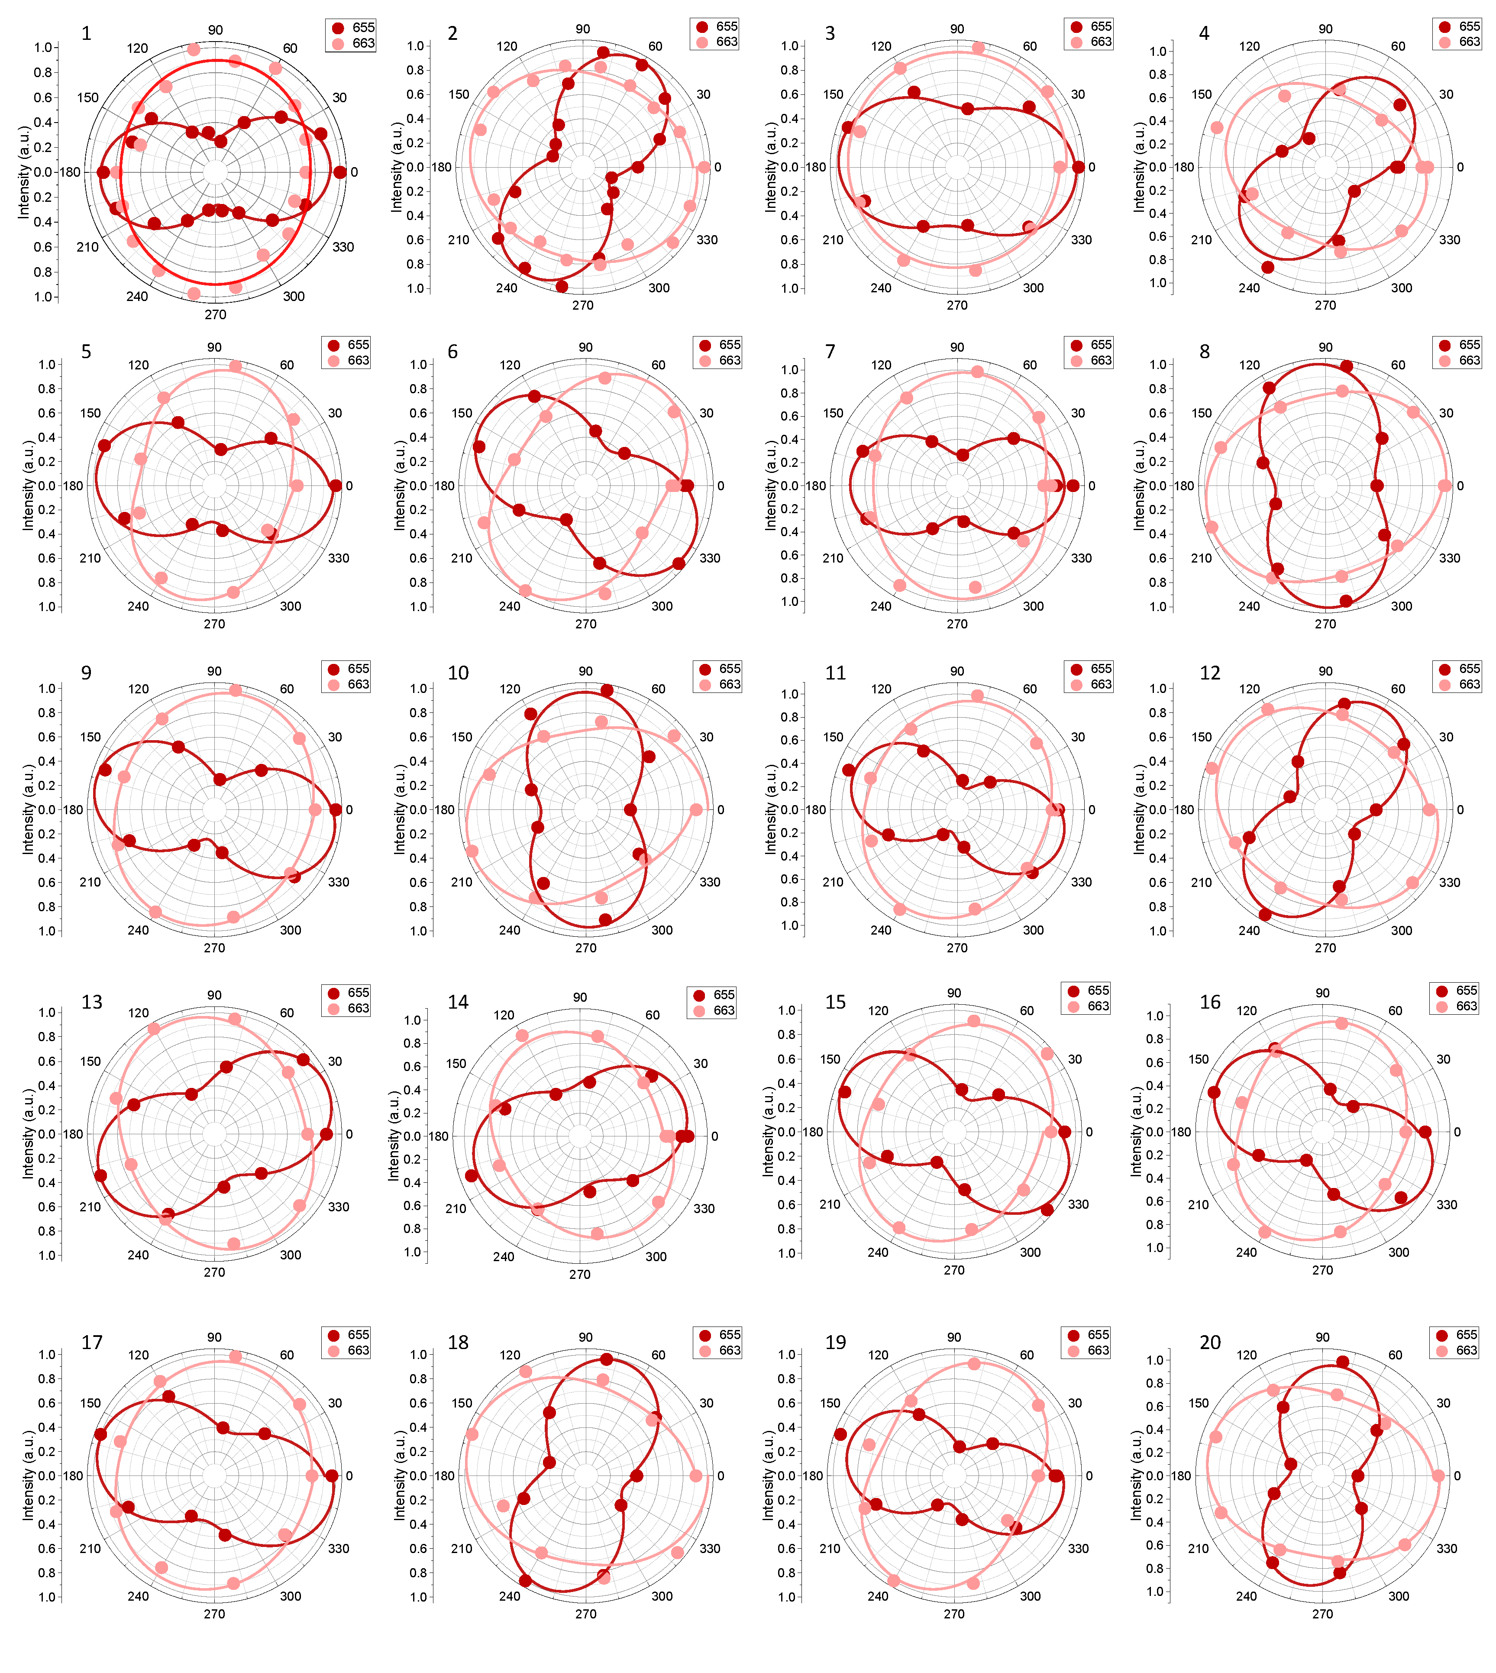
Figure S6. Linear polarization spectra of nanoparticle to prove its side up orientation.

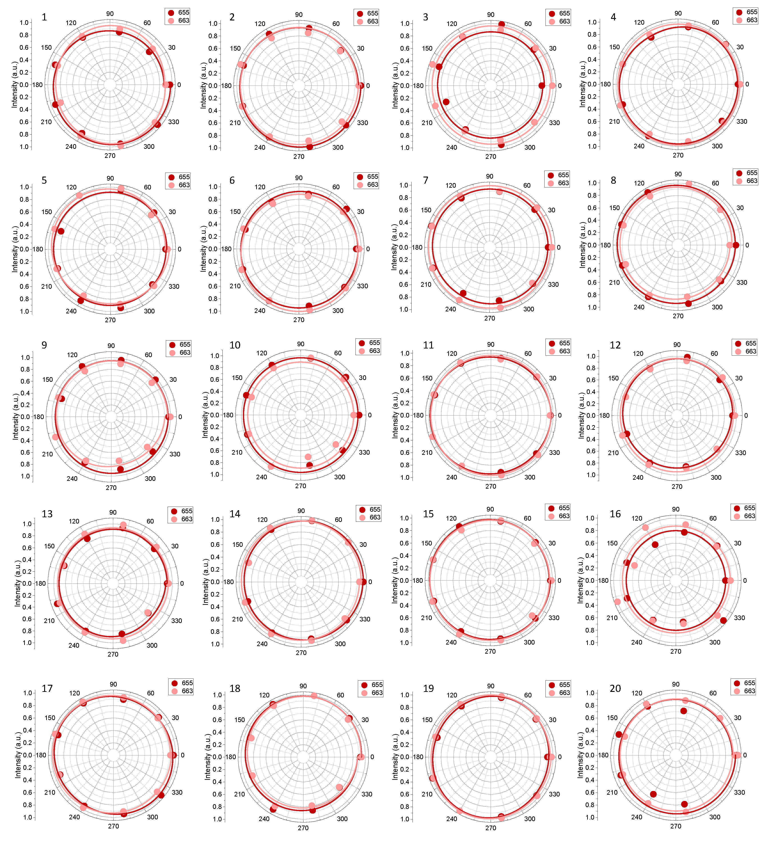
Figure S7. Non-linear polarization spectra of nanoparticle to prove its top up orientation.

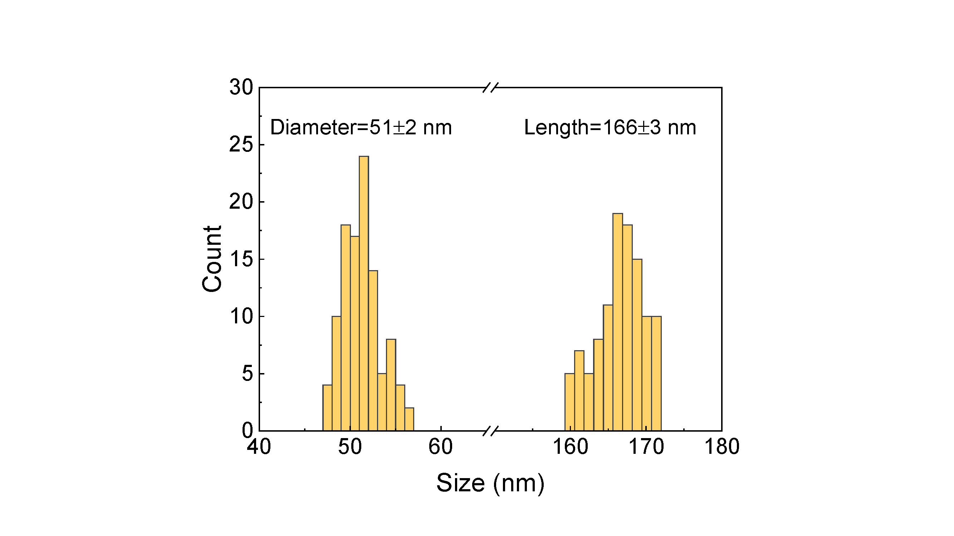
Figure S8. Diameter and Length histogram of NR5 shown in Figure 3a.
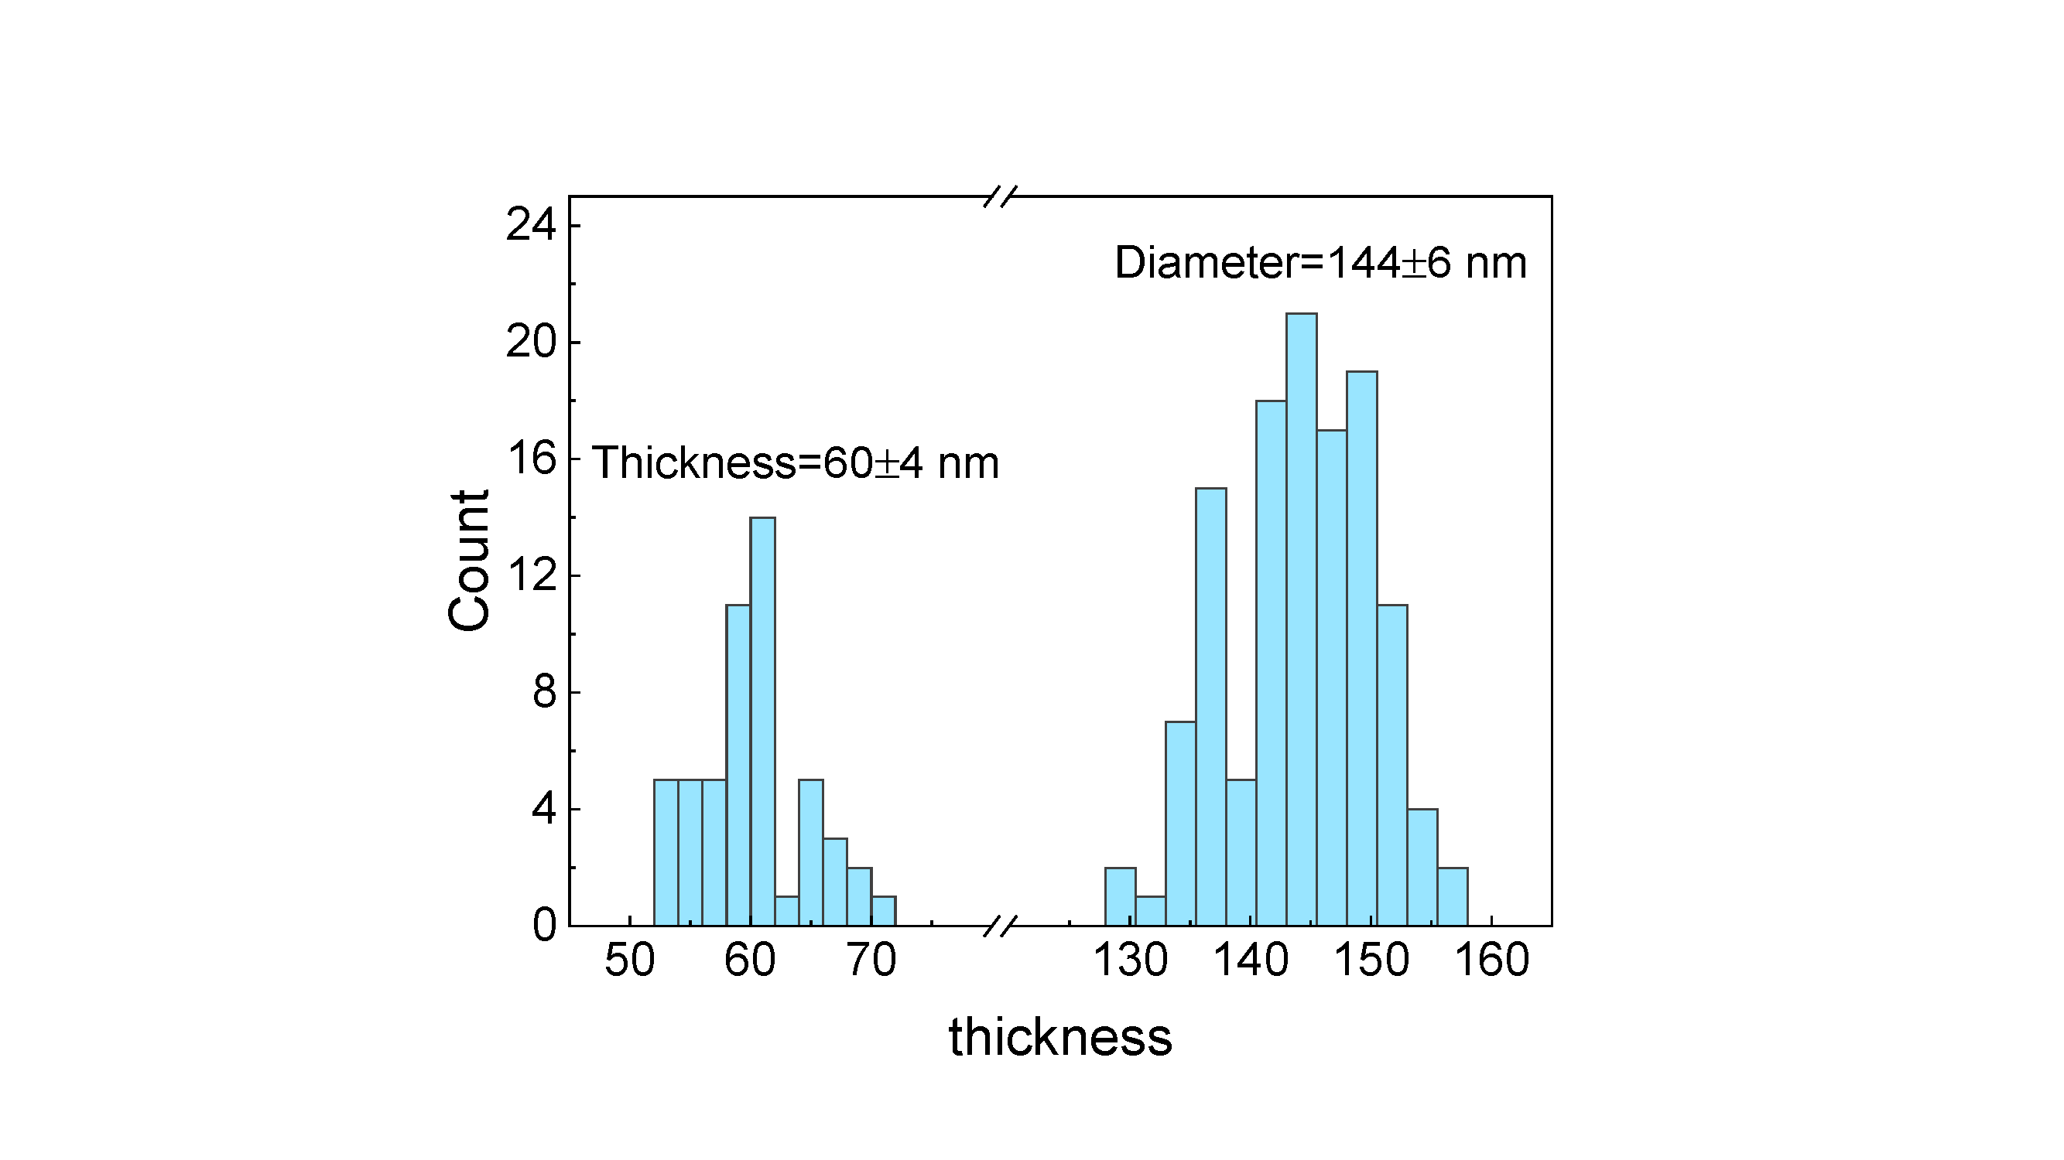
Figure S9. Thickness and Diameter histogram of NP5 shown in Figure 4a.
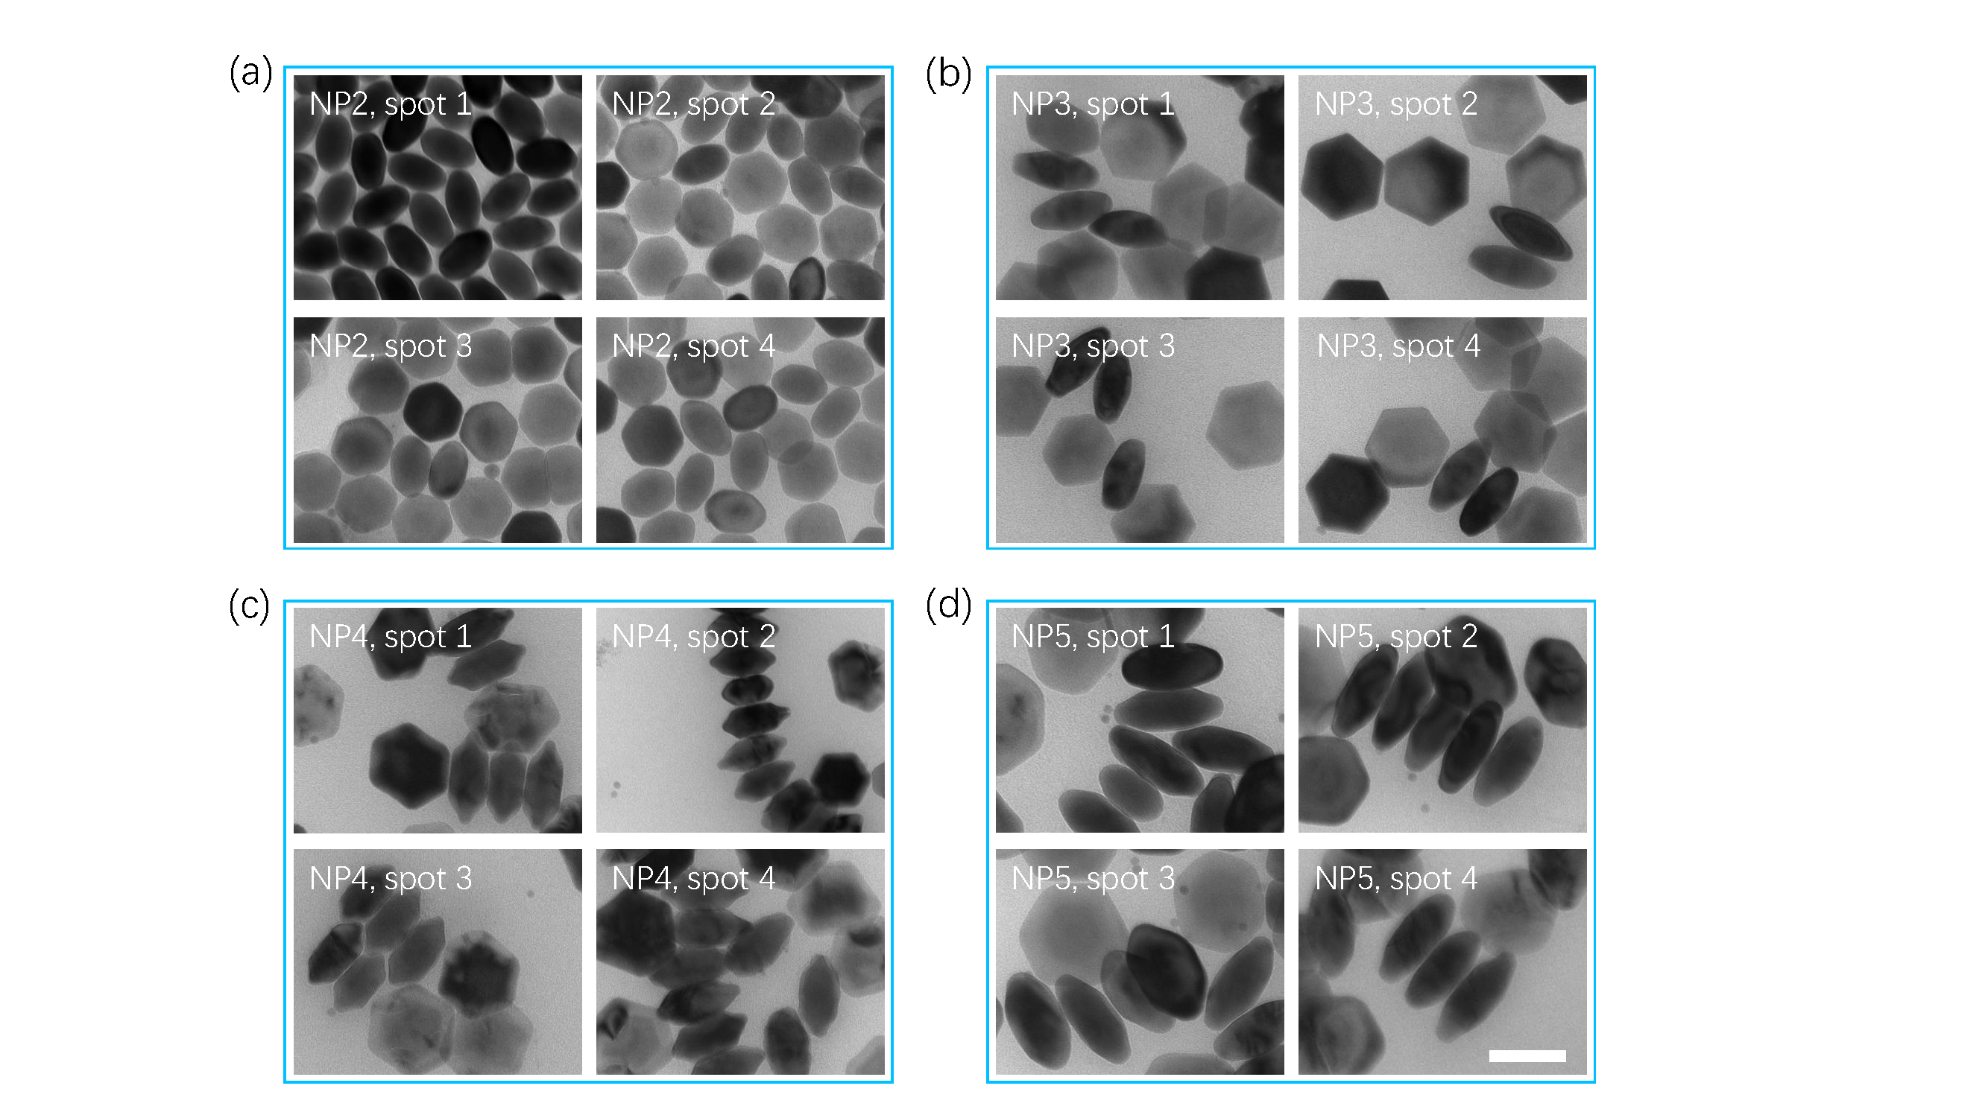
Figure S10. TEM of nanoplates displaying their thickness. Scale bar: 100 nm as shown in the last figure labeled with “NP5, spot 4”. The scalebar is applied to all the TEM images.
Reference
1. Liu, D., Xu, X., Du, Y., Qin, X., Zhang, Y., Ma, C., et al. Three-dimensional controlled growth of monodisperse sub-50 nm heterogeneous nanocrystals. Nat. Commun. 7, 10254 (2016).
2. Pohl, U. W. Epitaxy of semiconductors. Springer, 2020.
3. Boistelle, R., Astier, J. P. Crystallization mechanisms in solution. J. Cryst. Growth 90, 14-30 (1988).
4. Ren, W., Wen, S., Tawfik, S. A., Su, Q. P., Lin, G., Ju, L. A., et al. Anisotropic functionalization of upconversion nanoparticles. Chem. Sci. 9, 4352-4358 (2018).
5. Wen, S., Liu, Y., Wang, F., Lin, G., Zhou, J., Shi, B., et al. Nanorods with multidimensional optical information beyond the diffraction limit. Nat. Commun. 11, 6047 (2020).
6. Kresse, G., Furthmüller, J. Efficiency of ab-initio total energy calculations for metals and semiconductors using a plane-wave basis set. Comp. Mater. Sci. 6, 15-50 (1996).
7. Blöchl, P. E. Projector augmented-wave method. Phys. Rev. B 50, 17953 (1994).
8. Perdew, J. P., Burke, K., Ernzerhof, M. Generalized gradient approximation made simple. Phys. Rev. Lett. 77, 3865 (1996).
9. Xu, H., Han, S., Deng, R., Su, Q., Wei, Y., Tang, Y., et al. Anomalous upconversion amplification induced by surface reconstruction in lanthanide sublattices. Nat. Photonics 15, 732-737 (2021).
10. Li, P., Guo, Y., Liu, A., Yue, X., Yuan, T., Zhu, J., et al. Deterministic Relation between Optical Polarization and Lattice Symmetry Revealed in Ion-Doped Single Microcrystals. ACS Nano 16, 9535-9545 (2022).

