Spatial extent of dysbiosis in the branching coral Pocillopora damicornis during an acute disease outbreak

Austin Greene^{1,2,3,}*, Tess Moriarty⁴, William Leggatt⁴, Tracy D. Ainsworth⁵, Megan J. Donahue^{1,2}, Laurie Raymundo⁶

¹ University of Hawai‘i at Mānoa, Honolulu, USA
² Hawai‘i Institute of Marine Biology, Kāne‘ohe, HI
³ Woods Hole Oceanographic Institution, Woods Hole, USA
⁴ University of Newcastle, Ourimbah, Australia
⁵ University of New South Wales, Sydney, Australia
⁶ University of Guam Marine Laboratory, Guam, USA
* AustinLG@Hawaii.edu
All authors contributed equally to this work.

Corresponding author email: austinlg@hawaii.edu

This PDF file includes:

Table S1
Figures S1 to S2

Other supporting materials for this manuscript include the following:

Note: Datasets S1 to S3 include sequence data and analysis code files, described below, and are made available via an open-access repository at the Open Science Framework: https://osf.io/gpyz2/

Dataset_S1_BiopsyAnalysis.zip includes all data and code files related to the analysis of coral samples assessed at the physical biopsy scale in this manuscript.

Dataset_S2_HolobiontAnalysis.zip includes all data and code files related to coral samples assessed at the physical holobiont scale in this manuscript.

Dataset_S3_MetabolomicsAnalysis.zip includes all data and code files related to coral samples assessed using mass spectrometry in this manuscript.

Table S1. Sequencing read depth for across all biopsy and holobiont samples prior to rarefaction.

Sample type | Min | 25% | 50% | Mean | 75% | Max
Holobiont | 572 | 64622 | 80042 | 75222 | 95854 | 151130
Biopsy | 2222 | 25915 | 42066 | 43804 | 55913 | 127825

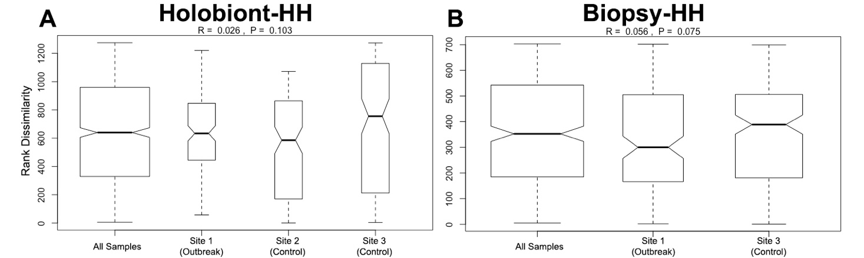
Figure S1. Results of analysis of similarity (ANOSIM) indicating no significant differences in microbial communities between visibly-healthy coral colonies sampled using either (A) holobiont methods or (B) polyp biopsies.

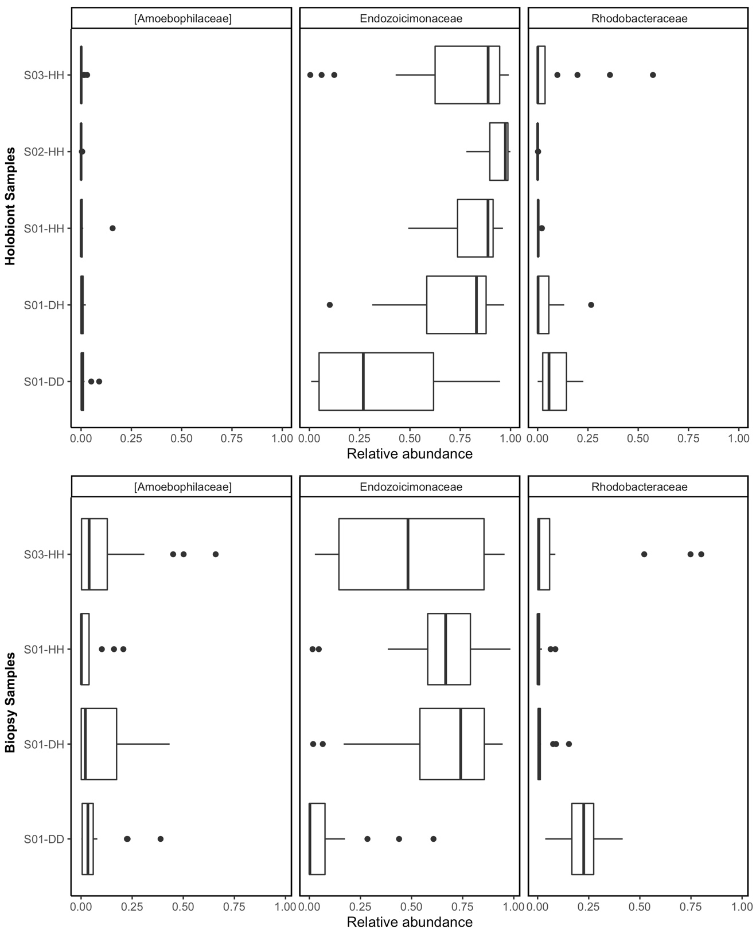

Figure S2. Relative abundance of Candidatus: Amoebophilaceae, Endozoicomonaceae and Rhodobacteraceae bacterial taxa across coral samples for both Holobiont (top) and Biopsy sample collection methods (bottom).

