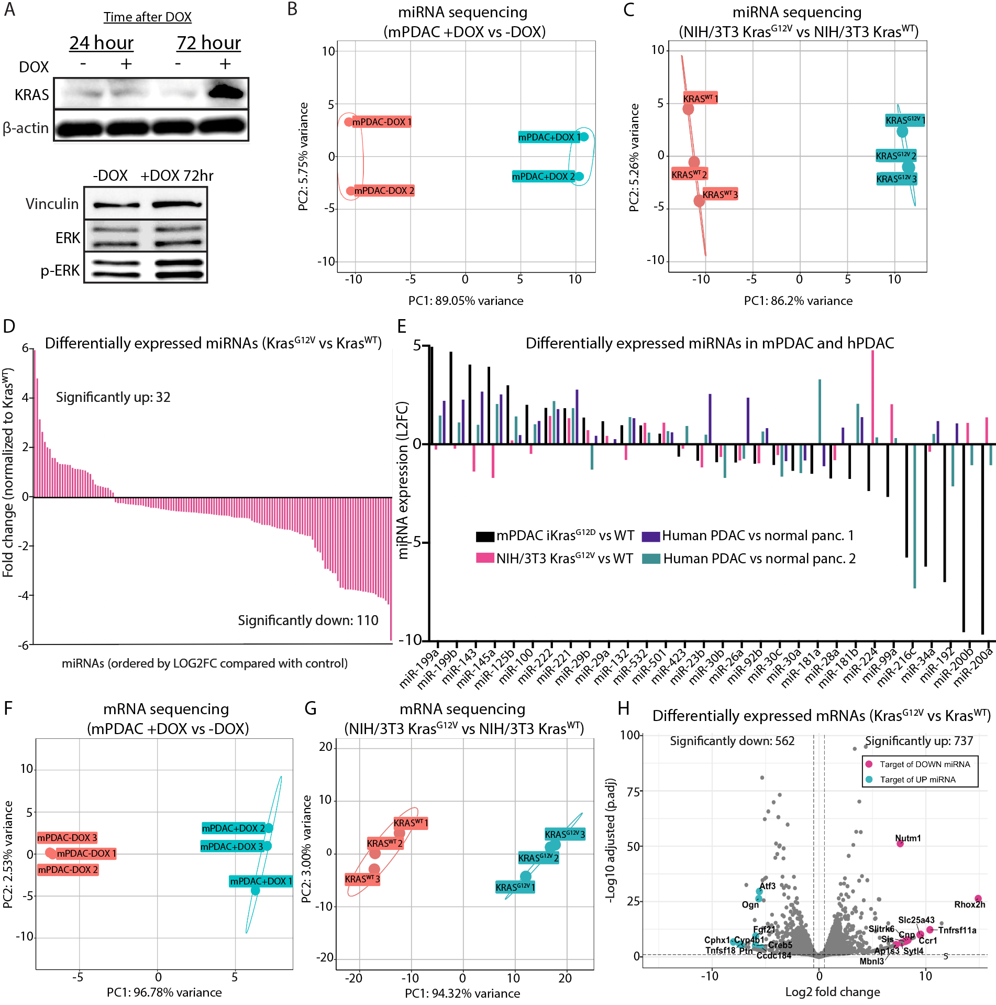
Supplemental Figure 1: miRNA and mRNA dysregulation in KRAS-mutant cells. A) Western blot analysis of mPDAC iKras^{G12D} showing an increase in total Kras protein after DOX addition (2 ug/mL) to induce Kras^{G12D} and western blot analysis of mPDAC iKras^{G12D} showing an increase in ERK phosphorylation after 72hr DOX addition to induce Kras^{G12D}. B) Principal component analysis of mPDAC iKras^{G12D} +/- DOX small-RNAseq samples. C) Principal component analysis of NIH/3T3 Kras^{G12V} vs Kras^{WT} small-RNAseq samples. D) Waterfall plot showing DE miRNAs in NIH/3T3 Kras^{G12V} vs Kras^{WT} control. E) Comparison of differentially regulated miRNAs in our datasets compared with two previously published small-RNA datasets in human PDAC vs healthy pancreas. F) Principal component analysis of mPDAC iKras^{G12D} +/- DOX mRNA-seq samples. G) Principal component analysis of NIH/3T3 Kras^{G12V} vs Kras^{WT} mRNA-seq samples. H) Volcano plot of DE mRNAs in NIH/3T3 Kras^{G12V} vs Kras^{WT} control. Genes targeted by upregulated miRNAs (in A)are shown in blue, and genes targeted by downregulated miRNAs are shown in pink.

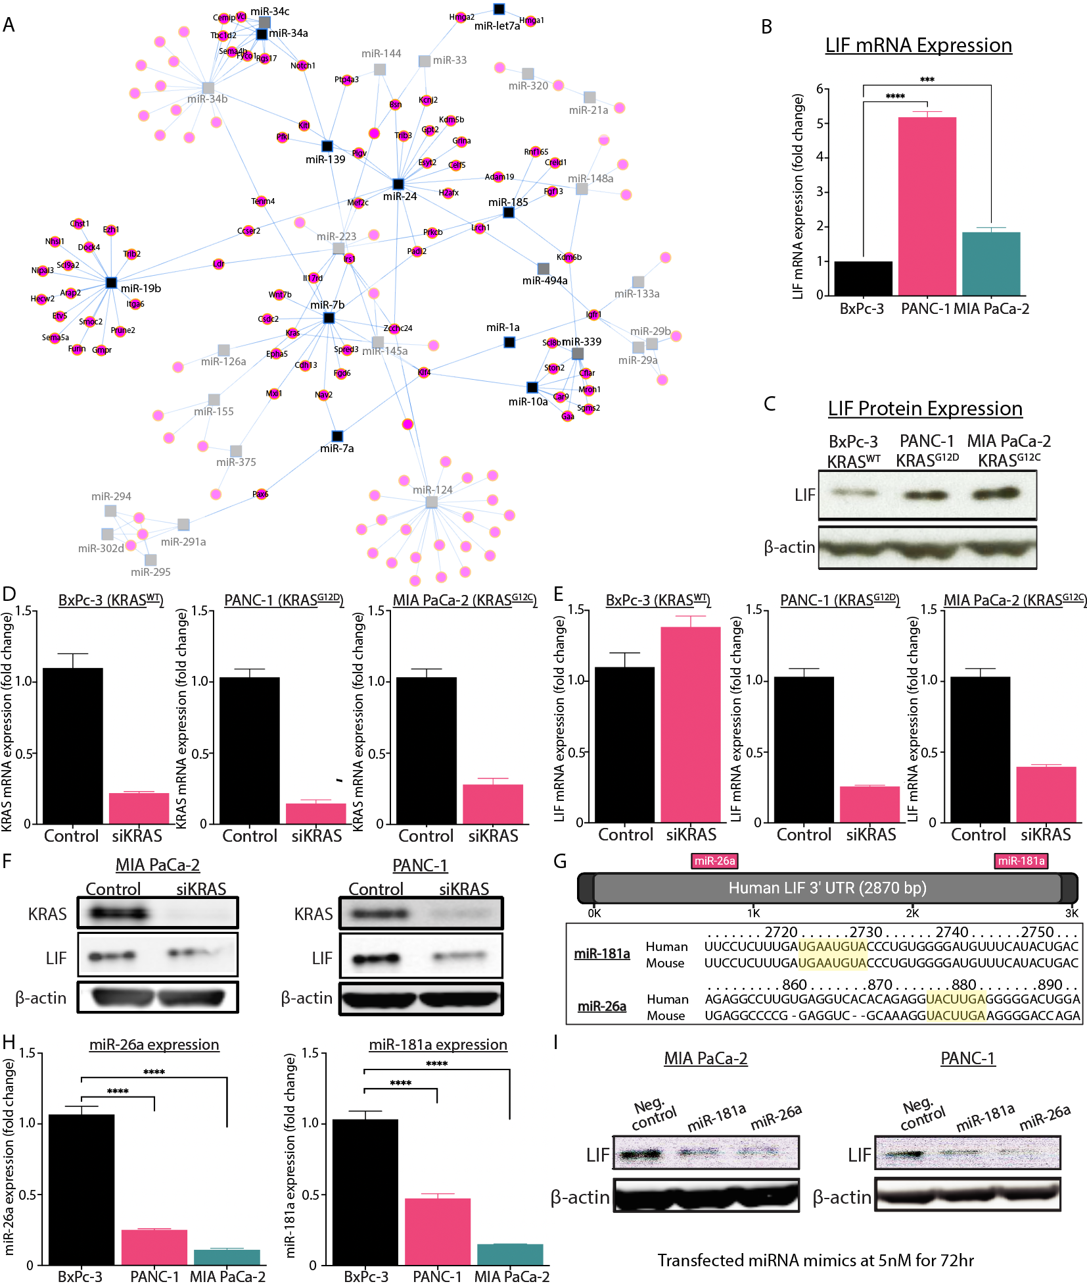
Supplemental Figure 2: Upregulated transcripts are regulated by downregulated miRNAs. A) Network-based visualization of miRNA-target interactions based on the significantly upregulated genes and the significantly downregulated miRNAs. The network shown is built from miRNA-target interactions based on ‘strong’ experimentally validated interactions from the miRTarBase database. Blue boxes represent miRNA nodes that are connected to target genes, shown in magenta circles. Only genes upregulated in Figure 1 are labeled. B) Fold change of LIF expression in PANC-1 (KRAS^{G12D}) and MIA PaCa-2 KRAS^{G12C} cell lines compared with BxPc-3 KRAS^{WT} control. C) Western blot analysis of LIF protein expression across the same cell lines in A. D) qRT-PCR of KRAS mRNA expression after KRAS siRNA in BxPc-3, PANC-1, and MIA PaCa-2 cells, respectively. E) qRT-PCR of LIF mRNA expression after KRAS siRNA in BxPc-3, PANC-1, and MIA PaCa-2 cells, respectively. F) Western blot analysis of LIF and KRAS protein expression in PANC-1 and MIA PaCa-2 cells after KRAS siRNA knockdown. G) Schematic of human LIF 3’ UTR showing selected predicted miRNA targeting events (top) and conservation of binding sites in mouse and human (bottom). H) SmallRNA expression fold change of miR-26a and miR-181a in PDAC cell lines. I) Western blot analysis of LIF expression after the addition of miR-26a and miR-181b miRNA mimics. ****p<0.0001, ***p<0.001.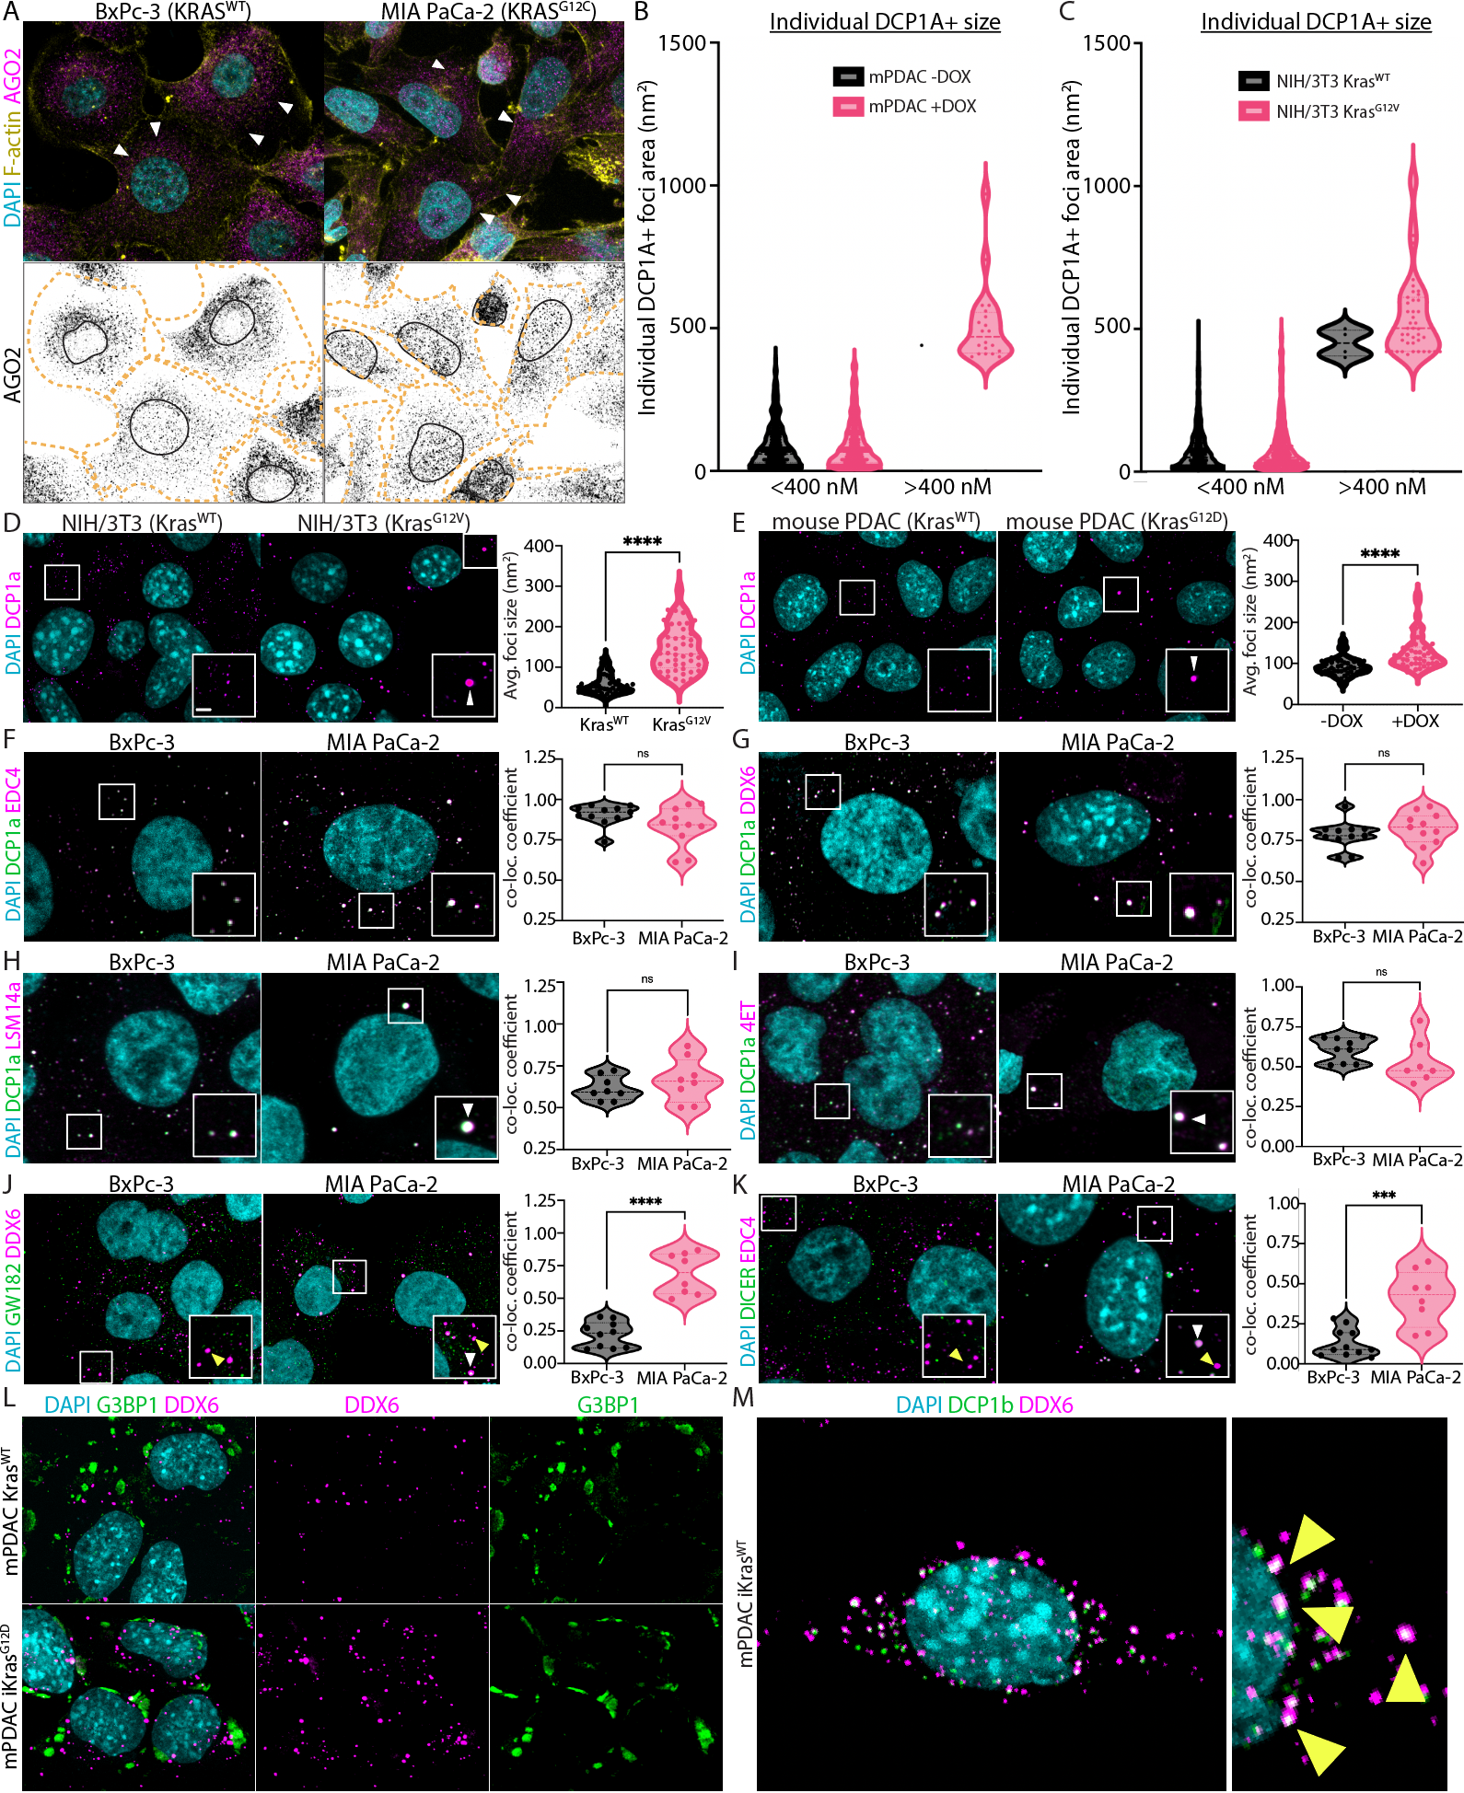 Supplemental Figure 3: Oncogenic KRAS induces KG formation. A) Representative IF images of BxPc-3 and MIA PaCa-2 stained for DAPI (cyan), AGO2 (magenta), and F-actin (yellow). Arrowheads show AGO2 distribution from perinuclear to membrane. B) Area quantification of 1000 total DCP1A+ foci in mPDAC iKras^{G12D} +/- DOX. C) Area quantification of 1000 total DCP1A+ foci in NIH/3T3 Kras^{WT} and Kras^{G12V}. D) Representative IF images of NIH/3T3 Kras^{WT} and Kras^{G12V} stained for DAPI (cyan) and DCP1a (magenta) and quantification of the average area of DCP1a+ foci. E) Representative IF images of mPDAC iKras^{G12D} -/+ DOX stained for DAPI (cyan) and DCP1A (magenta) and quantification of the average area of DCP1A+ foci. F) Representative IF images of BxPc-3 and MIA PaCa-2 stained for DAPI (cyan), DCP1A (green), and EDC4 (magenta) and quantification of Manders’’ correlation coefficient of EDC4+ DCP1A+ foci. G) Representative IF images of BxPc-3 and MIA PaCa-2 stained for DAPI (cyan), DCP1A (green), and DDX6 (magenta) and quantification of Manders’ correlation coefficient of DDX6+ DCP1A+ foci. H) Representative IF images of BxPc-3 and MIA PaCa-2 stained for DAPI (cyan), DCP1A (green), and LSM14A (magenta) and quantification of Manders’ correlation coefficient of LSM14A+ DCP1A+ foci. I) Representative IF images of BxPc-3 and MIA PaCa-2 stained for DAPI (cyan), DCP1A (green), and 4E-T (magenta) and quantification of Manders’ correlation coefficient of 4E-T+ DCP1A+ foci. J) Representative IF images of BxPc-3 and MIA PaCa-2 stained for DAPI (cyan) GW182 (green) and DDX6 (magenta) and quantification of Manders’ correlation coefficient of GW182+ DDX6+ foci. K) Representative IF images of BxPc-3 and MIA PaCa-2 stained for DAPI (cyan) DICER (green), and EDC4 (magenta) and quantification of Manders’ correlation coefficient of DICER+ EDC4+ foci. L) Representative IF images of mPDAC Kras^{WT} (left) and mPDAC iKras^{G12D} (right) cell lines stained for DAPI (cyan) and DDX6 (magenta) and SG marker G3BP1 (green) showing PBs and SGs occupy distinct subcellular areas. M) Representative IF image of mPDAC iKras^{WT} cell line ectopically expressing DCP1B-EGFP showing co-staining of DCP1B foci (green) with DDX6 (magenta), also stained for DAPI (cyan). Error bars represent +/- S.E.M. for three independent experiments. Each point represents one cell or one field of view. ****p<0.0001, ***p<0.001, ns = not significant. Scale bar = 1 uM. Yellow arrowheads indicate PBs and white arrowheads indicate KGs.

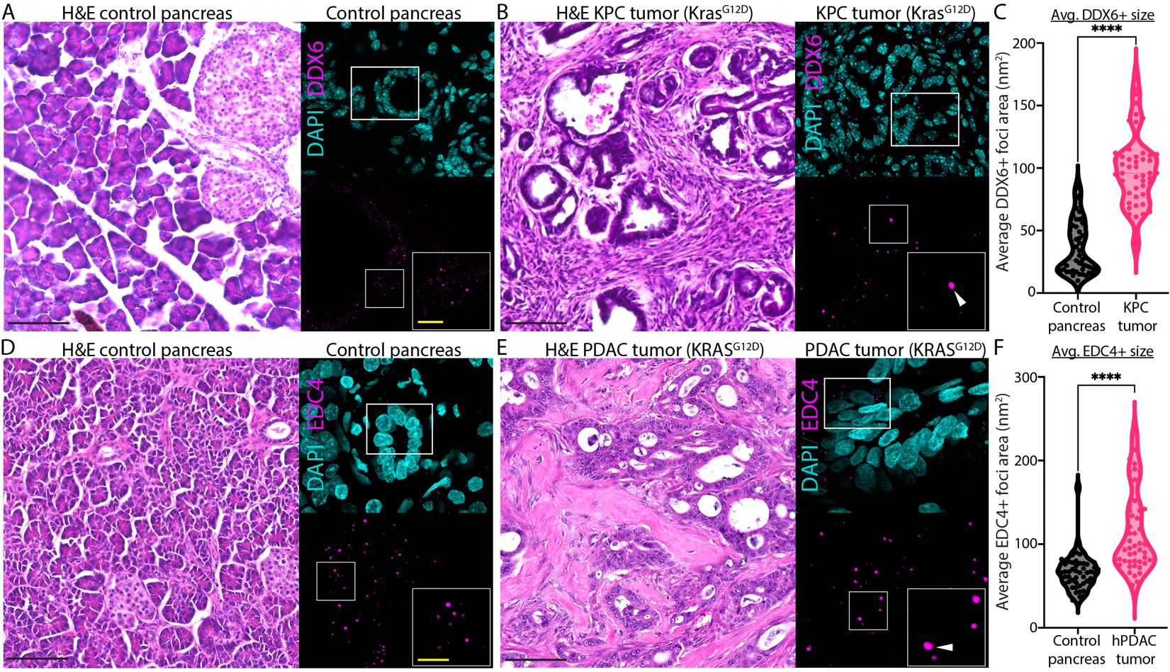
Supplemental Figure 4: Oncogenic KRAS induces KG formation in vivo. A) Representative H&E image and IF images of control mouse pancreatic tissue stained for DAPI (cyan) and DDX6 (magenta). B) Representative H&E image and IF images of Kras^{G12D} KPC tumors stained for DAPI (cyan) and DDX6 (magenta). C) Quantification of DDX6+ foci size from A and B. D) Representative H&E image and IF images of control human pancreatic tissue stained for DAPI (cyan) and EDC4 (magenta). E) Representative H&E image and IF images of KRAS^{G12D} human PDAC tumors stained for DAPI (cyan) and EDC4 (magenta). F) Quantification of EDC4+ foci size in D and E. Error bars represent +/- S.E.M. for three independent experiments and each point represents one cell. ****p<0.0001. N = 2 for each group in A-C. N=4 for D and N=6 for E. Each point represents one cell. Scale bars: Black = 100 uM, yellow = 5 uM. White arrowheads indicate KGs.
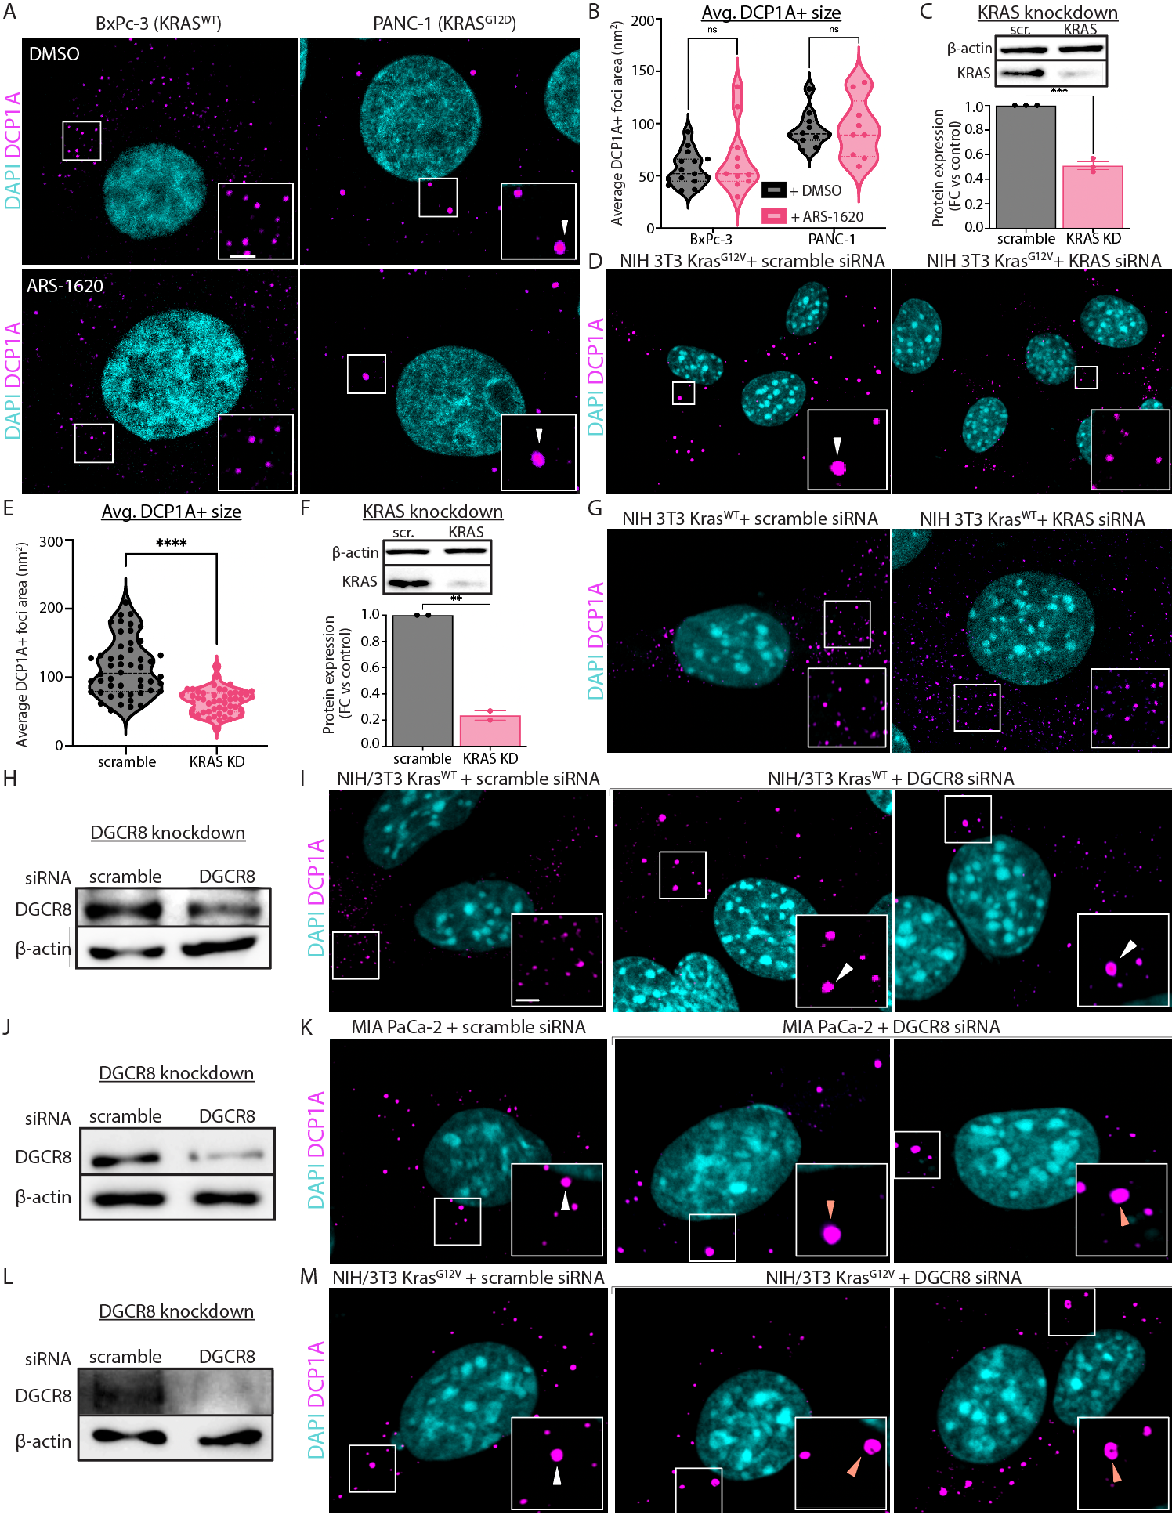
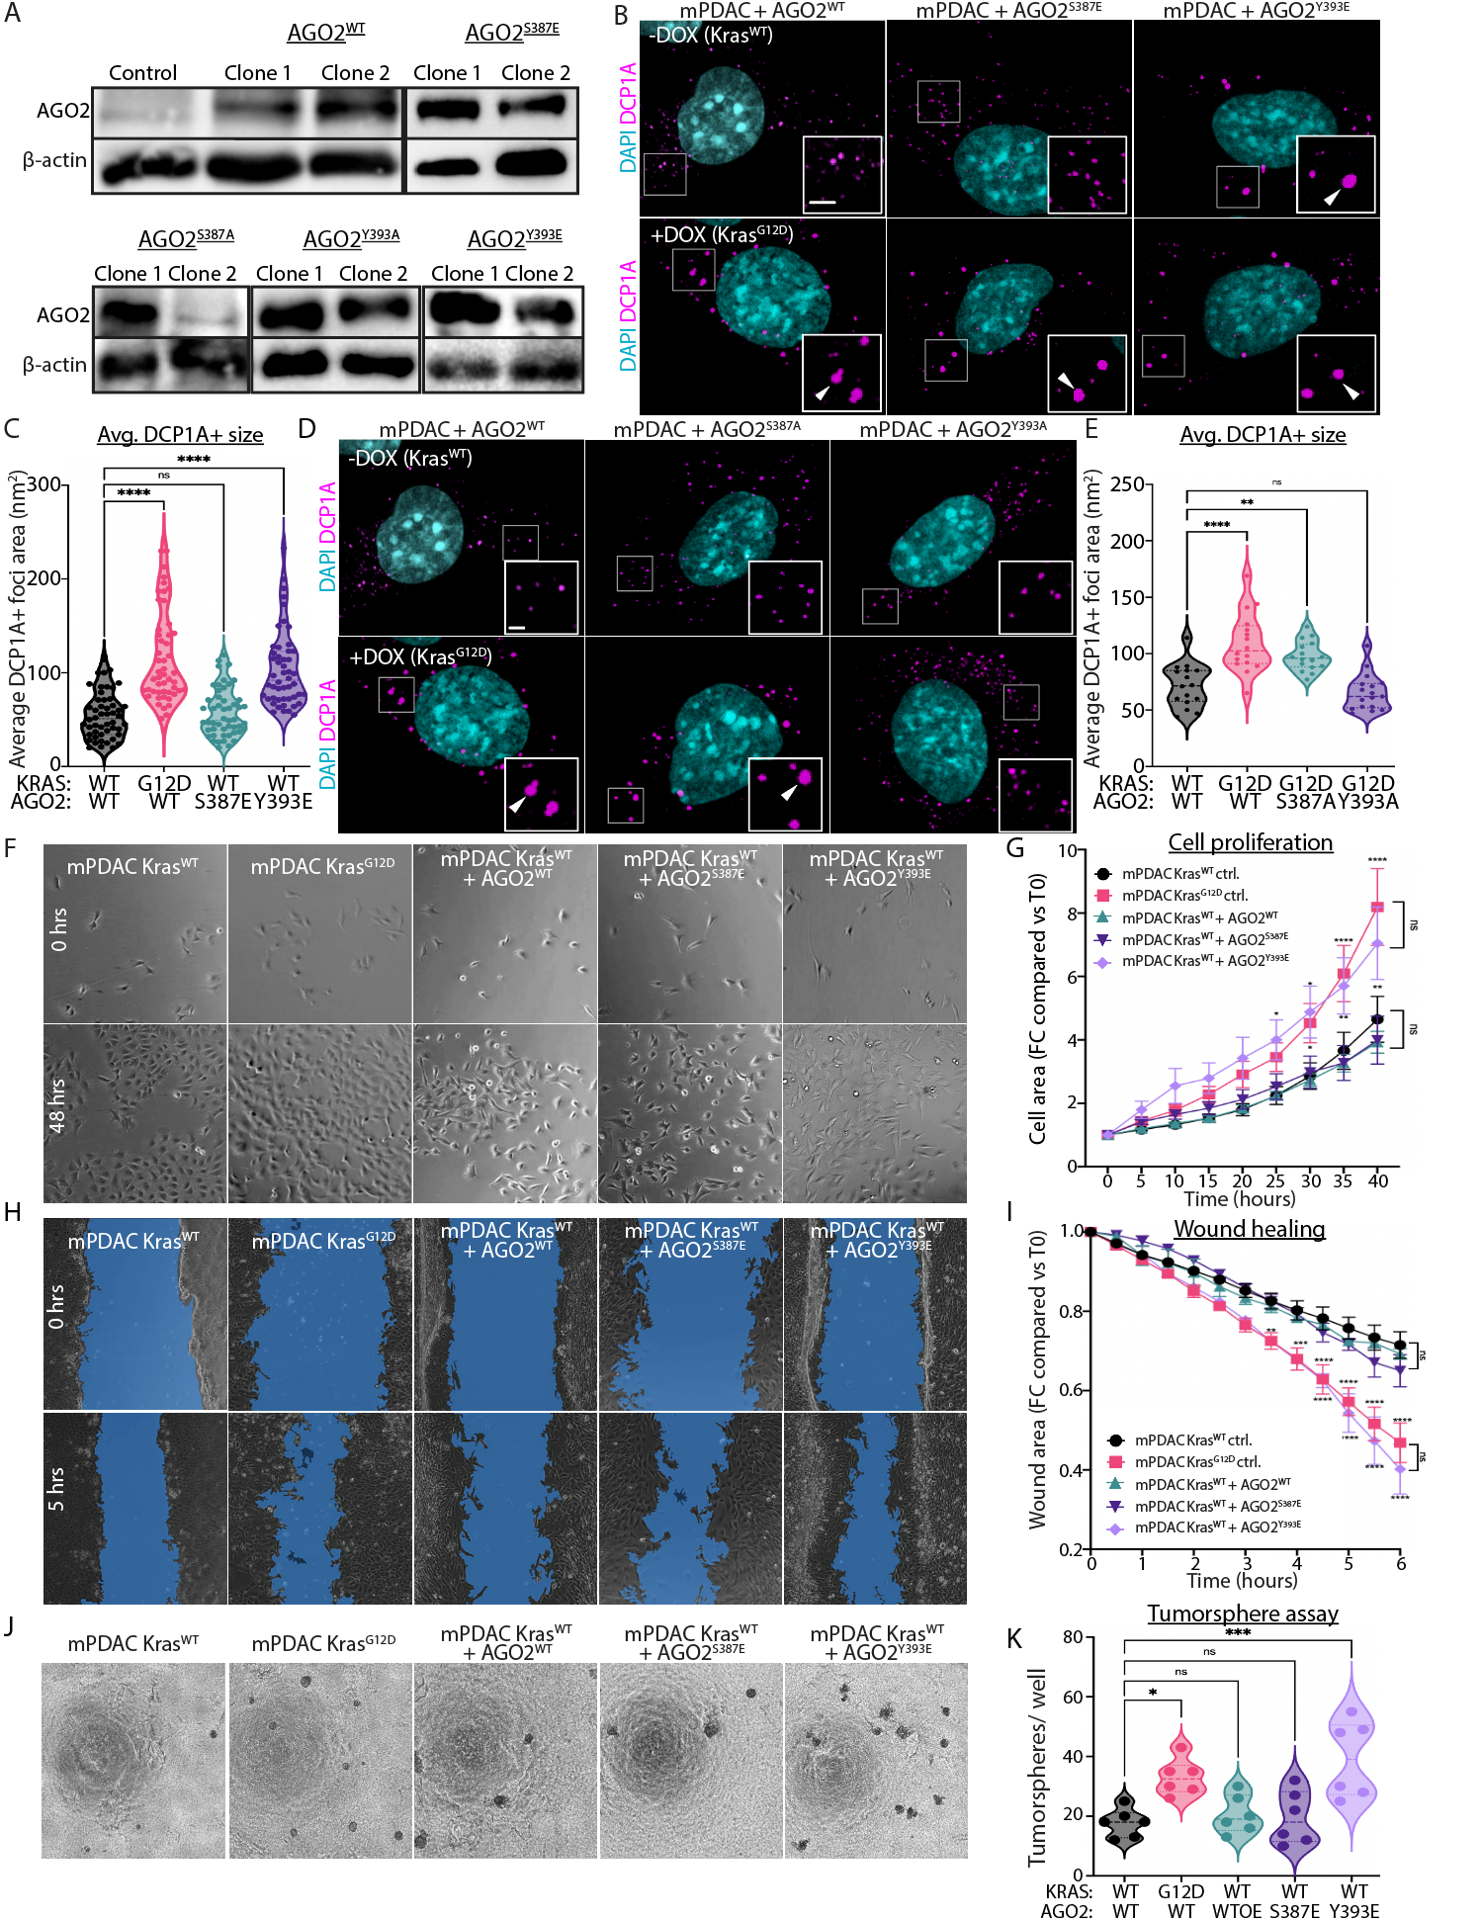
Supplemental Figure 5: KRAS and miRNA loss are required for KG formation. A) Representative IF image of BxPc-3 and PANC-1 cells treated with ARS-1620 vs. DMSO controls stained for DAPI (cyan) and DCP1A (magenta). B) Quantification of DCP1A+ foci area in A. C) Western bot confirmation of KRAS knockdown in NIH/3T3 Kras^{G12V} cells. D) Representative IF images of groups in C stained for DAPI (cyan) and DCP1A (magenta). E) Quantification of DCP1A+ foci size in D. F) Western bot confirmation of KRAS knockdown in NIH/3T3 Kras^{WT} cells. G) Representative IF images of groups in F stained for DAPI (cyan) and DCP1A (magenta). H) Western bot confirmation of DGCR8 knockdown in NIH/3T3 Kras^{WT} cells. I) Representative IF images of groups in A stained for DAPI (cyan) and DCP1a (magenta). J) Western bot confirmation of DGCR8 knockdown in MIA PaCa-2 cells. K) Representative IF images of groups in C stained for DAPI (cyan) and DCP1a (magenta). L) Western bot confirmation of DGCR8 knockdown in NIH/3T3 Kras^{G12V} cells. M) Representative IF images of groups in E stained for DAPI (cyan) and DCP1a (magenta). Error bars represent +/- S.E.M. for three independent experiments. Each point represents one cell or one field of view. ****p<0.0001, ***p<0.001, **p<0.01, ns = not significant. Scale bar = 1 uM. White arrowheads indicate KGs. Orange arrowheads indicate larger KGs in KRAS^{MUT} DGCR8 KD cells.
Supplemental Figure 6: p-AGO2^{Y393} leads to KG formation, cell proliferation, migration, and tumorsphere formation A) Western bot confirmation of AGO2 mutant expression in mPDAC iKras^{G12D} cells. B) Representative IF images of mPDAC iKras^{G12D} mouse PDAC cell lines ectopically expressing AGO2^{WT}, AGO2^{S387E}, or AGO2^{Y393E} +/- Kras^{G12D} induction stained for DAPI (cyan) and DCP1A (magenta). C) Quantification of DCP1A+ foci in B. D) Representative IF images of mPDAC iKras^{G12D} mouse PDAC cell lines ectopically expressing AGO2^{WT}, AGO2^{S387A}, or AGO2^{Y393A} +/- Kras^{G12D} induction stained for DAPI (cyan) and DCP1A (magenta). E) Quantification of DCP1A+ foci in D. F) Representative phase contrast images of mPDAC iKras^{G12D} cells ectopically expressing AGO2^{WT}, AGO2^{S387E}, or AGO2^{Y393E} +/- Kras^{G12D} induction at 0 and 48 hours. G) Quantification of cell proliferation measured in F. H) Representative phase contrast images of scratch wound healing assay in mPDAC iKras^{G12D} cells ectopically expressing AGO2^{WT}, AGO2^{S387E}, or AGO2^{Y393E} +/- Kras^{G12D} induction at 0 and 5 hours. I) Quantification of wound healing shown in H. J) Tumorsphere formation assay of mPDAC iKras^{G12D} cells ectopically expressing AGO2^{WT}, AGO2^{S387E}, or AGO2^{Y393E} +/- Kras^{G12D} induction. K) Quantification of total tumorspheres per well. Error bars represent +/- S.E.M. for two independent experiments performed in technical triplicate. ****p<0.0001, ***p<0.001, **p<0.01, *p<0.05, ns = not significant. Scale bar = 1 uM and white arrowhead = KG.
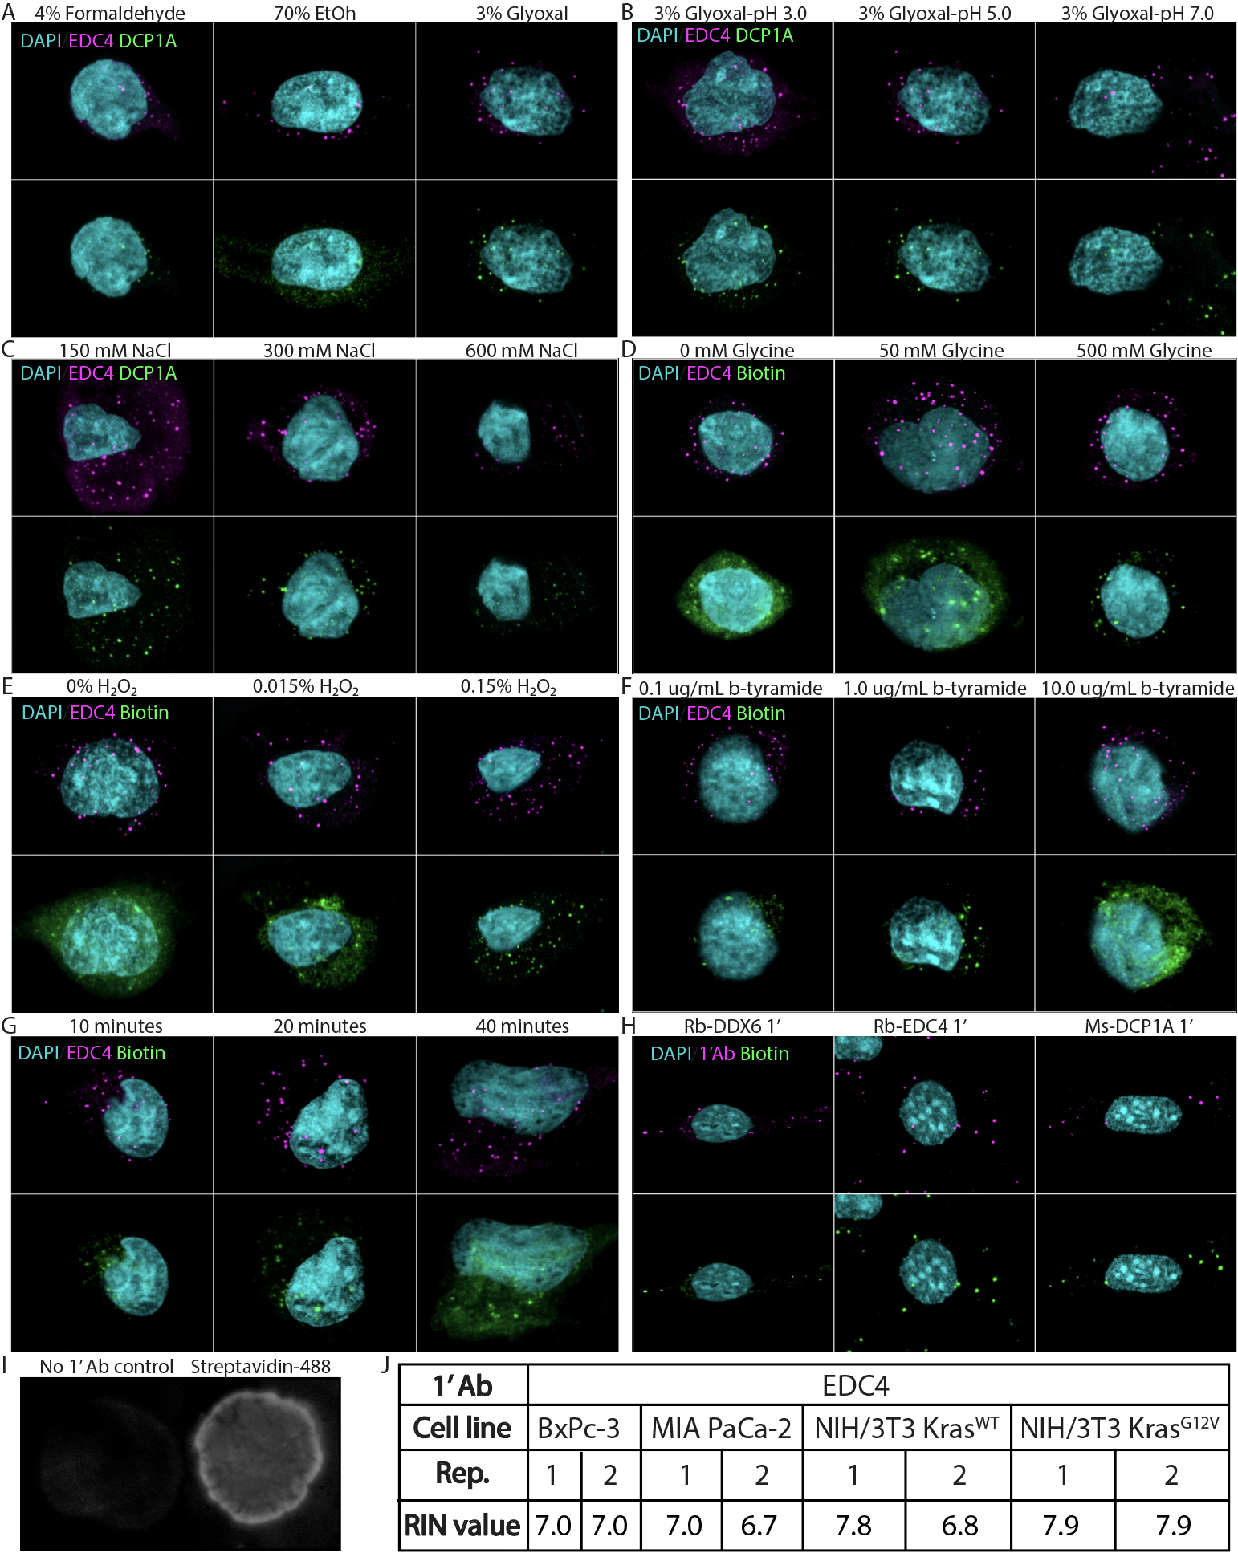
Supplemental Figure 7: TSA-RNA-Seq Optimization A) Representative IF image showing that glyoxal fixation maintains epitope integrity during staining. B) Representative IF image showing that glyoxal fixation at pH above 3.0 shows a sufficient signal-to-noise ratio (RNA is most stable at pH 5.0). C) Representative IF image showing NaCl titration to 300 mM maximizes signal-to-noise ratio without sacrificing signal. D) Representative IF image showing incubation with glycine is required to minimize background autofluorescence. E) Representative IF image showing incubation with H₂O₂ is required to quench endogenous peroxidases, which react with biotinylated tyramide. F) Representative IF image showing that TSA signal is dependent on biotinylated tyramide concentration and G) time. H) Representative IF image showing optimized TSA labeling protocol is sufficient for use with multiple primary antibodies. I) RNA-dot blot showing successful biotinylation of RNA after TSA labeling. J) TSA-seq RNA samples with RIN values run after biotinylated-tyramide labeling.
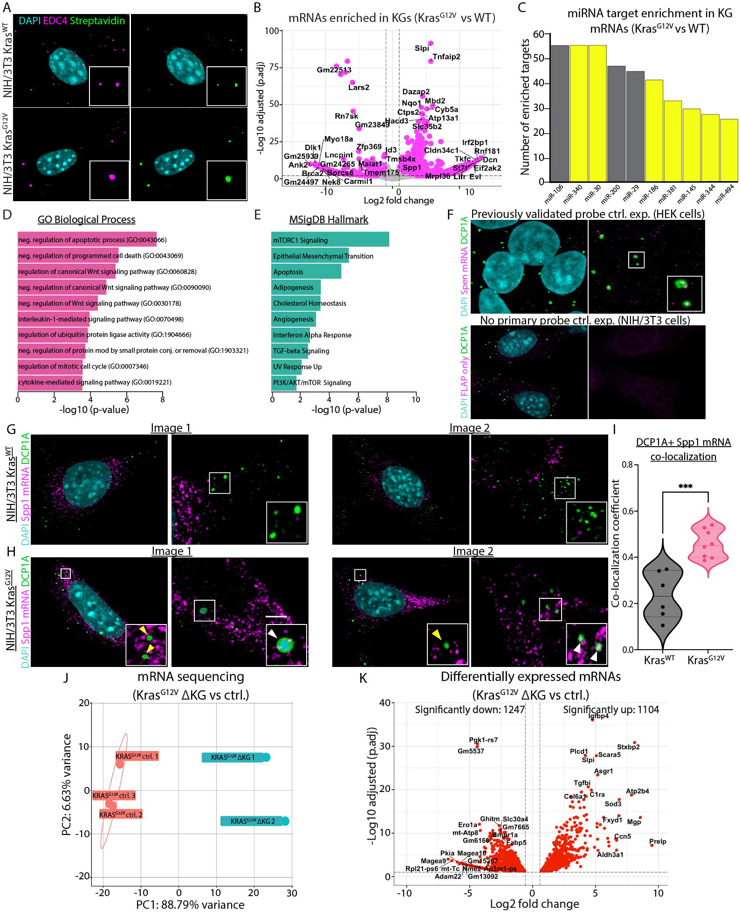
Supplemental Figure 8: KGs are enriched for pro-tumor transcripts and KG inhibition decreases mRNA accumulation A) Representative IF images confirming TSA labeling of EDC4+ foci in NIH/3T3 WT and Kras^{G12V} B) Volcano plot showing KGs are differentially enriched and depleted for transcripts in Kras^{G12V} mutant cells. C) MIENTURNET overrepresentation analysis for miRNA binding sites of transcripts differentially enriched in Kras^{G12V} KGs. MiRNAs highlighted in yellow are significantly downregulated in the same cells. D) GO BP analysis of KG-enriched transcripts. E) MsigDB Hallmark analysis of KG-enriched transcripts. F) Single-molecule inexpensive RNA FISH (smiRNA-FISH) of HEK cells stained for DAPI (cyan), SPEN mRNA (magenta), and DCP1A (green) (top panel) and smiRNA-FISH no primary probe control of NIH/3T3 Kras^{G12V} cells stained for DAPI (cyan), flap only (magenta), and DCP1A (green) (bottom panel). G) smiRNA-FISH of NIH/3T3 Kras^{WT} cells stained for DAPI (cyan), Spp1 mRNA (magenta), and DCP1A (green). H) smiRNA-FISH of NIH/3T3 Kras^{G12V} cells stained for DAPI (cyan), Spp1 mRNA (magenta), and DCP1A (green) I) Quantification of Manders’ coefficient for DCP1A+ foci colocalization with Spp1 mRNA in C and D. J) Principal component analysis of NIH/3T3 Kras^{G12V} control vs ΔKG mRNAseq samples. K) Volcano plot of differential gene expression in NIH/3T3 Kras^{G12V} control vs ΔKG cells showing a shift to increased mRNA downregulation (1247 down vs 1104 up). ***p<0.001. Scale bar = 1 uM. Yellow arrowhead = PB and white arrowhead = KG.

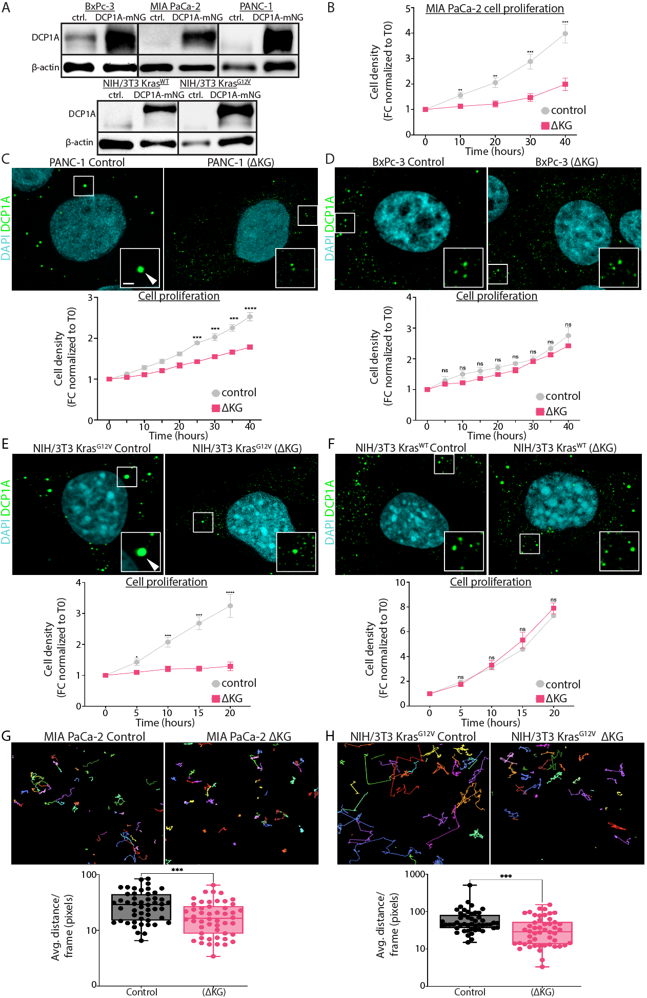
Supplemental Figure 9: KG inhibition prevents cell proliferation and migration in vitro A) Western blot confirming expression of DCP1A-mNG in BxPc-3, MIA PaCa-2, PANC-1, NIH/3T3 Kras^{WT,} and NIH/3T3 Kras^{G12V} cell lines. B) In vitro cell proliferation assay of MIA PaCa-2 control and ΔKG cells. C) Top: Representative IF images of PANC-1 control cells and cells ectopically expressing DCP1A-mNG (green). Bottom: In vitro cell proliferation assay of cells in top panel. D) Top: Representative IF images of BxPc-3 control cells and cells ectopically expressing DCP1A-mNG (green). Bottom: In vitro cell proliferation assay of cells in top panel. E) Top: Representative IF images of NIH/3T3 Kras^{G12V} control cells and cells ectopically expressing DCP1A-mNG (green). Bottom: In vitro cell proliferation assay of cells in top panel. F) Top: Representative IF images of NIH/3T3 Kras^{WT} control cells and cells ectopically expressing DCP1A-mNG (green). Bottom: In vitro cell proliferation assay of cells in top panel. G) Top: Lumaquant cell tracking assay results from MIA PaCa-2 control cells and cells ectopically expressing DCP1A-mNG. Bottom: Quantification of average linear distance traveled for cells tracked in top panel. H) Top: Lumaquant cell tracking assay results from NIH/3T3 Kras^{G12V} control cells and cells ectopically expressing DCP1A-mNG. Bottom: Quantification of average linear distance traveled for cells tracked in top panel. Error bars represent +/- S.E.M. for two independent experiments performed in technical triplicate. ****p<0.0001, ***p<0.001, **p<0.01, *p<0.05, ns = not significant. Scale bar = 1 uM and white arrowhead = KG.

Supplemental Table 3: Human PDAC tumor and control sample details

Sample ID | Tissue type | KRAS mutation | Other mutations
S18-11434 C25 | PDAC | G12D | TP53^{R273C} , CDKN2A^{R58fs}, SMAD4^{CNL}
S19-02985-A29 | PDAC | G12D | TP53^{R306*}
S19-02901-A1 | PDAC | G12D | TP53^{R196P}, CDKN2A^{E88fs}
S18-17454-C31 | PDAC | G12R | TP53^{S149fs}
S18-00749-T1 | PDAC | G12D | RNF43^{H388fs}
S19-02193-T2 | PDAC | G12D | TP53^{R248Q}, CDKN2A^{V28_E33del}
S18-07985-N2 | Normal adjacent | N/A | N/A
S19-02193-N2 | Normal adjacent | N/A | N/A
S19-02985-N2 | Normal adjacent | N/A | N/A
T1234188 | Normal pancreas | N/A | N/A

Supplemental Table 5: Primers used for SDM of AGO2

SDM site | Forward primer (5’>3’) | Reverse primer (5’>3’)
AGO2^{S387A} | gtgcagctttcaacacagatccatacgtc | ggatctgtgttgaaagctgcacttcgcatc
AGO2^{S387E} | gtgcagaattcaacacagatccatacgtc | ggatctgtgttgaattctgcacttcgcatc
AGO2^{Y393A} | cagatccagccgtccgtgaatttggaatcatggtc | ccaaattcacggacggctggatctgtgttgaaacttgc
AGO2^{Y393E} | cagatccagaggtccgtgaatttggaatcatggtc | ccaaattcacggacctctggatctgtgttgaaacttgc

