SUPPLEMENTARY MATERIALS
Trophic dynamics of two omnivorous shrimps in the middle Paraná River
Aquatic Sciences
M. Florencia Viozzi¹, Miguel Saigo^{1,2}, Verónica Williner^{1,2*}

¹Laboratorio de Macrocrustáceos, Instituto Nacional de Limnología, Consejo Nacional de Investigaciones Científicas y Técnicas, Argentina
²Facultad de Humanidades y Ciencias, Universidad Nacional del Litoral, Paraje El Pozo, 3000 Santa Fe, Argentina

*Corresponding author: vwilliner@inali.unl.edu.ar

Conflict of interest: The authors declare that they have no conflict of interest.

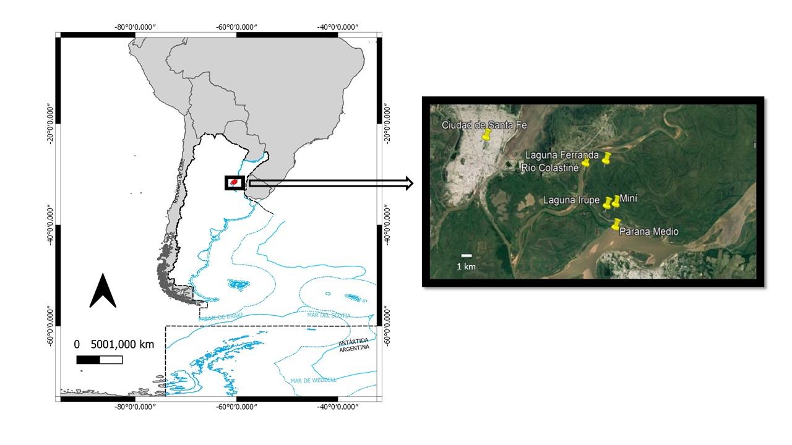
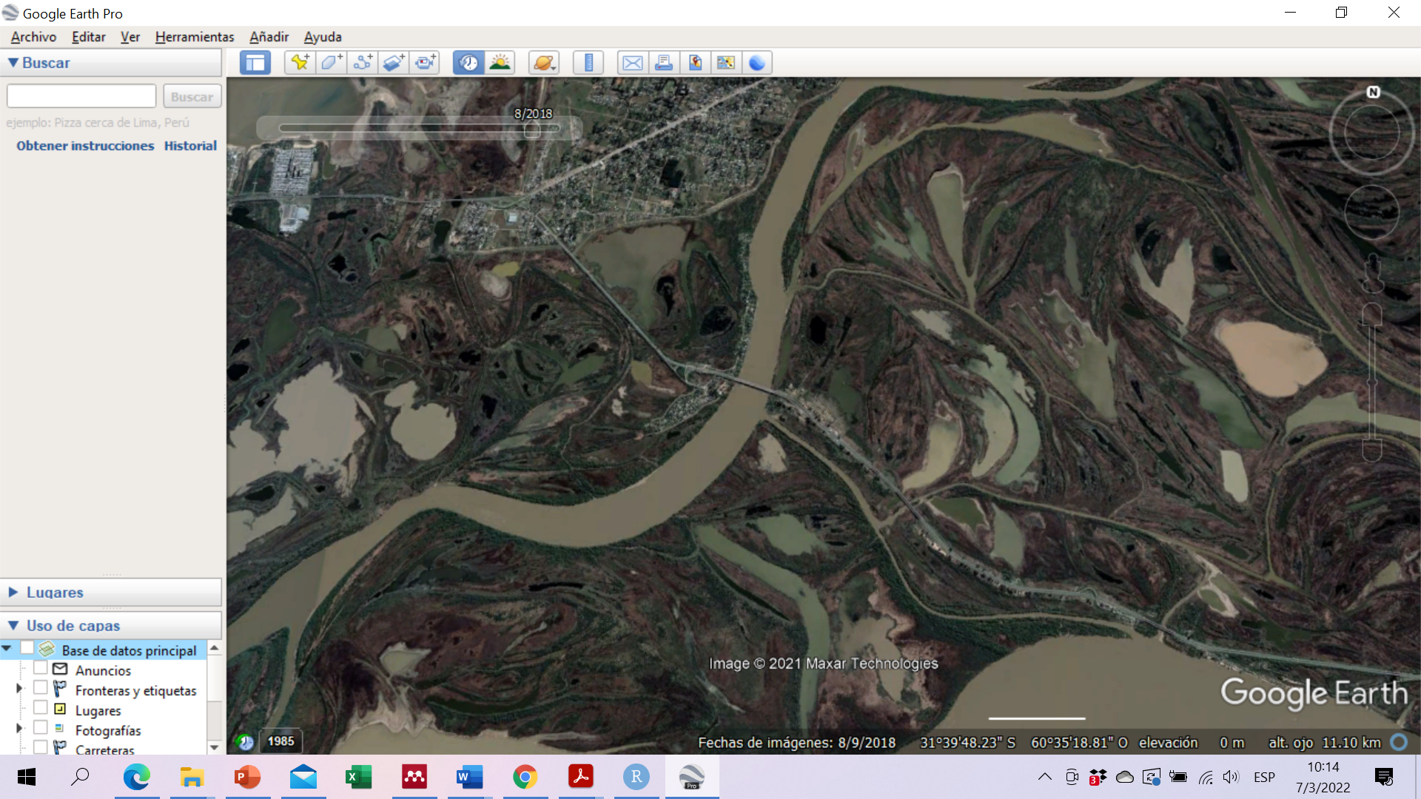



Fig. S1 A) Map of the area of the middle Paraná River covered by the study (made with layers from the National Geographic Institute). B) Satellite image of the study area.
Ferranda Lake
Miní Lake
Irupé Lake
1 km
Paraná River
Colastiné River
Tiradero -Viejo Stream
Miní Stream
A
B

Fig. S2 Hydrometric level of the Paraná River (from the hydrometer of the Santa Fe-Paraná subfluvial tunnel) corresponding to the period from 2015 to 2019. The orange rectangle demarcates the high water period analyzed in this study (hydrometric level between 4, 5 meters and 4 meters) and the green rectangle of low water (hydrometric values less than 2 meters).
Hydrometric level (m)

Table S1 Macrophyte species recorded and percent cover (dominant vegetation only) at sampling sites and hydro-sedimentological periods. Dominant species are highlighted in bold.
 | high water |  |  |  | low water
 | Irupé | Miní | Ferranda |  | Irupé | Miní | Ferranda
Macrophyte percent cover (%) | 20 | 35 | 30 |  | 5 | 10 | 8
Species | Panicum elephantipes  Pistia stratiotes  Salvinia biloba  Commelina sp. | Panicum elephantipes  Pistia stratiotes  Eichhornia crassipes  Hydrocotile rununculoides | Panicum elephantipes  Eichhornia azurea  Ludwigia peploides |  | P. elephantipes  Nymphoides indica  Ludwigia peploides | Panicum elephantipes  Eichhornea azurea  Nymphoides indica  Ludwigia peploides  Salvinia biloba | Panicum  elephantipes  E. azurea  Nymphoides indica  Salvinia biloba  Azolla filiculoides
Dominant vegetation type  (according to Torres et al. (2018). | floating | floating | floating |  | floating | floating | floating

Table S2 Prey relative importance index (IRI) in the diet of two shrimp species from the middle Paraná River, Argentina.
Fig. S3.2 Palaemon argentinus, diversity indices calculated to verify the number of stomachsused to represent the trophic spectrum of the species.
 | Macrobrachium borellii  n=80 |  |  | Palaemon argentinus  n=73
 | High Water | Low Water |  | High Water | Low Water
Alternaria sp | 8 | 33 |  | 7 | 1
Amoeba sp | 3 | 6 |  | - | 3
Bryozoa | 13 | 2 |  | 0.2 | 0.3
Chara sp (Cholorophyta) | - | - |  | - | 32
Chironominae larvae | 850 | 1026 |  | 639 | 14
Cladocera | 39 | 57 |  | 8 | -
Coleoptera | - | 3 |  | 1 | 2
Diptera larvae (Tipulidae) | - | 4 |  | - | -
Ephemeroptera larvae | 11 | 5 |  | - | -
filamentous algae | 59 | 4 |  | 7 | 102
Hydracarina | 3 | 5 |  | 7 | 0.1
Oligochaeta | 1686 | 1785 |  | 2953 | 150
Ostracods | 28 | 42 |  | 66 | 34
Rotifera | 2 | 2 |  | - | 0.3
unicellular algae | 2 | 3 |  | 17 | 1
Plant remains | 289 | 206 |  | 147 | 227

Table S3 Bayesian mixing model median estimates and standard deviation (95 % CI) of the proportional contributions of each food source of M. borellii estimated using muscle

 | High Water |  | Low Water
 | Uninformative  DIC= 79 | Moderately informative  DIC= 81 | Uninformative  DIC= 70 | Moderately informative  DIC= 78
Lake Ferranda
Epiphyton | 0.1±0.1 | 0.0±0.0 | 0.2±0.1 | 0.0±0.0
C3 Plants | 0.7±0.1 | 0.8±0.1 | 0.2±0.1 | 0.0±0.1
Seston | 0.1±0.1 | 0.0±0.0 | 0.1±0.1 | 0.0±0.1
G.C. | 0.1±0.1 | 0.1±0.1 | 0.5±0.2 | 0.9±0.1
Lake Irupé
Epiphyton | 0.1±0.1 | 0.0±0.0 | 0.2±0.1 | 0.0±0.0
C3 Plants | 0.8±0.1 | 0.9±0.1 | 0.2±0.1 | 0.1±0.0
Seston | 0.1±0.1 | 0.0±0.0 | 0.3±0.2 | 0.2±0.2
G.C. | 0.0±0.1 | 0.1±0.1 | 0.3±0.1 | 0.7±0.3
Lake Miní
Epiphyton | 0.1±0.1 | 0.0±0.0 | 0.0±0.0 | 0.0±0.0
C3 Plants | 0.7±0.1 | 0.8±0.1 | 0.1±0.1 | 0.0±0.0
Seston | 0.1±0.1 | 0.0±0.0 | 0.0±0.0 | 0.0±0.0
G.C. | 0.1±0.1 | 0.1±0.1 | 0.9±0.1 | 1±0.3

Table S4 Bayesian mixing model median estimates and standard deviation (95 % CI) of the proportional contributions of each food source of M. borellii estimated using hepatopancreas

 | High Water |  | Low Water
 | Uninformative  DIC= 80 | Moderately informative  DIC= 76 | Uninformative  DIC= 76 | Moderately informative  DIC= 86
Lake Ferranda
Epiphyton | 0.1±0.1 | 0.0±0.0 | 0.2±0.0 | 0.0±0.0
C3 Plants | 0.7±0.1 | 0.8±0.1 | 0.2±0.1 | 0.0±0.1
Seston | 0.1±0.1 | 0.0±0.0 | 0.2±0.1 | 0.1±0.1
G.C. | 0.1±0.1 | 0.2±0.1 | 0.4±0.1 | 0.9±0.1
Lake Irupé
Epiphyton | 0.2±0.2 | 0.0±0.1 | 0.2±0.1 | 0.0±0.1
C3 Plants | 0.6±0.2 | 0.8±0.1 | 0.3±0.1 | 0.1±0.2
Seston | 0.1±0.1 | 0.0±0.0 | 0.3±0.2 | 0.2±0.3
G.C. | 0.1±0.1 | 0.2±0.2 | 0.2±0.1 | 0.7±0.3
Lake Miní
Epiphyton | 0.0±0.0 | 0.0±0.0 | 0.1±0.1 | 0.0±0.0
C3 Plants | 0.8±0.1 | 0.9±0.1 | 0.1±0.1 | 0.0±0.0
Seston | 0.1±0.1 | 0.0±0.0 | 0.0±0.0 | 0.0±0.0
G.C. | 0.1±0.1 | 0.1±0.1 | 0.9±0.1 | 1±0.0

Table S5 Bayesian mixing model median estimates and standard deviation (95 % CI) of the proportional contributions of each food source of P. argentinus estimated using muscle

 | High Water |  | Low Water
 | Uninformative  DIC= 31 | Moderately informative  DIC= 30 | Uninformative  DIC= 29 | Moderately informative  DIC= 29
Lake Ferranda
Epiphyton | 0.1±0.1 | 0.0±0.0 | 0.1±0.1 | 0.1±0.1
C3 Plants | 0.6±0.1 | 0.8±0.1 | 0.5±0.2 | 0.5±0.2
Seston | 0.2±0.1 | 0.0±0.0 | 0.1±0.1 | 0.1±0.1
G.C. | 0.1±0.1 | 0.2±0.1 | 0.3±0.2 | 0.3±0.3
Lake Irupé
Epiphyton | 0.1±0.1 | 0.0±0.0 | 0.1±0.1 | 0.1±0.1
C3 Plants | 0.7±0.1 | 0.8±0.1 | 0.6±0.1 | 0.6±0.1
Seston | 0.1±0.1 | 0.0±0.0 | 0.1±0.1 | 0.1±0.1
G.C. | 0.1±0.1 | 0.2±0.1 | 0.2±0.1 | 0.2±0.2

Table S6 Bayesian mixing model median estimates and standard deviation (95 % CI) of the proportional contributions of each food source of P. argentinus estimated using hepatopancreas

 | High Water |  | Low Water
 | Uninformative  DIC= 28 | Moderately informative  DIC= 30 | Uninformative  DIC= 58 | Moderately informative  DIC= 59
Lake Ferranda
Epiphyton | 0.2±0.1 | 0.0±0.1 | 0.2±0.1 | 0.1±0.1
C3 Plants | 0.3±0.2 | 0.1±0.2 | 0.2±0.1 | 0.2±0.2
Seston | 0.2±0.0 | 0.0±0.1 | 0.3±0.1 | 0.1±0.1
G.C. | 0.3±0.2 | 0.9±0.2 | 0.3±0.2 | 0.6±0.3
Lake Irupé
Epiphyton | 0.2±0.2 | 0.0±0.1 | 0.1±0.1 | 0.1±0.1
C3 Plants | 0.2±0.2 | 0.1±0.2 | 0.3±0.2 | 0.2±0.2
Seston | 0.2±0.2 | 0.0±0.1 | 0.1±0.1 | 0.1±0.1
G.C. | 0.4±0.2 | 0.9±0.2 | 0.5±0.3 | 0.6±0.3

Table S7 Standard Area of Bayesian ellipses corrected for small samples (SEAc) expressed in ‰²
Lake/Period | Species | SEAc
Ferranda HW | M. borellii | 2,77
Ferranda HW | P. argentinus | 2,08
Ferranda LW | M. borellii | 1,19
Ferranda LW | P. argentinus | 3,58
Irupé HW | M. borellii | 5,37
Irupé HW | P. argentinus | 2,16
Irupé LW | M. borellii | 5,10
Irupé LW | P. argentinus | 1,27
Mini HW | M. borellii | 1,13
Mini LW | M. borellii | 2,40

