Supplementary table 1 – Association of alpha diversity metrics and clinical variables
Clinical variables | Average Shannon index “yes” group | Average Shannon index “no” group | T statistics | P-value
Female samples
Miscarriage | 1.59 | 1.41 | 0.67 | 0.51
Tubal factor | 1.49 | 1.40 | 0.53 | 0.60
Recurrent implantation failure | 1.51 | 1.43 | 0.23 | 0.83
Previous miscarriage | 1.38 | 1.45 | -0.32 | 0.75
Recurrent miscarriage | 0.05 | 1.45 | -0.32 | 0.75
Endometriosis | 1.49 | 1.42 | 0.33 | 0.74
Myometritis | 1.80 | 1.40 | 1.44 | 0.18
Follicular fluid samples
Miscarriage | 2.33 | 1.84 | 1.58 | 0.16
Tubal factor | 1.97 | 1.86 | 0.54 | 0.59
Recurrent implantation failure | 2.32 | 1.88 | 3.01 | 0.01
Previous miscarriage | 1.83 | 1.91 | -0.31 | 0.76
Recurrent miscarriages | NA | 1.90 | NA | NA
Endometriosis | 2.00 | 1.87 | 0.43 | 0.67
Myometritis | 2.49 | 1.83 | 2.32 | 0.06
Vaginal samples
Miscarriage | 0.96 | 1.09 | -0.54 | 0.60
Tubal factor | 1.10 | 1.06 | 0.22 | 0.83
Recurrent implantation failure | 0.97 | 1.08 | -0.44 | 0.69
Previous miscarriage | 1.08 | 1.07 | 0.01 | 0.99
Recurrent miscarriage | 0.05 | 1.09 | 0.01 | 0.99
Endometriosis | 1.02 | 1.09 | -0.32 | 0.75
Myometritis | 1.11 | 1.07 | 0.27 | 0.79
Male samples
Normal spermiogram | 2.89 | 2.80 | 0.62 | 0.54
Oligozoospermia | 2.94 | 2.78 | 1.00 | 0.32
Asthenozoospermia | 2.83 | 2.83 | -0.03 | 0.98
Teratozoospermia | 2.79 | 2.86 | -0.43 | 0.67
Azoospermia | 2.12 | 2.85 | -0.85 | 0.55
Miscarriage | 2.98 | 2.81 | 0.77 | 0.46
Recurrent miscarriages | NA | 2.83 | NA | 0.46
Penis samples
Normal spermiogram | 2.88 | 2.81 | 0.45 | 0.65
Oligozoospermia | 2.85 | 2.84 | 0.05 | 0.96
Asthenozoospermia | 2.79 | 2.86 | -0.33 | 0.75
Teratozoospermia | 2.80 | 2.86 | -0.29 | 0.77
Azoospermia | 2.97 | 2.84 | -0.29 | 0.77
Miscarriage | 3.02 | 2.82 | 0.57 | 0.59
Recurrent miscarriages | NA | 2.84 | NA | 0.59
Sperm samples
Normal spermiogram | 2.89 | 2.79 | 0.39 | 0.70
Oligozoospermia | 3.07 | 2.69 | 1.39 | 0.18
Asthenozoospermia | 2.87 | 2.78 | 0.31 | 0.76
Teratozoospermia | 2.77 | 2.86 | -0.30 | 0.77
Azoospermia | 1.27 | 2.86 | -0.30 | 0.77
Miscarriage | 2.94 | 2.80 | 0.47 | 0.65
Recurrent miscarriages | NA | 2.82 | NA | 0.65

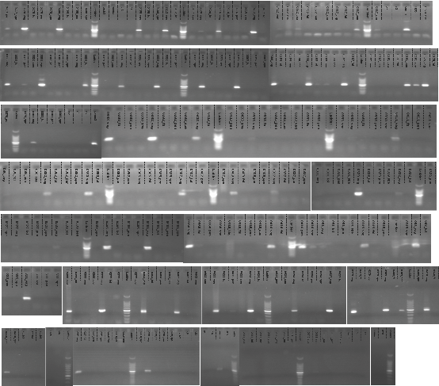

Supplementary figure 1 – Evaluation of the PCR product after the amplification of the V1-V2 region of the 16S rRNA gene. Samples were categorized based on band intensity and used for sequencing libraries preparation.

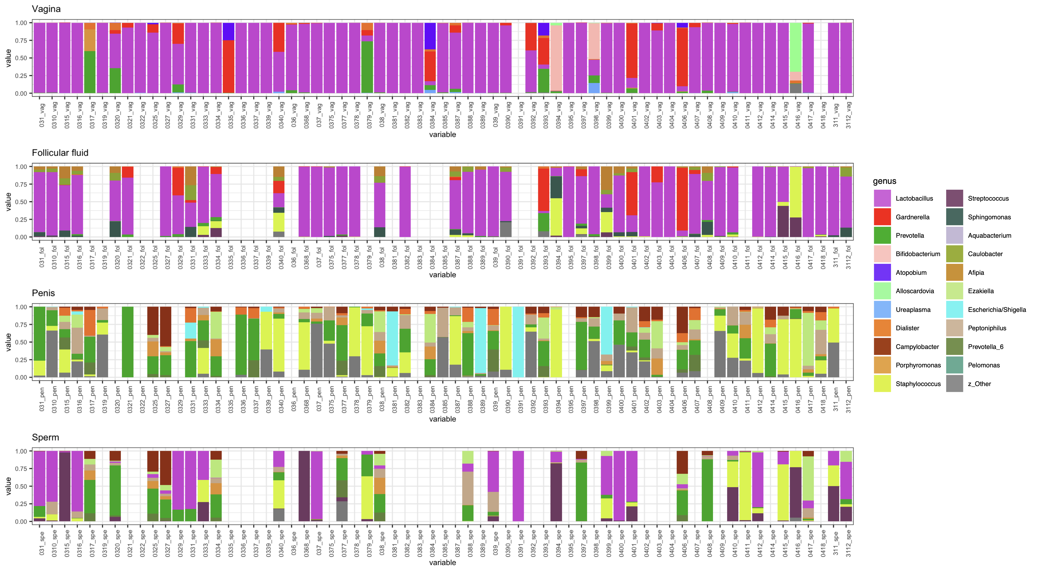

Supplementary figure 2 – Percent stacked barplot of the most abundant genera in the four sample types. Samples belonging to the same couple are aligned vertically. Missing bars indicate samples that did not pass the filtration steps indicated in the manuscript.

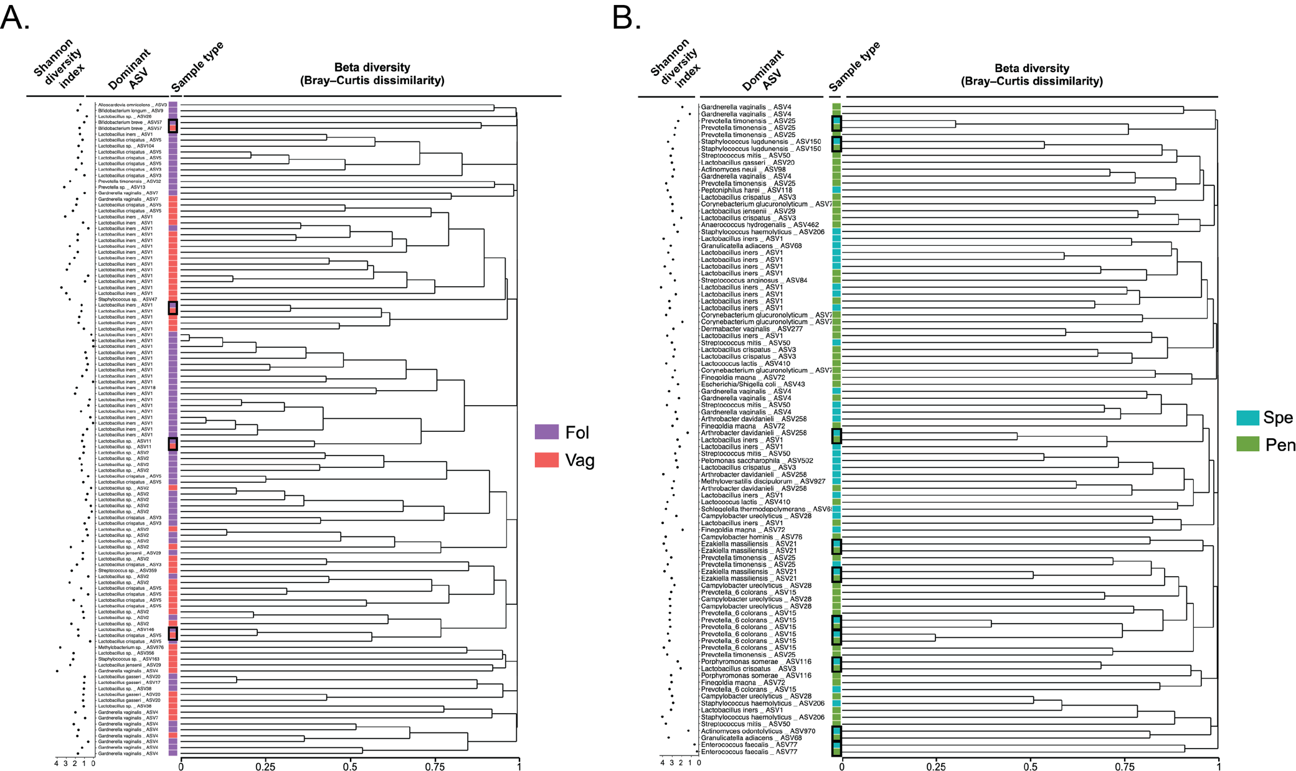
Supplementary figure 3 – Clustering of the samples based on community composition. Hierarchical clustering dendrogram from the Bray-Curtis dissimilarity analysis of (A) female and (B) male samples based on Bray-Curtis dissimilarity (right panel). For each sample, the dominant ASV with species identification is displayed, along with the Shannon diversity index. Black boxes depict samples from the same patient.

