When one does not want, two fight less: low mobility and similar odors result in peaceful interspecific encounters in termites

Daniela Lúcio Santana¹, Leandro Bacci², Paulo Fellipe Cristaldo³ & Ana Paula Albano Araújo^{1,4}

¹Post Graduate Program in Ecology and Conservation, Universidade Federal de Sergipe, São Cristóvão- SE, Brazil
²Laboratory of Integrated Pest Management, Department of Agronomy, Universidade Federal de Sergipe, São Cristóvão- SE, Brazil
³ Laboratory of Insect Ecology, Department of Agronomy, Universidade Federal Rural de Pernambuco, Recife, Brazil
⁴ Ecological Interactions Laboratory, Department of Ecology, Universidade Federal de Sergipe, São Cristóvão- SE, Brazil
Corresponding author:
Ana Paula Albano Araújo
anatermes@academico.ufs.br
https://orcid.org/0000-0001-7853-8001

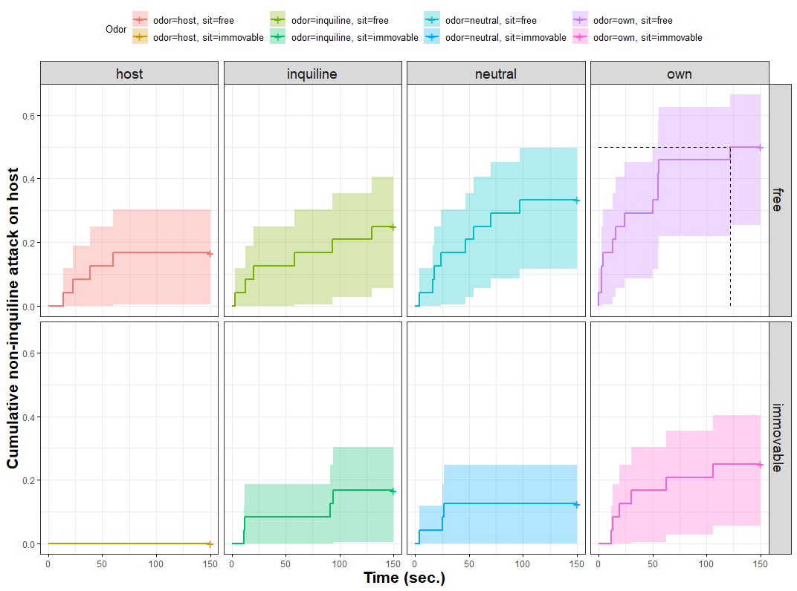

SM Fig. 1. Attacks initiated by non-inquiline target individuals of Nasutitermes corniger treated with different odors (host, inquiline, neutral, or own odor) and mobility (free or kept immovable) under the host Constrictotermes sp.

