Supplementary Information
Title: Unraveling the Effects of the COVID-19 Pandemic on the Burden of Respiratory Syncytial Virus in a Tertiary Hospital in Catalonia, Spain: Season 2022-2023 Analysis
Authors:
Aida Perramon-Malavez¹, Victor Lopez De Rioja¹, Anna Creus^{2,3}, Cristina Andrés⁴, Cristina Montañola-Sales⁵, Jorgina Vila^{2,3}, Esther Lera², Andrés Antón⁴, Núria Worner^{2,3}, Joan Balcells⁶, Maria Piñana⁴, Pere Soler-Palacin^{3,7}, Clara Prats¹ and Antoni Soriano-Arandes^{3,7,*}
¹ Computational Biology and Complex Systems (BIOCOM-SC) group, Department of Physics, Universitat Politècnica de Catalunya (UPC), Barcelona, Catalonia, Spain.
² Paediatric Hospital Medicine, Department of Paediatrics, Children’s Hospital, Vall d’Hebron Barcelona Hospital Campus, Barcelona, Catalonia, Spain.
³ Infection and Immunity in Paediatric Patients, Vall d’Hebron Research Institute, Barcelona, Catalonia, Spain.

⁴ Respiratory Viruses Unit, Virology Section, Microbiology Department, Vall d'Hebron Hospital Universitari, Vall d'Hebron Research Institute, Vall d'Hebron Barcelona Hospital Campus, Barcelona, Catalonia, Spain.
⁵ Quantitative Methods Department, Institut Químic de Sarrià, Universitat Ramon Llull (URL), Barcelona, Catalonia, Spain.
⁶ Paediatric Intesive Care Unit, Children’s Hospital, Vall d’Hebron Barcelona Hospital Campus, Barcelona, Catalonia, Spain.
⁷ Paediatric Infectious Diseases and Immunodeficiencies Unit, Children’s Hospital, Vall d’Hebron Barcelona Hospital Campus, Barcelona, Catalonia, Spain.
*Corresponding author : Antoni Soriano-Arandes, Passeig Vall d’Hebron 119-129, 08035 Barcelona, email : toni.soriano@vallhebron.cat ; tsorianoarandes@gmail.com; Tel : +34639712438 ; ORCID number : 0000-0001-9613-7228.

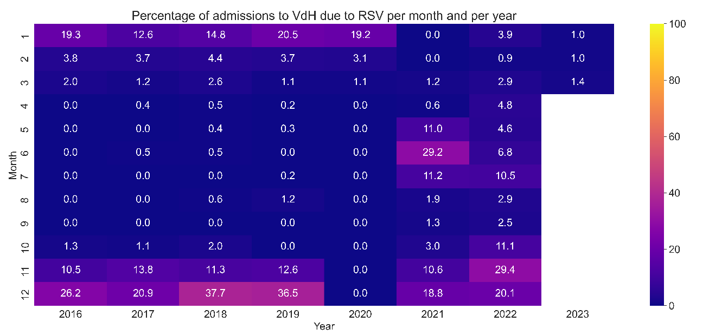

Figure 1S. Heatmap illustrating the proportion of admissions attributed to RSV at a referral hospital in Catalonia, Spain, following a monthly and yearly basis during the study period.

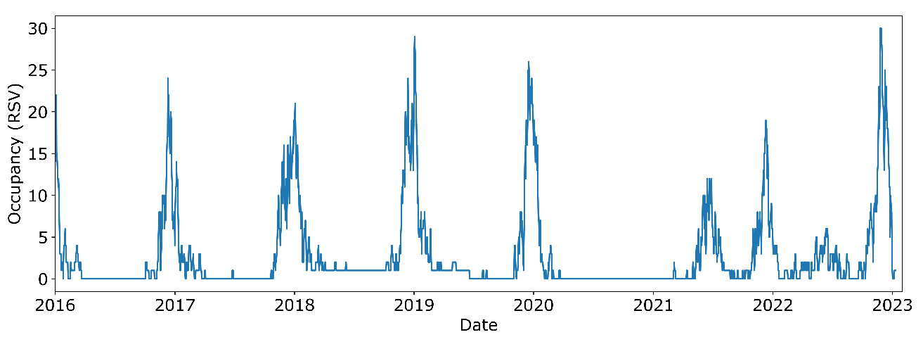
Figure 2S. Evolution of RSV-related occupancy at a referral hospital in Catalonia, Spain, for the study period.

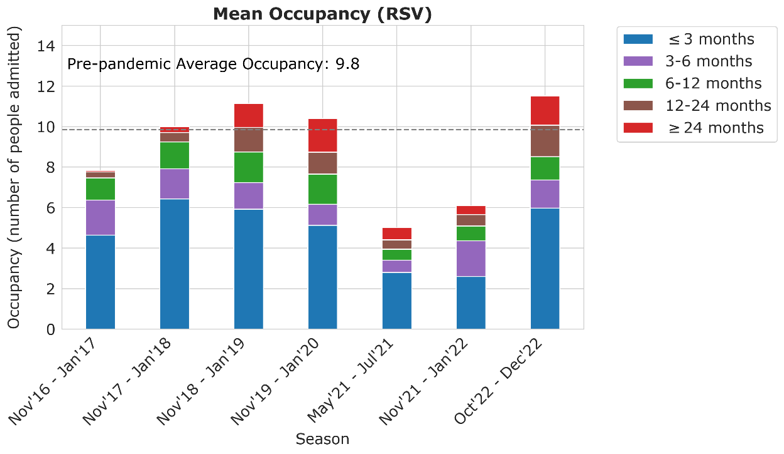
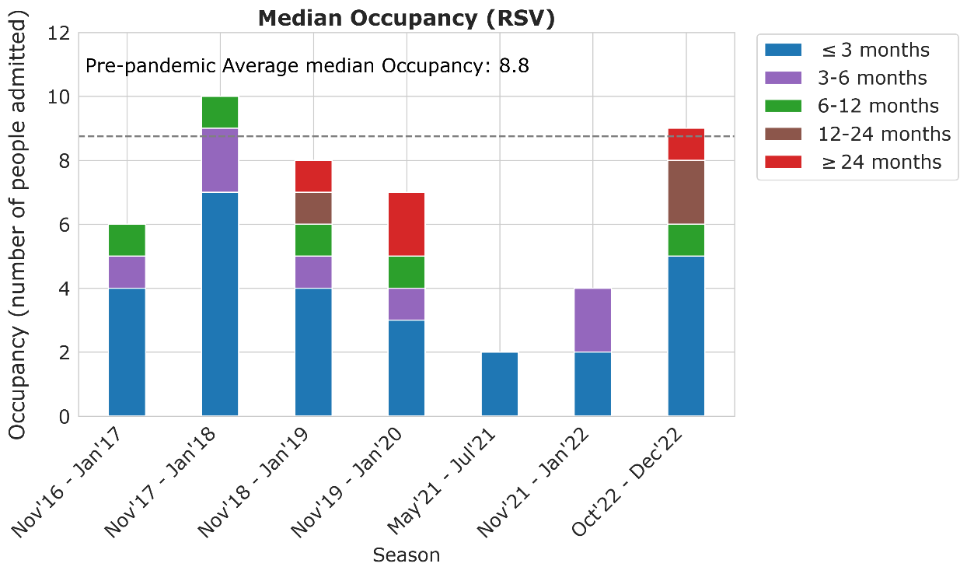
Figure 3S. Mean (A) and median (B) RSV-related paediatric occupancy in a referral hospital in Catalonia, Spain, categorized by age groups. The age groups include ≤3 months (represented in blue), 3-6 months (represented in purple), 6-12 months (represented in green), 12-24 months (represented in brown), and ≥24 months (represented in red). The dashed grey line depicts the pre-pandemic (2016-2020) averages.
A
B
* Notice that the sum of the means or medians for each age group may not align with the overall mean or median per season for all ages. The Pre-pandemic averages represented in Figure 2S correspond to the primary dataset encompassing all children <15 years.

