Supplementary information

N (male/female) |  | 35 (21/14) |  | Difference between groups
Age (y) |  | 72.4±4.9 (63-81) | t₍₃₃₎= -0.722, p=0.47
Education (y) |  | 14.8±3.4 (9-25) | 𝜒²₍₃₂₎= 172.5, p=0.52
MoCA | General cognition | 27.5±1.6 (23-30) | 𝜒²₍₃₂₎= 119.5, p=0.39
JLO | Visual | 23.3±4.1 (14-30) | t₍₃₀₎= 0.556, p=0.582
RO-C | Visual | 32.7±3 (21-36) | t₍₂₉₎= -0.523, p=0.6
BVMT-I | Memory | 16.4±5.1 (7-28) | t₍₃₀₎= 1.457, p=0.1
BVMT-D | Memory | 5.9±2.7 (0-11) | t₍₃₀₎= -0.963, p=0.34
BVMT-R | Memory | 8.4±4.1 (0-19) | t₍₂₉₎= 0.631, p=0.53
RAVLT-I | Memory | 36.2±8.5 (21-53) | t₍₃₁₎= -0.095, p=0.95
RAVLT-D | Memory | 5.1±2.9 (0-12) | t₍₃₁₎= -0.918, p=0.36
RAVLT-R | Memory | 11.3±2.7 (5-15) | t₍₃₂₎= -1.039, p=0.37
TMT-A (seconds until completion) | Attention | 43±17.7 (21-102) | t₍₃₂₎= 1.223, p=0.23
Digit span, forward | Attention/WM | 13±1.9 (10-17) | t₍₂₀₎= 0.212, p=0.83
Stroop-W | Attention | 79.2±11.3 (56-100) | t₍₃₂₎= -0.715, p=0.48
Stroop-C | Attention | 65.2±9.6 (39-82) | t₍₃₂₎= -0.808, p=0.42
Stroop-WC | Executive function | 44.7±10.3 (22-62) | t₍₃₂₎= 0.373, p=0.72
TMT-B (seconds until completion) | Executive function | 113.2±47.4 (42-280) | t₍₃₂₎= 1.076, p=0.29
FPT | Executive function | 25.9±7.5 (12-52) | t₍₃₂₎= 0.066, p=0.98
VFT-S | Language | 19.1±8.1 (10-53) | t₍₃₁₎= -0.442, p=0.66
VFT-L | Language | 41.8±11.26 (22-61) | t₍₃₀₎= 1.930, p=0.06
BNT-30 | Language | 26.15±3.83 (17-36) | t₍₃₁₎= -1.124, p=0.27
GDS | Depression | 3.09±2.36 (0-10) | t₍₃₂₎= -0.053, p=0.59
FAQ | Activity of daily living | 0.6±1.8 (0-9) | t₍₃₂₎= 0.572, p=0.57
Left Hippocampus |  |  | t₍₂₉₎= -0.722, p=0.47
Right Hippocampus |  |  | t₍₂₉₎=1.93, p=0.06*
Left Caudate |  |  | 𝜒²₍₂₉₎= 104, p=0.54
Right Caudate |  |  | t₍₂₉₎= -0.68, p=0.53
Left Putamen |  |  | 𝜒²₍₂₉₎= 126, p=0.89
Right Putamen |  |  | t₍₂₉₎= -0.716, p=0.53
Left Pallidum |  |  | 𝜒²₍₂₉₎=192, p<0.01*
Right Pallidum |  |  | 𝜒²₍₂₉₎= 154, p=0.18
Left Thalamus |  |  | 𝜒²₍₂₉₎= 123, p=0.92
Right Thalamus |  |  | t₍₃₀₎= -0.963, p=0.34
HV:CTV |  |  | t₍₂₉₎=0.7, p=0.48
C:CTV |  |  | 𝜒²₍₂₉₎=99, p=0.42
Supplementary Table S1 Baseline characteristics of subjects, cognitive tests within respective cognitive domain, cortical thickness derived from sMRI data, Data provided as means ± SD and range (min to max); Abbreviations: JLO: Judgment of Line Orientation; ROC-C: Rey-Osterrieth Complex Figure Test: copy; BVMT-I, -D; -R: Brief Visual Memory Test -immediate, -delayed, -recall; RAVLT-I, -D, -R: Rey’s Auditory Verbal Learning Test; TMT-A: Trail-Making Test part A; Stroop-W, C, CW: Stroop Color and Word Test, word, color, color-word score; TMT-B: Trail-Making Test part B; VFT-S, L: Verbal Fluency Test, semantic, lexical; FPT: five-point test; BNT-30: Boston Naming Test.

Experimental group |  |  |  |  |  |  | Correct responses |  |  |  |  |  |  |  |  |  |  |  | RT(s)
 |  |  |  |  |  |  | T0 |  | T1 |  |  |  |  | T2 |  |  |  |  | T0 |  |  |  |  | T1 |  |  |  |  | T2
N |  |  |  | 0 |  | 17 |  |  |  |  |  | 17 |  |  |  |  | 13 |  |  |  |  | 17 |  |  |  |  | 17 |  |  |  |  | 13
 |  |  | 1 |  |  | 15 |  |  |  |  | 15 |  |  |  |  | 11 |  |  |  |  | 15 |  |  |  |  | 15 |  |  |  |  | 11
Mean |  |  |  | 0 |  | 76.1 |  |  |  |  |  | 74.3 |  |  |  |  | 77.9 |  |  |  |  | 1.01 |  |  |  |  | 1.24 |  |  |  |  | 1.10
 |  |  |  | 1 |  | 73.0 |  |  |  |  |  | 77.5 |  |  |  |  | 77.8 |  |  |  |  | 1.09 |  |  |  |  | 1.46 |  |  |  |  | 1.33
Median |  |  |  | 0 |  | 74.0 |  |  |  |  |  | 79.0 |  |  |  |  | 82.0 |  |  |  |  | 0.975 |  |  |  |  | 1.18 |  |  |  |  | 1.05
 |  |  |  | 1 |  | 78.0 |  |  |  |  |  | 79.0 |  |  |  |  | 78.0 |  |  |  |  | 1.03 |  |  |  |  | 1.14 |  |  |  |  | 1.19
Standard deviation |  |  |  | 0 |  | 7.74 |  |  |  |  |  | 12.2 |  |  |  |  | 9.78 |  |  |  |  | 0.208 |  |  |  |  | 0.411 |  |  |  |  | 0.309
 |  |  |  | 1 |  | 12.8 |  |  |  |  |  | 6.32 |  |  |  |  | 4.12 |  |  |  |  | 0.250 |  |  |  |  | 0.707 |  |  |  |  | 0.402
Minimum |  |  |  | 0 |  | 62.0 |  |  |  |  |  | 45.0 |  |  |  |  | 53.0 |  |  |  |  | 0.701 |  |  |  |  | 0.809 |  |  |  |  | 0.755
 |  |  |  | 1 |  | 42.0 |  |  |  |  |  | 65.0 |  |  |  |  | 73.0 |  |  |  |  | 0.807 |  |  |  |  | 0.811 |  |  |  |  | 0.953
Maximum |  |  |  | 0 |  | 87.0 |  |  |  |  |  | 85.0 |  |  |  |  | 88.0 |  |  |  |  | 1.54 |  |  |  |  | 2.33 |  |  |  |  | 2.01
 |  |  |  | 1 |  | 84.0 |  |  |  |  |  | 85.0 |  |  |  |  | 85.0 |  |  |  |  | 1.72 |  |  |  |  | 2.91 |  |  |  |  | 2.12
Supplementary Table S2 VOMT descriptive statistics across experimental groups and timepoints.

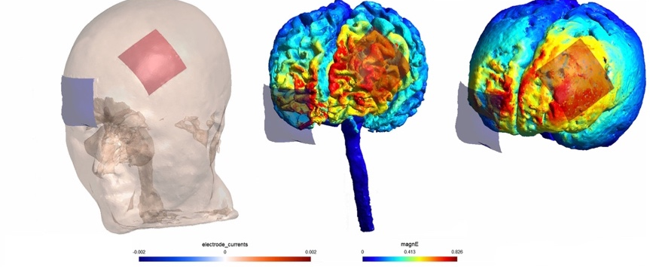
Supplementary Fig. S1 Current simulation of the lDLPFC electrode montage and the simulation of the electric fields on head model. The simulation was built using the male head model and the following stimulation parameters: two square-shape 1 mm thick rubber electrode.

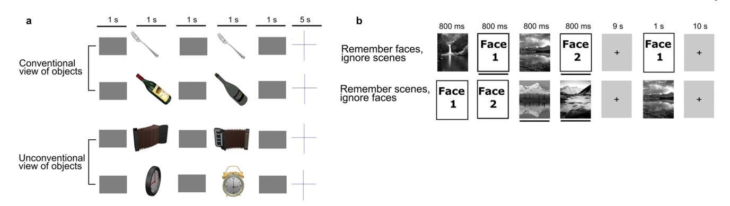
Supplementary Fig. S2 Prior to, immediately after, and at 1-month follow-up after the stimulation, participants performed a VOMT (a). VOMT—subjects respond to whether the two consecutive objects are the same or different by pressing a YES/NO button in two difficulty levels (conventional view of objects—lower difficulty level; unconventional view of objects—higher difficulty level). Online WMT—subjects view a block of faces and scenes (2 + 2, randomized order) preceded by a specific command on how to react to a probe that follows each block. Subjects respond whether the probe is consistent/ inconsistent with the prior instruction by pressing a YES/NO button (b).

Supplementary Figure 3 The flow chart of participants follow-up through the research.
Supplementary Fig. S3 The flow chart of participant follow-up through the research.
Enrolled N= 35
(a)MCI patients
Active tDCS
fMRI N=18
VOMT N= 18
sMRI N=17
WMT N=18
Sham tDCS
fMRI N=16
VOMT N=17
sMRI N=13
WMT N=17
Active tDCS
fMRI N=16
VOMT N=18
tDCS Protocol completion
Sham tDCS
fMRI N=16
VOMT N=17
1-month follow up
Active tDCS
fMRI N=14
VOMT N=11
Sham tDCS
fMRI N=14
VOMT N=13
Random group allocation

