Table 1. Mann-Kendall test and Sen's slope approach: detailed test statistics.
Statistical test |  | Formula
Mann-Kendall | (1) | 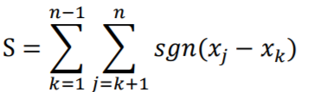 | where n is the length of the sample, 𝑥_{j} and 𝑥_{k} are from 𝑘=1, 2, …, n-1 and 𝑗= 𝑘+1, …, n. If n is bigger than 8, statistic S approximates to normal distribution
 | (2) | 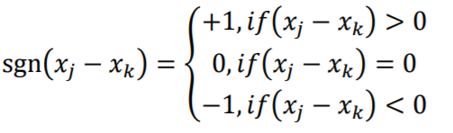
 | (3) | 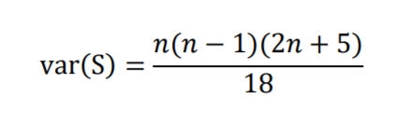 | var(S) is the variance of S
 | (4) | 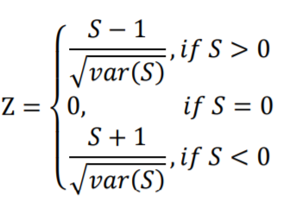 | T_{b} is the test statistic. If T_{b}>0, it indicates an increasing trend, and vice versa
Sen’s slope |  | 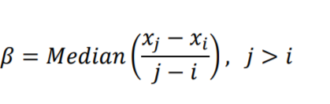 | 𝛽>0 indicates upward trend in a time series. Otherwise, the data series presents downward trend during the time period

