Supplementary information

Table S1. Cryo-EM data collection and refinement statistics for Omicron BA.1 spike trimer with HmAb K501SP3
PDB | 8C5R
EMDB | 16441
Microscope | Titan Krios
Camera | Falcon III
Voltage | 300kV
Recording mode | Counting
Electron dose (e/Å²) | 42
Defocus range (µm) | -1 to -2.8
Pixel size (Å) | 0.832
Micrograph collected | 1438
Micrograph Used | 1438
Total extracted particles | 46854
Refined particles | 19738
Symmetry imposed | C1
Map resolution (Å) | 3.73
Refinement and Validation
R.M.S.D  Bond length (Å)  Bond angles (˚)  Clash Score (all atom)  Ramachandran Outlier (%)  Side chain Outlier (%) | 0.26  0.48  19  0.3%  0.2%

Table S2. Heavy and light chain variable IgG sequence characteristics and germline usages.
Heavy
HmAb | V gene and allele | % identity to germline (V region) (nucleotide) | J gene and allele | % identity to germline (J region) (nucleotide) | CDRH3 sequence | CDRH3 Length
SP1 | IGHV5-51*01 F | 96.2 | IGHJ4*02 F | 91.7 | CARHSPLRQYLVQKGFDNW | 17
SP2 | IGHV3-66*01 F | 93.7 | IGHJ4*02 F | 81.3 | CARGPPGTGHDFW | 11
SP3 | IGHV1-58*02 F | 93.1 | IGHJ3*02 F | 96.0 | CAAVNCTTNACHDGFDIW | 16
SP4 | IGHV3-20*04 F | 94.1 | IGHJ3*02 F | 100.0 | CARWYCGTGCYSIIHTDAFDIW | 20
SP5 | IGHV3-21*01 F | 92.4 | IGHJ6*03 F | 88.7 | CARDSSYCSGTNCHLLATYFYYYMDVW | 25
SP6 | IGHV4-39*01 F | 96.9 | IGHJ4*02 F | 95.8 | CARLRGDEIYYESSGYYSYFDYW | 21
SP7 | IGHV3-23*04 F | 95.8 | IGHJ6*03 F | 90.3 | CAKSMGQRSASGVGGWDHYYYMDVW | 23
Light
HmAb | V gene and allele | % identity to germline (V region) (nucleotide) | J gene and allele | % identity to germline (J region) (nucleotide) | CDRL3 sequence | CDRL3 length
SP1 | IGKV2-28*01 F | 98.64 | IGKJ1*01 F | 100.0 | CMQALQTPWTF | 9
SP2 | IGKV1D-13*01 F | 97.13 | IGKJ2*01 F | 92.1 | CQQFNNYPYSF | 9
SP3 | IGKV3-20*01 F | 96.45 | IGKJ1*01 F | 97.1 | CQQYATSPWTF | 9
SP4 | IGLV1-40*01 F | 97.92 | IGLJ2*01 F | 94.3 | CQSHDSSLSGSVF | 11
SP5 | IGKV3-15*01 F | 94.98 | IGKJ4*01 F | 94.4 | CQQYNNLPLTF | 9
SP6 | IGLV1-40*01 F | 94.1 | IGLJ1*01 F | 100.0 | CQSYDSSLSGYVF | 11
SP7 | IGLV2-23*01 F | 97.22 | IGLJ2*01 F | 97.4 | CCSFAGTNTLVIF | 11
The analysis of variable heavy and light chains IgG nucleotide sequences of the mAbs were done using by IMGT/V-QUEST tool (www.imgt.org).

Table S3. IC50 values of each mAb to each tested isolate
Isolate | K501SP1 | K501SP2 | K501SP3 | K501SP4 | K501SP5 | K501SP6 | K501SP7 | Bebtelovimab
DK-AHH1 (WT D614G) | >100 | 0.33 | 0.74 | 4.62 | 2.35 | 30.6 | >100 | 0.15
Alpha | >100 | 0.15 | 0.16 | 2.59 | 1.54 | 8.5 | >100 | 0.03
Delta | >100 | 0.38 | 0.29 | 2.61 | 3.1 | 26.9 | >100 | 0.14
BA.1 | >100 | >100 | 1.74 | >100 | >100 | 23 | >100 | 0.14
BA.2 | >100 | >100 | 1.08 | 48.7 | >100 | 11.8 | >100 | 0.06
BA.5 | >100 | >100 | >100 | 47.7 | >100 | 25.9 | >100 | 0.13
BQ.1.1.20 | >100 | >100 | >100 | 40.3 | >100 | 9.73 | >100 | >10
XBB.1.4 | >100 | >100 | >100 | 25.9 | >100 | 3.06 | >100 | >10

Table S4. IC50 values of K501SP3 to each recombinant virus
Isolate | K501SP3 | K501SP7 | Bebtelovimab
Alpha RBD | 0.16 | >100 | <1
Delta RBD | 0.16 | >100 | <1
BA.1 RBD | 3.31 | >100 | <1
BA.2 RBD | 2.32 | >100 | <1
BA.5 RBD | >100 | >100 | <1
E484A | 0.25 | >100 | <1
F486V | 0.76 | >100 | <1
E484A+F486V | 4.44 | >100 | <1
BA.5 V486F | 0.22 | >100 | <1

Table S5. Antibodies with the same gene usage and CDRH3 length to HmAb K501SP3
Name | Protein + Epitope | Heavy V Gene | Heavy J Gene | Light V Gene | Light J Gene | CDRH3 | CDRL3 | References
13G9 | S; RBD | IGHV1-58 | IGHJ3 | IGKV3-20 | IGKJ1 | AAPYCSSTSCRDGFDI | QQYGRSPWT | Tingting Li et al., 2021
368.07.C.0165 | S; Unk | IGHV1-58 | IGHJ3 | IGKV3-20 | IGKJ1 | AAPNCSGGTCYDGFDI | QQYDGSAAWT | Kim et al., 2022
Ab_58G6 | S; RBD | IGHV1-58 | IGHJ3 | IGKV3-20 | IGKJ1 | AAPNCNSTTCHDGFDI | QQYDNSPWT | Tingting Li et al., 2021
ADI-75743 | S; RBD | IGHV1-58 | IGHJ3 | IGKV3-20 | IGKJ1 | AAPHCNRTSCHDAFDL | QQYARSPWT | Kaku et al. 2022
AZD-8895 | S; RBD | IGHV1-58 | IGHJ3 | IGKV3-20 | IGKJ1 | AAPYCSSISCNDGFDI | QHYGSSRGWT | Jinhui Dong et al., 2022
B1-182-1 | S; RBD | IGHV1-58 | IGHJ3 | IGKV3-20 | IGKJ1 | AAPYCSGGSCFDGFDI | QQYGNSPWT | Lingshu Wang et al., 2021
B1026 | S; RBD | IGHV1-58 | IGHJ3 | IGKV3-20 | IGKJ1 | ATNHCSRTICSDGFDI | QQYGSSPWT | Leander Witte et al., 2022
BD-837 | S; RBD | IGHV1-58 | IGHJ3 | IGKV3-20 | IGKJ1 | AAPHCNKTNCYDGFDI | QQYGSSPWT | Cao et al. 2022
BD-898 | S; RBD | IGHV1-58 | IGHJ3 | IGKV3-20 | IGKJ1 | AAPHCSGGTCYDGFDL | QQYSNSPWT | Cao et al. 2022
BD55-5811 | S; RBD | IGHV1-58 | IGHJ3 | IGKV3-20 | IGKJ1 | AAPYCSGGSCSDAFDI | QQYGSSPWT | Cao et al. 2022
BD56-418 | S; RBD | IGHV1-58 | IGHJ3 | IGKV3-20 | IGKJ1 | AAPYCSGGSCYDGFDI | QQYDTSPWT | Cao et al. 2022
BD56-424 | S; RBD | IGHV1-58 | IGHJ3 | IGKV3-20 | IGKJ1 | AAPSCTSTTCLDGFDI | QQYGSSPWT | Cao et al. 2022
BD56-447 | S; RBD | IGHV1-58 | IGHJ3 | IGKV3-20 | IGKJ1 | AAPYCSTTICDDGFDI | QQYDKSPWT | Cao et al. 2022
BD56-457 | S; RBD | IGHV1-58 | IGHJ3 | IGKV3-20 | IGKJ1 | AAPNCTRTTCLDGFDI | QQYGTSPWT | Cao et al. 2022
BD56-471 | S; RBD | IGHV1-58 | IGHJ3 | IGKV3-20 | IGKJ1 | ATPDCTNGVCTDAFDI | QQFGNSPWT | Cao et al. 2022
BD56-489 | S; RBD | IGHV1-58 | IGHJ3 | IGKV3-20 | IGKJ1 | AAPHCNKSRCYDAFDI | QQYGSSPWT | Cao et al. 2022
BD56-499 | S; RBD | IGHV1-58 | IGHJ3 | IGKV3-20 | IGKJ1 | AAPNCTRTTCLDGFDI | QQYGSSPWT | Cao et al. 2022
BD56-508 | S; RBD | IGHV1-58 | IGHJ3 | IGKV3-20 | IGKJ1 | AAPHCNPTTCYDGFDM | QQYDTSPWT | Cao et al. 2022
BD56-519 | S; RBD | IGHV1-58 | IGHJ3 | IGKV3-20 | IGKJ1 | AAPYCGPTNCHDGFDI | QQYGNSPWT | Cao et al. 2022
BD56-532 | S; RBD | IGHV1-58 | IGHJ3 | IGKV3-20 | IGKJ1 | AAPGCNRTTCHDGFDI | QQYGSSPPWT | Cao et al. 2022
BD56-556 | S; RBD | IGHV1-58 | IGHJ3 | IGKV3-20 | IGKJ1 | AAPHCNRTTCYDGFDM | QQYGSSPWT | Cao et al. 2022
BD56-589 | S; RBD | IGHV1-58 | IGHJ3 | IGKV3-20 | IGKJ1 | AAPYCSGGNCYDGFDI | QQYGSSPWT | Cao et al. 2022
BD56-593 | S; RBD | IGHV1-58 | IGHJ3 | IGKV3-20 | IGKJ1 | AAPHCNTTSCYDGFDL | QQYGRSPWT | Cao et al. 2022
BD56-606 | S; RBD | IGHV1-58 | IGHJ3 | IGKV3-20 | IGKJ1 | AAPYCSGGKCRDGFDM | QQYGNSPWT | Cao et al. 2022
BD57-012 | S; RBD | IGHV1-58 | IGHJ3 | IGKV3-20 | IGKJ1 | AAPYCTGGTCNDGFDI | QQYGRSPWT | Cao et al. 2022
BD57-022 | S; RBD | IGHV1-58 | IGHJ3 | IGKV3-20 | IGKJ1 | AAPSCSRTICFDGFDM | QQYGRSPWT | Cao et al. 2022
BD57-031 | S; RBD | IGHV1-58 | IGHJ3 | IGKV3-20 | IGKJ1 | AAPYCSGGTCNDGFDI | QQYGTSPWT | Cao et al. 2022
BD57-038 | S; RBD | IGHV1-58 | IGHJ3 | IGKV3-20 | IGKJ1 | AAPNCNRTTCHDGFDI | QQYGRSPWT | Cao et al. 2022
BD57-062 | S; RBD | IGHV1-58 | IGHJ3 | IGKV3-20 | IGKJ1 | ATNSCSRSTCYDGFDI | QQYDSPPPWT | Cao et al. 2022
BD57-079 | S; RBD | IGHV1-58 | IGHJ3 | IGKV3-20 | IGKJ1 | AAPYCTGGACNDGFDI | QQYGRSPWT | Cao et al. 2022
C005 | S; RBD | IGHV1-58 | IGHJ3 | IGKV3-20 | IGKJ1 | AAPHCSGGSCLDAFDI | QQYGSSPWT | Robbiani et al., 2020
C043 | S; RBD | IGHV1-58 | IGHJ3 | IGKV3-20 | IGKJ1 | AAPYCSGGTCLDGFDI | QQYGSSPWT | Gaebler et al., 2021
C125 | S; RBD | IGHV1-58 | IGHJ3 | IGKV3-20 | IGKJ1 | AAPYCSGGSCSDAFDI | QQYGSSPWT | Robbiani et al., 2020
C2066 | S; RBD | IGHV1-58 | IGHJ3 | IGKV3-20 | IGKJ1 | AANYCSGGSCSDAFDI | QQYGSSPWT | Cho et al., 2021
C597 | S; RBD | IGHV1-58 | IGHJ3 | IGKV3-20 | IGKJ1 | AAVDCNSTSCYDAFDI | QQYDISPWT | Gaebler et al., 2021
C598 | S; RBD | IGHV1-58 | IGHJ3 | IGKV3-20 | IGKJ1 | AAPYCNVTTCFDGFNI | QQYGSSPWT | Gaebler et al., 2021
C827 | S; RBD | IGHV1-58 | IGHJ3 | IGKV3-20 | IGKJ1 | AAPHCNRTSCFDGFDI | QQYGSSPWT | Zijun Wang et al., 2021
C864 | S; RBD | IGHV1-58 | IGHJ3 | IGKV3-20 | IGKJ1 | AAPQCNRTTCYDAFDM | QQYGSSPWT | Zijun Wang et al., 2021
COV2-2072 | S; RBD | IGHV1-58 | IGHJ3 | IGKV3-20 | IGKJ1 | AAPHCNRTSCYDAFDL | QQYGSSPWT | Zost et al., 2020
COV2-2196 | S; RBD | IGHV1-58 | IGHJ3 | IGKV3-20 | IGKJ1 | AAPYCSSISCNDGFDI | QHYGSSRGWT | Zost et al., 2020
COV2-2355 | S; RBD | IGHV1-58 | IGHJ3 | IGKV3-20 | IGKJ1 | AAPHCNRTSCYDAFDL | QQYGSSPWT | Zost et al., 2020
COV2-2381 | S; RBD | IGHV1-58 | IGHJ3 | IGKV3-20 | IGKJ1 | AAPYCSRTSCHDAFDI | QHFGSSSQWT | Zost et al., 2020
COV2-2684 | S; RBD | IGHV1-58 | IGHJ3 | IGKV3-20 | IGKJ1 | AAPHCNRTSCYDAFDL | QQYNNWWRT | Zost et al., 2020
COV2-2961 | S; RBD | IGHV1-58 | IGHJ3 | IGKV3-20 | IGKJ1 | AAPYCSSISCNDGFDI | QHYGSSRGWT | Zost et al., 2020
COV2-3025 | S; RBD | IGHV1-58 | IGHJ3 | IGKV3-20 | IGKJ1 | AAPYCSSISCNDGFDI | QHYGSSRGWT | Zost et al., 2020
COVOX-253 | S; RBD | IGHV1-58 | IGHJ3 | IGKV3-20 | IGKJ1 | AAPHCNSTSCYDAFDI | QQYGSSPYT | Dejnirattisai et al., 2021
COVOX-253H165L | S; RBD | IGHV1-58 | IGHJ3 | IGKV3-20 | IGKJ1 | AAPHCNSTSCYDAFDI | QQYGSSPWT | Dejnirattisai et al., 2021
COVOX-253H55L | S; RBD | IGHV1-58 | IGHJ3 | IGKV3-20 | IGKJ1 | AAPHCNSTSCYDAFDI | QQYGSSPWT | Dejnirattisai et al., 2021
CQTS004 | S; RBD | IGHV1-58 | IGHJ3 | IGKV3-20 | IGKJ1 | AAPYCSSTSCRDGFDI | QQYGRSPWT | CN111909263A
CS102 | S; RBD | IGHV1-58 | IGHJ3 | IGKV3-20 | IGKJ1 | AAPHCGGGSCYDGFDI | QQYGSSPWT | Reicke et al., 2021
CS127 | S; RBD | IGHV1-58 | IGHJ3 | IGKV3-20 | IGKJ1 | AAPNCSGGSCYDAFDI | QQYGSSPWT | Reicke et al., 2021
CS153 | S; RBD | IGHV1-58 | IGHJ3 | IGKV3-20 | IGKJ1 | AAPYCSGSSCLDGFDI | QQYGSSPWT | Reicke et al., 2021
CS180 | S; RBD | IGHV1-58 | IGHJ3 | IGKV3-20 | IGKJ1 | AAPACSSTRCYDGFDI | QQYGSSPWT | Reicke et al., 2021
CS44 | S; RBD | IGHV1-58 | IGHJ3 | IGKV3-20 | IGKJ1 | AAPYCSGGTCHDGFDI | QQYGSSPWT | Reicke et al., 2021
CV07-287 | S; RBD | IGHV1-58 | IGHJ3 | IGKV3-20 | IGKJ1 | AAPYCSSTNCYDAFDI | QQYGSSPWT | Kreye et al., 2020
CV2.1169 | S; RBD | IGHV1-58 | IGHJ3 | IGKV3-20 | IGKJ1 | AAPYCSGGTCLDGFDI | QQYGSSPWT | Planchais et al., 2022
CV3-1 | S; RBD | IGHV1-58 | IGHJ3 | IGKV3-20 | IGKJ1 | AAPSCSGGRCYDGFDI | QQYGTSPWT | Jennewein et al., 2021
HbnC3t1p1_C6 | S; RBD | IGHV1-58 | IGHJ3 | IGKV3-20 | IGKJ1 | AAPHCSSTICYDGFDI | QQYGSSPWT | Kreer et al., 2020
HbnC3t1p2_C6 | S; RBD | IGHV1-58 | IGHJ3 | IGKV3-20 | IGKJ1 | AAPYCSSTRCYDAFDI | QQYGRSPWT | Kreer et al., 2020
I14 | S; RBD | IGHV1-58 | IGHJ3 | IGKV3-20 | IGKJ1 | AAPYCSSTTCHDGFDI | QQYGRSPWT | Adreano et al., 2021
MnC5t2p1_G1 | S; RBD | IGHV1-58 | IGHJ3 | IGKV3-20 | IGKJ1 | AAPRCSGGSCYDGFDI | QQYGSSPWT | Kreer et al., 2020
Omi-12 | S; RBD | IGHV1-58 | IGHJ3 | IGKV3-20 | IGKJ1 | AAPHCNKTNCYDAFDI | QQFGSSPWT | Tuekprakhon et al. 2022
P008_081 | S; RBD | IGHV1-58 | IGHJ3 | IGKV3-20 | IGKJ1 | AAPNCSRTSCQDGFDI | QQYGSSPPWT | Graham et al., 2021
P5C3 | S; RBD | IGHV1-58 | IGHJ3 | IGKV3-20 | IGKJ1 | AAPNCSGGSCYDGFDL | QQYGSSPWT | Fenwick et al., 2021
PDI-204 | S; RBD | IGHV1-58 | IGHJ3 | IGKV3-20 | IGKJ1 | AAPYCSGGSCHDGFDI | QQYGSSPWT | Wheatley et al., 2021
PDI-222 | S; RBD | IGHV1-58 | IGHJ3 | IGKV3-20 | IGKJ1 | AAPNCSRTLCYDGFNM | QQYDSSPWT | Wheatley et al., 2021
PDI-290 | S; RBD | IGHV1-58 | IGHJ3 | IGKV3-20 | IGKJ1 | AAPYCYSTSCADGFDI | QQYGSSPWT | Wheatley et al., 2021
PDI-295 | S; RBD | IGHV1-58 | IGHJ3 | IGKV3-20 | IGKJ1 | AANNCGRTTCSDAFDI | QQFRSSPWT | Wheatley et al., 2021
PDI-306 | S; RBD | IGHV1-58 | IGHJ3 | IGKV3-20 | IGKJ1 | AAPYCNTTSCDDGFDI | QQYGSSPWT | Wheatley et al., 2021
PDI-308 | S; RBD | IGHV1-58 | IGHJ3 | IGKV3-20 | IGKJ1 | AAPNCNRTICADGFDI | QQYGSSPWT | Wheatley et al., 2021
PDI-310 | S; RBD | IGHV1-58 | IGHJ3 | IGKV3-20 | IGKJ1 | AAPGCNTTICPDGFDI | QQYGSLPWT | Wheatley et al., 2021
R200-1B9 | S; RBD | IGHV1-58 | IGHJ3 | IGKV3-20 | IGKJ1 | AAPHCNRTTCYDAFDL | QQYDRSPWT | Vanshylla et al., 2022
R259-1B9 | S; RBD | IGHV1-58 | IGHJ3 | IGKV3-20 | IGKJ1 | AAPYCTGGSCFDAFDI | QQYGSSPWT | Vanshylla et al., 2022
S2-E12 | S; RBD | IGHV1-58 | IGHJ3 | IGKV3-20 | IGKJ1 | ASPYCSGGSCSDGFDI | QQYVGLTGWT | Tortorici et al., 2020
Turner-07-2C08 | S; RBD | IGHV1-58 | IGHJ3 | IGKV3-20 | IGKJ1 | AAAYCSGGSCSDGFDI | QQYGSSPWT | Turner et al., 2021
Wang-C387 | S; RBD | IGHV1-58 | IGHJ3 | IGKV3-20 | IGKJ1 | AAPHCSGGSCYDAFDI | QQYGSSPWT | Wang et al., 2021
Wang-C388 | S; RBD | IGHV1-58 | IGHJ3 | IGKV3-20 | IGKJ1 | AAPHCSGGSCYDAFDI | QQYGSSPWT | Wang et al., 2021
XGv-347 | S; RBD | IGHV1-58 | IGHJ3 | IGKV3-20 | IGKJ1 | AAPFCSETSCSDGFDL | QQYDNSPWT | Cao et al. 2022
XGv-409 | S; RBD | IGHV1-58 | IGHJ3 | IGKV3-20 | IGKJ1 | AAPFCSGGTCSDGFDI | QQYGNSPWT | Cao et al. 2022
ZCB11 | S; RBD | IGHV1-58 | IGHJ3 | IGKV3-20 | IGKJ1 | AAPSCSRTICSDGFDI | QQYSSSPWT | Zhou et al., 2022

Table S6. Antibodies with similar gene usage and CDRH3 length to HmAb K501SP6
Name | Protein + Epitope | Heavy V Gene | Heavy J Gene | Light V Gene | Light J Gene | CDRH3 | CDRL3 | References
368.10.D.0035 | S; Unk | IGHV4-39 | IGHJ4 | IGLV1-40 | IGLJ1 | VRDPHGDYAVAY | QSFDSSLSVHYV | Kim et al., 2022
368.10.D.0252 | S; Unk | IGHV4-39 | IGHJ4 | IGLV1-40 | IGLJ1 | ARDSHGDYCVDY | QSYDTRLSASYV | Kim et al., 2022
BD55-5212 | S; RBD | IGHV4-39 | IGHJ4 | IGLV1-40 | IGLJ1 | ASTSSAWYKGYYFDF | QSYDSSLSGWV | Cao et al. 2022
BD56-1424 | S; RBD | IGHV4-39 | IGHJ4 | IGLV1-40 | IGLJ1 | TRDAHGDFSWDY | QTYDTSLSGSGYV | Cao et al. 2022
C2767P3S | S; RBD | IGHV4-39 | IGHJ4 | IGLV1-40 | IGLJ1 | ARDSSGSYHLDY | QSYDSSLSVLYV | CN113150135A
XGv-008 | S; RBD | IGHV4-39 | IGHJ4 | IGLV1-40 | IGLJ1 | ARDHYGDYALVY | QSYDTSLSALYV | Cao et al. 2022
368.04.B.0045 | S; Unk | IGHV4-39 | IGHJ6 | IGLV1-40 | IGLJ3 | ARELKRRGFGEKWFYYYGMDV | QSYDSSLSGWV | Kim et al., 2022
C2048 | S; RBD | IGHV4-39 | IGHJ5 | IGLV1-40 | IGLJ3 | ARLVGGNGWYGRSLGDNRFDP | QSYDSSLSALQLV | Cho et al., 2021

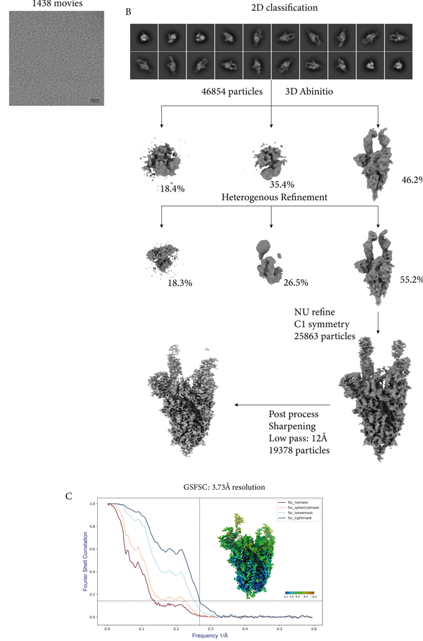

Figure S1. Cryo-EM workflow for the omicron BA.1 spike trimer complexed with K501SP3. Panel A shows a representative micrograph used for structure determination. Panel B shows flow of the data processing as described in the method section and Table S5. Finally, panel C shows the gold standard Fourier Shell Correlation (FSC) curve of omicron spike trimer with K501SP3 (3.73Å).

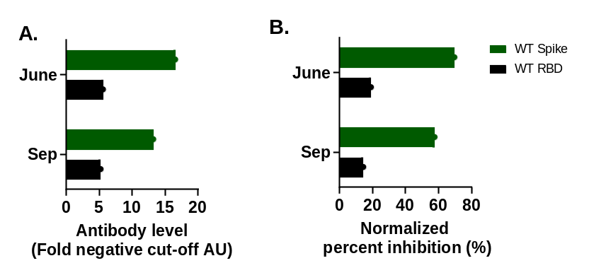
Figure S2. Binding and competition of plasma for SARS-CoV-2 spike. As previously described (28), spike-specific and RBD-specific IgG levels (WT Spike, green; WT RBD, black.) from plasma were measured at the June and September time points in subject K501 (A.). Inhibition activity of K501 plasma against SARS-CoV-2 Spike and VoC RBDs were also measured using an ACE2 inhibition assay (B.).
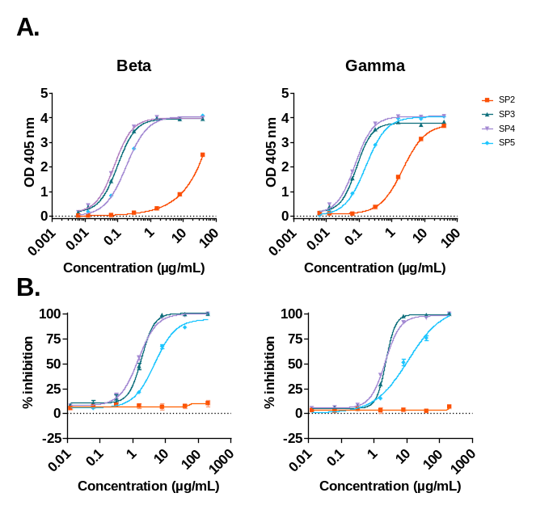
Figure S3. Cross reactive binding and inhibition of RBD-specific HmAbs to Beta and Gamma variants. HmAbs K501SP2 – K501SP5 (each represented by a different color as shown in the key) were tested for binding (A.) and competition with ACE2 (B.) against the RBD of two SARS-CoV-2 variants (Beta and Gamma). IC50’s were calculated and are shown in Figure 2. Throughout all graphs, data is represented as mean and SD for each experiment
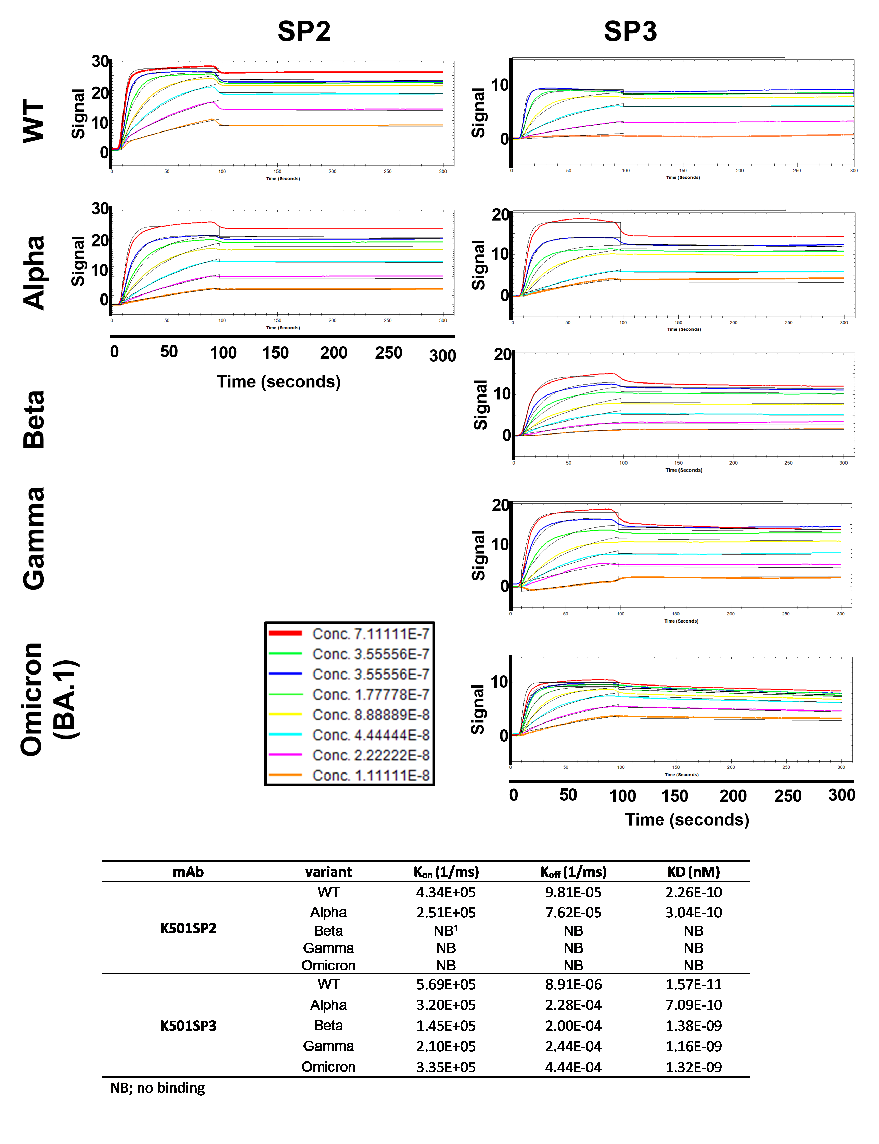
Figure S4. Binding affinities of HmAbs K501SP2 and K501SP3 to SARS-CoV-2 VoC RBDs. Binding affinities of HmAbs K501SP2 and K501SP3 to five VoC RBDs (WT, Alpha, Beta, Gamma, Omicron (BA.1)) by biosensor QCM Attana A200 instrument (Attana AB) is shown. HmAbs (25 μg/ml, diluted in 10mM Na-acetate pH 4.5) were immobilized on a LNB carboxyl chip and binding affinity of RBDs were tested using six serial, 2 fold dilution series of RBD antigens starting at 32 µg/ml. Data shown is reference-subtracted. Concentrations are represented by different colors as shown in the key. Curve fitting was performed using a 1:1 binding model using TraceDrawer software (Ridgeview Instruments AB) and Kon, Koff and KD values were determined with a global fit and are shown in Figure 2.

