Supporting information

Tables
Table S1 Three factors with three levels of the preparation parameters in the orthogonal design
Factors | Labels | Levels
Factors | Labels | 1 | 2 | 3
Molar ratio of Fe(II) to Mn(II) | A | 1 | 3 | 5
Mass ratio of PS to Fe-Mn hydroxide | B | 1 | 3 | 5
Molar ratio of OH⁻ to Fe(II) | C | 2 | 4 | 6

Table S2 Three factors with three levels of the preparation parameters in the orthogonal design
Factors | Labels | Levels
Factors | Labels | 1 | 2 | 3 | 4 | 5
Initial pH | D | 3 | 5 | 7 | 9 | 11
P-CP concentration (mM) | E | 2 | 4 | 6 | 8 | 10
Dosage (g/L) | F | 0.5 | 1.0 | 1.5 | 2.0 | 2.5
Temperature (°C) | G | 30 | 40 | 50 | 60 | 70

Table S3 Main effect of the preparation parameters on p-CP removal (default α = 0.05)
Source | SS (III) | df | MS | F | Sig.
Corrected model | 11.207ª | 6 | 1.868 | 17.104 | 0.056
Intercept | 128.142 | 1 | 128.142 | 1173.465 | 0.001
Molar ratio of Fe(II) to Mn(II) | 5.249 | 2 | 2.625 | 24.034 | 0.040
Mass ratio of PS to Fe-Mn hydroxide | 5.488 | 2 | 2.744 | 25.130 | 0.038
Molar ratio of OH⁻ to Fe(II) | 0.469 | 2 | 0.235 | 2.149 | 0.318
Error | 0.218 | 2 | 0.109
Total | 139.568 | 9
Corrected Total | 11.425 | 8
a: R² = 0.981

Table S4 Main effect of the aqueous conditions on p-CP removal (default α = 0.05)
Source | SS (III) | df | MS | F | Sig.
Corrected model | 89.877ª | 16 | 5.617 | 2.302 | 0.117
Intercept | 151.241 | 1 | 151.241 | 61.975 | 0.000
Initial pH | 9.857 | 4 | 2.464 | 1.010 | 0.457
P-CP concentration (mM) | 12.200 | 4 | 3.050 | 1.250 | 0.364
Dosage (g/L) | 3.972 | 4 | 0.993 | 0.407 | 0.799
Temperature (°C) | 63.848 | 4 | 15.962 | 6.541 | 0.012
Error | 19.523 | 8 | 2.440
Total | 260.641 | 25
Corrected Total | 109.400 | 24
a: R² = 0.822

Table S5 Parametrical statistics for the kinetics fitting
Parametrical types | Factors | Levels | Adj. R² | k
Preparation parameters | Molar ratio of Fe(II) to Mn(II) | 1 | 0.98233 | 0.00362
Preparation parameters | Molar ratio of Fe(II) to Mn(II) | 3 | 0.99249 | 0.00416
Preparation parameters | Molar ratio of Fe(II) to Mn(II) | 5 | 0.9615 | 0.00156
Preparation parameters | Mass ratio of PS to Fe-Mn hydroxide | 1 | 0.99607 | 0.00427
Preparation parameters | Mass ratio of PS to Fe-Mn hydroxide | 3 | 0.98563 | 0.00331
Preparation parameters | Mass ratio of PS to Fe-Mn hydroxide | 5 | 0.95593 | 0.0016
Preparation parameters | Molar ratio of OH⁻ to Fe(II) | 2 | 0.91481 | 0.00222
Preparation parameters | Molar ratio of OH⁻ to Fe(II) | 4 | 0.98805 | 0.00225
Preparation parameters | Molar ratio of OH⁻ to Fe(II) | 6 | 0.96711 | 0.00235
Aqueous conditions | Initial pH | 3 | 0.98392 | 0.00131
Aqueous conditions | Initial pH | 5 | 0.96461 | 0.00125
Aqueous conditions | Initial pH | 7 | 0.95974 | 0.00125
Aqueous conditions | Initial pH | 9 | 0.98518 | 0.00182
Aqueous conditions | Initial pH | 11 | 0.98342 | 0.00242
Aqueous conditions | p-CP concentration (mM) | 2 | 0.93691 | -0.00286
Aqueous conditions | p-CP concentration (mM) | 4 | 0.94707 | -0.00191
Aqueous conditions | p-CP concentration (mM) | 6 | 0.963 | -0.0014
Aqueous conditions | p-CP concentration (mM) | 8 | 0.98136 | -0.00148
Aqueous conditions | p-CP concentration (mM) | 10 | 0.99561 | -9.6454E-4
Aqueous conditions | PS-hydroxide dosage (g/L) | 0.5 | 0.98563 | -0.00129
Aqueous conditions | PS-hydroxide dosage (g/L) | 1.0 | 0.98145 | -0.0012
Aqueous conditions | PS-hydroxide dosage (g/L) | 1.5 | 0.96642 | -0.00192
Aqueous conditions | PS-hydroxide dosage (g/L) | 2.0 | 0.98533 | -0.00143
Aqueous conditions | PS-hydroxide dosage (g/L) | 2.5 | 0.98818 | -0.00169
Aqueous conditions | Temperature (°C) | 30 | 0.95173 | -2.67683E-4
Aqueous conditions | Temperature (°C) | 40 | 0.98018 | -4.47411E-4
Aqueous conditions | Temperature (°C) | 50 | 0.9747 | -0.00193
Aqueous conditions | Temperature (°C) | 60 | 0.96146 | -0.00383
Aqueous conditions | Temperature (°C) | 70 | 0.95447 | -0.00457

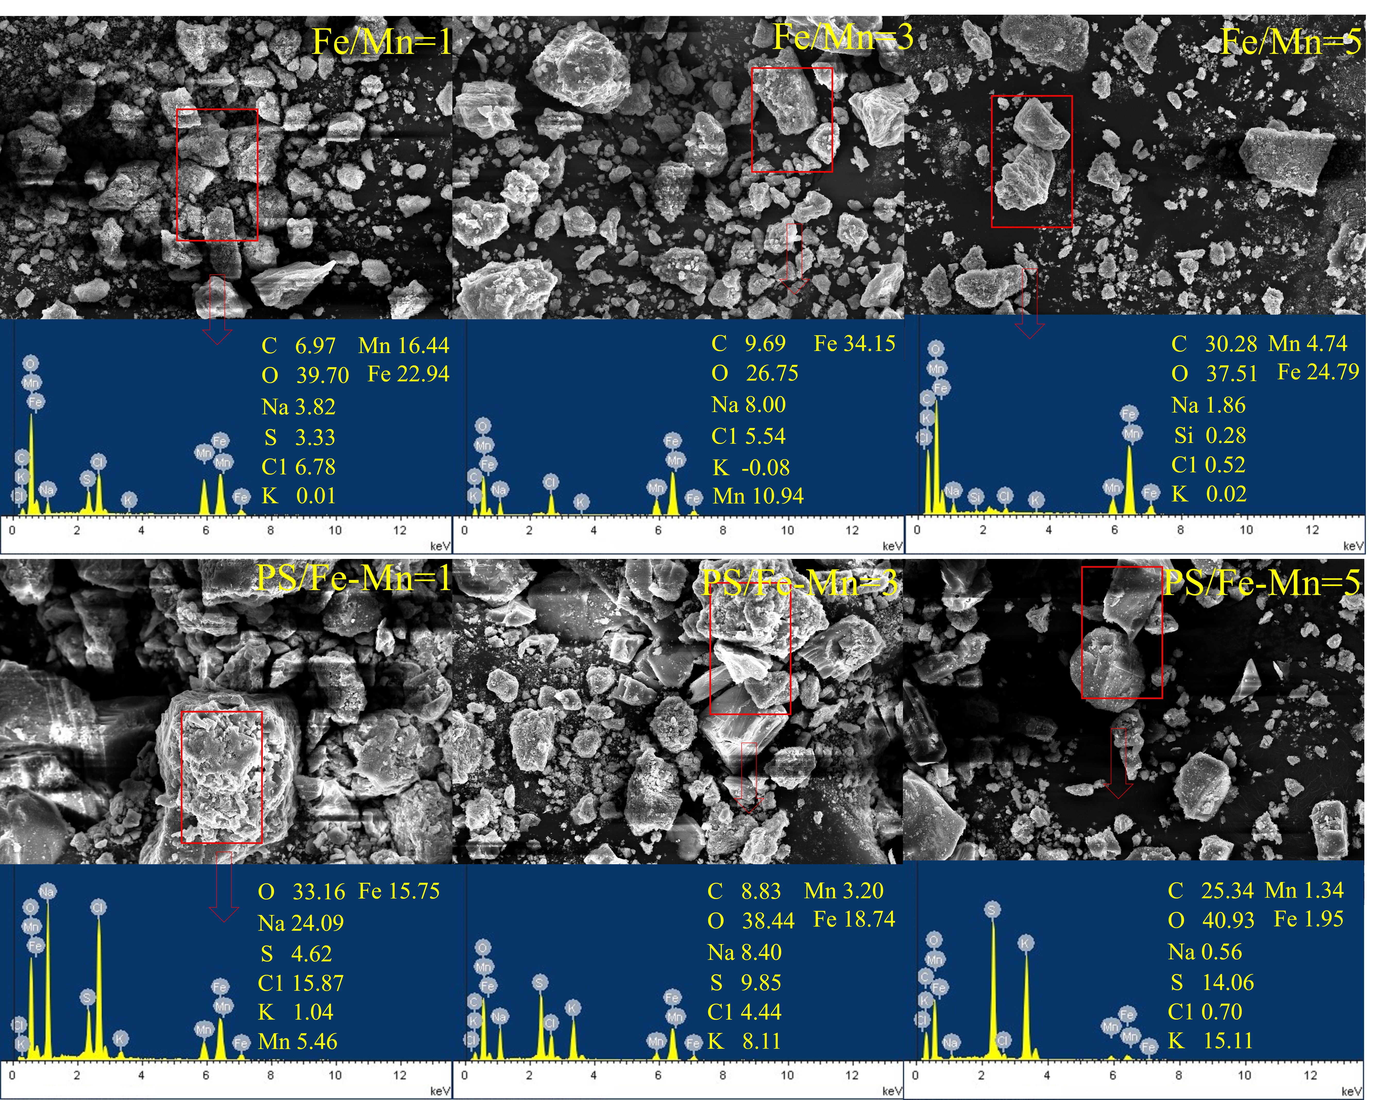
Fig. S1 EDS of Fe-Mn hydroxide affected by the molar ratios of Fe(II) to Mn(II) and the PS-hydroxide influenced by the mass ratios of PS to Fe-Mn hydroxide

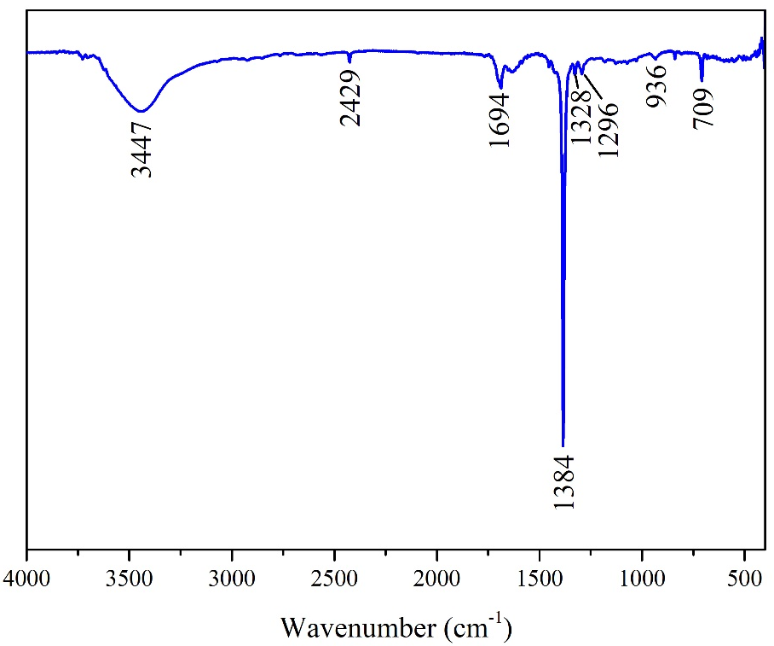
Fig. S2 FTIR spectrum of benzene

