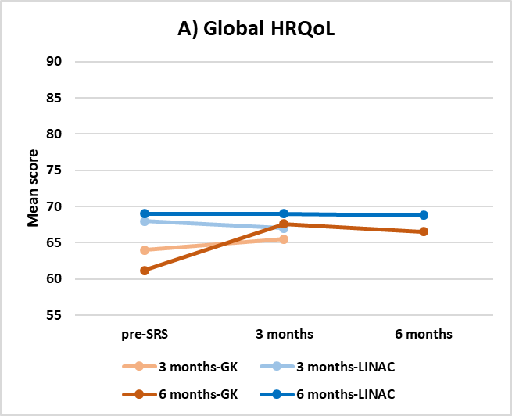

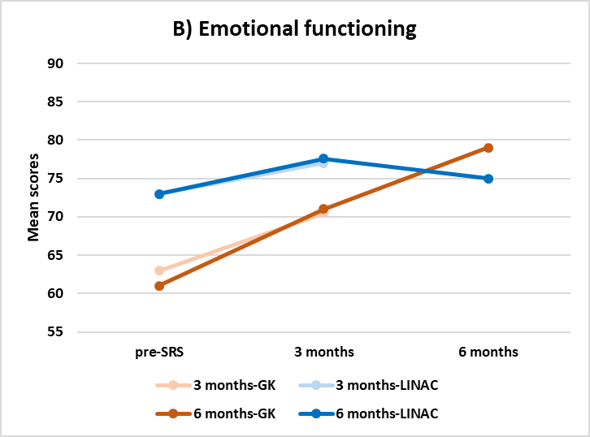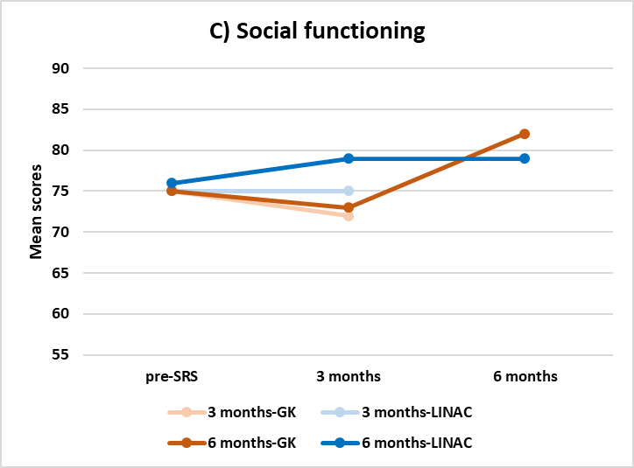
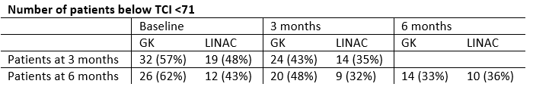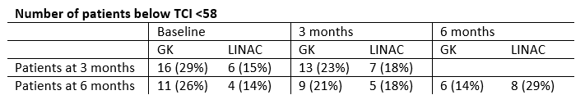
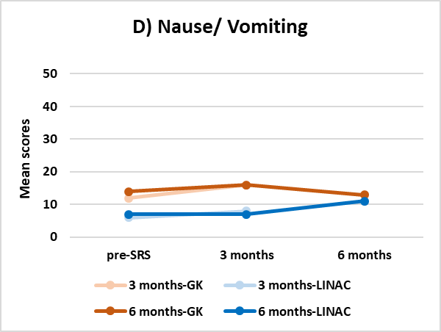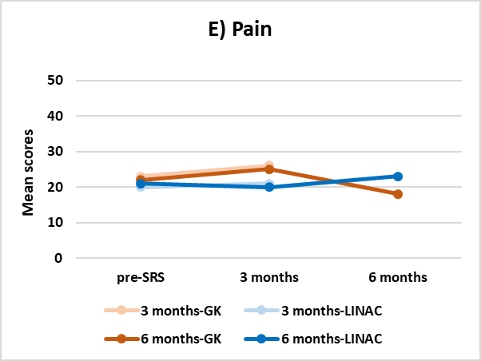
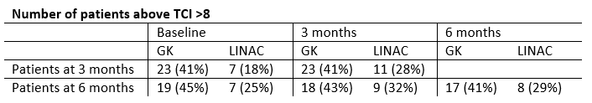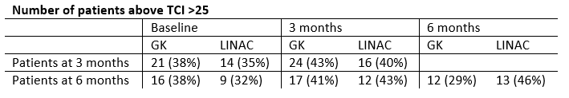

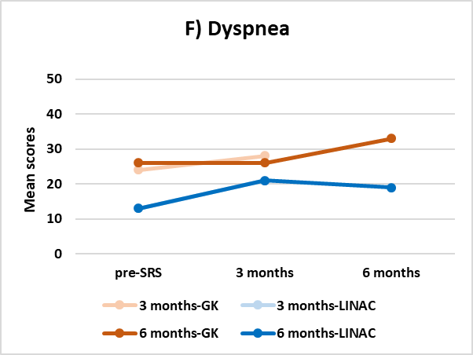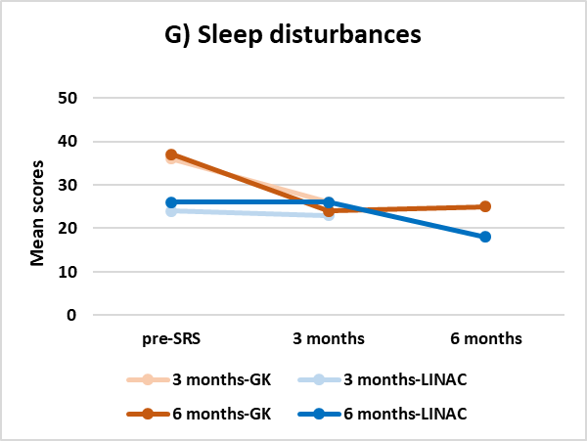
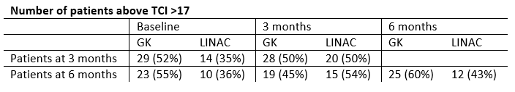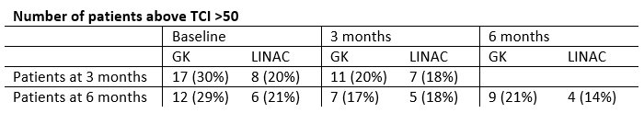

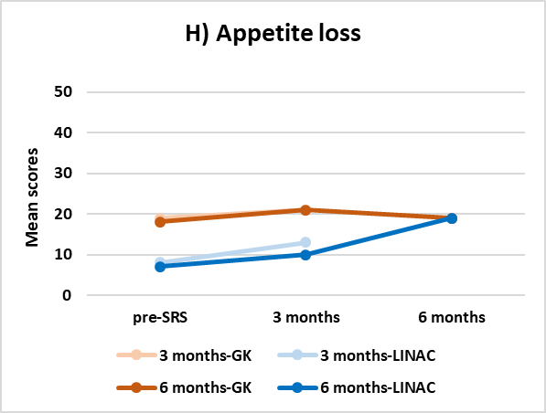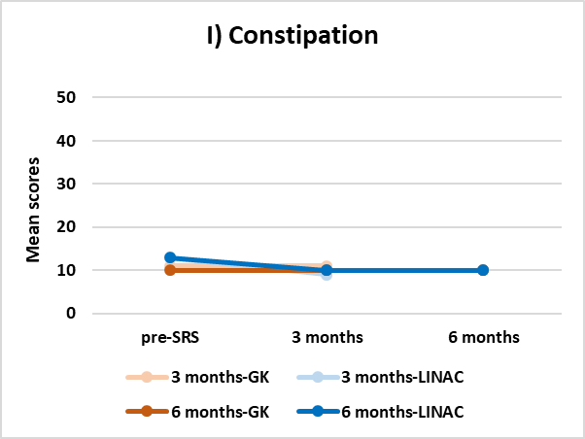
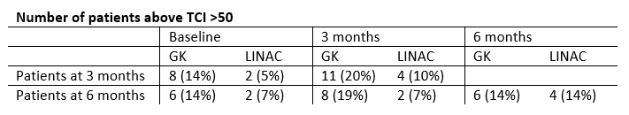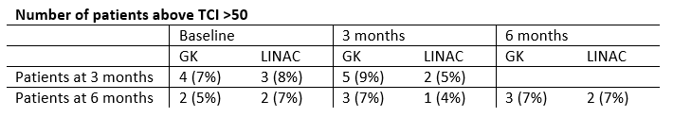

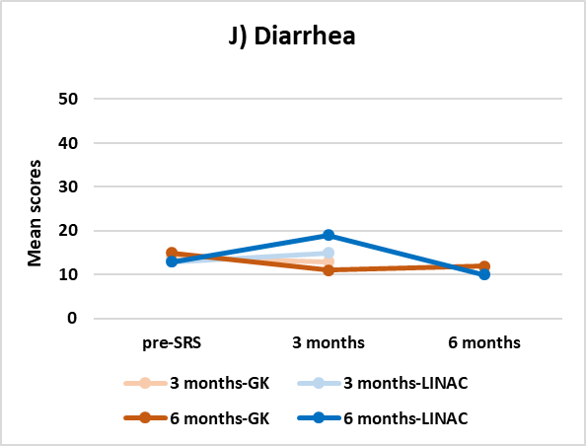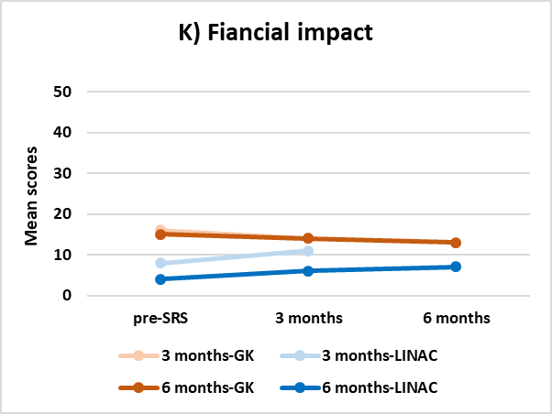
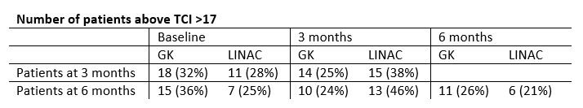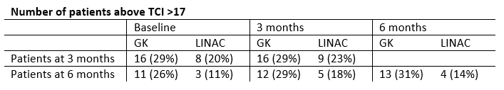

Supplementary Figure 1: Unadjusted mean functioning scores on the EORTC QLQ-C30 of patients present at 3 months and patients present at 3 and 6 months, among different time measurements. Note: Scores of functioning domains (A-C) range from 0 to 100. Higher scores reflect better perceived Health Related Quality of Life. Score of symptom domains (D-K) range from 0 to 100. Higher scores reflects poorer Health Related Quality of Life. Thresholds for clinical importance are defined by horizontal, dotted black lines. GK: Gamma Knife; LINAC: Linear accelerator; TCI: threshold clinical importance; pre-SRS: before treatment of the LINAC or the GK stereotactic radiosurgery.
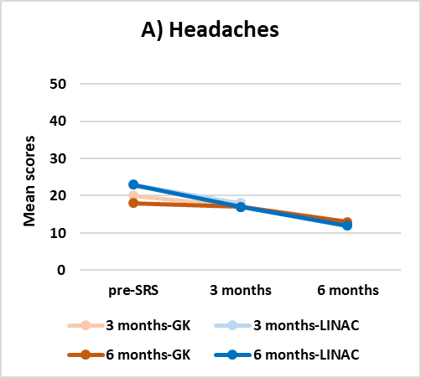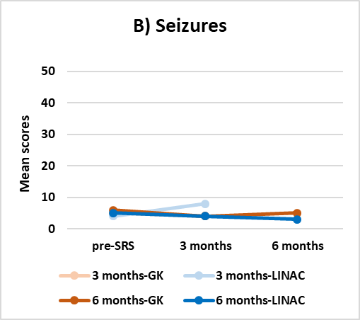

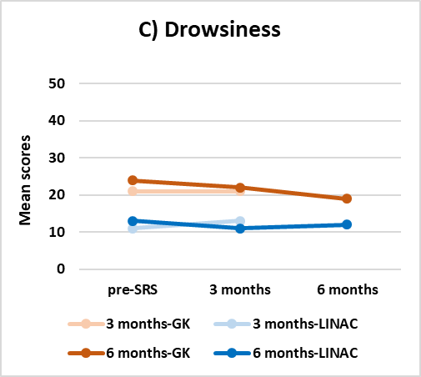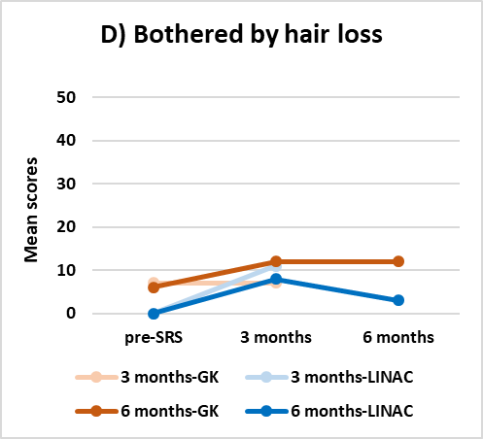

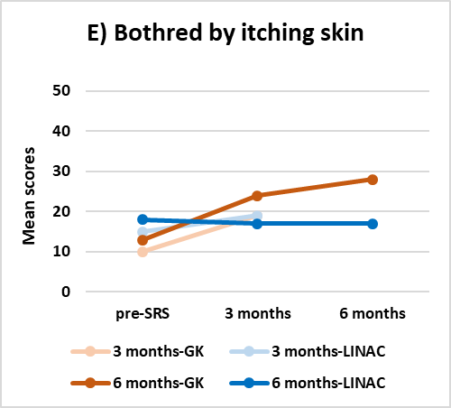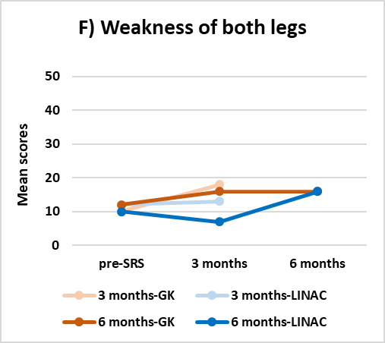

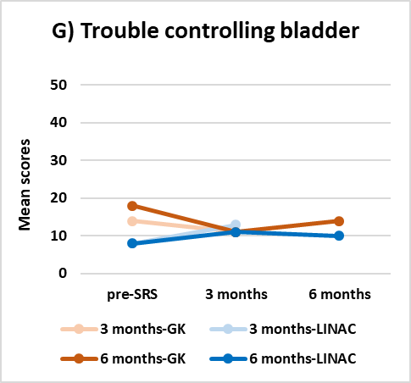
Supplementary Figure 2: Unadjusted mean functioning scores on the EORTC QLQ-BN20 of patients present at 3 months and patients present at 3 and 6 months, among different time measurements. Note: Score of symptom domain range from 0 to 100. Higher scores reflects poorer Health Related Quality of Life. GK: Gamma Knife; LINAC: Linear accelerator; TCI: threshold clinical importance; pre-SRS: before treatment of GK or LINAC stereotactic radiosurgery.

Supplementary Table 1: Mean scores EORTC QLQ-C30/BN20 of Pre-SRS group at baseline.
 | Pre-SRS  mean (SD) |  | TCI*
 | LINAC  N= 67 | GK  N= 111
Global health status ^{A} | 65.1 (20.6) | 62.2 (22.3) | N.A.
EORTC QLQ-C30 functioning domains
Physical functioning ^{A} | 78.8 (21.4) | 76.6 (21.8) | <83
Role functioning ^{A} | 67.2 (29.2) | 63.2 (33.4) | <58
Emotional functioning ^{A} | 71.9 (21.0) | 62.5 (27.9) | <71
Cognitive functioning ^{A} | 76.3 (22.8) | 72.6 (25.3) | <75
Social functioning ^{A} | 72.9 (22.7) | 70.9 (30.7) | <58
EORTC QLQ-C30 symptom domains
Fatigue ^{B} | 31.4 (24.8) | 44.7 (27.1) | >39
Nausea/ Vomiting ^{B} | 6.0 (15.5) | 10.9 (18.1) | >8
Pain ^{B} | 20.8 (25.5) | 26.4 (29.9) | >25
Dyspnea ^{B} | 21.2 (29.5) | 24.5 (27.3) | >17
Sleep disturbances ^{B} | 27.1 (34.1) | 37.9 (37.4) | >50
Appetite loss ^{B} | 10.1 (22.9) | 18.0 (30.9) | >50
Constipation ^{B} | 10.9 (20.6) | 13.0 (23.5) | >50
Diarrhea ^{B} | 11.5 (22.4) | 11.9 (22.0) | >17
Financial impact ^{B} | 12.0 (23.3) | 15.5 (28.1) | >17
EORTC QLQ-BN20 symptom domains
Motor dysfunction | 19.8 (19.3) | 20.5 (24.9) | N.A.
Future uncertainty | 39.1 (23.5) | 40.5 (24.9) | N.A.
Visual disorder | 12.3 (20.7) | 11.9 (16.7) | N.A.
Communication deficit | 12.8 (18.6) | 15.2 (21.8) | N.A.
EORTC QLQ-BN20 symptom items
Headaches | 19.3 (25.8) | 17.6 (24.2) | N.A.
Seizures | 5.4 (16.2) | 5.2 (18.7) | N.A.
Drowsiness | 14.1 (21.3) | 20.8 (24.8) | N.A.
Bothered by hair loss | 0.0 (0.0) | 7.3 (21.4) | N.A.
Bothered by itching skin | 14.1 (27.1) | 11.2 (21.3) | N.A.
Weakness of both legs | 14.1 (22.1) | 16.1 (27.7) | N.A.
Trouble controlling bladder | 9.4 (21.8) | 14.4 (24.2) | N.A.

Mean scores in red indicate scores under the TCI for functional domains or above the TCI for symptom domains. *Based on thresholds by Giesinger et al. (2020). Patients who score below the threshold for clinical importance for functioning domains or above the threshold for symptom domains indicate clinically important symptom or functional impairment. ^{A} Global health status or functional domain: scores from 0 to 100. Higher score reflect better perceived Health Related Quality of Life. ^{B} Symptom domain: scores from 0 to 100. Higher score scores reflects poorer Health Related Quality of Life.
N: number; GK: Gamma Knife; LINAC: Linear accelerator; pre-SRS: before treatment of the LNIAC or the GK stereotactic radiosurgery; SD: Standard Deviation; TCI: Threshold for clinical importance.

Supplementary table 2: Mean scores EORTC QLQ-C30/BN20 of group present at 3 months for each time measurement:
 | Pre-SRS  mean (SD) |  | 3 months  mean (SD) |  | TCI*
 | LINAC  N= 40 | GK  N= 56 | LINAC  N= 40 | GK  N= 56
Global health status ^{A} | 68.3 (20.4) | 63.7 (23.7) | 66.5 (21.0) | 66.2 (21.7) | N.A.
EORTC QLQ-C30 functioning domains
Physical functioning ^{A} | 84.7 (18.5) | 79.8 (20.4) | 81.1 (20.1) | 74.8 (22.5) | <83
Role functioning ^{A} | 73.3 (24.7) | 66.1 (33.3) | 69.6 (26.4) | 61.0 (35.4) | <58
Emotional functioning ^{A} | 72.5 (20.8) | 63.3 (27.8) | 76.7 (16.3) | 71.2 (25.7) | <71
Cognitive functioning ^{A} | 78.8 (21.0) | 73.8 (26.2) | 79.2 (18.0) | 73.8 (26.6) | <75
Social functioning ^{A} | 75.0 (19.6) | 74.7 (29.8) | 74.6 (23.0) | 72.3 (29.7) | <58
EORTC QLQ-C30 symptom domains
Fatigue ^{B} | 28.1 (25.5) | 40.5 (28.5) | 35.3 (26.0) | 39.1 (27.0) | >39
Nausea/ Vomiting ^{B} | 6.3 (18.0) | 12.2 (20.0) | 7.5 (14.6) | 15.8 (24.5) | >8
Pain ^{B} | 20.0 (24.8) | 22.6 (27.4) | 21.3 (24.0) | 25.9 (32.1) | >25
Dyspnea ^{B} | 12.5 (18.0) | 23.8 (26.7) | 20.8 (25.8) | 28.0 (33.5) | >17
Sleep disturbances ^{B} | 24.2 (30.2) | 35.7 (37.5) | 23.1 (27.7) | 26.2 (32.2) | >50
Appetite loss ^{B} | 8.3 (21.0) | 18.5 (30.4) | 12.5 (22.2) | 20.8 (32.2) | >50
Constipation ^{B} | 12.5 (20.9) | 10.7 (23.9) | 9.2 (18.5) | 10.7 (24.7) | >50
Diarrhea ^{B} | 12.5 (23.5) | 14.3 (24.5) | 15.4 (22.7) | 13.1 (26.7) | >17
Financial impact ^{B} | 8.3 (18.1) | 16.1 (29.1) | 10.8 (23.1) | 13.7 (24.4) | >17
EORTC QLQ-BN20 symptom domains
Motor dysfunction | 16.4 (17.6) | 12.3 (17.8) | 12.8 (19.9) | 11.5 (16.4) | N.A.
Future uncertainty | 36.0 (22.2) | 40.0 (24.2) | 32.2 (21.0) | 30.8 (22.6) | N.A.
Visual disorder | 10.8 (21.9) | 9.5 (13.1) | 5.3 (12.8) | 7.9 (15.7) | N.A.
Communication deficit | 10.3 (15.8) | 13.3 (19.2) | 9.7 (15.1) | 10.7 (15.3) | N.A.
EORTC QLQ-BN20 symptom items
Headaches | 23.3 (28.4) | 19.6 (27.5) | 18.3 (23.8) | 16.7 (26.2) | N.A.
Seizures | 4.3 (13.6) | 4.8 (19.5) | 8.3 (22.3) | 3.6 (15.1) | N.A.
Drowsiness | 10.8 (21.9) | 20.8 (25.9) | 12.5 (18.0) | 20.8 (26.7) | N.A.
Bothered by hair loss | 0.0 (0.0) | 6.5 (21.5) | 10.8 (17.5) | 13.7 (23.6) | N.A.
Bothered by itching skin | 15.0 (27.2) | 9.5 (17.6) | 19.2 (26.0) | 19.0 (26.1) | N.A.
Weakness of both legs | 11.7 (20.7) | 10.1 (20.0) | 12.5 (20.9) | 17.9 (25.4) | N.A.
Trouble controlling bladder | 8.3 (16.5) | 14.3 (22.8) | 13.3 (23.6) | 10.7 (21.2) | N.A.

Mean scores in red indicate scores under the TCI for functional domains or above the TCI for symptom domains. *Based on thresholds by Giesinger et al. (2020). Patients who score below the threshold for clinical importance for functioning domains or above the threshold for symptom domains indicate clinically important symptom or functional impairment. ** Range of patients that completed the EORTC QLQ-C30 questionnaire. Differences in number of patients that completed each functional and/or symptom domain due to missing values. ^{A} Global health status or functional domain: scores from 0 to 100. Higher scores reflect better perceived Health Related Quality of Life. ^{B} Symptom domain: scores from 0 to 100. Higher score scores reflects poorer Health Related Quality of Life.
N: number; GK: Gamma Knife; LINAC: Linear accelerator; pre-SRS: before treatment of the LINAC or the GK stereotactic radiosurgery; SD: Standard Deviation; TCI: Threshold for clinical importance.

Supplementary table 3: Mean scores EORTC QLQ-C30/-BN20 of group present at 3 and 6 months for each time measurement:
 | Pre-SRS baseline, mean (SD) |  | 3 months, mean (SD) |  | 6 months, mean (SD)
 | LINAC  N= 28 | GK  N= 42 | LINAC  N= 28 | GK  N= 41-42** | LINAC  N= 28 | GK  N= 42 | TCI*
Global health status ^{A} | 69.3 (21.5) | 60.7 (23.6) | 69.3 (20.4) | 67.7 (21.9) | 68.5 (23.7) | 66.7 (24.6) | N.A.
EORTC QLQ-C30 functioning domains
Physical functioning ^{A} | 84.0 (20.2) | 78.2 (22.2) | 87.4 (13.9) | 76.9 (22.6) | 84.3 (17.0) | 75.7 (24.1) | <83
Role functioning ^{A} | 71.4 (25.6) | 65.1 (36.2) | 72.6 (26.5) | 63.1 (36.0) | 72.6 (24.1) | 68.3 (32.5) | <58
Emotional functioning ^{A} | 73.2 (21.4) | 61.2 (28.7) | 78.3 (14.4) | 71.0 (25.6) | 74.9 (17.6) | 78.5 (21.3) | <71
Cognitive functioning ^{A} | 80.4 (22.2) | 71.4 (29.1) | 81.0 (16.2) | 73.8 (28.1) | 74.4 (25.8) | 77.4 (22.3) | <75
Social functioning ^{A} | 75.6 (20.5) | 74.6 (31.1) | 78.6 (21.7) | 73.0 (31.2) | 79.2 (23.0) | 82.1 (22.8) | <58
EORTC QLQ-C30 symptom domains
Fatigue ^{B} | 28.2 (26.8) | 41.8 (30.4) | 31.0 (21.9) | 38.9 (28.2) | 36.5 (24.4) | 36.2 (29.0) | >39
Nausea/ Vomiting ^{B} | 7.1 (20.5) | 13.5 (21.5) | 7.1 (12.4) | 16.3 (25.4) | 10.5 (18.6) | 13.1 (21.3) | >8
Pain ^{B} | 20.8 (26.7) | 21.8 (26.2) | 20.2 (19.4) | 25.0 (32.8) | 22.6 (25.7) | 17.9 (28.4) | >25
Dyspnea ^{B} | 13.1 (18.9) | 26.2 (28.1) | 21.4 (24.4) | 26.1 (33.4) | 19.0 (26.3) | 32.5 (33.3) | >17
Sleep disturbances ^{B} | 26.2 (29.2) | 36.5 (37.4) | 25.9 (28.2) | 23.8 (32.3) | 17.9 (30.7) | 25.4 (30.2) | >50
Appetite loss ^{B} | 7.1 (22.9) | 17.5 (28.7) | 9.5 (20.0) | 20.6 (32.1) | 18.5 (31.1) | 19.0 (32.2) | >50
Constipation ^{B} | 13.1 (21.0) | 9.5 (21.2) | 9.5 (17.8) | 9.5 (24.7) | 9.9 (20.3) | 10.3 (25.0) | >50
Diarrhea ^{B} | 13.1 (26.2) | 15.1 (23.5) | 18.5 (23.3) | 11.1 (22.9) | 9.9 (20.3) | 11.9 (23.1) | >17
Financial impact ^{B} | 3.6 (10.5) | 15.1 (29.6) | 5.9 (13.0) | 13.5 (24.4) | 7.1 (21.0) | 12.7 (20.8) | >17
EORTC QLQ-BN20 symptom domains
Motor dysfunction | 13.1 (17.4) | 14.0 (19.6) | 8.7 (14.6) | 10.1 (16.4) | 15.9 (19.7) | 9.7 (15.0) | N.A.
Future uncertainty | 35.9 (22.0) | 40.9 (25.5) | 29.4 (16.9) | 30.2 (23.6) | 31.3 (19.0) | 28.4 (23.3) | N.A.
Visual disorder | 9.9 (24.8) | 10.6 (13.2) | 5.6 (14.0) | 7.9 (16.5) | 13.1 (20.3) | 12.4 (17.4) | N.A.
Communication deficit | 7.1 (15.5) | 14.6 (20.9) | 7.9 (12.8) | 10.3 (15.4) | 8.3 (14.7) | 11.4 (16.0) | N.A.
EORTC QLQ-BN20 symptom items
Headaches | 22.6 (28.8) | 17.5 (25.6) | 16.7 (21.3) | 16.7 (26.8) | 11.9 (22.6) | 12.7 (23.2) | N.A.
Seizures | 4.8 (14.9) | 6.3 (22.4) | 3.6 (10.5) | 4.0 (16.8) | 2.5 (12.8) | 4.8 (17.4) | N.A.
Drowsiness | 13.1 (24.6) | 23.8 (27.8) | 10.7 (15.9) | 22.2 (27.2) | 11.9 (20.7) | 19.0 (26.7) | N.A.
Bothered by hair loss | 0.0 (0.0) | 6.3 (22.4) | 8.3 (17.3) | 11.9 (19.2) | 2.4 (8.7) | 11.9 (25.3) | N.A.
Bothered by itching skin | 17.9 (30.7) | 12.7 (19.4) | 16.7 (26.4) | 23.8 (27.8) | 16.7 (29.4) | 27.8 (29.4) | N.A.
Weakness of both legs | 9.5 (20.0) | 11.9 (21.7) | 7.1 (13.9) | 15.9 (24.7) | 15.5 (27.9) | 15.9 (23.6) | N.A.
Trouble controlling bladder | 8.3 (17.3) | 17.5 (23.6) | 10.7 (22.3) | 11.1 (21.7) | 9.5 (23.8) | 13.5 (25.6) | N.A.

Mean scores in red indicate scores under the TCI for functional domains or above the TCI for symptom domains. *Based on thresholds by Giesinger et al. (2020). Patients who score below the threshold for clinical importance for functioning domains or above the threshold for symptom domains indicate clinically important symptom or functional impairment.** Range of patients that completed the EORTC QLQ-C30 questionnaire. Differences in number of patients that completed each functional and/or symptom domain due to missing values. ^{A} Global health status or functional domain: scores from 0 to 100. Higher scores reflect better perceived Health Related Quality of Life. ^{B} Symptom domain: scores from 0 to 100. Higher score scores reflects poorer Health Related Quality of Life.
N: number; GK: Gamma Knife; LINAC: Linear accelerator; pre-SRS: before treatment of the LINAC or the GK stereotactic radiosurgery; SD: Standard Deviation; TCI: Threshold for clinical importance.

