Supplementary Information
The influence of phosphorus availability on rice root traits driving iron plaque formation and dissolution, and implications for phosphorus uptake
Plant and Soils
Authors: Martinengo Sara, Santoro Veronica, Schiavon Michela, Celi Luisella, Martin Maria, Said-Pullicino Daniel
Affiliation: Department of Agricultural, Forest and Food Sciences, University of Torino, Grugliasco, Italy.
Correspondence to: sara.martinengo@unito.it
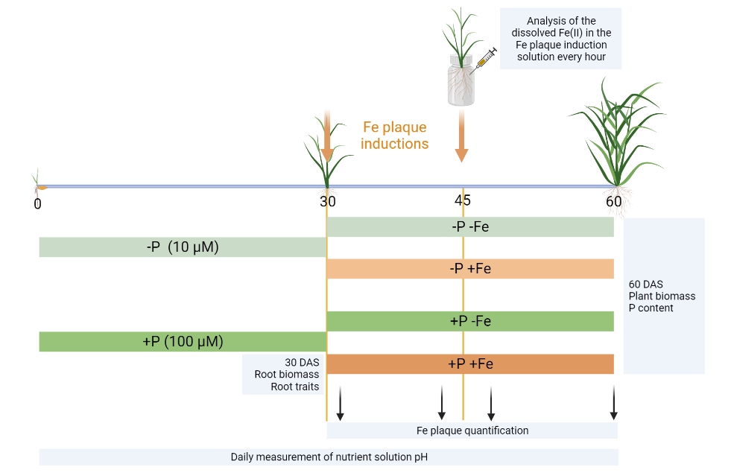
Figure S1 Graphical summary of the experimental set-up and of the conducted measurements on plants and nutrient solution. Figure created with BioRender.com

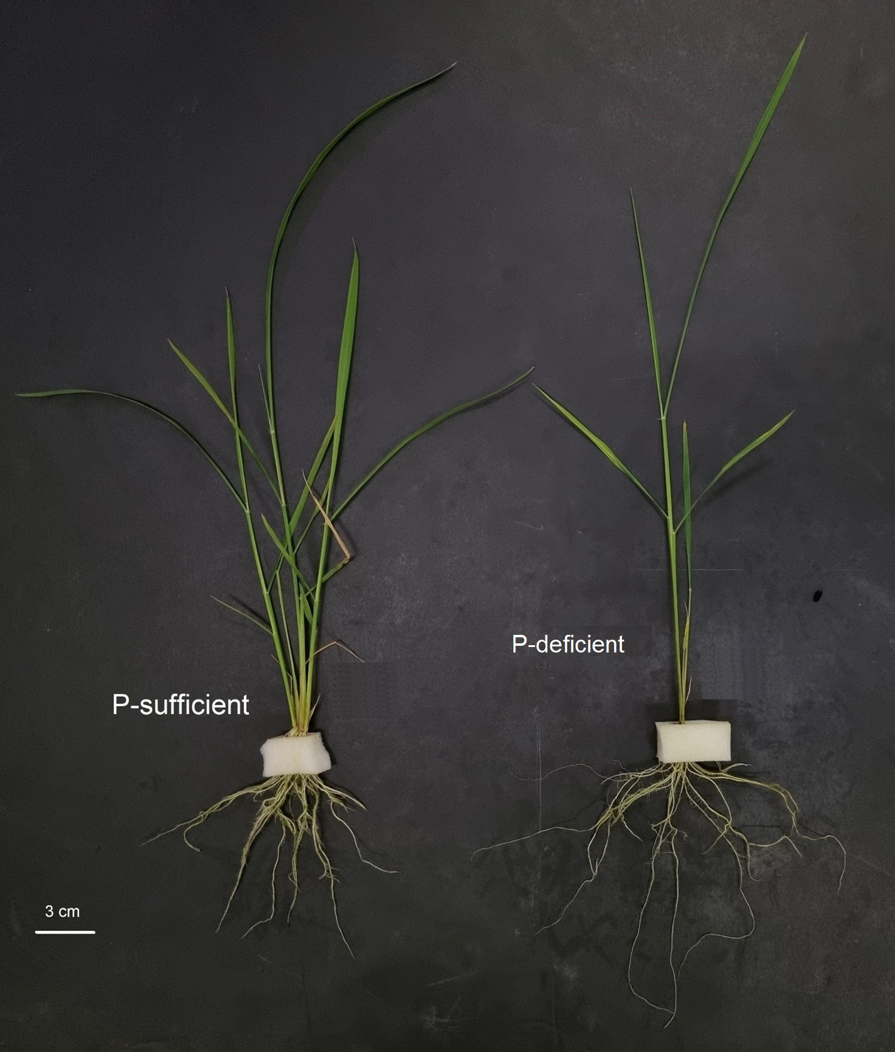
Figure S2 Photograph of the rice plants at 30 days after seeding (DAS) grown in P-deficient (10 μM) and P-sufficient (100 μM) nutrient solution

