Supplementary Materials for

The Hippo-YAP signaling pathway drives CD24-mediated immune evasion in esophageal squamous cell carcinoma via macrophage phagocytosis

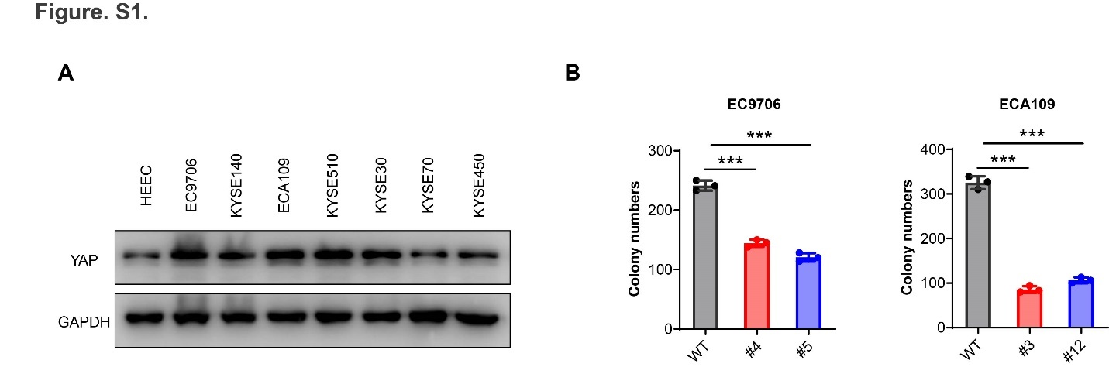

Figure. S1.

Expression of YAP in different esophageal cancer cell lines compared with an immortalized esophageal epithelial cell line (HEEC)
- Western blot analysis of YAP expression in ESCC cell lines and one immortalized esophagus cell line (HEEC).
- Statistical analysis of the results from the colony formation assay.

Figure. S2.

CD24 expression is regulated by Hippo signaling pathway
(A) The expression level of CD24 was significantly down-regulated after silencing TEAD1.
(B) The CD24 promoter activity was significantly down-regulated after silencing TEAD1.
(C) High cell density inhibited CD24 expression in different human esophageal squamous cells.
(D) qRT-PCR analysis of CD24 mRNA levels in ESCC cells treated with DMSO or VP (2.5 mM) for 24 hours.
(E-F) High-cell density inhibited nuclear localization of YAP and reduced the level of membrane CD24 expression, scale bars, 100 μm.

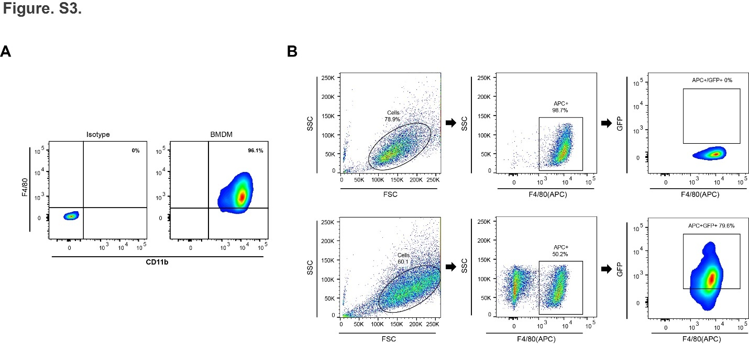

Figure. S3.

Gating strategy for phagocytosis assay
- Mature BMDMs were defined as CD11b + F4/80 + subpopulations.
- Schematic view of the gating strategy used for a flow cytometry-based phagocytosis assay analysis.

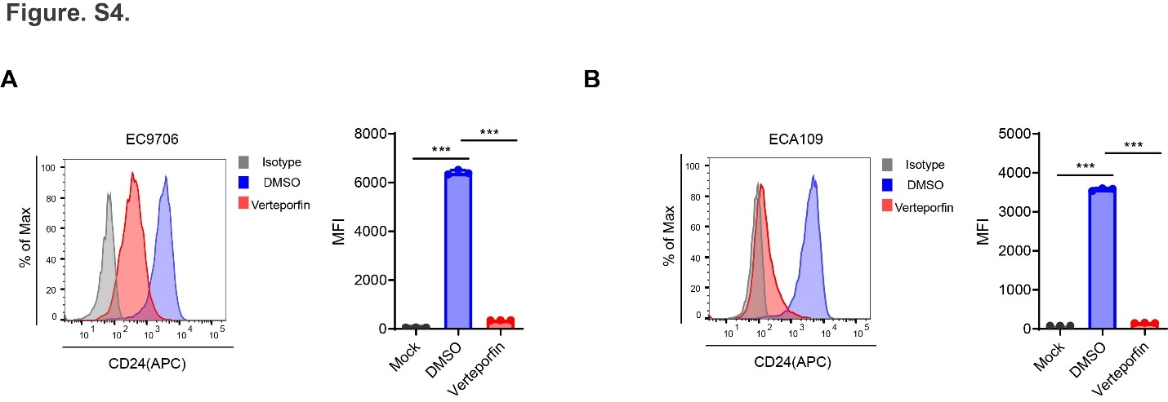
Figure. S4.

VP treatment inhibited membrane CD24 expression in ESCC
(A-B) Flow cytometry results showed that the CD24 membrane expression in EC9706 (A) and ECA109 (B) decreased after VP treatment.

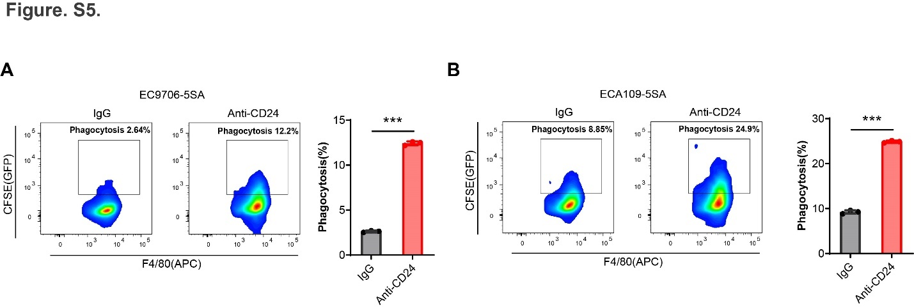
Figure. S5.

CD24 blockade promotes macrophage-mediated phagocytosis of YAP-activated ESCC cells
(A-B) Blockade of CD24 by using anti-CD24 monoclonal antibodies increased macrophage-mediated phagocytosis in YAP-activated ESCC cells.

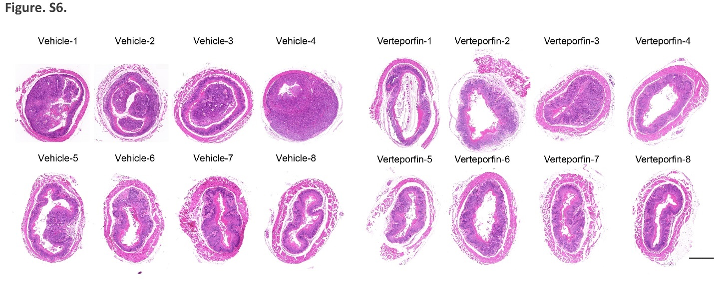
Figure. S6.

Pathological features of both the control and verteporfin–treated mice after administration of eight doses of VP. Scale bars, 500μm

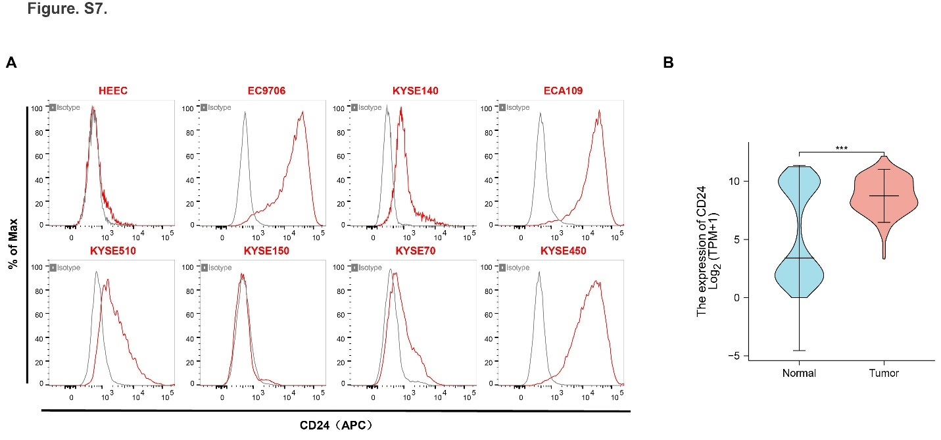
Figure. S7.

CD24 is highly expressed in ESCC samples and cell lines
(A) The expression level of CD24 is increased in ESCC cell lines compared to that of normal esophageal epithelial cell lines (HEEC).
(B) The data of TCGA showed a high expression of CD24 in esophageal cancer.

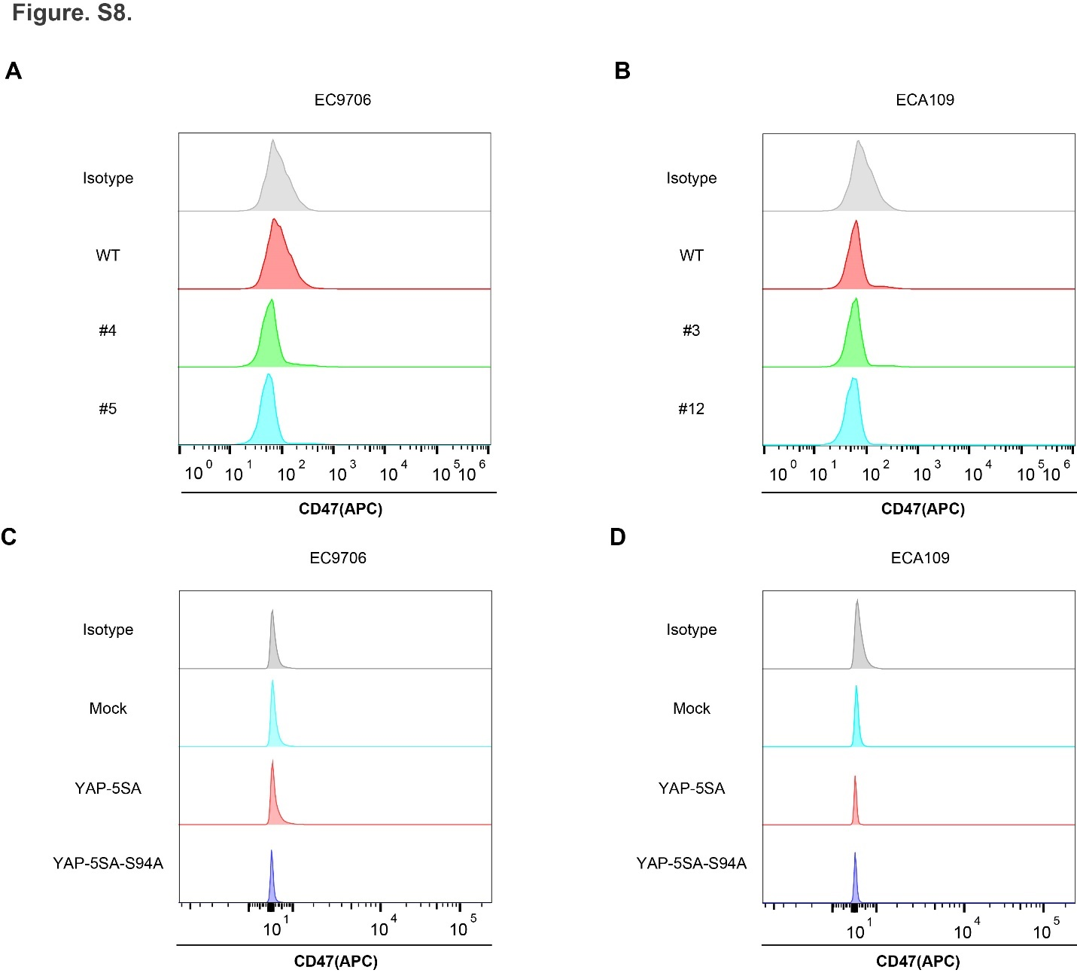

Figure. S8.

CD47 expression was not associated with YAP depletion or activation
(A-B) YAP knockout does not affect the expression of CD47 in ESCC cells.
(C-D) YAP activation does not affect the expression of CD47 in ESCC cells.

Supplementary Table1

Sequences of the siRNA
Name | species | Forward (5' -> 3') | Reverse (5' -> 3')
siTEAD1-1 | human | GUGUGUUUGAAGUUUCAAATT | UUUGAAACUUCAAACACACTT
siTEAD1-2 | human | CGAUUUGUAUACCGAAUAATT | UUAUUCGGUAUACAAAUCGTT
si-NC | human | UUCUCCGAACGUGUCACGUTT | ACGUGACACGUUCGGAGAATT

Supplementary Table2

Clinicopathological correlation of YAP and CD24 expression in ESCC
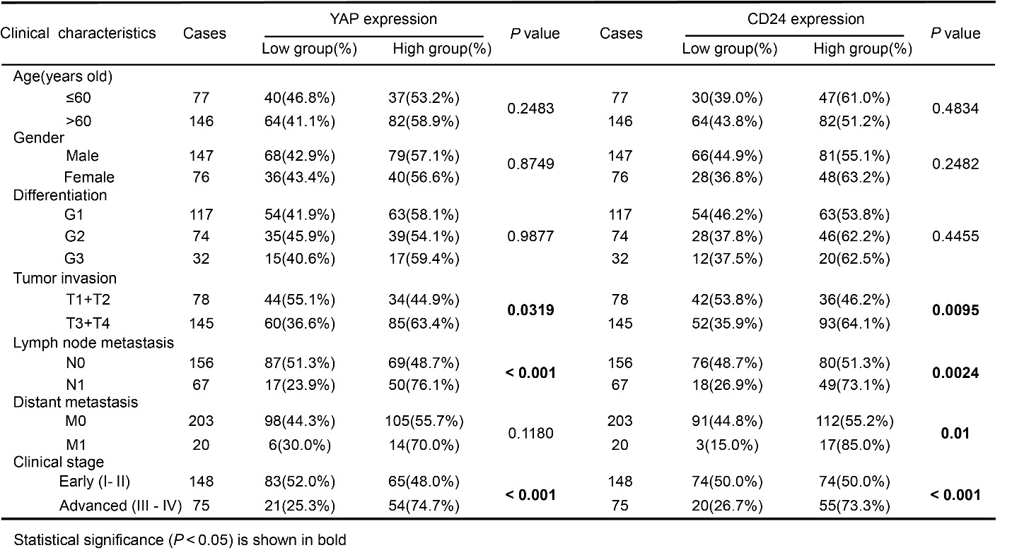

Supplementary Table3

Clinicopathological correlation of CD68 expression in ESCC

Supplementary Table4

The guide RNA sequence and screening primers
Oligos | Forward (5' -> 3') | Reverse (5' -> 3')
pX460-YAP-KO-1 | CACCGTAATAGGCCAGTACTGATGC | AAACGCATCAGTACTGGCCTATTAC
pX461-YAP-KO-2 | CACCGACCCCCACTGGAGTAGTCTC | AAACGAGACTACTCCAGTGGGGGTC
pX460-YAP-KO-3 | CACCGTGTACCTCTGCCAGCAGGTT | AAACAACCTGCTGGCAGAGGTACAC
screening primers | GCAATTAAGCGCTGACTGGG | GGCTCAGAACCAAGACTCAGTAA

Supplementary Table5

Primer sequences for Real-time PCR
Gene | species | Forward (5' -> 3') | Reverse (5' -> 3')
YAP | human | TCCACCAGTGCAGCAGAATA | TTGGGTCTAGCCAAGAGGTG
TEAD1 | human | AACTCAGGACAGGCAAGACG | AGCTTGGAATGAAAATCACGA
CTGF | human | GCACAAGGGCCTATTCTGTC | ACGTGCACTGGTACTTGCAG
CD24 | human | CTGCTGGCACTGCTCCTAC | ACCACGAAGAGACTGGCTGT
GAPDH | human | CGAGATCCCTCCAAAATCAA | TTCACACCCATGACGAACAT

Supplementary Table6

Primer sequences for ChIP-qPCR
Oligos | Forward (5' -> 3') | Reverse (5' -> 3')
CD24-site1 | TCTCGAACGGTTCTGCTCTT | GGCGGTCCCACTACAATTCA
CD24-site2 | AAGCAGCTTGTGGAGGACA | GCCCAGCTTCTCCATTCCTT

Supplementary Table7

Clinical characteristics of 223 human ESCC tissue samples
No. | Age | Sex | Pathology diagnosis | Clinical stages | Grade | TNM | Date of death
201401772 | 66 | M | ESCC | Ⅲ | G1 | T3N1M0 | 2016/4/17
201402586 | 60 | F | ESCC | Ⅲ | G2 | T3N2M0 | 2016/11/11
201402742 | 57 | M | ESCC | Ⅱ | G1 | T2N0M0 | survival
201402843 | 68 | F | ESCC | Ⅲ | G1 | T3N1M0 | 2015/1/10
201403038 | 57 | M | ESCC | Ⅱ | G2 | T2N0M0 | survival
201403091 | 57 | F | ESCC | Ⅲ | G1 | T3N1M0 | 2014/12/21
201403147 | 64 | F | ESCC | Ⅰ | G1 | T1BN0M0 | survival
201403182 | 70 | M | ESCC | Ⅱ | G1 | T2N0M0 | survival
201403183 | 67 | F | ESCC | Ⅳ-B | G2 | T2N1M1 | 2014/7/18
201403235 | 52 | M | ESCC | Ⅳ-A | G1 | T3N3M0 | 2018/4/24
201403365 | 40 | F | ESCC | Ⅳ-B | G3 | T3N1M1 | 2015/5/27
201403368 | 56 | F | ESCC | Ⅳ-B | G1 | T3N1M1 | 2015/2/27
201403464 | 68 | M | ESCC | Ⅰ | G3 | T1BN0M0 | survival
201403512 | 61 | F | ESCC | Ⅱ | G1 | T2N0M0 | 2018/11/1
201403592 | 74 | F | ESCC | Ⅱ | G2 | T2N0M0 | 2015/8/1
201403902 | 65 | M | ESCC | Ⅰ | G1 | T1BN0M0 | survival
201403906 | 61 | M | ESCC | Ⅳ-A | G1 | T4AN0M0 | survival
201404002 | 51 | F | ESCC | Ⅱ | G2 | T3N0M0 | survival
201404060 | 71 | M | ESCC | Ⅲ | G1 | T3N1M0 | 2019/1/11
201404106 | 54 | F | ESCC | Ⅳ-A | G1 | T4AN0M0 | survival
201404193 | 63 | M | ESCC | Ⅰ | G1 | T1BN0M0 | survival
201404297 | 74 | F | ESCC | Ⅳ-B | G3 | T4AN2M1 | 2017/3/21
201404298 | 66 | M | ESCC | Ⅱ | G3 | T2N0M0 | survival
201404364 | 66 | M | ESCC | Ⅳ-A | G1 | T4AN0M0 | 2016/8/15
201404391 | 67 | M | ESCC | Ⅱ | G1 | T2N0M0 | survival
201404500 | 57 | M | ESCC | Ⅱ | G1 | T3N0M0 | survival
201404501 | 71 | F | ESCC | Ⅰ | G2 | T1BN0M0 | survival
201404523 | 67 | M | ESCC | Ⅱ | G1 | T3N0M0 | 2018/11/28
201404658 | 66 | M | ESCC | Ⅱ | G2 | T3N0M0 | 2015/9/18
201404721 | 59 | M | ESCC | Ⅱ | G2 | T2N0M0 | 2015/4/30
201405057 | 67 | F | ESCC | Ⅰ | G2 | T1BN0M0 | survival
201405214 | 60 | M | ESCC | Ⅱ | G3 | T2N0M0 | 2015/4/9
201405296 | 77 | M | ESCC | Ⅱ | G2 | T3N0M0 | 2014/8/14
201405532 | 70 | M | ESCC | Ⅱ | G2 | T3N0M0 | survival
201406128 | 44 | M | ESCC | Ⅳ-B | G2 | T3N0M1 | 2016/4/6
201406276 | 54 | F | ESCC | Ⅱ | G2 | T3N0M0 | 2014/8/6
201406329 | 61 | M | ESCC | Ⅱ | G1 | T2N0M0 | 2016/5/11
201406373 | 52 | M | ESCC | Ⅳ-B | G1 | T3N0M1 | 2015/10/13
201406924 | 63 | F | ESCC | Ⅰ | G1 | T1BN0M0 | survival
201407091 | 69 | M | ESCC | Ⅱ | G2 | T3N0M0 | survival
201407338 | 57 | M | ESCC | Ⅱ | G1 | T3N0M0 | survival
201407489 | 61 | M | ESCC | Ⅳ-B | G3 | T3N0M1 | 2015/1/9
201407683 | 56 | M | ESCC | Ⅳ-A | G1 | T4AN0M0 | 2014/9/14
201407707 | 62 | M | ESCC | Ⅱ | G1 | T2N0M0 | survival
201407800 | 74 | F | ESCC | Ⅱ | G1 | T2N0M0 | survival
201407825 | 59 | F | ESCC | Ⅳ-B | G1 | T2N0M1 | 2016/7/24
201407825 | 72 | M | ESCC | Ⅱ | G3 | T3N0M0 | survival
201407958 | 56 | F | ESCC | Ⅱ | G2 | T2N1M0 | 2017/4/18
201408091 | 58 | M | ESCC | Ⅱ | G2 | T2NIM0 | survival
201408284 | 62 | M | ESCC | Ⅳ-B | G2 | T4BN1M1 | 2017/2/29
201408343 | 59 | M | ESCC | Ⅳ-A | G1 | T4AN1M0 | survival
201408344 | 64 | F | ESCC | Ⅱ | G1 | T2N0M0 | survival
201408399 | 58 | F | ESCC | Ⅱ | G1 | T3N0M0 | survival
201408519 | 78 | M | ESCC | Ⅱ | G2 | T2N1M0 | survival
201408941 | 60 | F | ESCC | Ⅰ | G2 | T2N0M0 | survival
201408966 | 73 | M | ESCC | Ⅲ | G2 | T3N1M0 | 2015/6/14
201408998 | 71 | M | ESCC | Ⅳ-A | G1 | T4AN0M0 | survival
201409211 | 59 | F | ESCC | Ⅳ-B | G3 | T1BN0M1 | 2015/2/8
201409248 | 58 | F | ESCC | Ⅱ | G2 | T2N0M0 | 2017/3/20
201409280 | 67 | M | ESCC | Ⅱ | G3 | T3N0M0 | 2018/11/21
201409536 | 61 | F | ESCC | Ⅱ | G1 | T3N0M0 | survival
201409570 | 59 | M | ESCC | Ⅰ | G2 | T1BN0M0 | survival
201409637 | 72 | F | ESCC | Ⅱ | G2 | T2N0M0 | 2015/3/26
201409930 | 67 | M | ESCC | Ⅳ-B | G1 | T3N1M1 | 2015/6/10
201410018 | 75 | F | ESCC | Ⅳ-B | G2 | T3N1M1 | 2014/12/12
201410163 | 65 | F | ESCC | Ⅱ | G1 | T3N0M0 | survival
201410336 | 76 | M | ESCC | Ⅲ | G2 | T3N1M0 | 2015/7/22
201410501 | 58 | M | ESCC | Ⅱ | G1 | T2N0M0 | survival
201410528 | 59 | F | ESCC | Ⅱ | G2 | T2N0M0 | 2017/5/26
201410798 | 64 | M | ESCC | Ⅰ | G3 | T1BN0M0 | 2017/5/5
201410867 | 63 | M | ESCC | Ⅱ | G2 | T3N0M0 | survival
201410985 | 51 | M | ESCC | Ⅲ | G3 | T3N2M0 | 2015/9/11
201411004 | 75 | M | ESCC | Ⅳ-B | G1 | T3N1M1 | 2016/9/13
201411078 | 60 | M | ESCC | Ⅲ | G2 | T3N2M0 | 2016/7/14
201411130 | 60 | M | ESCC | Ⅱ | G1 | T2N0M0 | survival
201411202 | 63 | M | ESCC | Ⅱ | G1 | T3N0M0 | survival
201411242 | 66 | M | ESCC | Ⅱ | G3 | T3N0M0 | survival
201411609 | 60 | M | ESCC | Ⅲ | G1 | T3N1M0 | 2015/6/24
201411768 | 62 | M | ESCC | Ⅱ | G2 | T2N0M0 | 2014/11/19
201411795 | 65 | F | ESCC | Ⅱ | G1 | T3N0M0 | 2017/3/31
201411808 | 55 | M | ESCC | Ⅱ | G1 | T3N0M0 | 2019/7/5
201411913 | 66 | F | ESCC | Ⅲ | G2 | T3N2M0 | 2015/12/5
201411936 | 65 | M | ESCC | Ⅳ-B | G1 | T3NIM1 | 2016/7/16
201412055 | 72 | F | ESCC | Ⅱ | G1 | T3N0M0 | 2015/6/10
201412056 | 57 | M | ESCC | Ⅲ | G1 | T3N1M0 | survival
201412079 | 59 | M | ESCC | Ⅱ | G1 | T3N0M0 | 2015/4/11
201412167 | 65 | M | ESCC | Ⅱ | G1 | T3N0M0 | survival
201412203 | 51 | M | ESCC | Ⅱ | G1 | T3N0M0 | 2018/11/11
201412934 | 73 | F | ESCC | Ⅲ | G1 | T3N2M0 | 2016/6/1
201413161 | 75 | F | ESCC | Ⅲ | G1 | T2N2M0 | 2015/8/8
201413187 | 63 | M | ESCC | Ⅱ | G2 | T3N0M0 | survival
201413311 | 60 | F | ESCC | Ⅱ | G1 | T3N0M0 | survival
201413312 | 47 | M | ESCC | Ⅳ-B | G3 | T3N3M1 | 2015/7/15
201413313 | 65 | M | ESCC | Ⅱ | G2 | T2N1M0 | 2015/3/15
201413404 | 64 | F | ESCC | Ⅱ | G1 | T2N0M0 | survival
201413428 | 57 | F | ESCC | Ⅲ | G2 | T3N2M0 | 2018/10/18
201413490 | 72 | M | ESCC | Ⅳ-B | G3 | T2N0M1 | 2016/6/18
201413509 | 66 | F | ESCC | Ⅱ | G1 | T3N0M0 | 2016/6/18
201413563 | 63 | M | ESCC | Ⅱ | G1 | T2N0M0 | 2017/11/22
201413564 | 75 | M | ESCC | Ⅰ | G1 | T1BN0M0 | survival
201500107 | 58 | F | ESCC | Ⅱ | G1 | T3N0M0 | survival
201500191 | 68 | M | ESCC | Ⅱ | G1 | T3N0M0 | survival
201500227 | 62 | F | ESCC | Ⅱ | G2 | T3N0M0 | survival
201500376 | 70 | M | ESCC | Ⅱ | G2 | T2N0M0 | 2019/3/9
201500504 | 70 | M | ESCC | Ⅲ | G1 | T3N1M0 | 2016/3/8
201500965 | 61 | M | ESCC | Ⅲ | G2 | T2N2M0 | 2016/7/15
201501160 | 70 | M | ESCC | Ⅱ | G3 | T2N0M0 | survival
201501289 | 65 | M | ESCC | Ⅱ | G3 | T3N0M0 | survival
201501538 | 73 | M | ESCC | Ⅲ | G1 | T3N1M0 | 2015/7/7
201501597 | 57 | F | ESCC | Ⅲ | G1 | T3N1M0 | survival
201501621 | 65 | F | ESCC | Ⅰ | G2 | T1BN0M0 | survival
201501704 | 58 | M | ESCC | Ⅲ | G1 | T3N2M0 | 2016/2/14
201501717 | 64 | M | ESCC | Ⅱ | G1 | T2N0M0 | 2016/2/14
201502248 | 71 | F | ESCC | Ⅱ | G2 | T3N0M0 | survival
201502282 | 58 | M | ESCC | Ⅱ | G2 | T3N0M0 | survival
201502283 | 64 | M | ESCC | Ⅱ | G1 | T3N0M0 | survival
201502284 | 75 | F | ESCC | Ⅲ | G2 | T3N1M0 | 2016/5/3
201502405 | 65 | M | ESCC | Ⅱ | G1 | T3N0M0 | survival
201502436 | 62 | M | ESCC | Ⅱ | G1 | T3N0M0 | 2016/6/5
201502588 | 66 | M | ESCC | Ⅱ | G2 | T2N0M0 | 2017/7/6
201502786 | 64 | F | ESCC | Ⅲ | G1 | T3N1M0 | 2017/10/9
201502814 | 72 | F | ESCC | Ⅲ | G3 | T3N2M0 | 2016/5/13
201502913 | 62 | F | ESCC | Ⅲ | G1 | T3N1M0 | survival
201502990 | 58 | M | ESCC | Ⅱ | G1 | T2N0M0 | 2016/3/12
201503241 | 57 | M | ESCC | Ⅱ | G3 | T3N0M0 | 2015/7/25
201503280 | 67 | M | ESCC | Ⅱ | G1 | T3N0M0 | 2017/2/20
201503686 | 60 | M | ESCC | Ⅱ | G2 | T3N0M0 | survival
201504330 | 62 | M | ESCC | Ⅱ | G1 | T2N0M0 | 2016/4/17
201504390 | 59 | M | ESCC | Ⅱ | G2 | T3N0M0 | survival
201504438 | 76 | M | ESCC | Ⅱ | G3 | T3N0M0 | 2015/8/21
201504517 | 57 | F | ESCC | Ⅱ | G2 | T3N0M0 | survival
201504575 | 62 | M | ESCC | Ⅱ | G3 | T3N0M0 | 2016/1/25
201504644 | 69 | M | ESCC | Ⅱ | G1 | T3N0M0 | survival
201504927 | 68 | M | ESCC | Ⅱ | G1 | T2N0M0 | 2017/4/4
201505086 | 69 | F | ESCC | Ⅳ-B | G1 | T3N1M1 | 2016/6/5
201505265 | 57 | M | ESCC | Ⅲ | G2 | T3N2M0 | 2016/5/7
201505383 | 81 | F | ESCC | Ⅲ | G1 | T3N1M0 | 2015//7/11
201505465 | 74 | F | ESCC | Ⅱ | G2 | T3N0M0 | 2017/4/15
201505504 | 63 | F | ESCC | Ⅱ | G1 | T3N0M0 | survival
201505748 | 60 | M | ESCC | Ⅱ | G2 | T2N0M0 | survival
201505945 | 62 | M | ESCC | Ⅱ | G1 | T3N0M0 | 2016/6/14
201505977 | 73 | M | ESCC | Ⅱ | G1 | T2N0M0 | survival
201506186 | 59 | M | ESCC | Ⅲ | G2 | T3N1M0 | 2016/7/1
201506339 | 67 | F | ESCC | Ⅱ | G2 | T2N0M0 | survival
201506340 | 69 | M | ESCC | Ⅱ | G1 | T3N0M0 | survival
201506517 | 61 | F | ESCC | Ⅱ | G2 | T3N0M0 | survival
201506538 | 65 | M | ESCC | Ⅱ | G1 | T3N0M0 | survival
201506757 | 63 | M | ESCC | Ⅱ | G1 | T2N0M0 | survival
201507122 | 59 | M | ESCC | Ⅱ | G2 | T2N0M0 | survival
201507123 | 63 | M | ESCC | Ⅳ-B | G2 | T3N2M1 | 2016/2/19
201507549 | 61 | M | ESCC | Ⅱ | G1 | T3N0M0 | survival
201507654 | 62 | M | ESCC | Ⅲ | G1 | T3N1M0 | survival
201507862 | 48 | M | ESCC | Ⅱ | G2 | T3N0M0 | 2018/11/14
201507863 | 75 | M | ESCC | Ⅰ | G1 | T1BN0M0 | 2017/5/13
201508011 | 62 | M | ESCC | Ⅱ | G3 | T3N0M0 | survival
201508012 | 68 | M | ESCC | Ⅲ | G1 | T3N2M0 | 2016/10/16
201508028 | 63 | M | ESCC | Ⅰ | G1 | T1BN0M0 | survival
201508319 | 66 | M | ESCC | Ⅱ | G2 | T3N0M0 | survival
201508321 | 64 | F | ESCC | Ⅱ | G2 | T2N0M0 | survival
201508358 | 58 | F | ESCC | Ⅱ | G2 | T3N0M0 | survival
201508478 | 66 | M | ESCC | Ⅱ | G1 | T3N0M0 | survival
201508479 | 71 | M | ESCC | Ⅱ | G1 | T3N0M0 | 2015/12/27
201508532 | 68 | M | ESCC | Ⅱ | G2 | T2N0M0 | survival
201508604 | 60 | M | ESCC | Ⅱ | G1 | T3N0M0 | 2016/7/3
201508686 | 59 | F | ESCC | Ⅱ | G2 | T3N0M0 | 2017/9/27
201508687 | 58 | M | ESCC | Ⅱ | G1 | T3N0M0 | survival
201508789 | 62 | M | ESCC | Ⅱ | G2 | T3N0M0 | 2018/2/27
201508790 | 75 | F | ESCC | Ⅱ | G1 | T2N0M0 | survival
201508887 | 73 | M | ESCC | Ⅱ | G1 | T3N0M0 | 2017/10/14
201509200 | 61 | M | ESCC | Ⅲ | G3 | T3N1M0 | 2017/6/17
201509279 | 71 | M | ESCC | Ⅱ | G1 | T3N0M0 | 2016/9/19
201509338 | 64 | M | ESCC | Ⅲ | G2 | T3N2M0 | 2018/12/20
201509595 | 62 | M | ESCC | Ⅲ | G1 | T3N1M0 | survival
201510098 | 63 | M | ESCC | Ⅰ | G2 | T1BN0M0 | survival
201510099 | 65 | M | ESCC | Ⅱ | G1 | T3N0M0 | 2018/1/11
201510100 | 57 | M | ESCC | Ⅲ | G2 | T3N1M0 | survival
201510149 | 64 | F | ESCC | Ⅱ | G1 | T2N0M0 | survival
201510163 | 60 | F | ESCC | Ⅲ | G3 | T3N1M0 | 2016/3/11
201510214 | 59 | F | ESCC | Ⅱ | G2 | T3N0M0 | 2017/7/12
201510243 | 58 | M | ESCC | Ⅰ | G2 | T1AN0M0 | survival
201510280 | 52 | M | ESCC | Ⅱ | G1 | T3N0M0 | survival
201510336 | 59 | F | ESCC | Ⅱ | G1 | T2N0M0 | survival
201510355 | 63 | M | ESCC | Ⅲ | G1 | T3N1M0 | 2018/11/17
201510519 | 75 | F | ESCC | Ⅱ | G3 | T3N0M0 | survival
201510806 | 67 | M | ESCC | Ⅱ | G2 | T3N0M0 | 2016/10/7
201510870 | 71 | F | ESCC | Ⅱ | G1 | T2N0M0 | survival
201510932 | 66 | M | ESCC | Ⅱ | G1 | T3N0M0 | survival
201510935 | 65 | F | ESCC | Ⅱ | G1 | T3N0M0 | survival
201511060 | 62 | M | ESCC | Ⅱ | G1 | T3N0M0 | survival
201511106 | 55 | M | ESCC | Ⅱ | G3 | T2N0M0 | survival
201511148 | 66 | F | ESCC | Ⅰ | G1 | T1BN0M0 | survival
201511185 | 30 | M | ESCC | Ⅱ | G3 | T2N0M0 | 2016/6/15
201511325 | 65 | F | ESCC | Ⅲ | G2 | T3N1M0 | 2016/5/15
201511647 | 58 | M | ESCC | Ⅱ | G2 | T3N0M0 | 2018/4/26
201511648 | 66 | F | ESCC | Ⅲ | G2 | T3N1M0 | survival
201511758 | 58 | M | ESCC | Ⅳ-B | G1 | T3N1M1 | 2017/11/30
201511780 | 58 | M | ESCC | Ⅰ | G1 | T1BN0M0 | survival
201512035 | 63 | F | ESCC | Ⅱ | G1 | T3N0M0 | survival
201512176 | 67 | F | ESCC | Ⅱ | G1 | T2N0M0 | survival
201512177 | 64 | M | ESCC | Ⅰ | G1 | T1BN0M0 | 2018/7/9
201512559 | 59 | M | ESCC | Ⅲ | G1 | T3N1M0 | 2017/9/20
201512600 | 74 | F | ESCC | Ⅲ | G1 | T3N1M0 | 2017/2/19
201512601 | 72 | M | ESCC | Ⅲ | G2 | T3N2M0 | 2016/3/23
201512602 | 57 | M | ESCC | Ⅲ | G1 | T3N2M0 | 2016/12/6
201513165 | 63 | M | ESCC | Ⅱ | G1 | T2N0M0 | survival
201513229 | 80 | M | ESCC | Ⅲ | G3 | T3N1M0 | 2016/6/14
201513268 | 63 | F | ESCC | Ⅱ | G1 | T3N0M0 | 2016/6/13
201513471 | 61 | M | ESCC | Ⅲ | G2 | T3N1M0 | 2016/12/18
201513503 | 60 | M | ESCC | Ⅲ | G3 | T3N1M0 | 2018/9/14
201513624 | 63 | M | ESCC | Ⅱ | G1 | T2N0M0 | survival
201503931 | 73 | M | ESCC | Ⅱ | G1 | T2N0M0 | survival
201504023 | 58 | F | ESCC | Ⅲ | G3 | T3N2M0 | 2017/2/13
201504286 | 37 | M | ESCC | Ⅱ | G3 | T3N0M0 | 2017/6/13
201504289 | 59 | F | ESCC | Ⅱ | G3 | T2N0M0 | 2017/3/16
201504321 | 72 | M | ESCC | Ⅲ | G1 | T3N1M0 | 2016/8/13
201507433 | 59 | M | ESCC | Ⅰ | G1 | T1BN0M0 | 2018/11/4
201509634 | 52 | M | ESCC | Ⅱ | G1 | T3N0M0 | 2018/4/27
201509765 | 62 | F | ESCC | Ⅳ-B | G2 | T3N0M1 | 2016/10/31
201509766 | 52 | M | ESCC | Ⅲ | G3 | T3N1M0 | 2016/7/31
201511781 | 65 | M | ESCC | Ⅳ-A | G2 | T3N3M0 | 2017/6/14
201512030 | 64 | M | ESCC | Ⅱ | G2 | T3N0M0 | 2018/1/5

