Table S1: Expanded summary of model performance and breakpoint location. Bold font indicates the highest correlation per variable; highlighted in gray indicates the highest correlation per mountain system. R², Pearson’s squared R; AIC, Akaike information criterion; RMSE, root mean square error; P, precipitation; Tmax, maximum temperature; Tmin, minimum temperature; Elev, elevation.
 |  | R² |  |  |  | AIC |  |  |  | RMSE
System | Model | P | T_{max} | T_{min} | Elev | P | T_{max} | T_{min} | Elev | P | T_{max} | T_{min} | Elev
Alps | Linear | 0.09±0.002 | 0.002±0.002 | 0.002±0,001 | 0.53±0.020 | -16566±84.88 | -11690±53.72 | -20331±62.93 | -29852±88.04 | 1.48±0.006 | 3.52±0.008 | 2.88±0.007 | 1.79±0.007
Alps | Segmented | 0.24±0.003 | 0.84±0.001 | 0.77±0.002 | 0.78±0.001 | -36256±82.65 | -34355±95.07 | -35030±82.40 | -37973±73.92 | 1.35±0.005 | 1.41±0.007 | 1.38±0.006 | 1.21±0.004
Alps | Gaussian | 0.14±0.003 | 0.82±0.001 | 0.74±0.001 | 0.80±0.001 | 35267±83.41 | 35902±93.97 | 35778±91.92 | 31047±82.88 | 1.43±0.005 | 1.49±0.006 | 1.48±0.005 | 1.15±0.004
Pyrenees | Linear | 0.28±0.005 | 0.00±0.0002 | 0.10±0.005 | 0.40±0.007 | -5794±29.43 | -3218±36.20 | -4899±38.71 | -4975±43.14 | 3.28±0.021 | 1.79±0.02 | 1.96±0.016 | 1.86±0.016
Pyrenees | Segmented | 0.85±0.025 | 0.67±0.005 | 0.50±0.007 | 0.71±0.007 | -5689±351.28 | -5408±38.62 | -18861±34.39 | -17053±37.47 | 1.51±0.873 | 1.62±0.014 | 1.46±0.011 | 1.28±0.013
Pyrenees | Gaussian | 0.81±0.003 | 0.74±0.005 | 0.55±0.008 | 0.68±0.006 | 7403±50.81 | 6871±50.46 | 6603±42.73 | 13939±47.06 | 1.69±0.001 | 1.44±0.015 | 1.39±0.013 | 1.35±0.012
Carpathian | Linear | 0.36±0.04 | 0.53±0.003 | 0.61±0.003 | 0.58±0.002 | -16566±52.40 | -11690±79.65 | -14553±60.47 | -11346±76.16 | 1.46±0.0008 | 2.19±0.011 | 1.72±0.009 | 2.1±0.009
Carpathian | Segmented | 0.61±0.04 | 0.86±0.001 | 0.84±0.001 | 0.85±0.001 | -19073±56.70 | -17668±66.61 | -18861±53.43 | -11043±59.43 | 1.14±0.0009 | 1.19±0.008 | 1.11±0.006 | 1.22±0.007
Carpathian | Gaussian | 0.36±0.01 | 0.87±0.001 | 0.85±0.002 | 0.88±0.002 | 16401±305.27 | 13912±100.13 | 13342±57.11 | 10859±100.70 | 1.4±0.015 | 1.49±0.007 | 1.06±0.006 | 1.1±0.01
Caucasus | Linear | 0.23±0.02 | 0.36±0.003 | 0.27±0.002 | 0.46±0.003 | -5794±24.21 | -5134±35.11 | -5119±37.34 | -5096±40.51 | 3.45±0.013 | 3.62±0.013 | 3.57±0.013 | 3.54±0.014
Caucasus | Segmented | 0.86±0.02 | 0.91±0.001 | 0.89±0.002 | 0.92±0.001 | -10880±28.23 | -11155±47.19 | -10999±46.34 | -6435±49.02 | 1.45±0.014 | 1.31±0.011 | 1.37±0.011 | 1.29±0.011
Caucasus | Gaussian | 0.22±0.003 | 0.89±0.001 | 0.84±0.001 | 0.90±0.001 | 16468±49.53 | 10991±60.08 | 11483±74.45 | 6641±88.97 | 3.73±0.011 | 1.13±0.01 | 1.63±0.01 | 1.47±0.011

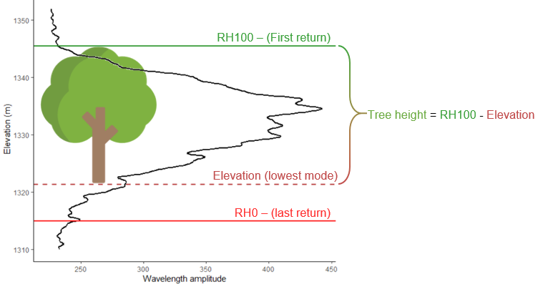
Figure ED1: Outline of the procedure of height estimation with GEDI data.

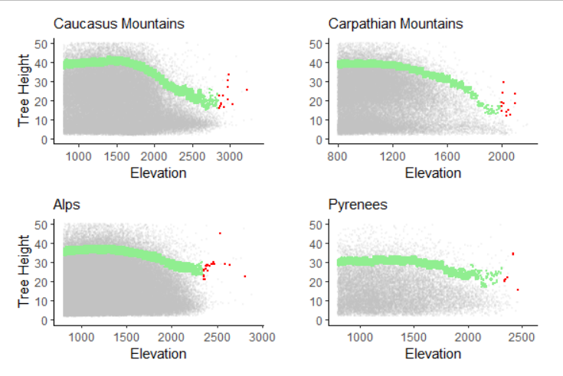
Figure ED2: Example of the histogram noise removal procedure. Herein we remove 0.1% of points located at higher altitudes (red color). The noise in this regions may be induced by snow cover or topographical complexity.

