Two telomere-to-telomere gapless genomes reveal insights into Capsicum evolution and capsaicinoid biosynthesis

Chen et al.

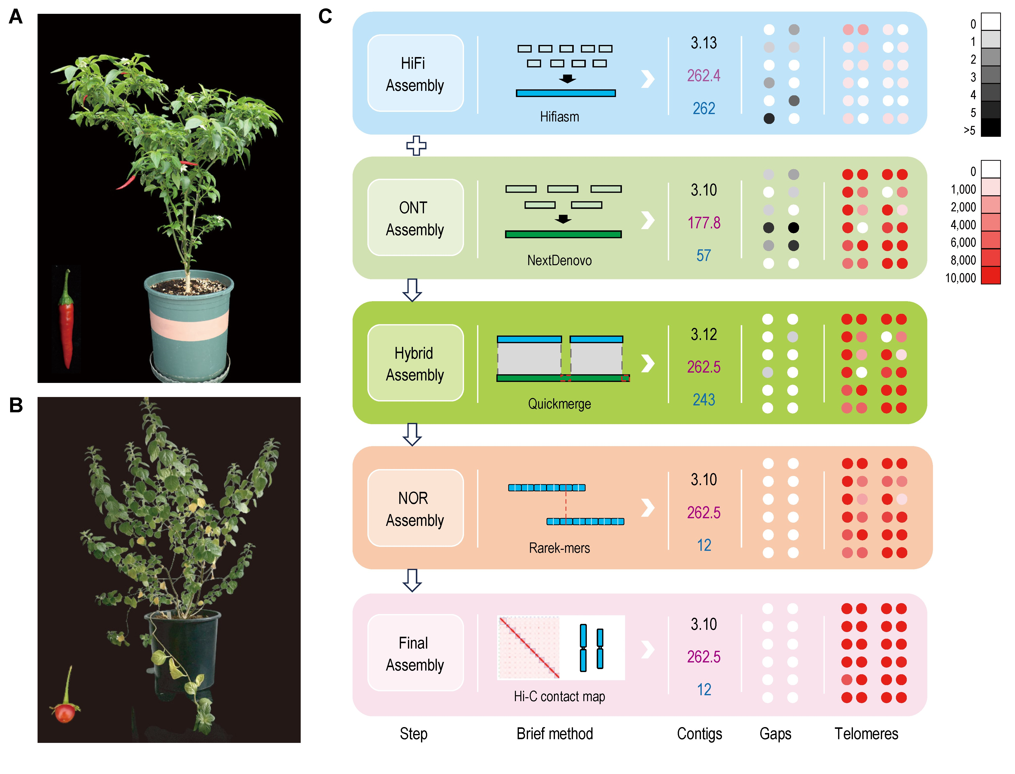

Supplementary Fig. 1. Pepper genome assembly pipeline for C. annuum and C. rhomboideum. (A-B) An image of the chili pepper C. annuum (A) and its wild nonpungent relative C. rhomboideum (B). (C) Computational pipeline for T2T gap-free genome assembly of C. annuum. The number above “Contigs” means assembly size, contig N50 and contig number; the black circles above “Gaps” means gap number in 12 chromosomes; and the red circles above “Telomeres” means copy numbers of seven-base telomeric repeat in 24 telomere regions.

Supplementary Fig. 2. Alignment of C. annuum genome assemblies. (A) Syntenic dot plot between the HiFi assembly and the final CaT2T assembly. The red box means T2T contigs assembled by Hifiasm using only HiFi data. (B) Syntenic dot plot between the ONT assembly and the final CaT2T assembly. The red box means T2T contigs assembled by NextDenovo using only ONT data. (C) Syntenic dot plot between the hybrid assembly and the final CaT2T assembly. The red box means T2T contigs. (D) Syntenic dot plot between the final CaT2T assembly and the reported Ca59 reference.

Supplementary Fig. 3. Estimating rDNA copy number and overview of rDNA arrays in C. annuum. (A) The 45S rDNA-containing reads extracted from 42× HiFi (>20 kb) data were used to conduct 19-mer analysis, and the rDNA arrays were estimated to be 1,428 copies (60,000 counts / 42× depth); (B) The 45S rDNA-containing reads were partitioned into units, where each unit represents a single repeat copy. These units varied on the repeat length and could be divided into two major types; (C) Different types of repeat unit were counted and summed after rDNA assembly; (D) Pairwise sequence identity across the NOR region based on non-overlapping 5 kb window size. The above rectangle meant the assembly was based on ONT long reads and HiFi contigs. Two issue regions corresponding to multiple Type A and Type B contigs were assembled using Hi-C interaction matrix. The below rectangle meant the (+) or (-) direction of each rDNA repeat unit.

Supplementary Fig. 4. The composition and distribution of repetitive sequences and protein-coding genes in C. annuum telomeric 500 kb regions. DNA: DNA transposons. LINE: long interspersed nuclear elements. LTR: long terminal repeats. SINE: short interspersed nuclear elements.

Supplementary Fig. 5. The composition and distribution of repetitive sequences and protein-coding genes in C. rhomboideum telomeric 500 kb regions. DNA: DNA transposons. LINE: long interspersed nuclear elements. LTR: long terminal repeats. Tsat: 183-bp telomeric-specific satellites. SINE: short interspersed nuclear elements.

Supplementary Fig. 6. Whole genome alignments of C. annuum and C. rhomboideum. (A) Genomic alignment dot plot between the CaT2T and CrT2T assemblies generated using Minimap2 and D-GENIES. (B) Dot plots of interspecies syntenic blocks of CaT2T and CrT2T. Each dot indicates a syntenic gene pair detected by MCScanX.

Supplementary Fig. 7. Overview of the Hi-C count matrix and sequencing coverage depth for the CaT2T and CrT2T genome. A, Hi-C interaction matrix of CaT2T; B, Hi-C interaction matrix of CrT2T. Chromosomes were anchored in order from top to bottom: Chr01 to Chr12 (CaT2T) and Chr01 to Chr13 (CrT2T). C, NGS, HiFi and ONT coverage depth in CaT2T; D, NGS, HiFi and ONT coverage depth in CaT2T. The abnormal low or high coverage depth was due to repetitive sequences as telomeres/subtelomeres and multiple long arrays of satellite repeats.

Supplementary Fig. 8. An example of closed gaps in CaT2T compared to Ca59. HiFi reads were mapped to Ca59 and CaT2T genome using Minimap2 (-x asm5) and the coverage depth in Chr03: 71.45-72.16 Mb was manually checked in IGV.

Supplementary Fig. 9. Nuclear chloroplast and mitochondria DNA insertion in pepper genome. (A) An example of chloroplast DNA insertion in CaT2T nuclear Chr09: 268.10-268.50 Mb. Synteny comparison between Ca59, CaT2T and chloroplast (NC_018552.1) of pepper. (B) The coverage of ultra-long ONT and HiFi reads across the chloroplast DNA insertion site at Chr09: 268.10-268.50 Mb. (C) An overview of nuclear plastid DNA (NUPTs) and nuclear mitochondria DNA (NUMTs) in Physalis grisea, Ca59, CaT2T and CrT2T assemblies.

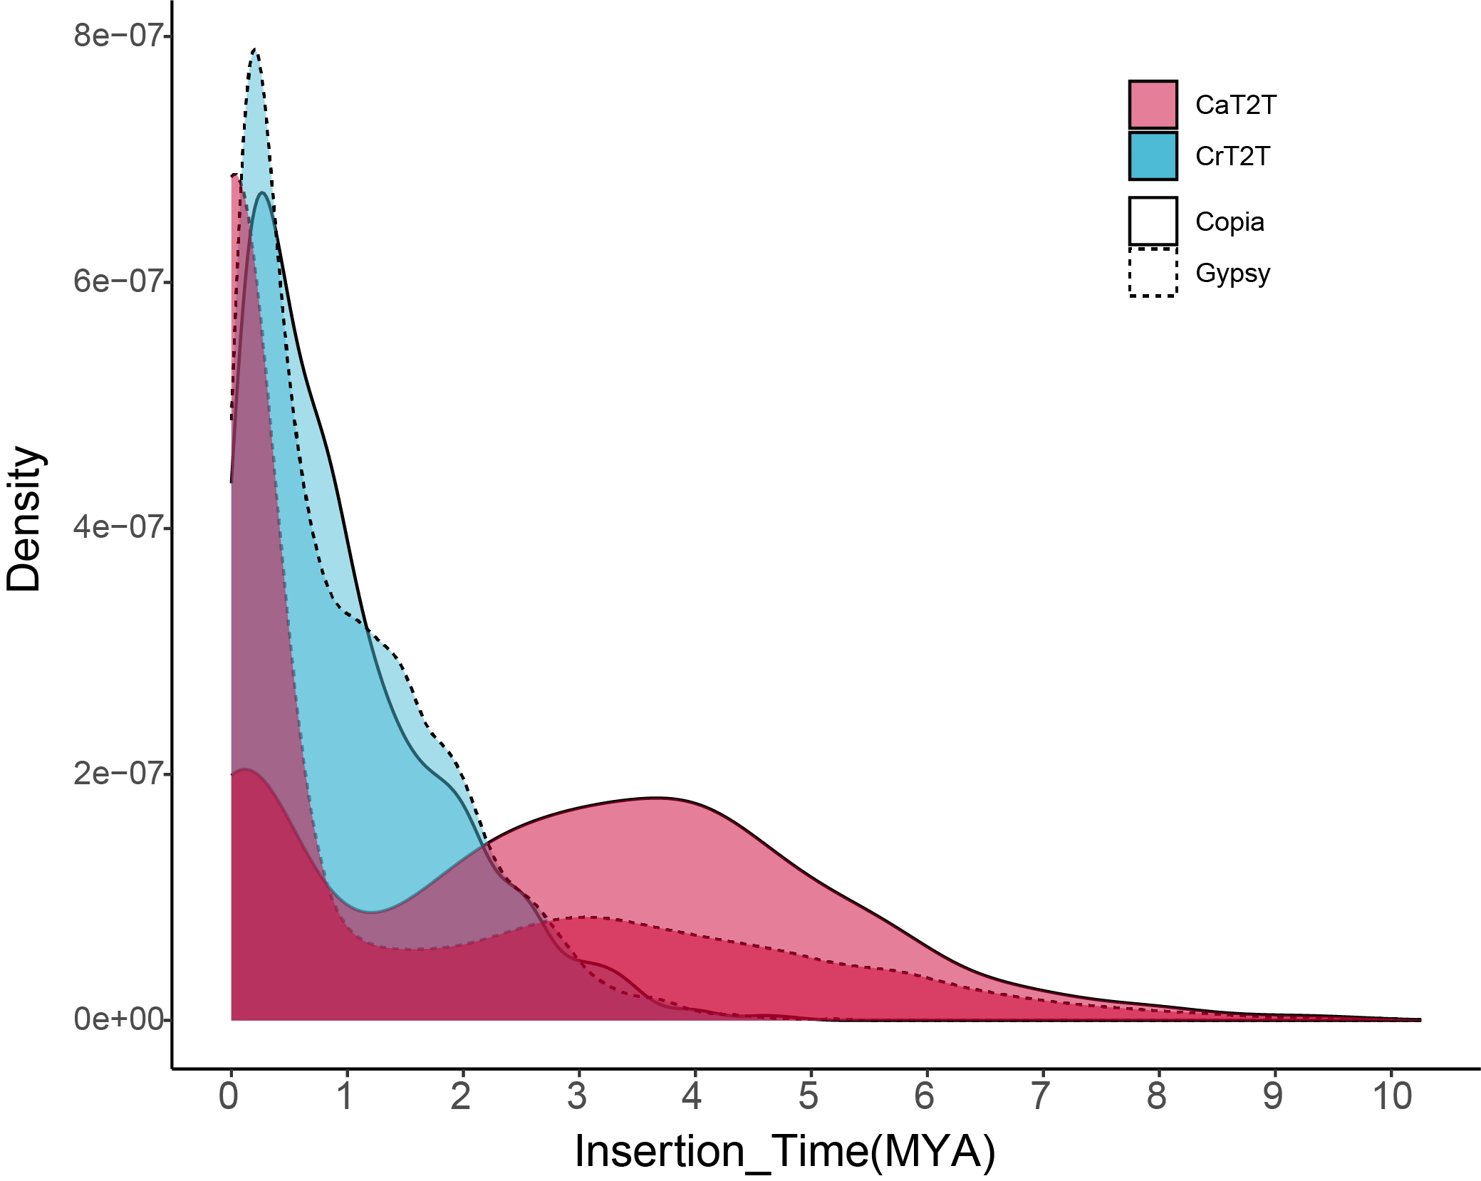

Supplementary Fig. 10. Distribution of insertion times of intact Gypsy and Copia retrotransposons in CaT2T and CrT2T assemblies.

Supplementary Fig. 11. An example of novel annotated gene models in gap-closure regions in CaT2T. (A) Among the 614 genes located in gap-closure regions, 110 were unmapped from a CaT2T reference genome to Ca59 using Liftoff with parameters of ‘-copies -flank 0.1 -sc 0.9’. (B) An example of the highly expressed novel genes in gap-closure regions of Chr05: 249.08 Mb -249.13 Mb.

Supplementary Fig. 12. Expression heatmap of putative CBGs in different tissues of C. annuum.

Supplementary Fig. 13. Prediction of centromeres in Capsicum assemblies without CHIP-seq data. (A) The inter-chromosome interactions were positively correlated with the ChIP peak in C. annuum. (B) The C. rhomboideum showed higher inter-chromosome interactions than C. annuum. (C) The predicted centromeres in C. baccatum, C. pubescens and C. rhomboideum were positively correlated with the CRM density. (D) The enrichment of CRM in centromeres, especially in C. pubescens and C. rhomboideum.

Supplementary Fig. 14. Pairwise sequence identity heatmap in centromeres of two Capsicum T2T assemblies. The non-overlapping 5 kb bins were aligned with each other using minimap2, and only the best local alignment between each pair was retained. Sequence identity was calculated from the highest scoring alignment between each pair, and was shown using StainedGlass. The centromere length in C. annuum were identified by ChIP-seq, while the centromeres in C. rhomboideum were predicted by CRM retrotransposon distribution.

Supplementary Fig. 15. GO enrichment analysis of annotated genes in centromere regions. (A) Venn diagram of common proteins in C. annuum and C. rhomboideum centromere regions. (B) GO enrichment analysis of 252 genes in C. annuum centromere regions. (C) GO enrichment analysis of 386 genes in C. rhomboideum centromere regions.

(See next page for caption)

Supplementary Fig. 16. Characteristics of the centromere on 12 centromeres of C. annuum. The distributions of TAD and chromatin loops, A/B compartment, ChIP-seq signal (H3K27me3, red; H3K9me2, green; H3K4me3, purple), methylation level (CG, red; CHG, green; CHH, purple), ATAC-seq signal, TE elements (Athila, bule; CRM, yellow; Tekay, red; others, grey), gene density (green), TE transcript abundances (blue) and gene transcript abundances (red) were plotted from the top to bottom successively. The centromere region was marked by the bottom blue rectangle.

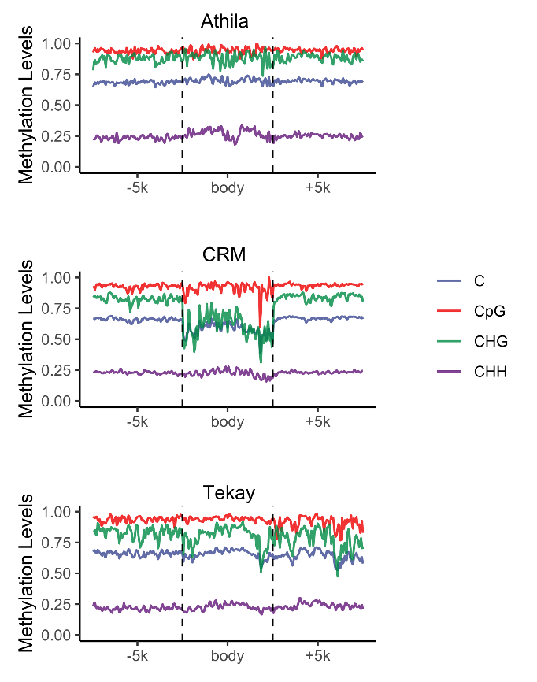

Supplementary Fig. 17. Methylation levels of centromere-located Athila, Tekay and CRM including the upstream and downstream 5 kb regions in C. annuum.

Supplementary Fig. 18. A neighbor-joining phylogenetic tree of capsaicin synthase (CS) genes in representative species of Solanaceae plants. (A). Neighbor-joining phylogenetic tree of CS family. The two C. annuum CS genes with placenta-specific high expression are marked with red stars. The support value was placed on the branch with bootstrap (n=1000). (B). Gene expression profiles (in normalized TPMs) of different tissues in two species are presented in the heatmap alongside the gene names.

Supplementary Fig. 19. Microsynteny analysis of key CBGs present in a syntenic block conserved among various Solanaceae species. (A) Dot plot of ACL, BCAT, CCoAOMT, FatA, KasIII and KasI among various Solanaceae species. Ca, C. annuum; Cb, C. bacatum; Cc, C. chinense; Cr, C. rhomboideum; Pp, Physalis pubescens; and Sl, Solanum lycopersicum. (B) Microsynteny relationships of ACL, BCAT, CCoAOMT, FatA, KasIII and KasI among various Solanaceae species. The red lines denote the conserved CBGs among different species.

Supplementary Fig. 20. Nucleotide dot plot (A) and sequence identity heatmap (B) of capsaicin synthase and its gene copies from different Capsicum species and a close relative Physalis pubescens.

Supplementary Fig. 21. Epigenomic and transcriptomic patterns of two functionally characterized transcription factors (MYB31, MYB48) and six putative CBGs (ACL, BCAT, CCoAOMT, FatA, KasI-1 and KasIII).

