Supporting Information

Securing Vanadium by Ion-anchoring Separators for Long-lasting Aqueous Zinc-Vanadium Batteries
Yao Qin, Xin Wang*

Songshan Lake Materials Laboratory, Dongguan, Guangdong 523808, China
E-mail: wangxin@sslab.org.cn

Methods
Preparation of the SA Polymeric Membranes. 1.2 g of sodium alginate (SA, Aladdin) was dissolved in 25 mL of deionized (DI) water, heated at 50 °C, and stirred until completely dissolved to give a homogeneous gel. It was aged for 24 h until the bubbles were eliminated. The gel was transferred with a blade to paste onto a smooth substrate, which was then immersed completely into the 2M ZnSO₄ solution to allow ion exchange between Na⁺ and Zn²⁺. After about 10 min, a polymeric film was formed and naturally detached from the substrate.

Preparation of the SZ Membranes. 1.0 g of 2-methylimidazole (Hmim, Aladdin) was dissolved in 50 mL of DI water, and stirred until completely dissolved, forming a homogeneous solution. The previously prepared polymeric membrane was placed flat in a dry flat-bottomed vessel. The solution was quickly poured into the shaking vessel until it covered the polymeric membrane completely. The ZIF-8 grew in situ on the polymeric membrane during this period. After about 1 min, the membrane was removed and rinsed off with DI water to remove the loose ZIF-8 particles. The SZ membrane was obtained and collected for further use.

Preparation of NaV₃O₈•1.5H₂O Cathode¹. Commercial V₂O₅ powder (3.0 g, Alfa Aesar) was added into a NaCl aqueous solution (2 mol L⁻¹). After stirring at 30 °C for 72 h in a water bath. The suspension was centrifuged and washed with DI water and ethanol several times. The NaV₃O₈•1.5H₂O nanowires were obtained and collected by freeze-drying.

Electrochemical Measurements. The cathode materials were composed of NaV₃O₈•1.5H₂O, conductive carbon black, and polyvinylidene difluoride (PVDF) at a mass ratio of 7:2:1. The mixtures were dispersed in N-methylpyrrolidone (NMP), and then coated onto the carbon fabric (Φ = 14 mm) to make the cathodes. A piece of Zn foil with a thickness of 80 μm was punched into disks (Φ = 15 mm, Φ = 12 mm) as the anodes. The GF and SZ separator were punched into disks (Φ = 19 mm) to separate the cathode and anode, and 1 M Zn(CF₃SO₃)₂ aqueous solution was used as the electrolyte. All cells were assembled in the air atmosphere. Electrochemical properties were measured on a NEWARE multichannel battery test system. The CV and EIS tests were performed on an electrochemical workstation (CHI760E).
Ionic conductivities of the separators were measured using stainless steel as the electrodes and calculated through the following equation:
σ =$\frac{d}{RS}$
Where d represents the thickness of the separator, R represents the resistance according to EIS measurement, and S is the contact area between the separator and electrodes.

The Zn²⁺ transference number (t_{Zn}²⁺) was calculated by the following equation:
$$t_{{Zn}^{2+}}=\frac{I_{s}(∆V-I_{0}R_{0})}{I_{0}(∆V-I_{s}R_{s})}$$
Where ∆V is the applied voltage (10 mV); I₀ and R₀ are the initial current and resistance, respectively. I_{s} and R_{s} are the steady-state current and resistance, respectively.

Density Functional Theory Computations. All combination structures were optimized by Density functional theory (DFT) at B3LYP hybrid functional with 6-311G(d, p) basis set using Gaussian 09 program^{2, 3}. Optimization and Frequency are selected as the job type when structural optimization is carried out. All calculations were carried out with the atom-pairwise dispersion correction (DFT-D3) ⁴ and integral-equation-formalism polarizable continuum model (IEF-PCM) with the default solvent (water) and solvent parameters⁵. The calculation formula for combined energy is as follows:
E=E_{ab}-E_{a}-E_{b}
Where E is the binding energy, E_{a} and E_{b} are the energies of ZIF and bonded ions (VO²⁺ or Zn²⁺), respectively, and E_{ab} is the total energy after binding.

Characterizations. Morphologies of the as-prepared SZ membranes, cathode materials, and Zn anodes were characterized by a Gemini 300 scanning electron microscope. X-ray photoelectron spectroscopy (XPS) was carried out on a Thermo Fisher Escalab XI+ X-ray photoelectron spectrometer. Information on the chemical composition of the materials was collected by an INVENIO-R Fourier Transform Infrared (FTIR) spectrometer. X-ray diffractograms (XRD) were recorded on a D8 Advance X-ray diffractometer with Cu Kα radiation. The adsorption of VO₂⁺ on the SZ separator was quantified by the iCAP 7200 inductive coupled plasma emission spectrometer (ICP). The tensile properties of different separators were tested on a YH-9000 electronic universal material testing machine.
Table S1. Electrolyte absorption and retention capacity of different separators
Entry | Mass (mg)
Entry | GF | SZ | Polyacrylamide (PAM)
W_{a} | 30.8 | 23.0 | 92.6
W_{b} | 199.3 | 68.5 | 305.7
Electrolyte absorption (%) | 547.1 | 197.8 | 230.1
Electrolyte retention (%) | 84.5 | 66.4 | 69.7
Thickness (μm) | 417 | 280 | 500

The electrolyte absorption is calculated using the following equation:
Electrolyte absorption (%) = $\frac{Wb-Wa}{Wa}$ x 100%
Electrolyte retention (%) = $\frac{Wb-Wa}{Wb}$ x 100%
W_{a} is the weight of the dry separator, and W_{b} corresponds to the weight of the separator after being immersed into 1 M Zn(CF₃SO₃)₂ electrolyte.

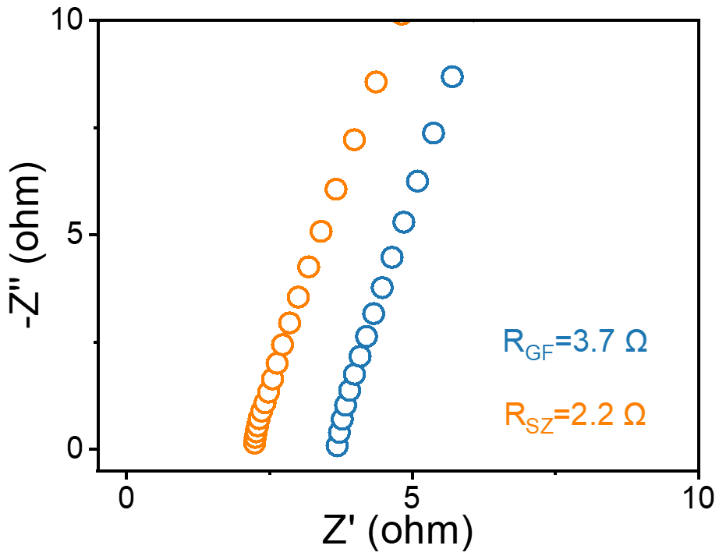
Figure S1. EIS of the symmetrical cells with stainless steel foils as electrodes.

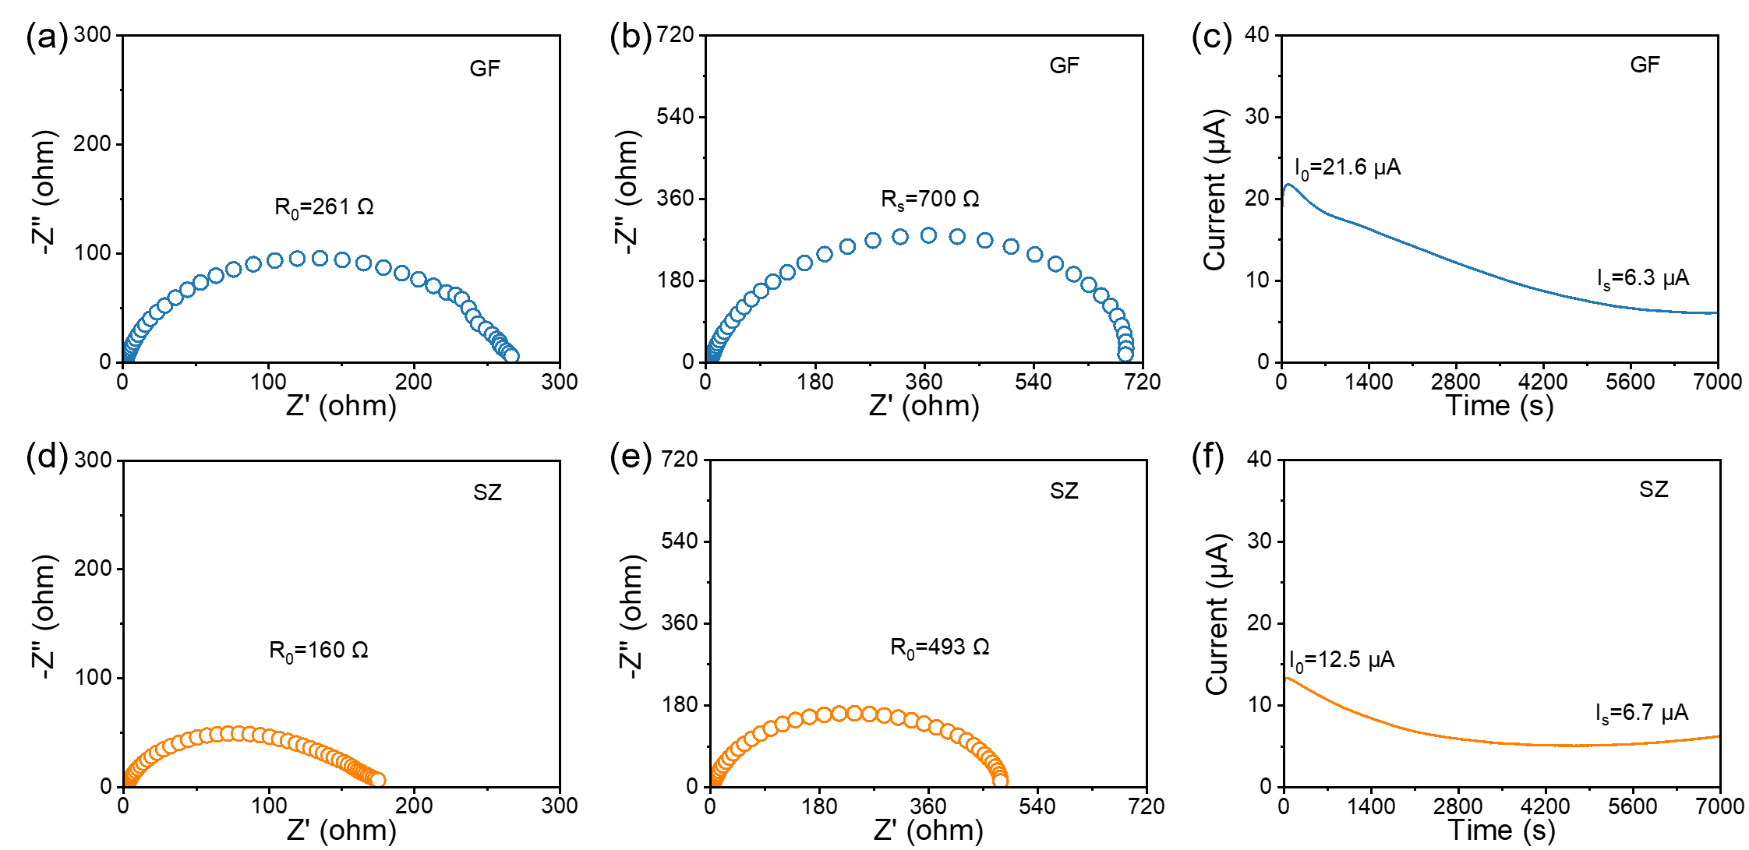
Figure S2. EIS of the Zn/Zn symmetrical cells with different separators (a, d) before polarization and (b, e) after polarization at a constant potential (10 mV). (c, d) Corresponding current-time plots.

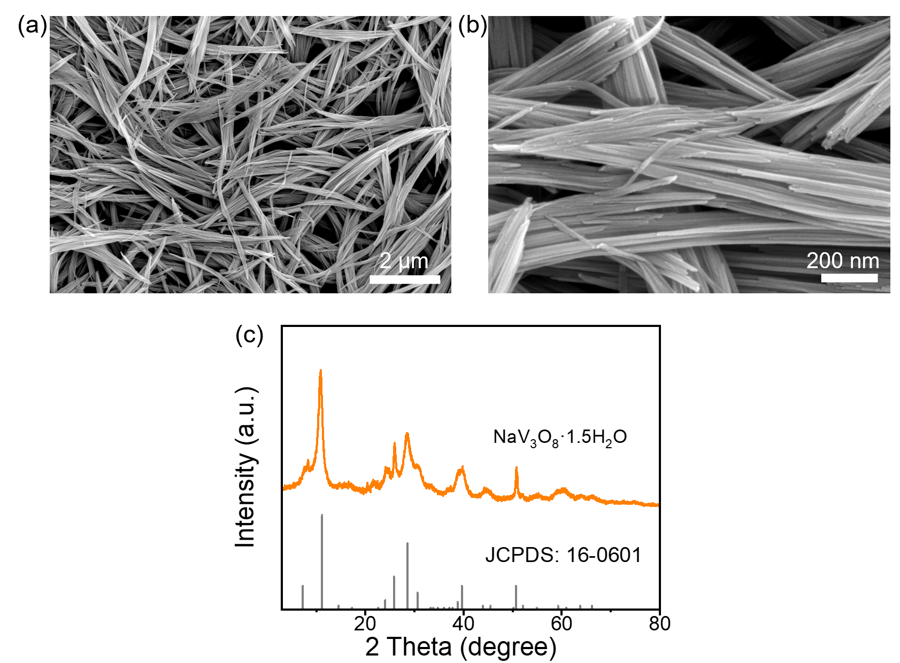
Figure S3. Characterization of NaV₃O₈•1.5H₂O cathode materials. (a, b) SEM images. (c) XRD diffractogram.

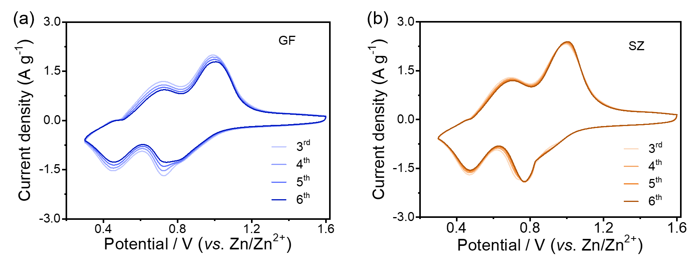
Figure S4. CV plots of (a) GF cell and (b) SZ cell at a scan rate of 1 mV s⁻¹.

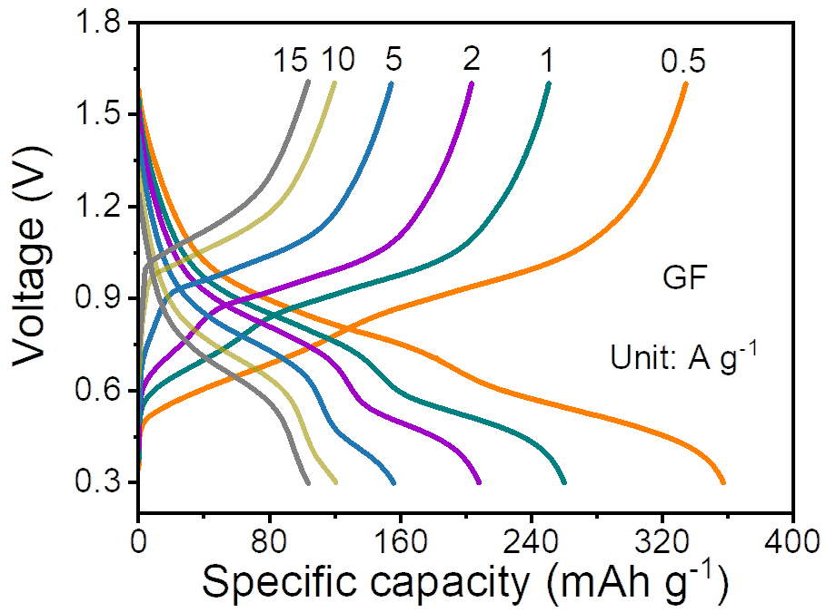
Figure S5. Voltage-capacity of the GF cells at various current densities from 0.5 to 15 A g⁻¹.

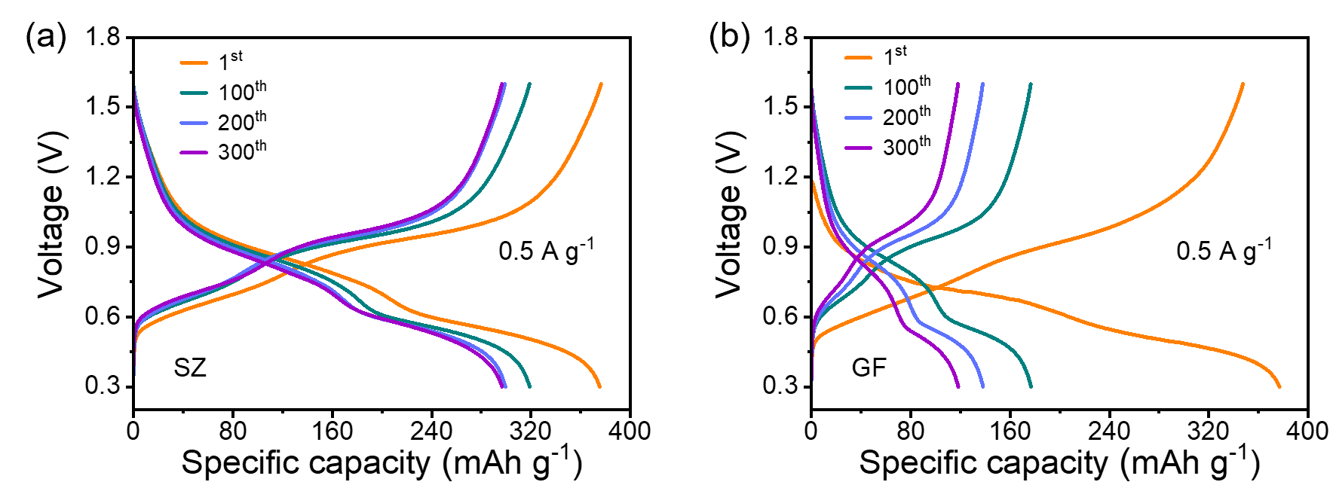
0.172 V
0.246 V
Figure S6. Galvanostatic charge-discharge profiles of (a) SZ and (b) GF cells at different cycle numbers at 0.5 A g⁻¹.

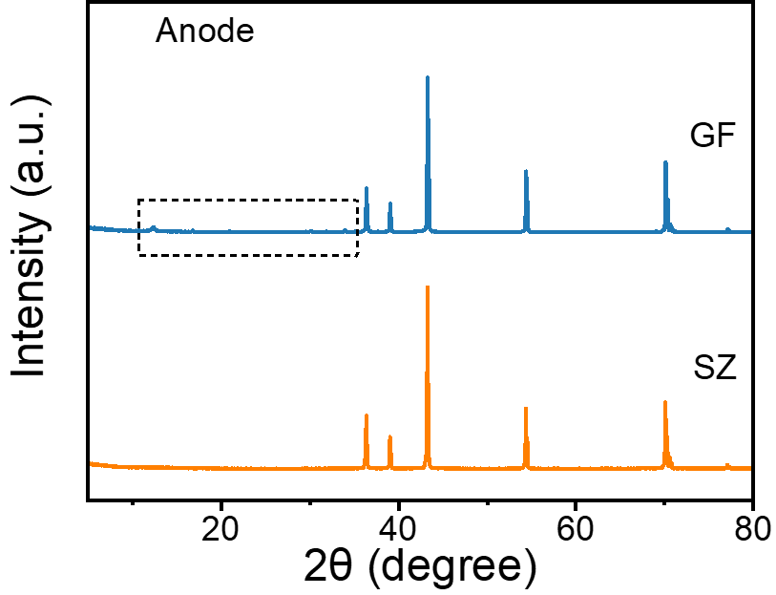
Figure S7. XRD diffractograms of the Zn anode with different separators after cycling.

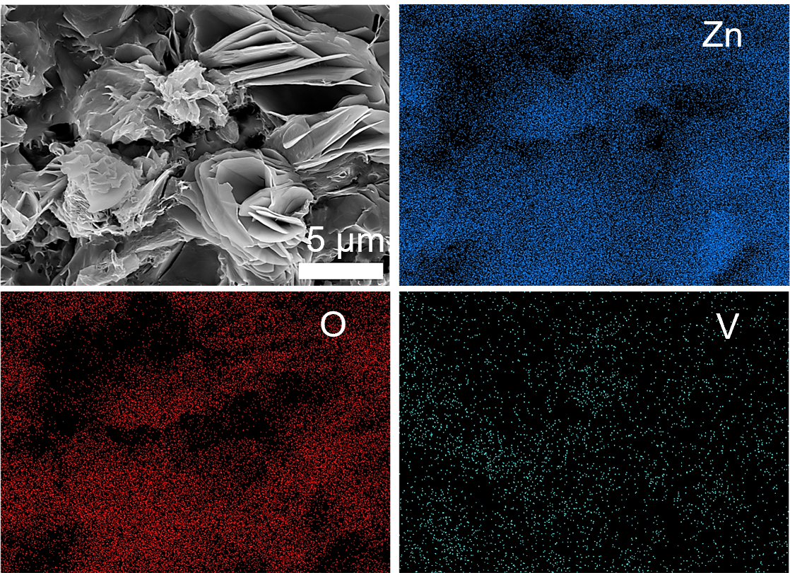
Figure S8. SEM and EDS images of the Zn anode working with the the GF separator in the Zn/V cells.

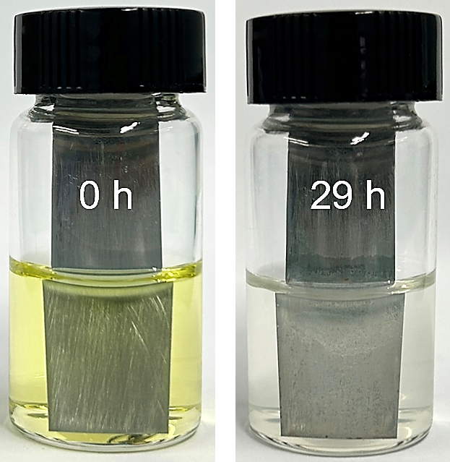
Figure S9. Optical images of Zn plates immersed in V-solution for 0 h and 29 h.

Notably, the V-solution used in this work is the supernatant obtained by immersing the V-based electrode in an aqueous solution with pH of about 3-4 for 24 h.

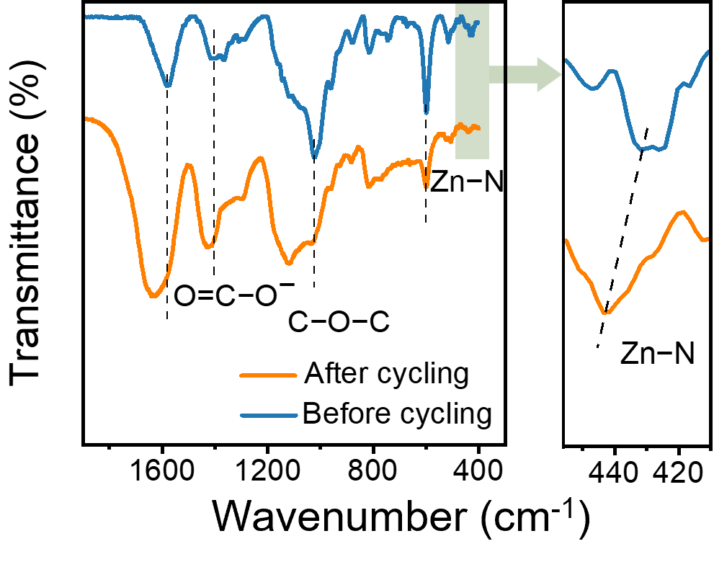
Figure S10. FTIR spectra of the SZ separators before and after cycling in the Zn/V cells.

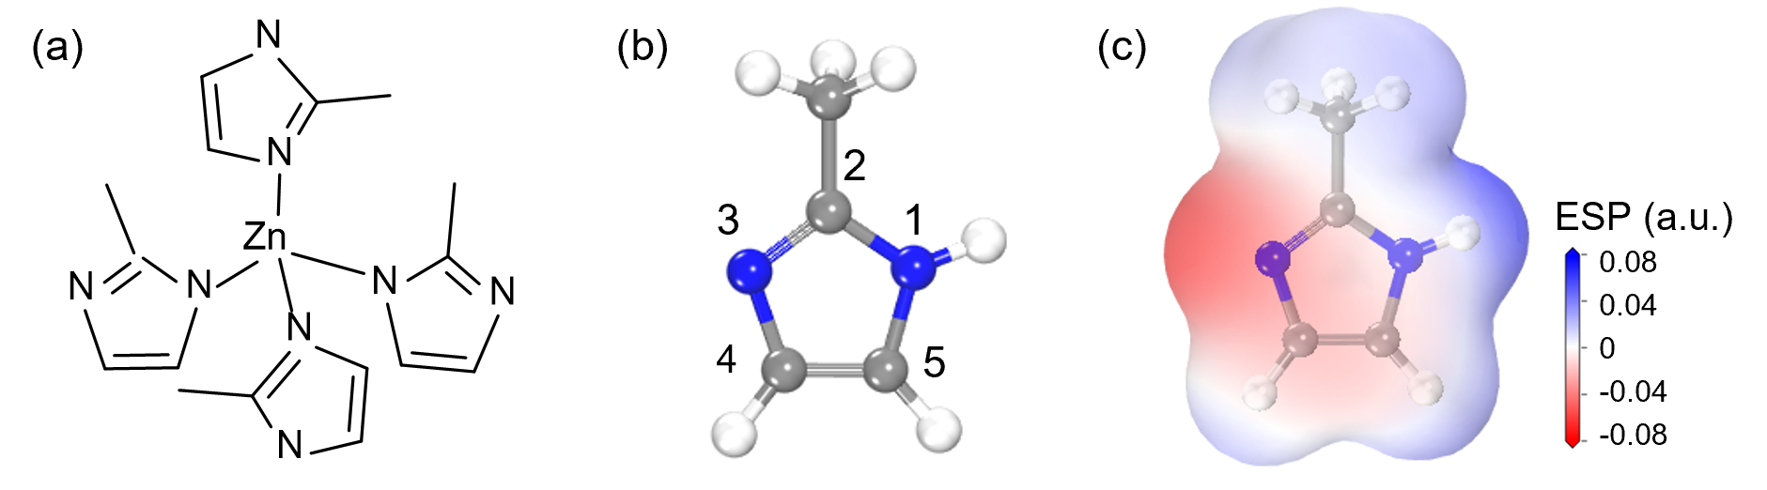
Figure S11. (a) Chemical structure of the ZIF-8 termination. (b) The ball-and-stick model of a Hmim molecule and the corresponding ESP surface map.

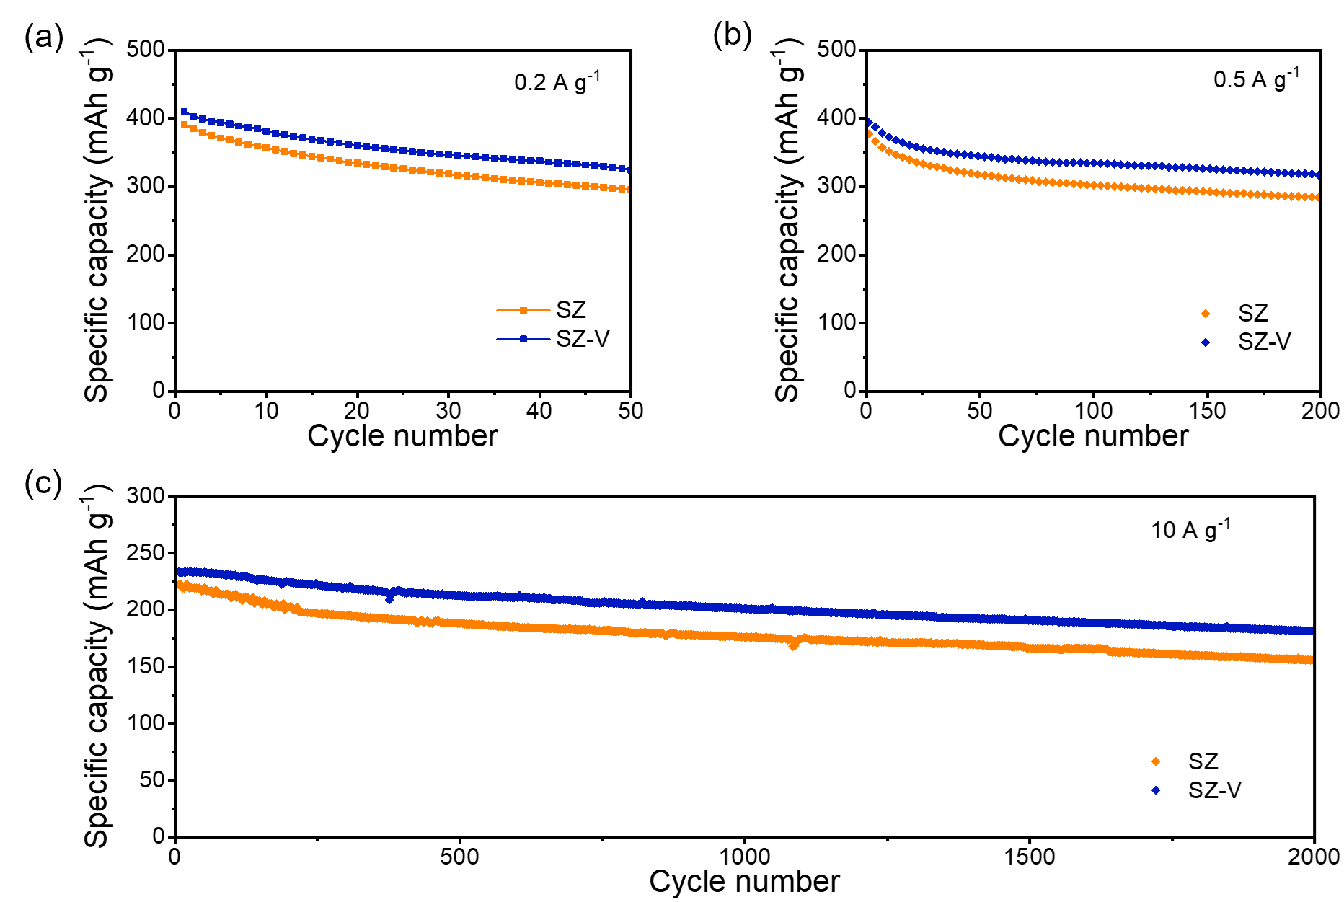

Figure S12. Cycling performance of the SZ and SZ-V cells at current densities of (a) 0.2, (b) 0.5, and (c) 10 A g⁻¹.

Table S2. Comparison of performance of batteries involving different separators

Separators | Cathode | Electrolyte | Voltage (V) | Capacity  (mAh g⁻¹) | Retention (cycles) | Targets | Ref.
SiO₂/GF | NaV₃O₈ | 1 M ZnSO₄  1 M Na₂SO₄ | 0.3-1.6 | 111 (1 A g⁻¹) | 75% (1000) | √ | 6
Graphene/GF | V₂O₅ | 2M ZnSO₄ | 0.2-1.4 | 160 (5 A g⁻¹) | 75% (1000) | √ | 7
C/Cu nanocomposite /cellulose nanofiber | Zn₃V₃O₈ | 2M ZnSO₄ | 0.2-1.6 | 167 (1 A g⁻¹) | 78% (500) | √ | 8
ZSM-5 | V₂O₅ | 3M ZnSO₄ | 0.2-1.6 | 170 (5 A g⁻¹) | 84% (15000) | √ | 9
PAN/GO | Zn_{0.27}V₂O₅ | 3M Zn(CF₃SO₃)₂ | 0.1-1.6 | 278 (2 A g⁻¹) | 72% (2800) | √ | 10
Cellulose@GO | V₂O₅ | 2M Zn(CF₃SO₃)₂ | 0.4-1.5 | 86 (1 A g⁻¹) | 95% (800) | √ | 11
PAN | NH₄V₄O₁₀ | 2M ZnSO₄ | 0.4-1.4 | 253 (5 A g⁻¹) | 84% (1000) | √ ◇ | 12
Chitosan/filter paper | MnO₂ | 1M ZnSO₄ | 0.8-2.0 | 186 (1 A g⁻¹) | 98% (1000) | √ | 13
g-C₃N₄/cellulose | V₂O₅ | 1M ZnSO₄ | 0.3-1.6 | 250 (0.2 A g⁻¹) | 60% (50) | √ | 14
Nanocellulose paper | V₂O₅ | 2M ZnSO₄ | 0.3-1.6 | 253 (1 A g⁻¹) | 65% (100) | √ | 15
Cellulose@graphene | MnO₂ | 3M ZnSO₄ | 0.8-1.9 | 190 (1.5 A g⁻¹) | 88% (5000) | √ | 16
Nafion | V₂O₅ | 3M ZnSO₄ | 0.2-1.6 | ~370 (5 A g⁻¹) | 84% (1300) | √ | 17
PVDF@PDA | NH₄V₄O₁₀ | 3M ZnSO₄ | 0.4-1.4 | 208 (5 A g⁻¹) | 92% (1000) | √ ◇ | 18
GO/GF | MnO₂ | 2 M ZnSO₄  0.5 M MnSO₄ | 0.6-1.7 | 85 (0.5 A g⁻¹) | 77 (500) | √ | 19
SPSF@PMIA fiber | V₂O₅ | 2M Zn(CF₃SO₃)₂ | 0.4-1.4 | 173 (5 A g⁻¹) | 75% (1000) | √ | 20
Zn-Nafion | V₂O₅ | 2M ZnSO₄ | 0.2-1.6 | 400 (2 A g⁻¹) | 74% (1000) | √ ◇ | 21
NaZnF₃/Nafion/cotton textiles | V₂O₅ | 2M ZnSO₄ | 0.2-1.6 | 130 (1 A g⁻¹) | 88% (650) | √ | 22
Cellulose paper/GF | NH₄V₄O₁₀ | 2M ZnSO₄ | 0.4-1.4 | 144 (4 A g⁻¹) | 89% (850) | √ ◇ | 23
ZrO₂@Cellulose | MnO₂ | 2M ZnSO₄ | 0.8-1.8 | 80 (2.5 A g⁻¹) | 87% (3000) | √ | 24
Zeolite | I₂ | 0.5M ZnSO₄ | 0.6-1.6 | 80 (1 A g⁻¹) | 96% (1000) | √ ◇ | 25
UiO-66/GF | MnO₂ | 2 M ZnSO₄  0.1 M MnSO₄ | 0.8-1.8 | 225 (1 A g⁻¹) | 85% (1000) | √ | 26
PVDF@LiTFSI | V₂O₅ | 1M Zn(TFSI)₂ | 0.2-1.6 | 324 (0.5 A g⁻¹) | 88% (475) | √ | 27
Zn-MBA/non-woven fabrics | V₂O₅ | 3M Zn(CF₃SO₃)₂ | 0.2-1.6 | 265 (5 A g⁻¹) | 84% (1000) | √ ◇ | 28
Filter membrane | NaV₃O₈ | 3M Zn(CF₃SO₃)₂ | 0.3-1.6 | 178 (5 A g⁻¹) | 84% (5000) | √ | 29
N-doped carbon/GF | KV₁₂O_{30-y} | 2M ZnSO₄ | 0.2-1.6 | 251 (5 A g⁻¹) | 79% (1000) | √ | 30
Bacterial cellulose@ nano-hydroxyapatite | V₂O₅ | 2M ZnSO₄ | 0.2-1.6 | 100 (10 A g⁻¹) | 82% (2500) | √ | 31
BaTiO₃/GF | MnO₂ | 2M ZnSO₄ | 0.8-1.8 | 106 (1 A g⁻¹) | 68% (1800) | √ ◇ | 32
SZ | NaV₃O₈ | 1M Zn(CF₃SO₃)₂ | 0.3-1.6 | 252 (5 A g⁻¹) | 79% (1000) | √ ◇ | This work
SZ-V | NaV₃O₈ | 1M Zn(CF₃SO₃)₂ | 0.3-1.6 | 260 (5 A g⁻¹) | 95% (1000) | √ ◇ | This work
√ : solved Zn anode problems solely
◇: resolved both the Zn anode and cathode

References

1. Wan F, et al. Aqueous rechargeable zinc/sodium vanadate batteries with enhanced performance from simultaneous insertion of dual carriers. Nat. Commun. 9, 1656 (2018).
2. Grimme S. Accurate description of van der Waals complexes by density functional theory including empirical corrections. J. Comput. Chem. 25, 1463-1473 (2004).
3. Costa AC, Jr, et al. DFT: B3LYP/6-311G (d, p) vibrational analysis of bis-(diethyldithiocarbamate)zinc(II) and natural bond orbitals. Spectrochim. Acta A Mol. Biomol. Spectrosc. 105, 251-258 (2013).
4. Grimme S, Ehrlich S, Goerigk L. Effect of the damping function in dispersion corrected density functional theory. J. Comput. Chem. 32, 1456-1465 (2011).
5. Li H, Jensen JH. Improving the efficiency and convergence of geometry optimization with the polarizable continuum model: new energy gradients and molecular surface tessellation. J. Comput. Chem. 25, 1449-1462 (2004).
6. Yang Y, et al. Regulating dendrite-free Zn deposition by a self-assembled OH-terminated SiO₂ nanosphere layer toward a Zn metal anode. ACS Appl. Mater. Interfaces. 14, 37759-37770 (2022).
7. Li C, et al. Directly grown vertical graphene carpets as janus separators toward stabilized Zn metal anodes. Adv. Mater. 32, e2003425 (2020).
8. Li Y, et al. Functional ultrathin separators proactively stabilizing zinc anodes for zinc-based energy storage. Adv. Mater. e2300019 (2023).
9. Zhu J, et al. A molecular-sieve electrolyte membrane enables separator-free zinc batteries with ultralong cycle life. Adv. Mater. 34, e2207209 (2022).
10. Yao L, et al. Ultra‐stable Zn anode enabled by fiber-directed ion migration using mass-producible separator. Adv. Funct. Mater. 2209301 (2022).
11. Cao J, et al. Manipulating crystallographic orientation of zinc deposition for dendrite-free zinc ion batteries. Adv. Energy Mater. 11, 2101299 (2021).
12. Fang Y, et al. Regulating zinc deposition behaviors by the conditioner of PAN separator for zinc-ion batteries. Adv. Funct. Mater. 32, 2109671 (2021).
13. Yang X, et al. Chitosan modified filter paper separators with specific ion adsorption to inhibit side reactions and induce uniform Zn deposition for aqueous Zn batteries. Chem. Eng. J. 450, 137902 (2022).
14. Yang Y, et al. Manipulating Zn-ion flux by two-dimensional porous g-C₃N₄ nanosheets for dendrite-free zinc metal anode. Chem. Eng. J. 433, 134077 (2022).
15. Zhang X, et al. Recyclable nanopaper separators with uniform sub-20 nm nanopores for high-power and high-capacity zinc metal anodes. Electrochim. Acta 430, 141081 (2022).
16. Zhang X, et al. Ultra-long-life and highly reversible Zn metal anodes enabled by a desolvation and deanionization interface layer. Energy Environ. Sci. 14, 3120-3129 (2021).
17. Ghosh M, Vijayakumar V, Kurungot S. Dendrite growth suppression by Zn²⁺‐integrated nafion ionomer membranes: beyond porous separators toward aqueous Zn/V₂O₅ batteries with extended cycle life. Energy Technol. 7, 1900442 (2019).
18. Liu Y, et al. A functionalized separator enables dendrite‐free Zn anode via metal‐polydopamine coordination chemistry. InfoMat 5, e12374 (2022).
19. Cao J, et al. A universal and facile approach to suppress dendrite formation for a Zn and Li metal anode. J. Mater. Chem. A 8, 9331-9344 (2020).
20. Hu W, et al. Deposition behavior regulated by an SPSF@PMIA nanofiber separator for high-performance zinc ion batteries. J. Mater. Chem. A 10, 24761-24771 (2022).
21. Wu B, et al. A cation selective separator induced cathode protective layer and regulated zinc deposition for zinc ion batteries. J. Mater. Chem. A 9, 4734-4743 (2021).
22. Guo G, et al. Regulating zinc deposition behaviors by functional cotton textiles as separators for aqueous zinc-metal batteries. J. Power Sources 553, 232321 (2023).
23. Yang Z, et al. A piece of common cellulose paper but with outstanding functions for advanced aqueous zinc-ion batteries. Mater. Today Energy 28, 101076 (2022).
24. Cao J, et al. Modulating Zn deposition via ceramic-cellulose separator with interfacial polarization effect for durable zinc anode. Nano Energy 89, 106322 (2021).
25. Li Z, et al. Long-life aqueous Zn-I₂ battery enabled by a low-cost multifunctional zeolite membrane separator. Nano Lett. 22, 2538-2546 (2022).
26. Song Y, et al. Metal-organic frameworks functionalized separators for robust aqueous zinc-ion batteries. Nanomicro Lett. 14, 218 (2022).
27. Zhang F, et al. Hierarchical porous separator with excellent isotropic modulus enabling homogeneous Zn²⁺ flux for stable aqueous Zn battery. Sci. China Mater. 66, 982-991 (2023).
28. Tao Z, et al. Suppression of vanadium oxide dissolution via cation metathesis within a coordination supramolecular network for durable aqueous Zn-V₂O₅ batteries. Small, e2301620 (2023).
29. Qin Y, et al. Advanced filter membrane separator for aqueous zinc-ion batteries. Small 16, e2003106 (2020).
30. Yang X, et al. In situ separator modification via CVD-derived N-doped carbon for highly reversible Zn metal anodes. Nano Research 15, 9785-9791 (2021).
31. Qin H, et al. A nature-inspired separator with water-confined and kinetics-boosted effects for sustainable and high-utilization Zn metal batteries. Small 19, e2300130 (2023).
32. Liang Y, et al. Novel concept of separator design: efficient ions transport modulator enabled by dual-interface engineering toward ultra-stable Zn metal anodes. Adv. Funct. Mater. 32, 2112936 (2022).

