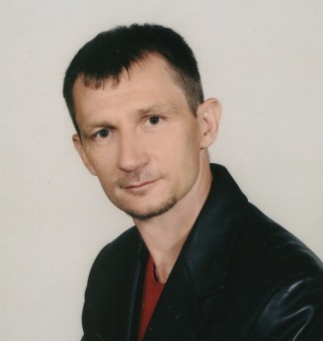
Oleksandr Lavrut has received Diploma in Automated control of technical and organizational systems, PhD and habilitation degree Doctor of Sciences degrees in Engineering Sciences (Military cybernetics, Control systems and communication) from Kharkiv Military University (Ukraine), and the tittle of Professor from the Hetman Petro Sahaidachnyi National Army Academy (Lviv, Ukraine). He is the Coauthor of 69 publications in referred scientific journals and nineteen books. His research interests include the theoretical aspects of construction of telecommunication networks, control and communication systems. Oleksandr Lavrut is the member of the Editorial Board of the scientific journal “Military Technical Collection”.
ORCID: https://orcid.org/0000-0002-4909-6723

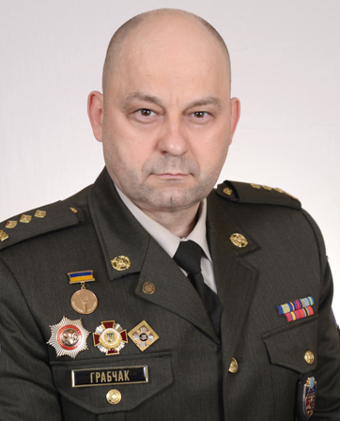
Volodymyr Hrabchak has received Diploma from the Rostov Military Institute of Missile Forces (Russia) in the specialty Aircraft control systems, PhD degree in Technical Sciences from the Ivan Kozhedub Kharkiv National Air Force University (Kharkiv, Ukraine), habilitation degree Doctor of Engineering Sciences from the Central Scientific Research Institute of Armaments and Military Equipment of Armed Forces of Ukraine (Kyiv, Ukraine) and the tittle of Professor from the Hetman Petro Sahaidachnyi National Army Academy (Lviv, Ukraine). He is the coauthor of more than 120 scientific papers and 16 books. Scientific interests concern the theoretical aspects of external ballistics, signal processing and control of radio-electronic and telecommunication systems. Volodymyr Hrabchak is the member of the Editorial Board of the scientific journal “Military Technical Collection”.
ORCID: https://orcid.org/0000-0003-3569-0681

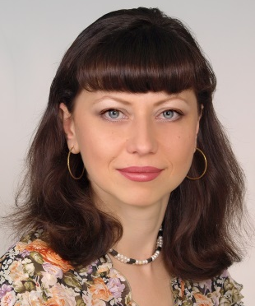
Tetiana Lavrut has received Diploma in Geography and PhD degree in Geographical Sciences from V. N. Karazin Kharkiv National University (Ukraine), and the tittle of Associate Professor from the Poltava National Technical University named after Yuri Kondratyuk (Ukraine). She is the Coauthor of 29 publications in referred scientific journals and two books; 11 of them are dedicated to the study of telecommunications and communication. From 2014 she is a Senior Researcher at the Hetman Petro Sahaidachnyi National Army Academy (Lviv, Ukraine ). Her research interests concern the Geoinformation systems (GIS); Telecommunication systems and communication. Tetiana Lavrut is the Technical Editor of the scientific journal “Military Technical Collection”.
ORCID: https://orcid.org/0000-0002-1552-9930

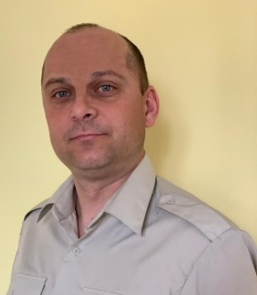
Yurii Chahan received Diploma in the specialty "Combat application and control of the actions of units (units, formations) of Ground Forces" and a scientific degree of Candidate in technical sciences (weapons and military equipment) from the Hetman Petro Sahaidachnyi National Army Academy (Lviv, Ukraine). He is the Coauthor of more than 30 scientific publications in refereed scientific journals. Since 2013, he is a senior researcher at the Scientific Center at the Hetman Petro Sahaidachnyi National Army Academy. The sphere of scientific interests includes the theoretical aspects of telecommunication systems, logistics, and technical aspects of transport.
ORCID: 0000-0001-7837-0528

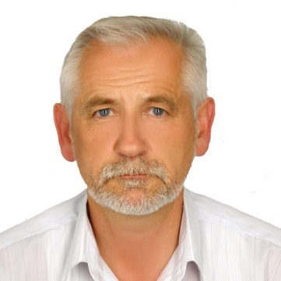
Yuriy Nastishin has received Diploma in Physics and PhD degree in Physics and Mathematics from Ivan Franko Lviv National University (Ukraine), habilitation degree Doctor of Sciences in Physics and Mathematics from the Institute of Physical Optics (Lviv, Ukraine). He is the author of more than 130 publications in referred scientific journals and two books. Professional activity: Member of the Council for the defense of the dissertations for the PhD and Habilitation Scientific degrees in Physics and Mathematics at the Institute of Physical Optics (2007-2016), Member of the Editorial Board of the Ukrainian Journal of Physical Optics (2006-2016), Referee for several scientific journals such as Physical Review Letters, Physical Review E, Optics Express, Molecular Liquids, Applied Optics, Applied Materials and Interfaces, Soft Matter, Optics Letters. His research interests include experimental and theoretical studies in Liquid Crystals and Optics. From 2017 he is a Leading Researcher at the Hetman Petro Sahaidachnyi National Army Academy and from this time his research interests are expanded to the theoretical aspects of electronics, wireless networks, metrology and queuing systems. Yuriy Nastishin is the Editor-in-Chief of the scientific journal “Military Technical Collection”. ORCID: 0000-0001-7521-3906

