Supporting Information

Perovskite single-pixel detector for dual-color metasurface imaging recognition in complex environment
Jiahao Xiong^{1,#}, Zhi-Hong Zhang^{1,2,#}, Zile Li^{3,4,#}, Peixia Zheng¹, Jiaxin Li³, Xuan Zhang¹, Zihan Gao¹, Zhipeng Wei², Guoxing Zheng^{3,4,}*, Shuang-Peng Wang^{1,}* and Hong-Chao Liu^{1,}*

¹Institute of Applied Physics and Materials Engineering, University of Macau, Tapia,
Macao SAR, 999078, China.
²State Key Laboratory of High Power Semiconductor Lasers, Changchun University of Science and Technology, Changchun, 130022, China
³Electronic Information School, and School of Microelectronics, Wuhan University, Wuhan, 430072, China
⁴Peng Cheng Laboratory, Shenzhen, 518055, China
# J. H. X., Z. H. Z., and Z. L. L. contributed equally to this work.
*E-mail: G. X. Z. (gxzheng@whu.edu.cn); S.-P. W. (spwang@um.edu.mo); H.-C. L. (hcliu@um.edu.mo)

This file includes:
Section 1. Design and fabrication of metasurface target in experiments
1-1 Design of metasurface target
1-2 Fabrication of metasurface target
Section 2. Photoelectric performance of FAPbBr_{2.4}I_{0.6} and FAPbI₃ DIP-SPD
Section 3. DIP-SPD single-pixel imaging system in complex environment
3.1 Hadamard patterns utilized in experiments
3.2 Single-pixel imaging results of DIP-SPD at different DMD modulation frequencies
3.3 Effect of the scattering medium on traditional camera imaging
3.4 Single-pixel detection signals in background light environment

Section 1. Design and fabrication of metasurface target in experiments

1.1 Design of metasurface target
Fig. S1 Predefined metasurface images were reflected under red or green lasers with right circular polarization (RCP) and left circular polarization (LCP). a Preset reflection image of the metasurface under RCP red light illumination. b Preset reflection image of metasurface under LCP red light illumination. c Preset reflection image of metasurface under RCP green light illumination. d Preset reflection image of the preset metasurface under LCP green light illumination.

Figure S1 displays the designed reflected images of the metasurface when illuminated by lasers of varying colors and polarizations. The metasurface utilized in the experiment is fabricated through silicon processing on a sapphire substrate (SOS), which will reflect two sets of different images under the irradiation of lasers in the red and green bands, respectively. Figures S1(a) and S1(c) depict the images of “UM” and “IAPME” can be obtained under the irradiation of an RCP laser in the red band, while the images of “CUST” and “WHU” under the irradiation of RCP laser in the green band. Additionally, the reflected images from the metasurface exhibit polarization-dependent transformations, with the images reflected under left-handed circular polarization (LCP) being rotated 180° relative to those reflected under right-handed circular polarization (RCP), as illustrated in Figs. S1(b) and S1(d).
During the design process, the nanobrick structure was chosen to achieve the intended function. On the sapphire substrate, two crystalline silicon nanobricks were arranged, with dimensions of 150 nm×100 nm (L=150 nm, W=100 nm) and 100 nm×50 nm (L=100 nm, W=50 nm), respectively. These nanobricks were designed to respond to lasers in the red and green bands. The pitch of the metasurface cell was set to 300 nm with a height of 230 nm. Next, the phase distribution matrices, φ1 and φ2, were designed based on the holographic images at different wavelengths, as shown in Figs. S2(a) and S2(b). In the phase distribution matrix φ1, groups of adjacent 10×10 elements were selected and half of the groups were randomly replaced with the corresponding element values from the phase distribution matrix φ2. Figure S2(c) displays a partial view of the gds file used for processing the metasurface.
Fig. S2 Phase distribution matrices of holographic images at different wavelengths and partial graphics of the gds file of the metasurface. a The phase distribution matrix φ1 of the red image. b The phase distribution matrix φ2 of the green image. c Partial graphics of the gds file of the metasurface.

1.2 Fabrication of metasurface target
Fig. S3 Schematic diagram of the preparation process of the metasurface used in the experiment.

The preparation process for the metasurface target used in the experiment is illustrated in Fig. S3. Initially, a layer of polymethyl methacrylate (PMMA) was applied onto the cleaned and dried SOS material as an electron beam resist and cured at 150 °C. Subsequently, a conductive poly (3,4-ethylenedioxythiophene) polystyrene sulfonate (PEDOT: PSS) layer was evenly spin-coated onto the PMMA layer with a constant speed and homogenization time and cured at 90 °C. In the second step, electron beam lithography (EBL) (Raith 150, 30 kV) was used to produce a mask pattern of the nanobrick structure on the PMMA layer, followed by cleaning the sample with deionized water to remove the conductive layer. In the third step, development and exposure procedures were executed to eliminate the same portion of the PMMA material as the nanobrick structure array, thereby preserving only the region outside of the processed pattern. In the fourth step, a 30 nm thick chromium film was deposited on the sample using a thermal evaporator. In the fifth step, the sample was immersed in hot acetone solution at 75 °C and cleaned using ultrasonic waves to completely remove the PMMA material covering the sample. In the sixth step, reactive ion etching (RIE) technology was employed to etch the crystalline silicon material. The chromium film provided protection, ensuring the processing pattern was fully transferred to the SOS. Finally, a chromium etching solution was used to remove any remaining chromium film. Following these steps, an array of crystalline silicon nanobricks remained on the sapphire substrate.

Section 2 Photoelectric performance of FAPbBr_{2.4}I_{0.6} and FAPbI₃ DIP-SPD
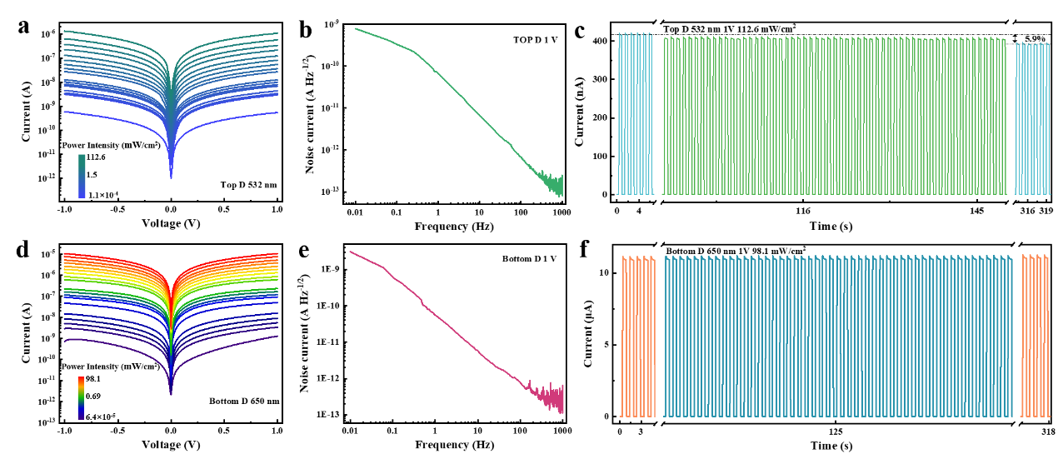
Fig. S4 Photoelectric performance of FAPbBr_{2.4}I_{0.6} and FAPbI₃ DIP-SPD. a The photocurrent and dark current of the top FAPbBr_{2.4}I_{0.6} device, which is selected under a weak light density from 1.1×10⁻⁴ mWcm⁻² to 112.6 mWcm⁻². b Frequency-dependent noise current of the top FAPbBr_{2.4}I_{0.6} device with 1 V bias. c The fast switching response of the top FAPbBr_{2.4}I_{0.6} device to light at 1 V bias varies with time and the optical power density of 112.6 mWcm⁻². d The photocurrent and dark current of the bottom FAPbI₃ device, which is selected under a weak light density from 6.4×10⁻⁵ mWcm⁻² to 98.1 mWcm⁻². e Frequency-dependent noise current of the bottom FAPbI₃ device with 1 V bias. f The fast switching response of the bottom FAPbI₃ device to light at 1 V bias varies with time and the optical power density of 98.1 mWcm⁻².

To further investigate the photoelectric responsiveness of FAPbBr_{2.4}I_{0.6} and FAPbI₃ DIP-SPD, the dark current and the photocurrent response of DIP-SPD under different laser irradiations were tested. The effective detection area of the DIP-SPD can be calculated based on the number and dimensions of interdigital electrode pairs used to output signals. In this case, 20 interdigital electrode pairs with an interdigital spacing of 80 μm and an interdigital length of 3 mm are employed, resulting in an effective detection area of 4.8×10⁻² cm². As displayed in Fig. S4(a), at an applied bias voltage of 1 V, the FAPbBr_{2.4}I_{0.6} device exhibits a low dark current of 550 pA. Upon laser irradiation with a spot area of 0.45 cm² and a power density of 112.6 mWcm⁻², the photocurrent reaches 1.1 μA, with an ON/OFF switching ratio of 2×10³. The minimum responsive optical power density of the FAPbBr_{2.4}I_{0.6} device is as low as 1.1×10⁻⁴ mWcm⁻². Figure S4(d) presents the photoelectric characteristics of the FAPbI₃ device. In comparison with the FAPbBr_{2.4}I_{0.6} device, the FAPbI₃ device exhibits an ON/OFF switching ratio of 10⁴ and a minimum detectable optical power of 6.4×10⁻⁵ mWcm⁻². This suggests that despite the light signal being transmitted through the FAPbBr_{2.4}I_{0.6} device, the FAPbI₃ device was still capable of adequately detecting the signal.
Figures S4(b) and S4(e) present the frequency-dependent noise currents of the FAPbBr_{2.4}I_{0.6} and FAPbI₃ devices, respectively. The noise current follows an inverse proportionality with frequency, leading to a decrease in noise current at higher frequencies, which improves the detection capability of the DIP-SPD for weak signals at high frequencies. Figure S4(c) presents the results of the optical switching cycle stability test of the FAPbBr_{2.4}I_{0.6} device under 1 V bias and 112.6 mWcm⁻² 532 nm laser irradiation. The test indicates that the top FAPbBr_{2.4}I_{0.6} device demonstrates a stable long-term switching response, with only a 5.9% reduction in the amplitude of the output photocurrent signal observed within 320 s. Meanwhile, Fig. S4(f) shows that the bottom FAPbI₃ device under 1 V bias and 98.1 mWcm⁻² 650 nm laser irradiation exhibits almost unchanged output photocurrent signal amplitude.

Section 3 DLI-PD single-pixel imaging system in complex environment

3.1 Hadamard patterns utilized in experiments
To enable the single-pixel detector to obtain the spatial information of a target, it is common practice to modulate the target image with a series of mask patterns. The size of the mask pattern (m × n) determines the dimension of the reconstructed image. Hadamard patterns, which are commonly used in sensing and imaging as a sampling base, are also frequently employed in single-pixel imaging (SPI)^{1,2}. Hadamard patterns are generated by the Hadamard matrix, each of which has a pixel value of +1 or -1 and is orthogonal to each other. The order of the Hadamard matrix must satisfy the condition m = n = 2^{k} (where k is a positive integer), and all higher-order Hadamard matrices can be derived from the original second-order Hadamard matrix $H^{2}$.
$$\begin{aligned}H^{2}=\left[\begin{matrix}1 & 1 \\ 1 & -1\end{matrix}\right],\#(S1)\end{aligned}$$
$$\begin{aligned}H^{2^{k}}=\left[\begin{matrix}H^{2^{k-1}} & H^{2^{k-1}} \\ H^{2^{k-1}} & -H^{2^{k-1}}\end{matrix}\right]. \#(S2)\end{aligned}$$
Because $H^{2^{k}}$ is an orthogonal matrix, which satisfies $HH^{T}=qI$, where $I$ is a scalar matrix and $q$ is a real constant, the reconstruction of the target image through Hadamard patterns does not require matrix inversion³. To generate a series of Hadamard patterns, each row of the Hadamard matrix can be multiplied by each column. This can be expressed as $H_{cr}=H(:,c)∙H(r,:)$, where $H(:,c)$ and $H(r,:)$ (1 ≤ c ≤ n, 1 ≤ r ≤ n) represent the c-th column and r-th row of the Hadamard matrix, respectively. Additionally, since digital micromirror device (DMD) is limited to displaying only two elements (0 and 1) instead of the +1 and -1 values in Hadamard patterns, it is necessary to display Hadamard patterns through differences. Although this approach doubles the number of Hadamard patterns required, it also helps to eliminate any offsets in the reconstructed image that may arise from slow changes in the brightness of the background light or the illumination source⁴. Figure S5 displays some of the Hadamard patterns generated by DMD.
Fig. S5 Several Hadamard patterns are generated by DMD.

3.2 Single-pixel imaging results of DIP-SPD at different DMD modulation frequencies
Figure S6 displays the SPI results of DIP-SPD at different DMD modulation frequencies. Figure S6(a) shows the imaging result obtained using a traditional camera under irradiation with an RCP red laser beam. Figures S6(b) to S6(e) show the reconstructed images obtained using DIP-SPD under irradiation with both RCP red and green laser beams. These images depict the SPI results of DIP-SPD at different DMD modulation frequencies: 1000 Hz in (b), 5000 Hz in (c), 10000 Hz in (d), and 18000 Hz in (e). When using Hadamard patterns to reconstruct a 64×64 pixels image, 8192 modulation patterns are required. As a result, the measuring time for the four results from (b) to (e) is 8.192 s, 1.6384 s, 0.8192 s, and 0.4551 s, respectively. The imaging results show that the noise in the reconstructed image of DIP-SPD increases with the DMD modulation frequency, leading to a decrease in imaging quality. However, even at a modulation frequency of 18000 Hz, the target pattern can still be clearly identified.
Fig. S6 Comparison of single-pixel imaging results of DIP-SPD under different DMD modulation frequencies. a Imaging result of the traditional camera under the RCP red lasers. b ~ e Imaging results of the DIP-SPD at different DMD modulation frequencies (1000Hz, 5000Hz, 10000Hz, and 18000Hz) under illumination with both RCP red and green laser beams.

3.3 Effect of the scattering medium on traditional camera imaging
Figure S7 displays the microscopic imaging results of the scattering medium under varying magnifications. The images illustrate that the surface of the laminating pouch film contains multiple irregular protrusions, which scatter light and result in blurry imaging using traditional cameras. To better demonstrate the effect of the scattering medium on the imaging performance of traditional cameras, we partially covered only one-half of the metasurface image (the portion within the yellow dotted box) with the medium, while leaving the other half (the portion within the blue dotted box), as illustrated in Fig. S8. Figure S8 depicts that the traditional camera is unable to obtain clear imaging results for the part of the target image shielded by the scattering medium, regardless of the type of laser used as the light source.
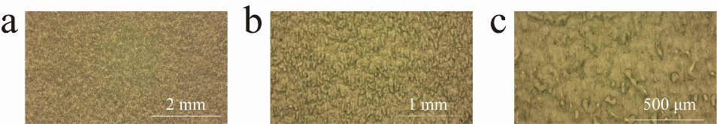
Fig. S7 Microscopic images of the scattering medium under different magnifications.

Fig. S8 Imaging results with a conventional camera when half of the metasurface target is obscured by a scattering medium.

3.4 Single pixel signal in background light environment
Fig. S9 Signal amplitude variation of DLI-PD when the backlight is turned on and off.

Figure S9 presents the intensity variation of the output signal of the top FAPbBr_{2.4}I_{0.6} device on DIP-SPD under the illumination of RCP red-green lasers when the background light is turned on and off. Figure S9(a) displays the voltage intensity value of the modulation signal for each measurement pattern. When the background light is turned on, the output signal curve of the device shifts upward as a whole, but the relative change trend remains unchanged. This indicates that the presence of the background light only adds a voltage bias to the output signal of the DIP-SPD. Figure S9(b) shows the modulated signal of Hadamard patterns for target image reconstruction after differential processing. The results presented in Fig. S9(b) indicate that the differential signal intensity used for image reconstruction remains consistent regardless of the presence or absence of the background light. Moreover, the quality of the reconstructed images is almost identical under both conditions, proving the strong background light resistance of the DIP-SPD. Hence, even with the background light turned on, the DIP-SPD can still effectively capture the superimposed dual-color metasurface images with exceptional clarity.

References
1 Pratt, W. K. et al. Hadamard transform image coding. Proc. IEEE 57, 58-68 (1969).
2 Duarte, M. F. et al. Single-pixel imaging via compressive sampling. IEEE Signal Process. Mag. 25, 83-91 (2008).
3 Gibson, G. M. et al. Single-pixel imaging 12 years on: a review. Opt. Express 28, 28190-28208 (2020).
4 Ye, Z. et al. Simultaneous full-color single-pixel imaging and visible watermarking using Hadamard-Bayer illumination patterns. Opt. Lasers Eng. 127, 105955 (2020).

