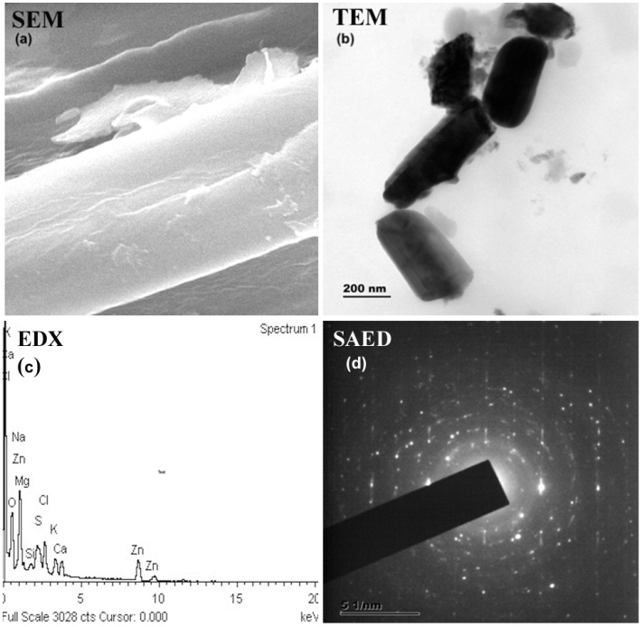

Sup Fig. 1(a) SEM (b) TEM (c) EDXS (d) SAED pictures of a ZnO NPs from S. polycystum.
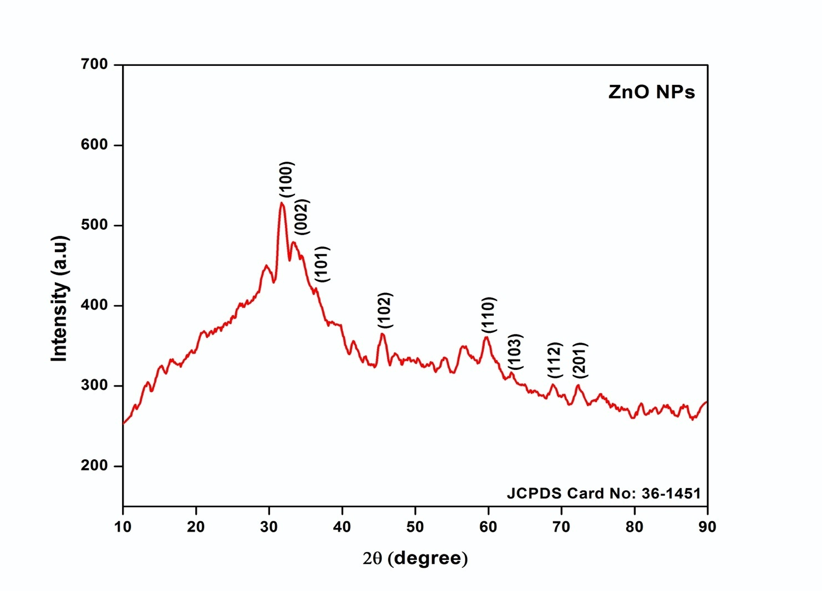
Sup fig 2; XRD pattern of ZnO NPs synthesized from S. polycystum

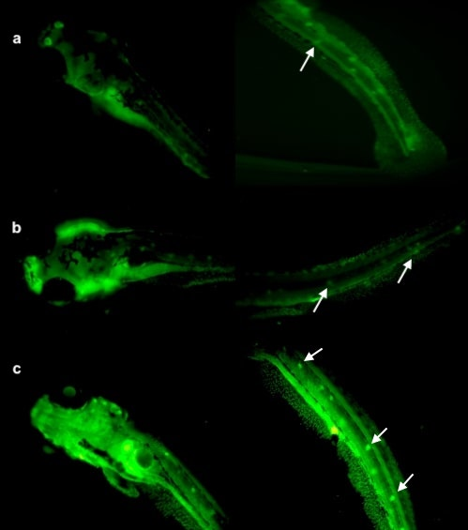

Sup Fig. 3. Representative microscopic images of AO stained a control b 60 and c 80 ppm ZnONP’s treated larvae under 40×magnifcation. The white arrows indicate the presence of apoptotic bodies

Table 1. Finne’s probit analysis with lower and upper confidence limits

Positive Percent | Percentile | Standard error | Confidence limit (95%)
Positive Percent | Percentile | Standard error | Lower | Upper
1 | 1.08694 | 0.171319 | 0.432188 | 1.31465
2 | 1.15522 | 0.154616 | 0.566076 | 1.36135
3 | 1.19855 | 0.144078 | 0.650902 | 1.3911
4 | 1.23114 | 0.136191 | 0.714635 | 1.41356
5 | 1.25764 | 0.129804 | 0.766417 | 1.43188
6 | 1.28021 | 0.124393 | 0.810443 | 1.44753
7 | 1.29999 | 0.119668 | 0.849003 | 1.46129
8 | 1.3177 | 0.115457 | 0.883491 | 1.47365
9 | 1.33381 | 0.111643 | 0.914822 | 1.48493
10 | 1.34864 | 0.108149 | 0.943629 | 1.49534
20 | 1.45884 | 0.082845 | 1.15632 | 1.57409
30 | 1.53829 | 0.065839 | 1.30704 | 1.63351
40 | 1.60619 | 0.053001 | 1.432 | 1.68811
50 | 1.66965 | 0.043727 | 1.54213 | 1.74581
60 | 1.7331 | 0.039066 | 1.63968 | 1.81609
70 | 1.801 | 0.040978 | 1.72382 | 1.91152
80 | 1.88045 | 0.051003 | 1.80026 | 2.04522
90 | 1.99065 | 0.072155 | 1.88817 | 2.24874
91 | 2.00548 | 0.075329 | 1.89926 | 2.27687
92 | 2.02159 | 0.078834 | 1.91119 | 2.30755
93 | 2.0393 | 0.082746 | 1.92417 | 2.34141
94 | 2.05908 | 0.087178 | 1.93854 | 2.37936
95 | 2.08165 | 0.092301 | 1.95479 | 2.42279
96 | 2.10816 | 0.098399 | 1.97371 | 2.47398
97 | 2.14075 | 0.105991 | 1.99677 | 2.53711
98 | 2.18407 | 0.116214 | 2.02716 | 2.6213
99 | 2.25235 | 0.132549 | 2.07459 | 2.75445

