Supplementary information
Supplementary Table 1 Matched influenza virus numbers to the H1 and H3 primers and probes of the RRT-PCR as searched by the BLAST tool†
HA  subtype | Primer/Probe | Matched influenza virus numbers
HA  subtype | Primer/Probe | N1 | N2 | N3 | N4 | N5 | N6 | Total
H1 | Forward primer | 2091 | 645 | 28 | 6 | 3 | 4 | 2777
H1 | Reverse primer | 963 | 145 | N/A | N/A | N/A | N/A | 1108
H1 | Probe | 4785 | 124 | 11 | N/A | N/A | N/A | 4920
H3 | Forward primer | 9 | 4815 | 1 | N/A | N/A | N/A | 4825
H3 | Reverse primer | 4 | 4357 | 2 | N/A | N/A | N/A | 4363
H3 | Probe | 26 | 4303 | 1 | N/A | N/A | N/A | 4340
† Searching parameters were defined as default except the one of “Max target sequences” set to 5000; N/A: Not applicable.
Supplementary Fig. S1: Amplification plots and the corresponding standard curves of the duplex TaqMan-MGB RRT-PCR of EA H1N1 or Pdm09 H1N1 and HL H3N2 SIVs by 10-fold serial dilutions of 5×10⁵ copies/μL HA plasmids. (Panel A) Duplex detection of HA genes of EA H1N1 and HL H3N2. The linear expression was y=-3.38x+36.106 (Efficiency=97.640%, R²=0.999) for EA H1N1 and y =-3.335x+37.406 (Efficiency=99.470%, R²=0.999) for HL H3N2, respectively. (Panel B) Duplex detection of HA genes of Pdm09 H1N1 and HL H3N2. The linear expression was y=-3.301x+35.933 (Efficiency=100.889%, R²=0.997) for Pdm09 H1N1 and y=3.301x+35.977 (Efficiency=100.885%, R²=0.996) for HL H3N2, respectively.
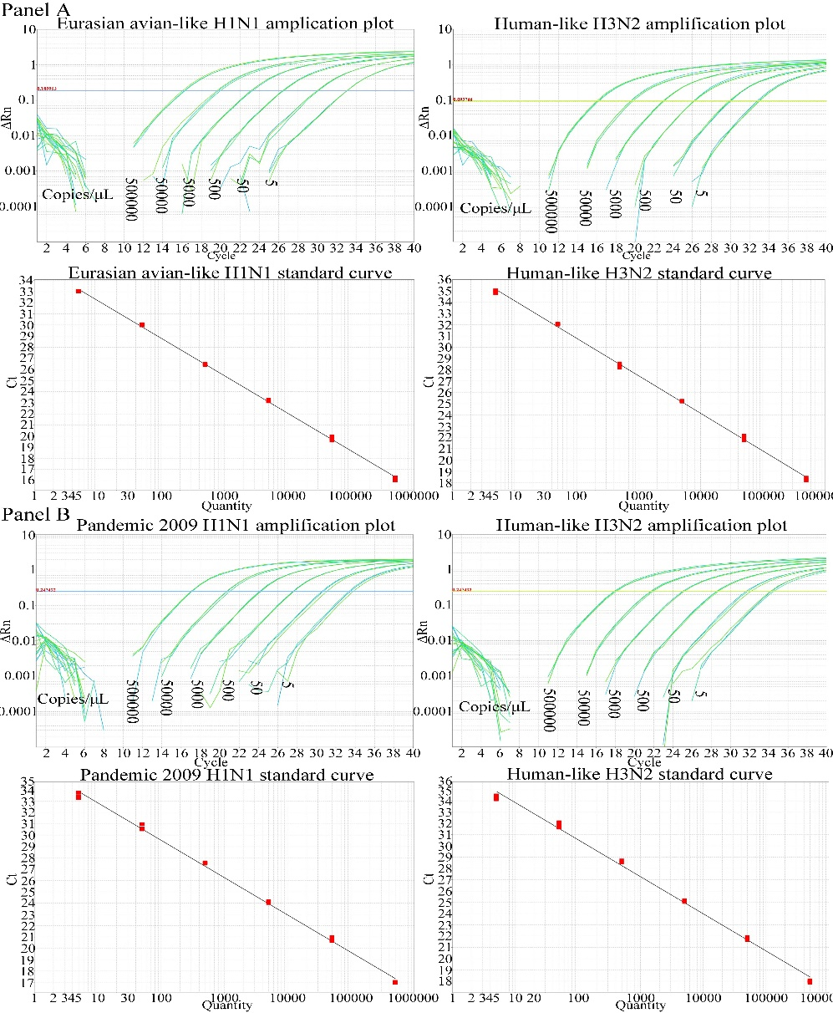
Supplementary Fig. S2: Detection limit of the duplex TaqMan-MGB RRT-PCR for different H1 and H3 subtype SIV strains. Each of the tested viruses including 4 EA H1N1 (F15, SG03, ZG14, and ZG16), 3 Pdm09 H1N1 (JS38, JS48 and JS285) and 2 HL H3N2 (SZ14, YC44) was succumbed to 10-fold serial dilutions according to EID₅₀ value. The lowest virus concentration as expressed in EID₅₀ that could still acquire regular amplification plot was defined as the detection limit.
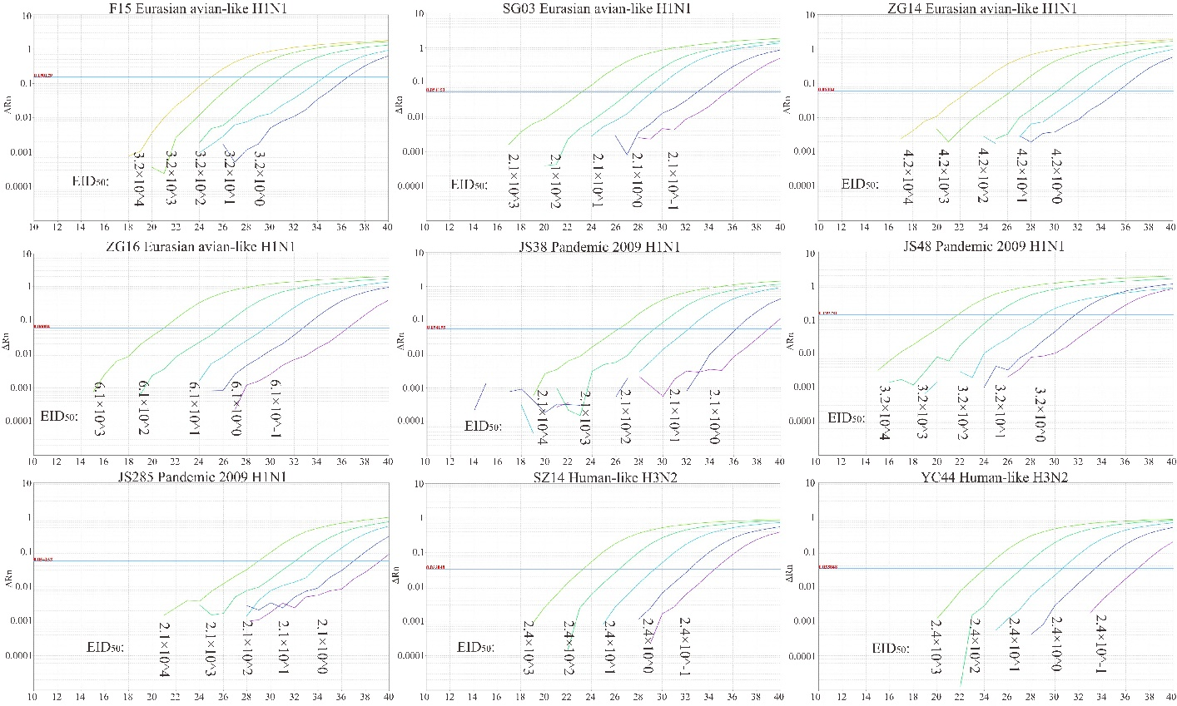
Supplementary Fig. S3: Specificity test of the H1 and H3 duplex RRT-PCR assay. Pathogens of H1 subtype swine influenza virus (SIV), H3 subtype SIV, classical swine fever virus (CSFV), pseudorabies virus (PRV), porcine reproductive and respiratory syndrome virus (PRRSV), porcine circovirus 2 (PCV2), porcine epidemic diarrhea virus (PEDV) and porcine parvovirus (PPV) were used for the detection. (A) H1 subtype SIV detection channel; (B) H3 subtype SIV detection channel. (a) H1 subtype SIV amplification curve; (b) H3 subtype SIV amplification curve; (c) Curves of CSFV PRV, PRRSV, PCV2, PEDV and PPV.
