Table S1 Composition and nutrient levels of the basal diet.
Item | Content % DM
Whole corn silage | 25.00
Oat hay | 2.00
Alfalfa hay | 15.00
Cracked Corn | 13.58
Whole cotton seed | 5.93
Steam flaked corn | 9.18
Wheat bran | 1.39
Soybean meal | 9.21
Dried beet pellet | 5.38
Rapeseed meal | 1.53
DDGS | 1.65
Premix¹⁾ | 1.00
Extruded soybean | 4.10
Molasses | 1.00
Fat powder | 2.26
Limestone | 0.29
Calcium phosphate | 0.56
MgO | 0.14
NaHCO₃ | 0.59
NaCl | 0.20
Mold remover | 0.01
Total | 100.00
Nutrient levels DM basis
NE_{L}, Mcal/kg ²⁾ | 1.64
Crude protein, % | 17.02
Ether extract, % | 5.13
Neutral detergent fiber, % | 34.48
Acid detergent fiber, % | 20.44
Calcium, % | 0.68
Phosphorus, % | 0.37
¹⁾ Premix contained (per kg of DM): 800,000 IU of vitamin A, 180,000 IU of vitamin D3, 7,000 mg of vitamin E, 45 mg of biotin, 300 mg of β-carotene, 600 mg of Cu, 1,000 mg of Fe, 2,200 mg of Zn, 1,800 mg of Mn, 20 mg of Co, 30 mg of Se and 39 mg of I.
²⁾ Data was calculated according to NRC models (NRC, 2001).

FigureS1 THI curve of cowsheds during the whole experiment.
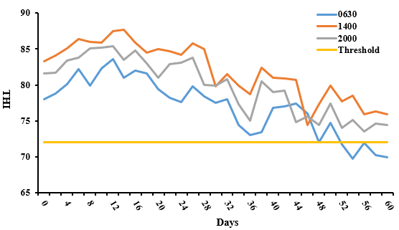
THI: temperature-humidity index. The THI values in the morning (0630), midday (1400) and night (2000) were recorded in the experiment and all the THI values were greater than 72 (threshold), indicating the dairy cows were exposed to the HS.

Table S2 Effect of NCG on nutrient apparent digestibility of lactating Holstein cows under HS.
Items | Groups |  |  |  | SEM | Probability
Items | Control | LNCG | MNCG | HNCG | SEM | P-NCG | Linear | Quadratic
CP, % | 84.30 | 85.88 | 86.40 | 85.30 | 1.10 | 0.58 | 0.33 | 0.38
EE, % | 94.33 | 94.97 | 94.99 | 95.45 | 0.514 | 0.5 | 0.15 | 0.88
NDF, % | 66.89 | 69.06 | 68.64 | 67.37 | 2.58 | 0.92 | 0.78 | 0.54
ADF % | 62.53 | 65.72 | 64.05 | 62.72 | 3.06 | 0.87 | 0.87 | 0.43
Ca, % | 63.31 | 61.25 | 65.34 | 67.22 | 3.36 | 0.63 | 0.44 | 0.34
P, % | 59.43 | 60.95 | 61.24 | 63.30 | 4.01 | 0.92 | 0.53 | 0.83
CP: crude protein, EE: ether extract, NDF: neutral detergent fiber, ADF: acid detergent fiber.

Table S3 Effect of NCG on blood biochemical indexes of lactating Holstein cows.
Items | Groups |  |  |  | SEM | Probability
Items | Control | LNCG | MNCG | HNCG | SEM | P-NCG | Linear | Quadratic
GLU, mmol/L | 4.87^{c} | 5.34^{b} | 5.78ª | 5.54^{ab} | 0.134 | ＜0.01 | ＜0.01 | 0.30
BUN, mmol/L | 4.89ª | 4.09^{b} | 4.37^{b} | 4.23^{b} | 0.171 | 0.01 | 0.72 | 0.95
TP, g/L | 70.50 | 73.67 | 70.10 | 74.54 | 1.66 | 0.14 | 0.22 | 0.83
ALB, g/L | 41.41 | 42.28 | 42.15 | 44.46 | 1.55 | 0.62 | 0.25 | 0.51
CRE, umol/L | 55.16 | 54.29 | 51.74 | 49.24 | 2.06 | 0.13 | 0.03 | 0.35
AST, Ul/L | 35.81 | 38.57 | 37.13 | 33.21 | 3.03 | 0.64 | 0.73 | 0.21
ALT, Ul/L | 47.90 | 43.18 | 43.63 | 45.88 | 3.36 | 0.75 | 0.51 | 0.38
BA, umol/L | 64.67ª | 43.00^{b} | 48.00^{b} | 46.67^{b} | 3.66 | 0.01 | ＜0.01 | 0.06
GLU: glucose, BUN: blood urea nitrogen, TP: total protein, ALB: albumin, CRE: creatinine, AST: aspartate aminotransferase, ALT: alanine aminotransferase, BA: blood ammonia. In the same row, different small letter superscripts mean P ≤ 0.05.

Figure S2 Unsupervised PCA score plots of the plasma samples in all groups (n = 5).
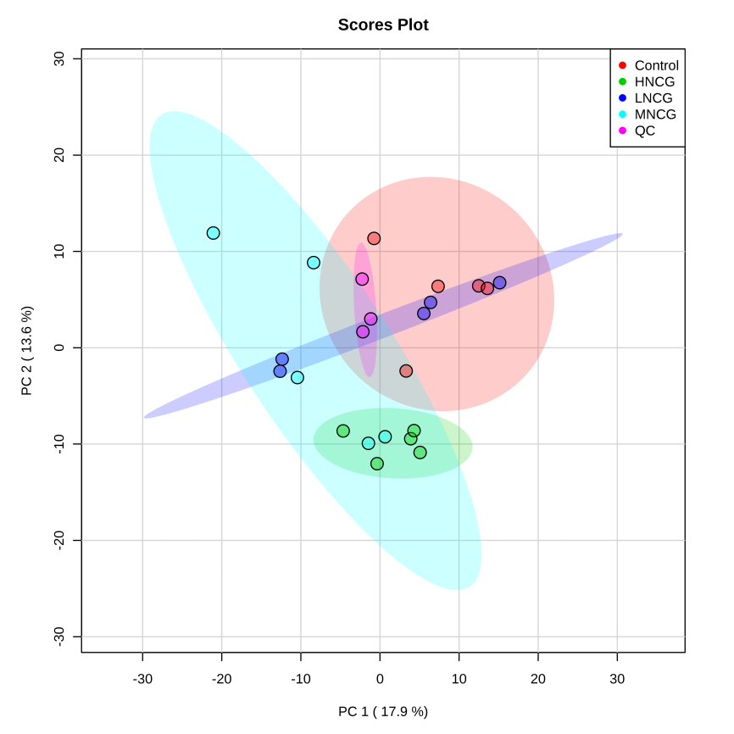
ESI+
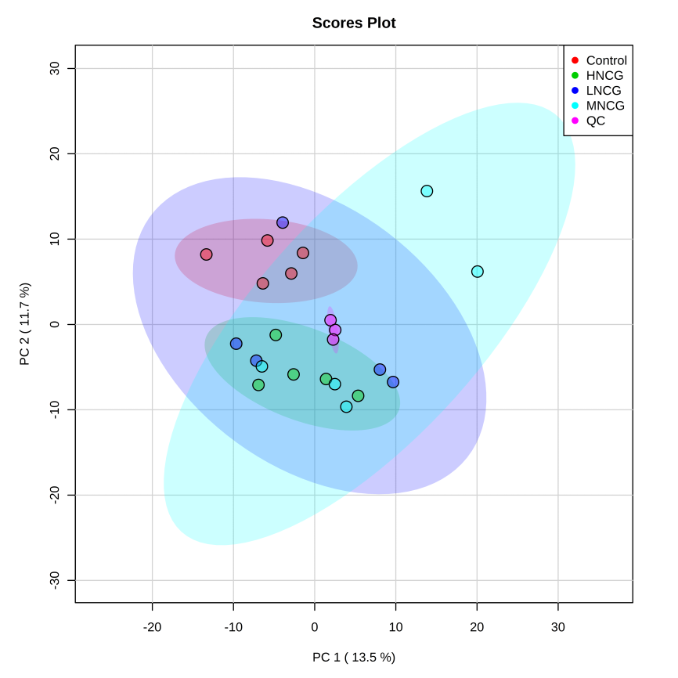
ESI-
ESI+: electrospray ionization in positive ion mode; ESI-: electrospray ionization in negative ion mode. Separation trend was found between control group and NCG treatment groups. Three QC samples were tightly clustered indicating the stability of the system and the method.

Figure S3 PLS-DA score plots of plasma samples in positive and negative modes between control and NCG groups.
ESI+: electrospray ionization in positive ion mode; ESI-: electrospray ionization in negative ion mode. Samples in the control group were clearly separated from those in the NCG treatment groups, indicating NCG had effects on the plasma metabonomic profile. R²X and R²Y indicate the fraction of the variables explained by the model, and the Q² shows the predictive abilities of the model. Control versus LNCG, ESI+: R²X = 0.409, R²Y = 0.965 and Q² = 0.509; ESI-: R²X = 0.353, R²Y = 0.986 and Q² = 0.533; Control versus MNCG, ESI+: R²X = 0.383, R²Y = 0.984 and Q² = 0.724; ESI-: R²X = 0.371, R²Y = 0.995 and Q² = 0.873; Control versus HNCG, ESI+: R²X = 0.327, R²Y = 0.997 and Q² = 0.699; ESI-: R²X = 0.327, R²Y = 0.998 and Q² = 0.812.

Table S4 Pathway analysis result with MetaboAnalyst of the different metabolites in plasma response to NCG treatment.
 | Total | Expected | Hits | Raw p | -log p | Impact
Lysine degradation | 25 | 0.19841 | 2 | 0.015657 | 4.1568 | 0.1
Synthesis and degradation of ketone bodies | 5 | 0.039683 | 1 | 0.039109 | 3.2414 | 0.14286
Aminoacyl-tRNA biosynthesis | 48 | 0.38095 | 2 | 0.053189 | 2.9339 | 0.06896
Biotin metabolism | 10 | 0.079365 | 1 | 0.076811 | 2.5664 | 0
alpha-Linolenic acid metabolism | 13 | 0.10317 | 1 | 0.098776 | 2.3149 | 0.125
Butanoate metabolism | 15 | 0.11905 | 1 | 0.11315 | 2.179 | 0.06667
Biosynthesis of unsaturated fatty acids | 36 | 0.28571 | 1 | 0.25192 | 1.3787 | 0
Glycerophospholipid metabolism | 36 | 0.28571 | 1 | 0.25192 | 1.3787 | 0.03846
Tryptophan metabolism | 41 | 0.3254 | 1 | 0.28188 | 1.2663 | 0.10256
Primary bile acid biosynthesis | 46 | 0.36508 | 1 | 0.31073 | 1.1688 | 0
Total: The total number of compounds in the pathways; the hits are the actually matched number from the user upload data; the raw p is the original p value calculated from the enrichment analysis; the impact is the pathway impact value calculated from pathway analysis.

