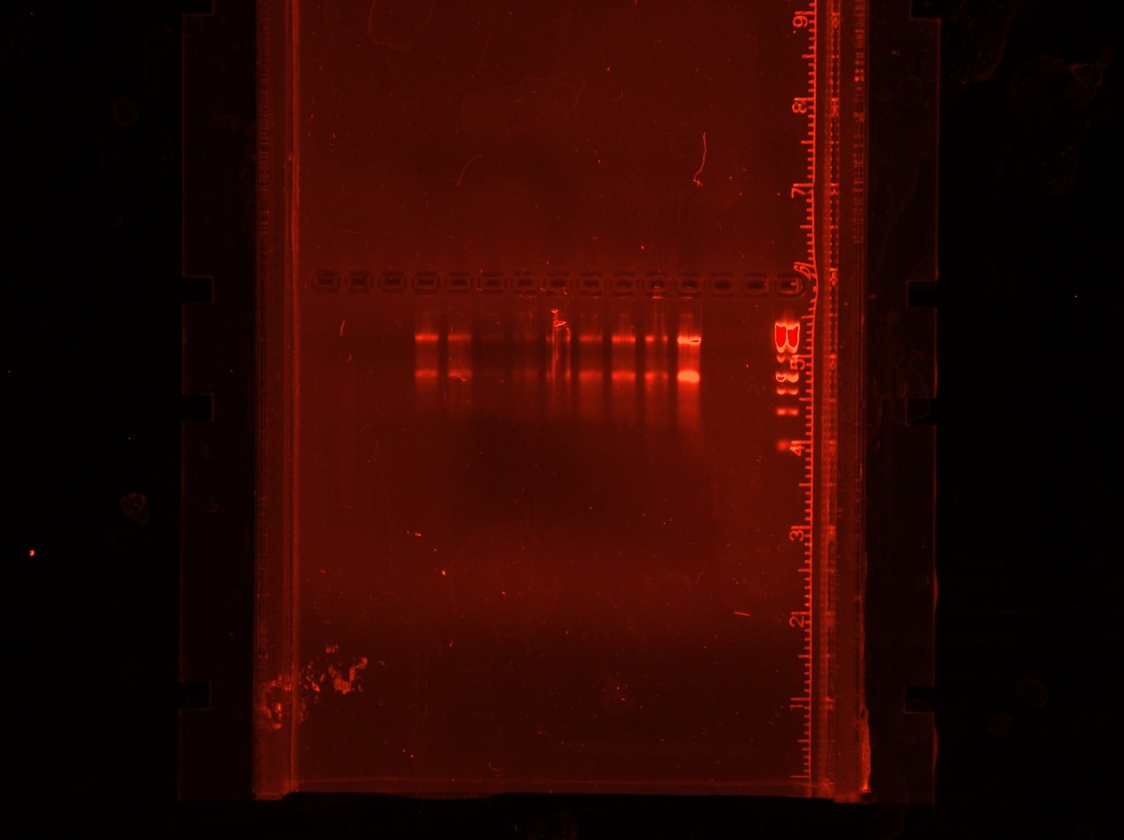

Supplementary figure 01; Full length (uncropped) Gel image, visualized under Molecular Imager Gel DocTM XR+ showing clear 28s and 18s RNA bands after degradation of gDNA with DNase addition.

