Supplementary Materials

Novel Green Genetically Encoded Fluorescent Sensor for Sulfate for Probing Sulfate Transport Activity of Solute Carrier Family 26 Member a2 (Slc26a2) Protein
Cuixin Lai^{1,2,3}, Lina Yang^{1,2,3}, Ruizhao Wang^{1,2,3}, Fedor V. Subach⁴, Kiryl D. Piatkevich^{1,2,3}*
¹School of Life Science, Westlake University, Hangzhou, Zhejiang, China
²Westlake Laboratory of Life Sciences and Biomedicine, Hangzhou, Zhejiang, China
³Institute of Basic Medical Sciences, Westlake Institute for Advance Study, Hangzhou, Zhejiang, China
⁴Complex of NBICS Technologies, National Research Center “Kurchatov Institute”, Moscow, 123182, Russia

Correspondence to: kiryl.piatkevich@westlake.edu.cn

Supplementary Figure 1. Screening of the selected mNeonGreen variants.
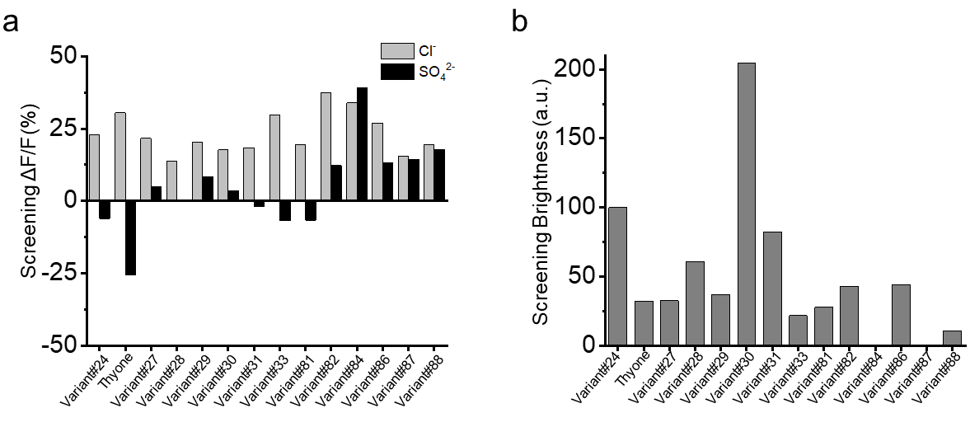
(a) Screening ΔF/F of the selected mNeonGreen variants in response to Cl⁻ (grey bars) and SO₄²⁻ (black bars) at pH=7.4; bar graph, mean. (b) Screening brightness of the selected mNeonGreen variants relative to Variant#24; bar graph, mean.

Supplementary Figure 2. Amino acid alignment of mNeonGreen with the anion sensitive variants identified in the screening.
10 20 30 40 50 60
| | | | | |
mNeonGreen MVSKGEEDNMASLPATHELHIFGSINGVDFDMVGQGTGNPNDGYEELNLKSTKGDLQFSP
Variant#24 MVSKGEEDNMASLPATHELHIFGSINGVDFDMVGQGTGNPNDGYEELNLKSTKGDLQFSP
Thyone MVSKGEEDNMASLPATHELHIFGSINGVDFDMVGQGTGNPNDGYEELNLKSTKGDLQFSP
Variant#27 MVSKGEEDNMASLPATHELHIFGSINGVDFDMVGQGTGNPNDGYEELNLKSTKGDLQFSP
Variant#28 MVSKGEEDNMASLPATHELHIFGSINGVDFDMVGQGTGNPNDGYEELNLKSTKGDLQFSP
Variant#29 MVSKGEEDNMASLPATHELHIFGSINGVDFDMVGQGTGNPNDGYEELNLKSTKGDLQFSP
Variant#30 MVSKGEEDNMASLPATHELHIFGSINGVDFDMVGQGTGNPNDGYEELNLKSTKGDLQFSP
Variant#31 MVSKGEEDNMASLPATHELHIFGSINGVDFDMVGQGTGNPNDGYEELNLKSTKGDLQFSP
Variant#33 MVSKGEEDNMASLPATHELHIFGSINGVDFDMVGQGTGNPNDGYEELNLKSTKGDLQFSP
Variant#81 MVSKGEEDNMASLPATHELHIFGSINGVDFDMVGQGTGNPNDGYEELNLKSTKGDLQFSP
Variant#82 MVSKGEEDNMASLPATHELHIFGSINGVDFDMVGQGTGNPNDGYEELNLKSTKGDLQFSP
Variant#84 MVSKGEEDNMASLPATHELHIFGSINGVDFDMVGQGTGNPNDGYEELNLKSTKGDLQFSP
Variant#86 MVSKGEEDNMASLPATHELHIFGSINGVDFDMVGQGTGNPNDGYEELNLKSTKGDLQFSP
Variant#88 MVSKGEEDNMASLPATHELHIFGSINGVDFDMVGQGTGNPNDGYEELNLKSTKGDLQFSP

70 80 90 100 110 120
| | | | | |
mNeonGreen WILVPHIGYGFHQYLPYPDGMSPFQAAMVDGSGYQVHRTMQFEDGASLTVNYRYTYEGSH
Variant#24 WILVPHIGYGFHQYLPYPDGMSPFQAAMVDGSGYQVHRTMQFEDGASLTVNYRYTYEGSH
Thyone WILVPHIGYGFHQYLPYPDGMSPFQAAMVDGSGYQVHRTMQFEDGASLTVNYRYTYEGSH
Variant#27 WILVPHIGYGFHQYLPYPDGMSPFQAAMVDGSGYQVHRTMQFEDGASLTVNYRYTYEGSH
Variant#28 WILVPHIGYGFHQYLPYPDGMSPFQAAMVDGSGYQVHRTMQFEDGASLTVNYRYTYEGSH
Variant#29 WILVPHIGYGFHQYLPYPDGMSPFQAAMVDGSGYQVHRTMQFEDGASLTVNYRYTYEGSH
Variant#30 WILVPHIGYGFHQYLPYPDGMSPFQAAMVDGSGYQVHRTMQFEDGASLTVNYRYTYEGSH
Variant#31 WILVPHIGYGFHQYLPYPDGMSPFQAAMVDGSGYQVHRTMQFEDGASLTVNYRYTYEGSH
Variant#33 WILVPHIGYGFHQYLPYPDGMSPFQAAMVDGSGYQVHRTMQFEDGASLTVNYRYTYEGSH
Variant#81 WILVPHIGYGFHQYLPYPDGMSPFQAAMVDGSGYQVHRTMQFEDGASLTVNYRYTYEGSH
Variant#82 WILVPHIGYGFHQYLPYPDGMSPFQAAMVDGSGYQVHRTMQFEDGASLTVNYRYTYEGSH
Variant#84 WILVPHIGYGFHQYLPYPDGMSPFQAAMVDGSGYQVHRTMQFEDGASLTVNYRYTYEGSH
Variant#86 WILVPHIGYGFHQYLPYPDGMSPFQAAMVDGSGYQVHRTMQFEDGASLTVNYRYTYEGSH
Variant#88 WILVPHIGYGFHQYLPYPDGMSPFQAAMVDGSGYQVHRTMQFEDGASLTVNYRYTYEGSH

130 140 150 160 170 180
| | | | | |
mNeonGreen IKGEAQVKGTGFPADGPVMTNSLTAADWCRSKKTYPNDKTIISTFKWSYTTGNGKRYRST
Variant#24 IKGEAQVKGTGFPADGPVMTNSLTAADWYRSKKTYPNDKTIISTFKYSYTTGNGKRYRST
Thyone IKGEAQVKGTGFPADGPVMTNSLTAADWIRAKKTYPNDKTIISTFKISYTTGNGKRYRST
Variant#27 IKGEAQVKGTGFPADGPVMTNSLTAADWTRNKKTYPNDKTIISTFKLSYTTGNGKRYRST
Variant#28 IKGEAQVKGTGFPADGPVMTNSLTAADWQRGKKTYPNDKTIISTFKFSYTTGNGKRYRST
Variant#29 IKGEAQVKGTGFPADGPVMTNSLTAADWSRAKKTYPNDKTIISTFKLSYTTGNGKRYRST
Variant#30 IKGEAQVKGTGFPADGPVMTNSLTAADWIRSKKTYPNDKTIISTFKWSYTTGNGKRYRST
Variant#31 IKGEAQVKGTGFPADGPVMTNSLTAADWYRSKKTYPNDKTIISTFKYSYTTGNGKRYRST
Variant#33 IKGEAQVKGTGFPADGPVMTNSLTAADWLRVKKTYPNDKTIISTFKVSYTTGNGKRYRST
Variant#81 IKGEAQVKGTGFPADGPVMTNSLTAADWYRSKKTYPNDKTIISTFKWSYTTGNGKRYRST
Variant#82 IKGEAQVKGTGFPADGPVMTNSLTAADWYRSKKTYPNDKTIIKTLKYSYTTGNGKRYRST
Variant#84 IKGEAQVKGTGFPADGPVMTNSLTAADWYRSKKTYPNDKTIISTFKWSYTTGNGKRYRST
Variant#86 IKGEAQVKGTGFPADGPVMTNSLTAADWYRSKKTYPNDKTIISTLKYSYTTGNGKRYRST
Variant#88 IKGEAQVKGTGFPADGPVMTNSLTAADWCRSKKTYPNDKTIISTFKWSYTTGNGKRYRST

190 200 210 220 230
| | | | |
mNeonGreen ARTTYTFAKPMAANYLKNQPMYVFRKTELKHSKTELNFKEWQKAFTDVMGMDELYK
Variant#24 ARTTYTFAKPMAANYLKNQPMYVFRKTELKHSKTELNFKEWQKAFTDVMGMDELYK
Thyone ARTTYTFAKPMAANYLKNQPMYVFRKTELKHSKTELNFKEWQKAFTDVMGMDELYK
Variant#27 ARTTYTFAKPMAANYLKNQPMYVFRKTELKHSKTELNFKEWQKAFTDVMGMDELYK
Variant#28 ARTTYTFAKPMAANYLKNQPMYVFRKTELKHSKTELNFKEWQKAFTDVMGMDELYK
Variant#29 ARTTYTFAKPMAANYLKNQPMYVFRKTELKHSKTELNFKEWQKAFTDVMGMDELYK
Variant#30 ARTTYTFAKPMAANYLKNQPMYVFRKTELKHSKTELNFKEWQKAFTDVMGMDELYK
Variant#31 ARTTYTFAKPMAANYLKNQPMYVFRKTELKHSKTELNFKEWQKAFTDVMGMDELYK
Variant#33 ARTTYTFAKPMAANYLKNQPMYVFRKTELKHSKTELNFKEWQKAFTDVMGMDELYK
Variant#81 ARSTYTFAKPMAANYLKNQPMYVFRKTELKHSKTELNFKEWQKAFTDVMGMDELYK
Variant#82 ARTTYTFAKPMAANYLKNQPMYVFRKTELKHSKTELNFKEWQKAFTDVMGMDELYK
Variant#84 ARTTYTFAKPMAANYLKNQPMYVFRKTELKHSKTELNFKEWQKAFTDVMGMDELYK
Variant#86 ARSTYTFAKPMAANYLKNQPMYVFRKTELKHSKTELNFKEWQKAFTDVMGMDELYK
Variant#88 ARGTYTFAKPMAANYLKNQPMYVFRKTELKHSKTELNFKEWQKAFTDVMGMDELYK

Introduced mutation are highlighted with red. The β-sheet-forming regions and α-helixes are shaded and illustrated with arrows and ribbons, respectively.

Supplementary Figure 3. pH titration of mNeonGreen.
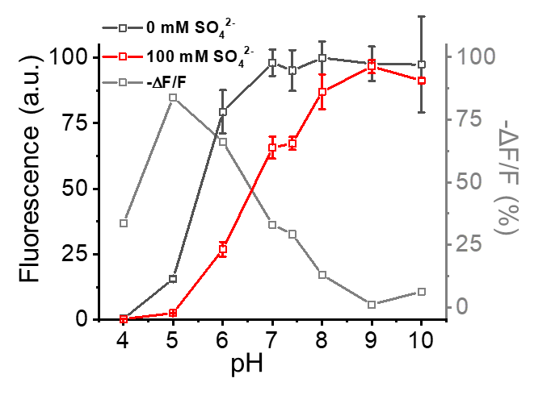
pH titration of mNeonGreen in the sulfate-free or 100 mM SO₄²⁻ buffer (n=3 technical replicates). Squares, mean; error bars, standard deviation (SD).

Supplementary Figure 4. Affinity of mNeonGreen to the selected anions.
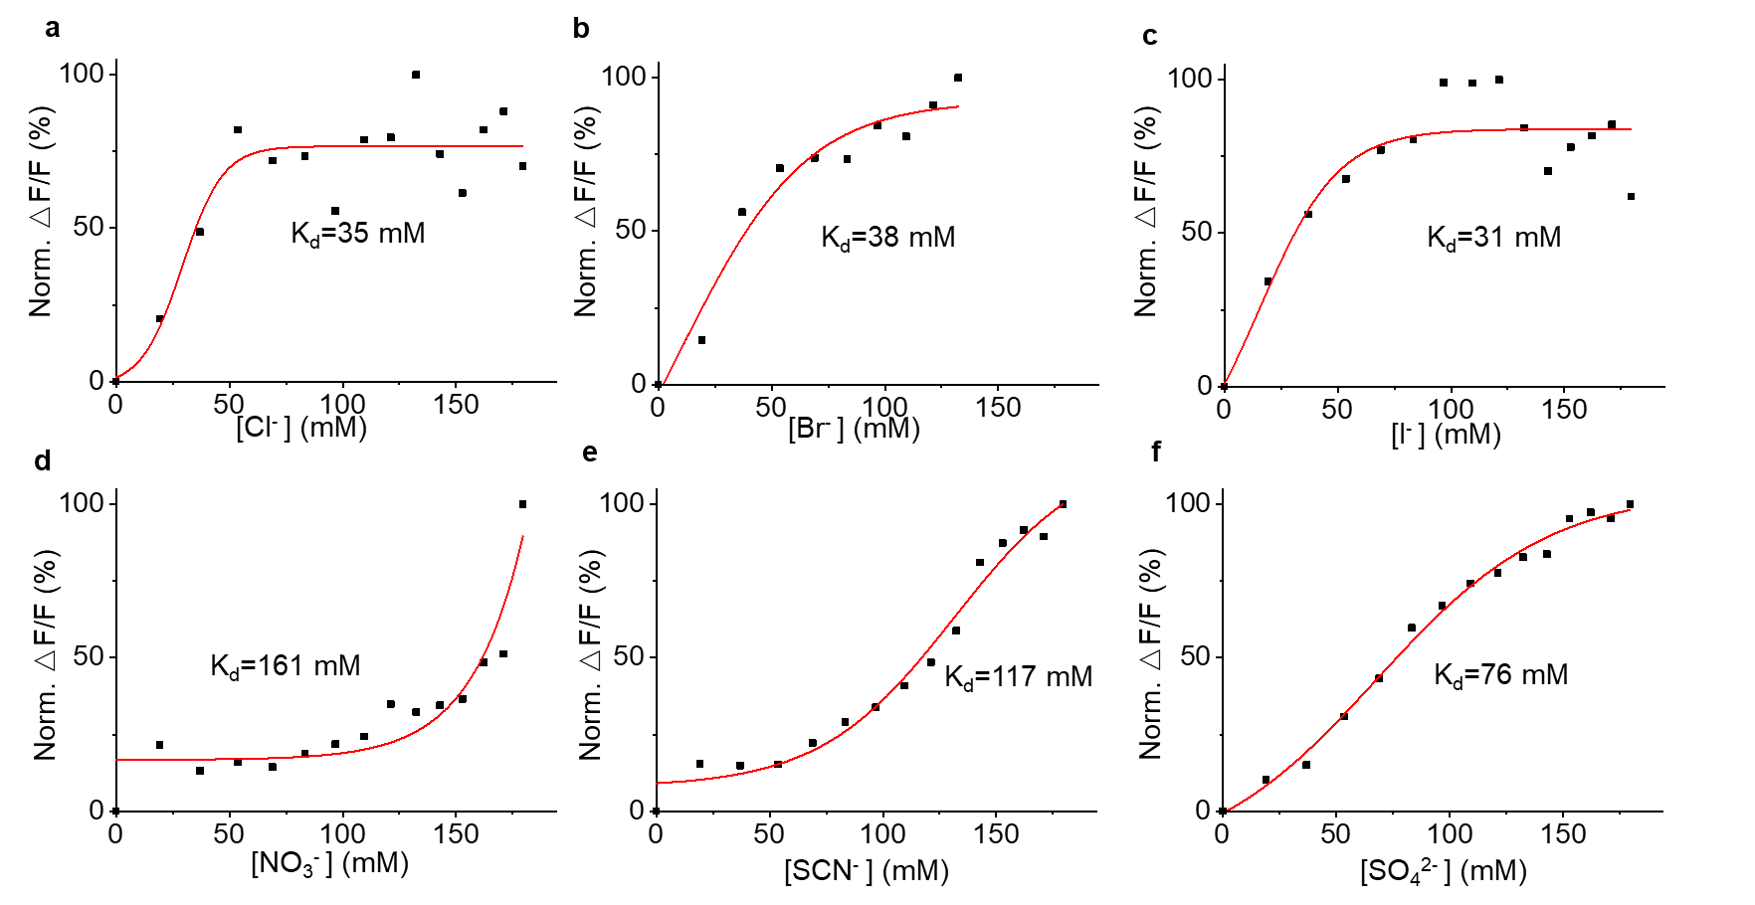
The titration curves of mNeonGreen against (a) chloride, (b) bromine, (c) iodine, (d) nitrate, (e) thiocyanate, and (f) sulfate ions (n=1 technical replicate each). The fluorescence changes were normalized using the highest value obtained for each ion. The data points, means, are shown as black squares, and red lines represent fitting using DoseResp equation.

Supplementary Figure 5. Affinity of Varient#24 (mNG-C149Y/W167Y) to the selected anions.
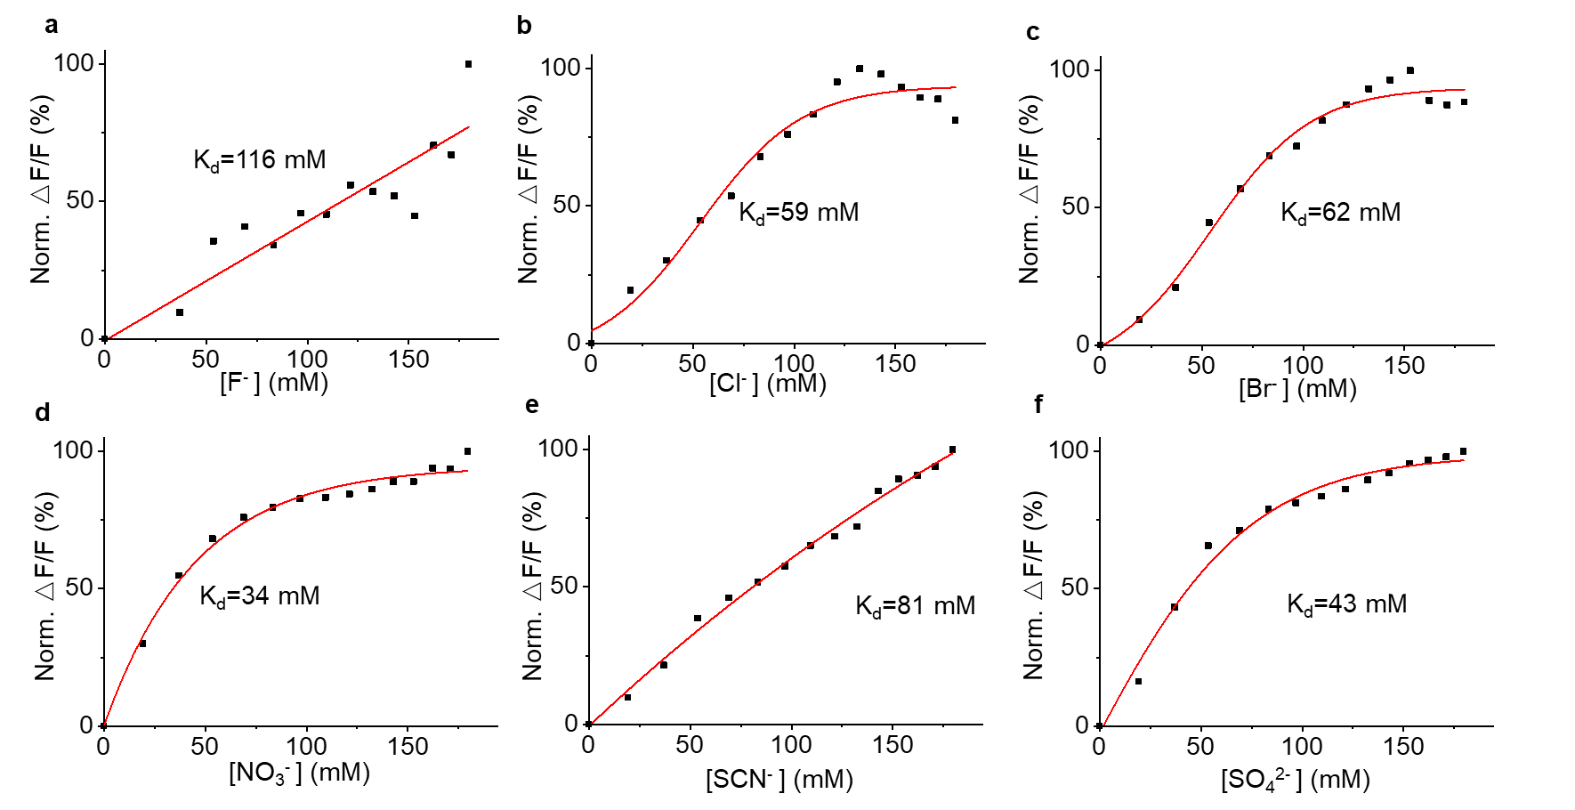
The titration curves of Varient#24 (mNG-C149Y/W167Y) against (a) chloride, (b) bromine, (c) iodine, (d) nitrate, (e) thiocyanate, and (f) sulfate ions (n=1 technical replicate each). The fluorescence changes were normalized using the highest value obtained for each ion. The data points, means, are shown as black squares, and red lines represent fitting using DoseResp equation.

Supplementary Figure 6. Affinity of Thyone to the selected anions.
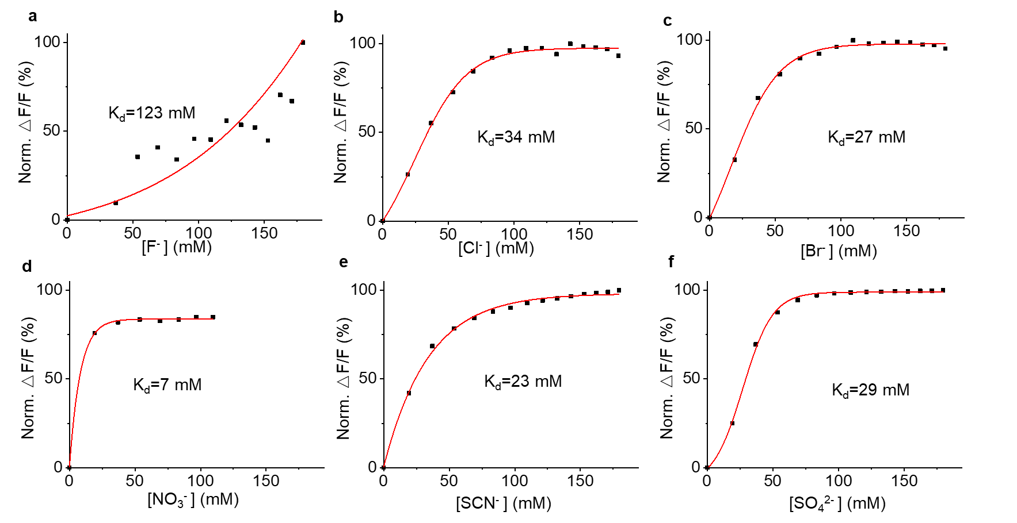
The titration curves of Thyone against (a) chloride, (b) bromine, (c) iodine, (d) nitrate, (e) thiocyanate, and (f) sulfate ions (n=1 technical replicate each). The fluorescence changes were normalized using the highest value obtained for each ion. The data points, means, are shown as black squares, and red lines represent fitting using DoseResp equation.

Supplementary Figure 7. Sulfate ionophore titration in mammalian cells.
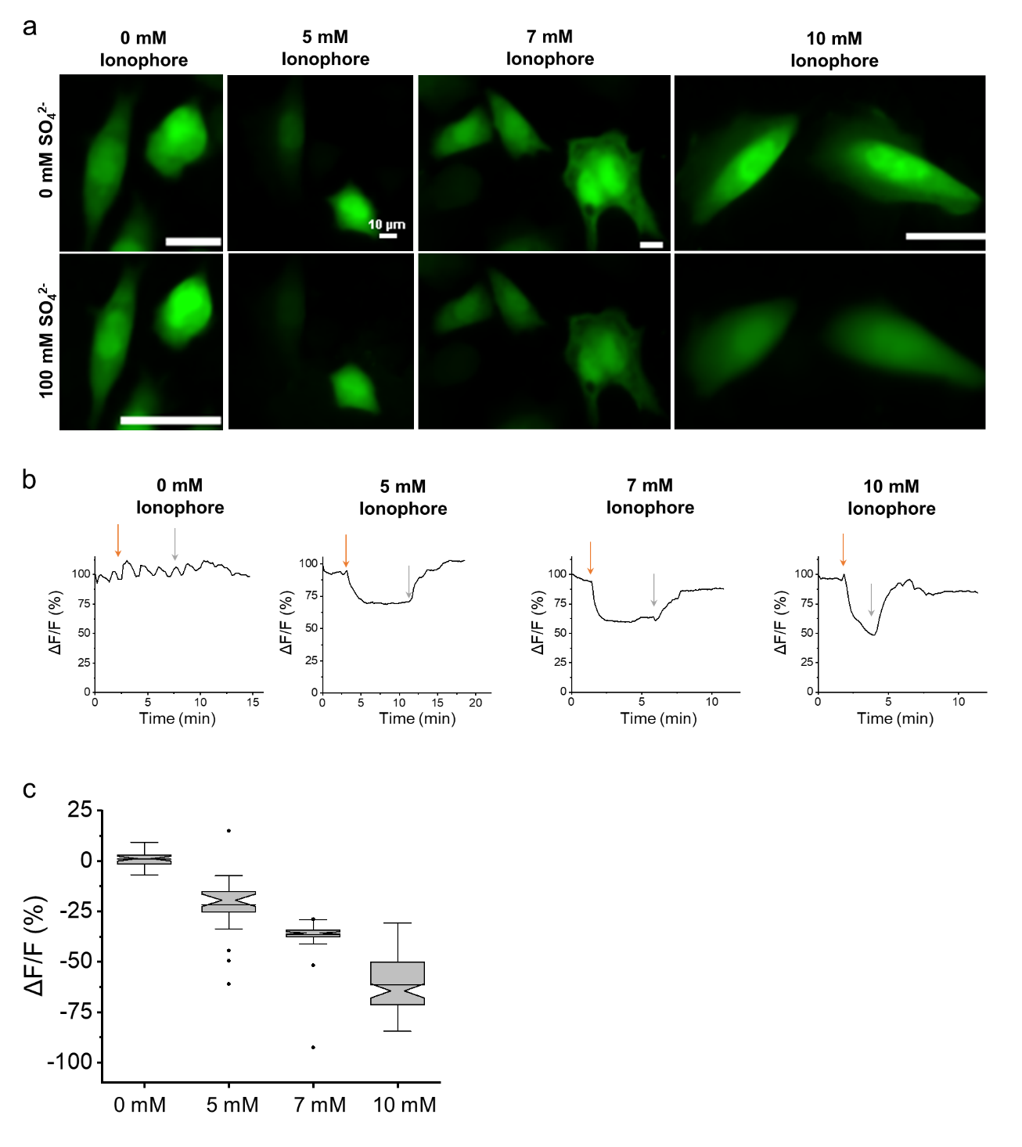
(a) Representative fluorescence images of live HEK cells expressing untagged Thyone in sulfate-free (top) and sulfate-containing (bottom) extracellular solution containing various concentrations of sulfate ionophore (n= 37, 26, 87, and 87 cells for 0, 5, 7, and 10 mM of sulfate ionophore, respectively, from 1-2 transfection each). Scale bar, 10 μm. (b) Representative single-trial traces of Thyone fluorescence upon adding (orange arrow) and washing out (grey arrow) sulfate-containing buffer with or without ionophore (n= 37, 26, 87, and 87 cells for 0, 5, 7, and 10 mM of sulfate ionophore, respectively, from 1-2 transfection each). (c) Quantification of Thyone fluorescence response for the experiments shown in panel b (n= 37, 26, 87, and 87 cells for 0, 5, 7, and 10 mM of sulfate ionophore, respectively, from 1-2 transfection each). Box plots with notches are used throughout this paper: narrow part of notch, median; top and bottom of the notch, 95% confidence interval for the median; top and bottom horizontal lines, 25% and 75% percentiles for the data; whiskers extend 1.5 × the interquartile range from the 25th and 75th percentiles; horizontal line, mean; outliers, dots.

