Reviewer #1: The study Wang et al. re-considered the GRF family genes in poplar and investigated their function in poplar leaf development. The finding that GRFs affect leaf development by changing cell proliferation and expansion level is worth for biomass production in woody plants. However, the novelty of the study and the quality of figures need to be considered carefully for publication.
Response: Thanks for your comments. We have clarified the novelty and revised our manuscript according to your comments. We hope that you will find our new version greatly improved.
Major comments:
The authors are shared with the published study about GRF15 in poplar (Zhou et al. 2019, Tree Physiol.). The study Zhou et al. is constructed well in terms of the experimental design and the scientific discussion. However, the main claim of the study Zhou et al. are quite similar with the study Wang et al., which means the novelty of Wang et al. is not enough for publication. The authors need to add more data about the molecular basis of the variety in GRF families by performing experiments like identifying direct downstream target genes etc.
Response: In this manuscript, we have demonstrated the unexpected diversified regulation on leaf size control by various poplar GRFs including PagGRF12a, PagGRF12b, PagGRF6b and PagGRF7a, which provides more and additional information than our previous report on PagGRF15. 1) We show that PagGRF7a acts distinctly as a negative regulator on leaf size control while PagGRF6b has no effect on leaf development, though PagGRF12a and PagGRF12b are similar to PagGRF15 functioning as positive regulators, indicating that different members of poplar GRFs can have distinct roles in leaf size control. Therefore, the investigation on the exact role of each poplar GRF is meaningful and valuable. 2) We demonstrate that the regulatory ways by different GRFs on leaf size control are diversified among these identified GRFs. PagGRF7a regulates leaf size through negatively affecting cell expansion while PagGRF12a and PagGRF12b positively affecting cell proliferation and negatively affecting cell expansion. All exhibit different manners with that of PagGRF15, which positively affects cell expansion. Indeed, the expression of cell proliferation and expansion marker genes is changed accordingly under the regulation by these different GRFs. Therefore, this study revealed the diverse regulatory mechanism of poplar GRFs in leaf size control. We believe that these results would benefit for understanding the complex mechanism of poplar leaf size control.
We have added a description about the comparison of this work to our previous work in the Discussion part. Page 9, Line 208-219.
In addition, as for revealing the molecular basis of different GRFs in leaf size control, we agree with you that identifying direct downstream target genes is important and the related work are ongoing.

Overall, the resolution of figures is too low for the publication quality. The microscopy images in Figure 3A, B and 4A-D are not clear for validation. The authors need to alter the images to those with higher resolution.
Response: Thanks. We have replaced the images to those with higher resolution.

The authors used miR396-resistant version of GRF transgene and claimed GRFs are important for leaf size/cell proliferation. However, what the result suggested seems the regulation of GRF genes by miR396 is important. The authors need to modify the discussion part.
Response: Thanks for your comments. We have added the following text to address the importance of the regulation of GRF genes by miR396. Page 9-10, Line 233-245. “Additionally, our study also suggests the importance of the regulation of GRF genes by miR396 in poplar, which is found in Arabidopsis (Rodriguez et al. 2010; Debernardi et al. 2014; Liang et al. 2014). Firstly, the miR396 regulation on GRFs using miR396-resistant version have been tested through transient expression assays in order to obtain the overexpression of GRFs. The fluorescence signals of the cells expressing PagGRF6b-YFP, PagGRF7a-YFP and PagGRF12a-YFP were faint and hardly detected, while the signals expressed their miR396-resistant version were strong, exampled as PagGRF12a-YFP in Fig. 3, which indicated that these GRFs were regulated by the existing miR396 in cells. Secondly, although PagGRF12a and PagGRF15 (PagGRF1/2d in this study) (Zhou et al., 2019) are positive regulators on leaf size, the PagmiR396b OE plants showed a phenotype of smaller leaves (Zhou et al., 2019), suggesting the “epistasis” effect of miR396b on the regulation of leaf size. Therefore, the interaction of miR396 and GRFs is important for leaf development.”
Reviewer #4: This manuscript presents a functional role of GRF genes in poplar. The authors identified 19 GRFs in poplar genome, analyzed the mRNA degradation via miR396 and morphological effects on leaf cells in GRF overexpressing poplars. While this study is well done, some results seems to be preliminary. I point out the following concerns should be addressed.
Response: Thanks for your comments. We have revised our manuscript according to your comments and we hope that you will find our new version greatly improved.
Major Compulsory Revisions
1. There is no gene expression analysis of 19 GRFs in this study. Tissue gene expression patterns of the GRFs will provide insight into their functionality in poplar.
Response: Thanks. The tissue expression of 19 GRFs have been provided in our previous paper (Zhou et al., 2019), and most GRFs showed higher expression in young leaves. We have added this information to the Results part. Page 7, Line 159-164.
2. Fifth leaves were used for morphological analyses in this study, but I wonder that the leaves of overexpressors were at same developmental stage as control leaves. Empirically, poplar leaves younger than tenth are at an expanding stage, and I think that it is better to use full expanded leaves for phenotyping analyses.
Response: Thanks. All the morphological analyses in this study were carried out according to the method in our previous study (Zhou et al., 2019). The plants in comparison were planted in the same condition and the leaves collected were at same developmental stage. Two-month-old plants were used in this assay, although the fifth leaves were not fully expanded, they could represent the alteration of other leaves (Fig. R1).
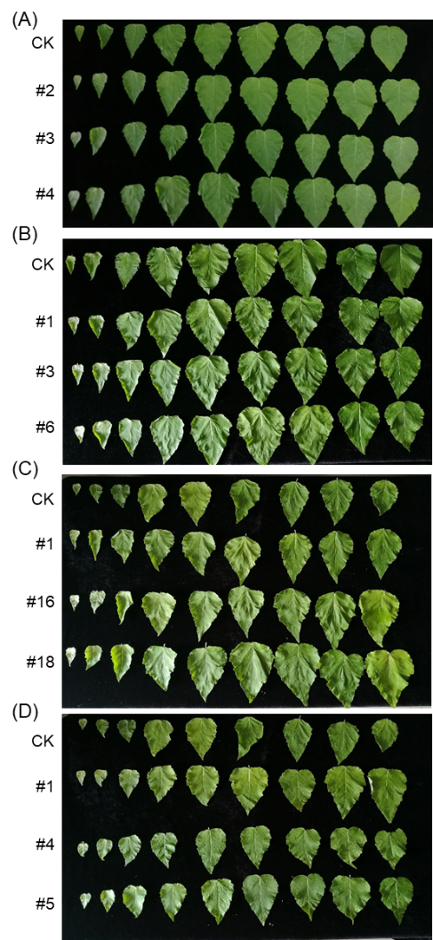
Fig. R1. Leaves of 2-month-old mPagGRF6b (A), mPagGRF7a (B), mPagGRF12a (C), and PagGRF12b (D) OE plants.

3. In Figure 4, leaf cell number of control plants are varied between the experiments; ca. 11 in (A), ca. 12 in (B), ca. 5.9 in (C) and ca. 5.9 in (D). The authors should explain this difference.
Response: Thanks. The plants in (A) and (B) were planted in one time point and the plants in (C) and (D) were planted in another, which may cause some differences. However, the leaf size and leaf cell size data of transgenic plants were compared with their CKs planted in the same time point. In addition, all the comparison was done with three independent biological repeats and the alteration was similar.

4. In Figure 5, expression analyses should be carried out in three independent transgenic lines.
Response: Expression analyses were carried out in three independent transgenic lines and the data was provided and replaced the original Fig. 5. All the expression alterations were in consistence.

Minor Essential Revisions
1. Line 53; "all" is not correct in this sentence.
Response: Thanks. We have rephrased it.
2. Line 137; Fluorescence of PagGRF-YFP should be described in an additional supplemental data.
Response: The fluorescence signals of PagGRF-YFP were weak and hard to detect (Fig. R2, Fig. 3), while the fluorescence signals of mPagGRF-YFP were strong and easy to detect (Fig. 3). Thus, we think it may not be necessary to present all these weak or non signal images in the manuscript.
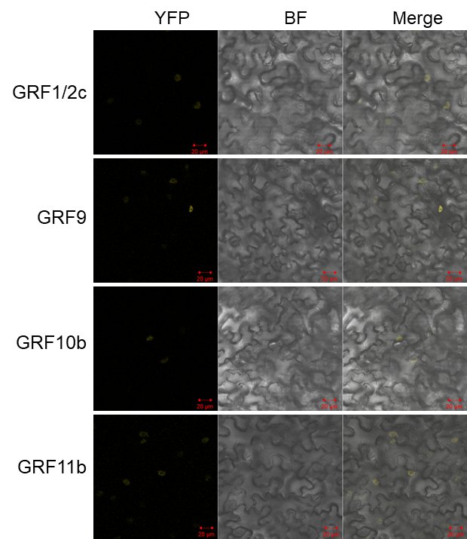
Fig. R2. The fluorescence signals of PagGRF1/2c-YFP, PagGRF9-YFP, PagGRF10b-YFP, and PagGRF11b-YFP. Bars = 20 μm.

3. Line 264; Spell out the abbreviations "FFD, GPL, and TQL".
Response: "FFD, GPL, and TQL" are not typical abbreviations. Just like “WRC” and “QLQ” domains, FFD, GPL, and TQL domains are named because of the conserved amino acids they contained. We have added the reference for "FFD, GPL, and TQL". Page 12, Line 297.

4. Line 288; How do you calculate the cell number in a leaf? Which leaf region (base, center and tip) do you use for the morphological analyses?
Response: The cell number was calculated according to the method in our previous report (Zhou et al., 2019). Which described “Palisade cells in the center of the leaf blade, between the midvein and leaf margin, were analyzed. The total number of palisade cells in the subepidermal layer was calculated by dividing the leaf area by the palisade cell area.”

5. Line 310; "Populous" shoud be "Populus"
Response: Thanks. We have corrected it.

6. Figure 1; The phylogenetic tree should not be a consensus tree.
Response: Thanks. We have regenerated the tree and replaced the original one in Fig. 1A with the new one.

7. Figure 2A; Explain the meaning of red and green characters in the legend.
Response: Characters in green and red are the nucleotide sequences of miR396 and GRFs, respectively. We have supplemented the legend to Fig. 2.

8. Figure 2B; Explain the meaning of a green box, bar and arrow in the legend.
Response: The green boxed are the introns of GRFs. Bars indicate the location of the complementary nucleotides of GRFs to miR396. Arrows indicate the complementary nucleotides of GRFs and miR396. We have added this to the legend to Fig. 2.

9. Figure 4, Leaf cell number; Represent "the unit" of the Y-axis.
Response: We have added the unit to the Y-axis for leaf cell number.

10. Figure 4, 5 and S4; Sample number (n) should be described. Error bars are standard deviation (SD)? or standard error (SE)?
Response: Sample numbers were added in the figure legend of Fig. 4, 5 and S4. Error bars are standard deviation (SD) and also indicated in the figure legend of Fig. 4, 5 and S4.

11. Figure 5; Statistical test should be applied in this data.
Response: Statistical test was carried out and all the significance was marked in Fig. 5.

12. Figure S4; I wonder if non-mutated endogenous genes were amplified in the RT-PCR assay.
Response: Our aim was to obtain the GRF OE lines thus we checked the overall expression of the GRF (including the non-mutated) in question, regardless how the non-mutated is affected. But we agree that it is interesting to see if the expression of the non-mutated is affected by transformation.

