Supplementary Material

Contrasting Negative Effects of Multipollutant Exposure on Femoral and Spinal Bone Mineral Density: Findings from a Population-based Study in US Adults

Supplementary Table S1. Abbreviation for different categories of environmental chemicals.
Categories | Abbreviation
Metallic elements | Cd: Cadmium  Pb: Lead  Hg: Mercury
Polycyclic aromatic hydrocarbons (PAHs) | P01: 1-hydroxynaphthalene  P02: 2-hydroxynaphthalene  P03: 3-hydroxyfluorene  P04: 2-hydroxyfluorene  P05: 3-hydroxyphenanthrene  P06: 1-hydroxyphenanthrene  P07: 2-hydroxyphenanthrene  P10: 1-hydroxypyrene  P17: 9-hydroxyfluorene
Phthalates | CNP: Mono(carboxynonyl) phthalate  COP: Mono(carboxyoctyl) phthalate  MBP: Mono-n-butyl phthalate  MEP: Mono-ethyl phthalate  MHP: Mono-(2-ethyl)-hexyl phthalate  MZP: Mono-benzyl phthalate  MNM: Mono-n-methyl phthalate  MC1: Mono-(3-carboxypropyl) phthalate  MHH: Mono-(2-ethyl-5-hydroxyhexyl) phthalate  MOH: Mono-(2-ethyl-5-oxohexyl) phthalate  MIB: Mono-isobutyl pthalate  ECP: Mono-2-ethyl-5-carboxypentyl phthalate
Phenols | BPA: Urinary Bisphenol A

Supplementary Figure S1. Flow Diagram of Inclusion/Exclusion Criteria.
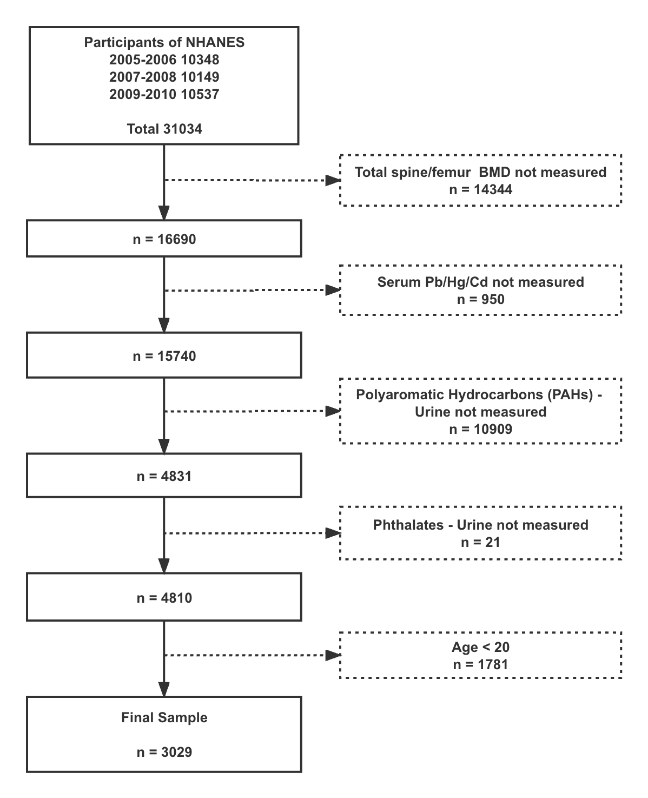

Supplementary Figure S2. The relationship between the total femur BMD environmental pollutants. Solid red line represents the smooth curve fit between variables according to GAM. Blue bands represent the 95% of confidence interval from the fit. Y axis represents bone density, and x axis represents the concentration of the environmental pollutants. Models were adjusted for age, gender, education, family PIR, alcohol drinking, physical activity, BMI, hypertension, 25-hydroxyvitamin D, serum albumin, serum ALP, total serum calcium, serum refrigerated iron, serum phosphorus, serum cotinine, and serum glycohemoglobin.
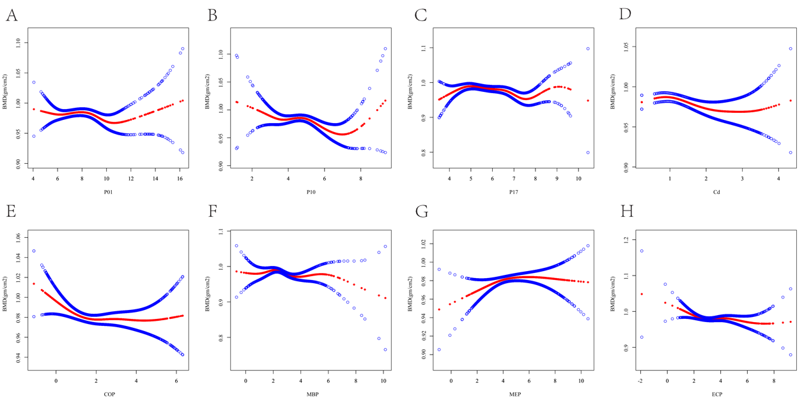

Supplementary Figure S3. The relationship between the total spine BMD environmental pollutants. Solid red line represents the smooth curve fit between variables according to GAM. Blue bands represent the 95% of confidence interval from the fit. Y axis represents bone density, and x axis represents the concentration of the environmental pollutants. Models were adjusted.
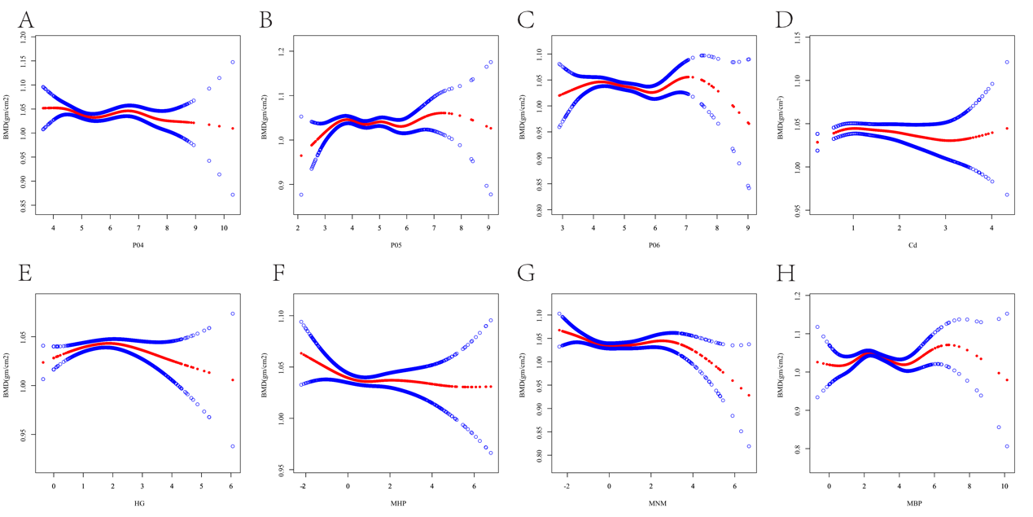

Supplementary Figure S4. The associations of environmental chemicals co-exposure and the total femur (A)/spine (B) BMD by BKMR. A₁, B₁ represent premenopause. A₂, B₂ represent postmenopause, A₃, B₃ represent male. Models were adjusted.
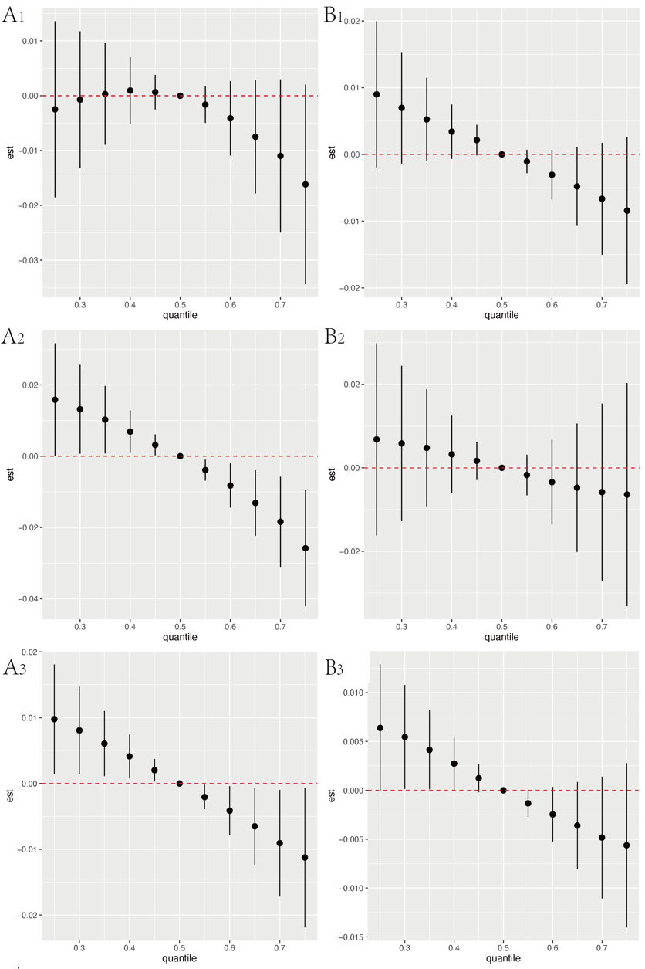

Supplementary Figure S5. The associations of environmental chemicals co-exposure and the total intertrochanter(A)/femoral neck(B)/trochanter BMD by BKMR. Models were adjusted.

